MANUAL GUIDE FOR CARCLASS
USER VIEW
Home page view:
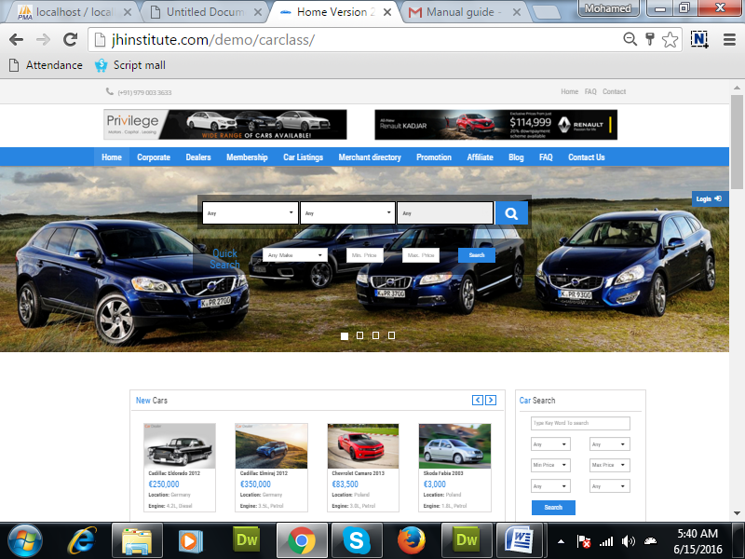
Description:
In this,users can view the new model cars, used cars as per their own functionality. For example : specified prize, specified brand etc.,

Car listing:
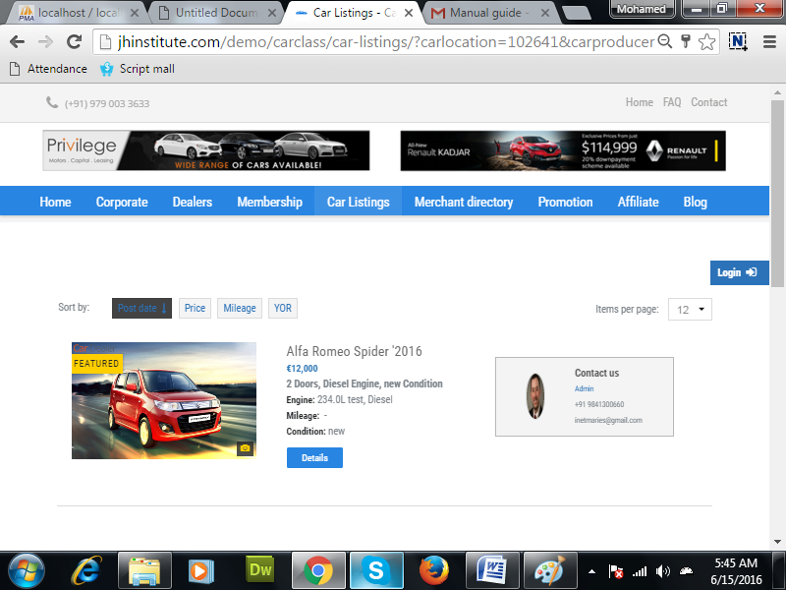
Description:
Here user can see the details of car based on their own filtration.

Dealers:
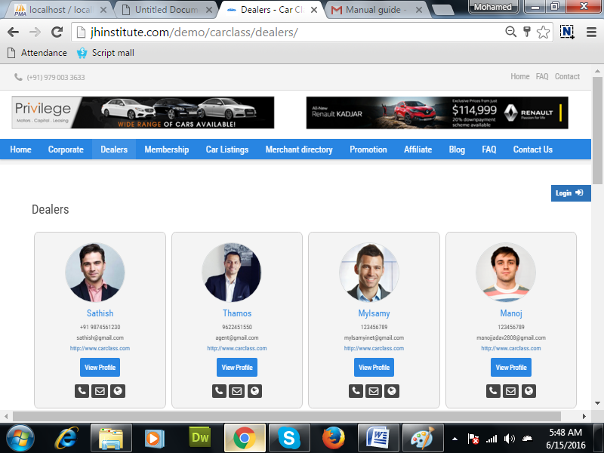
Description:
User can see the dealer’s detail.
If the user is a registered person who can view the dealer’s profile.

Member ship:
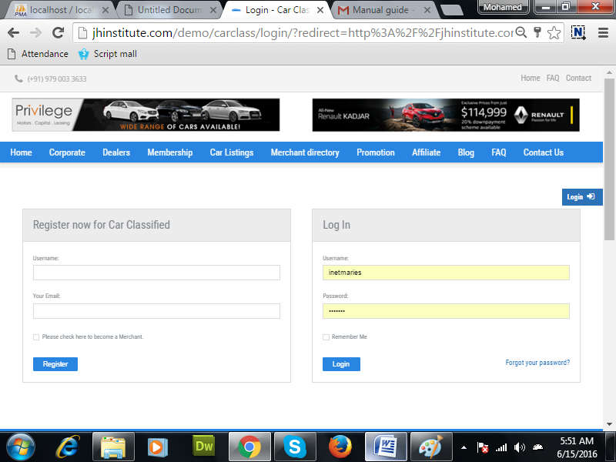
Description:
User can also get member ship in this page.

Car listing:
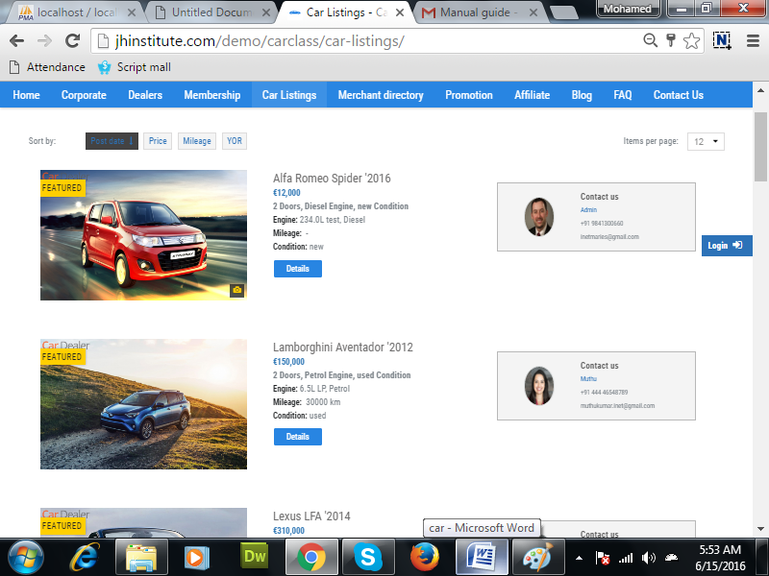
Description:
User can see the detail information of the car.
In this, users can sort by price, country, brand etc.,

Merchants directory:
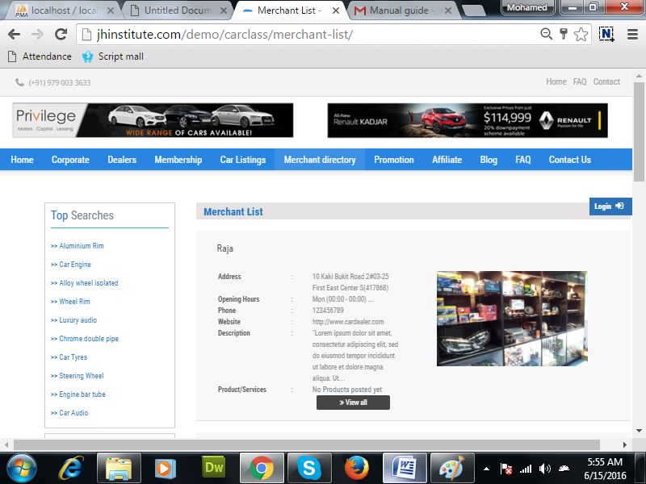
Description:
User can see the merchant detail of the products.

Register:
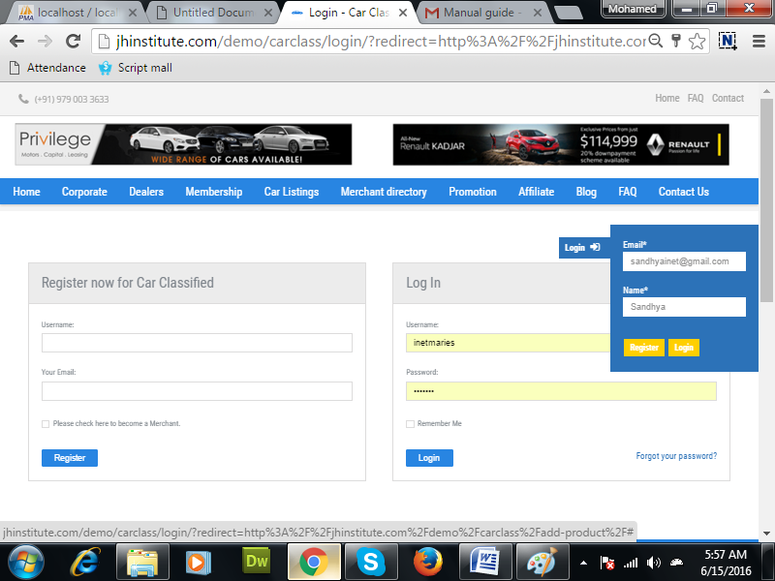

Description:
User can register easily. For registration, mail id and their name is enough to create a account.

Promotion:
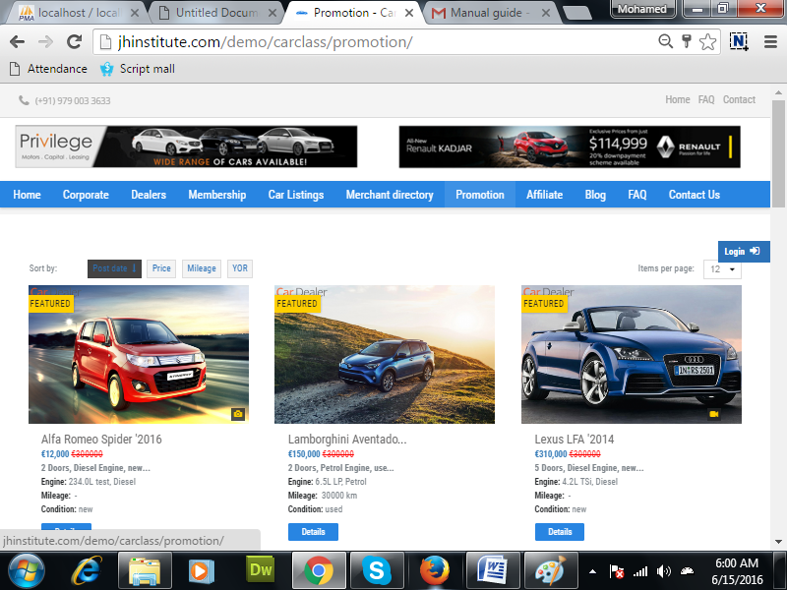
Description:

Login page:
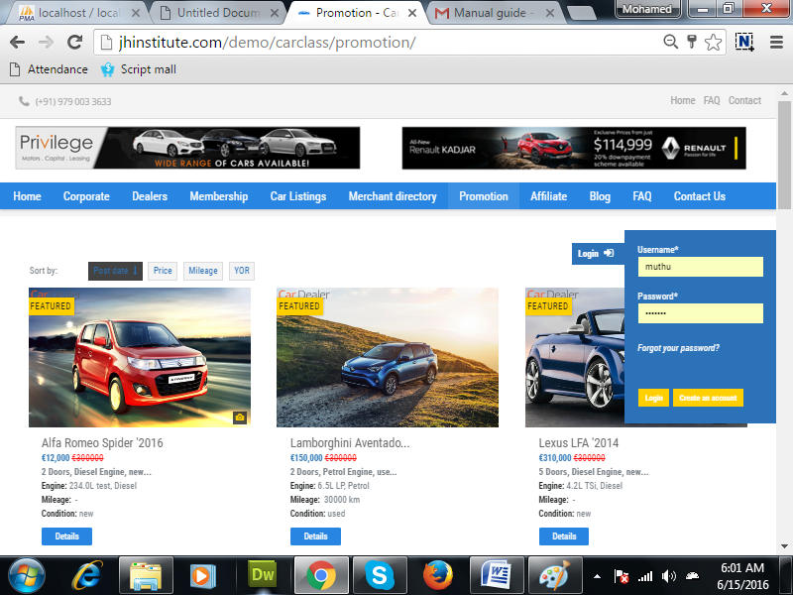
Description:
Easy to login. User have to give their name and password only.

Blogs:
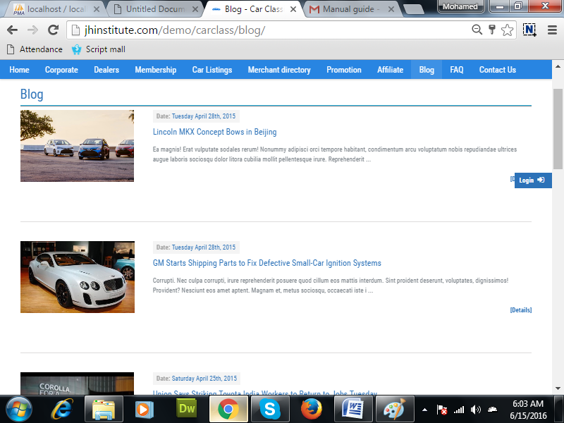

Frequently Asked Questions:
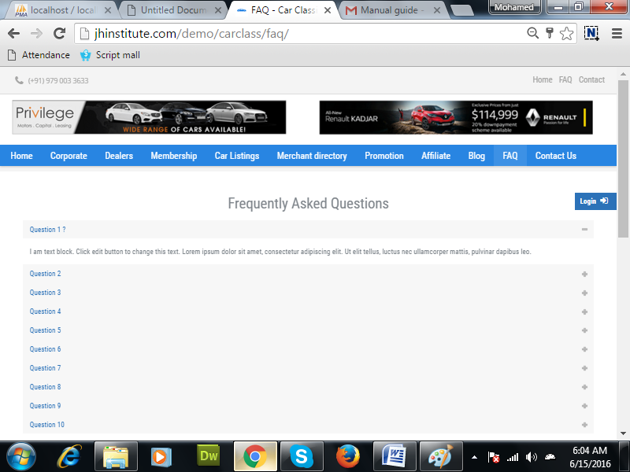
Description:
Here different users ask their questions and clarify it.

Contact :
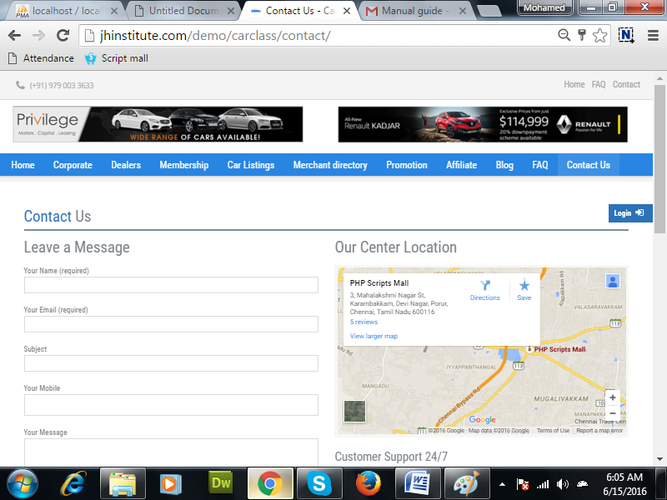
Description:
User can enter their detail for the owner will support to them.

Dealer’s Profile:
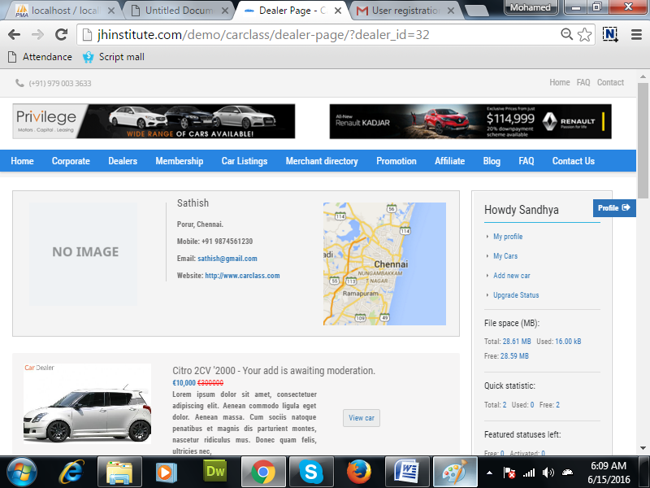
Description:
Detailed view of dealer’s profile.

Membership dealer:
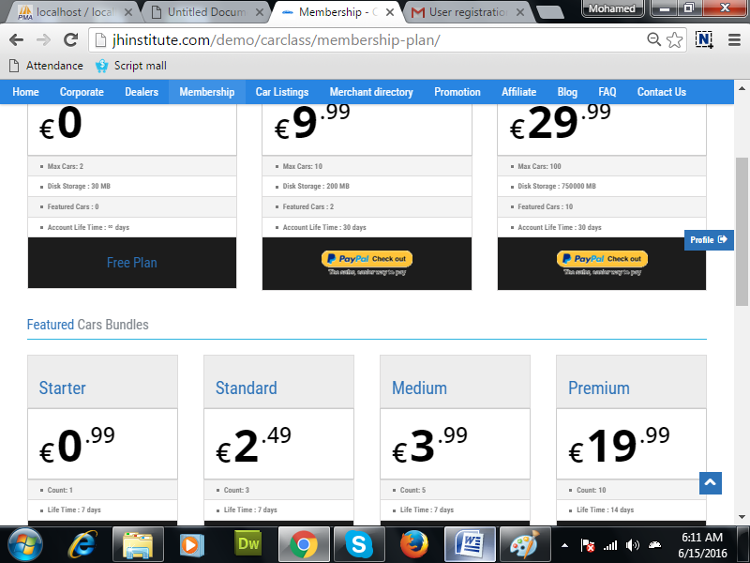
Description:
Different types of dealer and who have maximum number of cars, featured cars are shown.

Product:
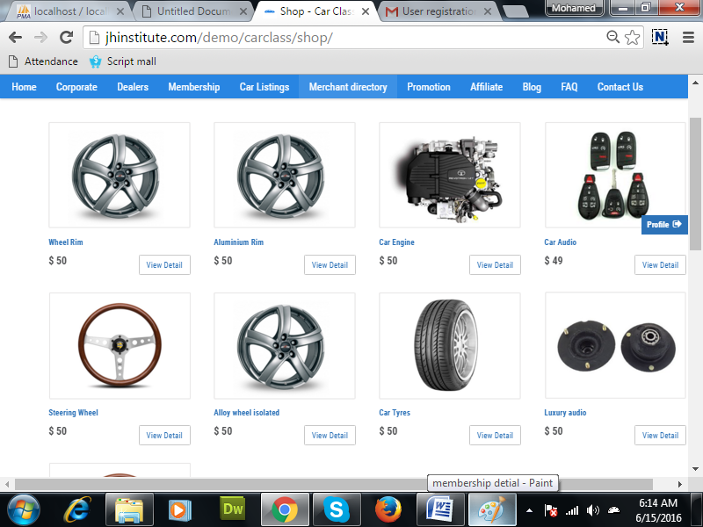
Description:
user can see the product detail and pize detail.

Merchant selling parts:
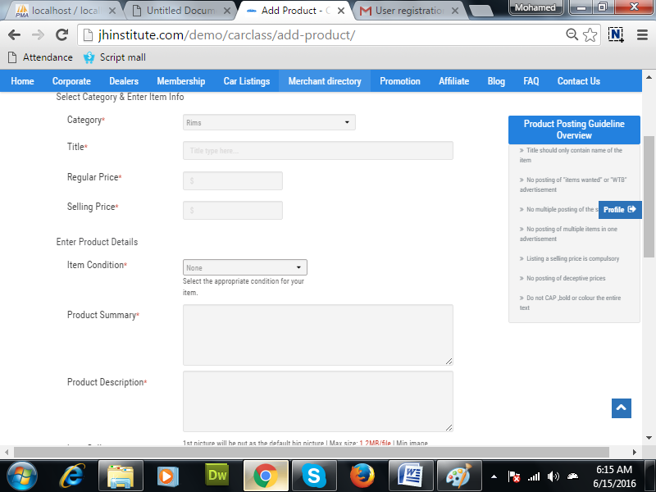
Description:
User is a merchant for selling car parts who can add the parts and their details.

Affliate:
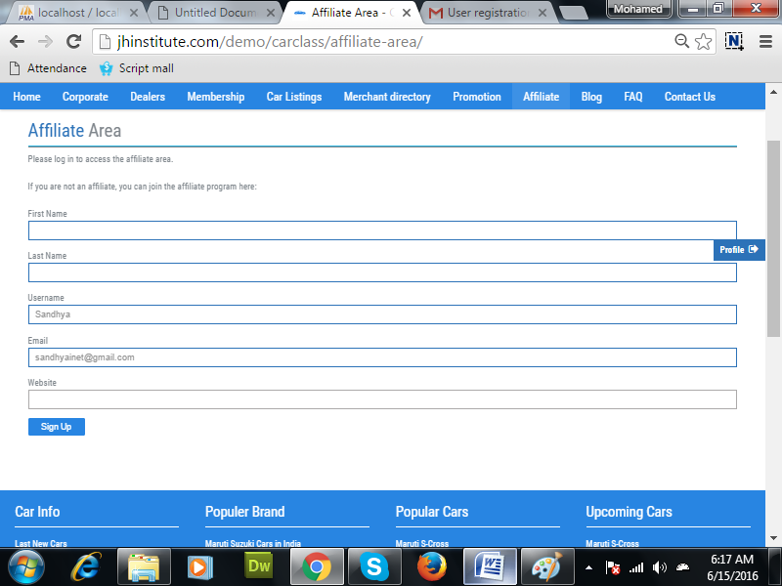
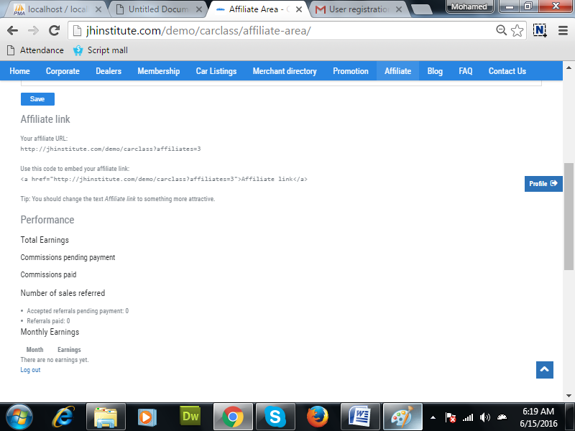
Description:
In affiliated area, user can view the information about the affiliated links and earnings.

