Module: User
Subject: Registration
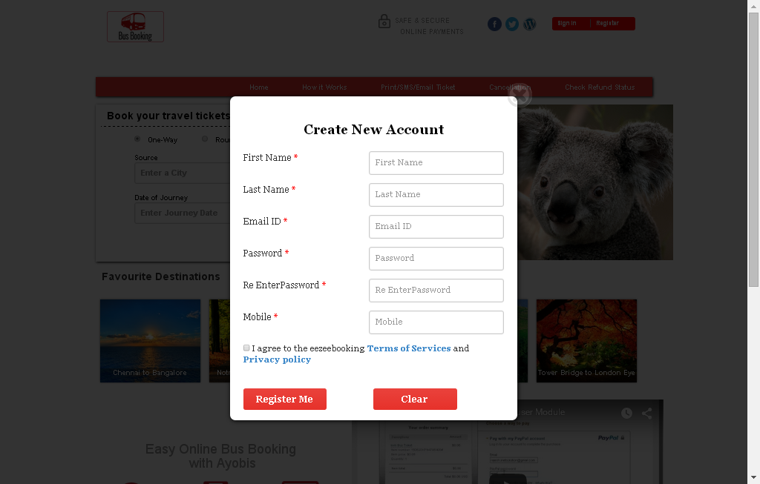
Description:
User can register with valid username and password

Subject: Login
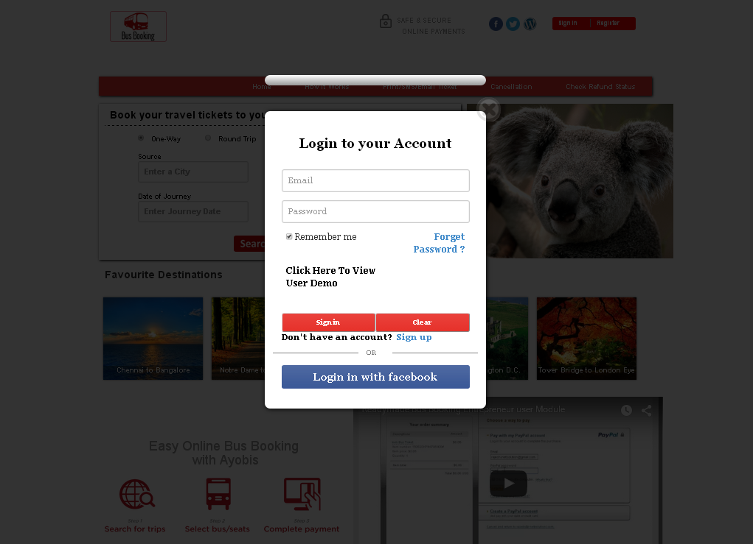
Description:
User can login with valid username and password and user can login with social network

Subject: Home screen
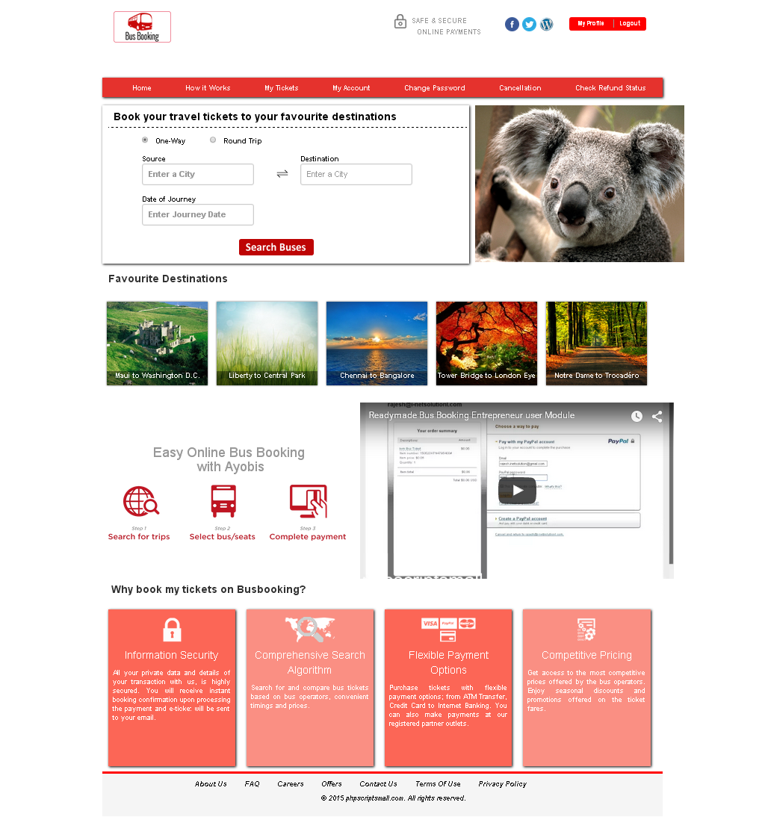
Description:
User home screen

Subject: Bus Search
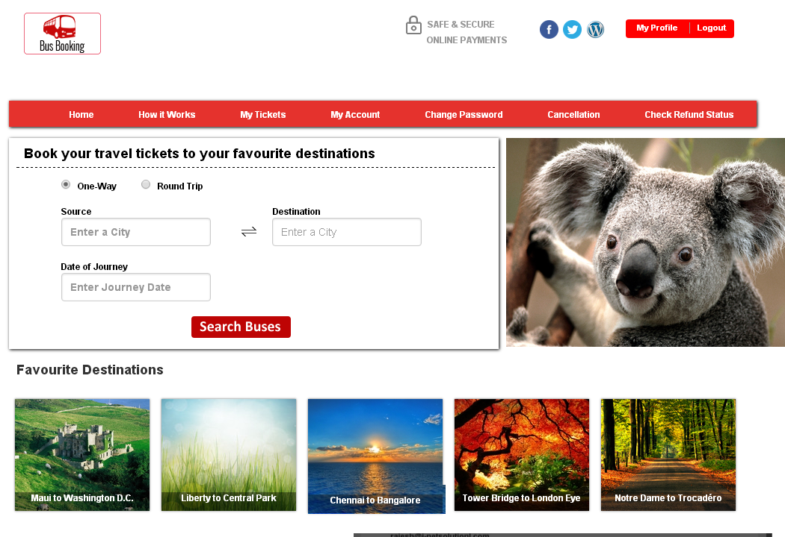
Description:
User can search with bus departure and arrival place. User can choose desired travel date

Subject: Search result
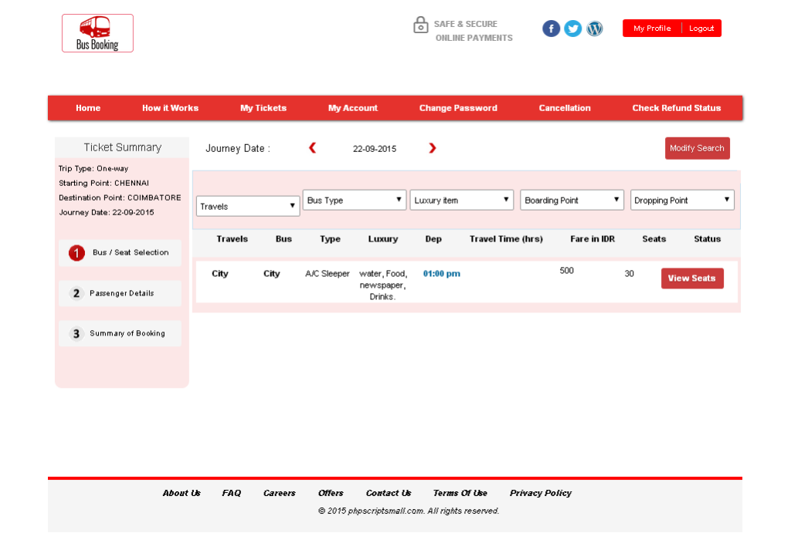
Description:
User can view various travel name with their details

Subject: Search options
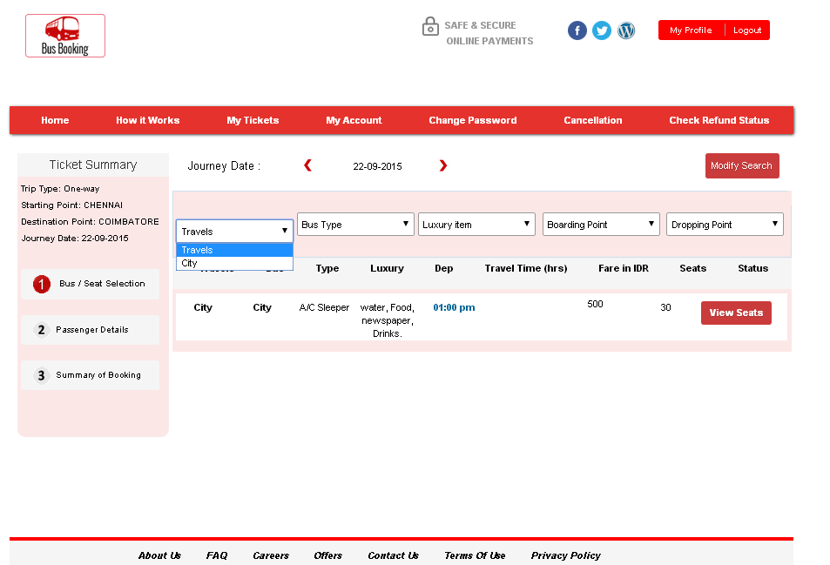
Description:
User can search bus with travels name, bus type, luxury items , boarding and dropping point

Subject: Choose seat number
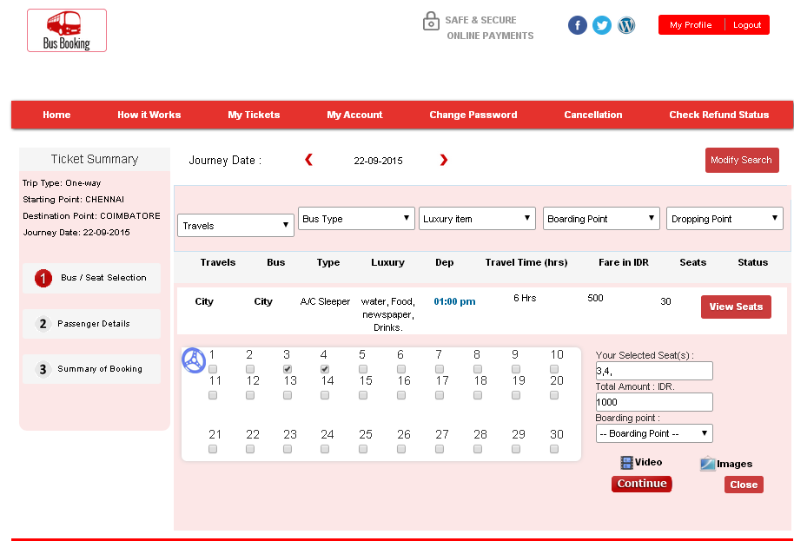
Description:
User can choose their desired seat number

Subject: Discount coupon
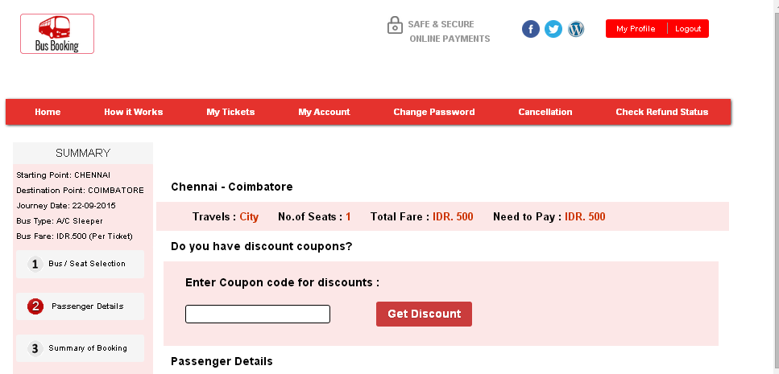
Description:
User can use their discount code

Subject: Passengers details
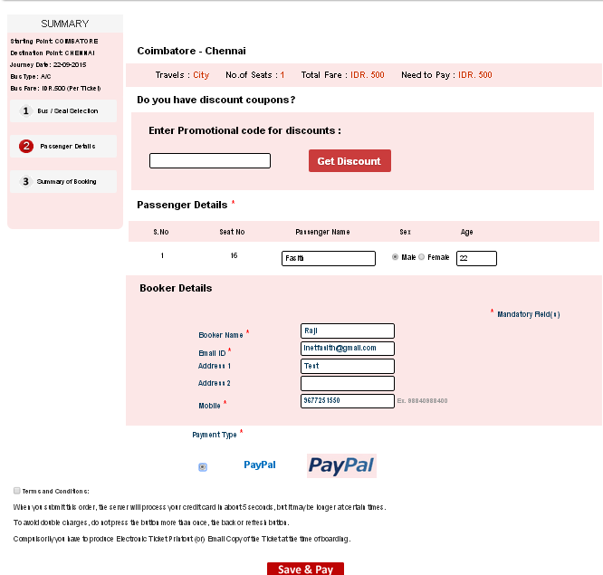
Description:
User enters passenger details

Subject: Payment method
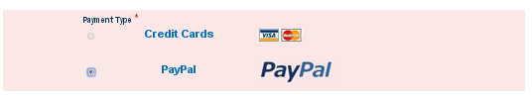
Description:
User can choose their payment gateway

Subject: Payment
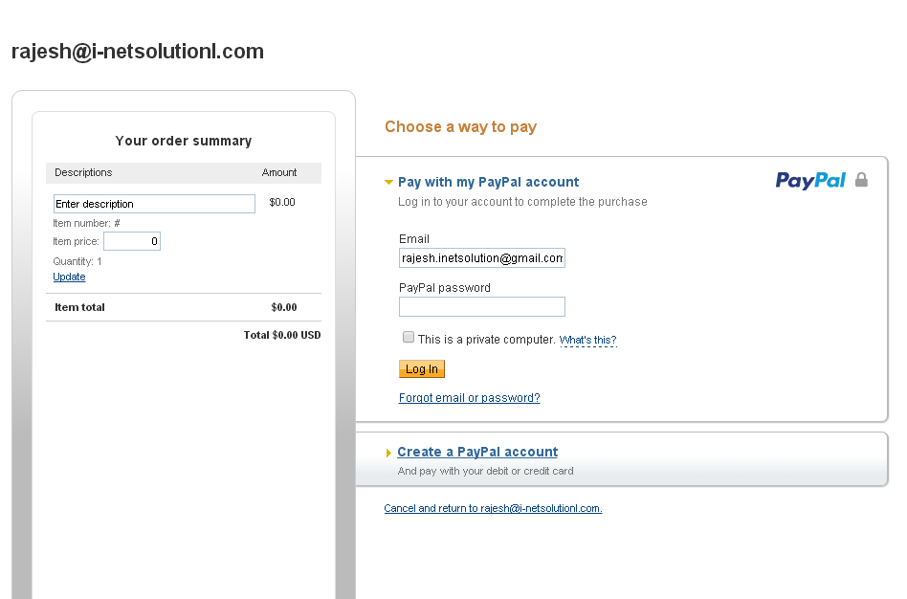
Description:
User can pay their payment using PayPal

Subject: Demo video
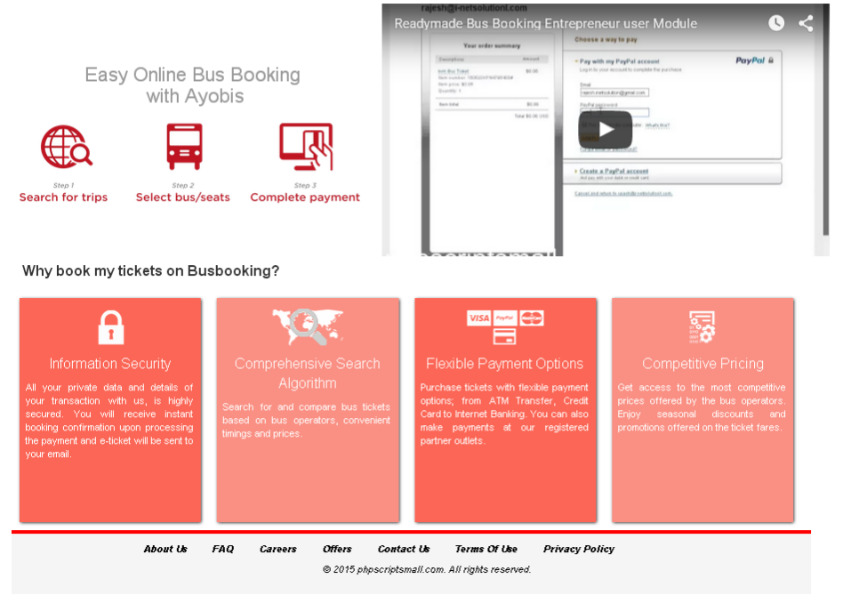
Description:
User home page have how to book video demo

Subject: Profile view
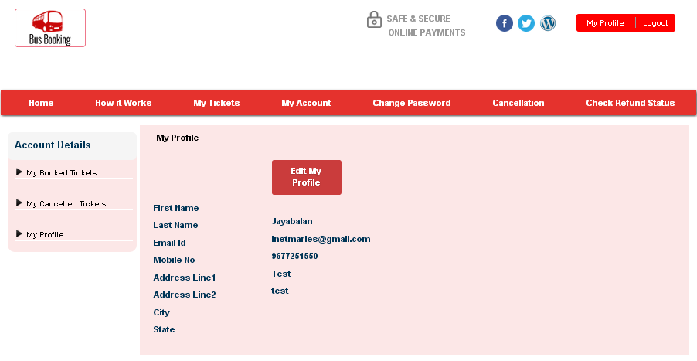
Description:
User can view their profile details

Subject: Edit profile
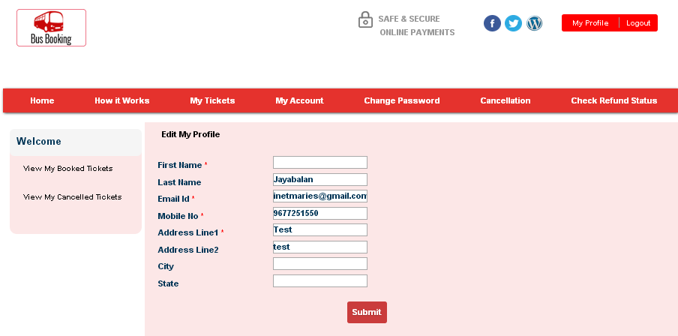
Description:
User can edit their profile details

Subject: Booked ticket history
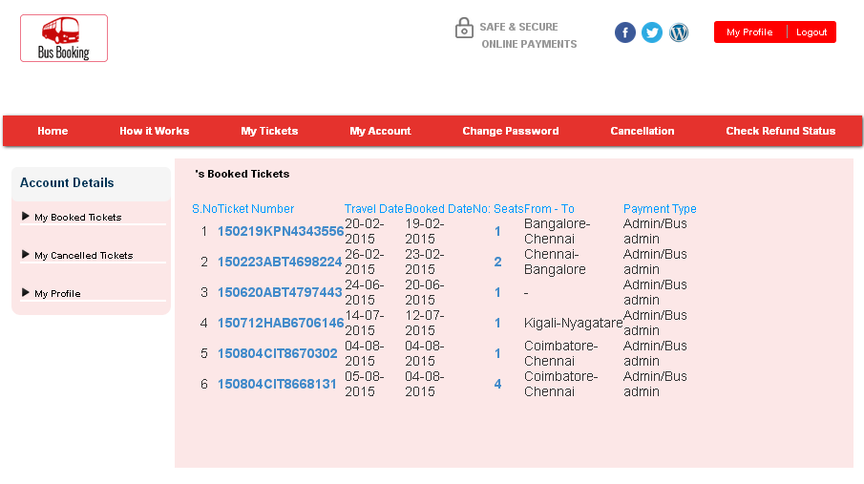
Description:
User can view booked ticket history

Subject: Cancel ticket
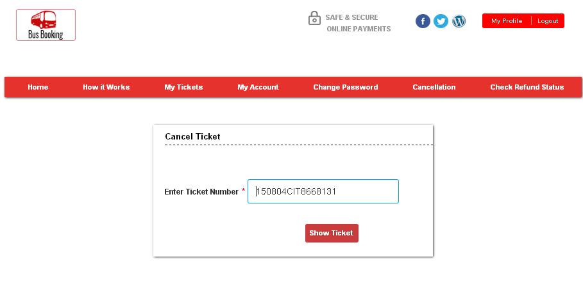
Description:
User can cancel ticket using ticket number

Subject: Cancelled ticket history
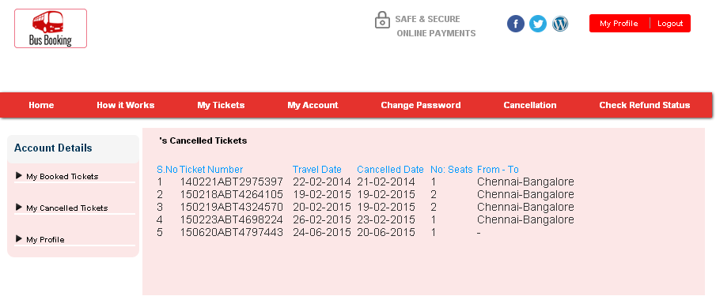
Description:
User can view cancelled ticket list

Subject: Change password
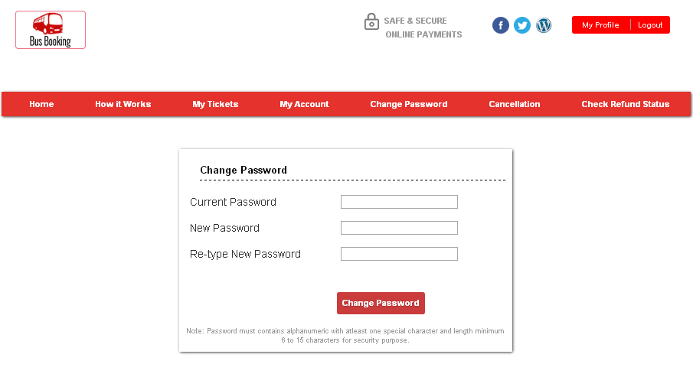
Description:
User can change their password

Subject: CMS
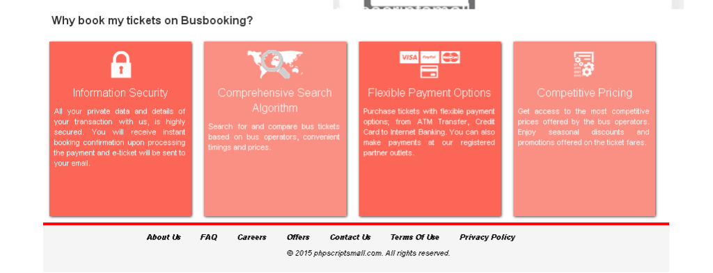
Description:
User home page have CMS contents

Subject: CMS-About us
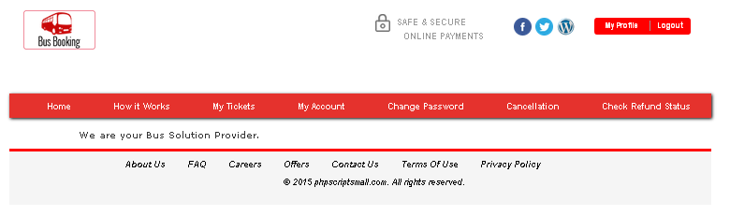
Description:
User can view website details

Subject: CMS-Carrier
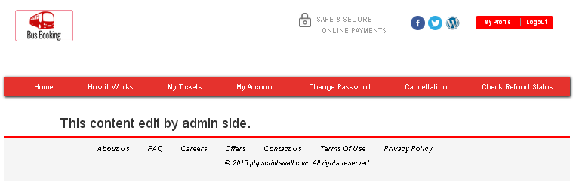
Description:
User can view details of carrier

Subject: CMS- Contact form
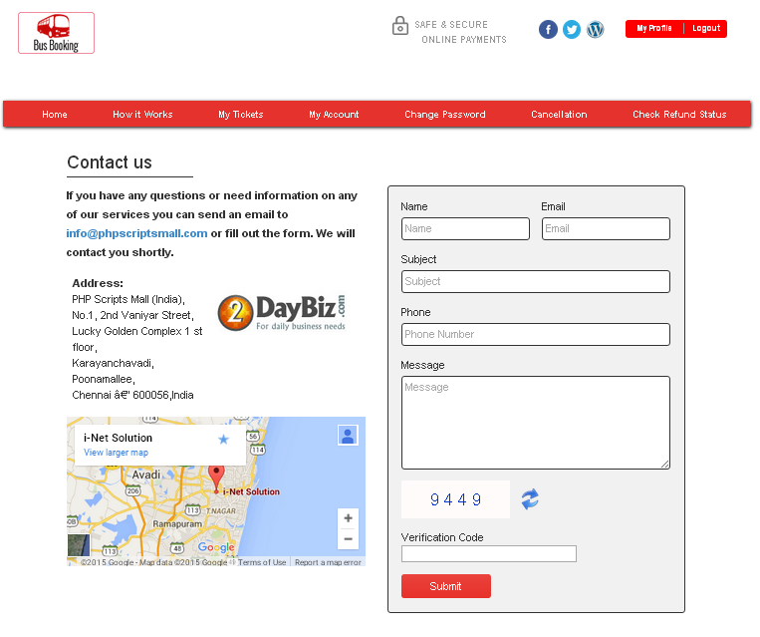
Description:
User can send enquiry to admin

Subject: CMS-FAQ
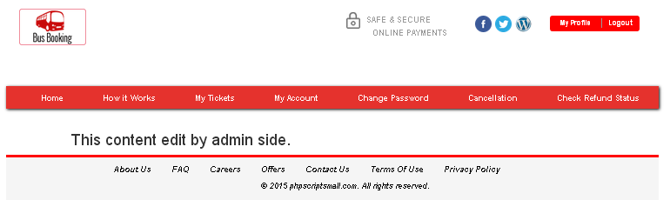
Description:
User can view FAQ of website

Subject: CMS-How its work
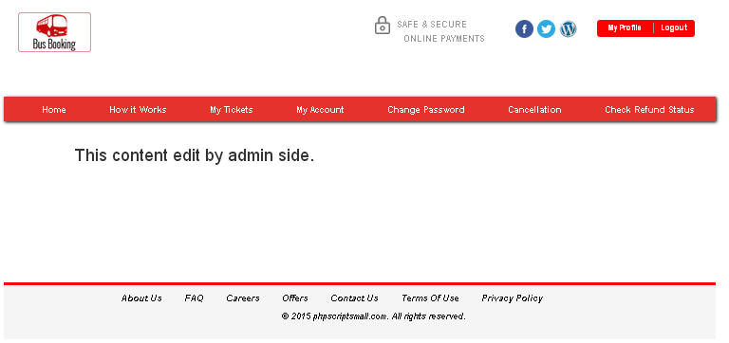
Description:
User can view how it works details

Subject: CMS- Offers
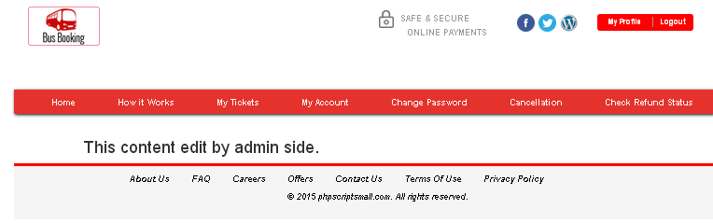
Description:
User can view offers details

Subject: CMS-Privacy policy
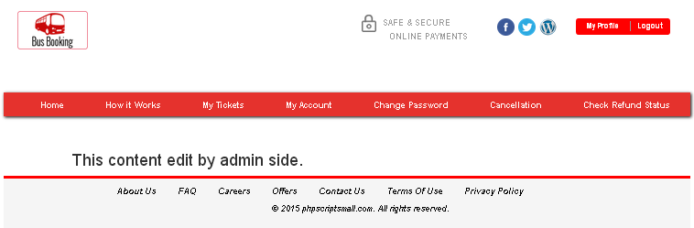
Description:
User can view privacy policy details

Subject: CMS-terms and Condition
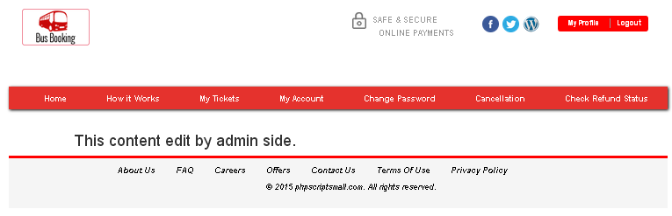
Description:
User can view terms and condition details

Subject: CMS-Social network connection
Description:
User have social network connections

Module: Bus admin
Subject: Bus admin login
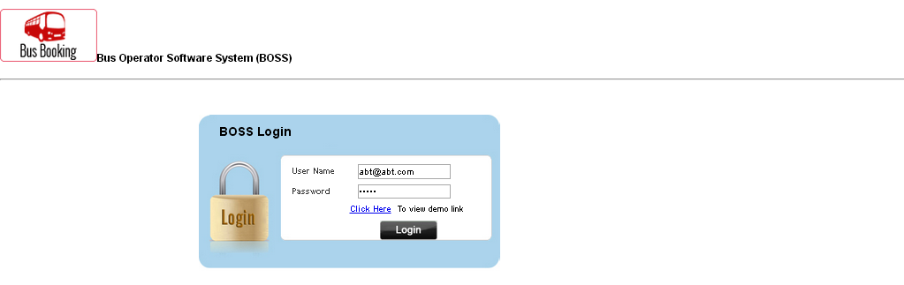
Description:
Bus admin can login with valid username and password

Subject: Dashboard
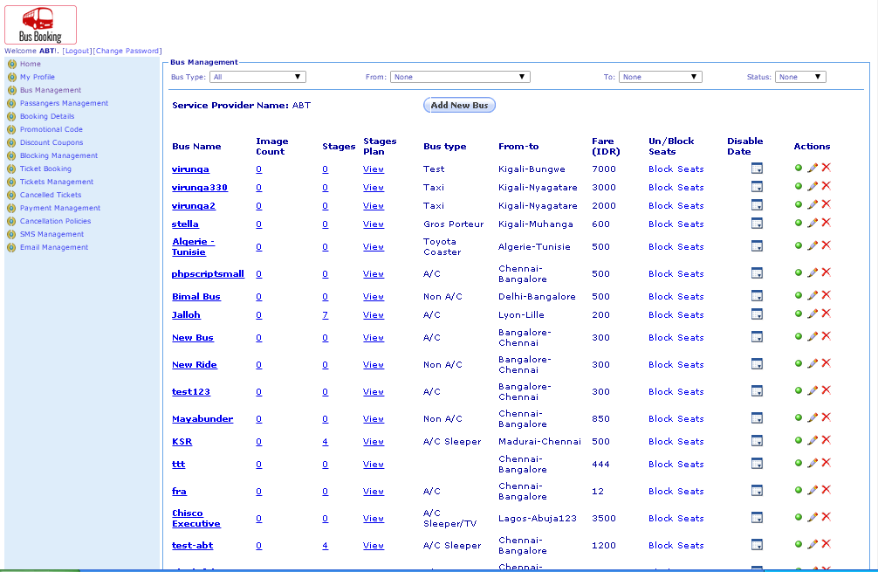
Description:
Bus admin view their dashboard

Subject: Add discount coupon
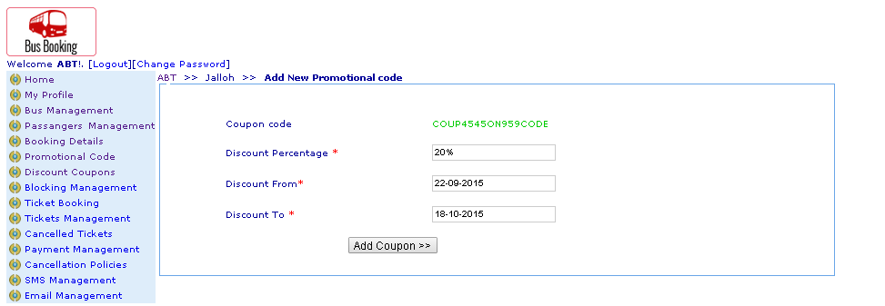
Description:
Bus admin can add their discount coupon

Subject: Add bus
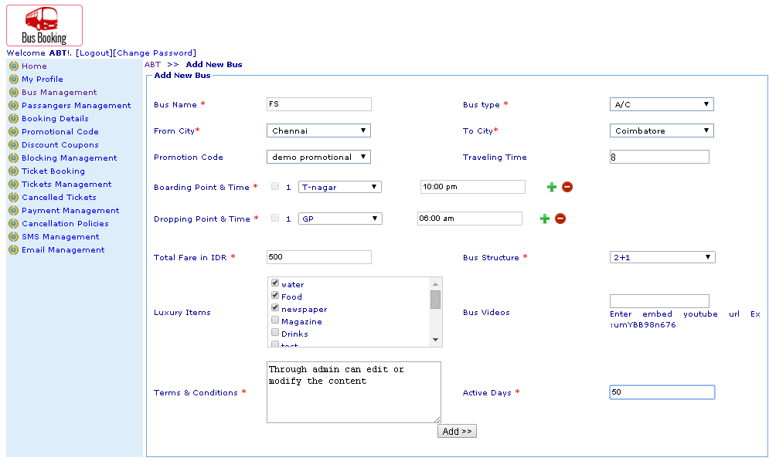
Description:
Bus admin can add new bus

Subject: Add promotion code
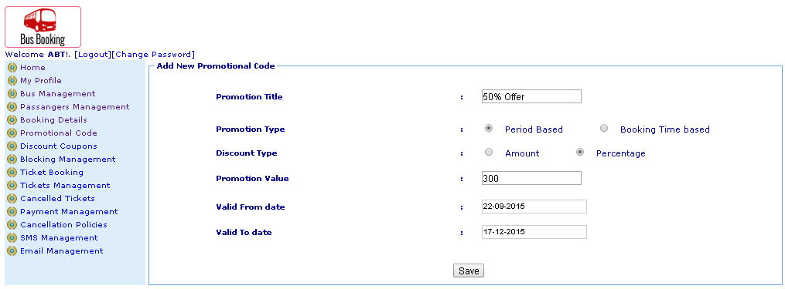
Description:
Bus admin can add new promotion code

Subject: Profile view
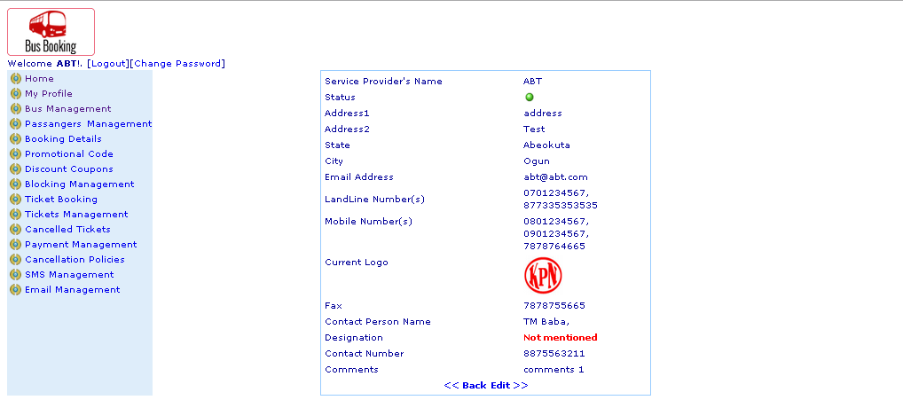
Description:
Bus admin can view their profile details

Subject: Edit profile
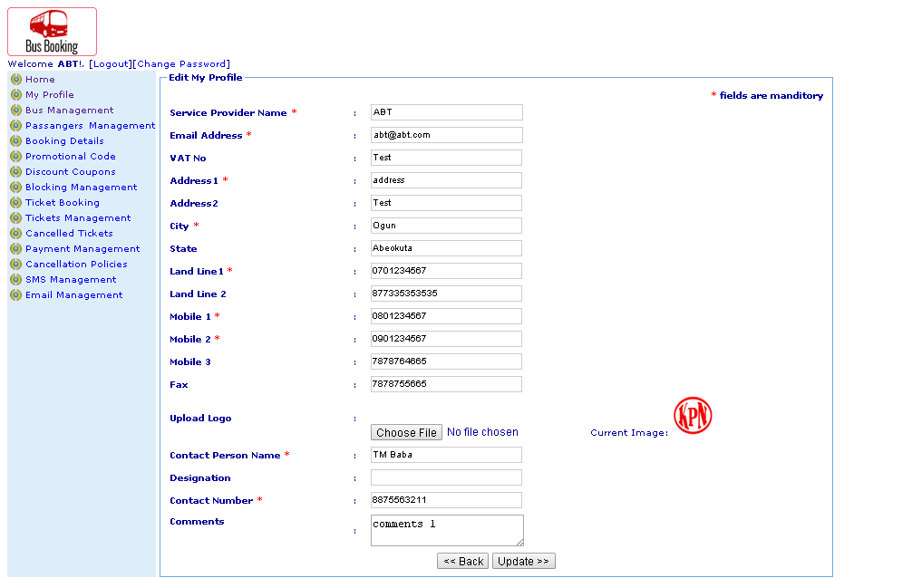
Description:
Bus admin can edit their profile

Subject: Block and unblock seat
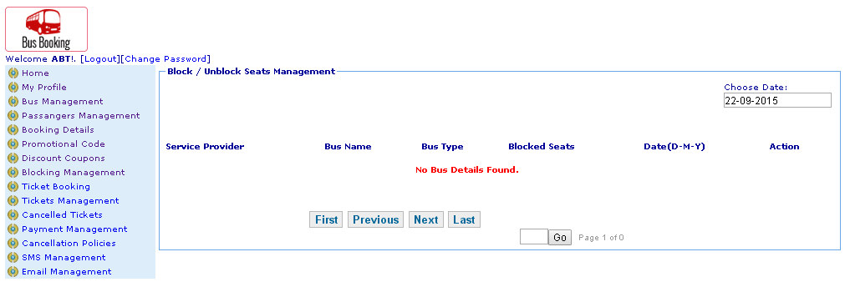
Description:
Bus admin can block and unblock seat

Subject: Block seat
Description:
Bus admin can block seat by desired date

Subject: Book ticket
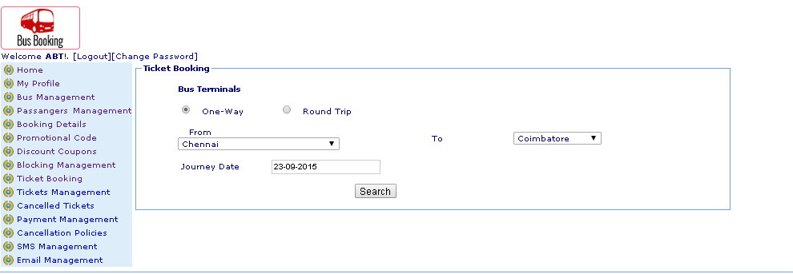
Description:
Bus admin can book ticket

Subject: Desired travels
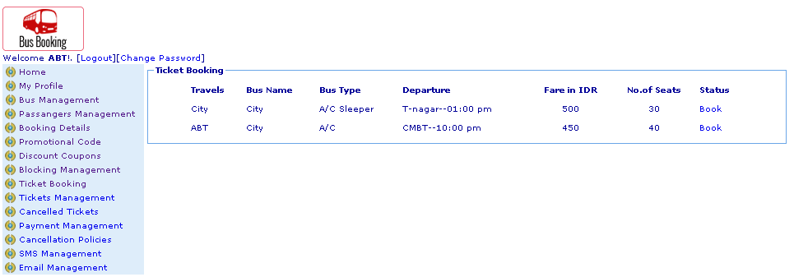
Description:
Bus admin can choose their desired travels

Subject: Desired seat choose
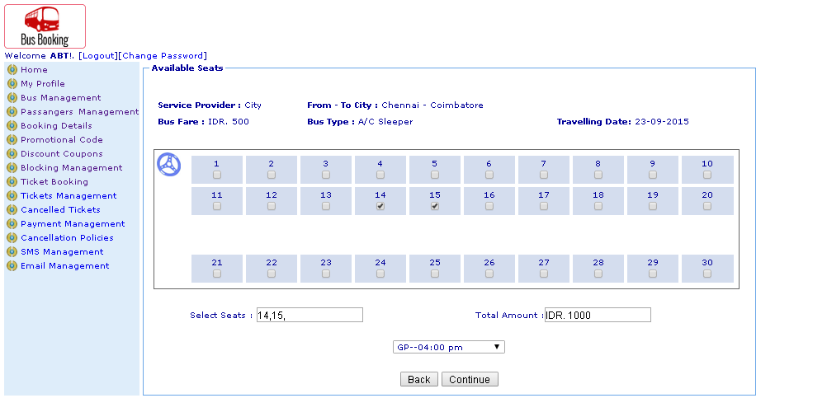
Description:
Bus admin can choose their desired seat number

Subject: Passenger details
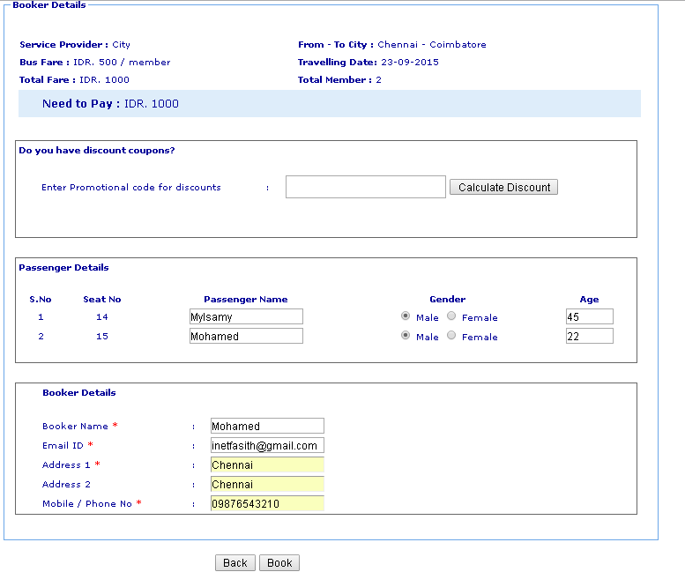
Description:
Bus admin enters passenger’s details

Subject: Booked ticket view
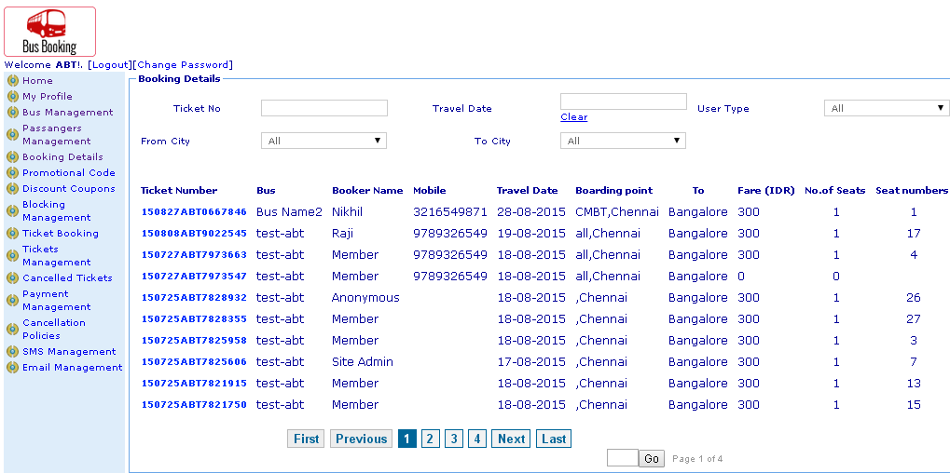
Description:
Bus admin can view booked ticket details

Subject: Cancel ticket
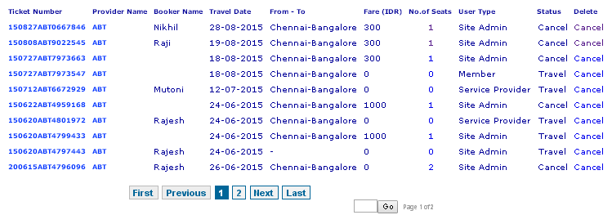
Description:
Bus admin can cancel passenger tickets

Subject: Promotion code
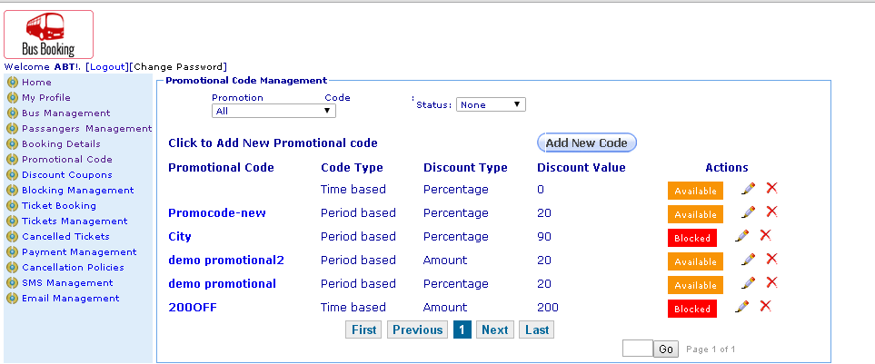
Description:
Bus admin can view promotion code details

Subject: Edit promotion code
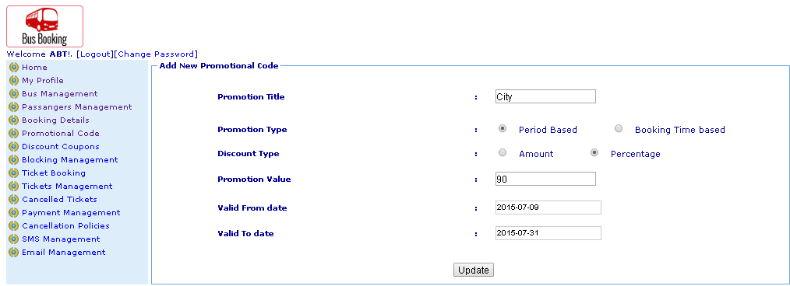
Description:
Bus admin can edit promotion code details

Subject: View bus details
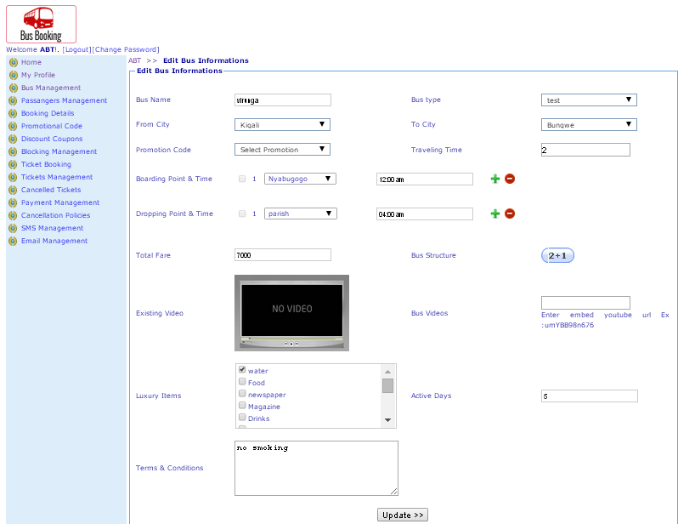
Description:
Bus admin can view bus details

Subject: View cancelled ticket details
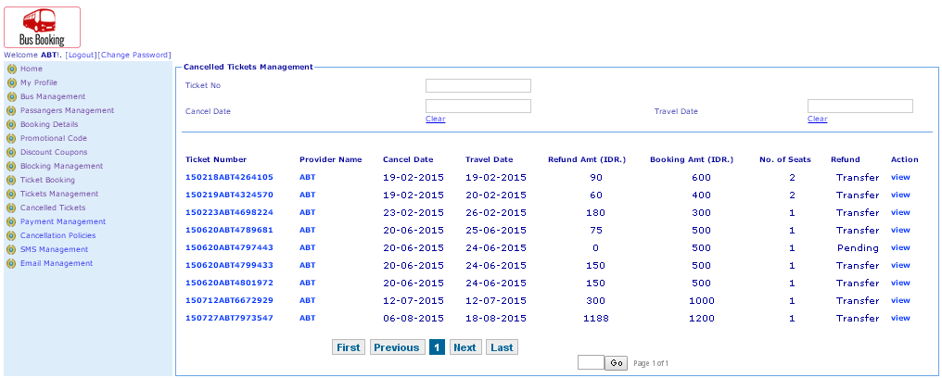
Description:
Bus admin can view cancel ticket details

Subject: View cancellation policy
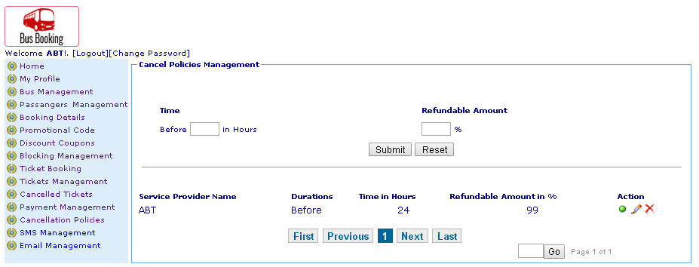
Description:
Bus admin can view cancellation policy

Subject: Cancel ticket status
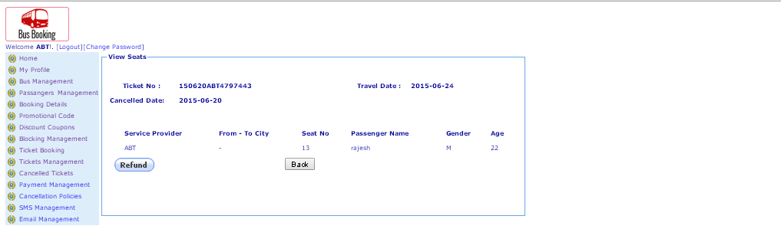
Description:
Bus admin can view status of cancel ticket fund transfer

Subject: View discount code
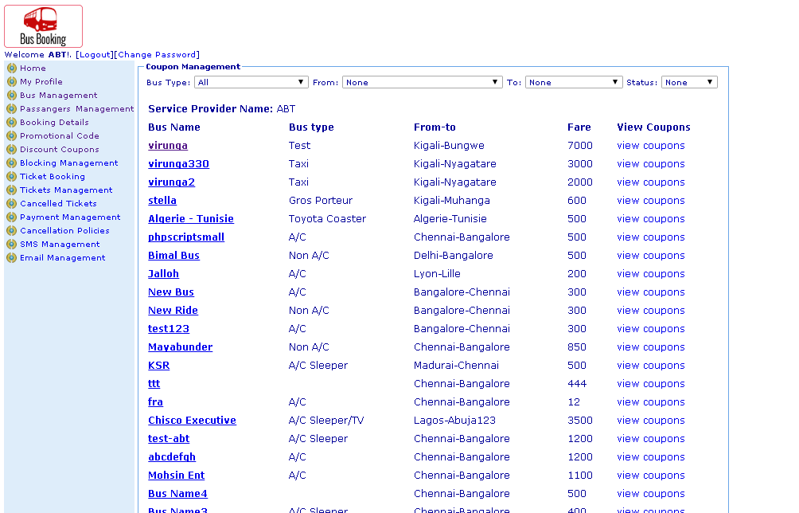
Description:
Bus admin can view discount code details

Subject: View Email details
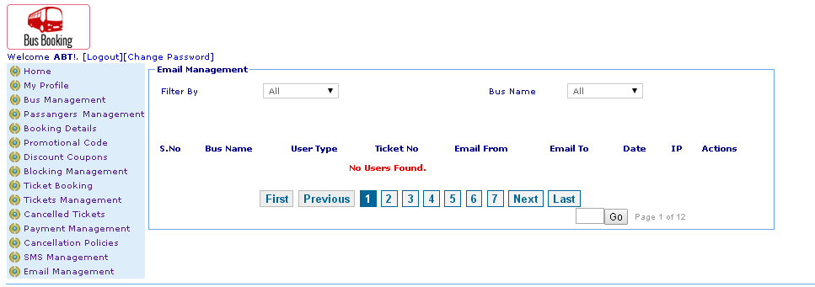
Description:
Bus admin can view user email details

Subject: View passengers details
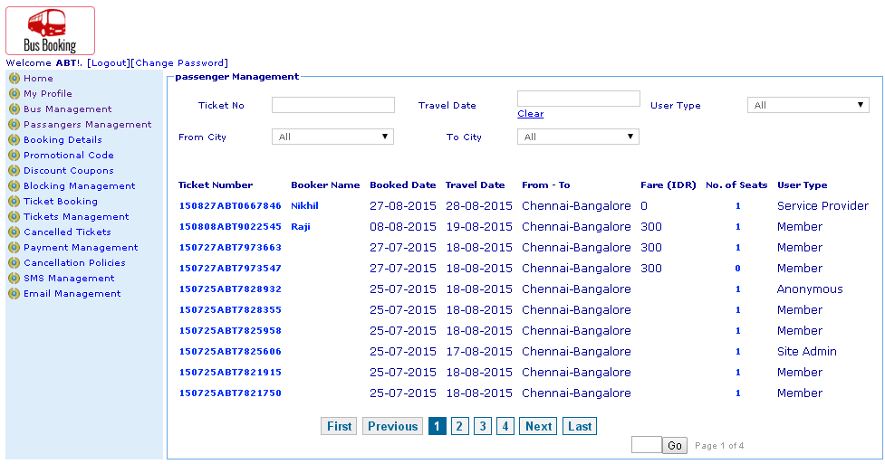
Description:
Bus admin can view passengers details

Subject: Passengers ticket details
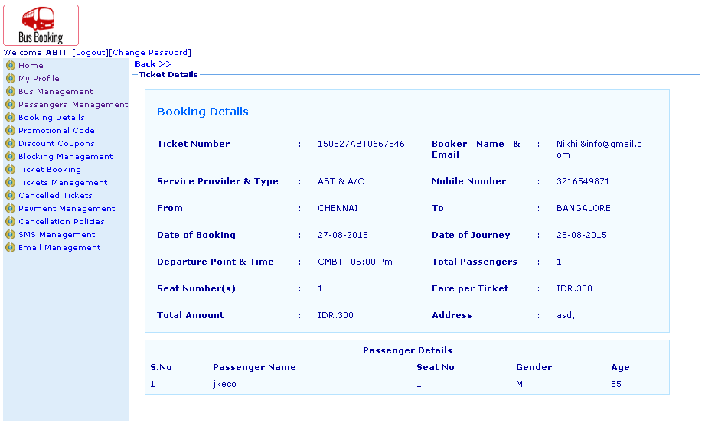
Description:
Bus admin can view ticket details

Subject: View payment details
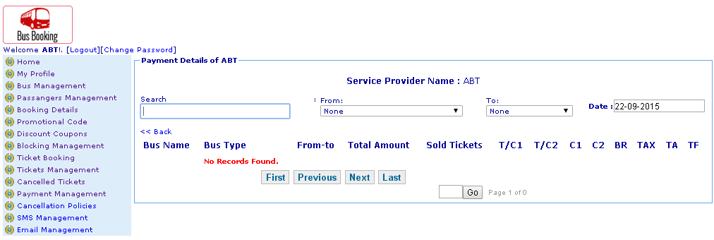
Description:
Bus admin can view payment details

Subject: View SMS tickets
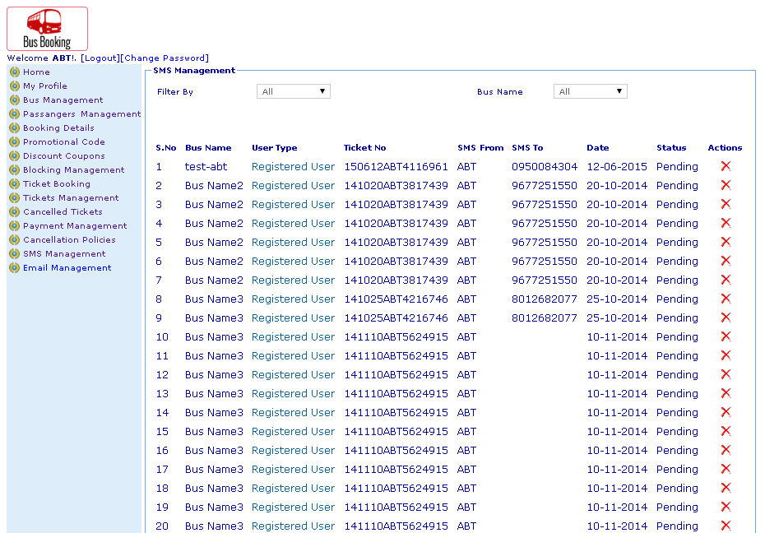
Description:
Bus admin can view SMS ticket details

Subject: Travels booked tickets details
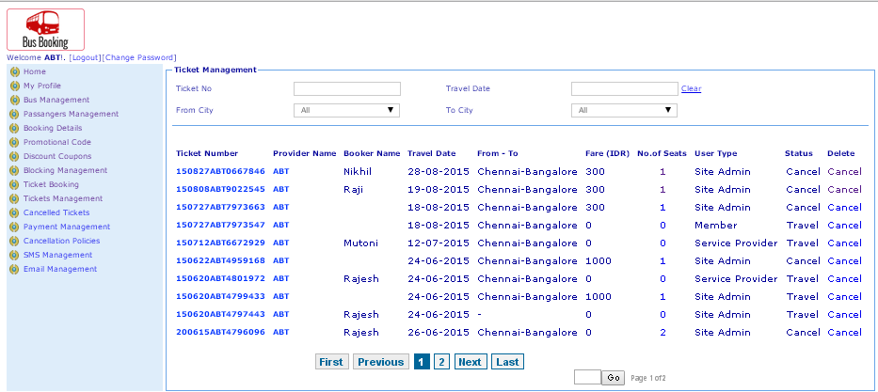
Description:
Bus admin can view booked bus ticket details

Subject: Home page search
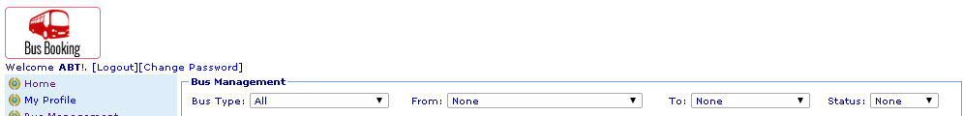
Description:
Bus admin search bus in home page

Subject: Booked ticket search
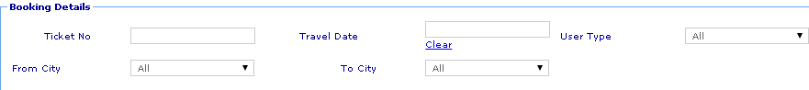
Description:
Bus admin can search booked ticket

Subject: Cancel ticket search
Description:
Bus admin can search cancel ticket

Subject: Cancel policy search
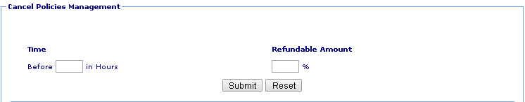
Description:
Bus admin can search cancel policy

Subject: Discount code search
Description:
Bus admin can search discount code

Subject: Email management search
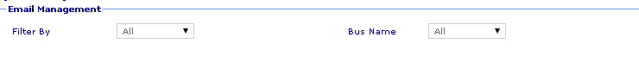
Description:
Bus admin can search email details

Subject: Passengers details search
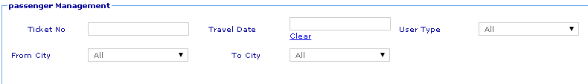
Description:
Bus admin can search passengers detail

Subject: Payment details search
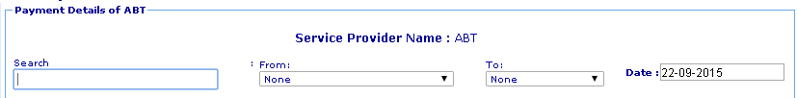
Description:
Bus admin can search payment details

Subject: Promotion code search
Description:
Bus admin can search promotion code details

Subject: SMS management search
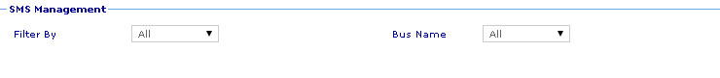
Description:
Bus admin can search SMS details

Subject: Ticket detail search
Description:
Bus admin can search ticket details

Module: Admin
Subject: Dashboard
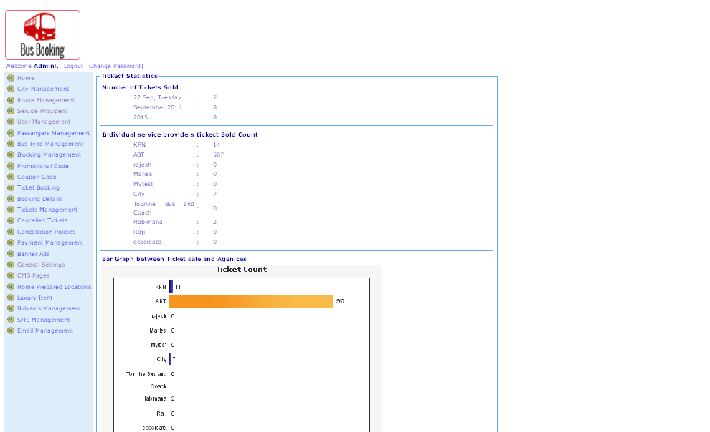
Description:
Admin can view their dashboard

Subject: Assign route
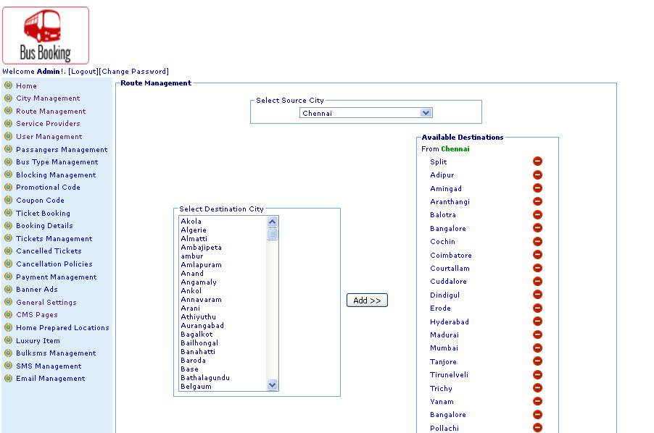
Description:
Admin can add and manage route

Subject: Banner ads
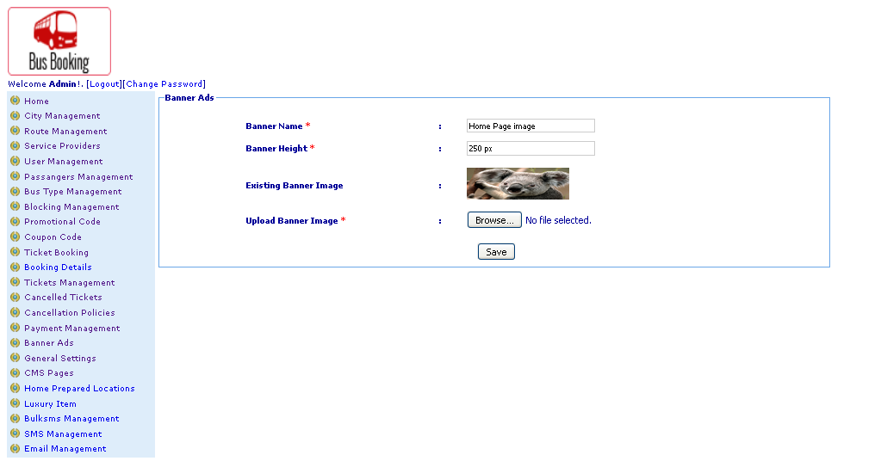
Description:
Admin can manage banner ads

Subject: Block and unblock seats
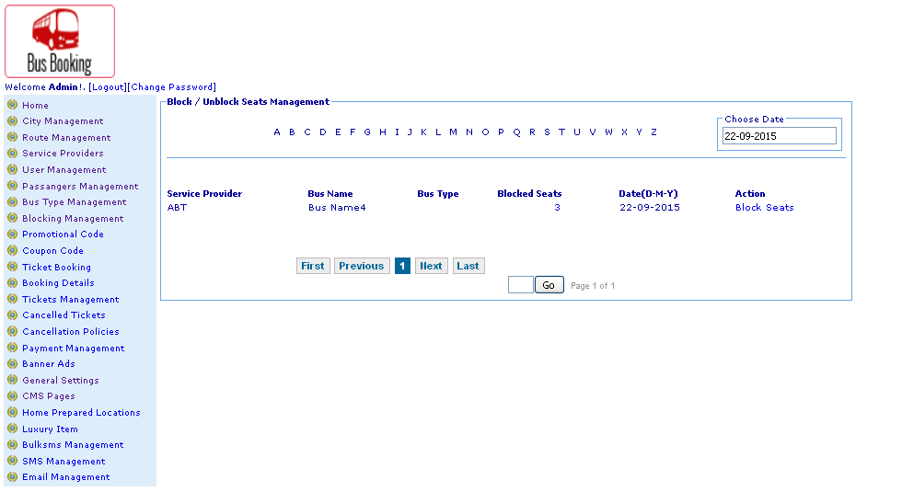
Description:
Admin can block and unblock seat

Subject: Block seat
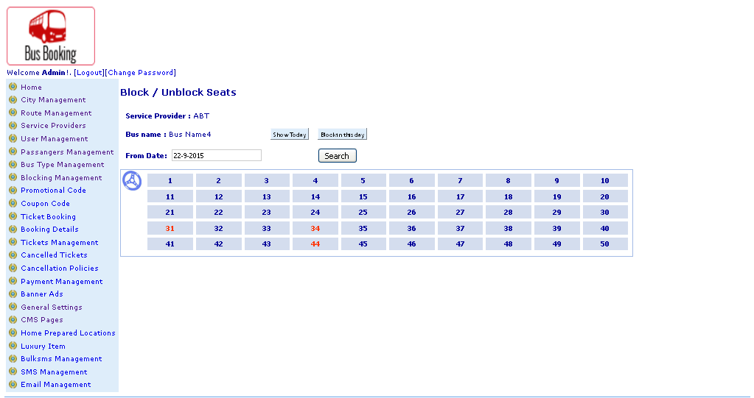
Description:
Admin can block specific seat with date

Subject: Book ticket
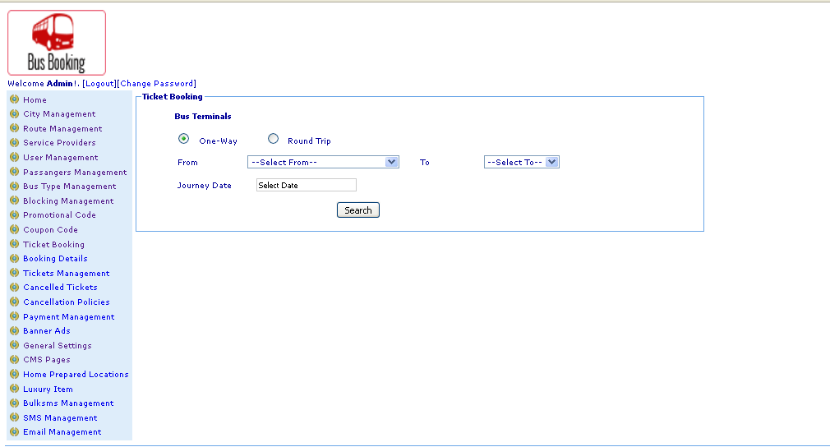
Description:
Admin can book ticket

Subject: Book with desired travels
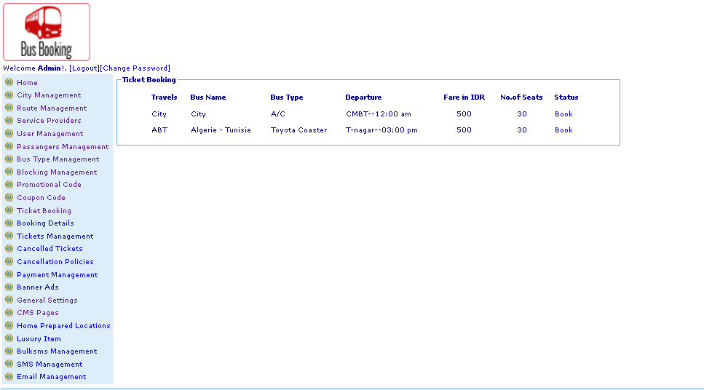
Description:
Admin can book ticket with desired travels

Subject: book with desired seat
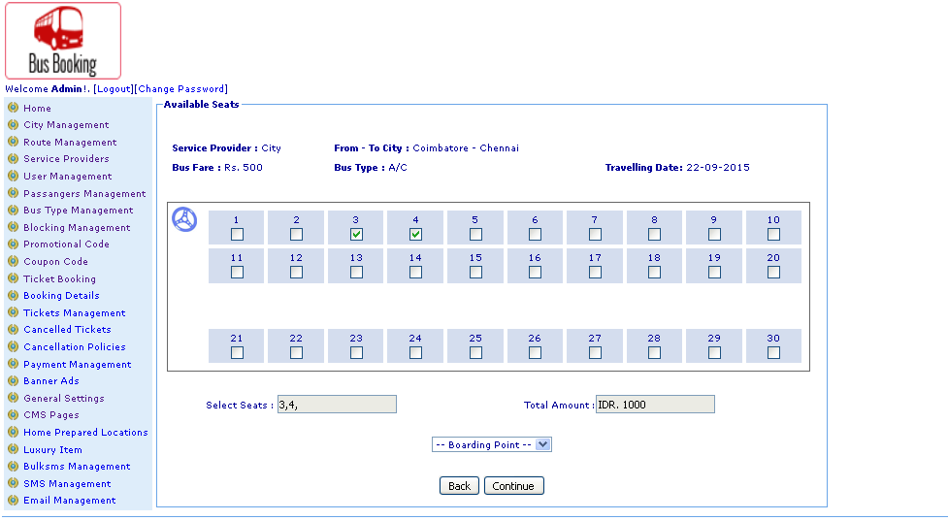
Description:
Admin can book with desired seat number

Subject: Discount and passengers details
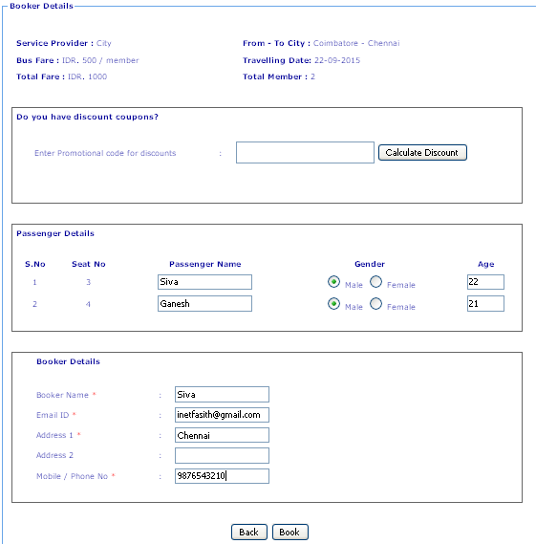
Description:
Admin can enter discount and passengers details

Subject: Booked ticket printout
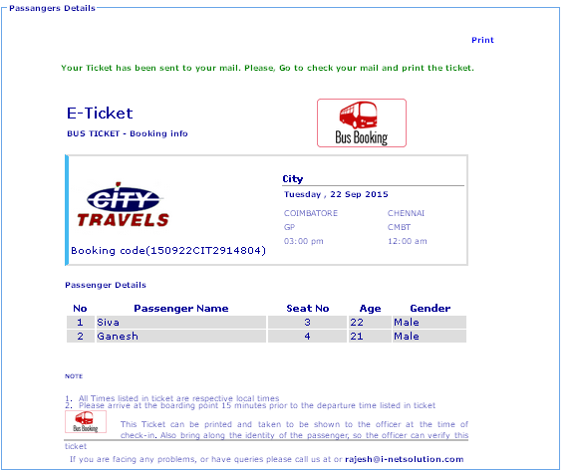
Description:
Admin can printout the bus tickets

Subject: Block seat on service provider
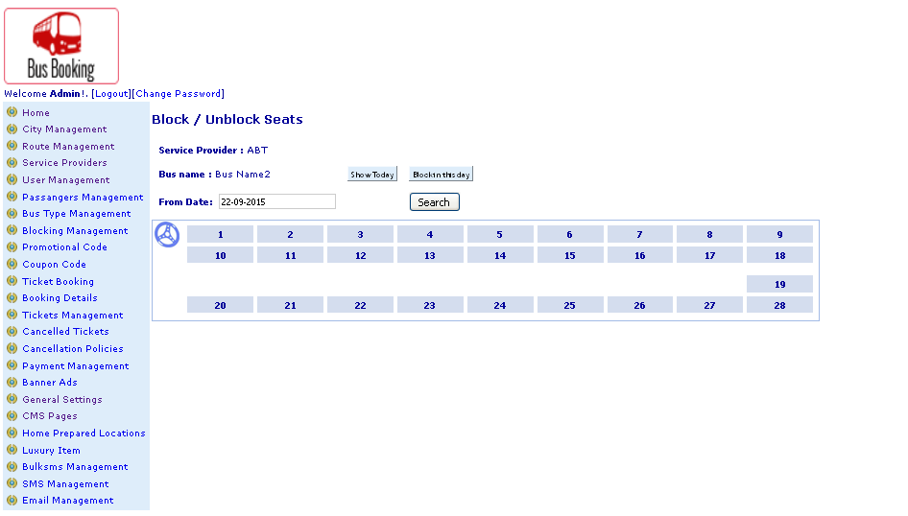
Description:
Admin can block seat on service providers bus

Subject: General settings
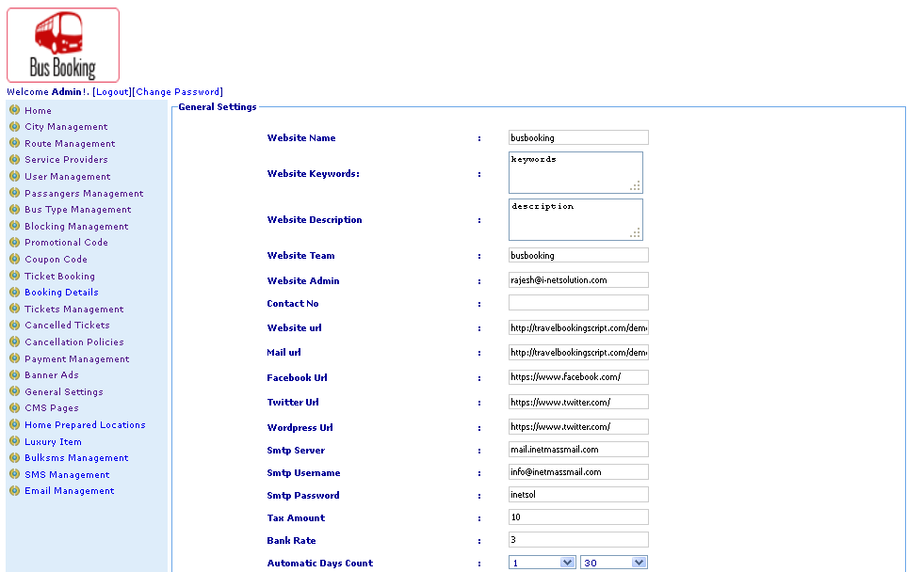
Description:
Admin can mange general settings of websites

Subject: Add bus type
Description:
Admin can add bus type

Subject: Add city
Description:
Admin can add city

Subject: Add coupon
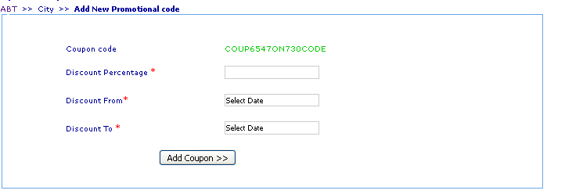
Description:
Admin can add new coupon

Subject: Add home prepared location
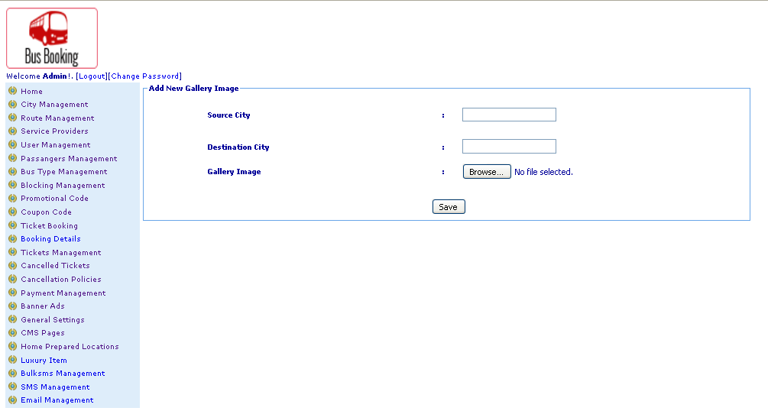
Description:
Admin can add new home prepared location

Subject: Add luxury items
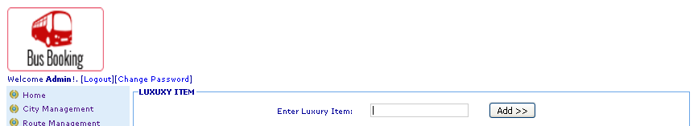
Description:
Admin can add new luxury items

Subject: Add promotion code
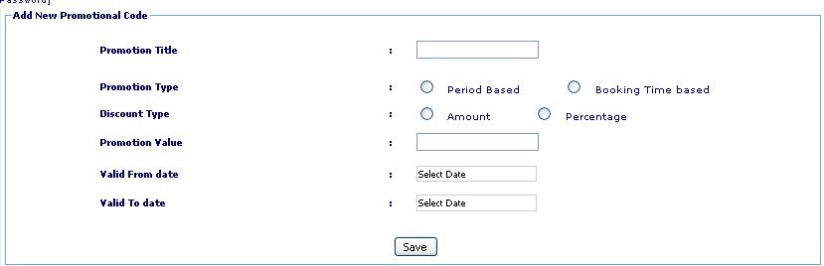
Description:
Admin can add new promotion code

Subject: Add service provider
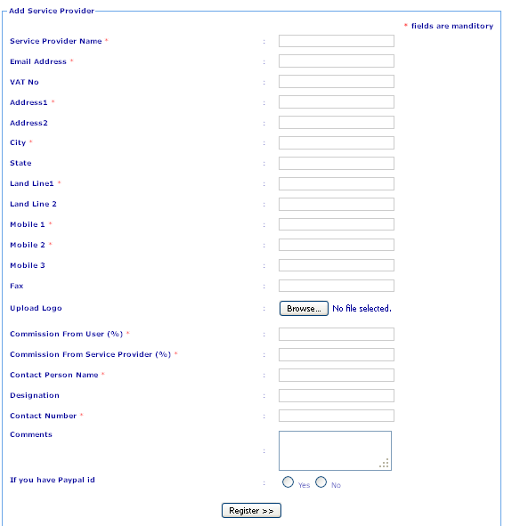
Description:
Admin can add new service provider

Subject: Disable date for service provider
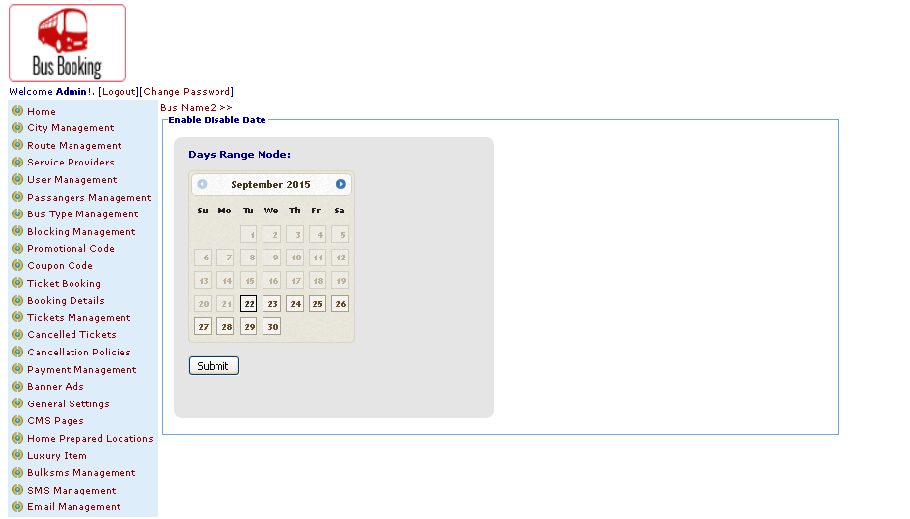
Description:
Admin can make disable dates for service provider

Subject: View user details
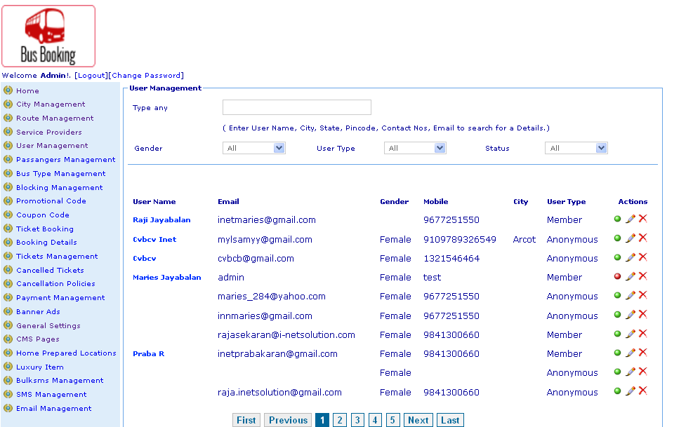
Description:
Admin can view user details

Subject: View bulk SMS details
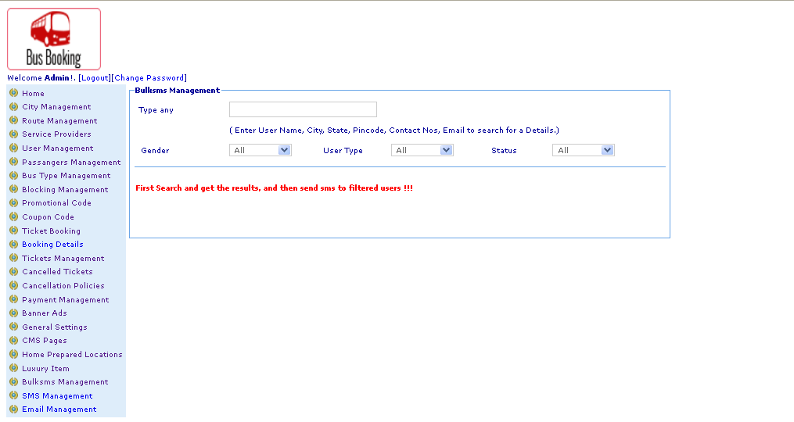
Description:
Admin can view bulk SMS details

Subject: View coupon details
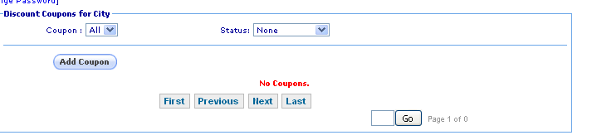
Description:
Admin can view coupon details

Subject: View bus type
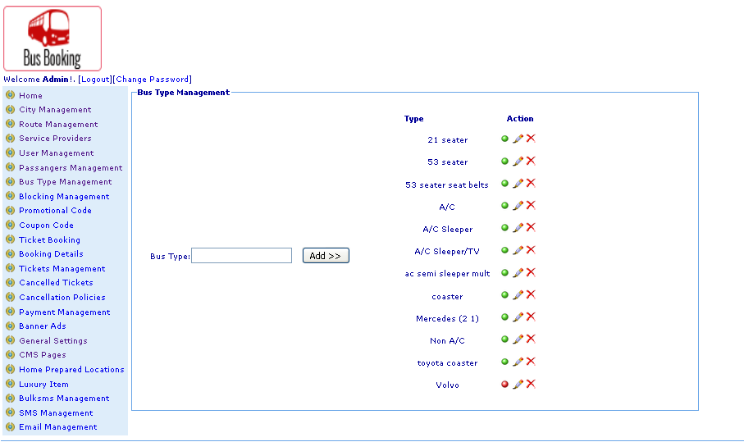
Description:
Admin can view bus types

Subject: View cancelled ticket by date
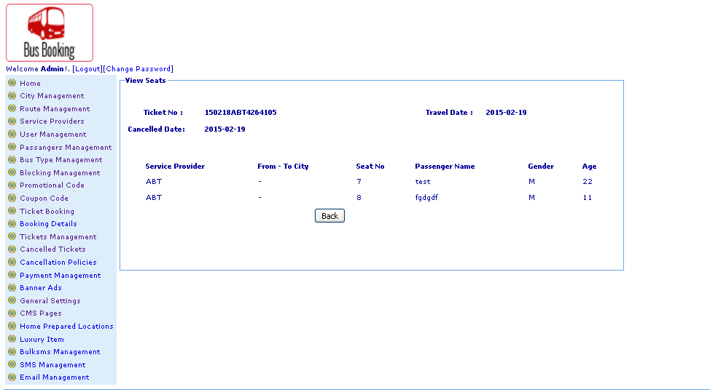
Description:
Admin can view cancelled ticket details

Subject: View cancellation policy
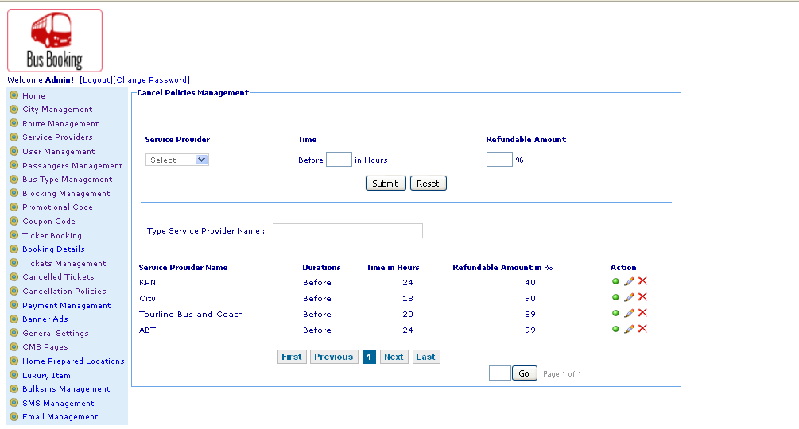
Description:
Admin can view cancellation policy

Subject: View cancelled ticket with details
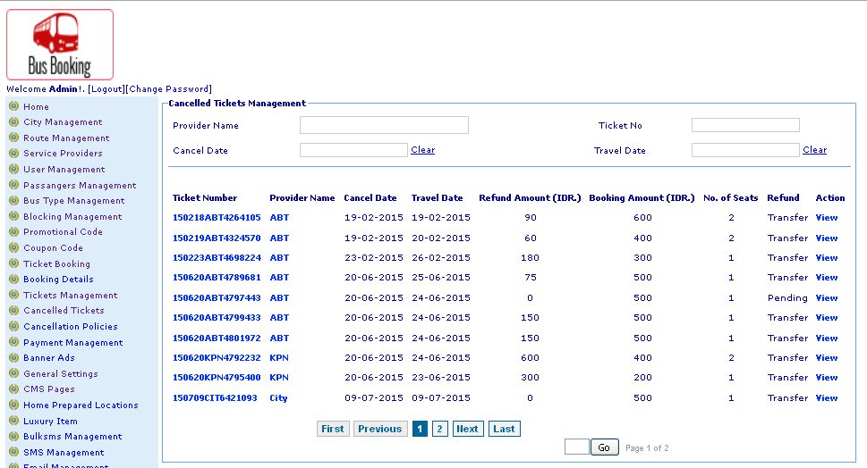
Description:
Admin can view canceled ticket with details

Subject: View city
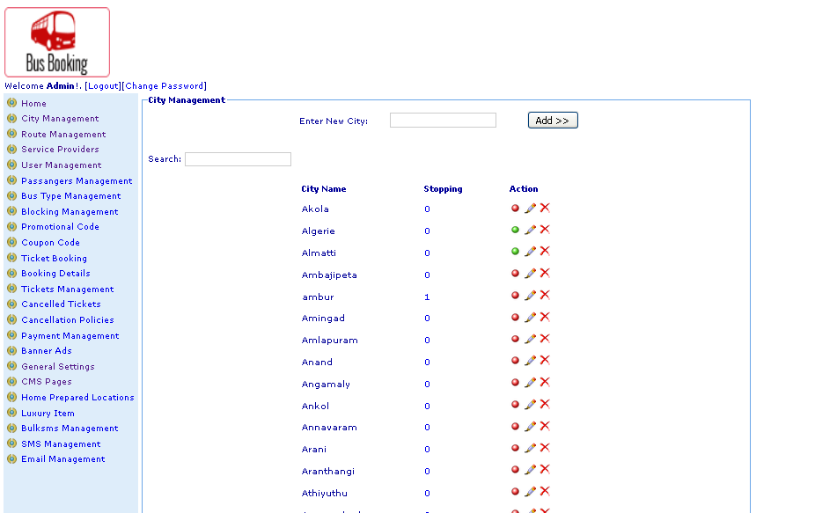
Description:
Admin can view city details

Subject: View coupon code details
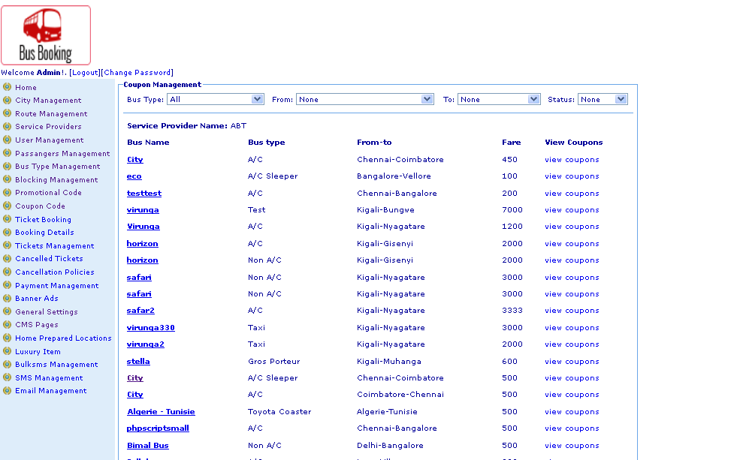
Description:
Admin can view coupon code details

Subject: View Email management details
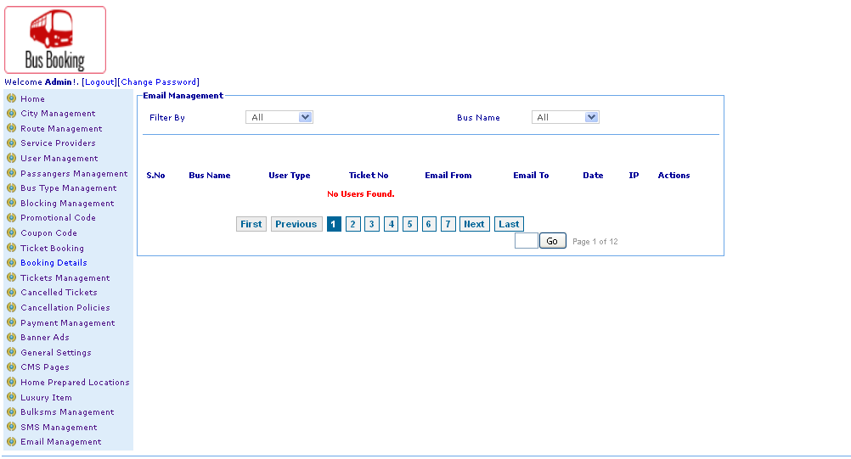
Description:
Admin can view email management details

Subject: View home prepared location details
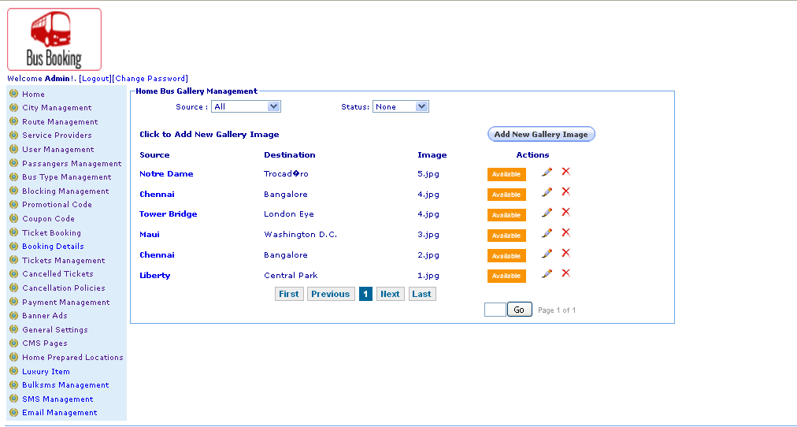
Description:
Admin can view home prepared location details

Subject: View luxury item details
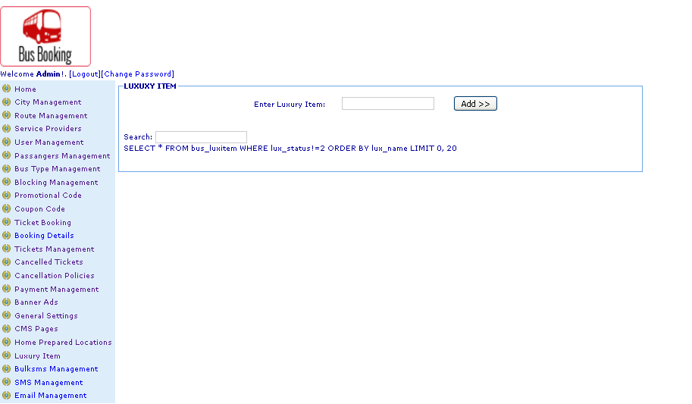
Description:
Admin can view luxury item details

Subject: View payment details
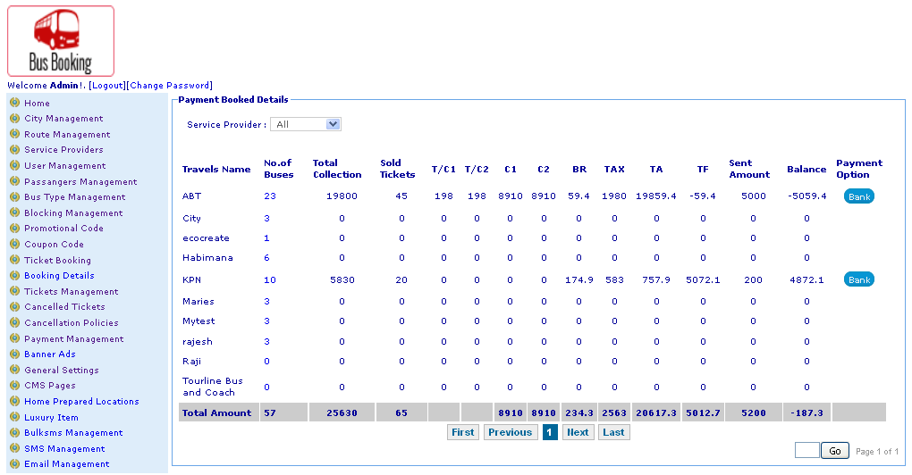
Description:
Admin can view payment details

Subject: View promotion code details
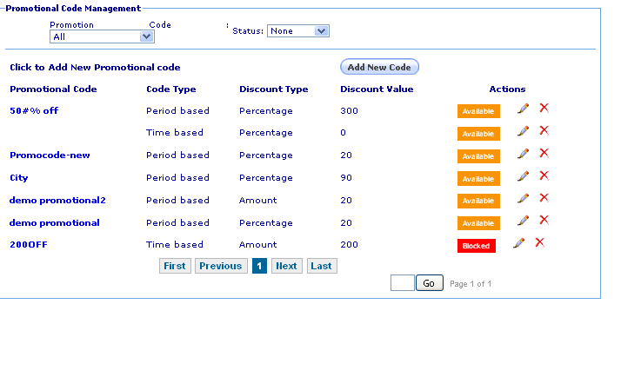
Description:
Admin can view promotion code details

Subject: View route by list details
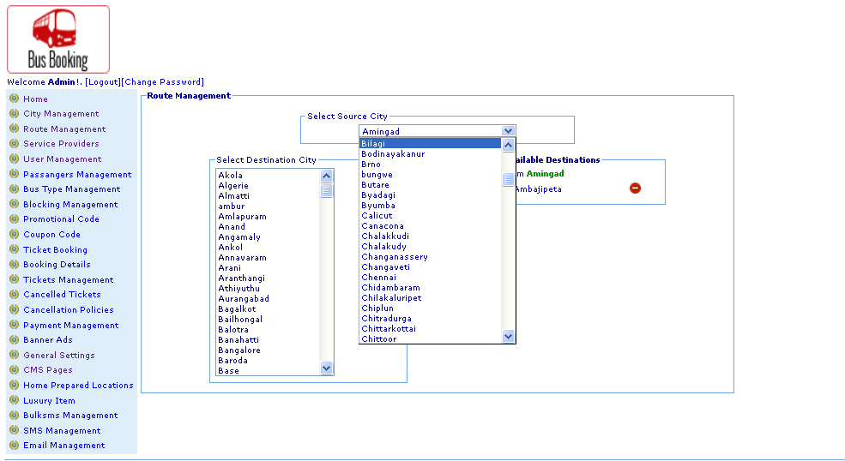
Description:
Admin can view route list details

Subject: View service providers details
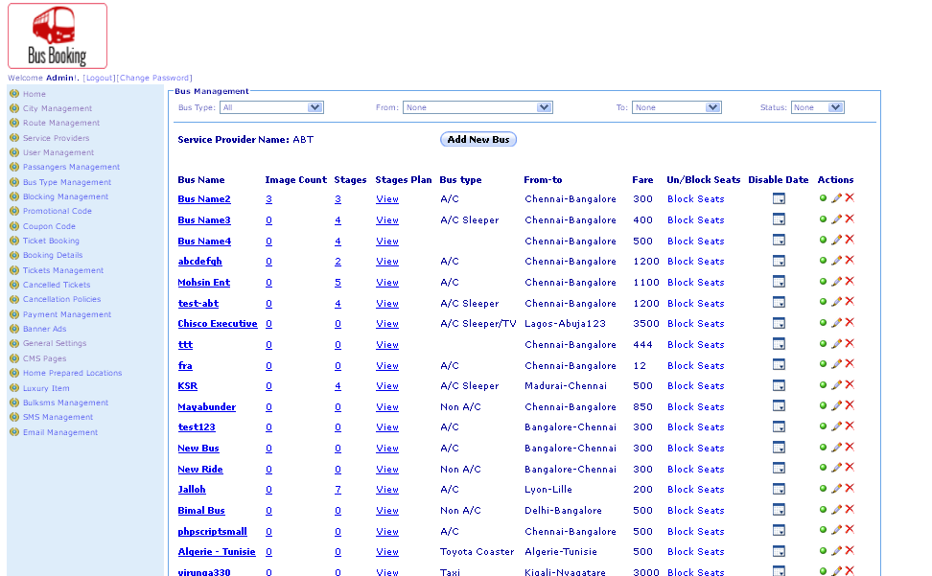
Description:
Admin can view service provider details

Subject: View passengers details
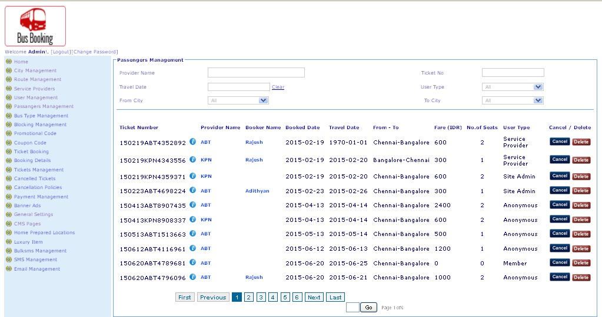
Description:
Admin can view passengers details

Subject: View SMS management details
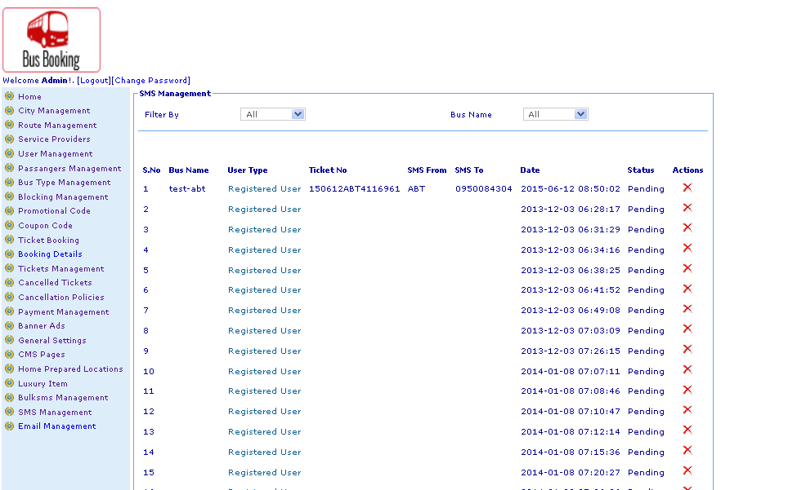
Description:
Admin can view SMS details
Subject: View ticket
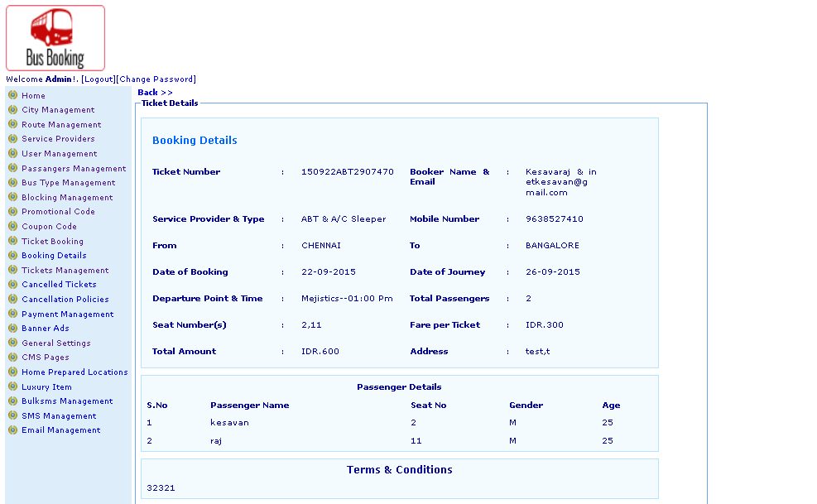
Description:
Admin can view passengers ticket

Subject: View passengers ticket details
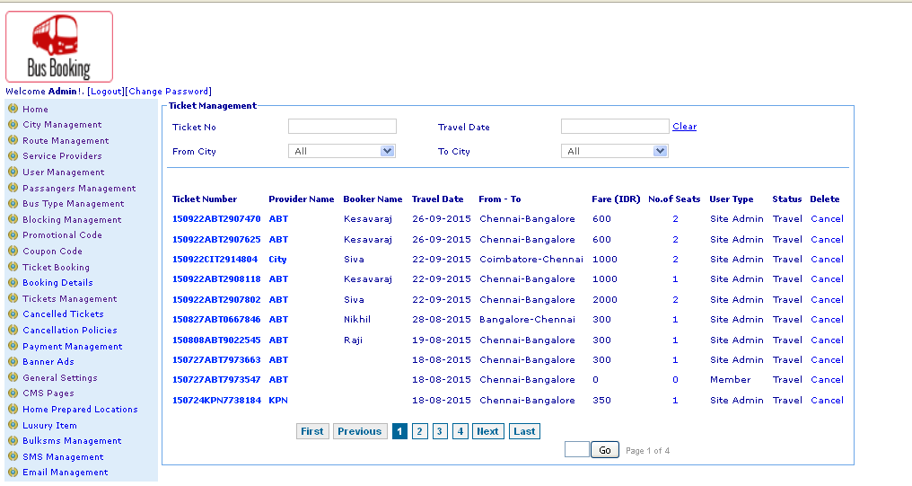
Description:
Admin can view passengers booked ticket details

Subject: Edit bus details
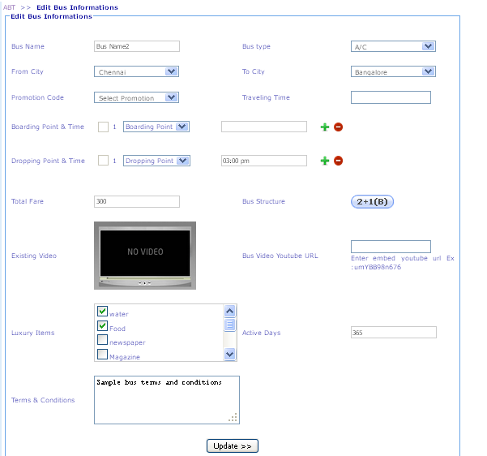
Description:
Admin can edit bus details

Subject: Edit bus type
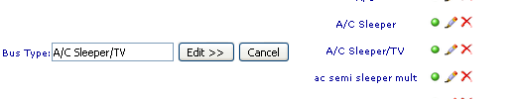
Description:
Admin can edit bus type

Subject: Edit city
Description:
Admin can edit city details

Subject: Edit home prepared location details
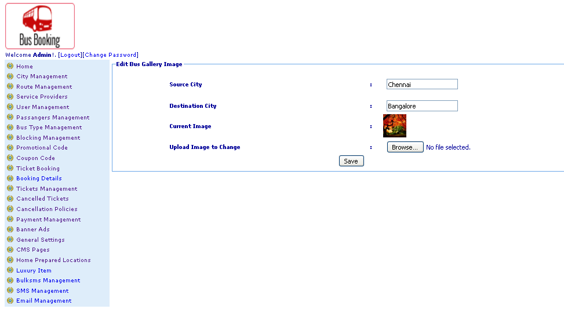
Description:
Admin can edit home prepared location detail

Subject: Edit promotion code details
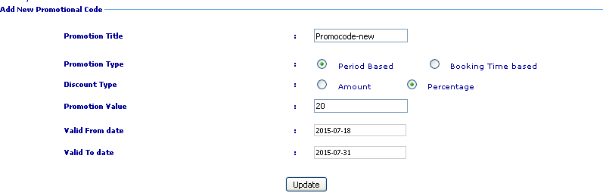
Description:
Admin can edit promotion code details

Subject: Edit user details
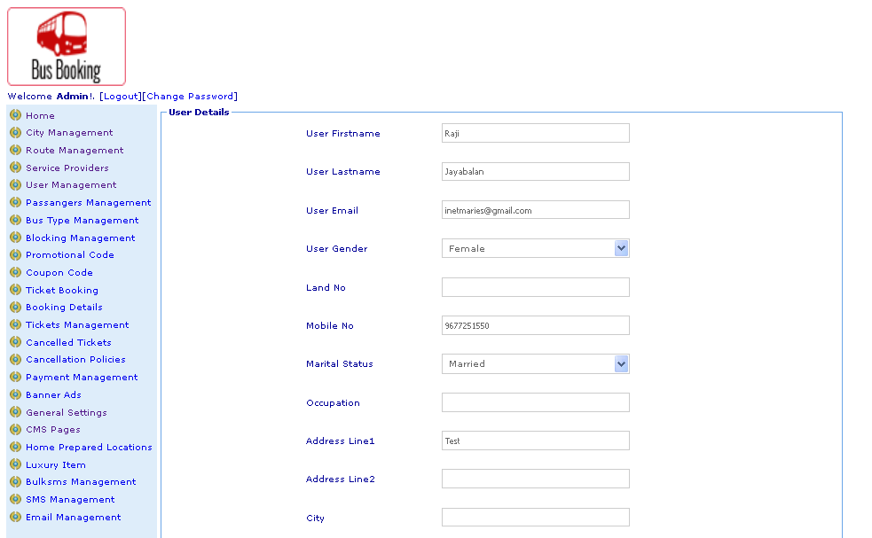
Description:
Admin can edit user details

Subject: CMS contents
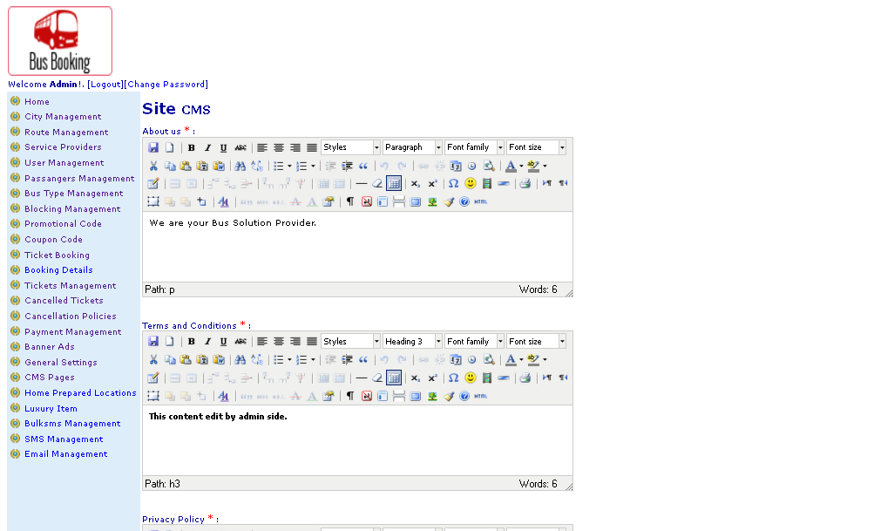
Description:
Admin can manage CMS contents

Subject: Search block seat details
Description:
Admin can search block seat details

Subject: Search bulk SMS details
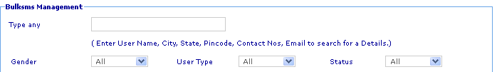
Description:
Admin can search bulk SMS details

Subject: Search cancels policy details
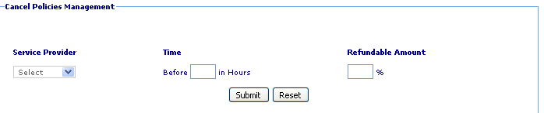
Description:
Admin can search cancel policy details

Subject: Search cancel ticket details
Description:
Admin can search cancelled ticket details

Subject: Search city details
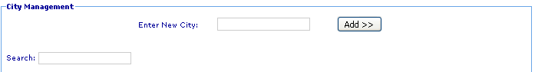
Description:
Admin can search city details

Subject: Search coupon code details
Description:
Admin can search coupon code details

Subject: Search cancel policy details
Description:
Admin can search cancel policy details

Subject: Search Email management details
Description:
Admin can search email management details

Subject: Search home location details
Description:
Admin can search home location details

Subject: Search luxury items details
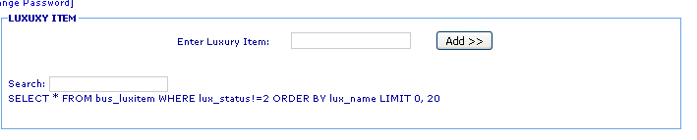
Description:
Admin can search luxury items details

Subject: Search passengers details
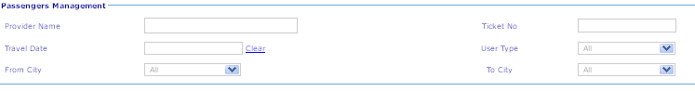
Description:
Admin can search passengers details

Subject: Search promotion code details
Description:
Admin can search promotion code details

Subject: Search service provider details
Description:
Admin can search service providers details

Subject: Search service providers bus details
Description:
Admin can search service providers bus details

Subject: Search SMS management details
Description:
Admin can search SMS management details

Subject: Search ticket details
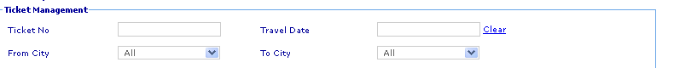
Description:
Admin can search passengers ticket details

Subject: Search Users details
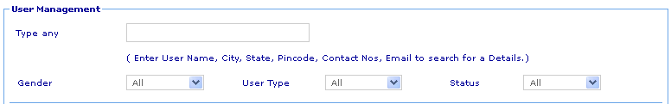
Description:
Admin can search users details

Subject: Search service provider list details
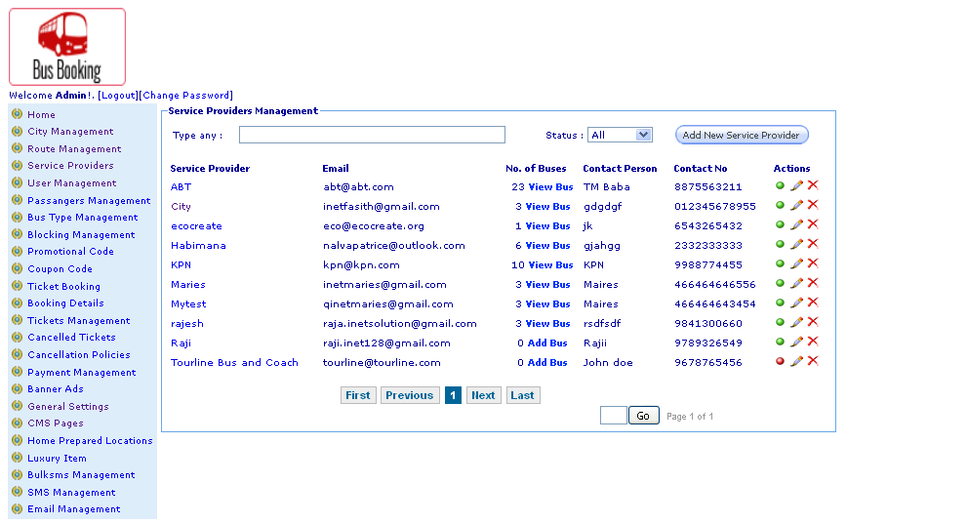
Description:
Admin can search service providers list details

Subject: Manage CMS content details
Description:
Admin can manage CMS content details

