AUTOMATED TRAVEL SCRIPT – API BASED
Tour package:
General
Activity:
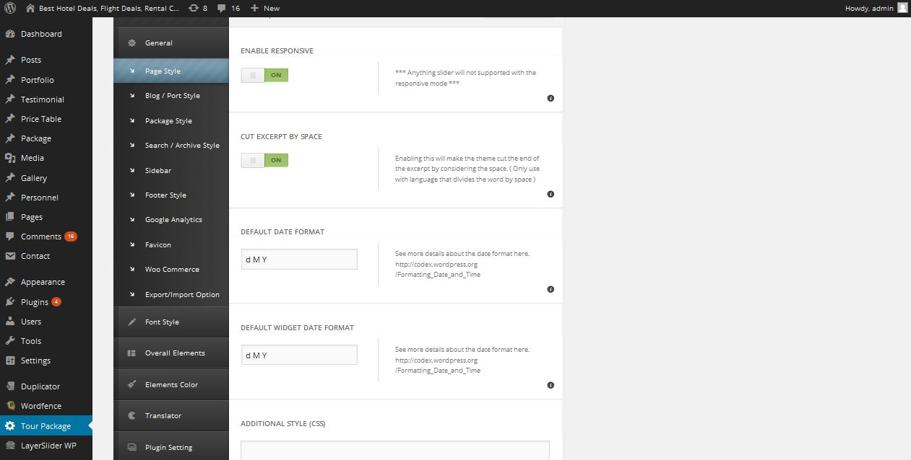
Description:
Admin can manage settings of page style

Blog style:
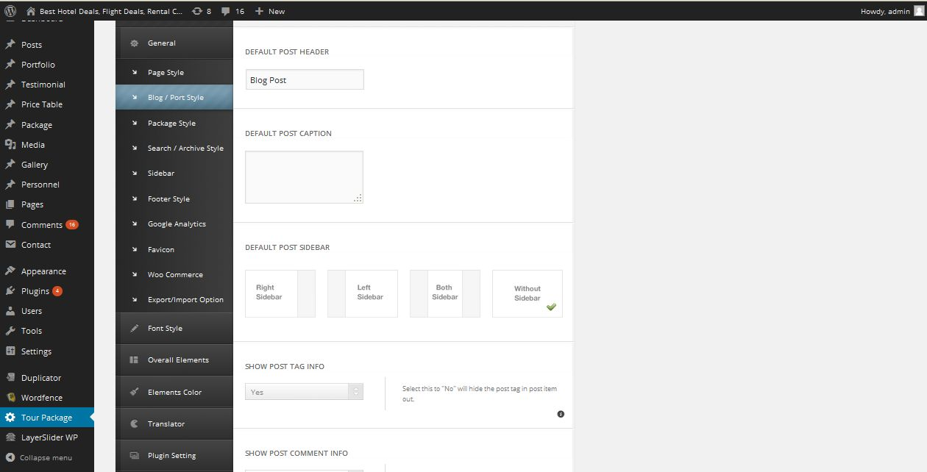
Description:
Admin manage blog page style

Package style:
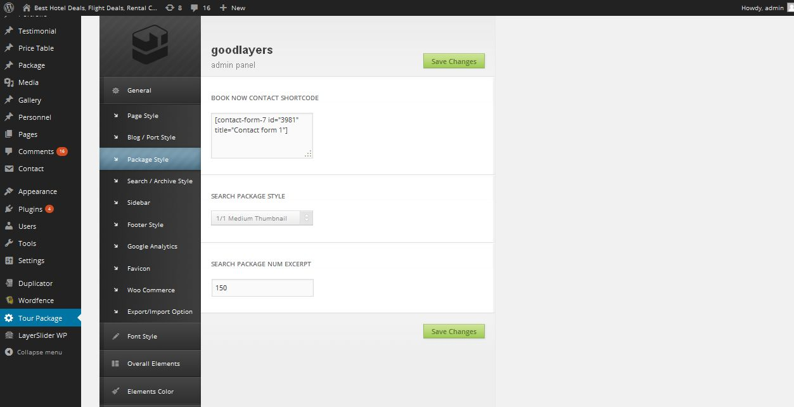
Description:
Admin manage package page layout setting

Search style:
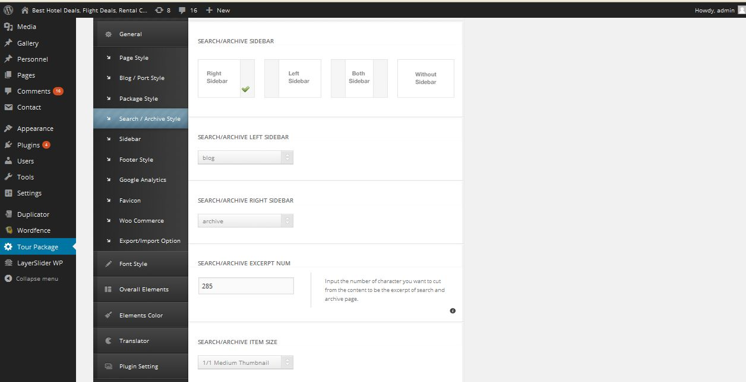
Description:
Admin manage settings of search result page

Sidebar:
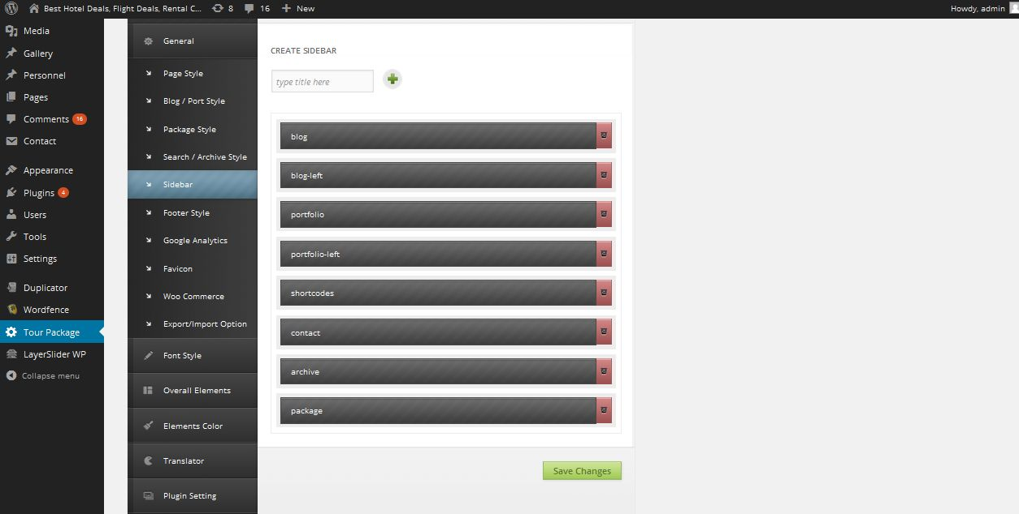
Description:
Admin manage sidebar fields settings

Footer:
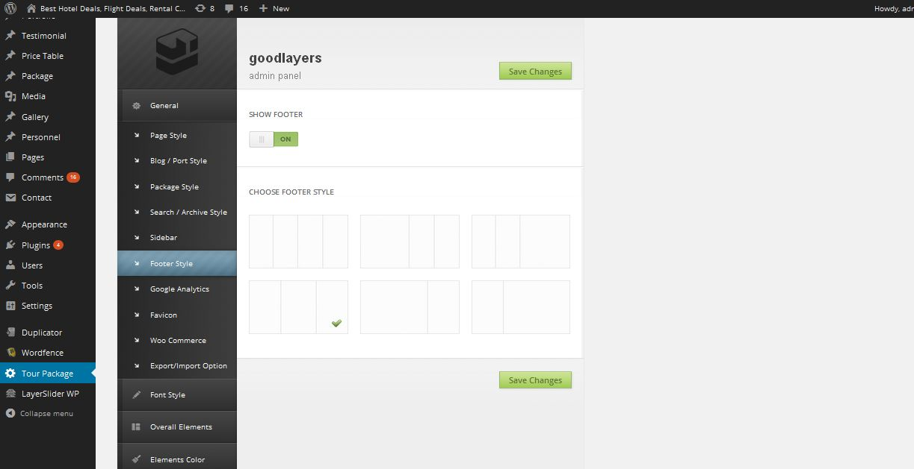
Description:
Admin manage settings of footer

Google analytics:
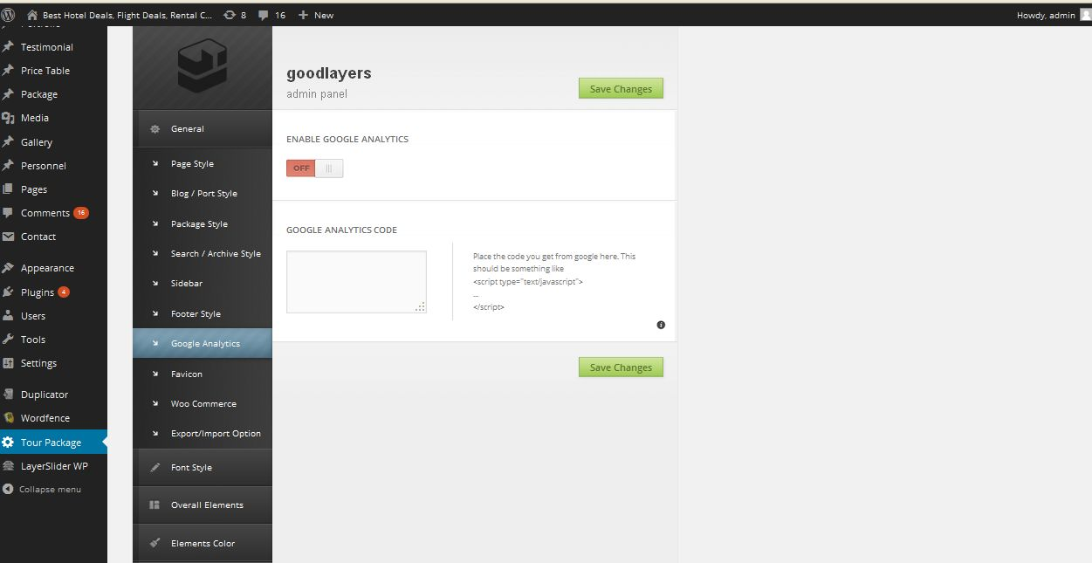
Description:
Admin manage google analytics enable or disable settings

Favicon:
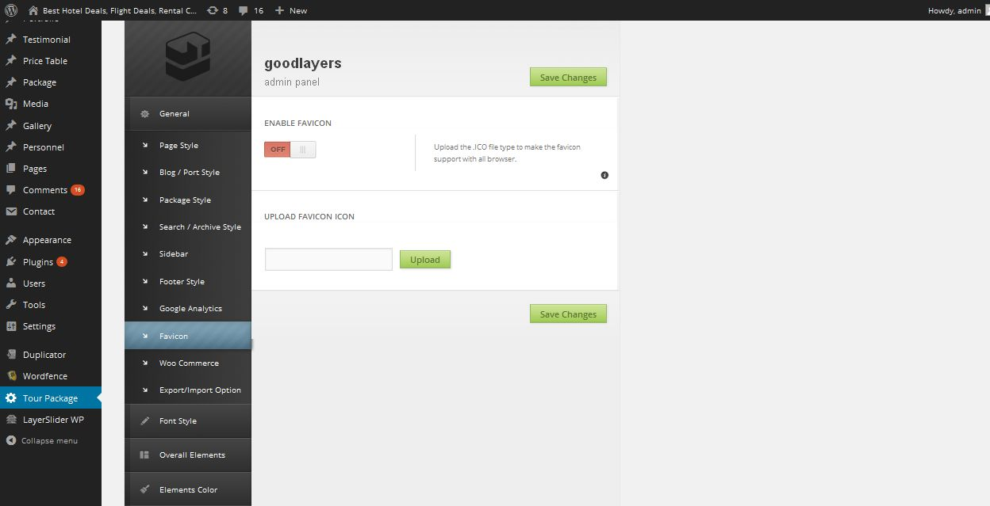
Description:
Admin manage favicon settings

Woo-commerce :
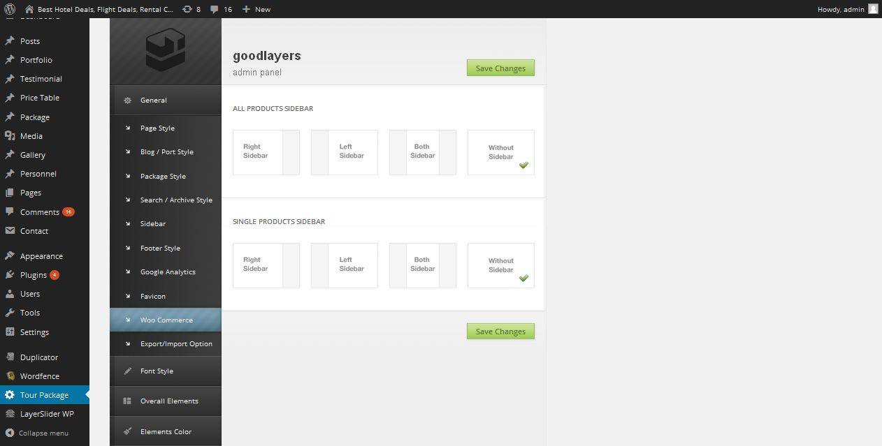
Description:
Admin mange woo commerce result page product count settings

Import-Export:
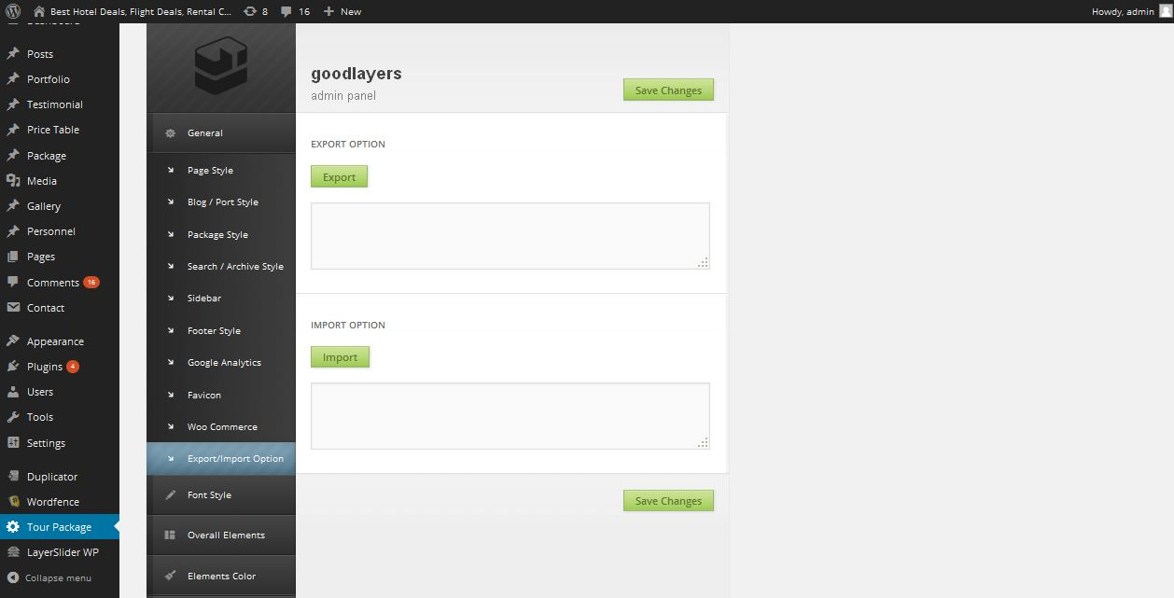
Description:
Admin manage settings of bulk import and export settings

Font size:
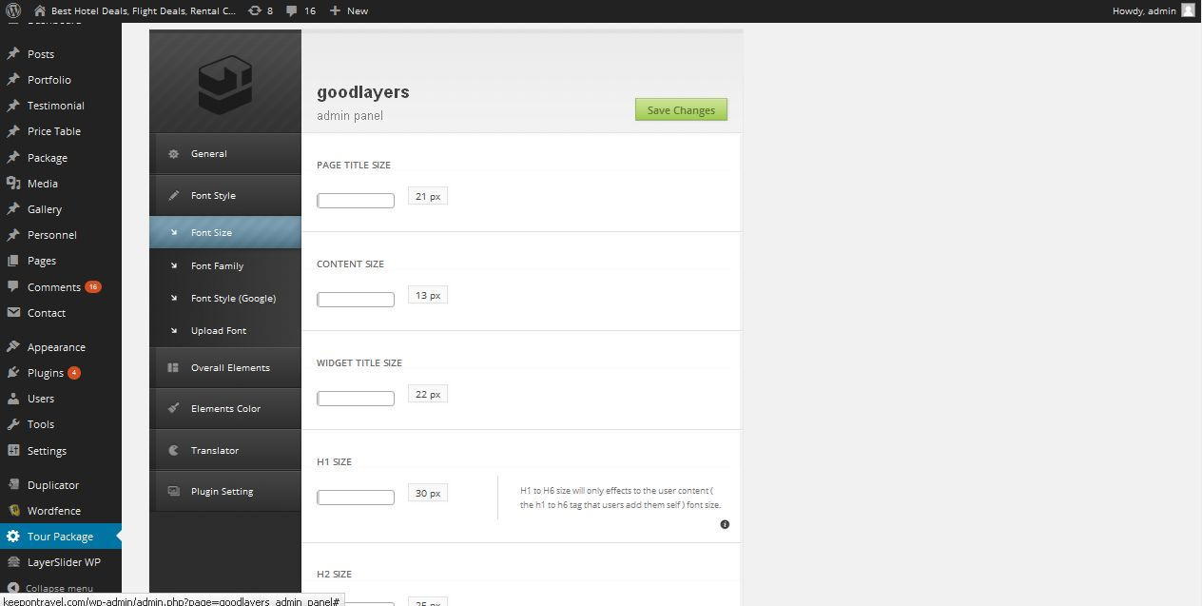
Description:
Admin manage website font size

Font type:
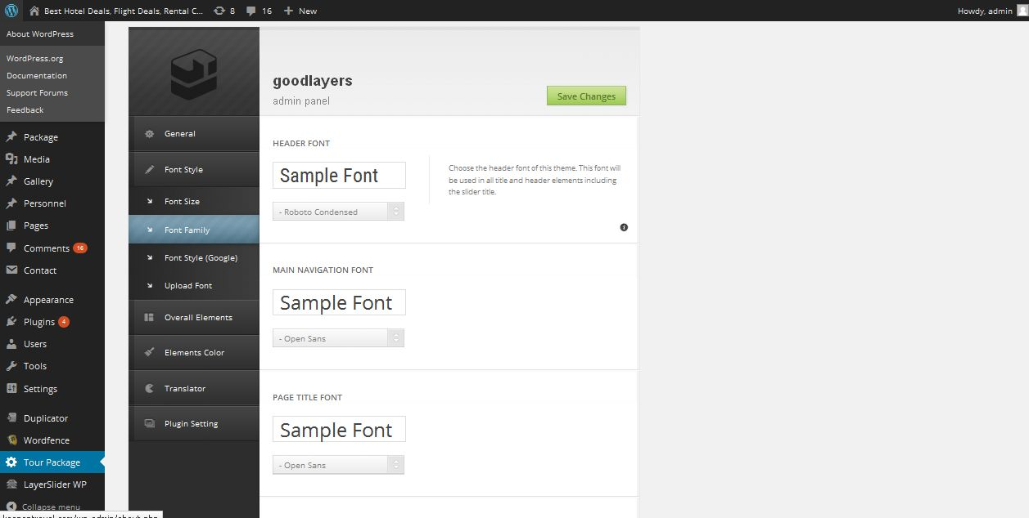
Description:
Admin select font type for website

Font style:
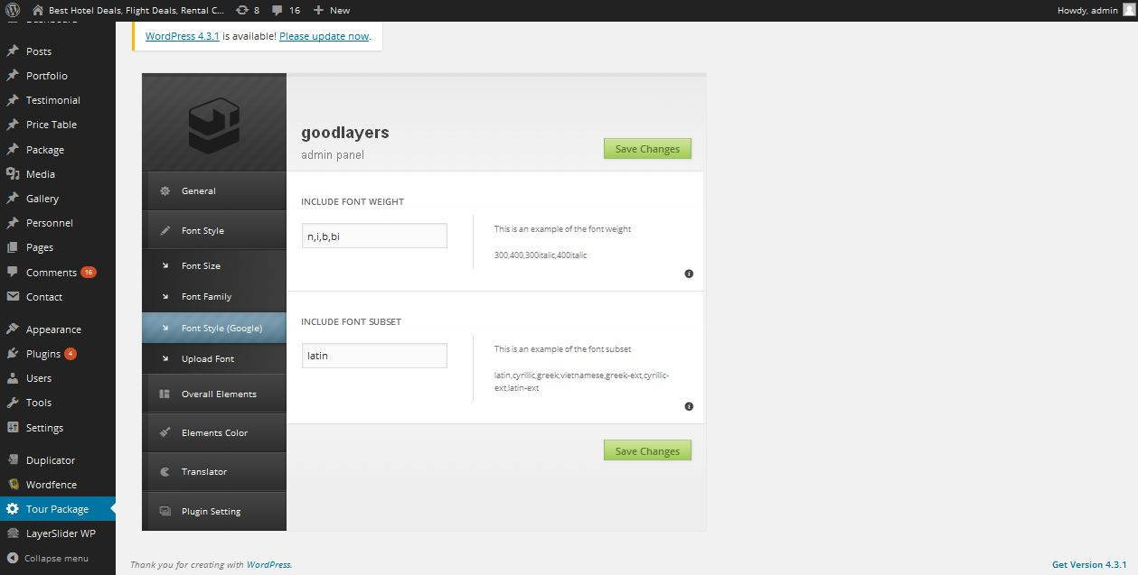
Description:
Admin manage font weight for the size

Upload font:
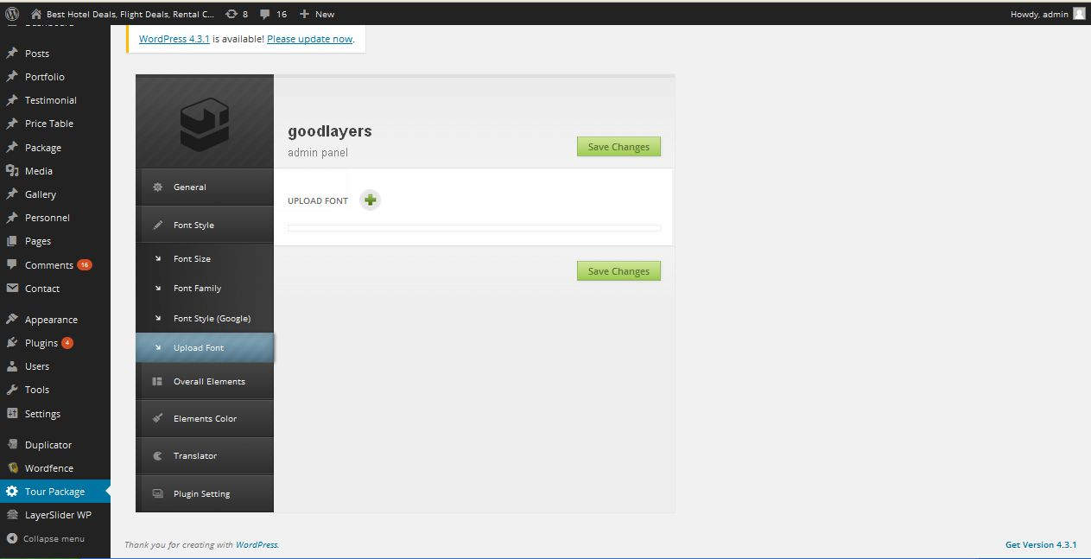
Description:
Admin can add new font

Logo:
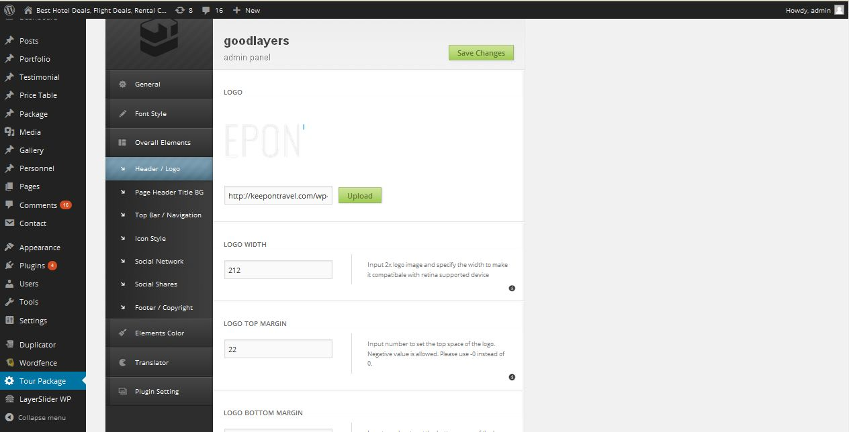
Description:
Admin can manage logo

Page header:
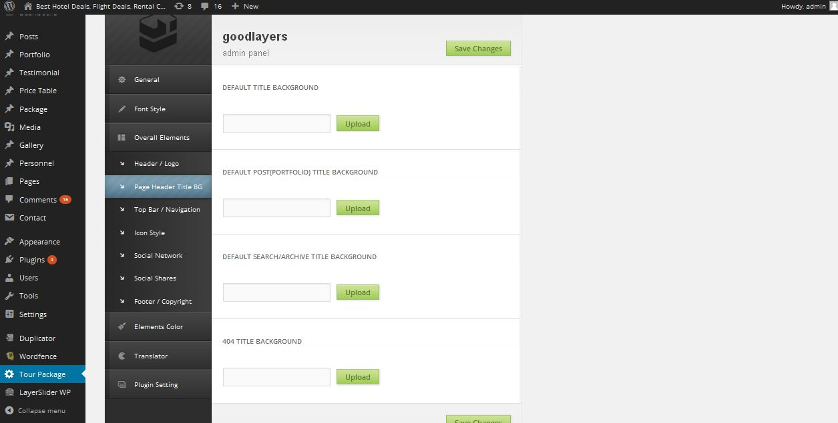
Description:
Admin manage page header name

Top bar:
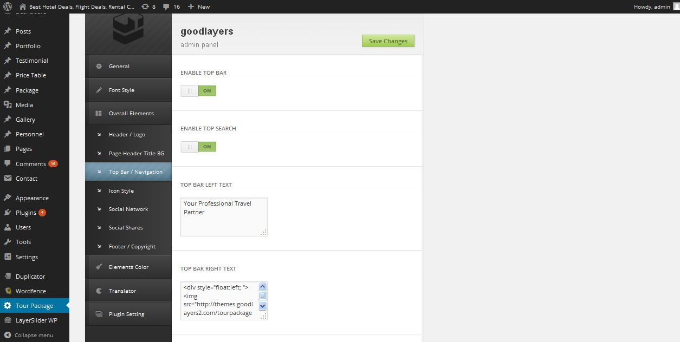
Description:
Admin can top bar settings

Icon:
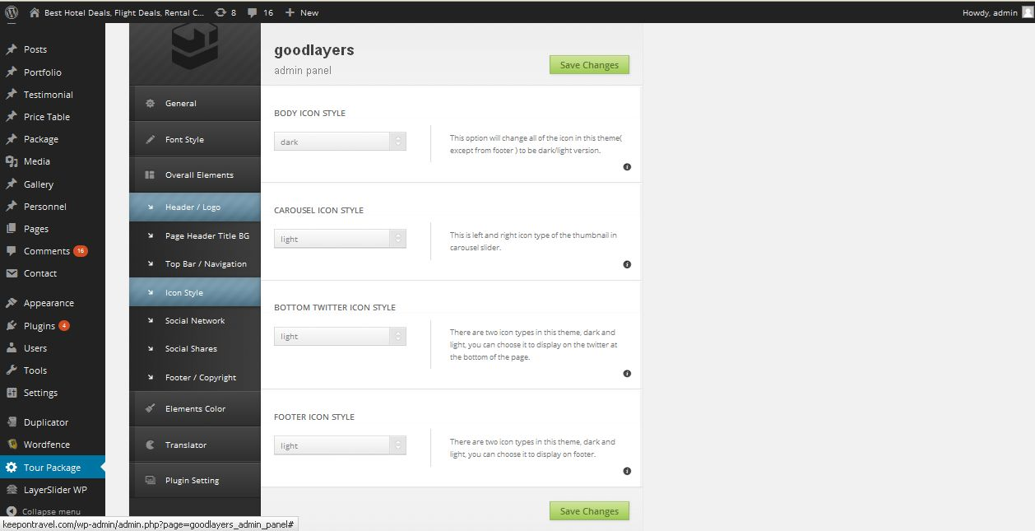
Description:
Admin manage website all icons settings

Social network:
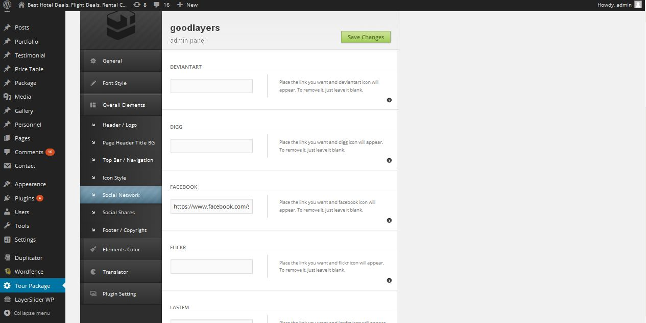
Description:
Admin manage social network connection link settings

Social sharing:
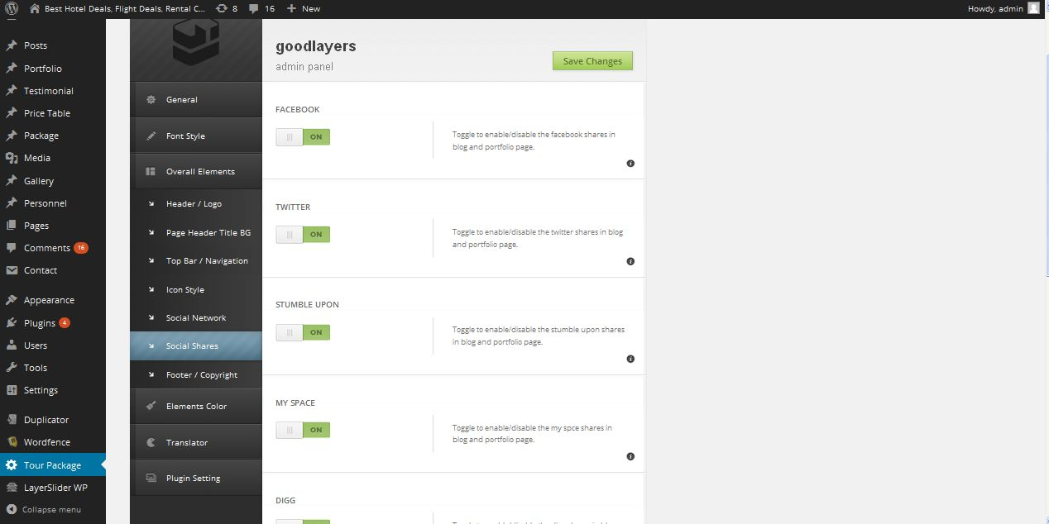
Description:
Admin manage settings of social network sharing option

Footer:
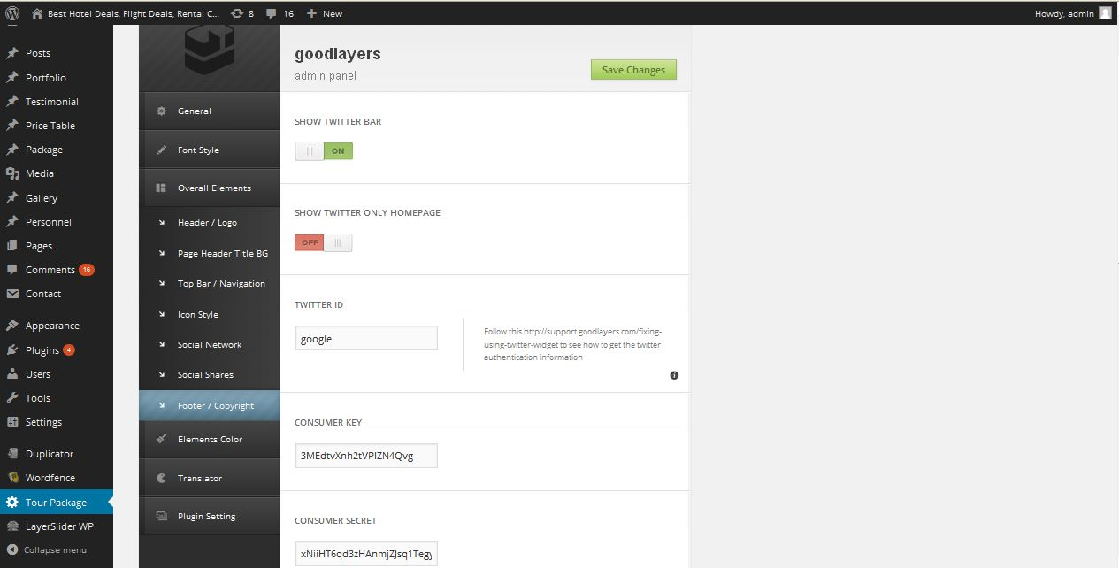
Description:
Admin manage footer copyright text and layout settings

Header top bar:
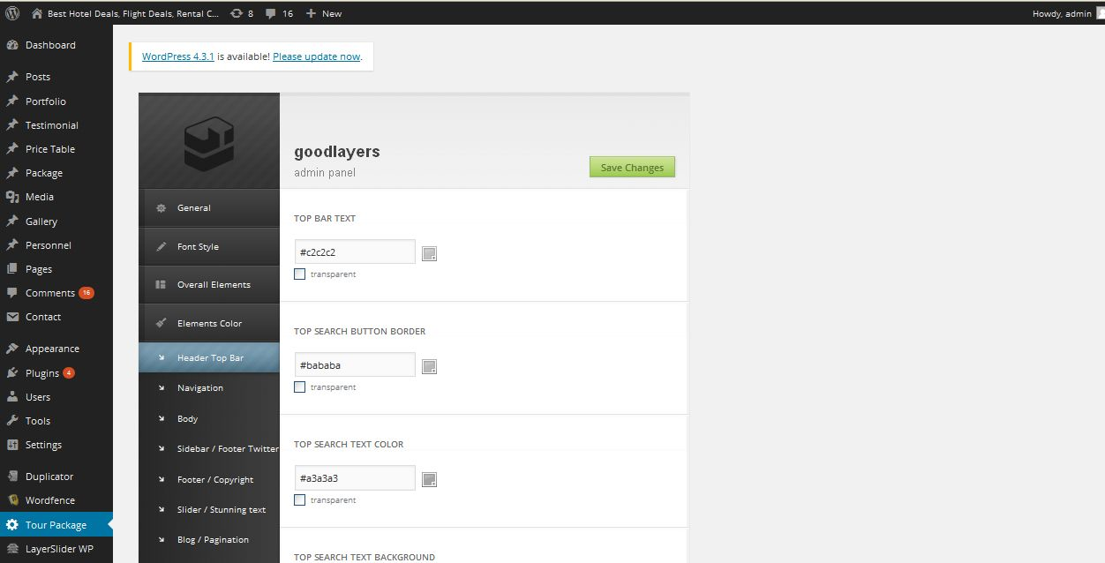
Description:
Admin manage settings of header top bar layout settings

Navigation:
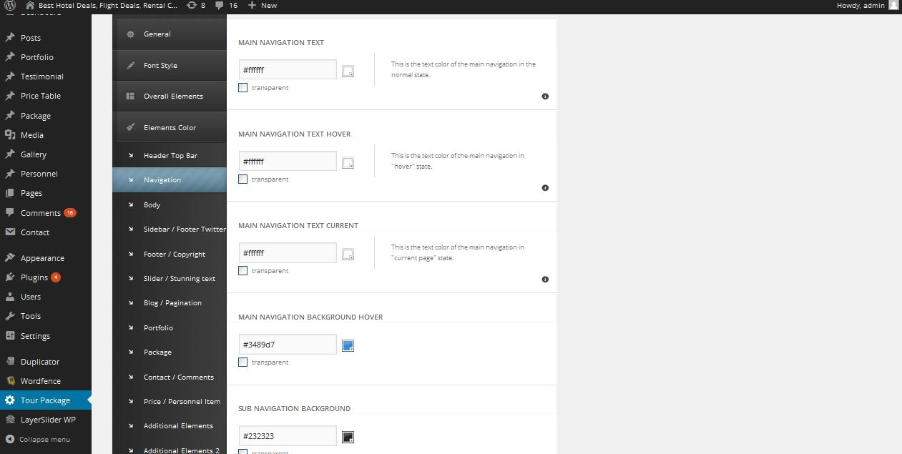
Description:
Admin manage navigation color settings

Body:
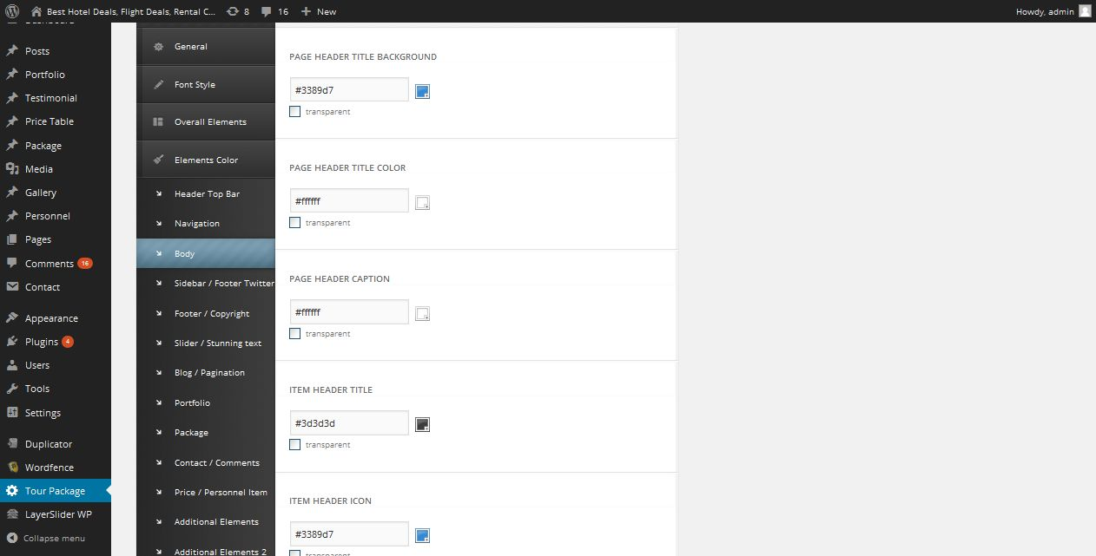
Description:
Admin manage body color settings

Sidebar-Footer:
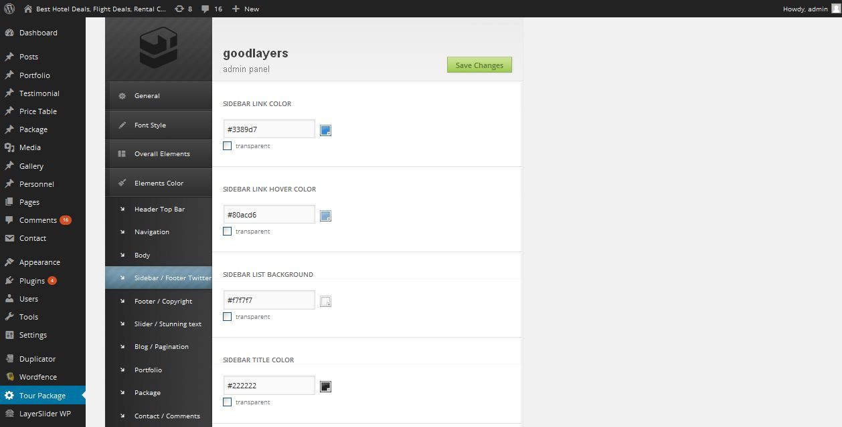
Description:
Admin manage color settings of sidebar content and footer social link logo color

Footer copyright :
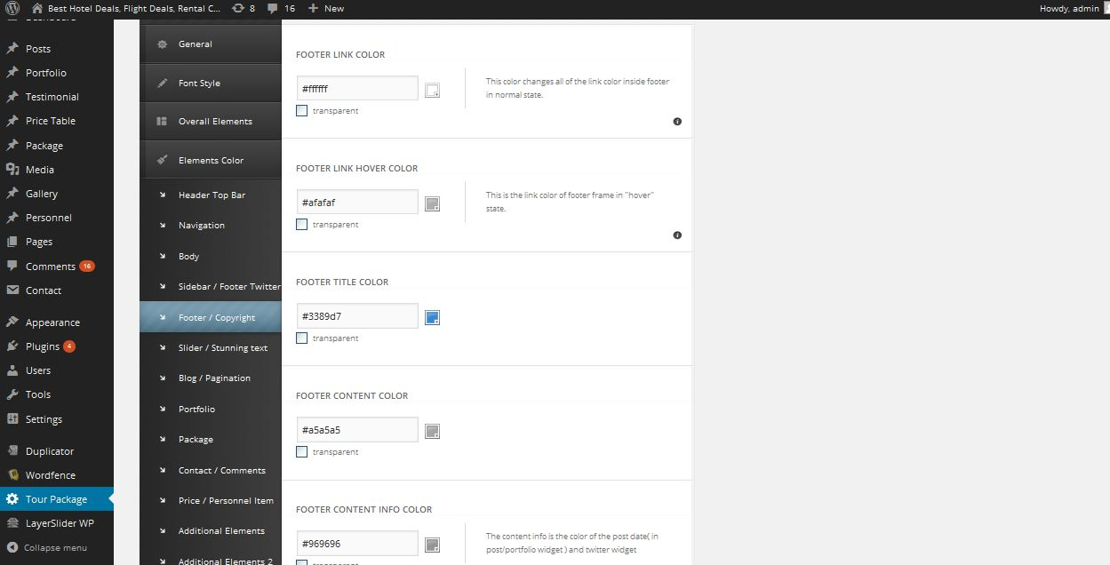
Description:
Admin can manage footer copy write color setting

Slider background:
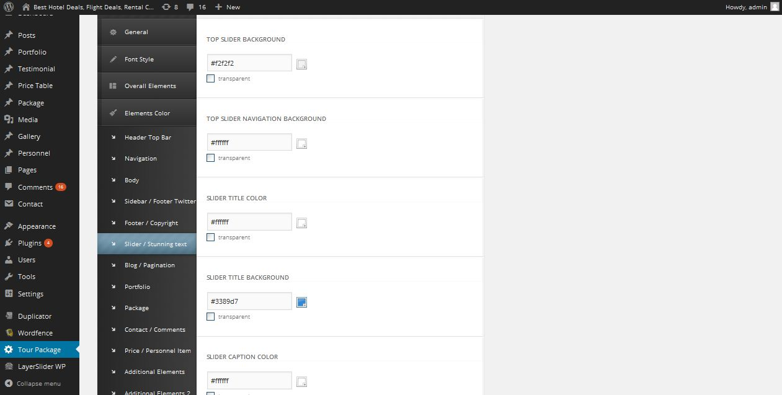
Description:
Admin manage settings of slider background color settings

Blog-pagination:
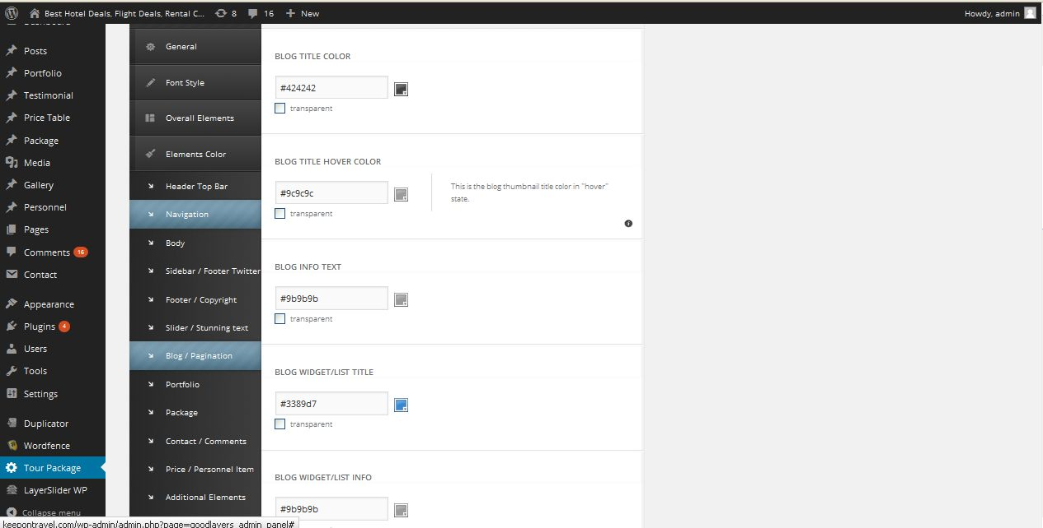
Description:
Admin manage color settings of blog and pagination

Portfolio:
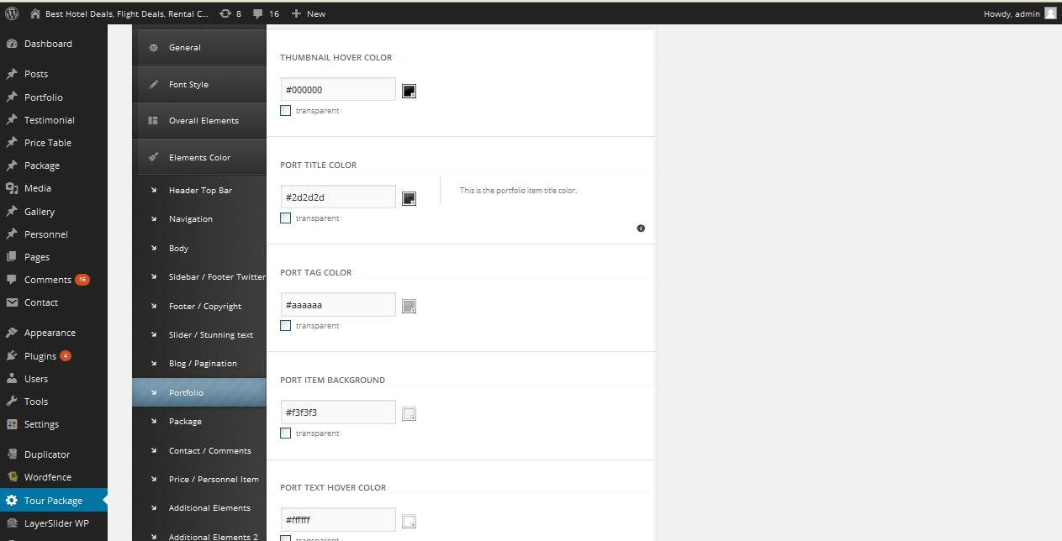
Description:
Admin manage portfolio color settings

Package:
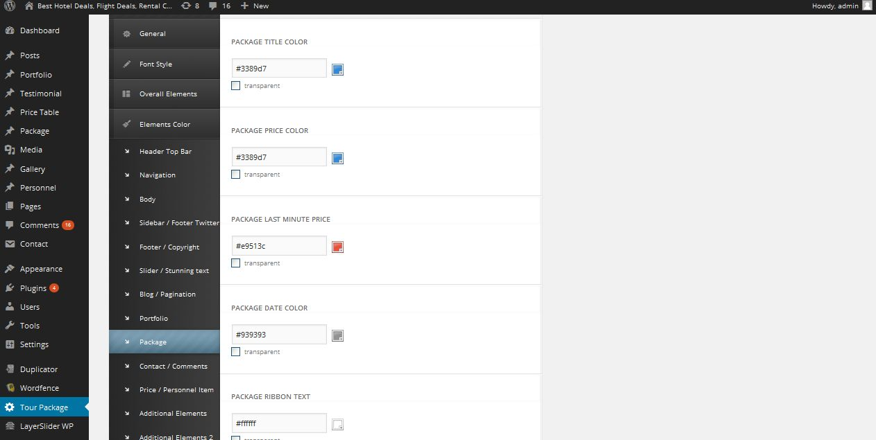
Description:
Admin package page color settings

Product contact-comment:
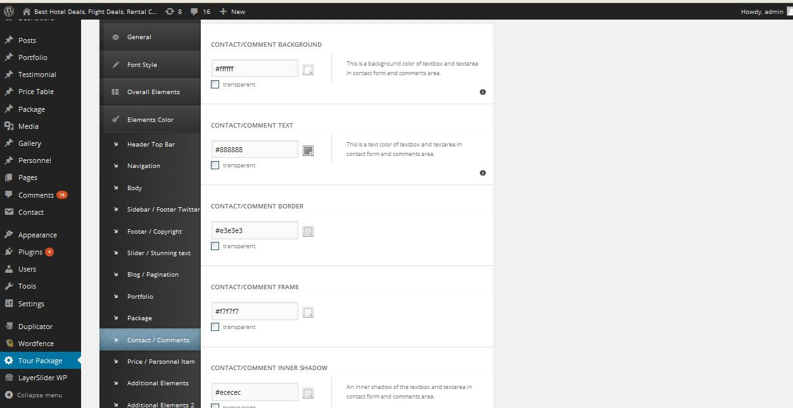
Description:
Admin manage color settings of product contact and comment

Price:
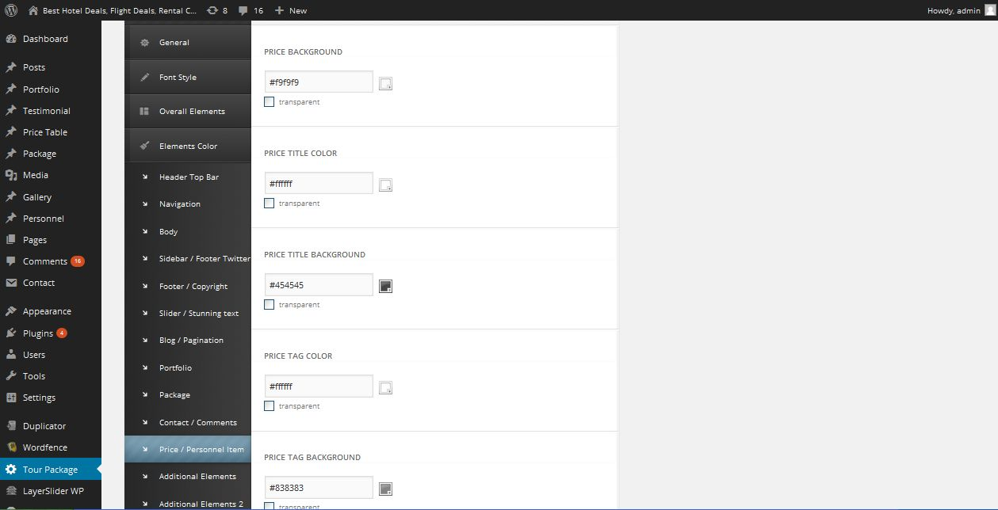
Description:
Admin manage color settings of price

Additional element:
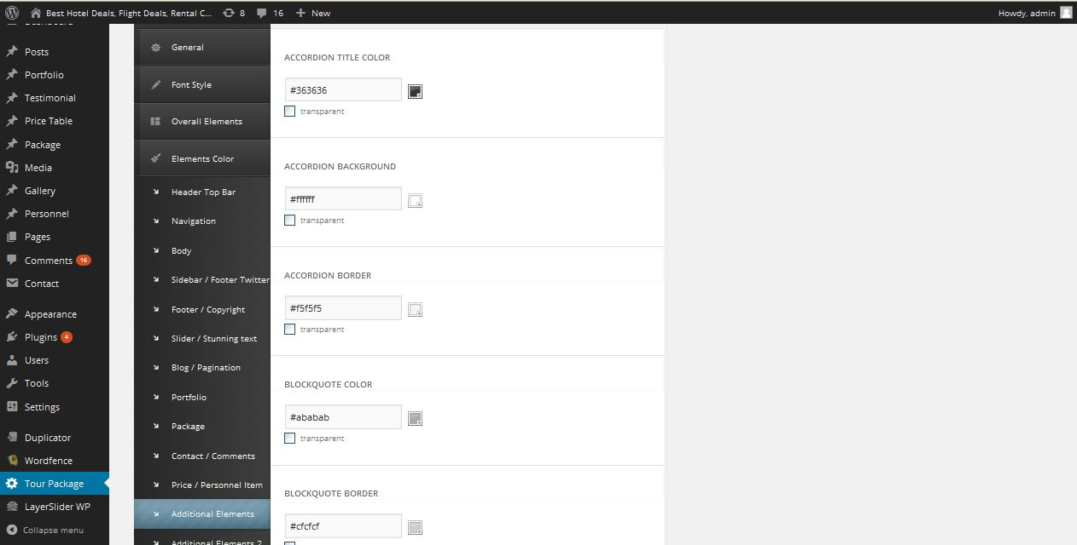
Description:
Admin manage color settings of additional element

Default color:
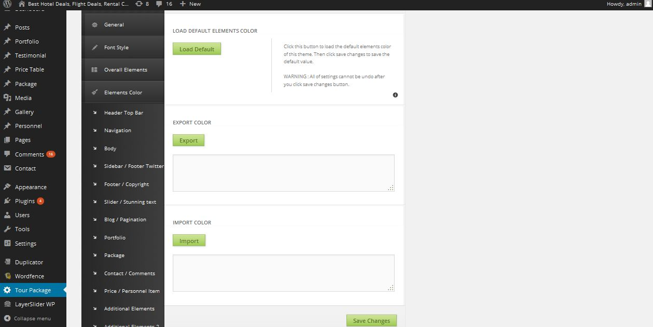
Description:
Admin can import and export color and change default color for whole site

Translation:
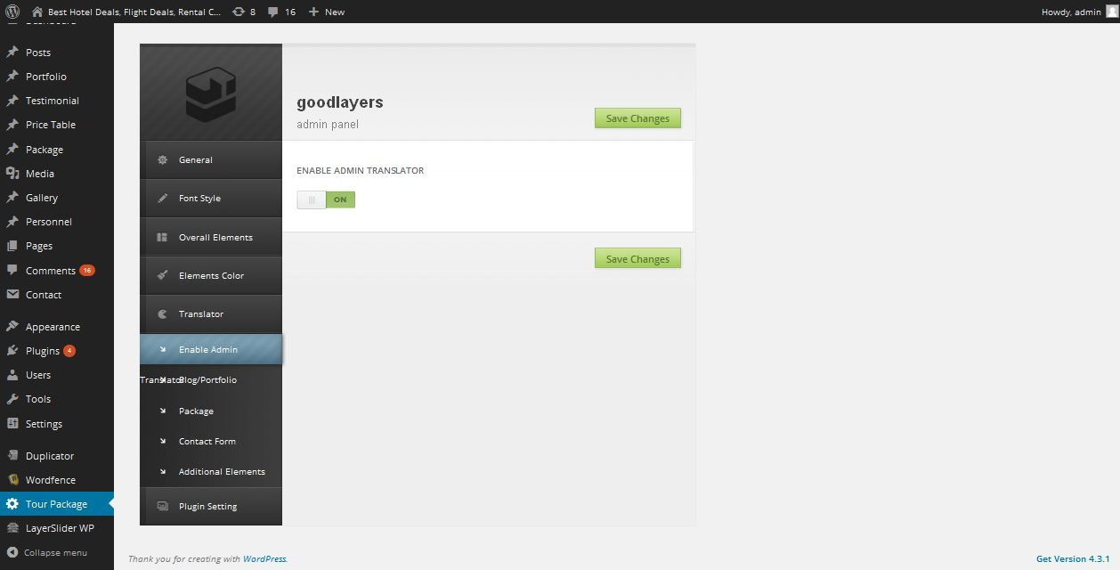
Description:
Admin manage translation settings

Translate portfolio:
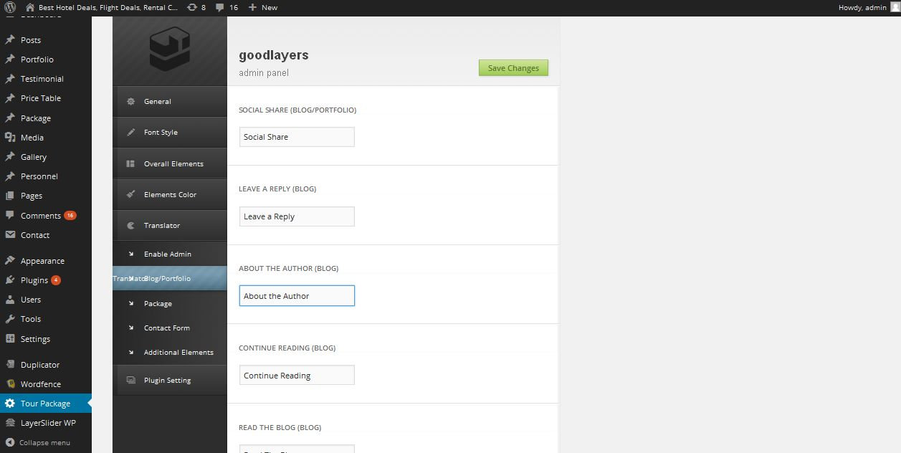
Description:
Admin can add new word for adding new language

Package:
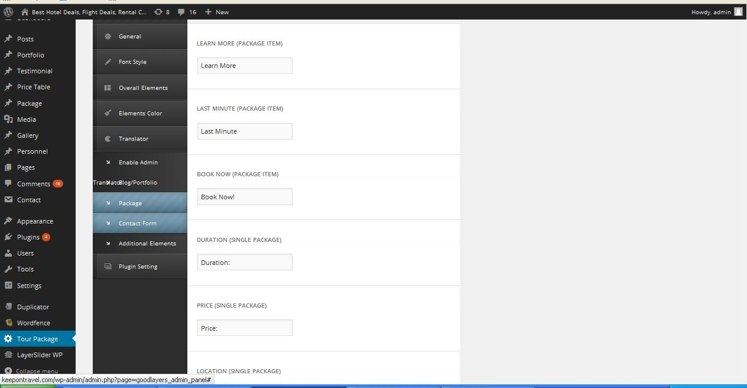
Description:
Admin add new words to package page fields

Contact form:
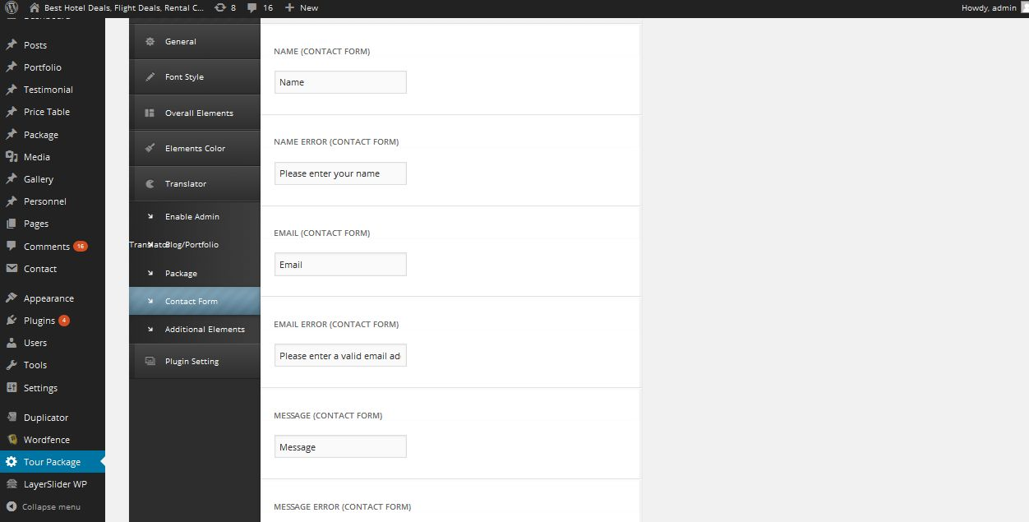
Description:
Admin add new words to contact form page fields

Additional element:
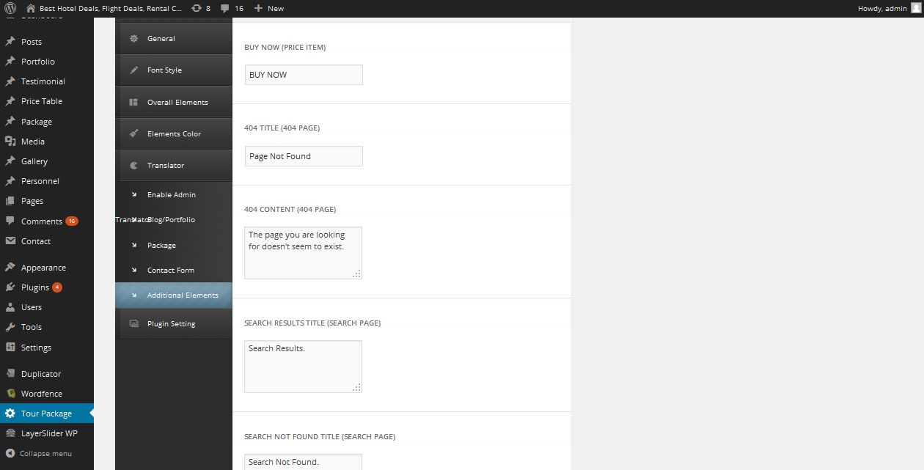
Description:
Admin add new words to additional element page fields

Enable plugin:
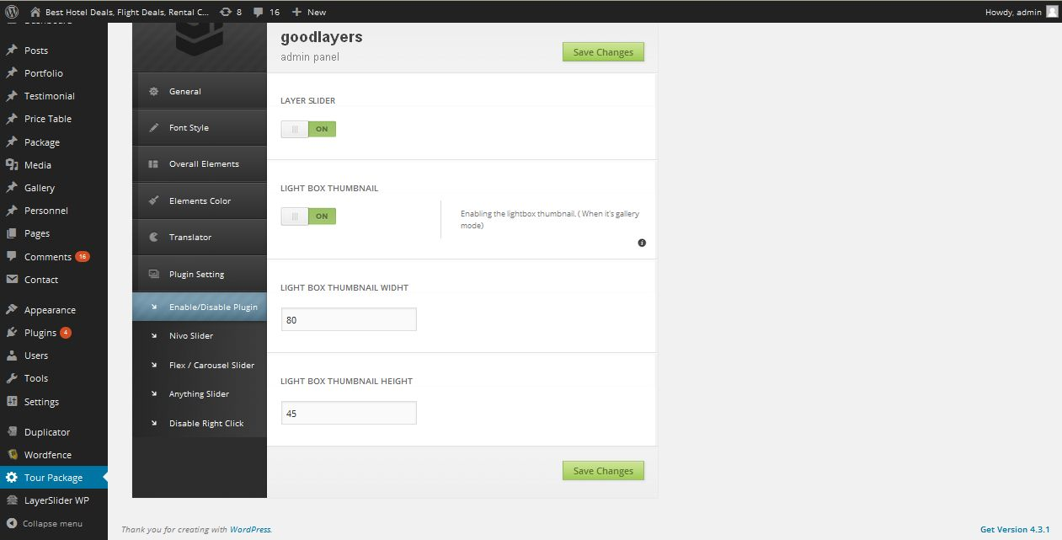
Description:
Admin can enable and disable their plugin

Slider setting:
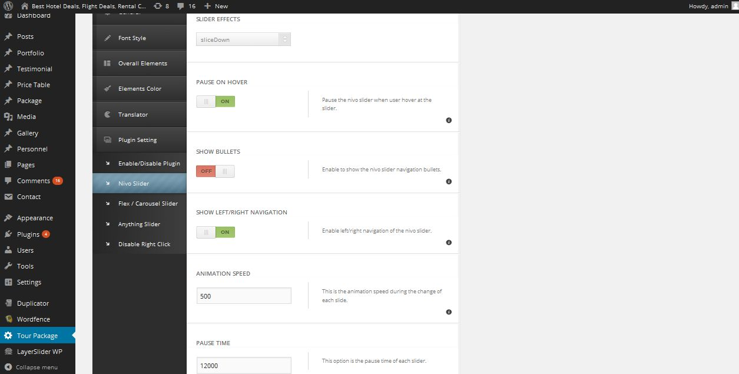
Description:
Admin manage slider settings

Flex-carousel settings:
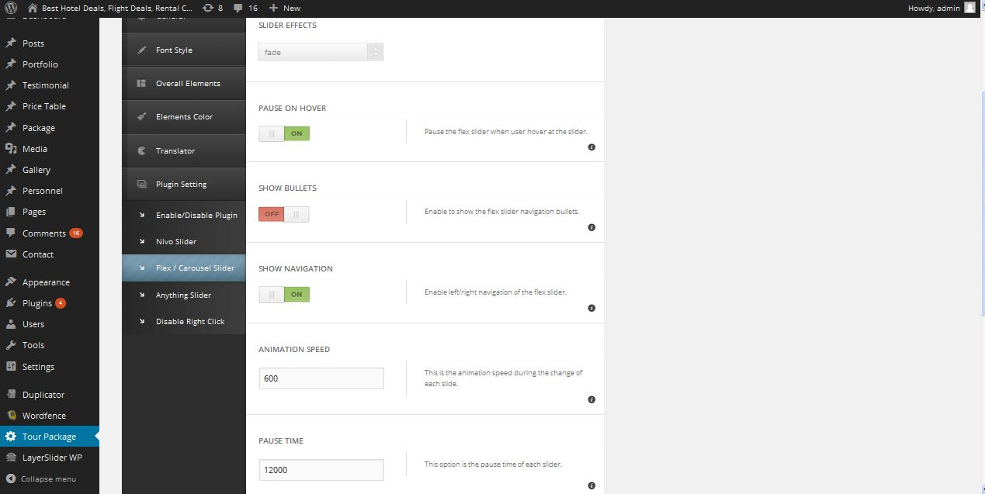
Description:
Admin mange slider effects settings

Anything slider:
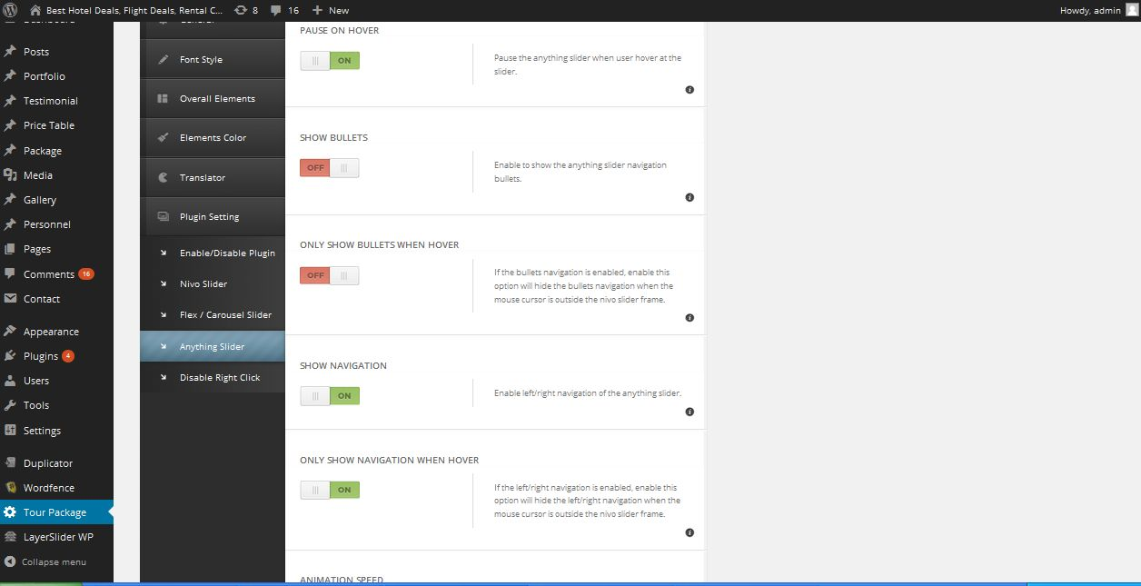
Description:
Admin mange settings of functionality of the slider

Right click:
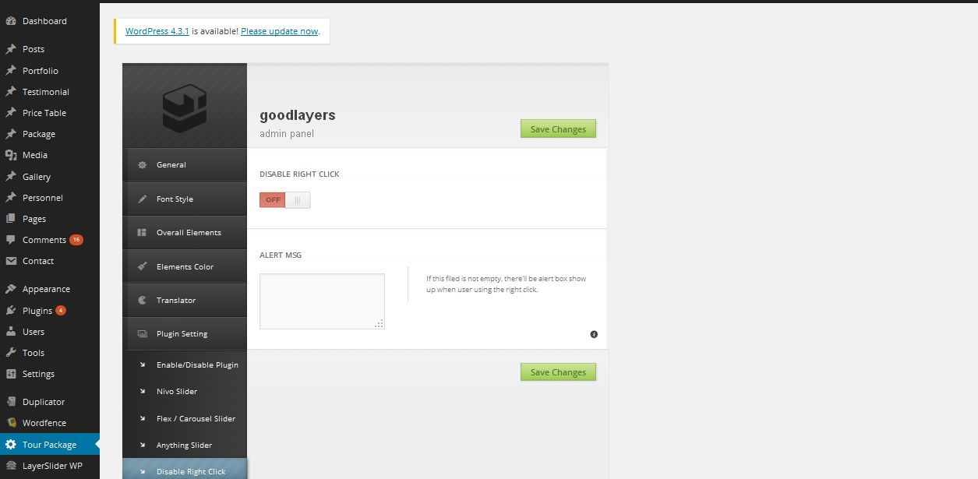
Description:
Admin mange settings of right on slide bar

Appearance:
Theme:
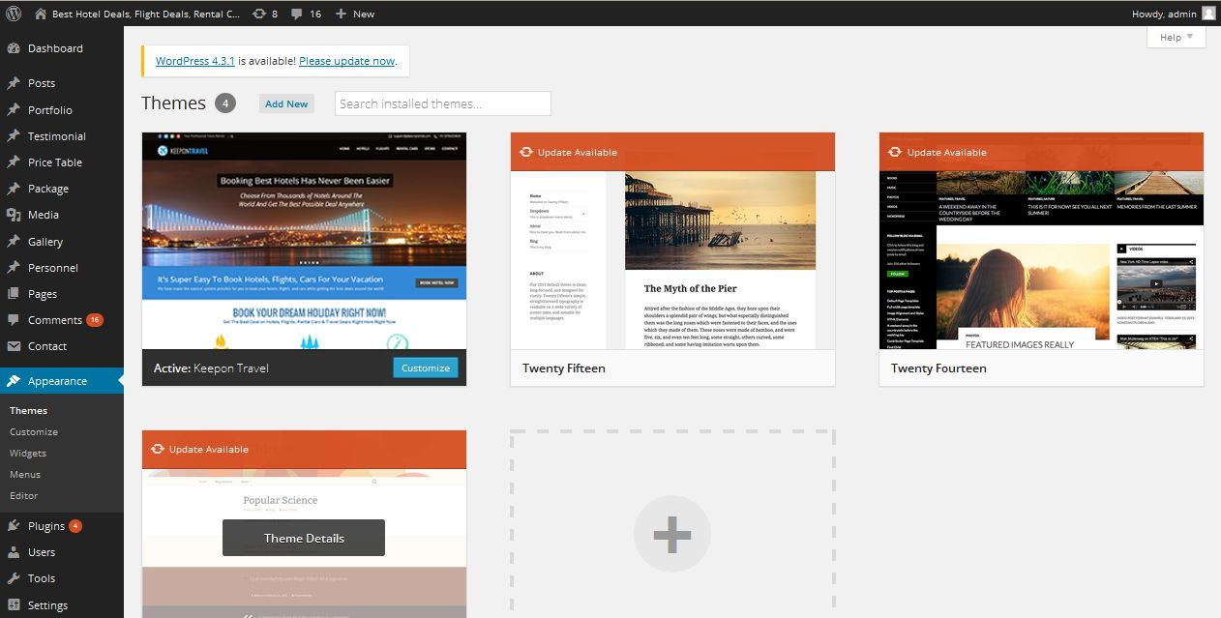
Description:
Admin can choose their theme style

Customize
Site title-tagline: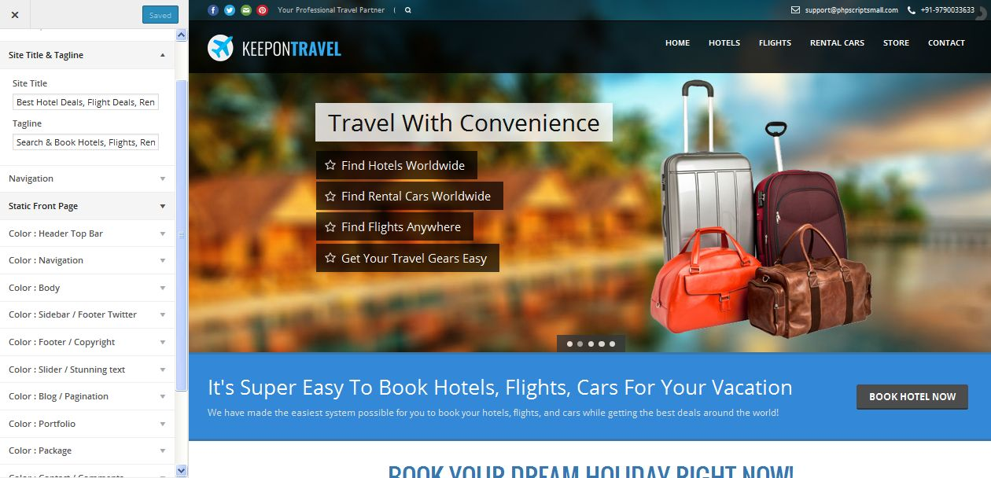

Description:
Admin can customize their site title and tag line

Navigation:
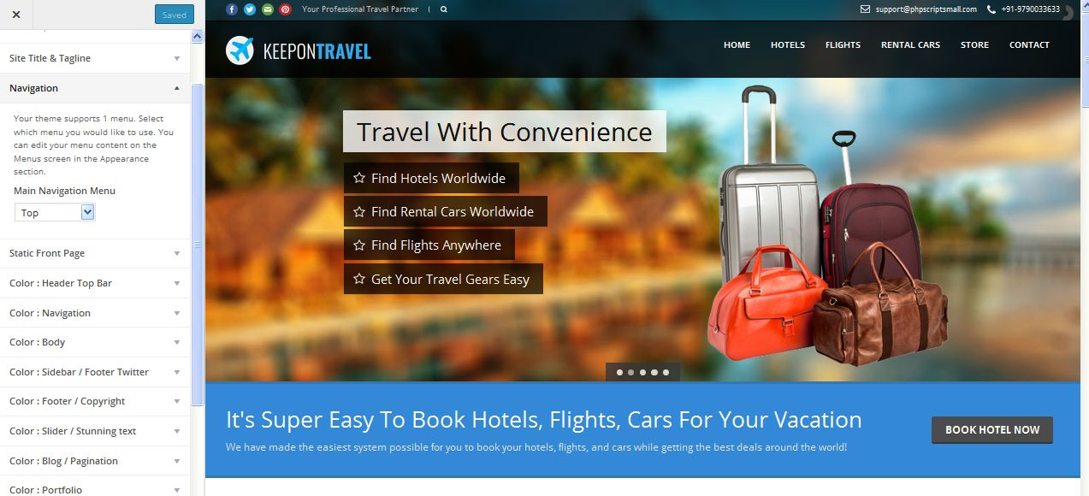
Description:
Admin manage navigation settings

Static front page:
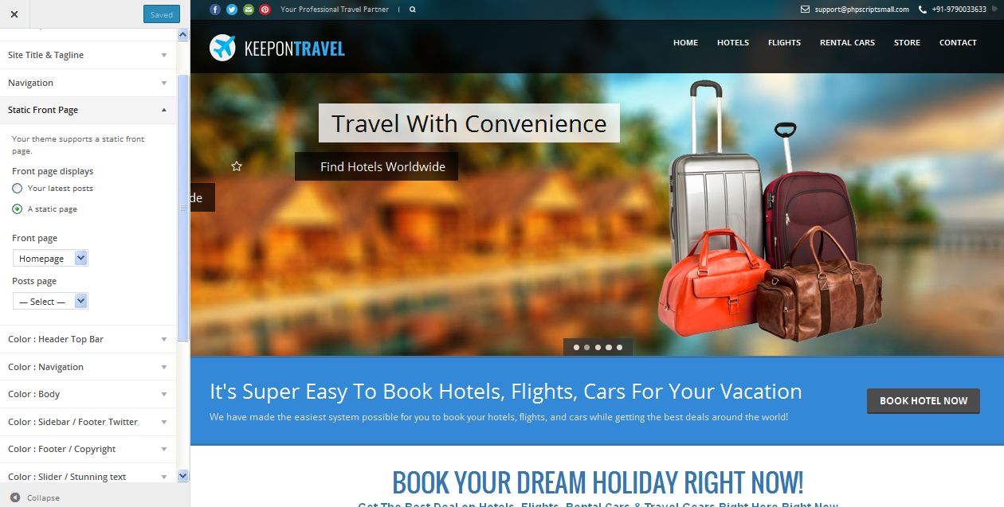
Description:
Admin manage static content page settings

Header top bar :
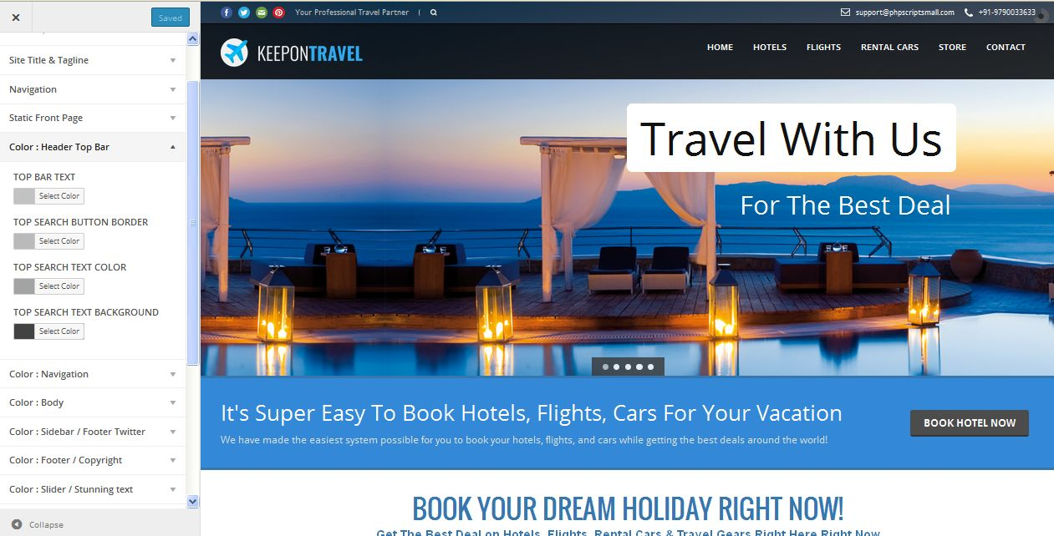
Description:
Admin manage color settings of header top bar

Navigation color:
Description:
Admin manage navigation color settings

Color body:
Description:
Admin manage color body settings

Color sidebar:
Description:
Admin manage sidebar color and footer twitter settings

Footer copyright:
Description:
Admin mange footer copyright settings

Slider-stunning text:
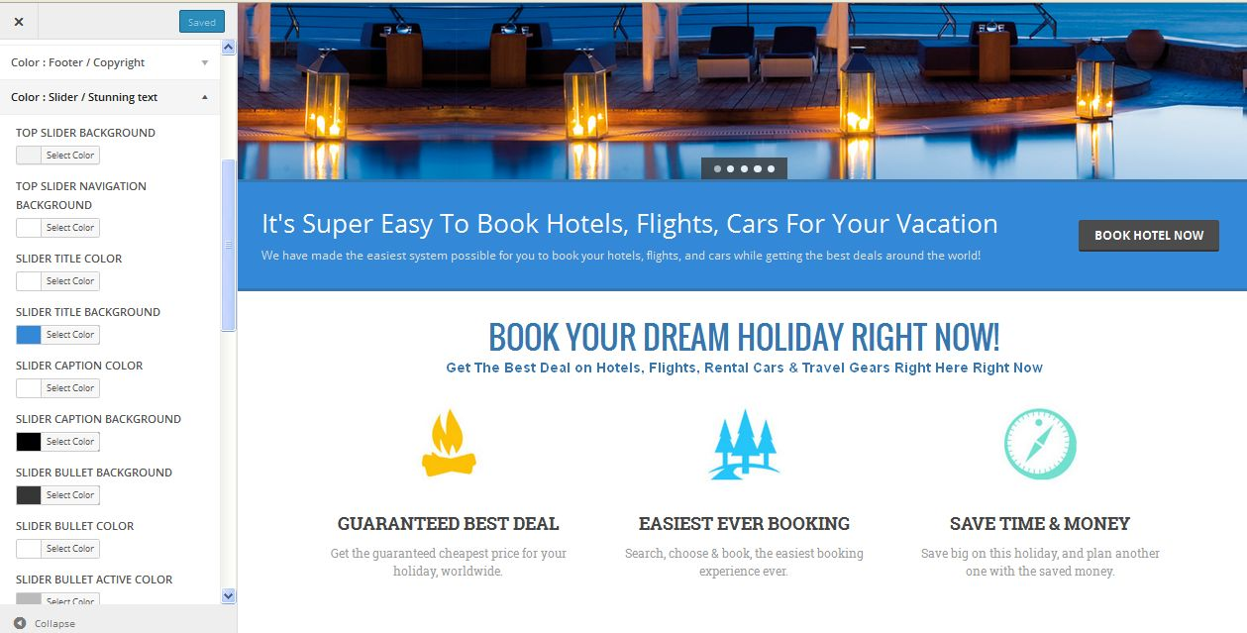
Description:
Admin manage slider and stunning text settings

Color and pagination:
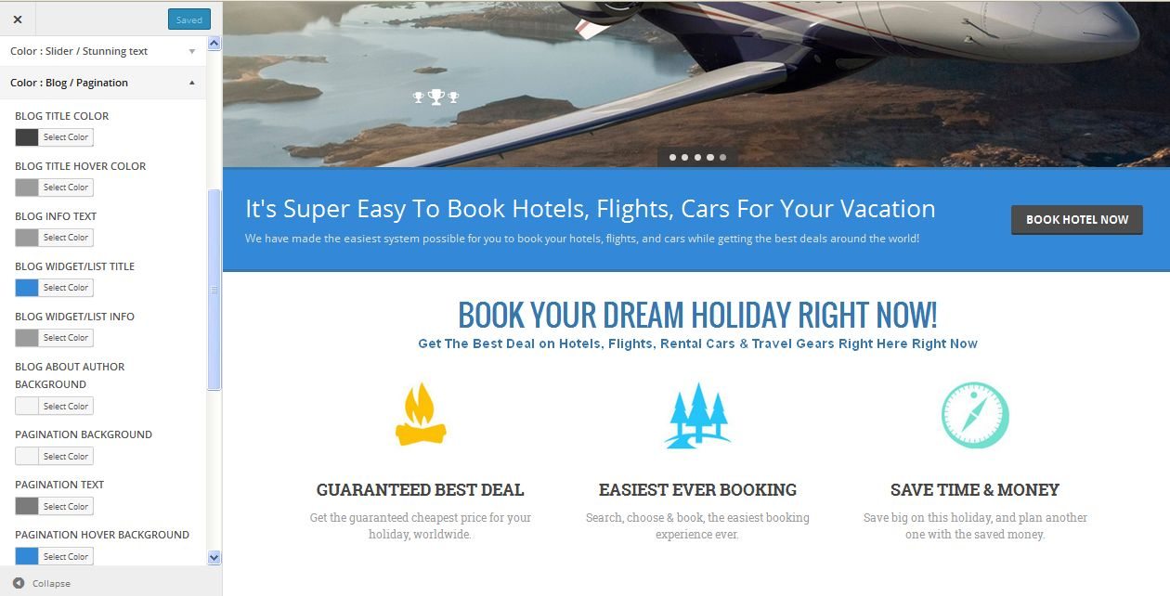
Description:
Admin manage color settings of color and pagination

Color portfolio:
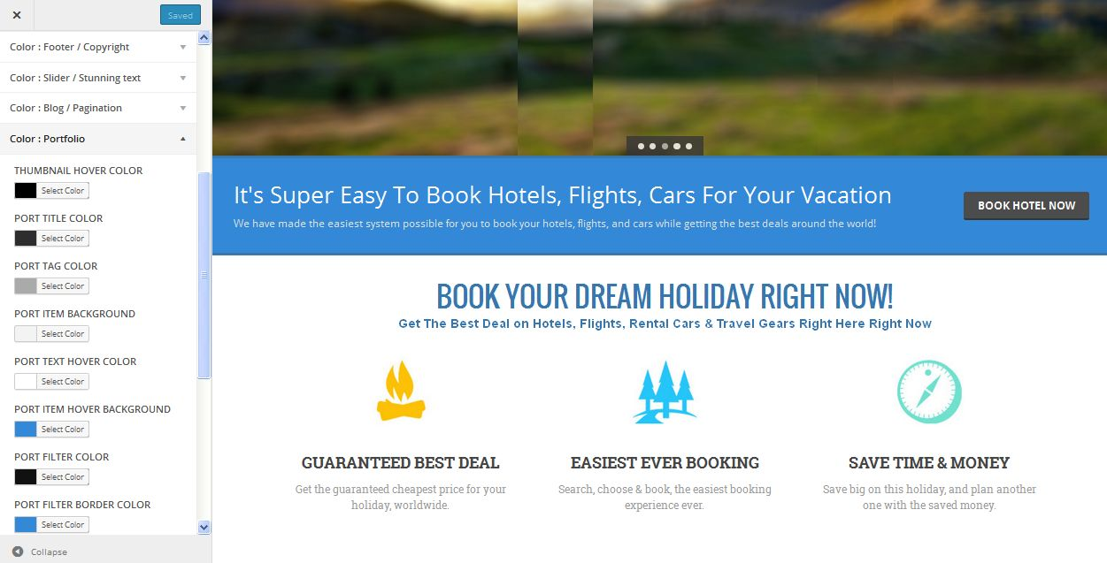
Description:
Admin mange color settings of portfolio

Color package:
Description:
Admin manage color settings of package

Color contact comment:
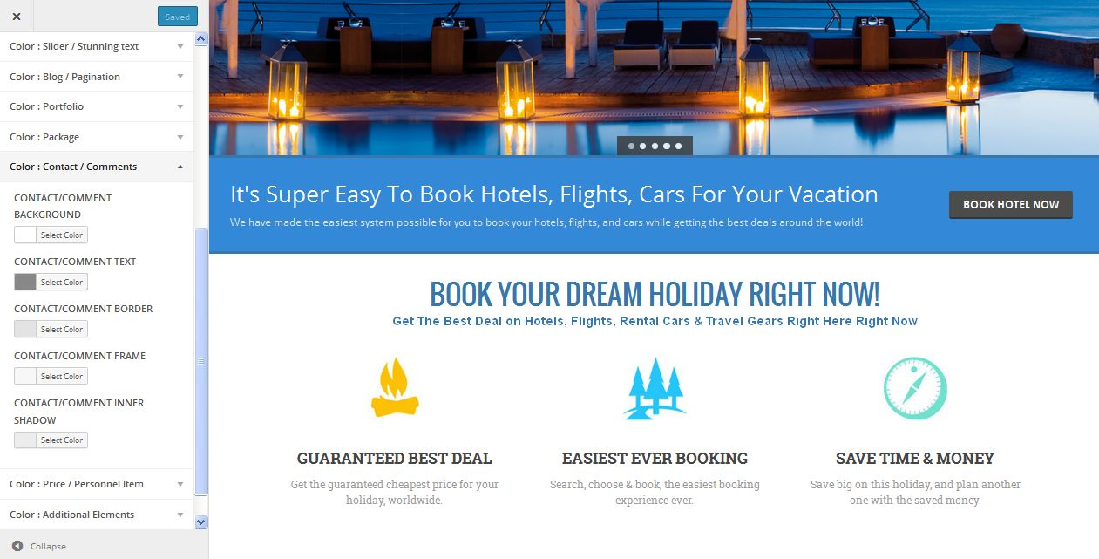
Description:
Admin mange settings of color and comment settings

Price and personal item:
Description:
Admin manage color settings of price and personal item

Additional element:
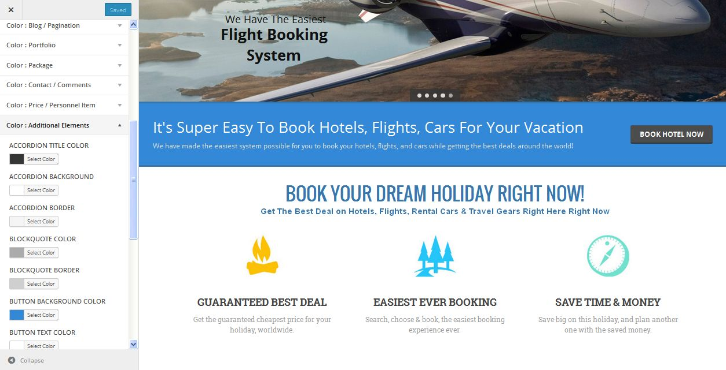
Description:
Admin manage color settings of additional element

Widgets:
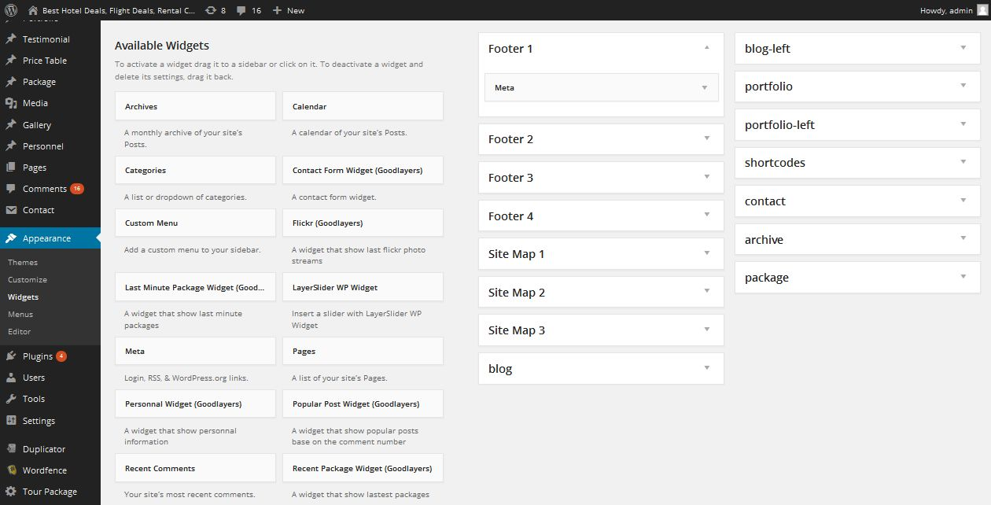
Description:
Admin manage widgets settings

Menu:
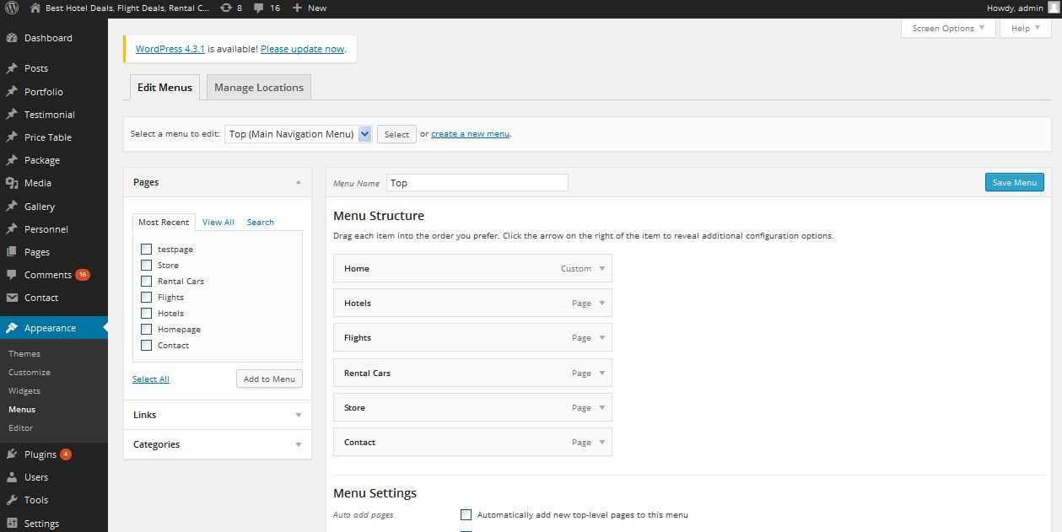
Description:
Admin mange settings of menu

Editor:
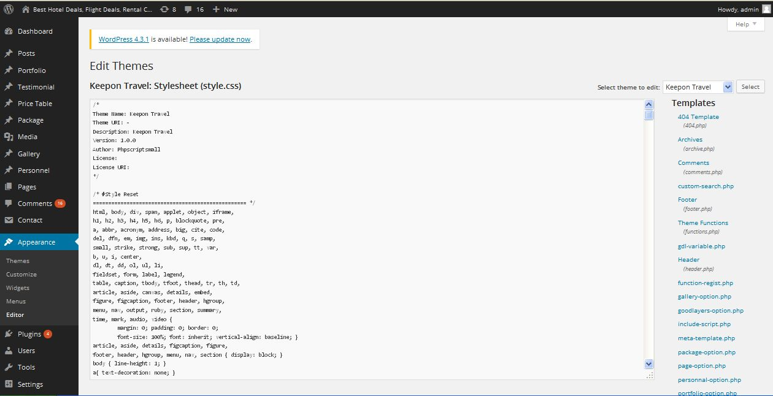
Description:
Admin can customize their script using CSS comment

