UNILEVEL MLM SCRIPT
MANUAL GUIDE
USER VIEW
Registration:
Step 1:
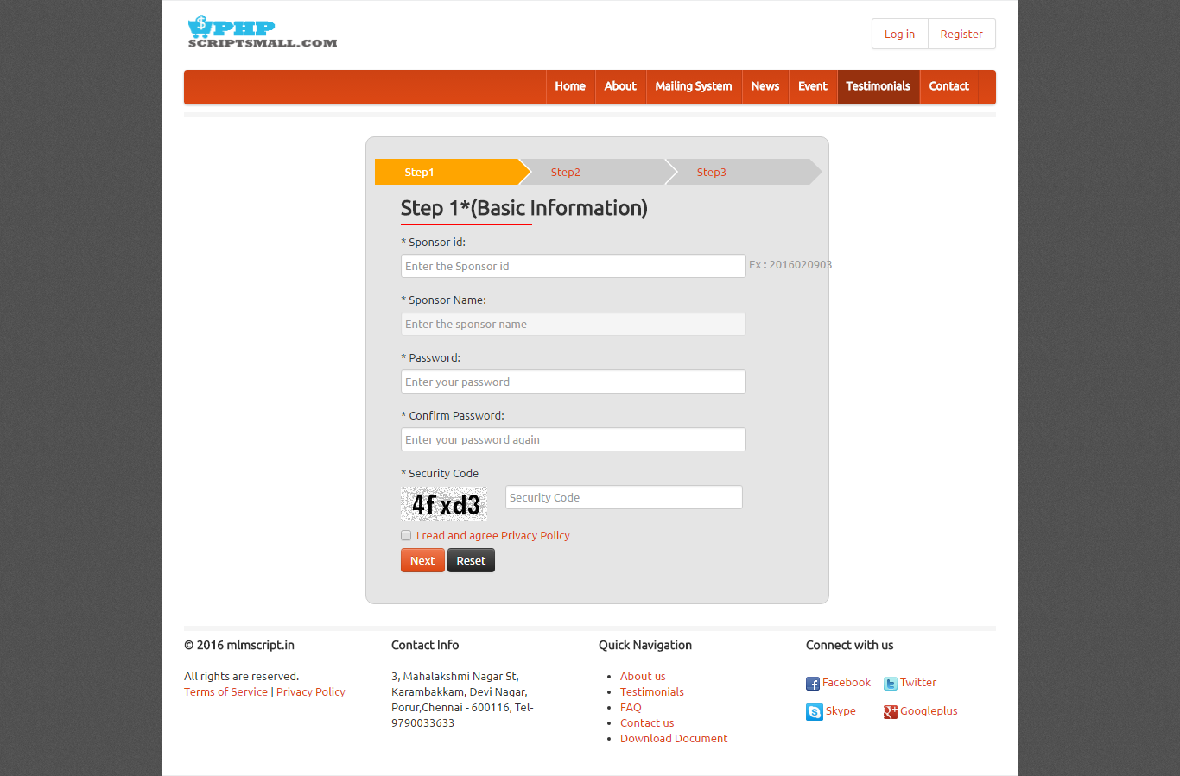
Description:
User complete first step by giving basic information ENTER THEIR SPONSOR ID

Step 2:
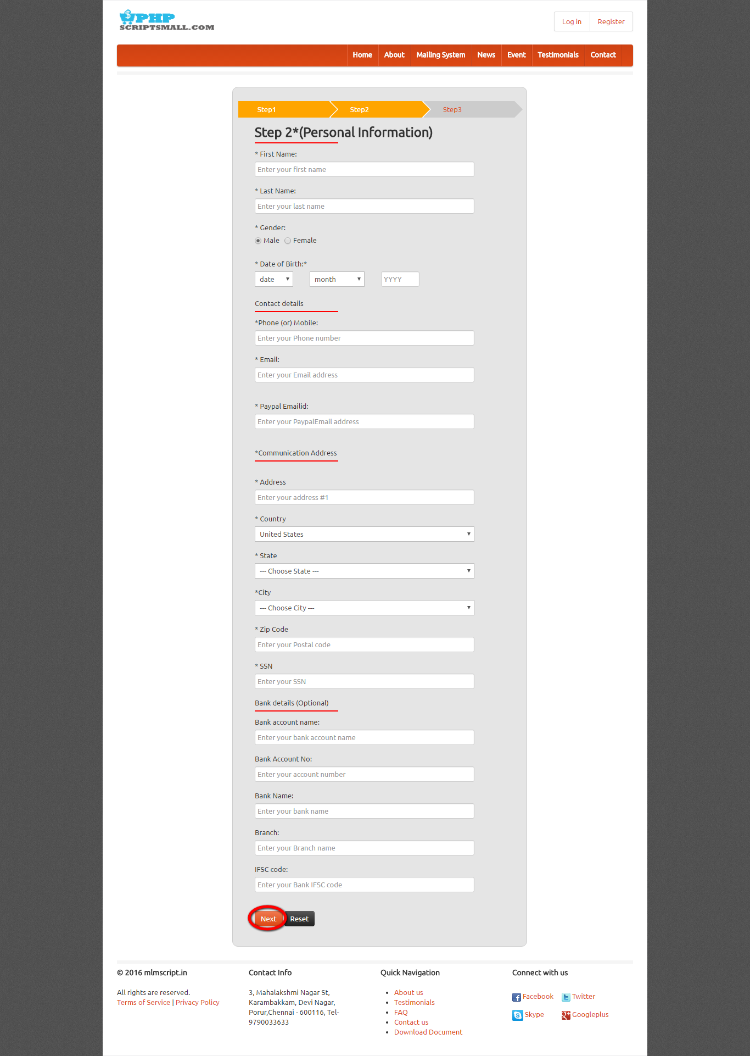
Description:
User completes the personal information as second step of registration. ENTER THEIR PERSONAL DETAILS

Registration:
Step 3:
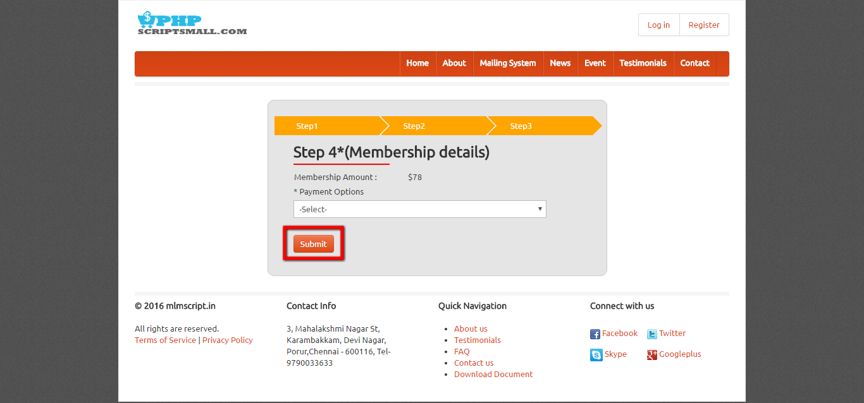
Description:
User has payment option before submitting for registration by selecting the membership plan details.

Login:
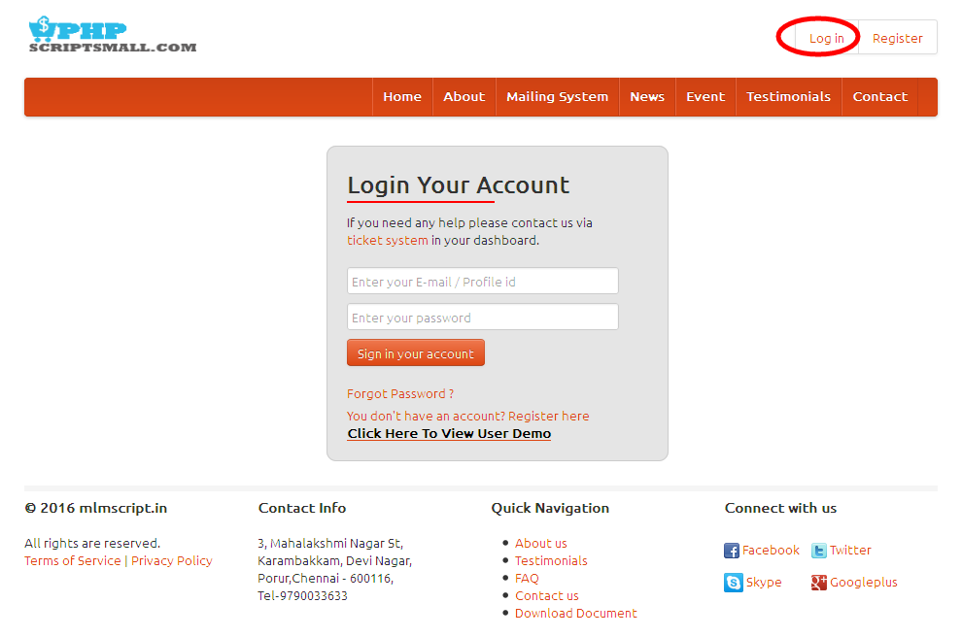
Description:
User can login via valid username and password.

My profile:
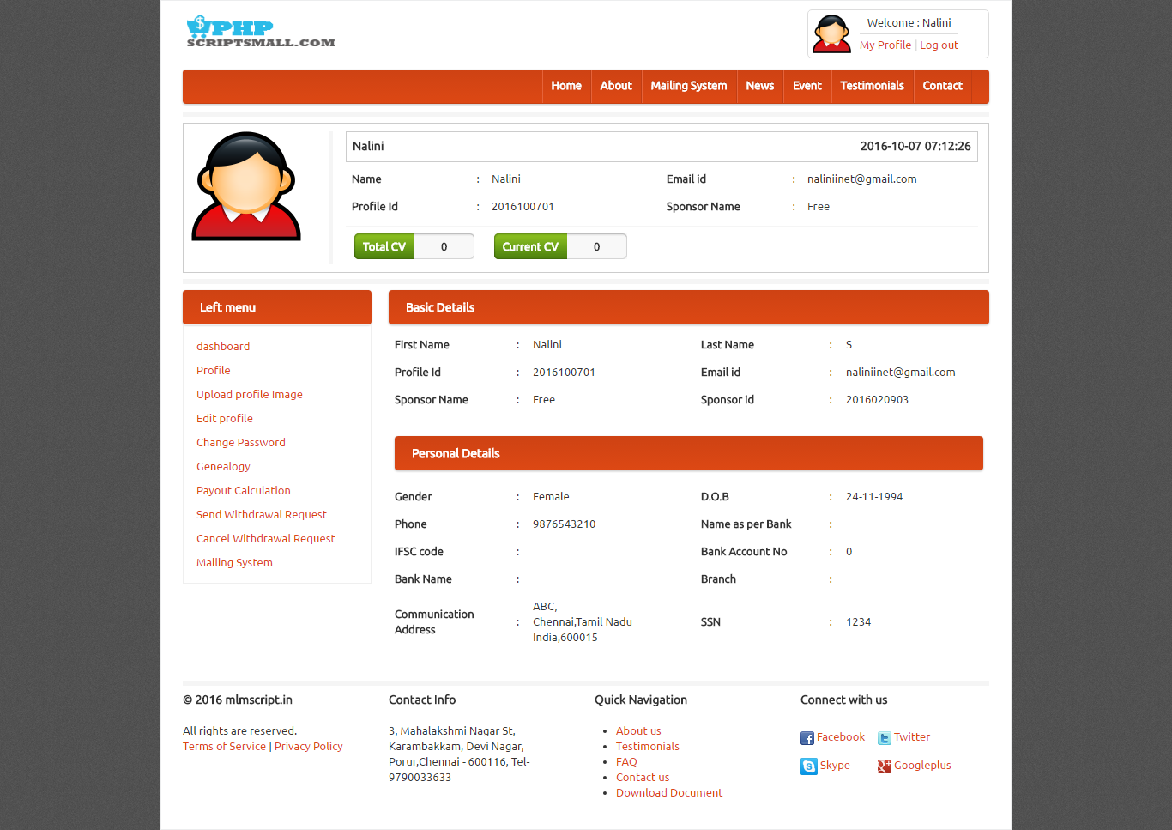
Description:
User can view their profile details with personal and basic details.

Upload profile image:
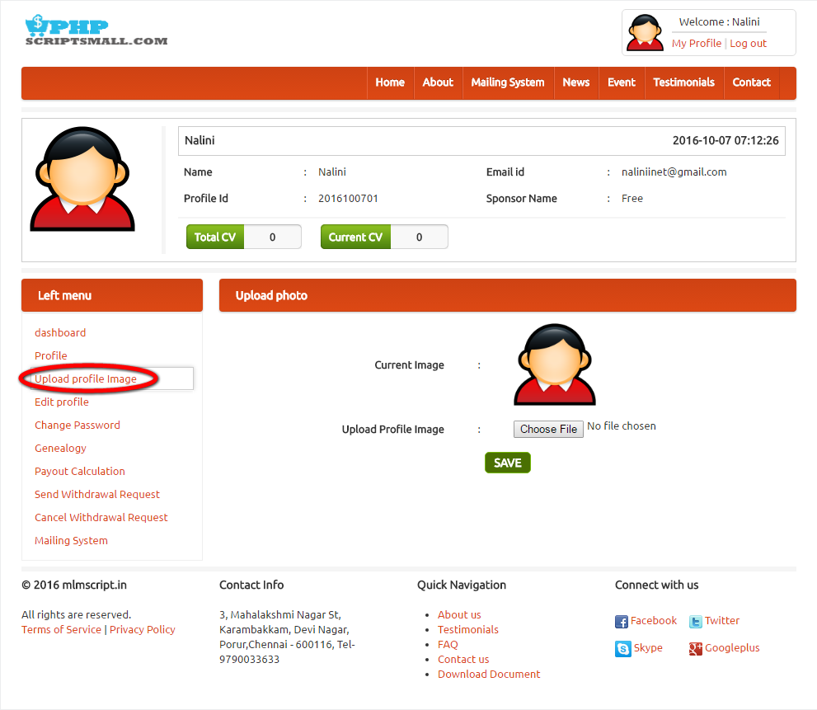
Description:
This page used to change the profile image to the profile.

Edit profile:
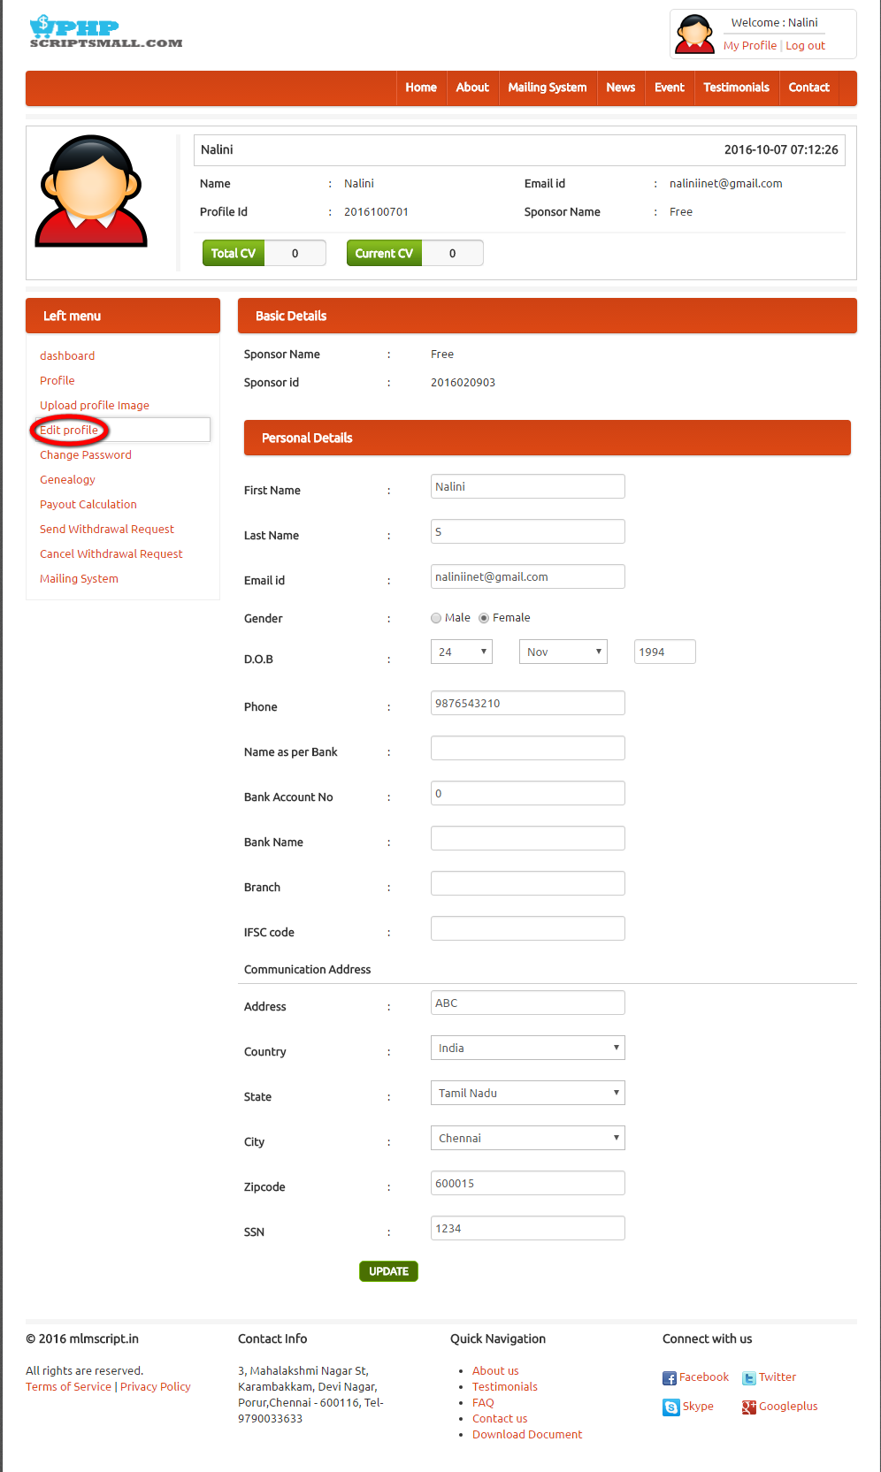

Description:
This page contains the edit option.

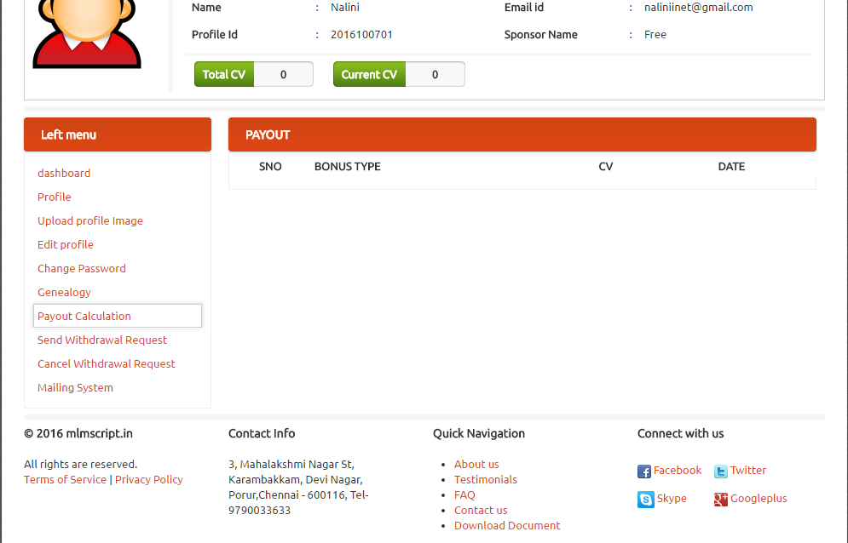
Description:
This page contains payout calculation details.

Send withdrawal details:
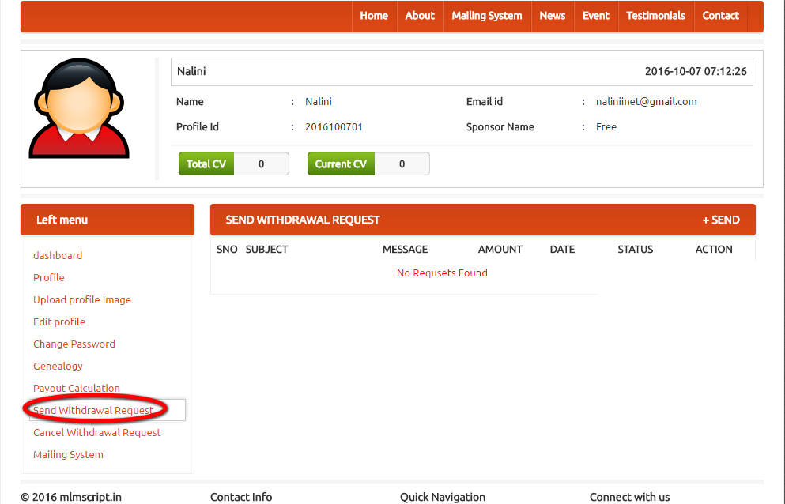
Description:
This page contains send withdrawal request pop up details.

Cancel withdrawal request:

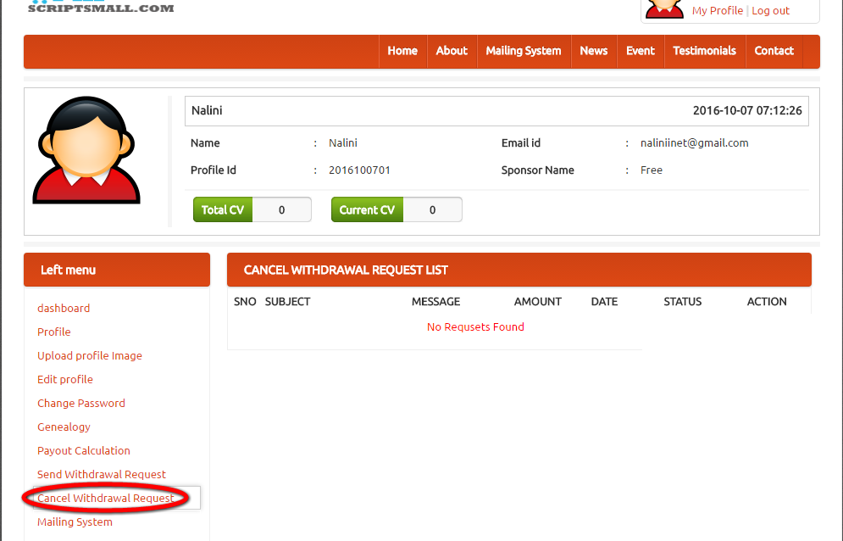
Description:
This page contains option of cancel withdrawal request detail.

Mailing system:
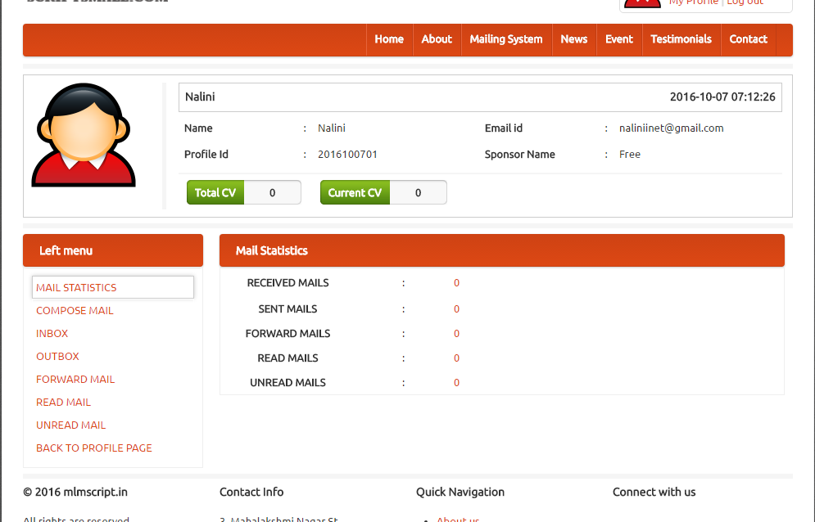
Description:
This page manages the mailing details.

Home page:
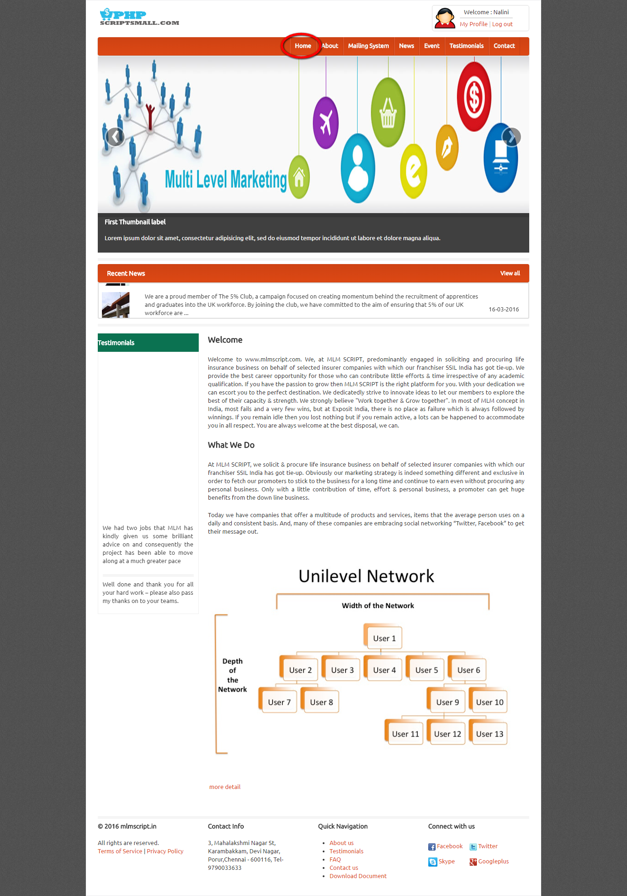
Description:
Home page has recent news, testimonial and what we do details.

About:
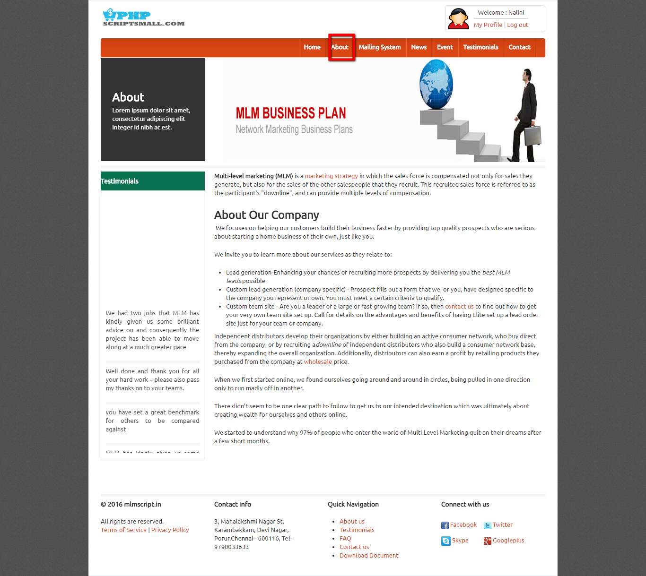
Description:
About page consists of entire details about the company

Mailing System:
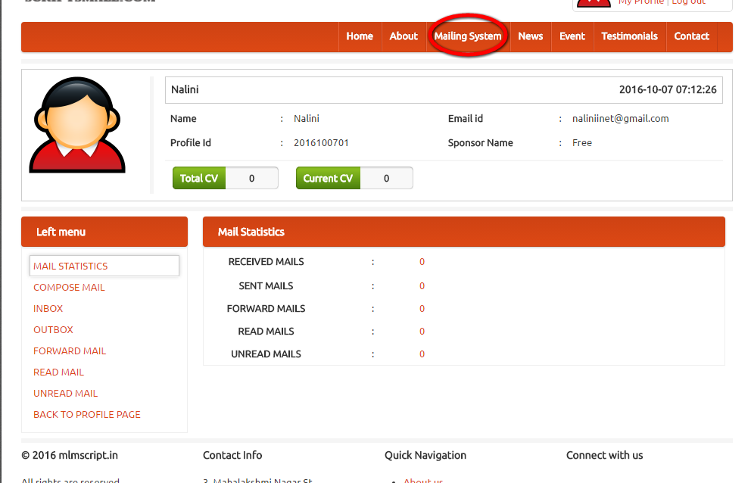
Description:
This page manages the mailing details.

News:
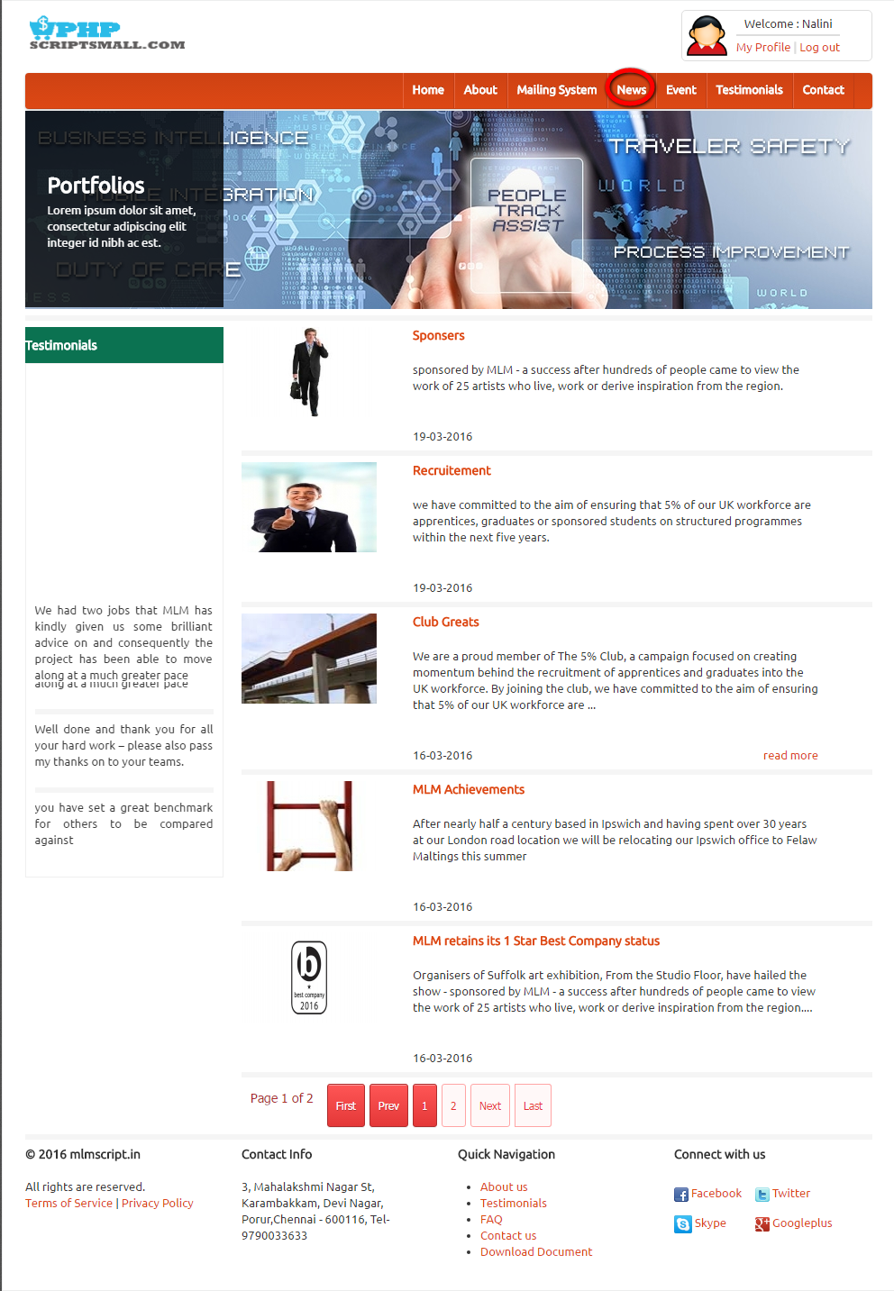
Description:
This page contains recent contact details.
Event:
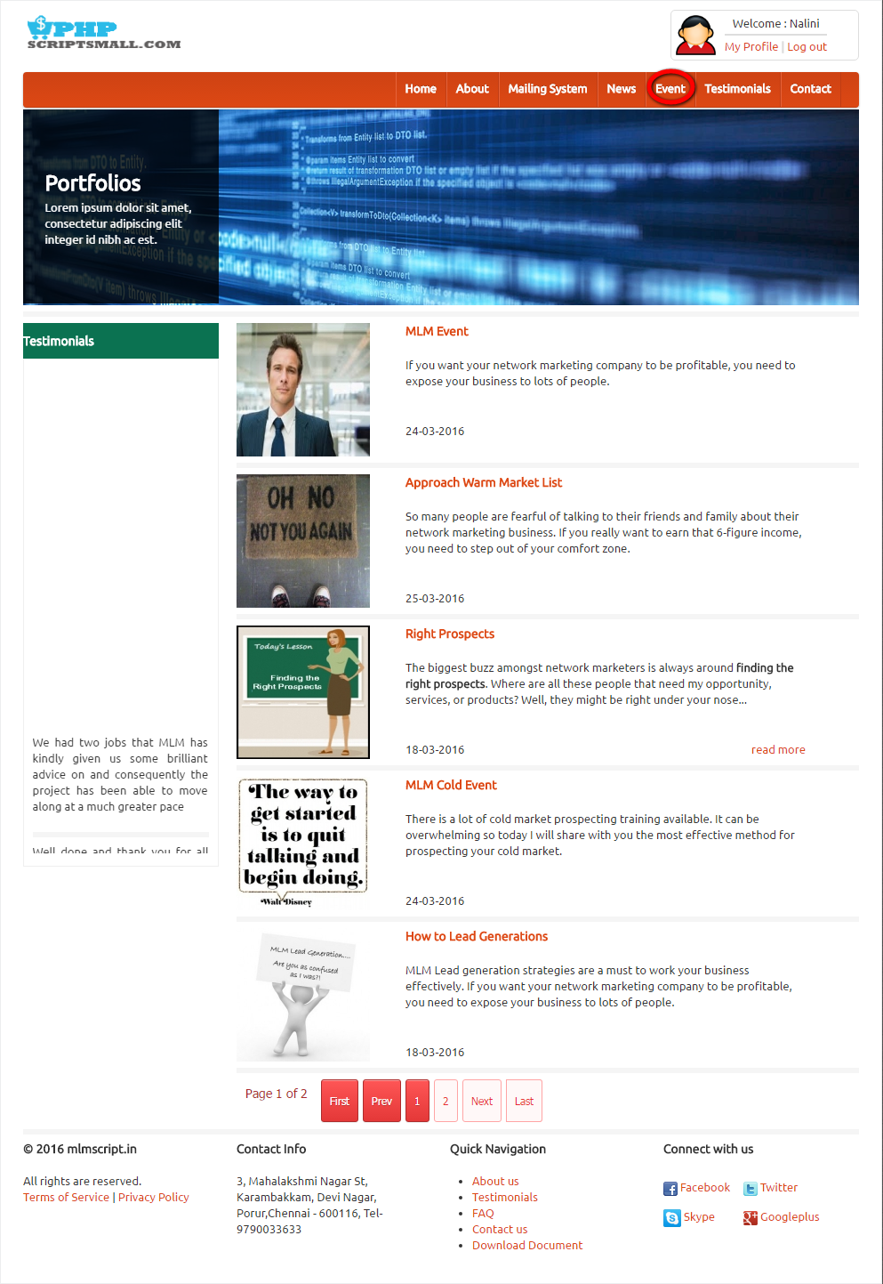
Description:
This page contains events detail.

Testimonial:
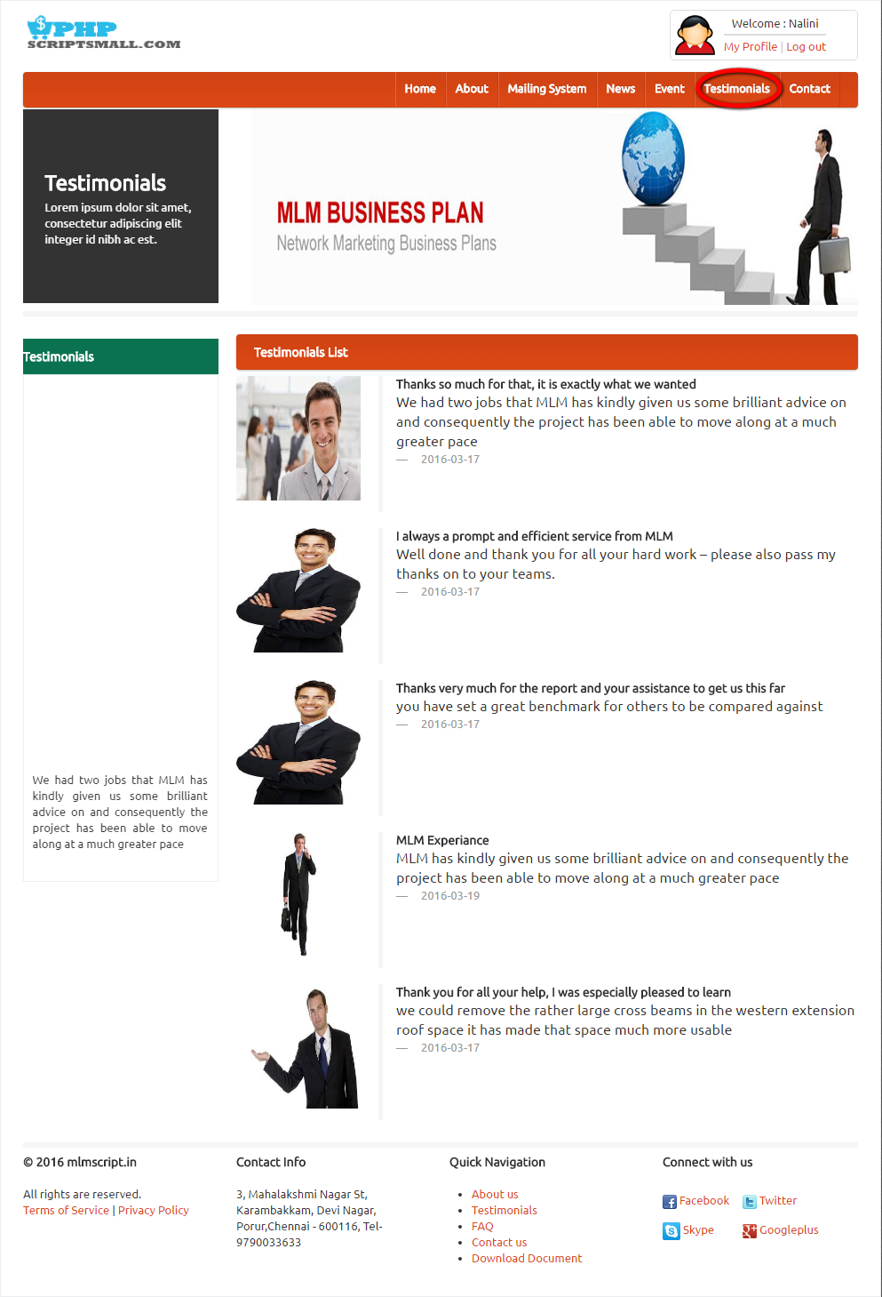
Description:
This page consists of testimonial details.
Contact:
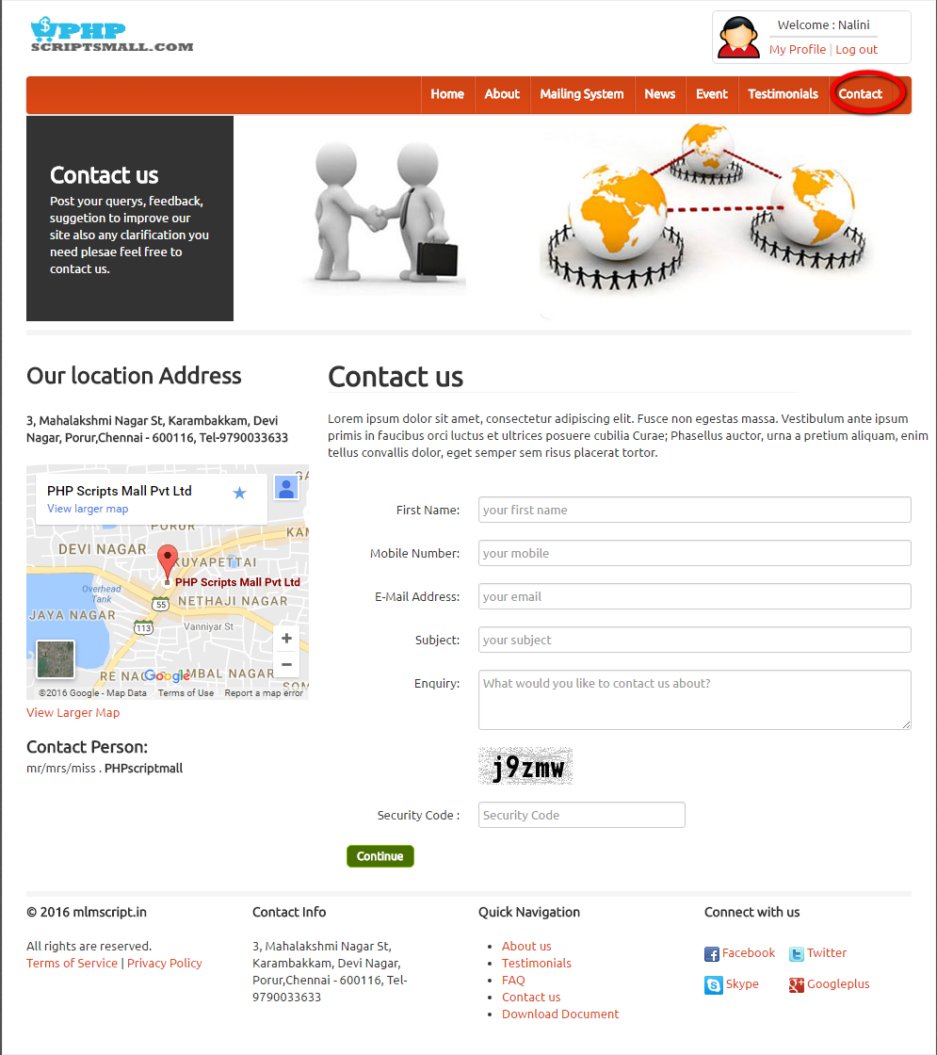
Description:
This page has enquiry details.

ADMIN VIEW
Admin-login:
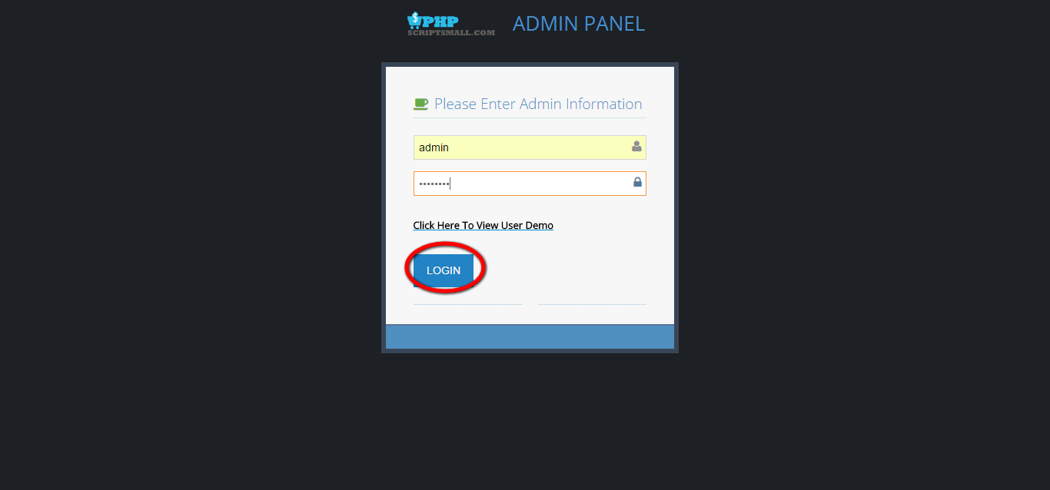
Description:
You can login via valid username and password.
Dashboard:
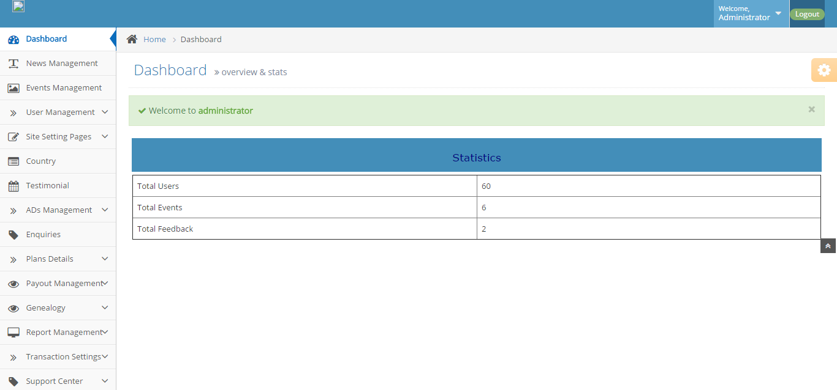
Description:
This page consists of statistic details about users, events and feedback.
News management:
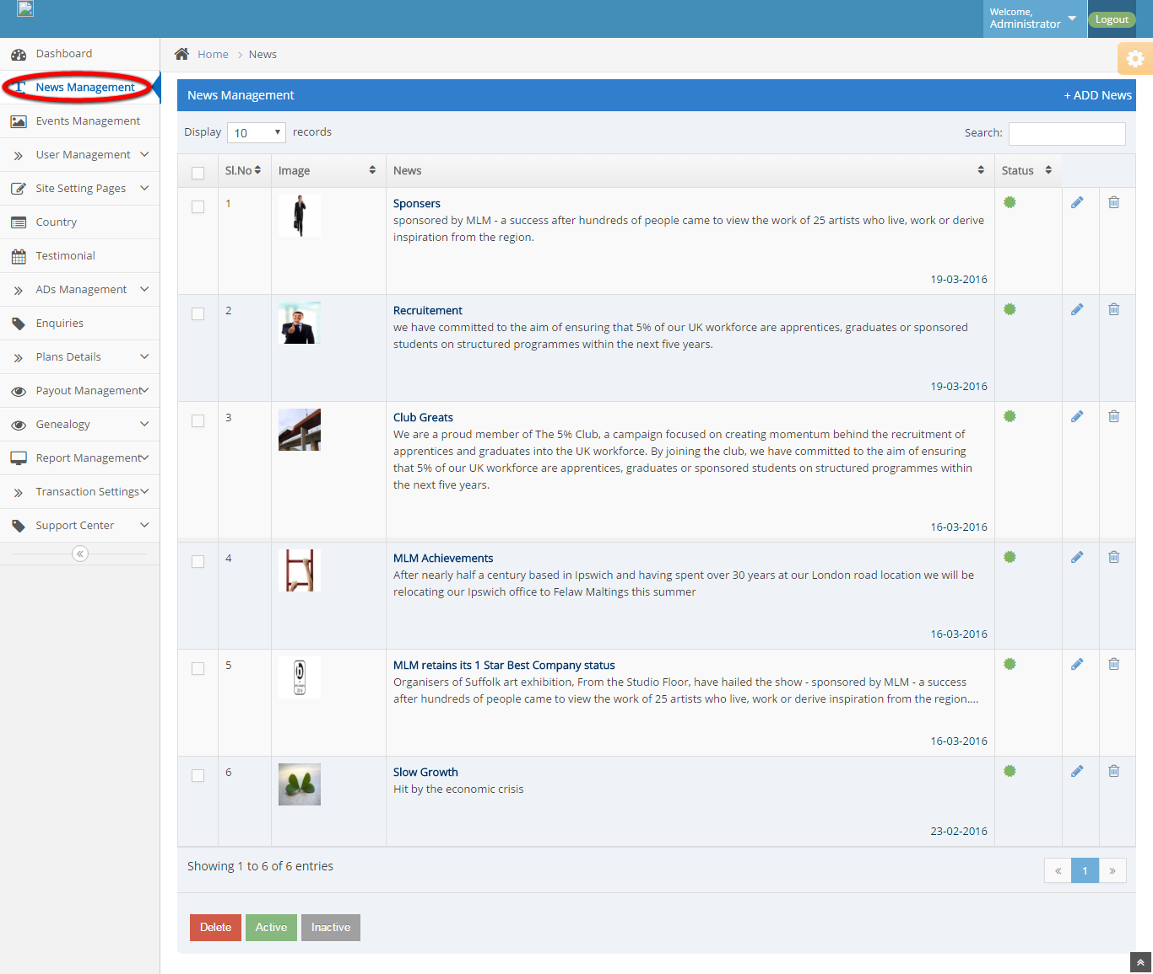
Description:
This page consists of relevant news details.

Events management:
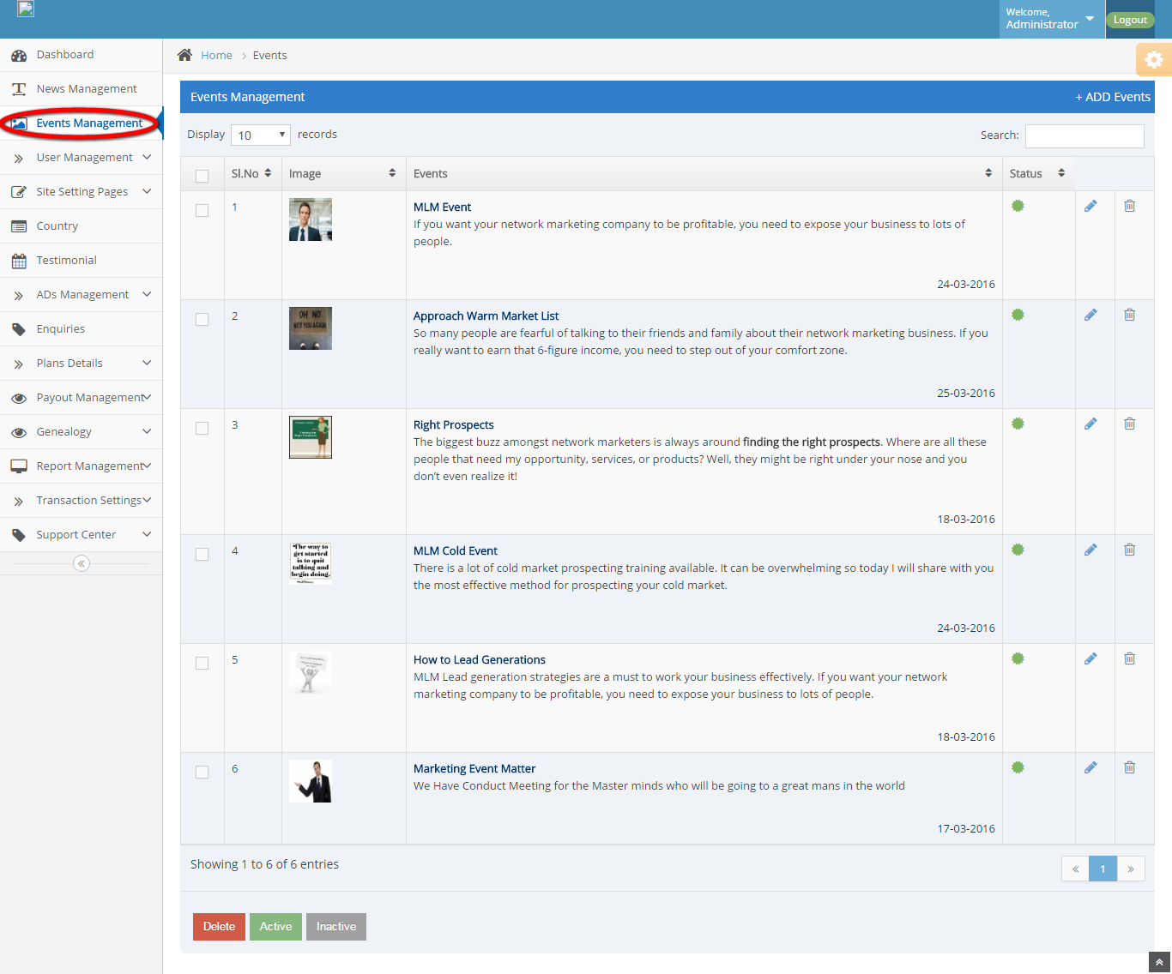
Description:
This page has events detail.

Members list:
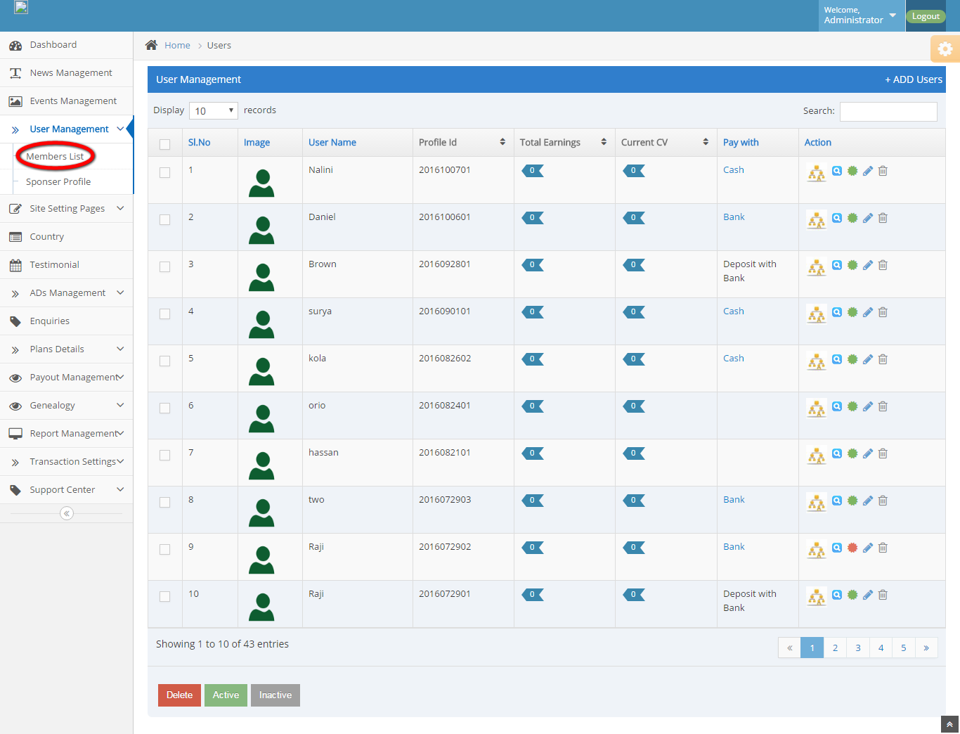
Description:
This page contains member’s detail.

Sponsor profile:
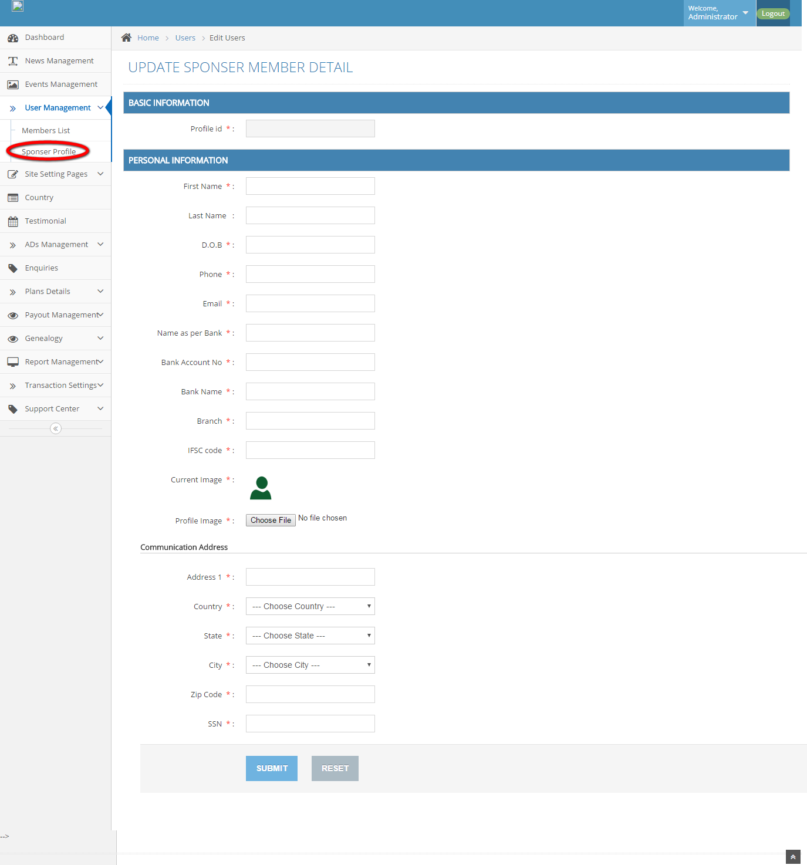
Description:
This page serves to add new sponsor detail.

CMS:
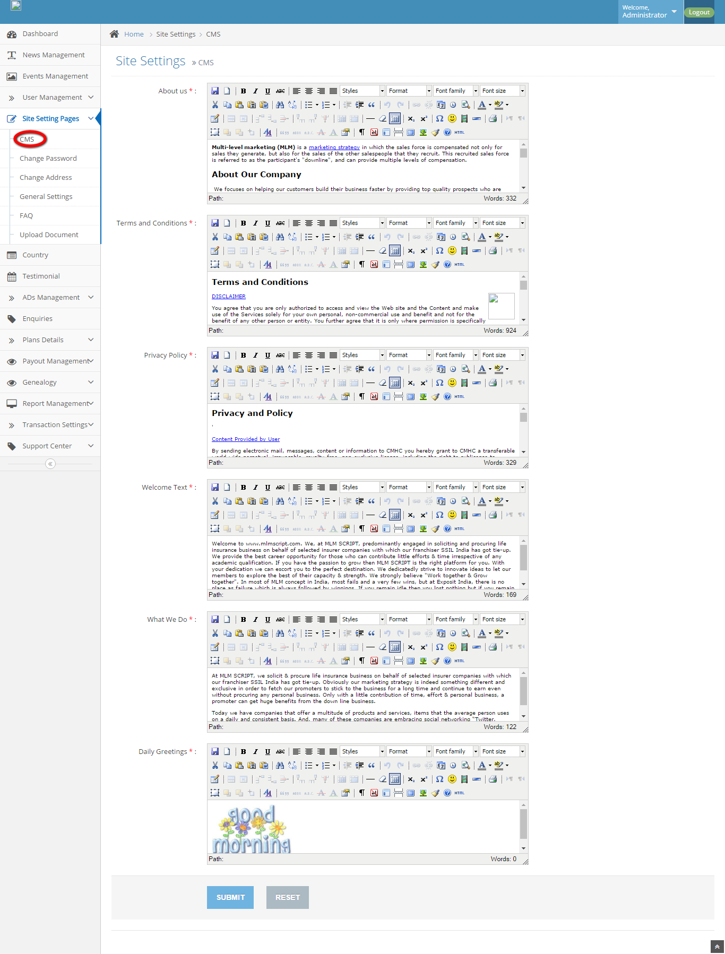
Description:
This page manages the CMS contents.
Change password:
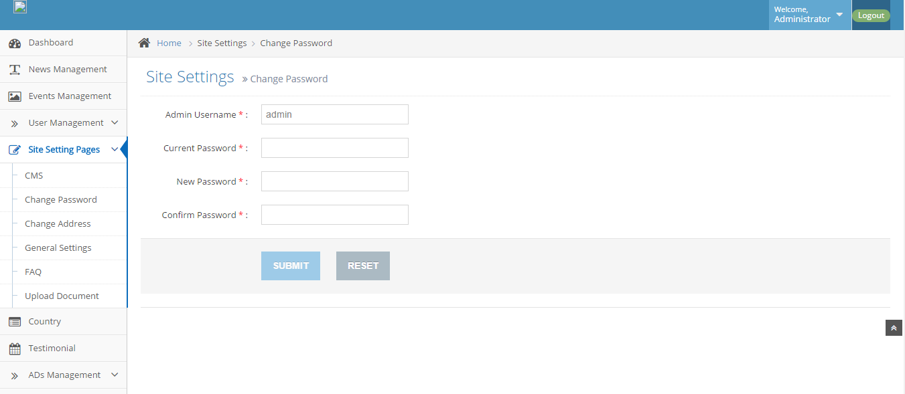
Description:
This page manages to vary the password.
Change address:
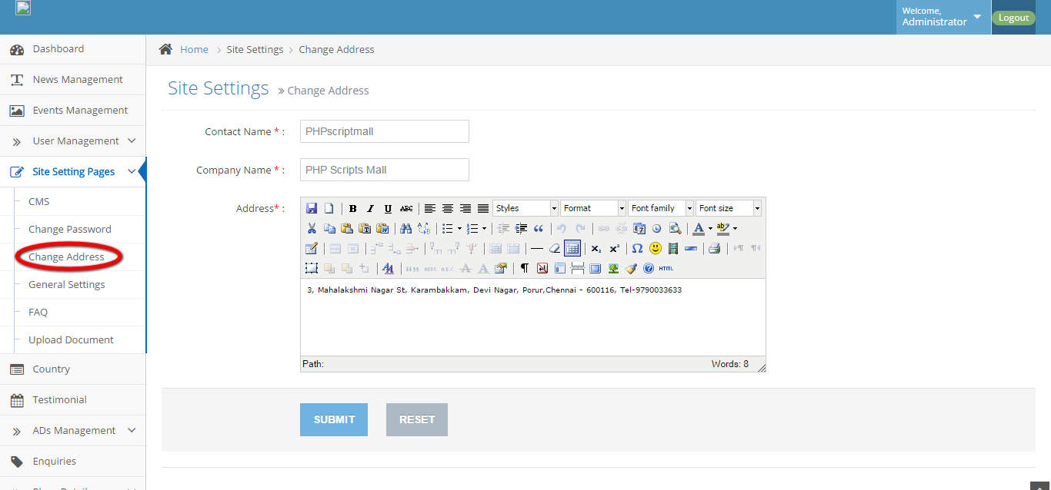
Description:
This page serves as change the company address on footer.
General settings:
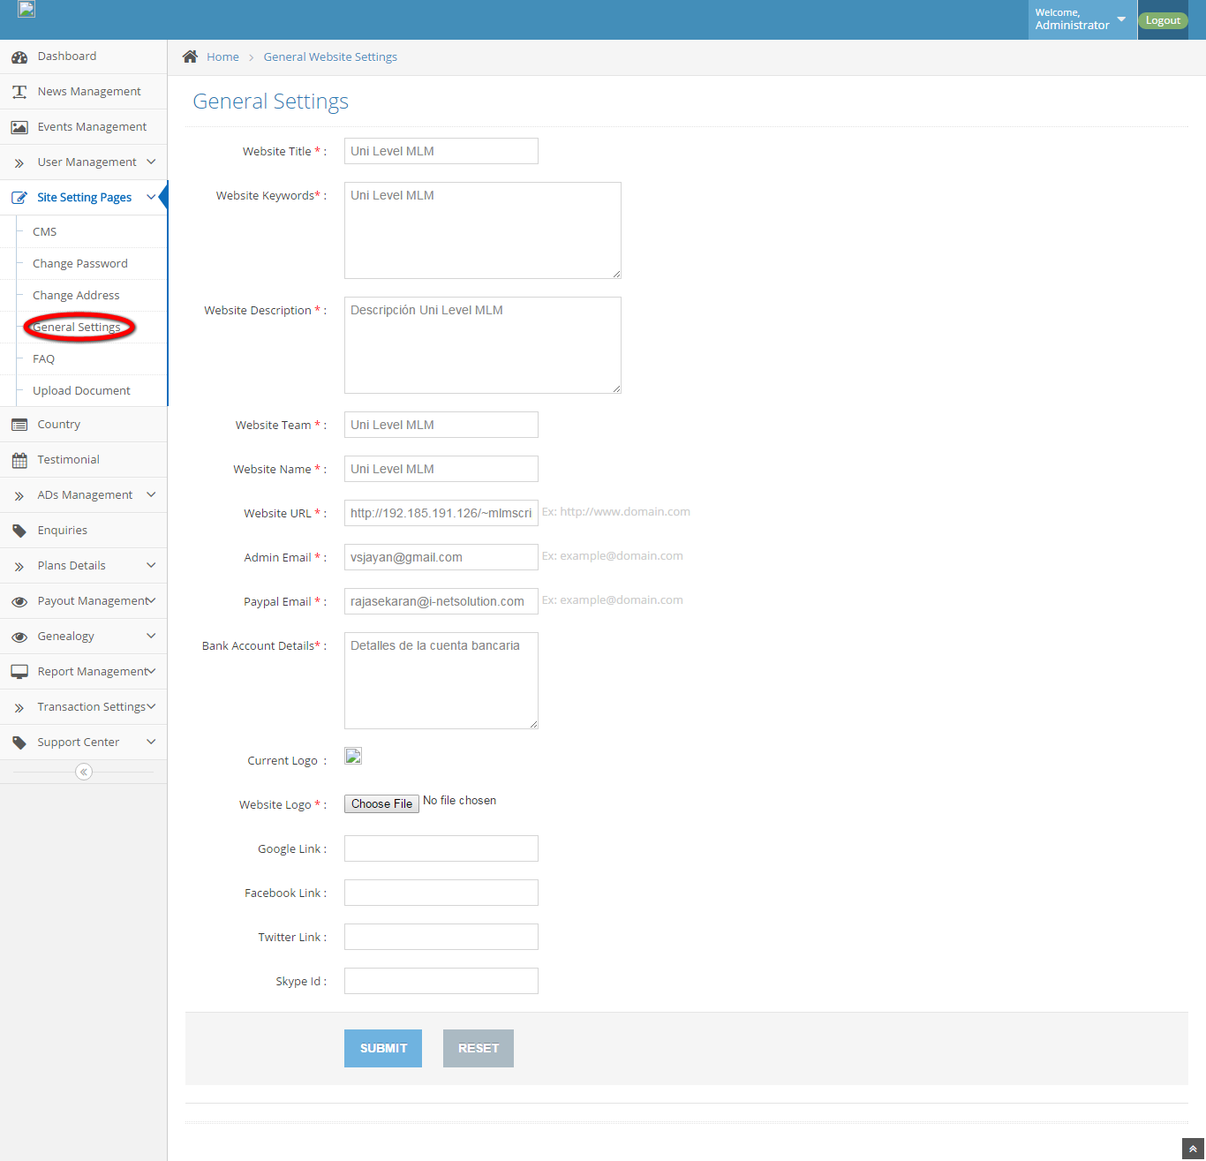
Description:
This page uses to maintain the general settings.

FAQ:
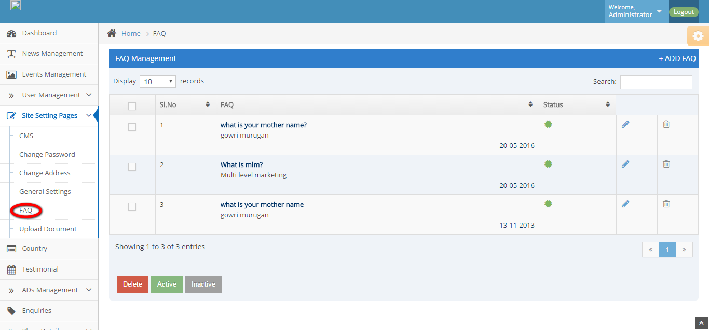
Description:
This page contains FAQ details.
Upload document:
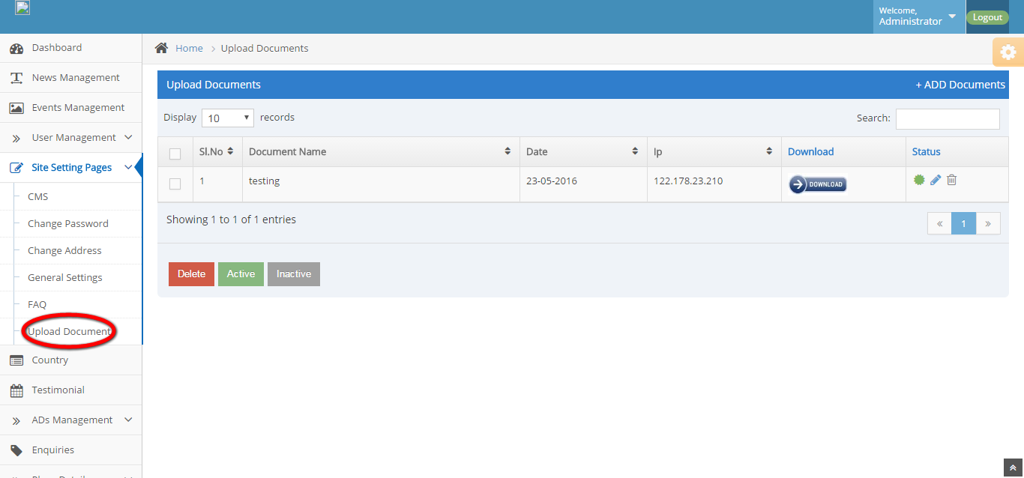
Description:
This page allows to upload any document.

Country:
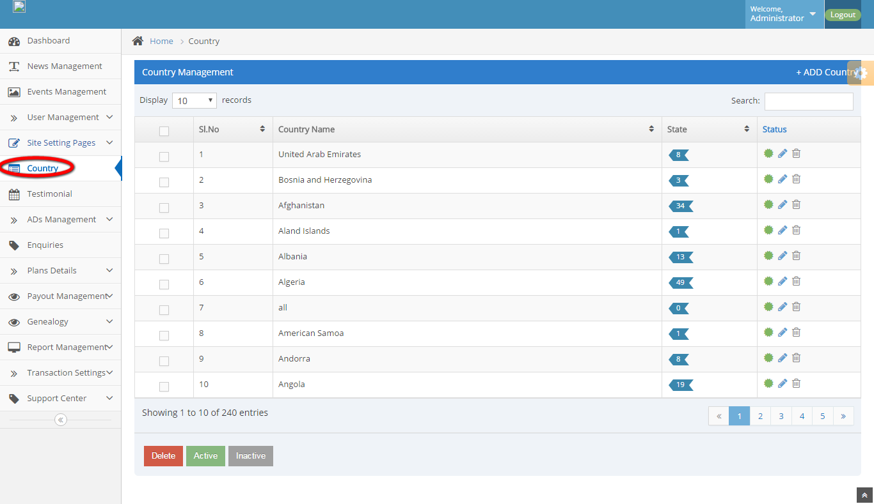
Description:
This page maintains the country and state details.

Testimonial:
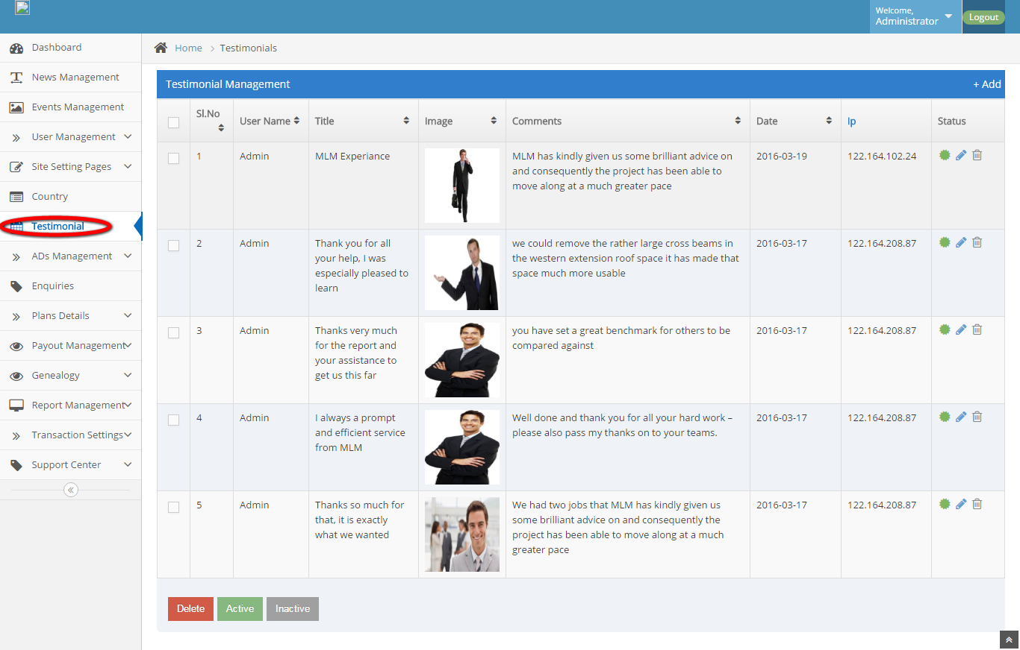
Description:
This page manages the testimonial details.

Banner Ads:
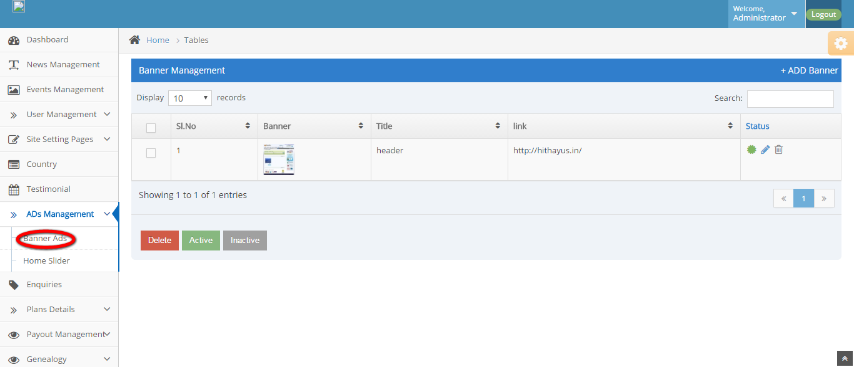

Description:
This page maintains the banner ads and changes the status as active and inactive.

Home slider:
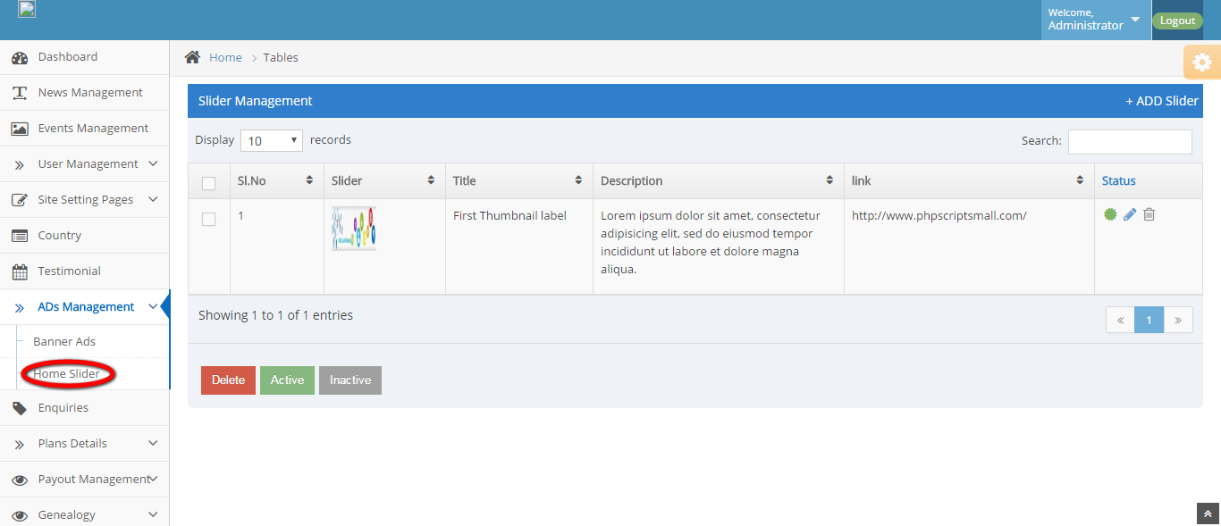
Description:
This page maintains the slider menu.
Enquiry:
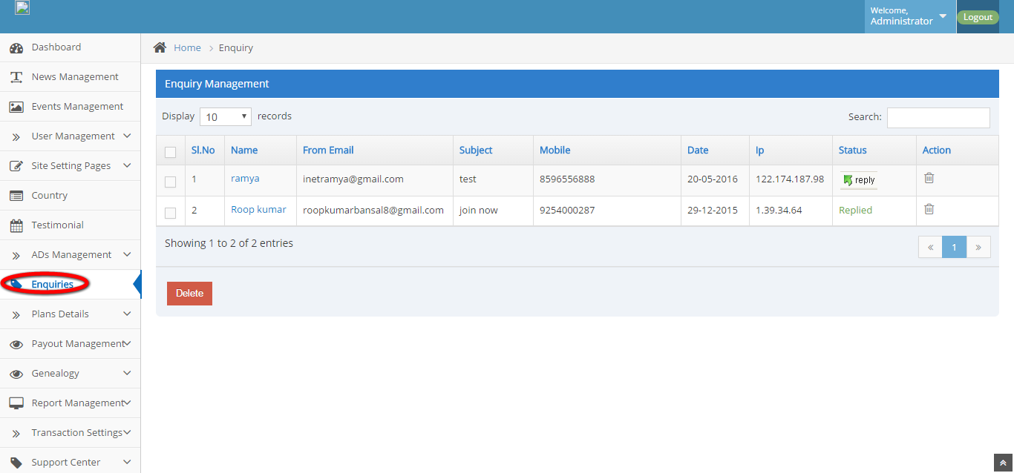

Description:
This page manages the enquiry details.
Membership plan:
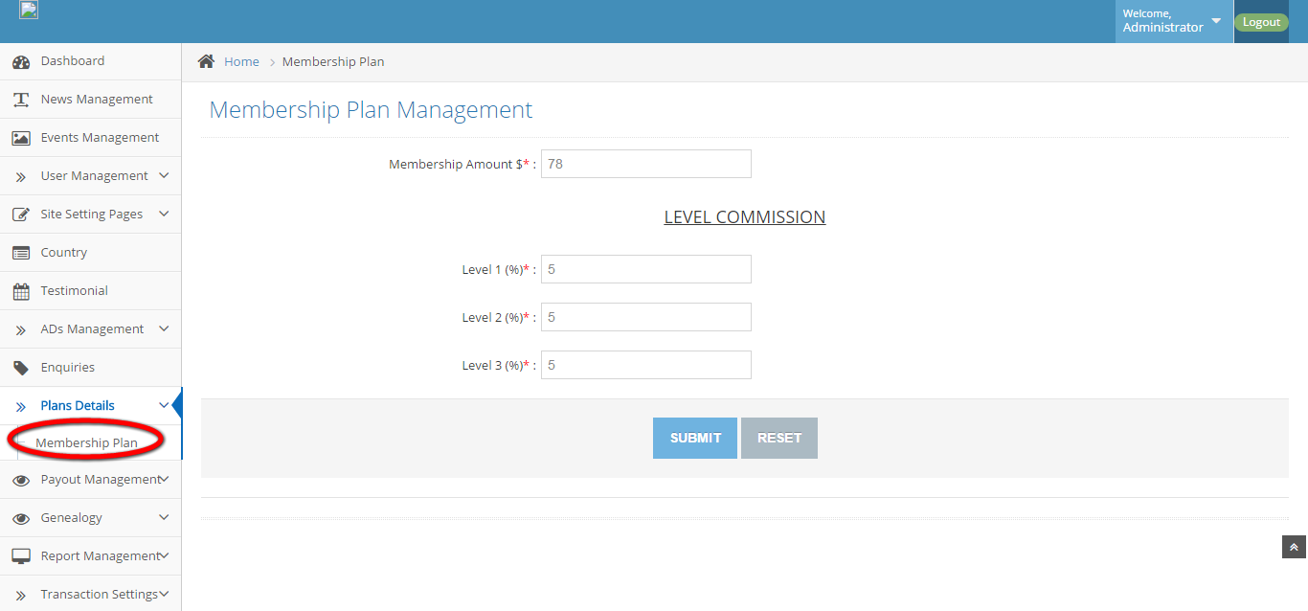
Description:
This page maintains the membership plans.
Commission payout:
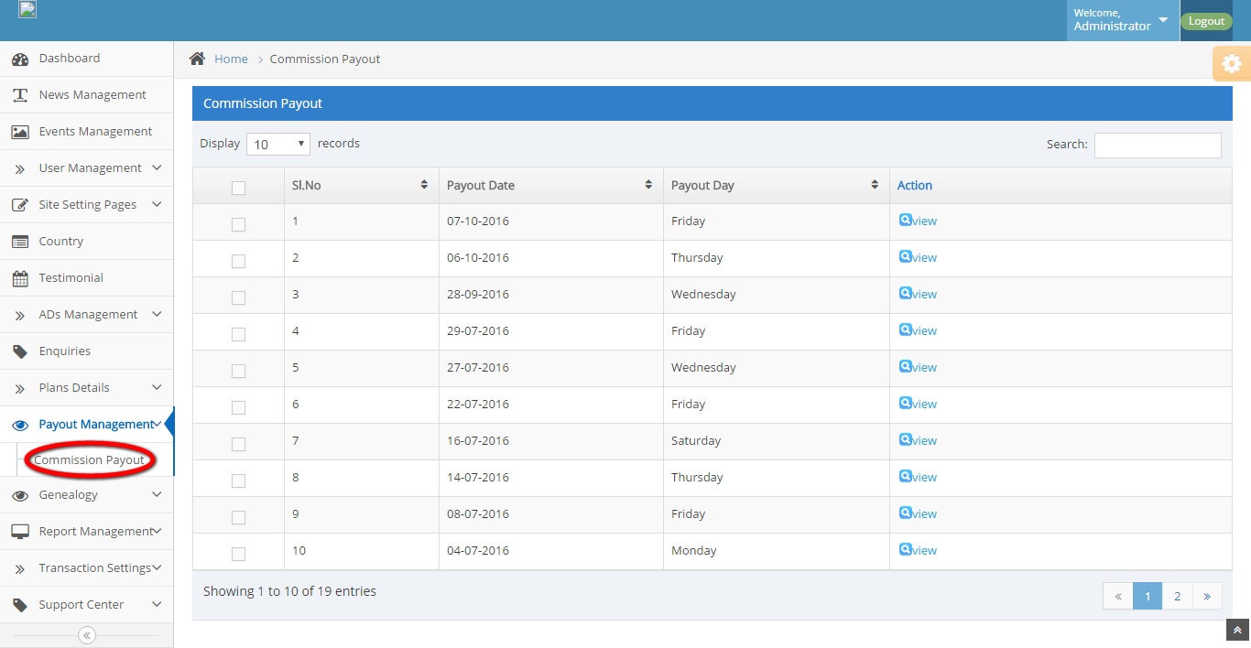
Description:
This page maintains the commission payout details.
Sunflower tree view:
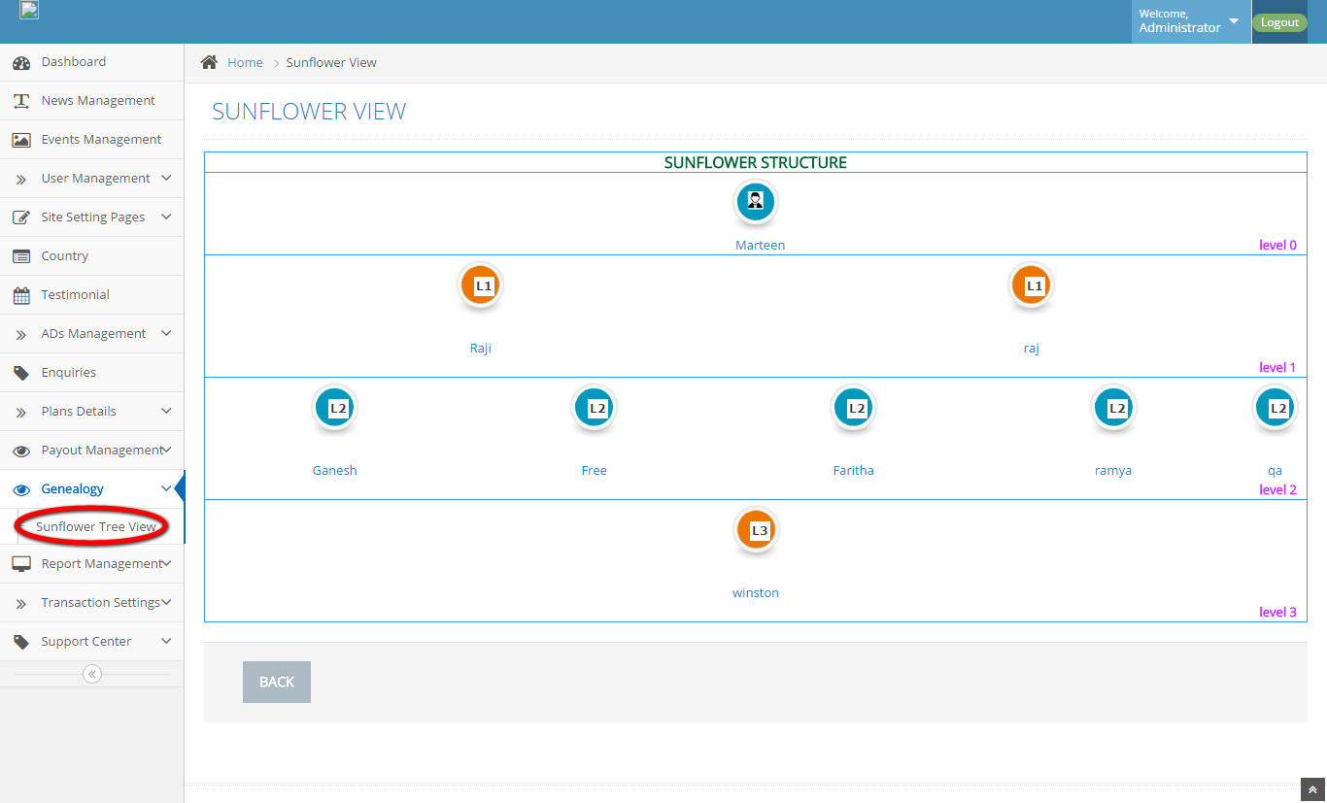
Description:
This page maintains the entire user details.

Active members:
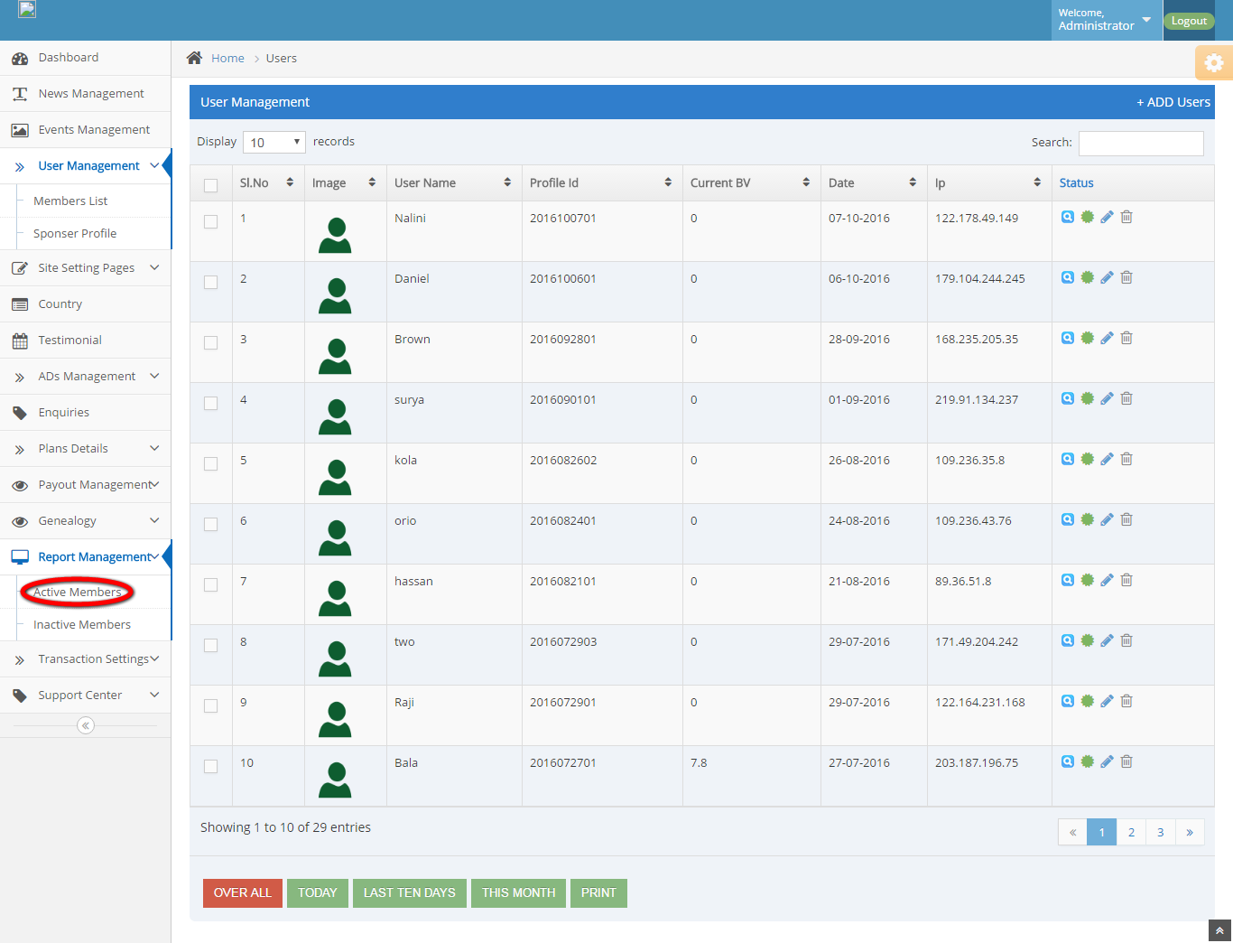
Description:
This page manages the active members details.

Inactive members:
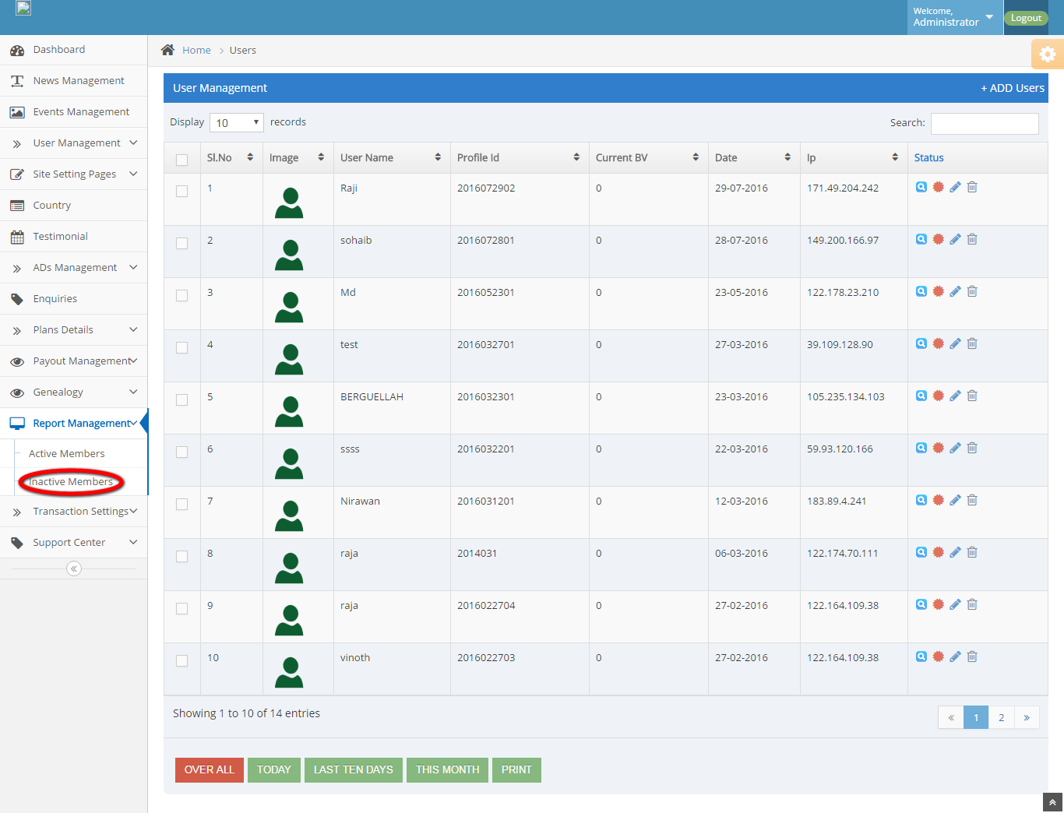
Description:
This page manages the inactive members’ detail.

User withdraw request:
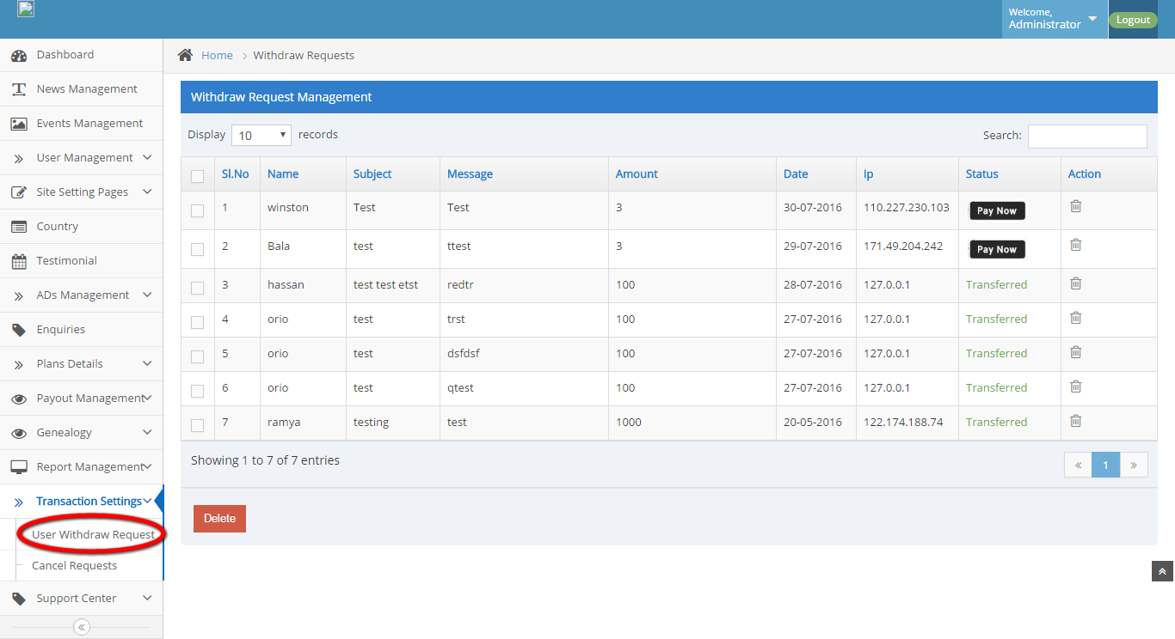
Description:
This page maintains the user withdraw request details.

Cancel request:
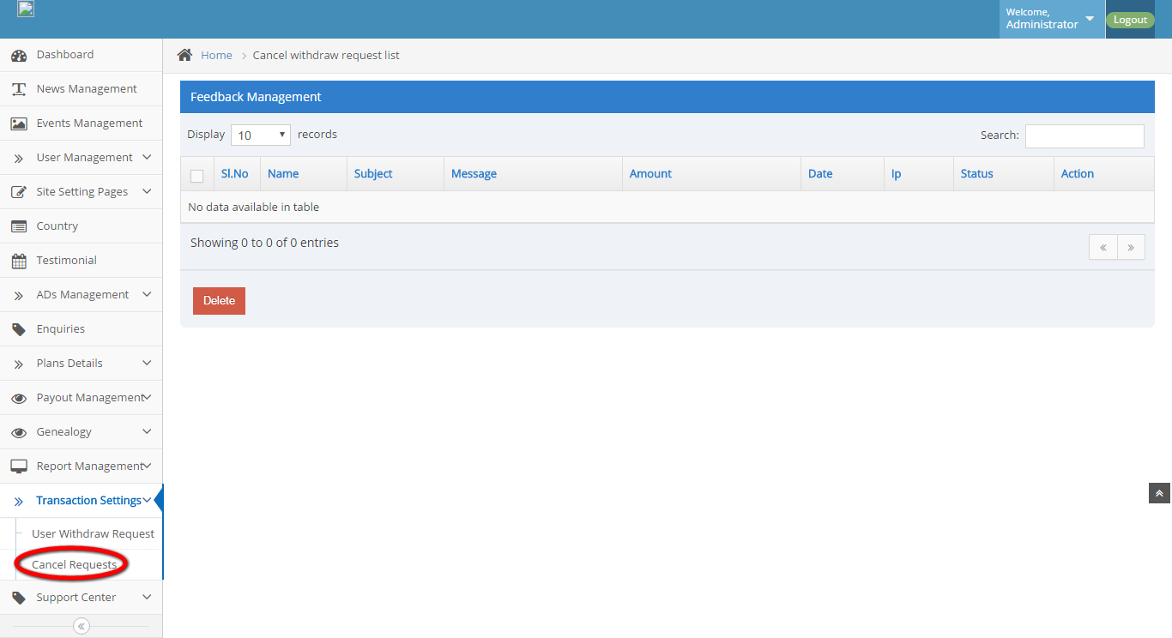
Description:
This page manages the cancel requests details.

Support center:
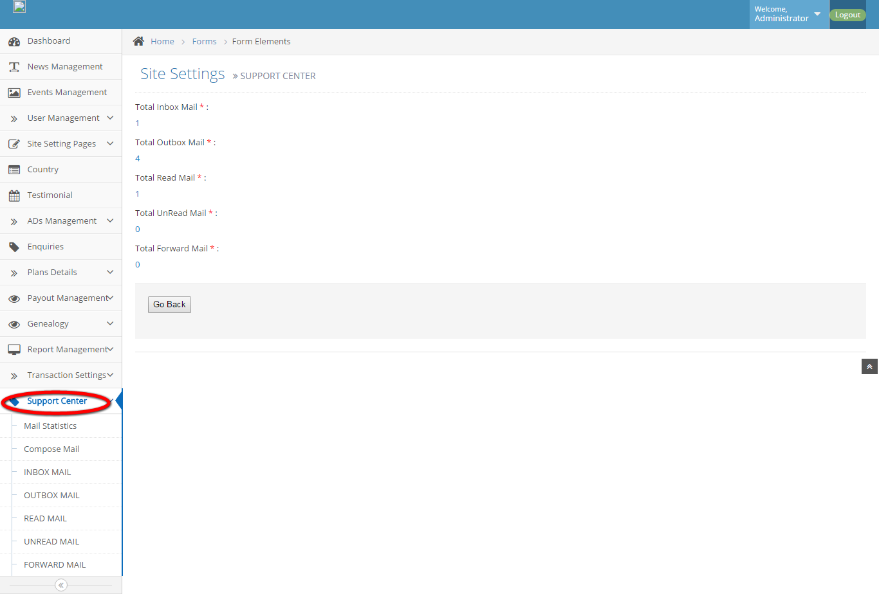
Description:
This page maintains the mailbox details.

