Responsive matrimony script
User view
Register:
Step 1:
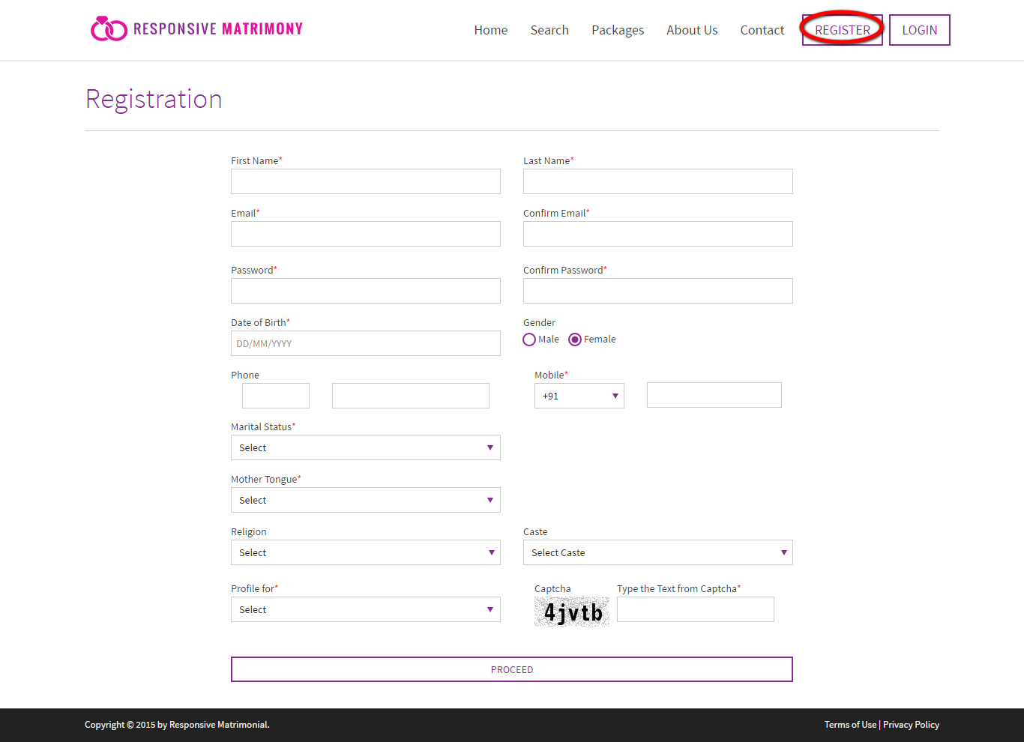
Description:
This page serves to proceed a first step of registration by filling the required fields.

Register
Step 2:
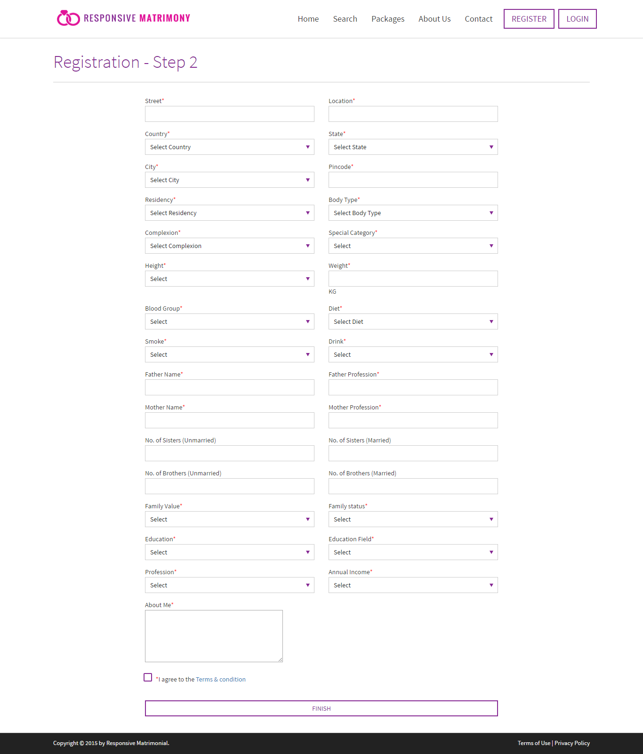
Description:
This page served to enter the required communication address details with some requirement details and user can agree for the terms and condition before finish the step.

Login:
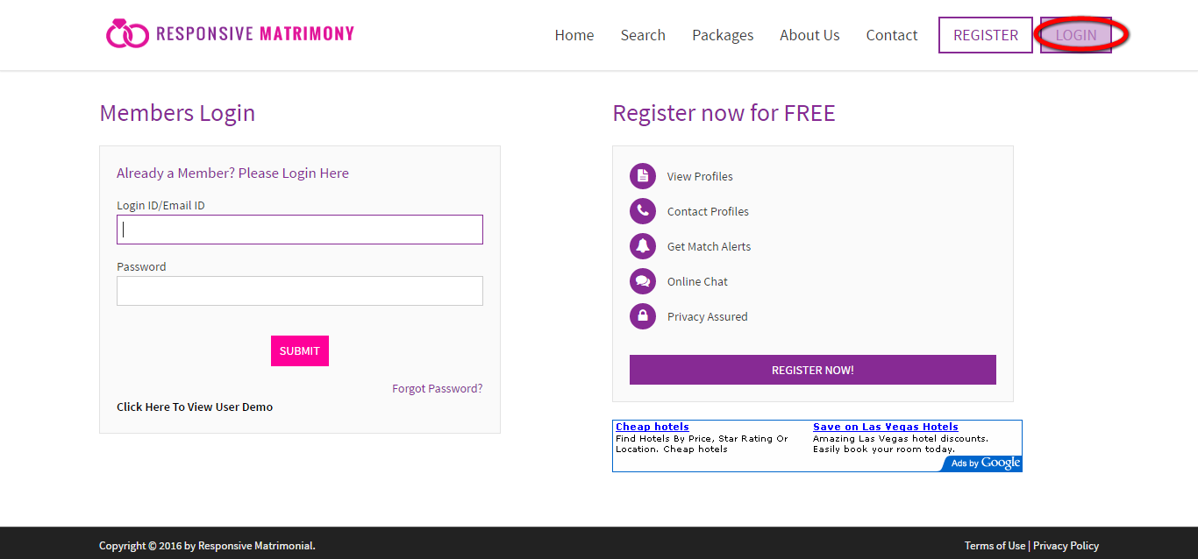
Description:
This page serves to login via valid user name and password.
User has the forget password option in case of recover the account details.

Partner profile:
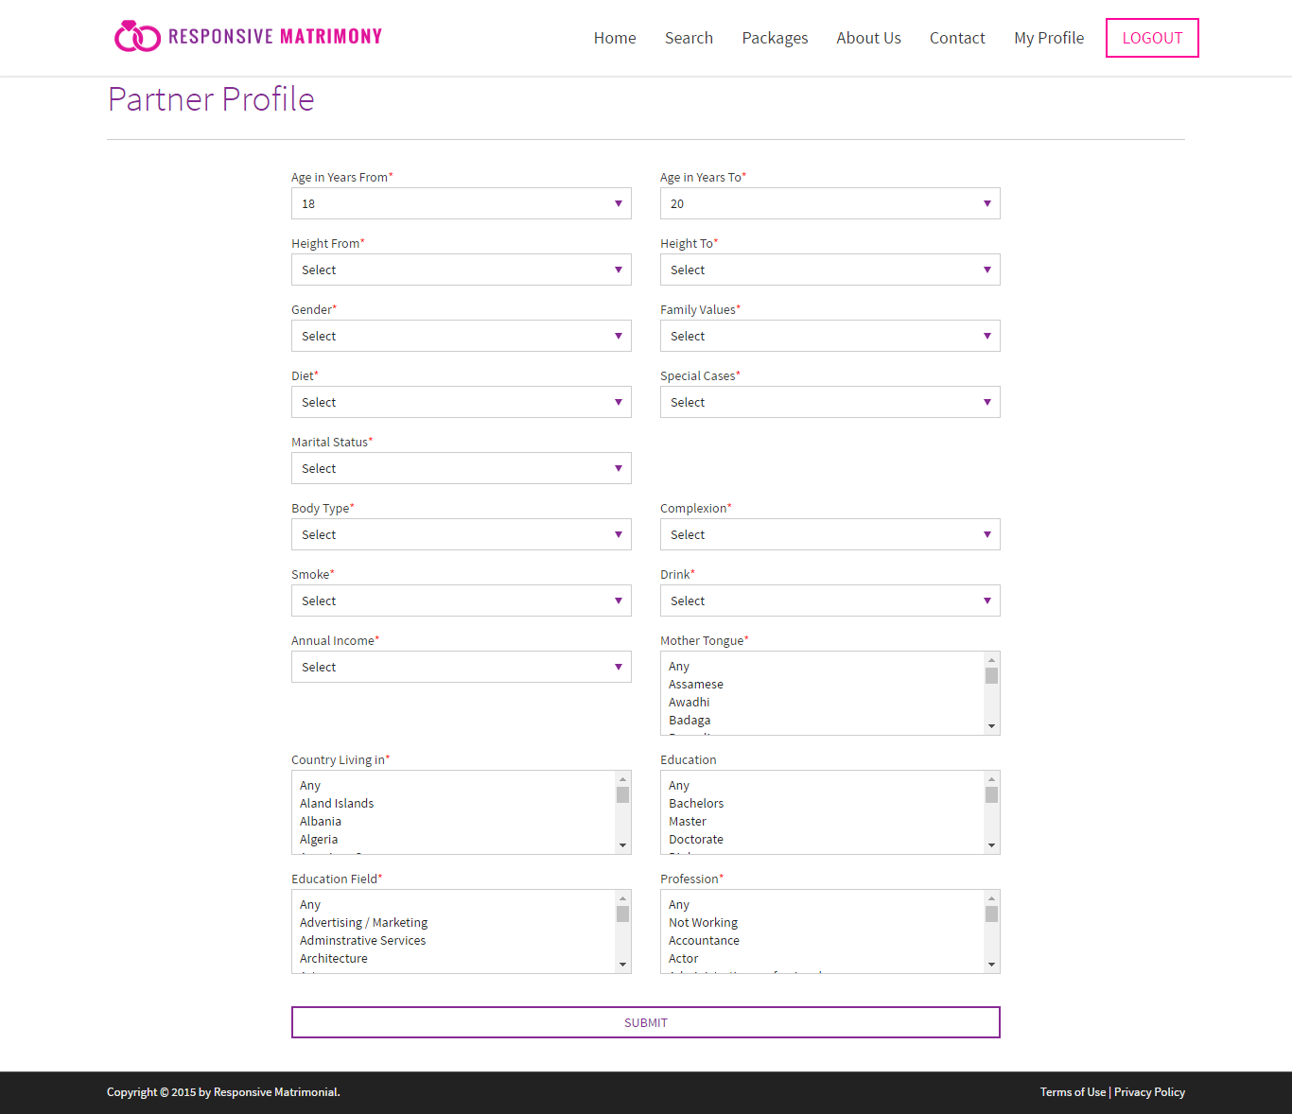
Description:
This page serves to get the entire details about the partner.

My profile:
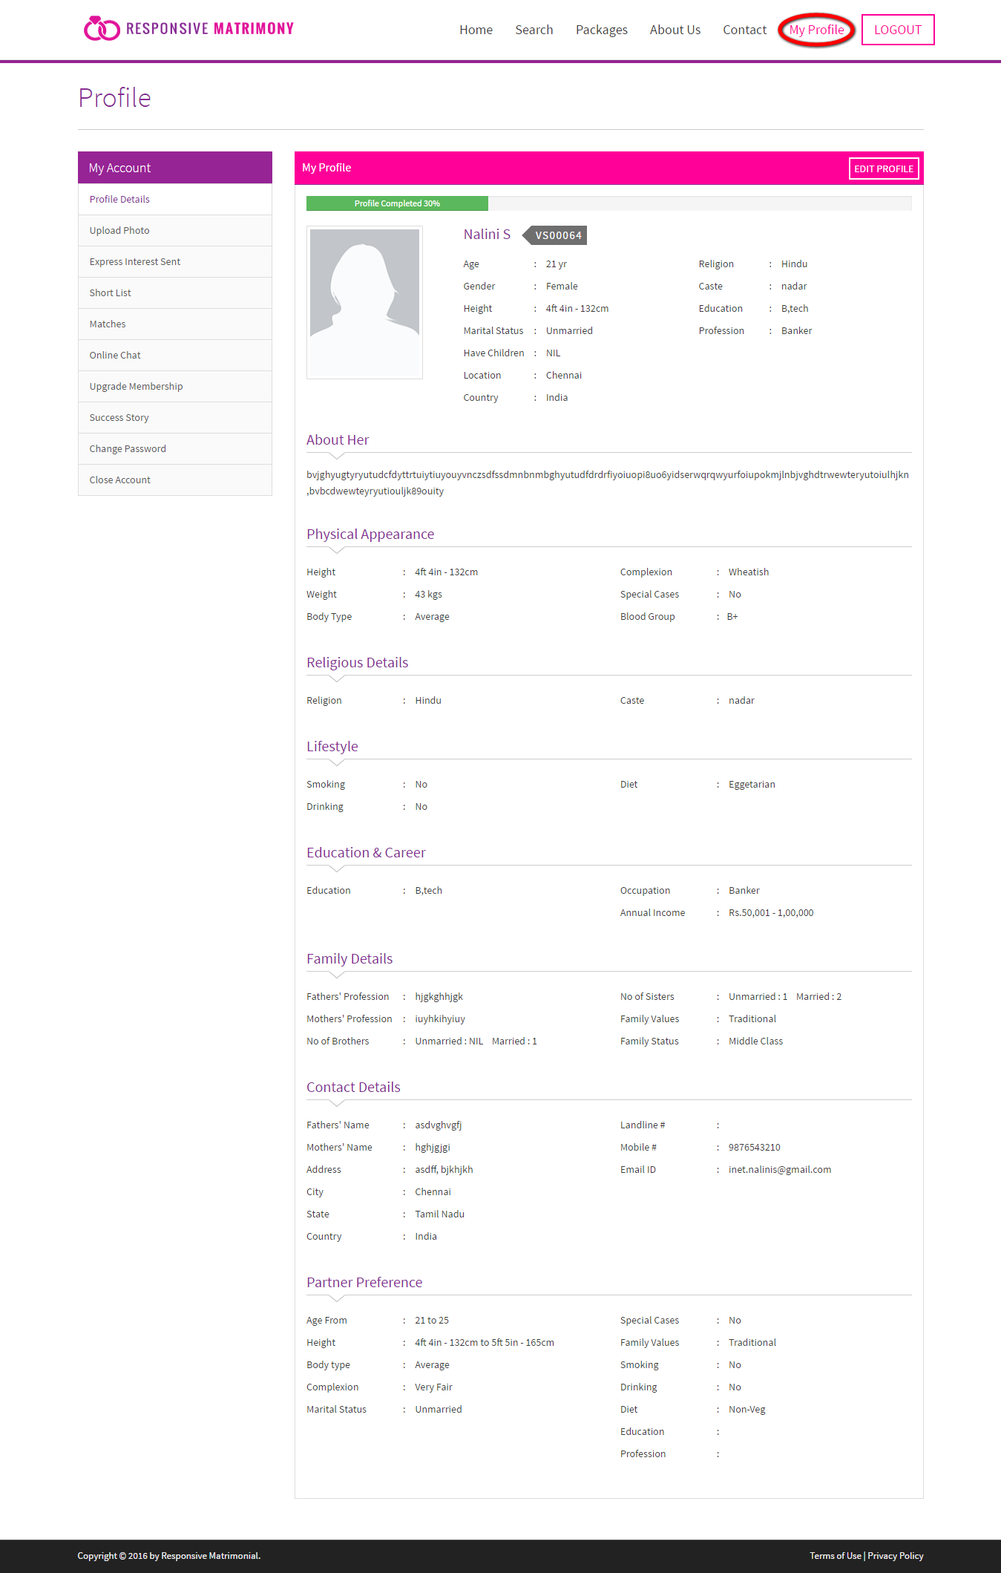
Description:
This page contains the entire profile details with edit option.
Upload picture:
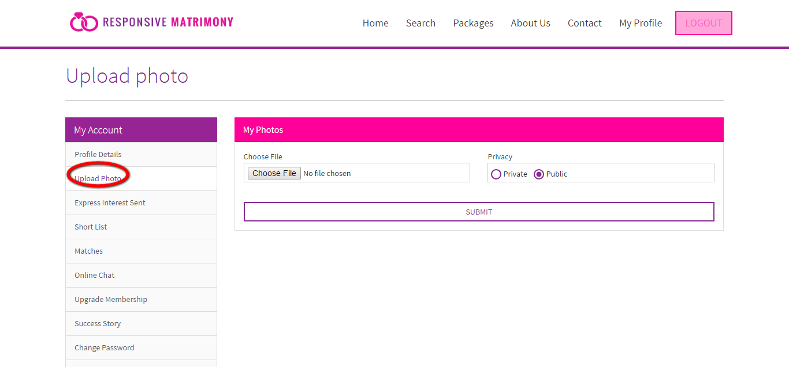
Description:
This page serves to upload a profile picture.

Express interest send:
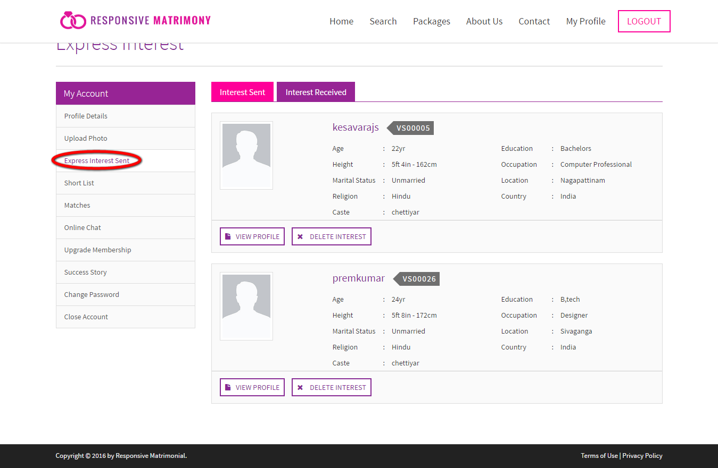
Description:
These page views the interest send details and received details. User can view the interested persons profile via this page.

Short list:
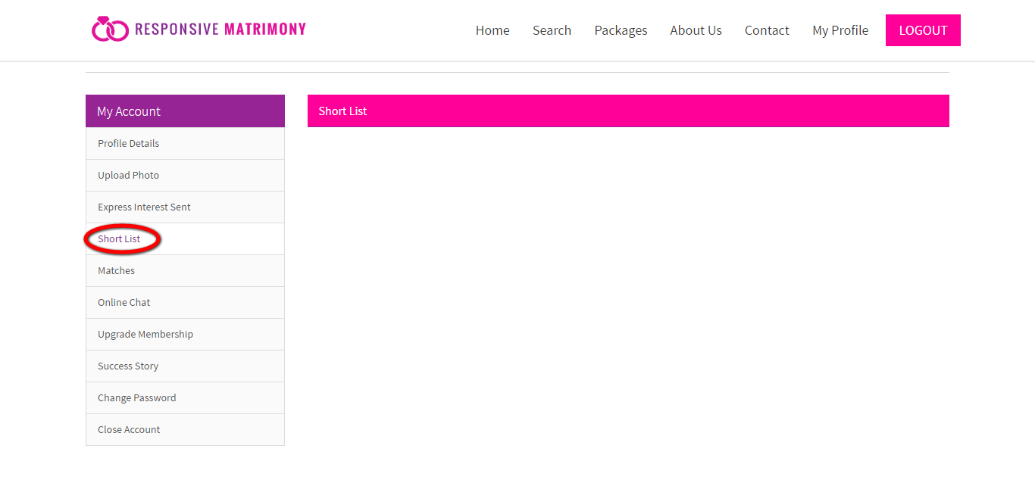
Description:
This page contains the shortlisted profile details.

Matches:
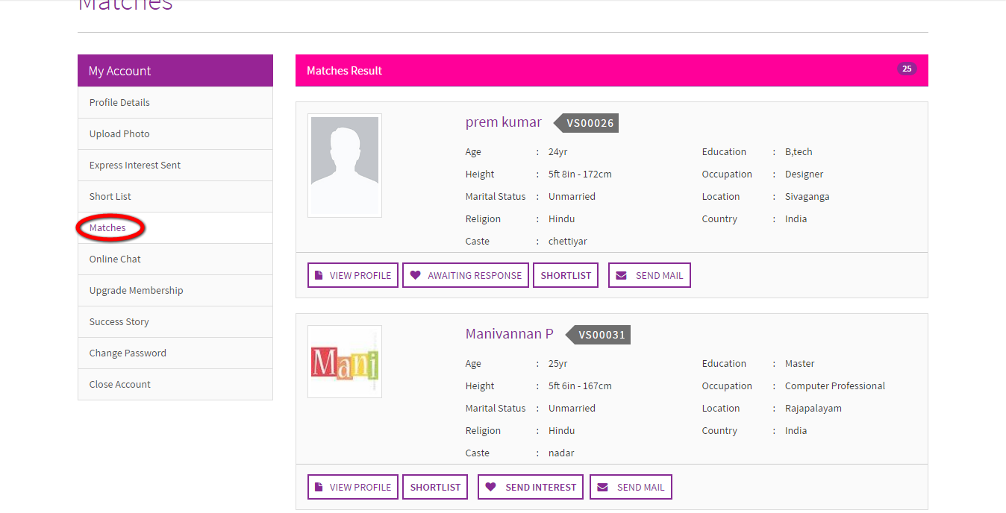
Description:
This page manages the matches that made from the profile will display. User can view the profile via quick link and more functionalities like send interest, shortlist and mail are there.

Online chat:
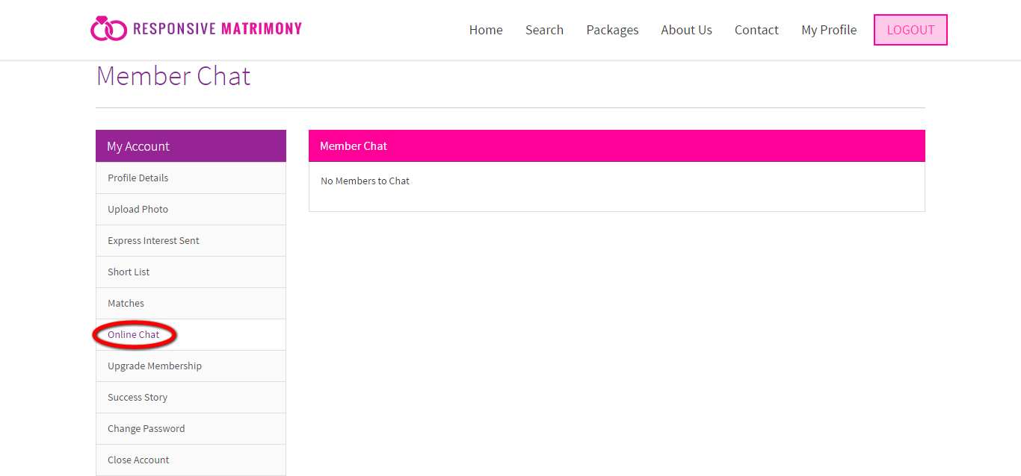
Description:
This page contains the members details that who are all in the online and user can chat with the members via this.

Upgrade membership:
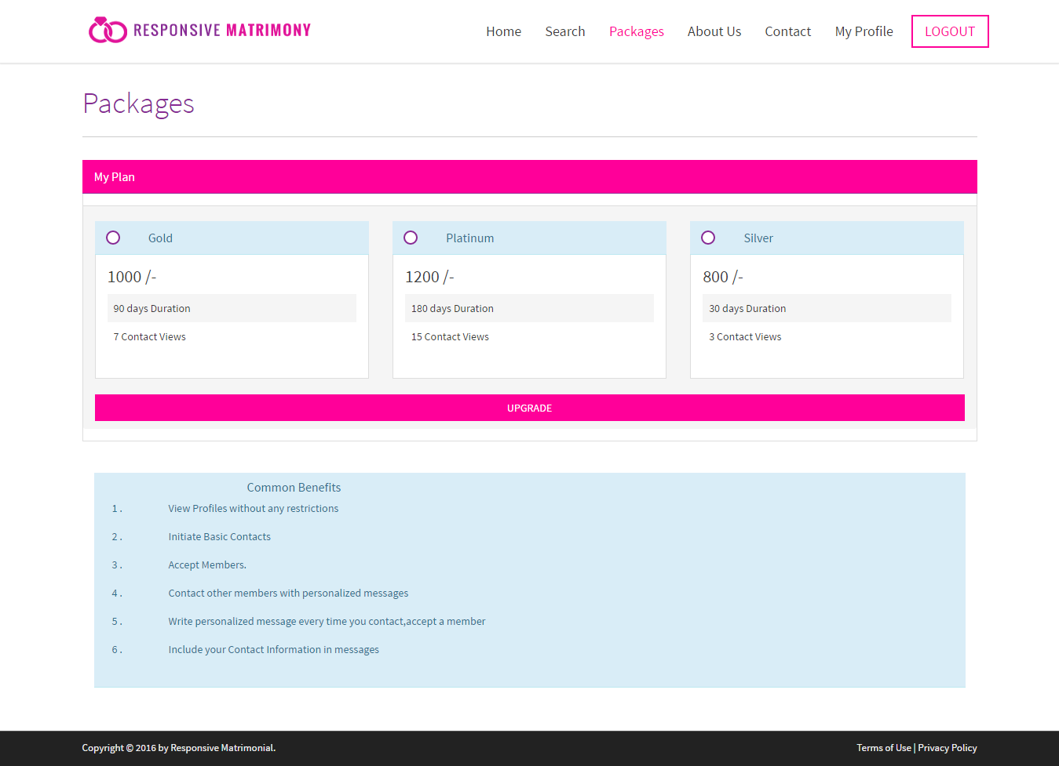
Description:
This page manages the membership plan with its feature. User also prospect the common benefit details.

Success story:
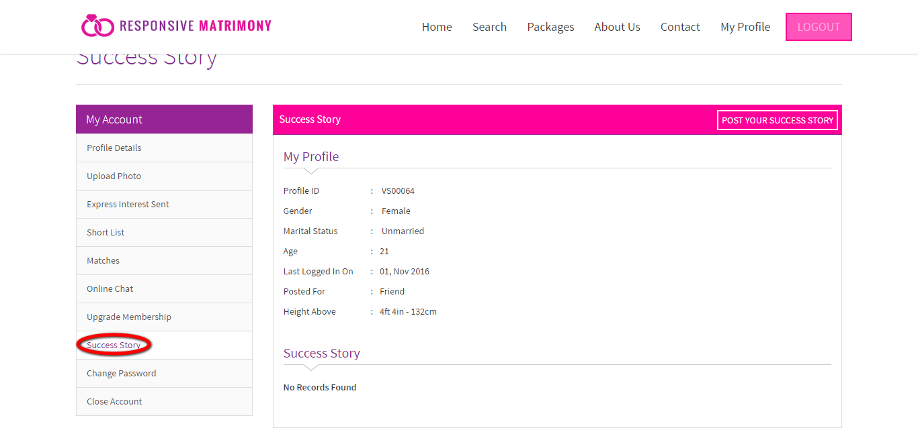
Description:
This page helps to view and post the success story details. User can view their own post in the profile details.

Change password:
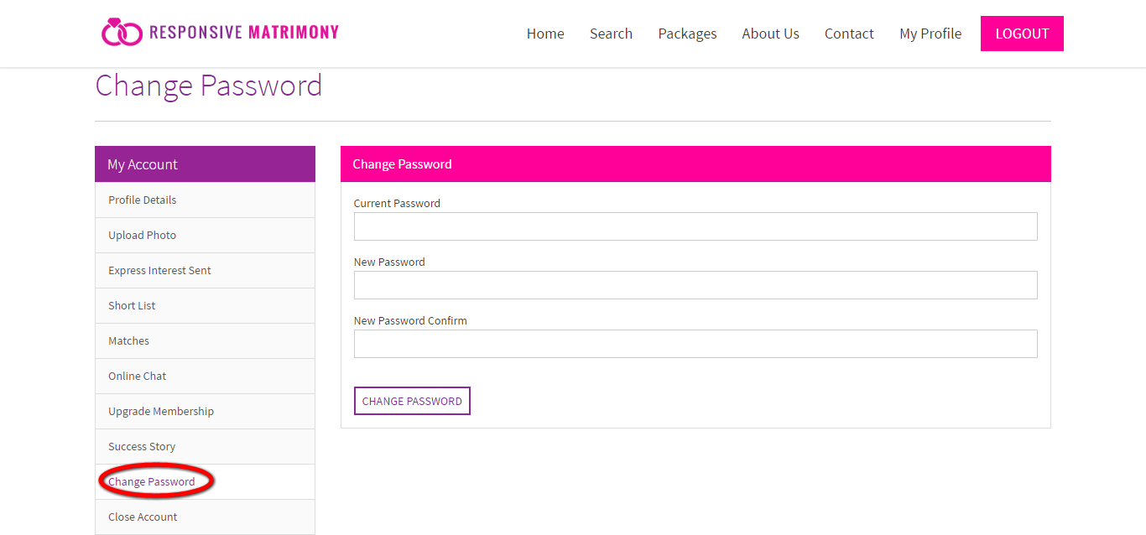
Description:
This page serves to change the account password.

Home:
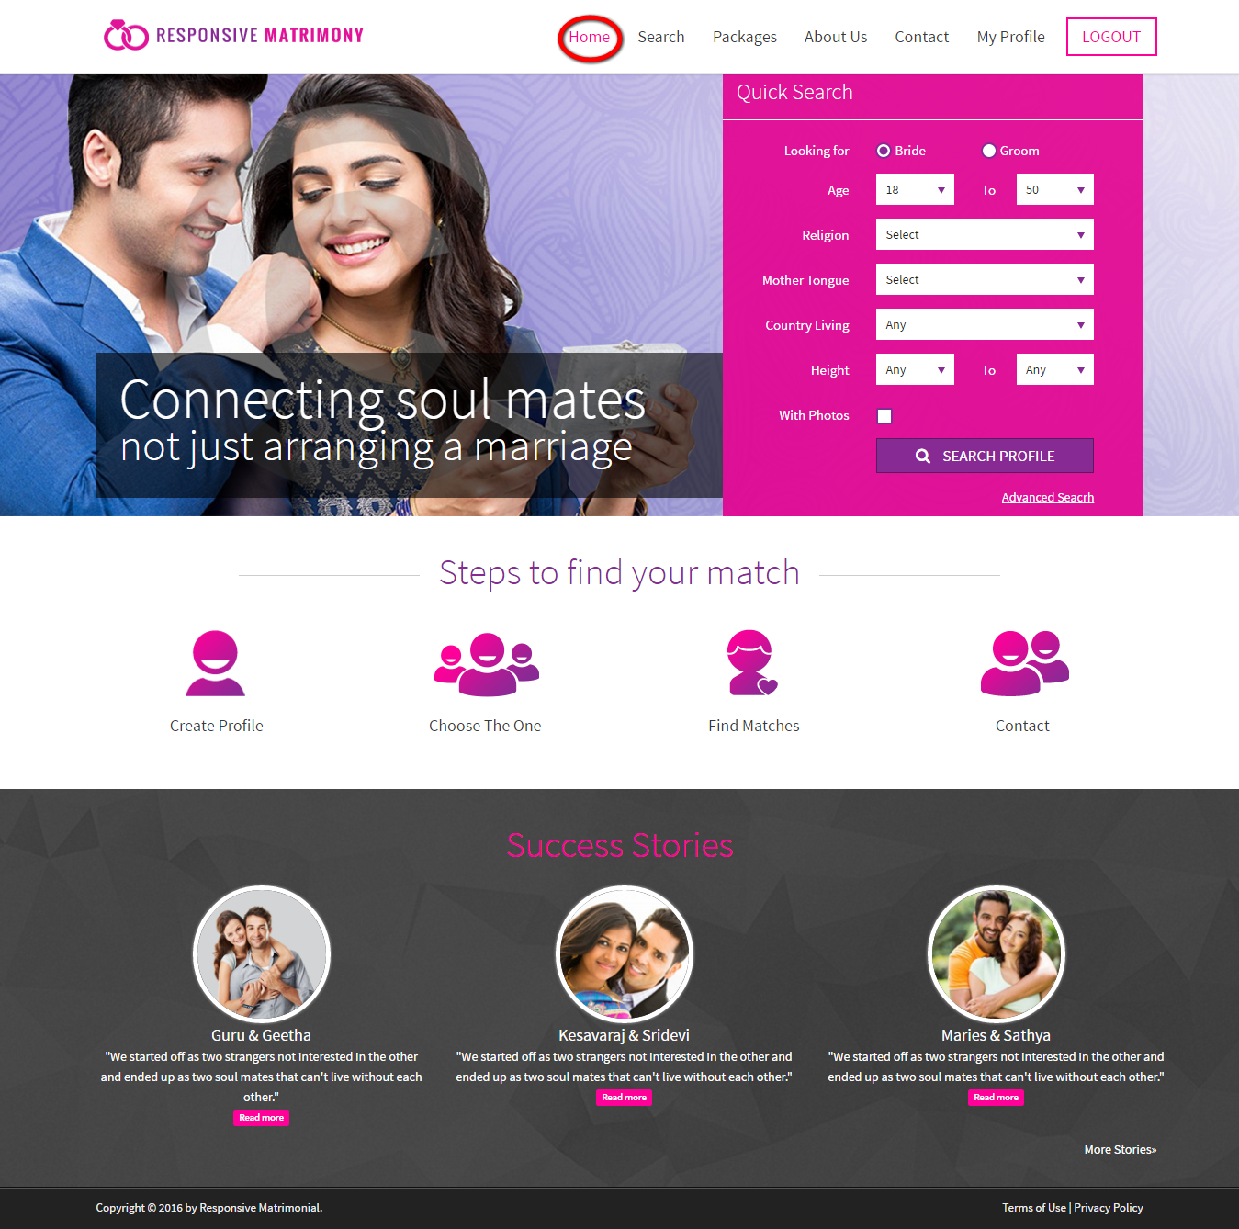
Description:
This page contains the search option with steps to proceed and some of the success stories.

Search:
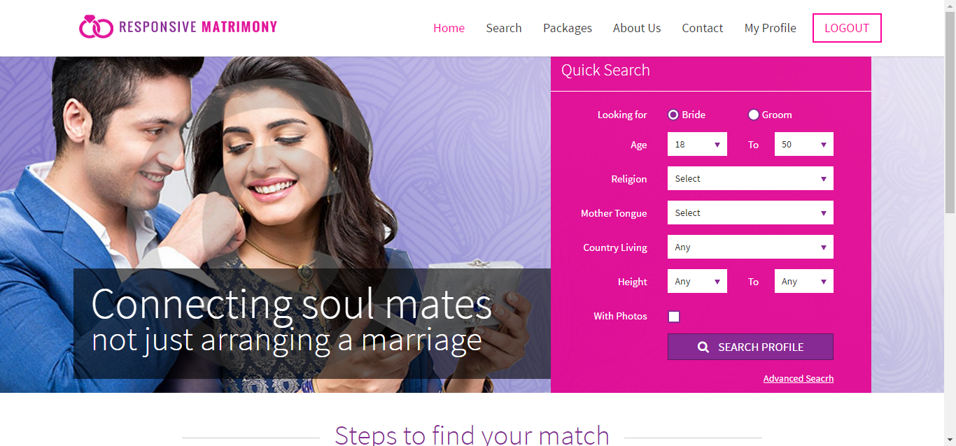
Description:
This page serves to search for a partner via entering the religion, month tongue and physical appearance details.

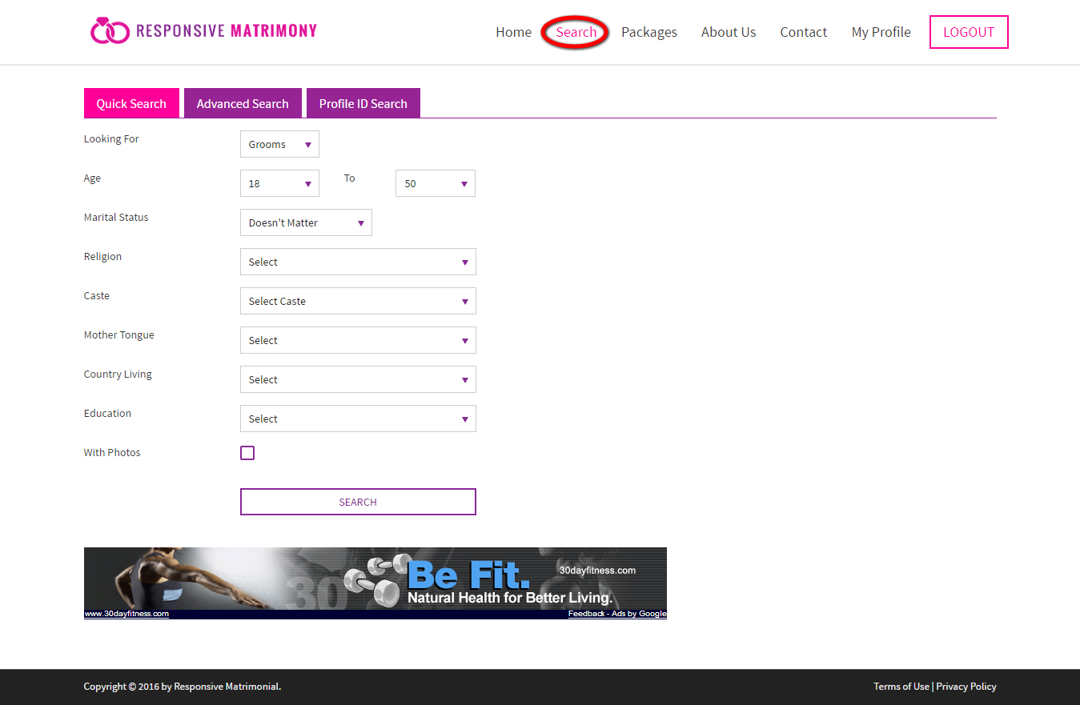
Description:
This page serves to search for their partner with the basic details.

Advanced search:
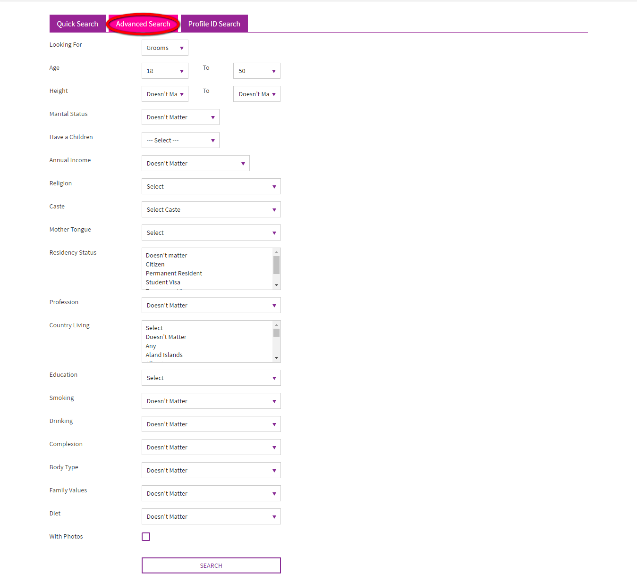
Description:
This page serves to search the partner with some in-depth details.

Profile ID search:
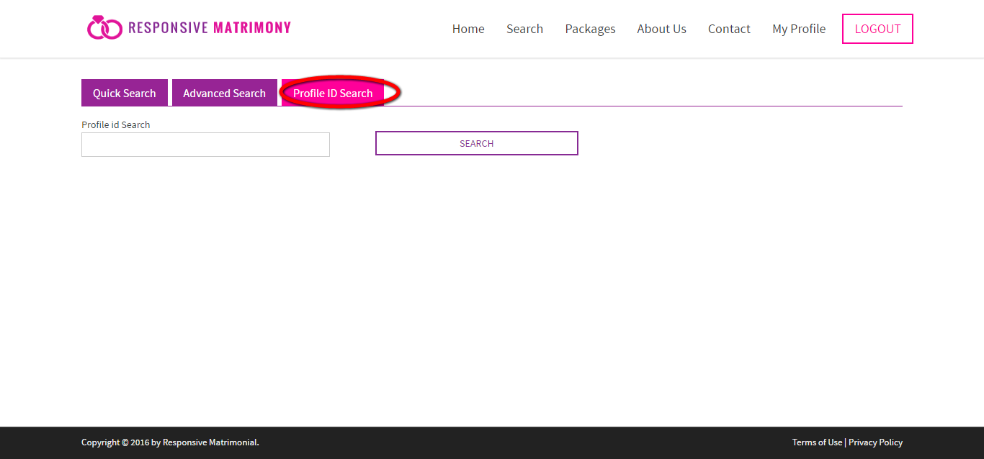
Description:
This page serves to search the partner via profile ID.

Search result:
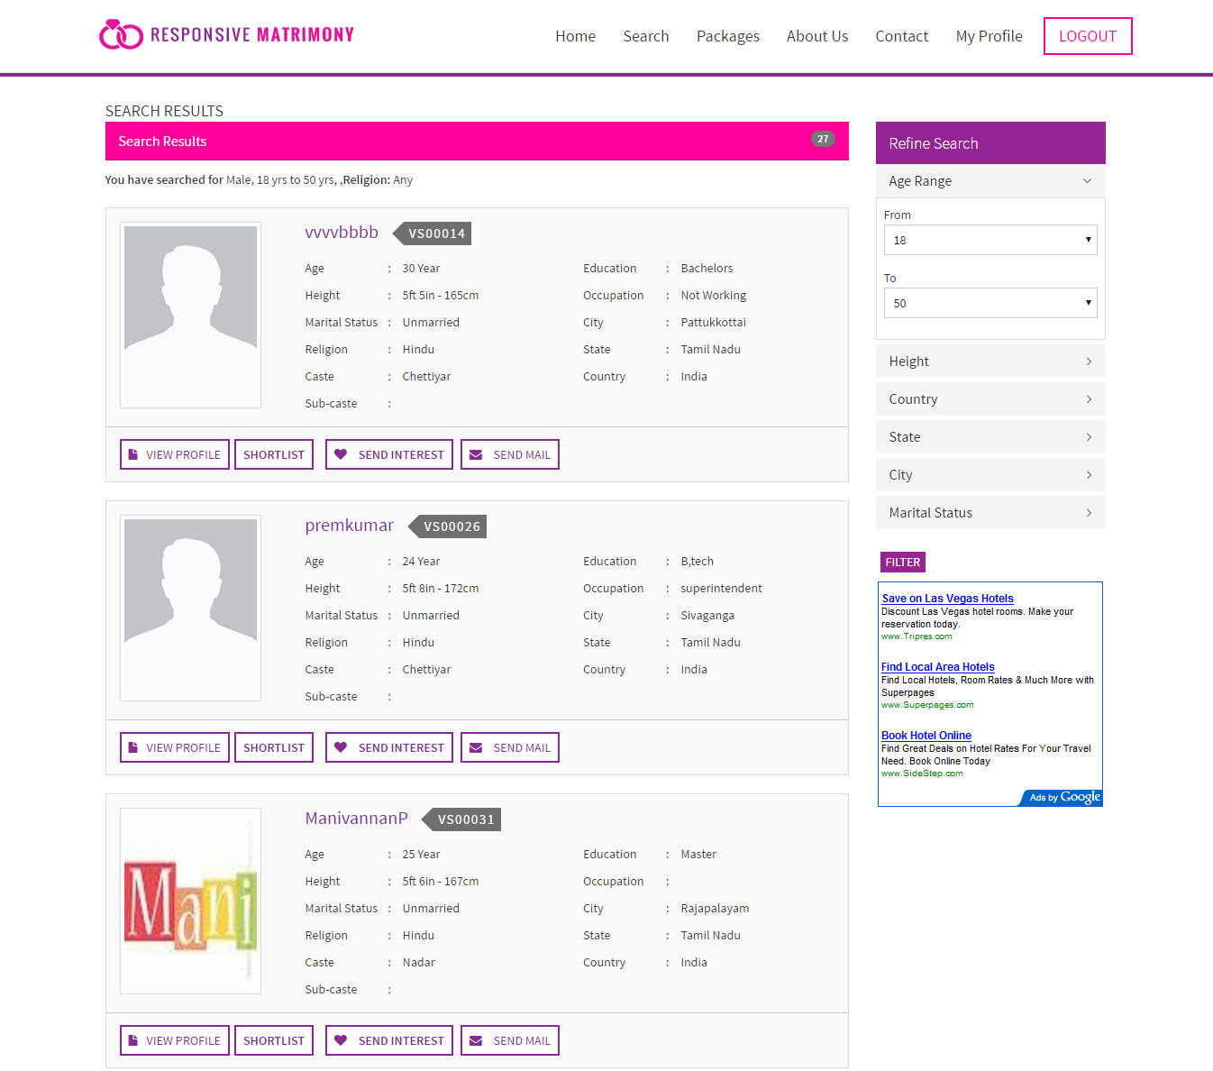
Description:
This page is the search that also has the refine search option. User can view some quick links for profile, send mail, shortlist, send interest.

Packages:
Description:
This page serves to upgrade their membership to any other plan. User can view the common benefits of the membership plan.

About us:
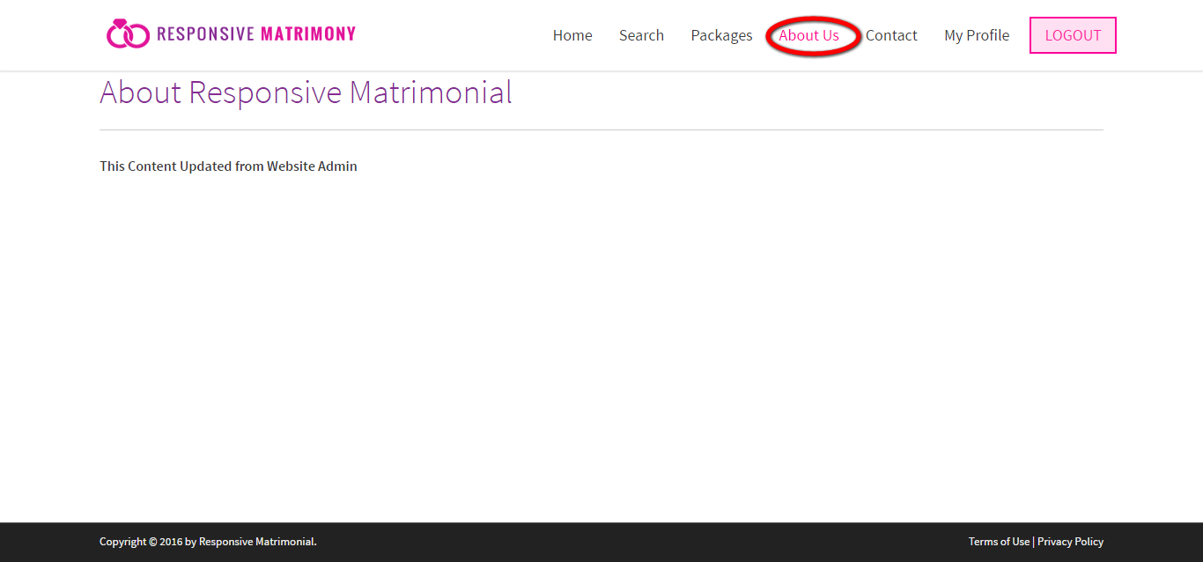
Description:
This page contains the content about the company.

Contact:
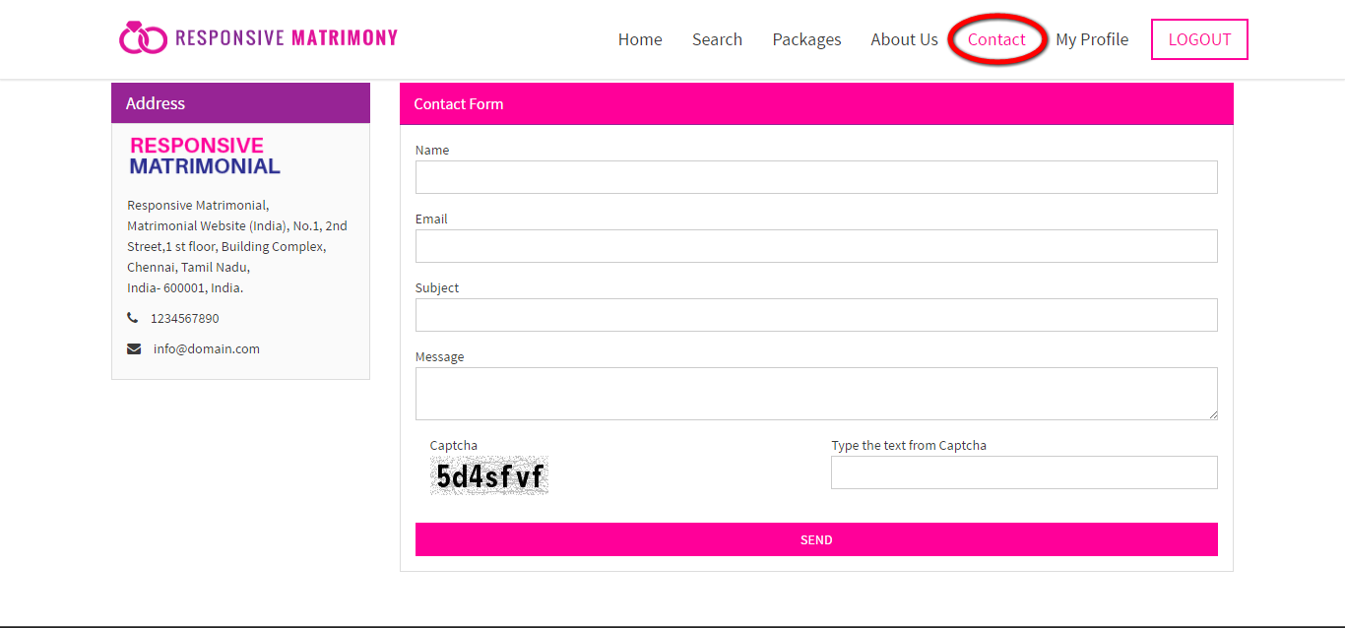
Description:
This page contains the contact details with feedback form which can be easy to contact the people among their queries.

Admin view
Login:
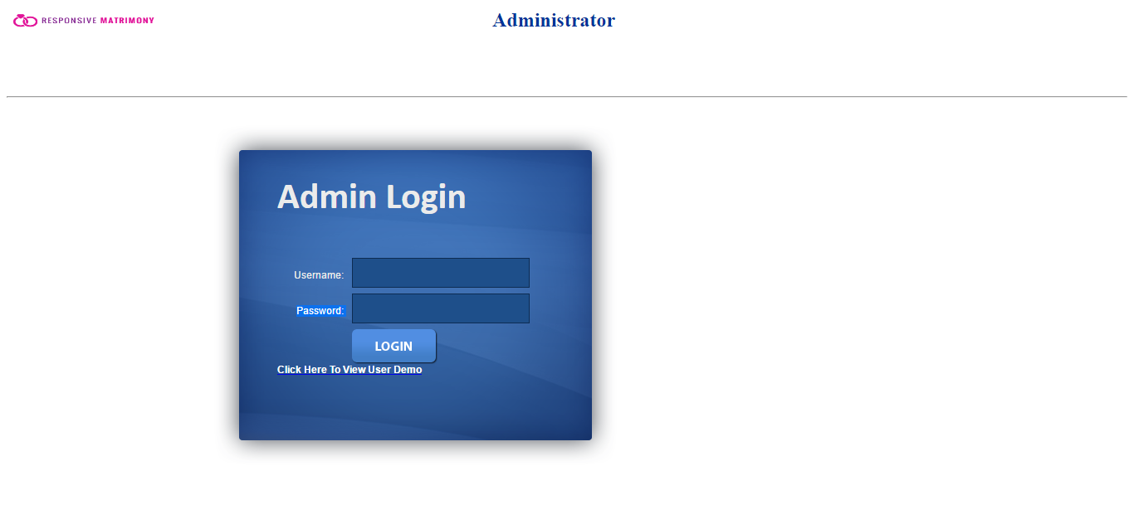
Description:
This page serves to login via valid user name and password.

Dashboard:
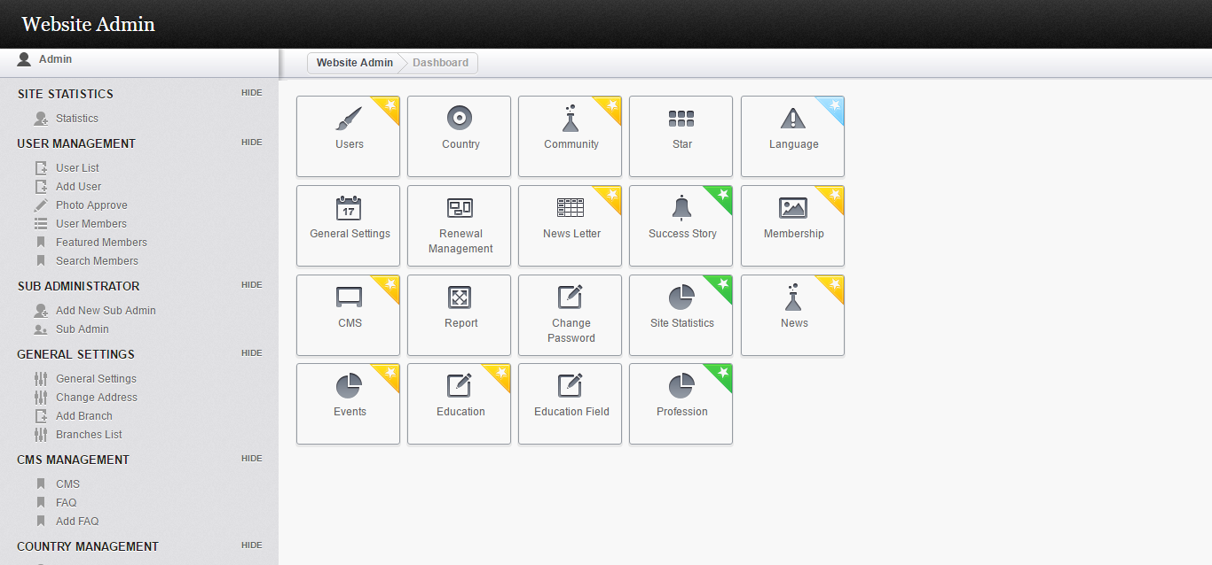
Description:
This page contains the shortcut links for users, country, community, star, language, general setting, renewal management, newsletter, success story, membership and etc.

Statistic:
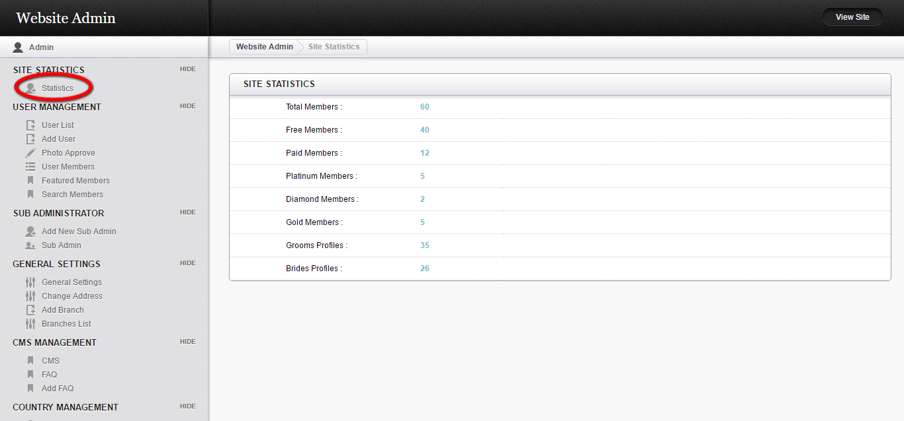
Description:
This page contains the statistic for members that using the membership, total member.

User list:
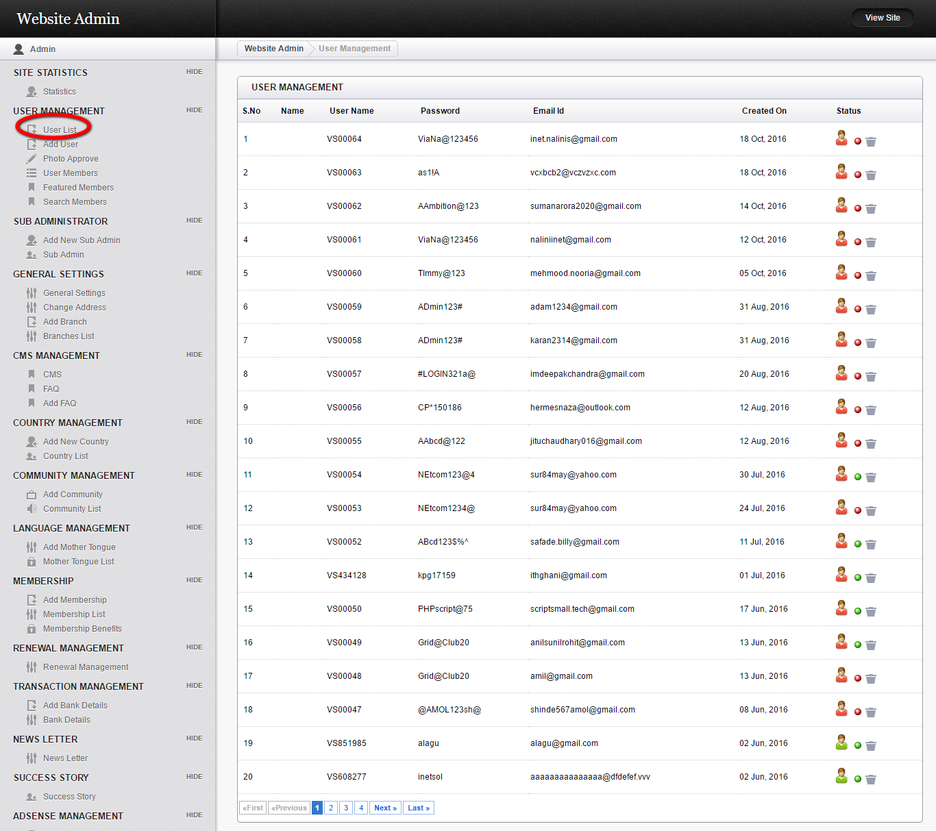
Description:
This page contains the user list with user name, password, mail id, created date with action option.

Photo approve:
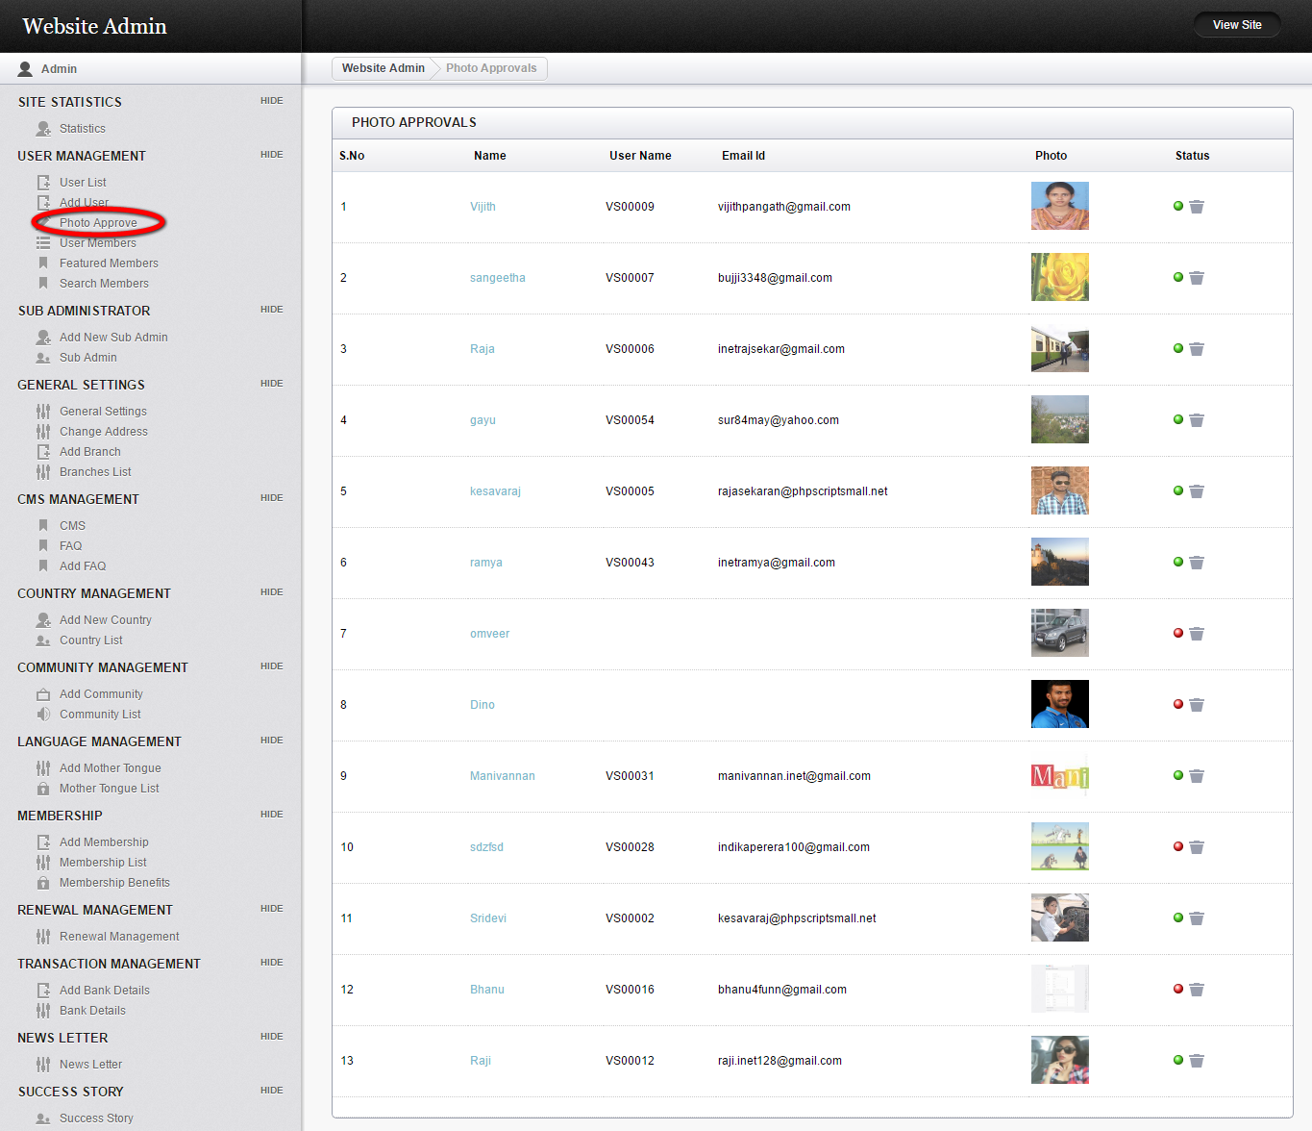
Description:
This page manages to approve the photos with the detail of name, user name, mail id, photo and action option.

User members:
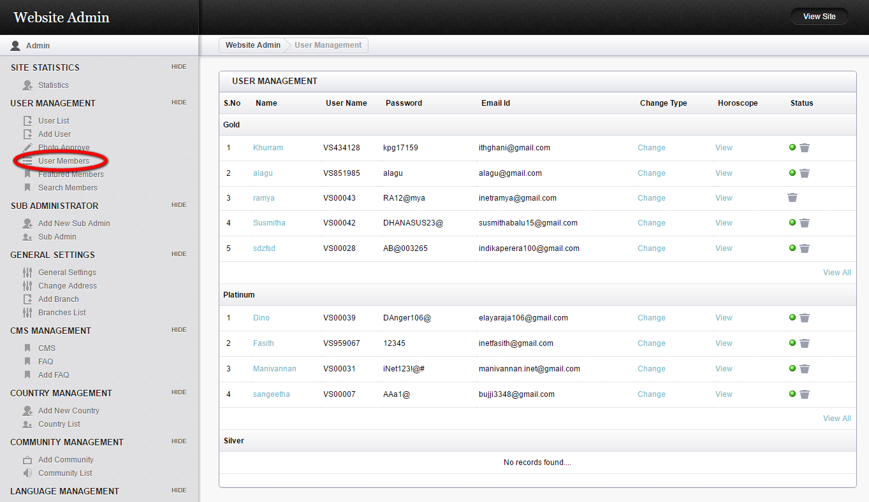
Description:
This page manages the member’s details under membership plan with name, user name, password, mail id, horoscope and action option.

Featured members:
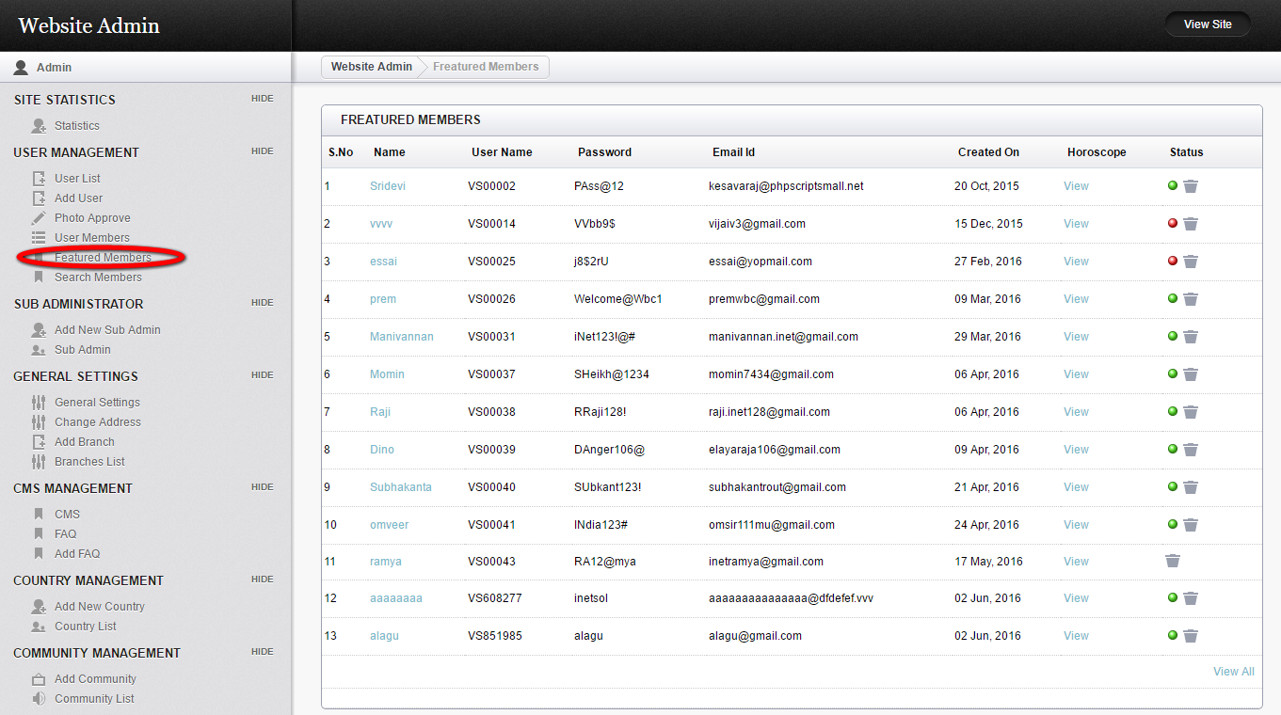
Description:
This page contains the details of the featured members with name, user name, mail id, horoscope and action detail.

Add new sub admin:
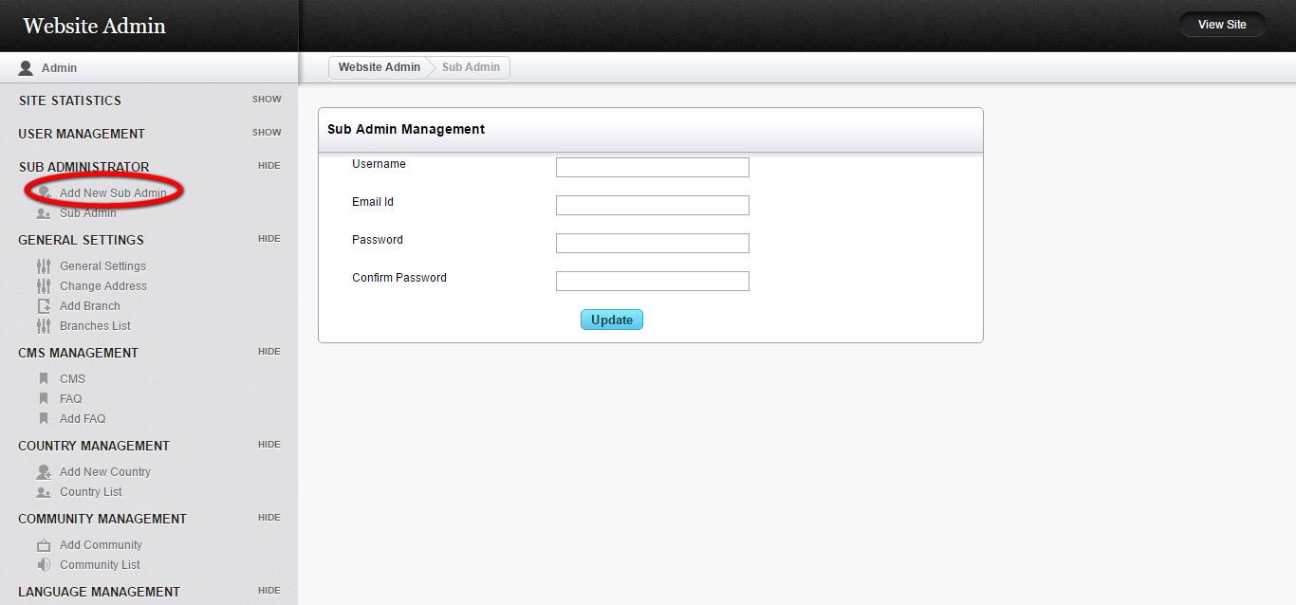
Description:
this page serves to add a sub admin by entering the user name, mail id and password.

Sub admin:
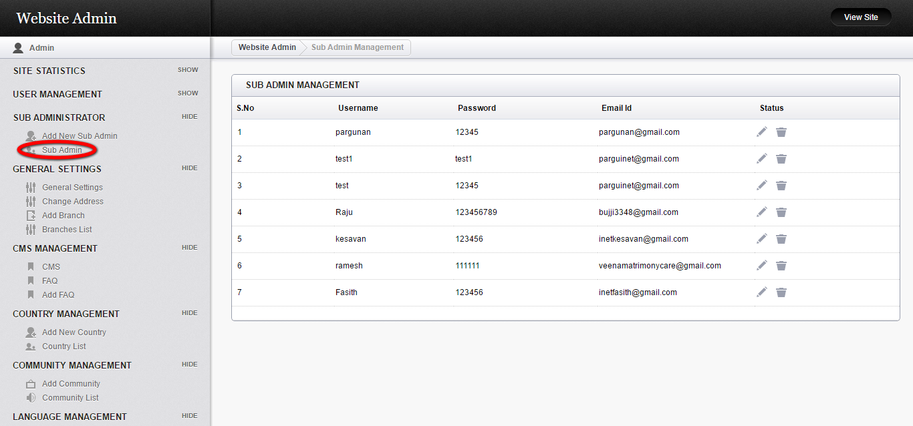
Description:
This page manages the sub admin details with user name, password with status option.

General setting:
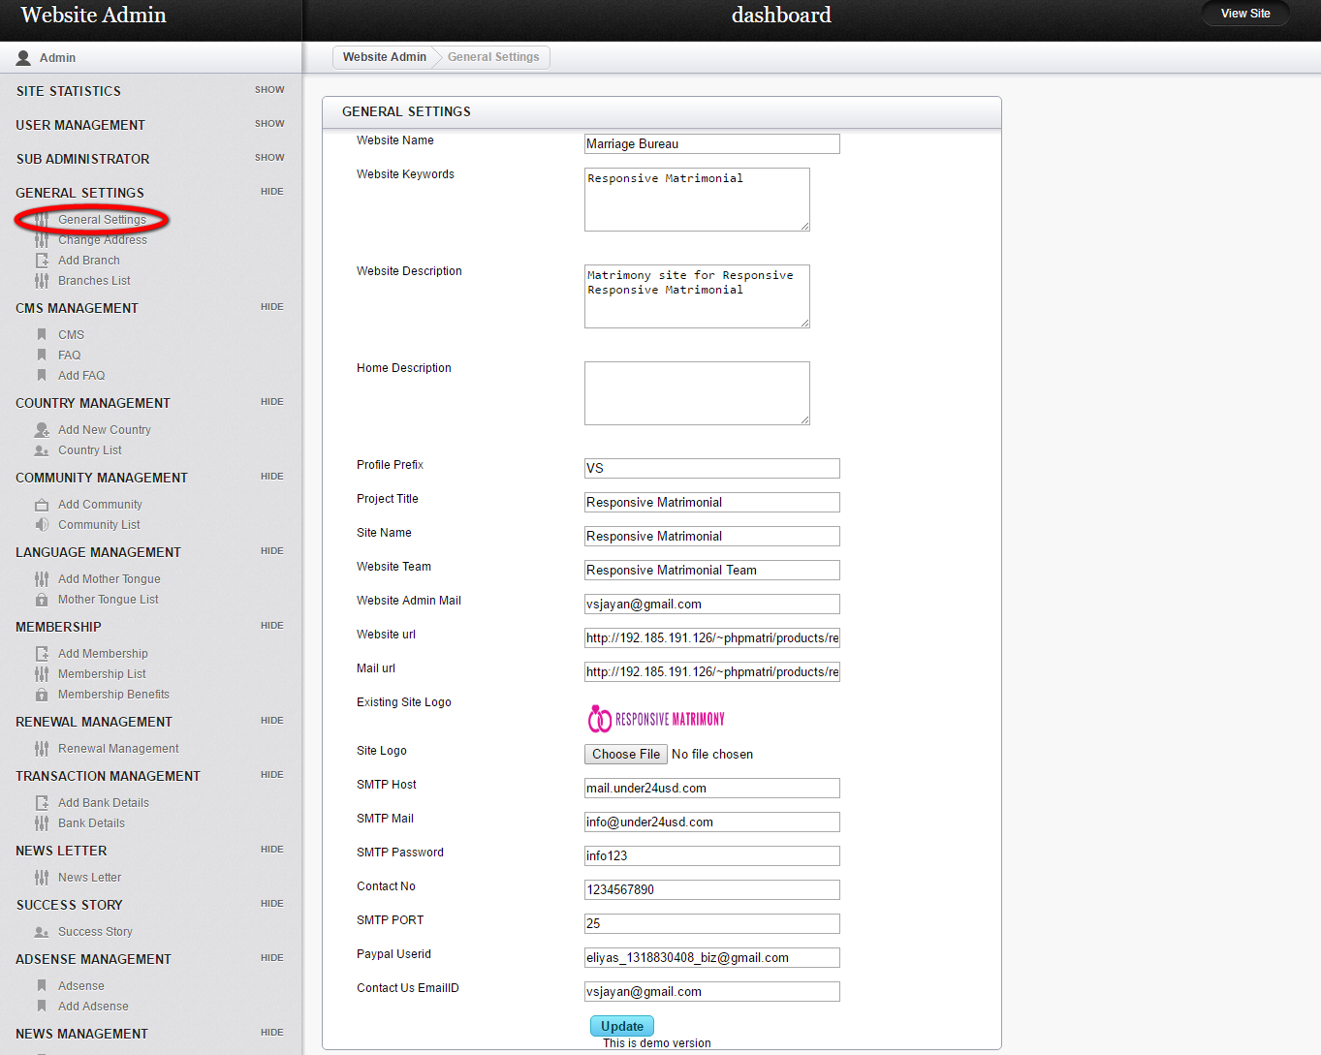
Description:
This page manages the profile and URL details.

Change address:
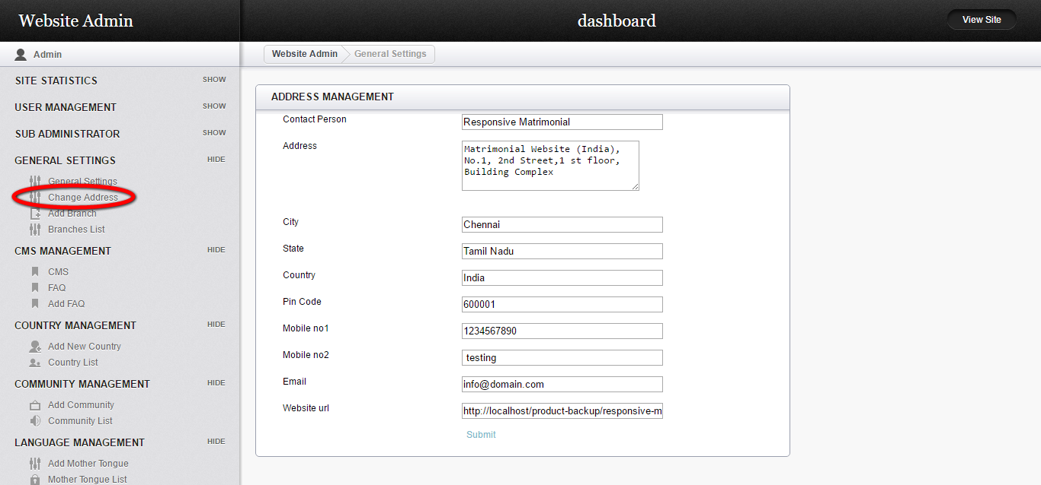
Description:
This page manages to edit the address details like contact person, address, city, state, country, pin code, URL and contact details.

Add branch:
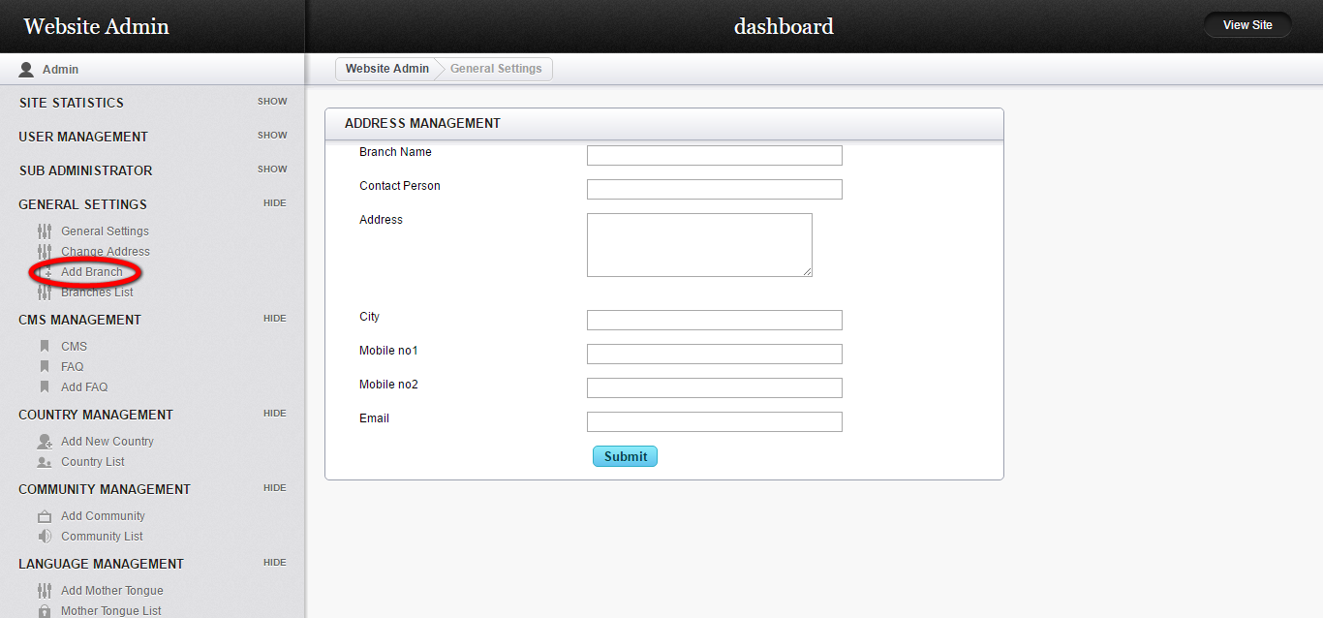
Description:
This page serves to add a new branch details with branch name, contact person, address and contact details.

CMS:
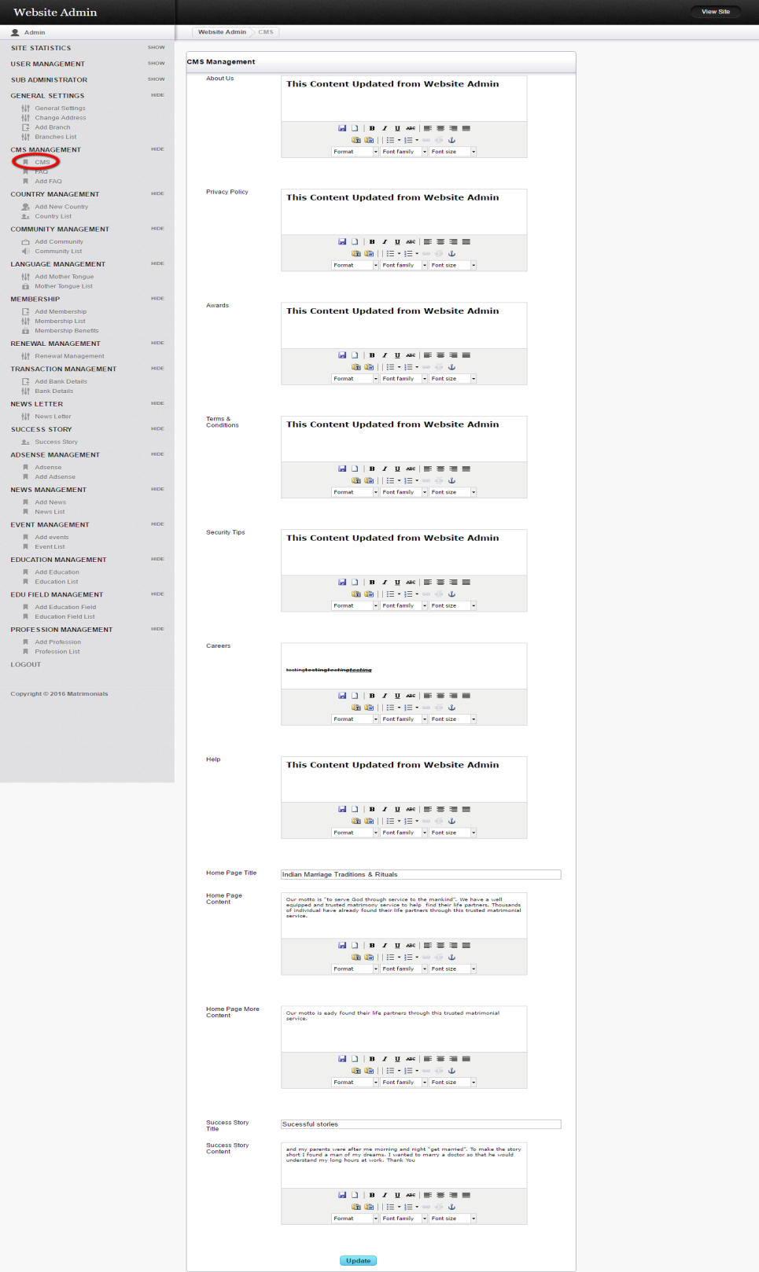
Description:
This page manages the entire CMS content details.

FAQ:
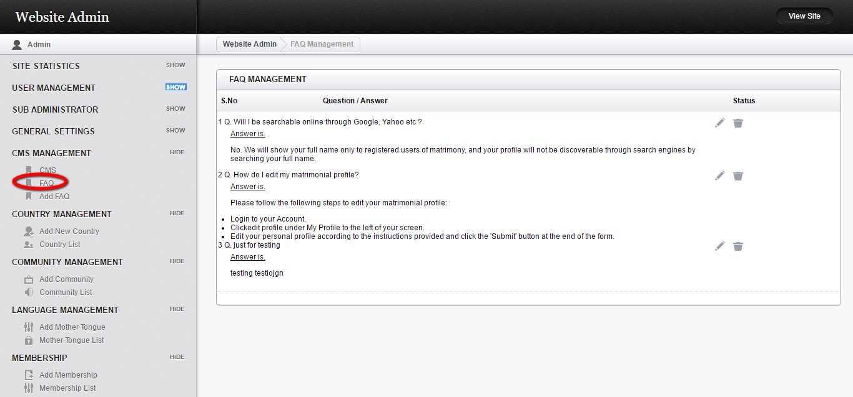
Description:
This page manages the FAQ contents detail.

Add new country:
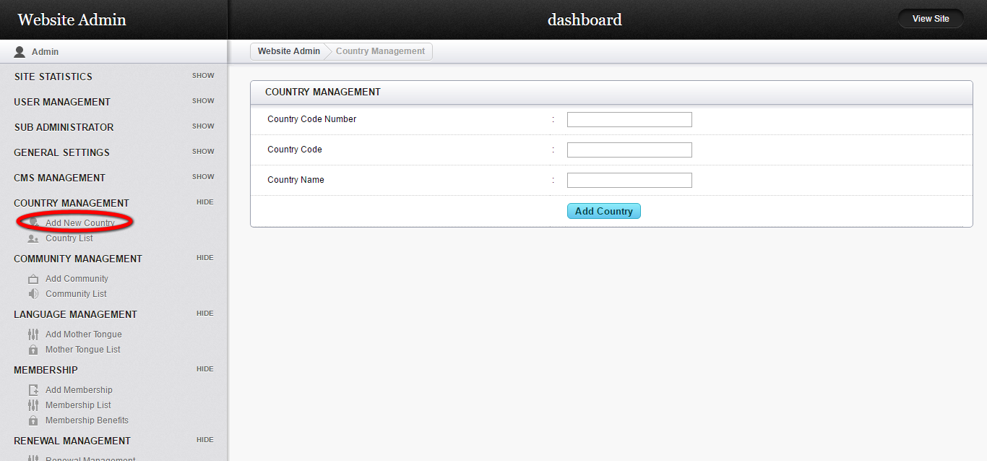
Description:
This page serves to add new country detail with country code and name.

Country list:
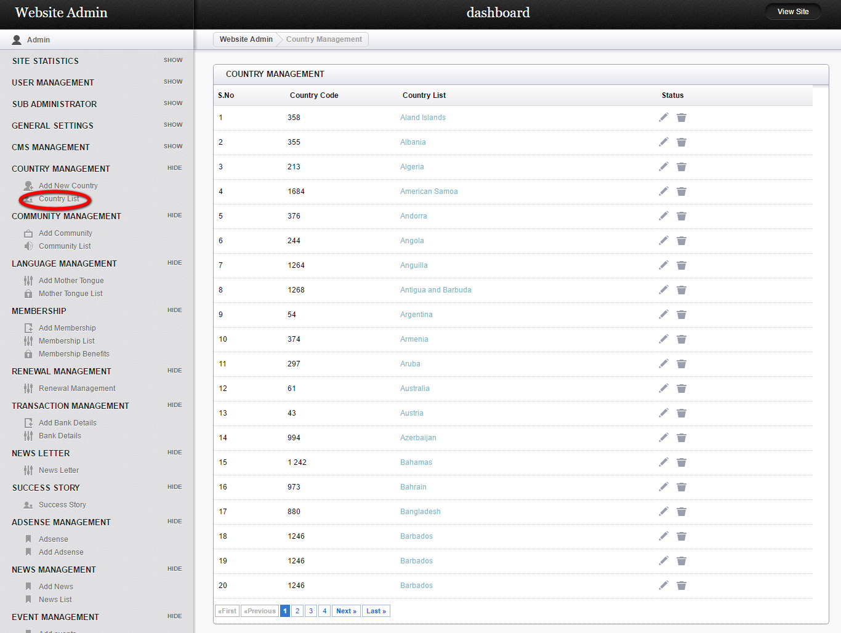
Description:
This page view the entire country details with country code, name and list.

Add community:
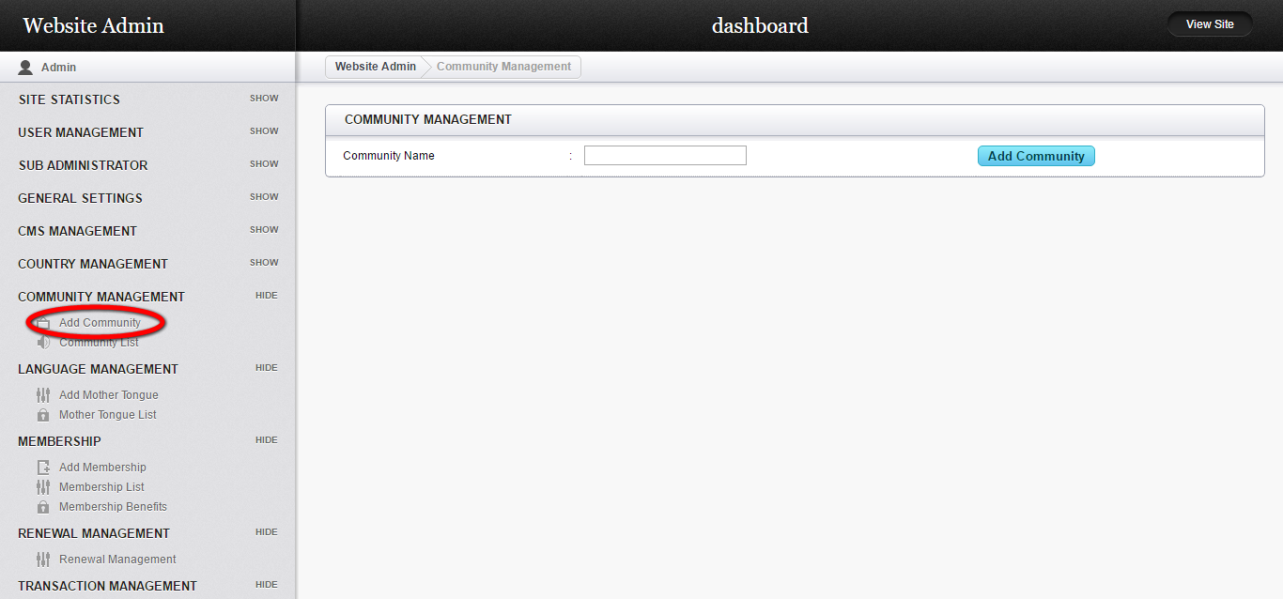
Description:
This page serves to add community name to the list.

Community list:
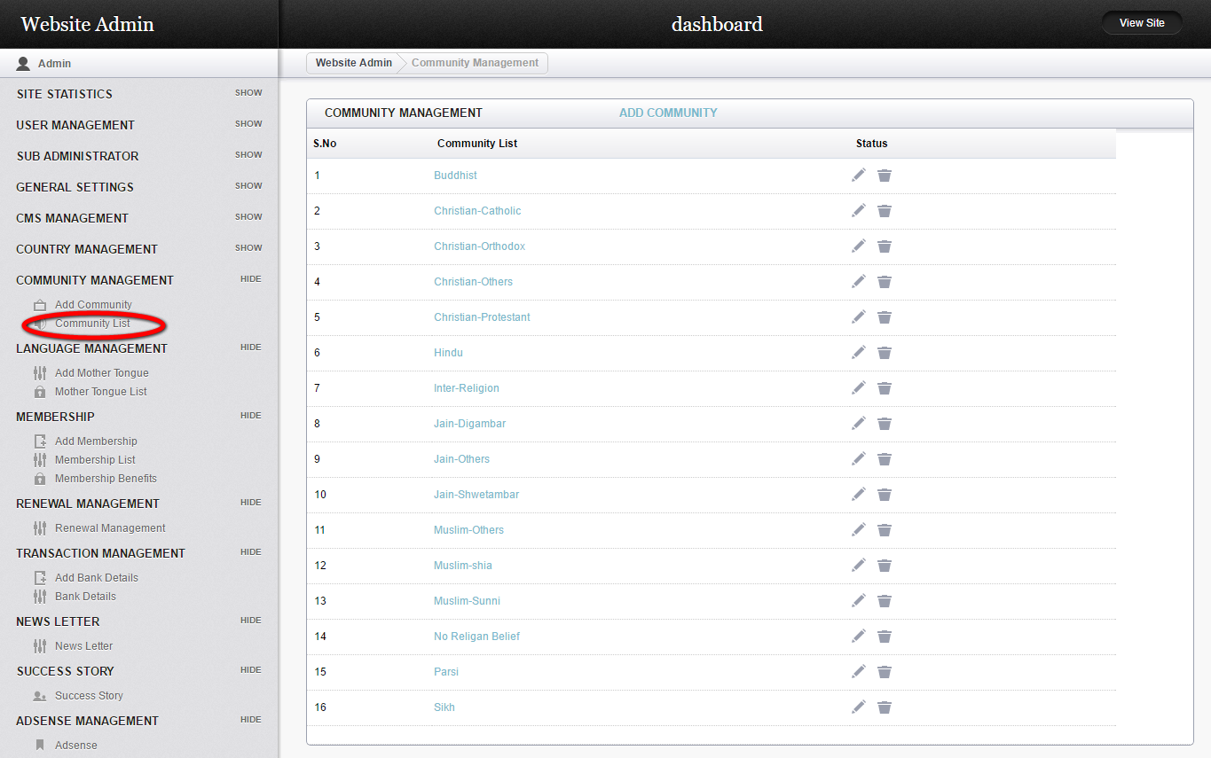
Description:
This page serves to view the entire community details.

Add mother tongue:
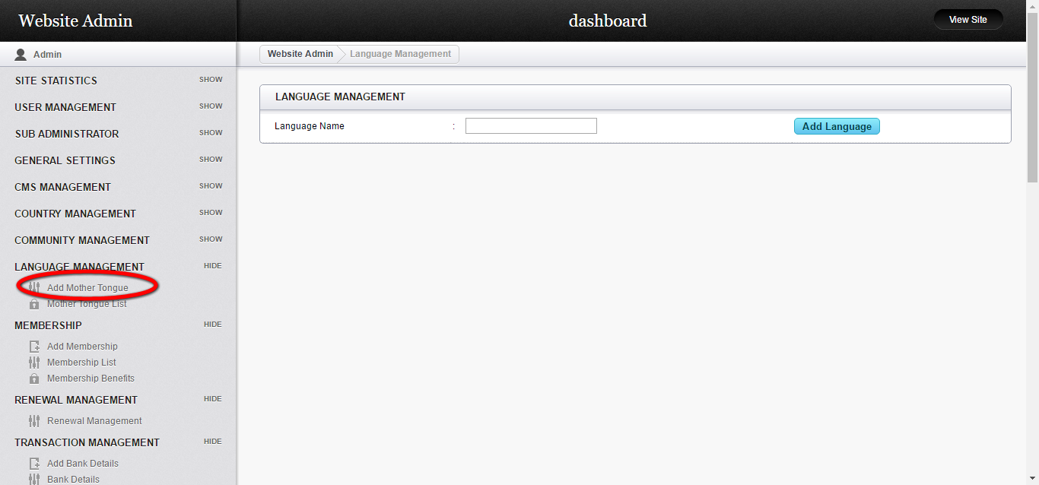
Description:
This page serves to add a mother tongue to the list.

Mother tongue list:
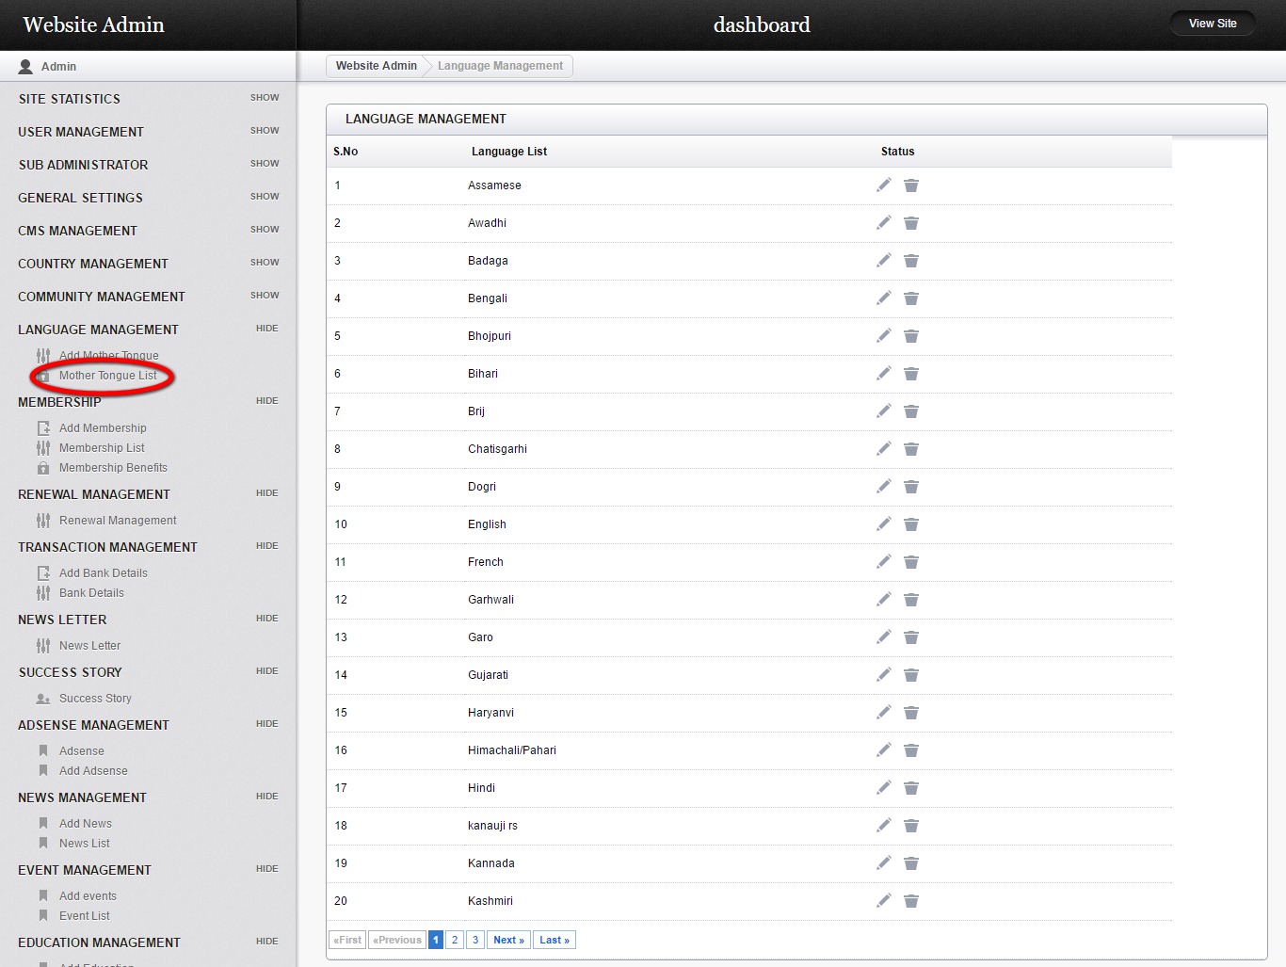
Description:
This page views the entire mother tongue list with the name and edit option.

Add membership:
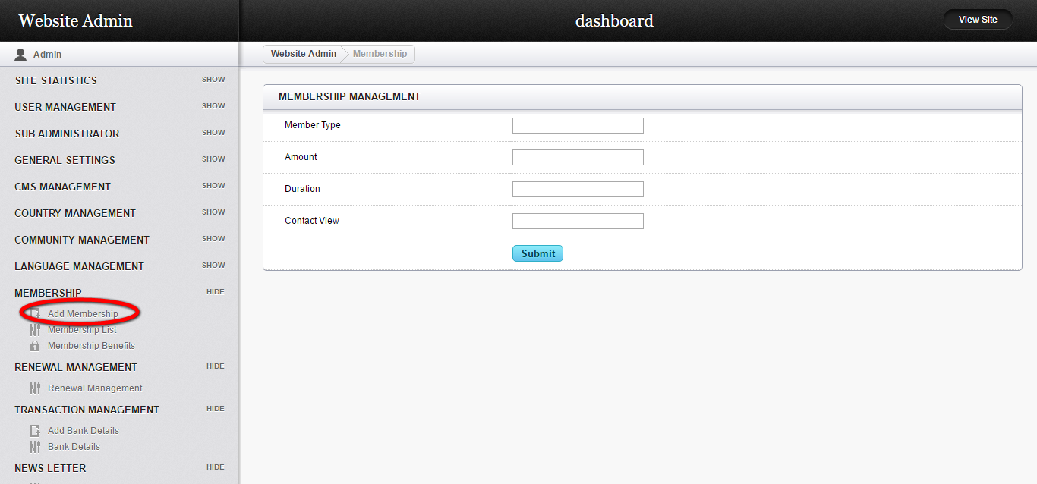
Description:
This page serves to add new membership with member type, amount, duration and contact view details.

Membership list:
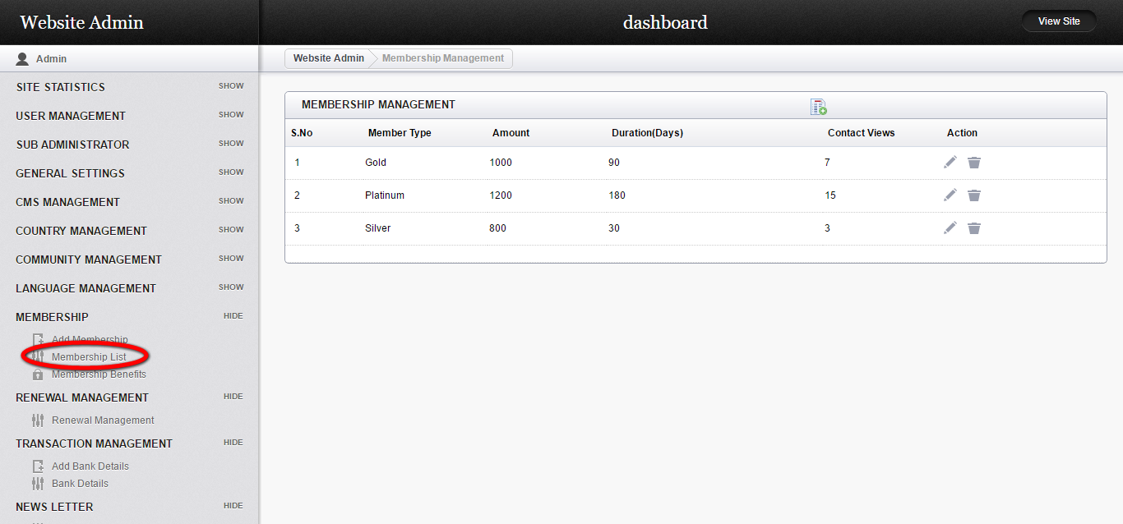
Description:
This page views the entire details like member type, amount, duration, counts of contact view with edit details.

Membership benefits:
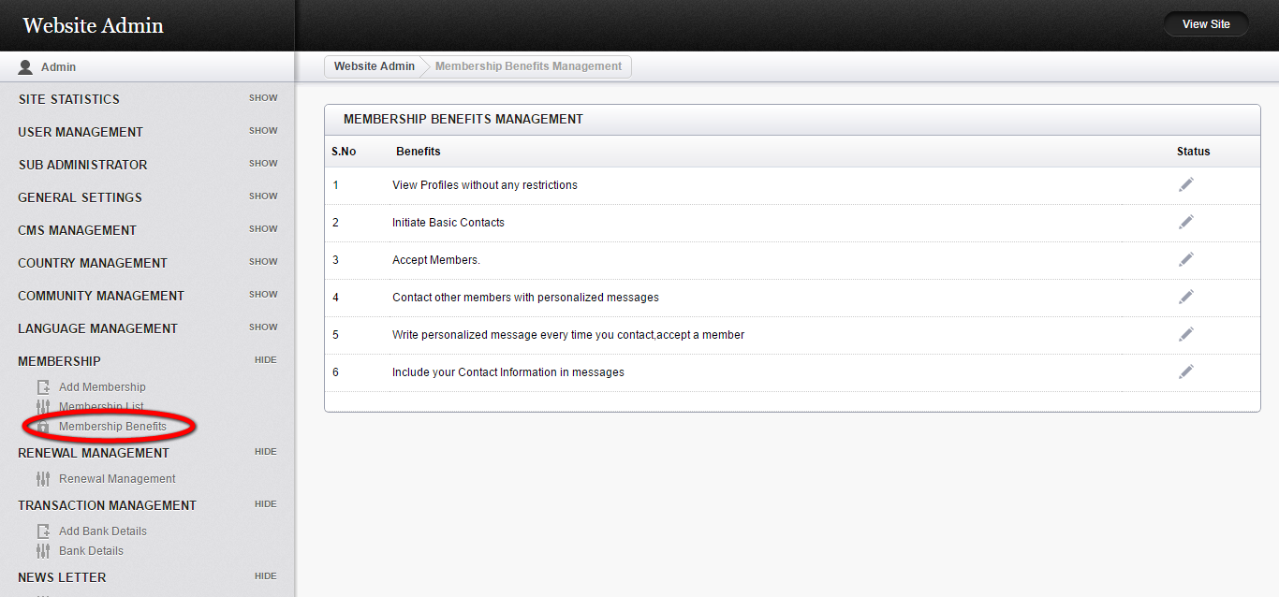
Description:
This page contains the benefit status.

Renewal management:
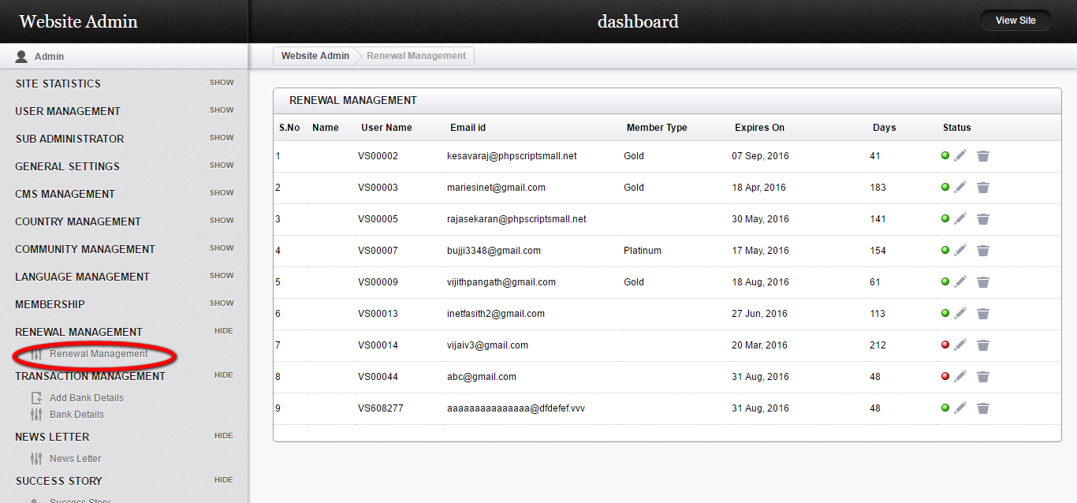
Description:
This page contains the renewal details with user name, mail id, member type, expire date and days with status details.

Bank details:
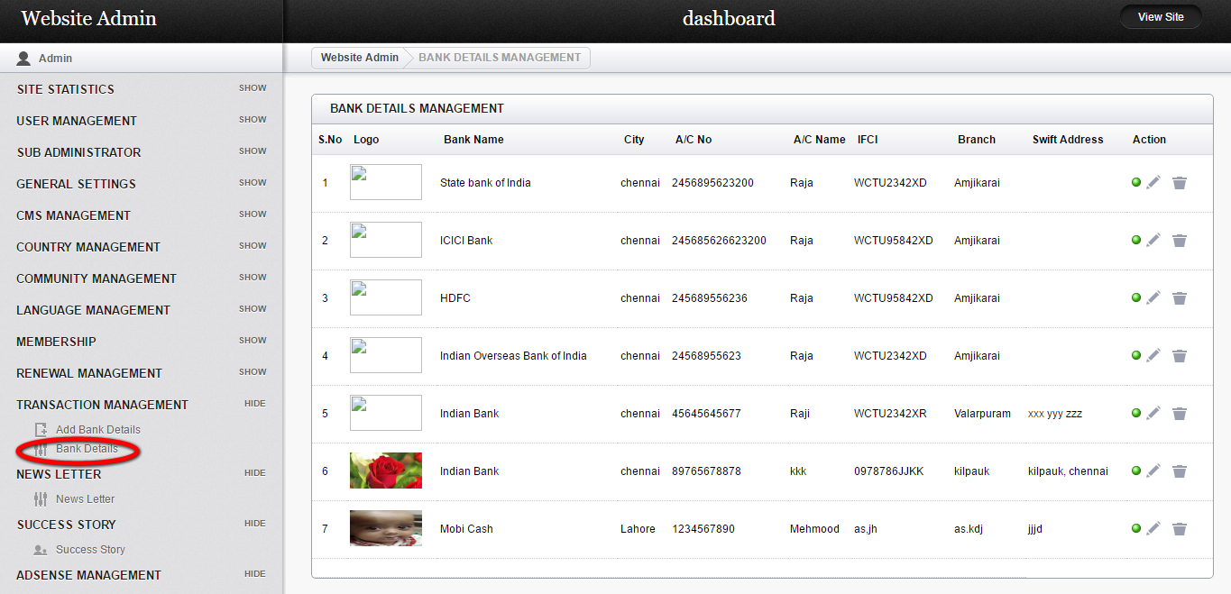
Description:
This page contains the bank details with bank name, logo, city, account detail, IFSI code, branch and edit option.

Newsletter:
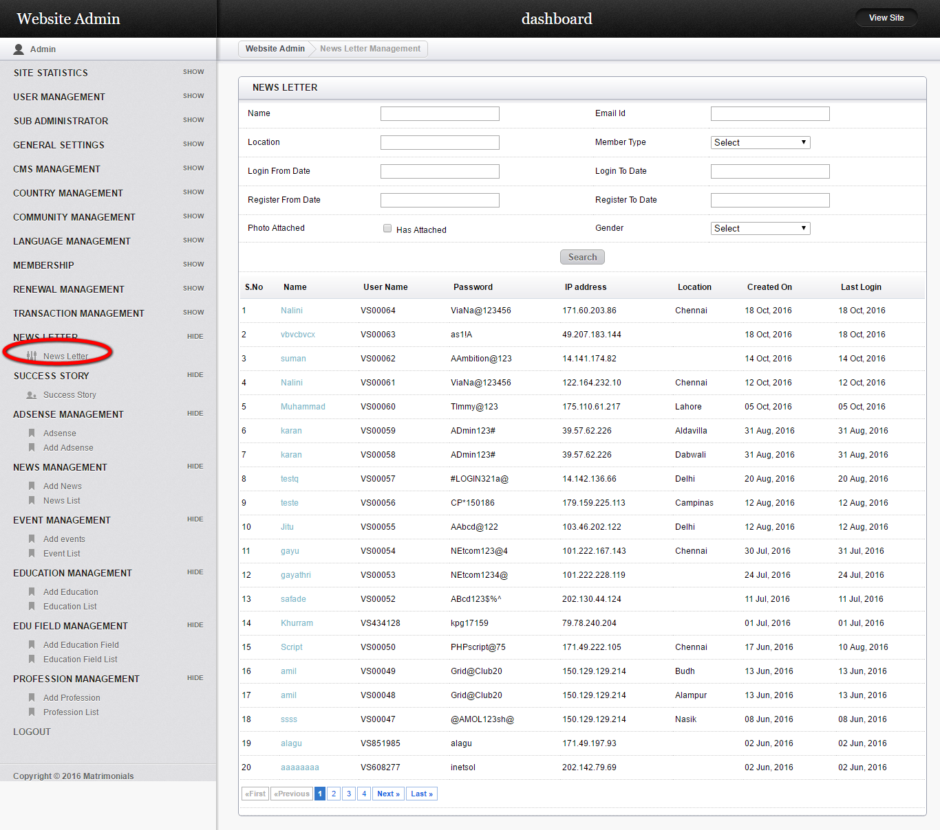

Description:
This page manages the newsletter subscribed user details with name, user name, password, IP address, location and last login details.

