Price comparison script
User view
Register:
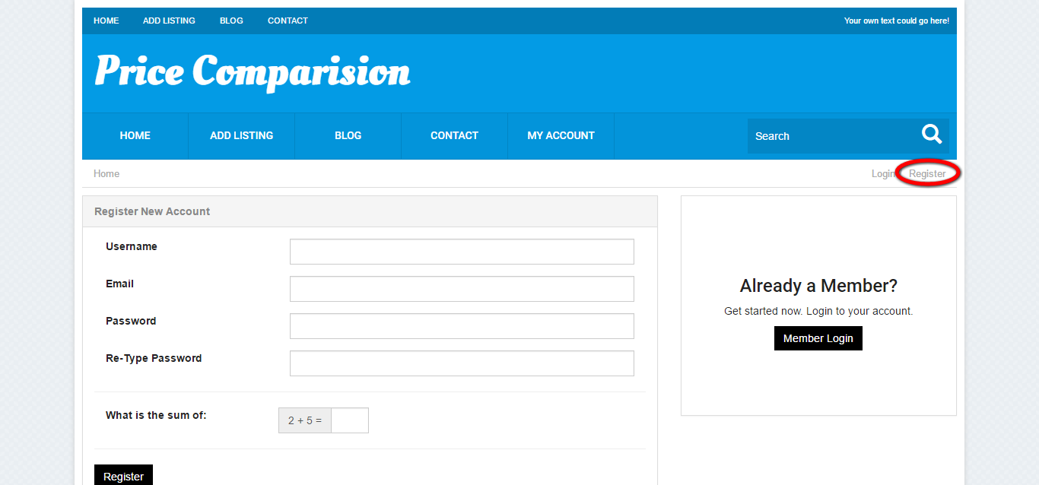
Description:
The new user can register via this page by entering the required fields like username, email id, password and calculation.

Login:
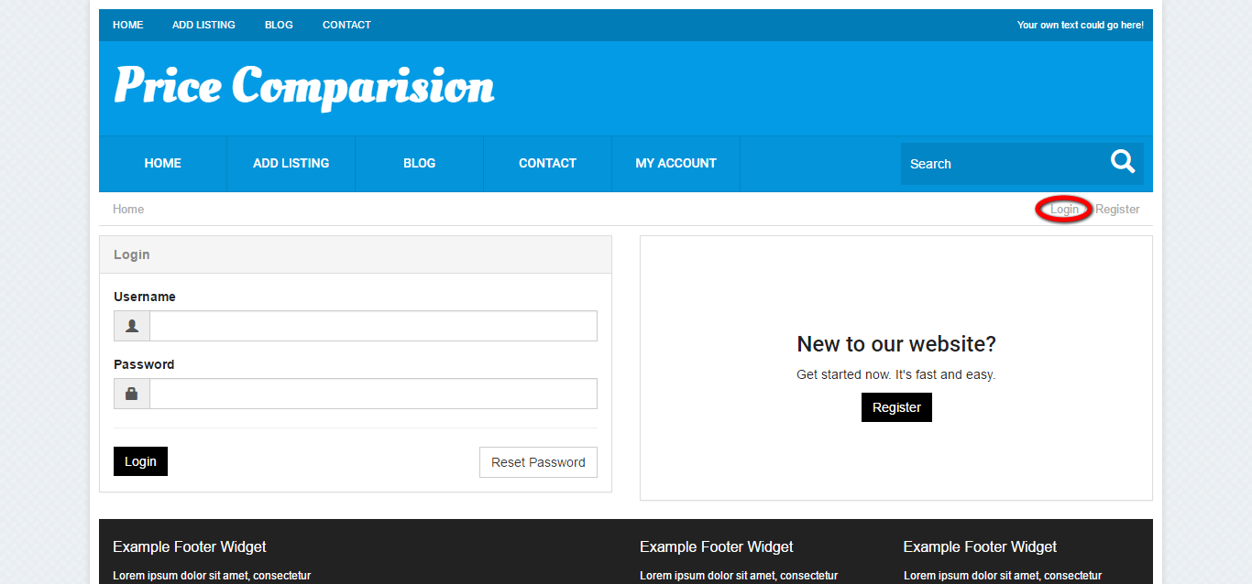
Description:
This page serves to login via valid username and password.

Dashboard:
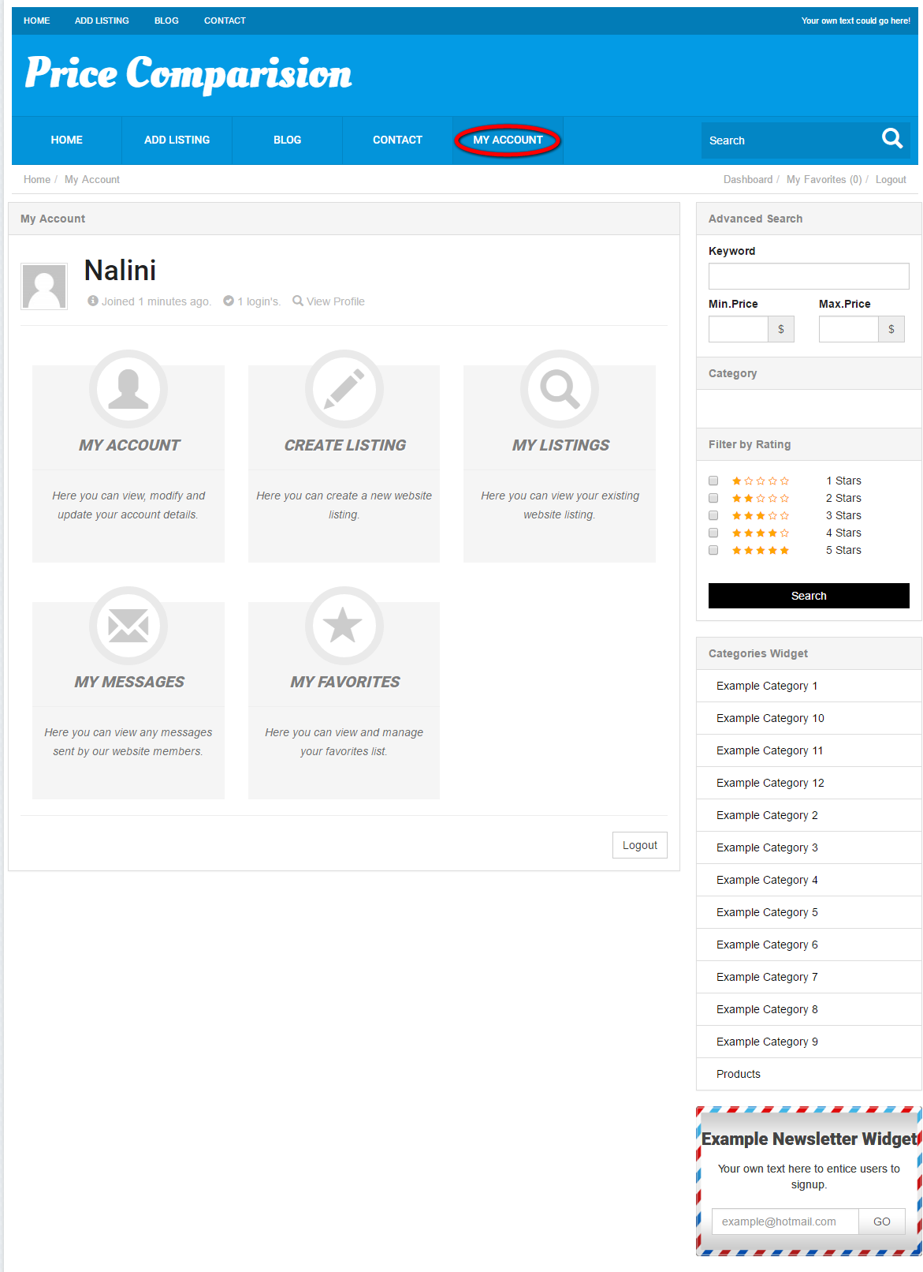
Description:
This page contains the quick ling to my account, my listing, add listing, my messages and my favorites.

My account:
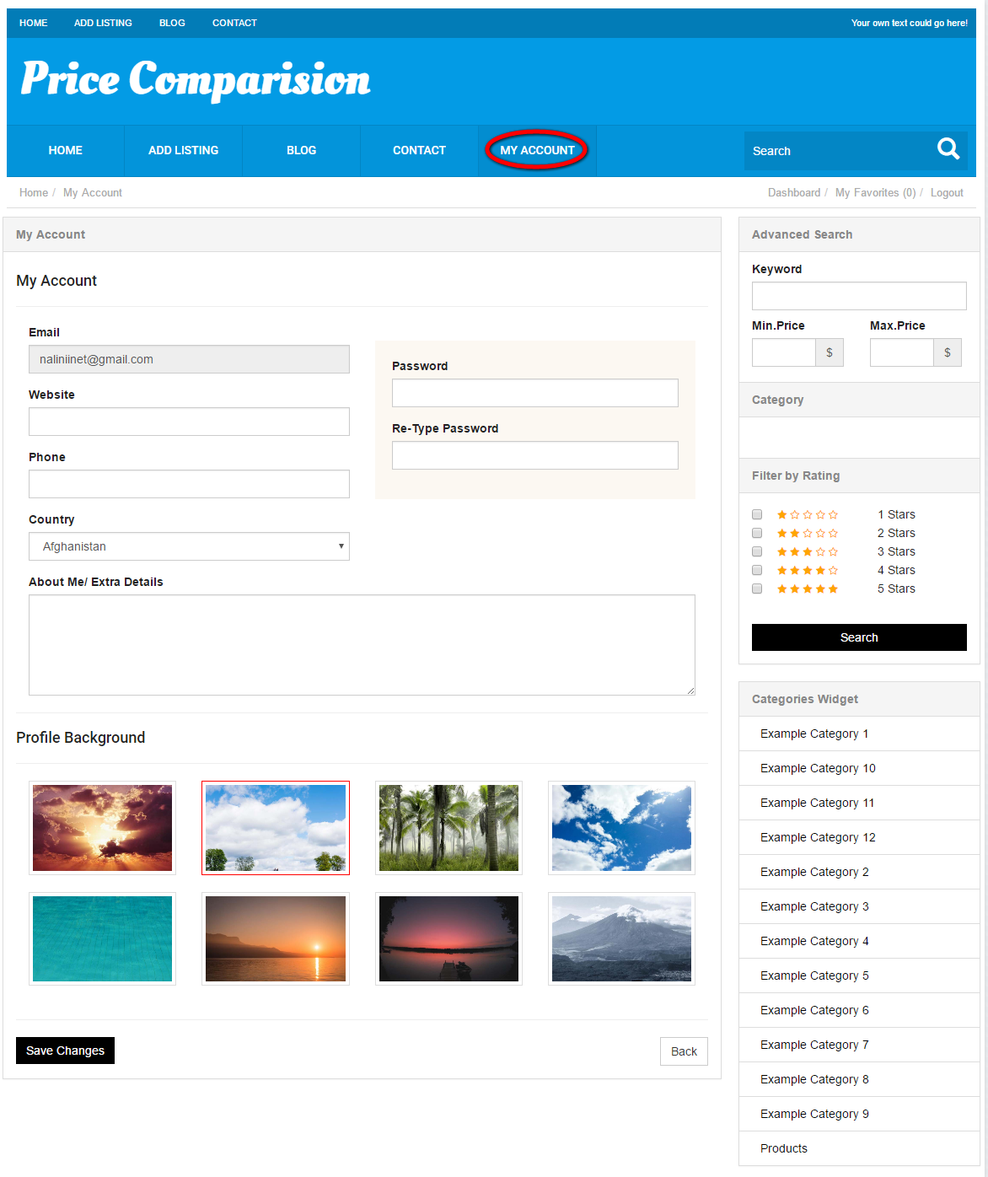
Description:
This page manages the account details like website, contact details, reset password option, country detail, add about me detail option and change profile background option.

Create listing:
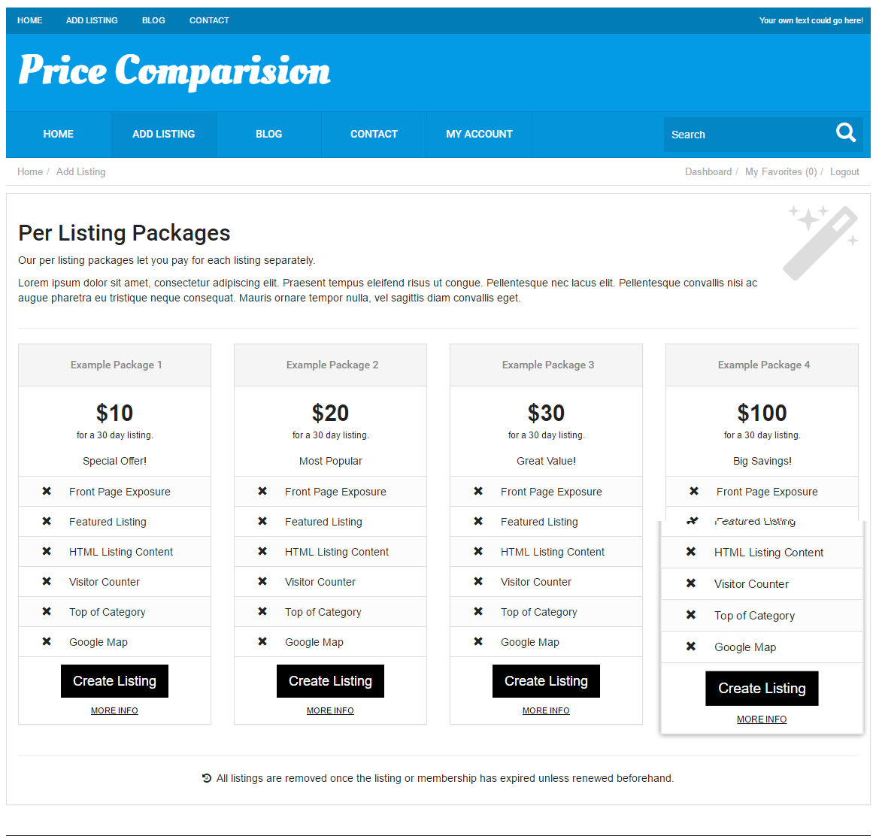
Description:
This page serves to select the membership plan detail to create their own listing and link to view more information about the plan.

Add listing:
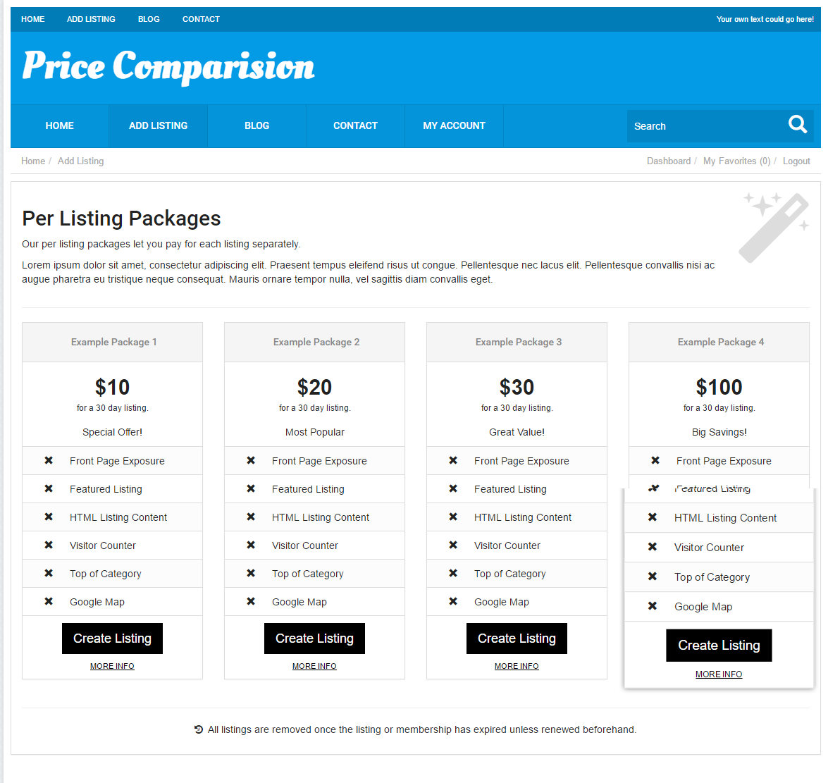
Description:
This page contains the membership plan details with its features and link to more information.

Add listing:
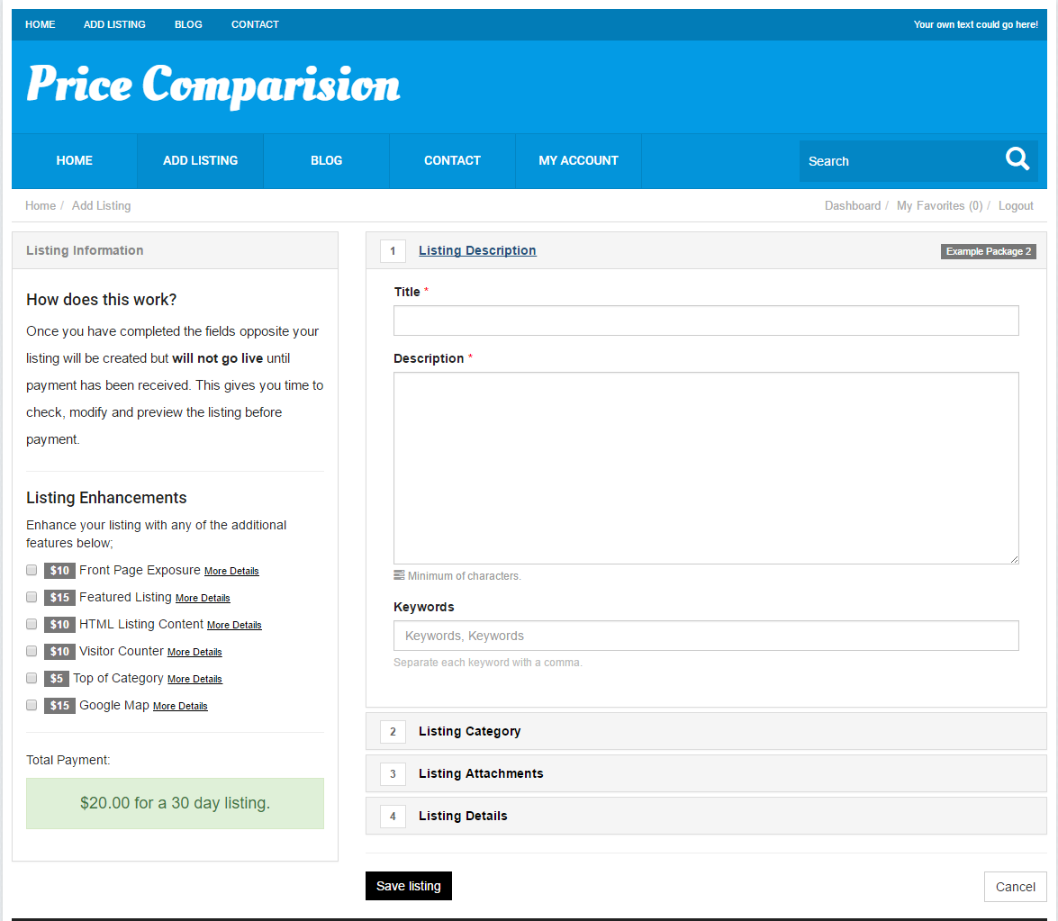
Description:
This page serves to add a product by filling entire required fields in the page.

My messages:
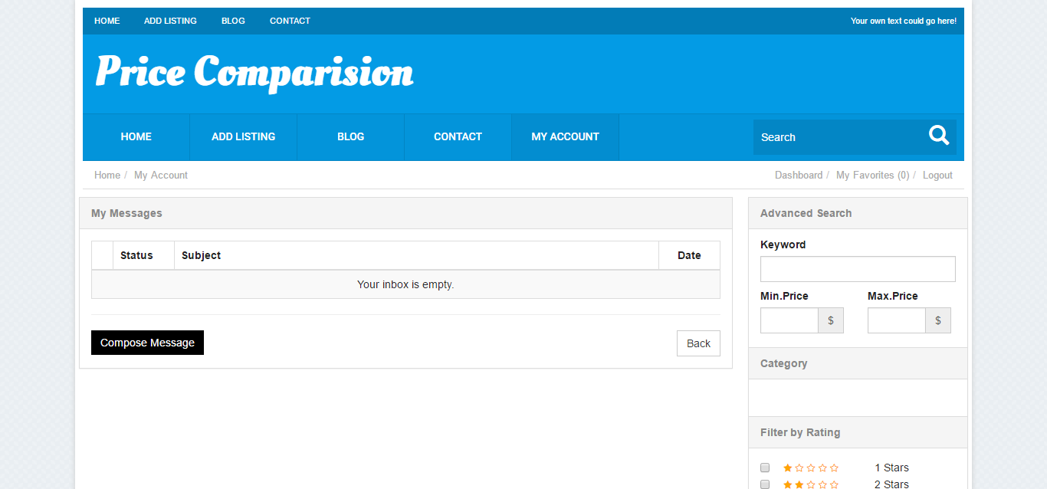
Description:
This page contains the details about the messages that received.

My favorite:
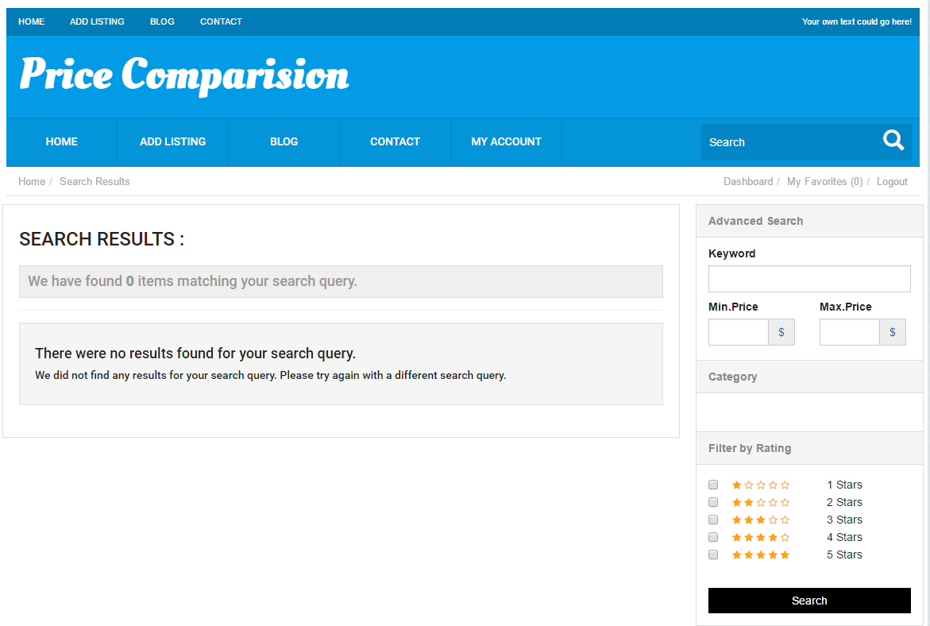

Description:
This page contains the favorite list details.

Home:
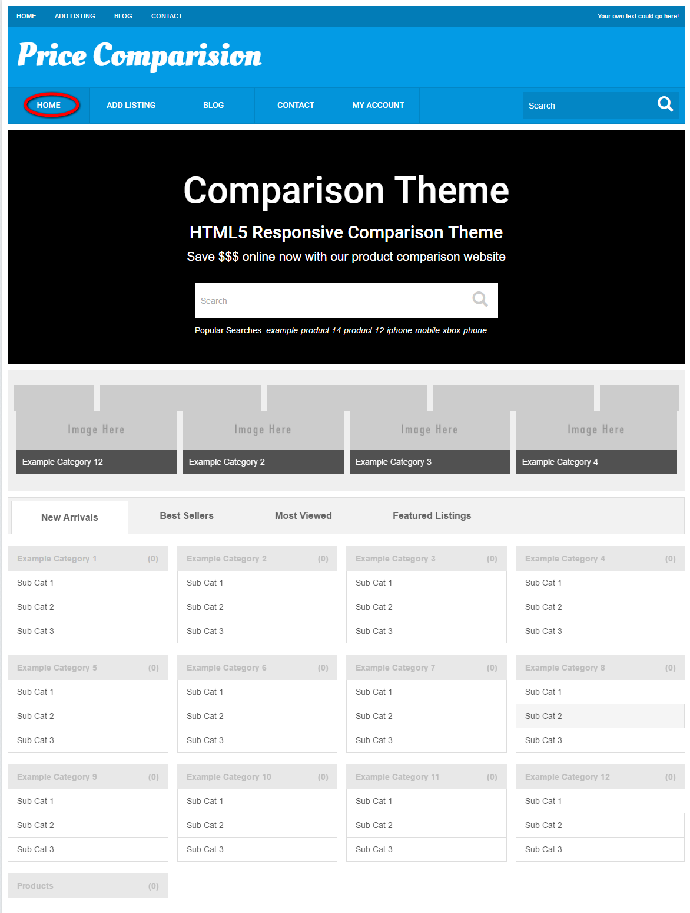
Description:
This page contains the search option with categories that arranged under new arrivals, best sellers, most viewed, featured listings.
Blog:
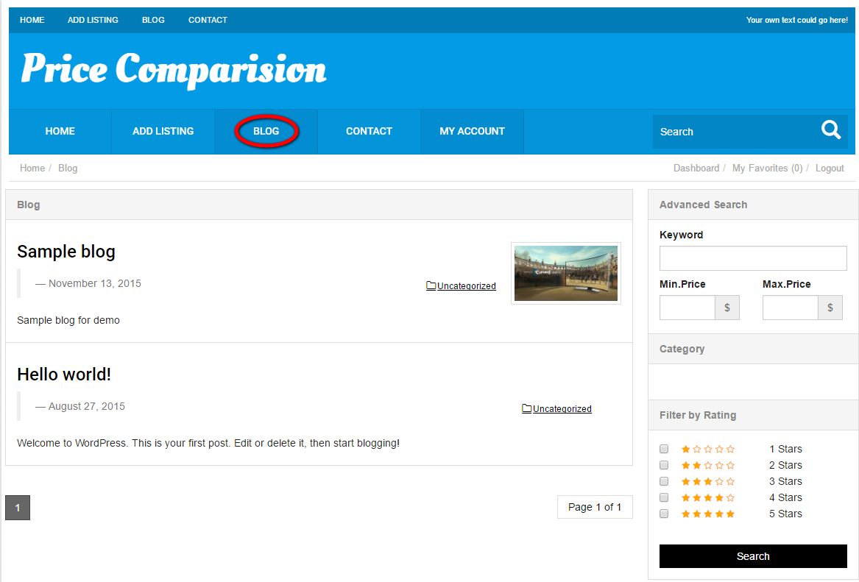
Description:
This page contains the details of the blog with category detail.

Newsletter:
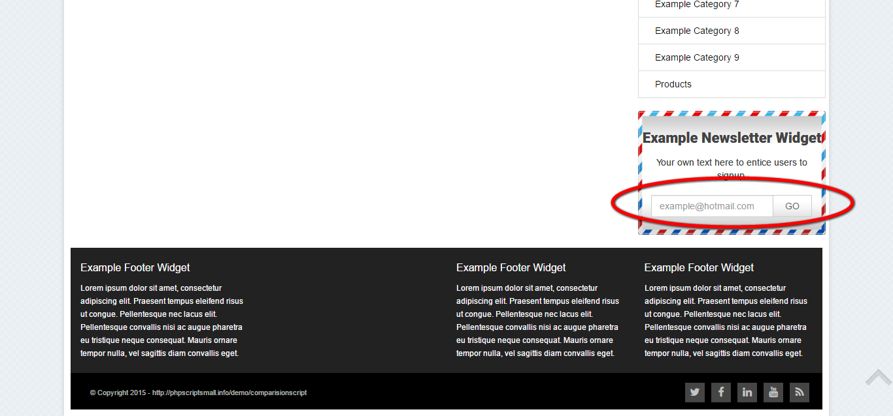
Description:
this serves as subscribe for the latest update via mail id.

Contact:
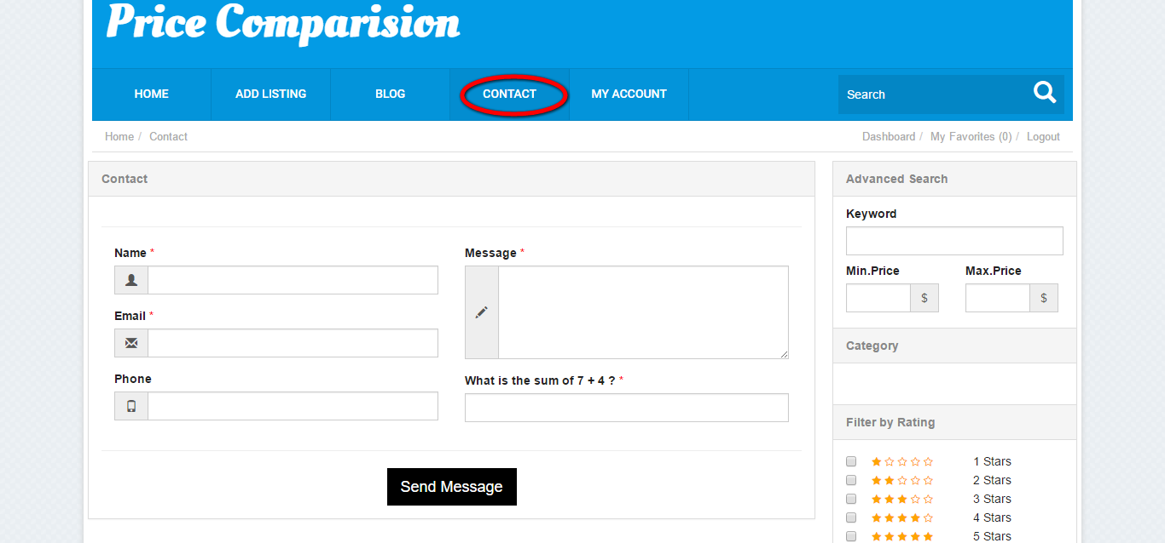
Description:
This page serves to send an enquiry to the concern company.

Admin view
Login:
Description:
This page is serves as login as admin with valid username and password.

Dashboard:
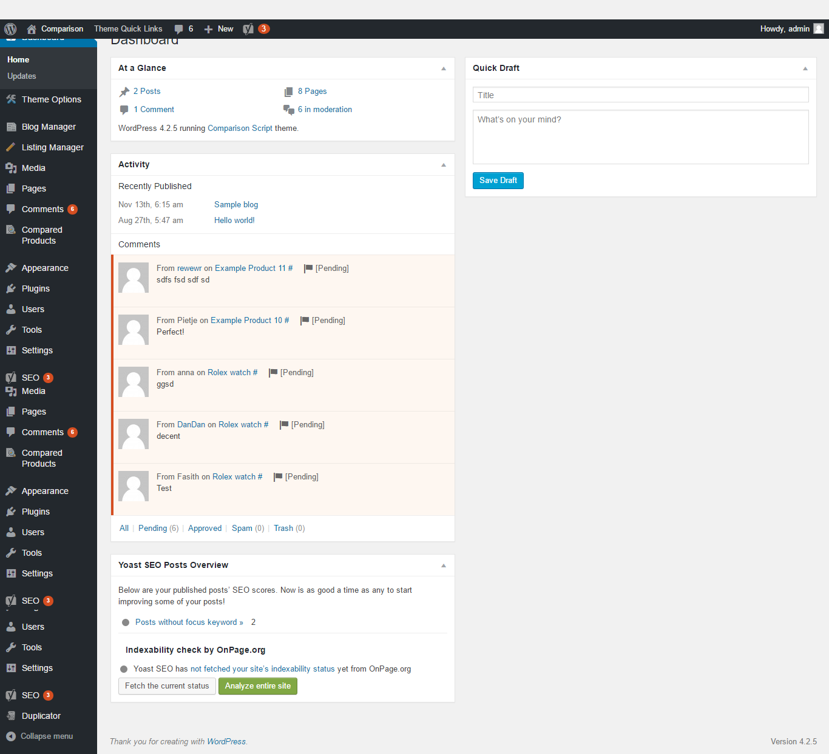
Description:
This page manages the recent activities with at a glance detail, quick draft and yoast SEO post overview.

Theme options:
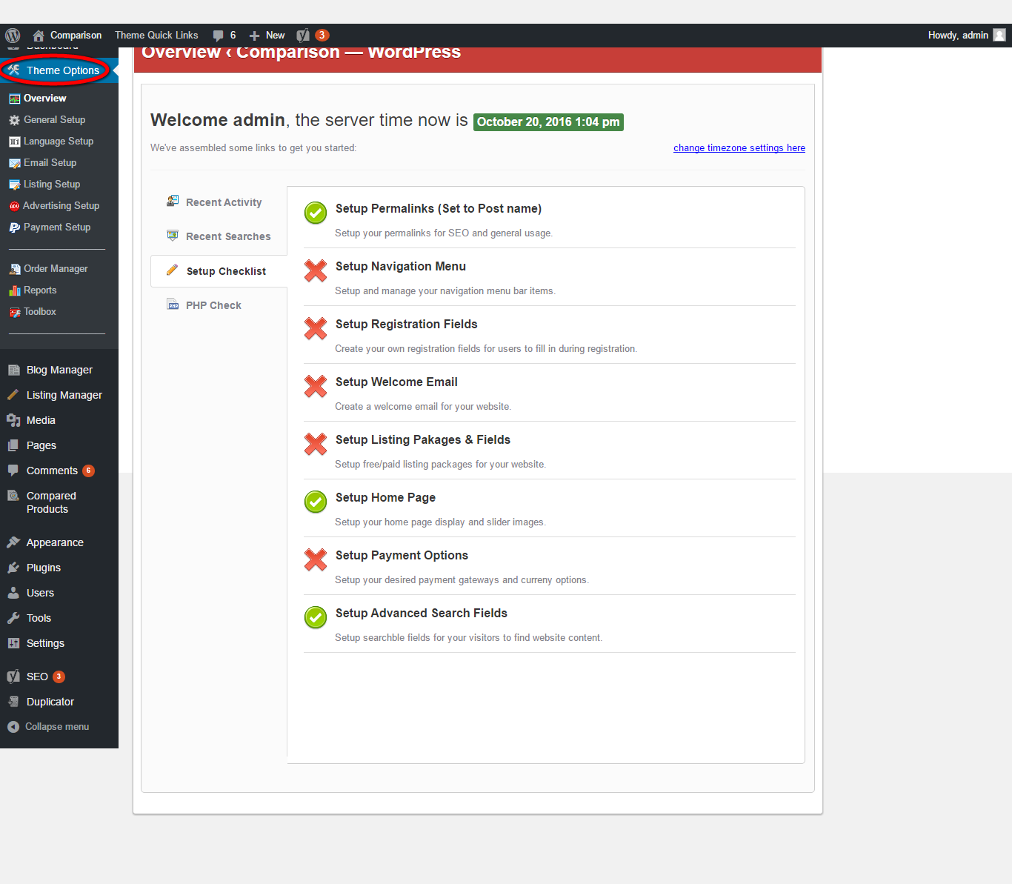
Description:
This page manages the theme details with the options of overview, general setup, language setup, email and listing setup, advertising setup, payment setup. Other than this admin can manage the order, reports and toolbox details.

Overview:
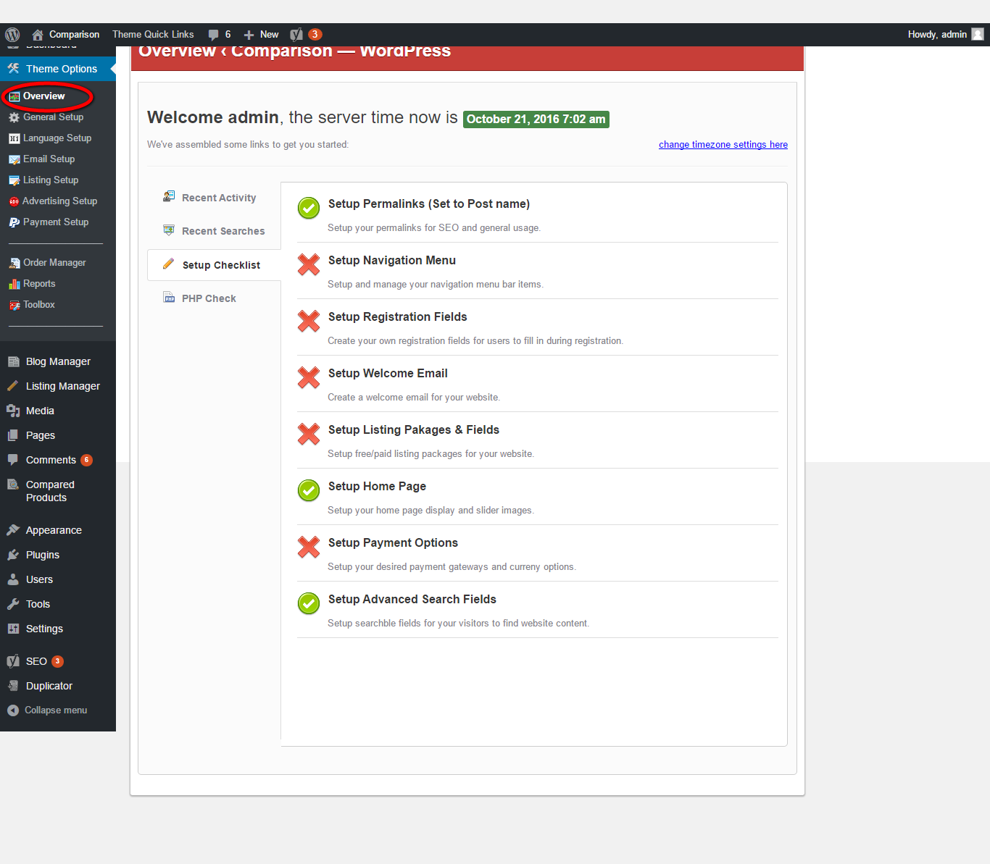
Description:
This page manages the recent activity and searches, setup checklist and PHP check details.

General setup:
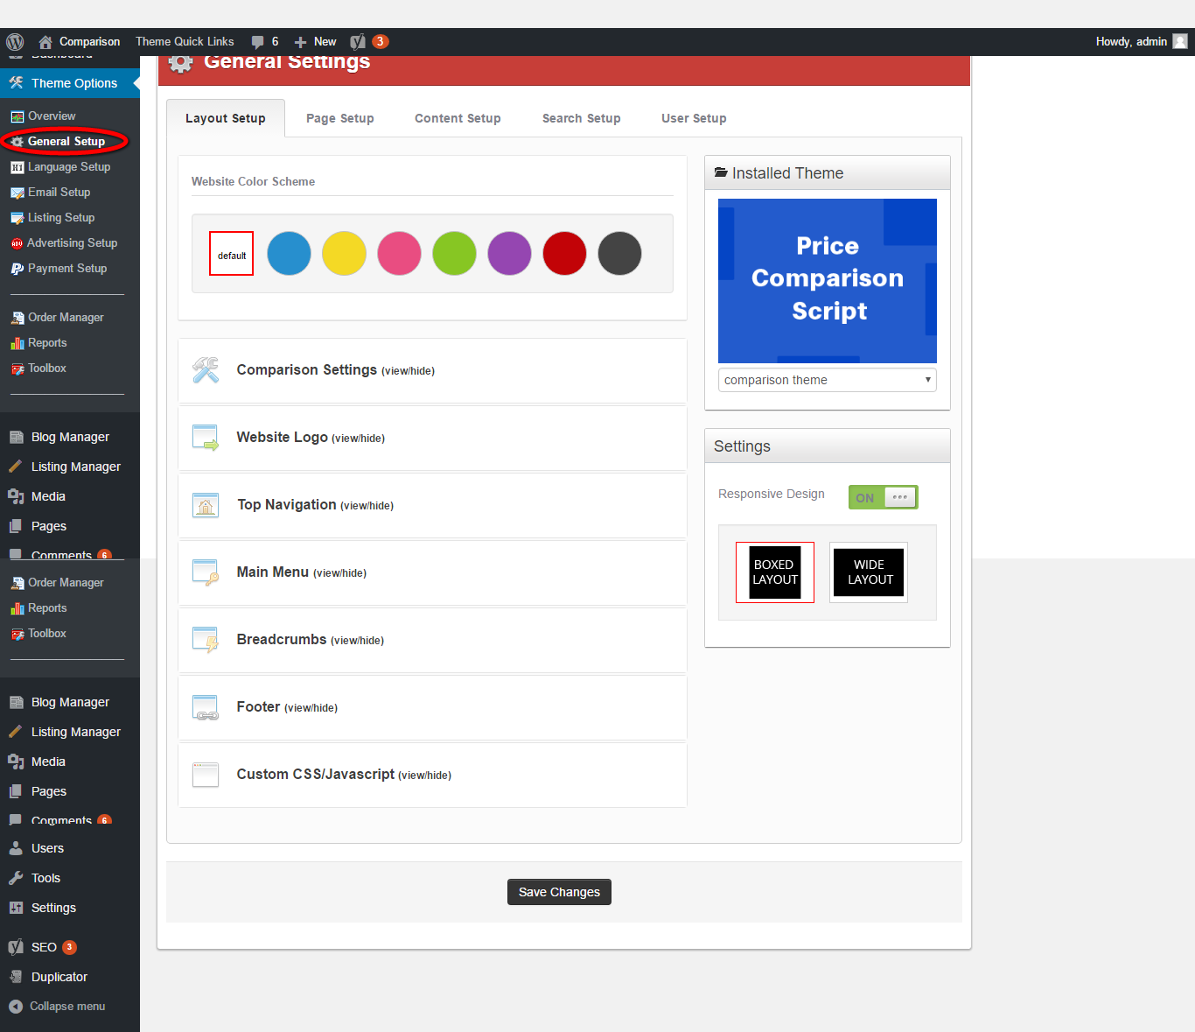
Description:
This page manages the general setup such as content setup, layout setup, search setup, page setup and user setup details.

Language setup:
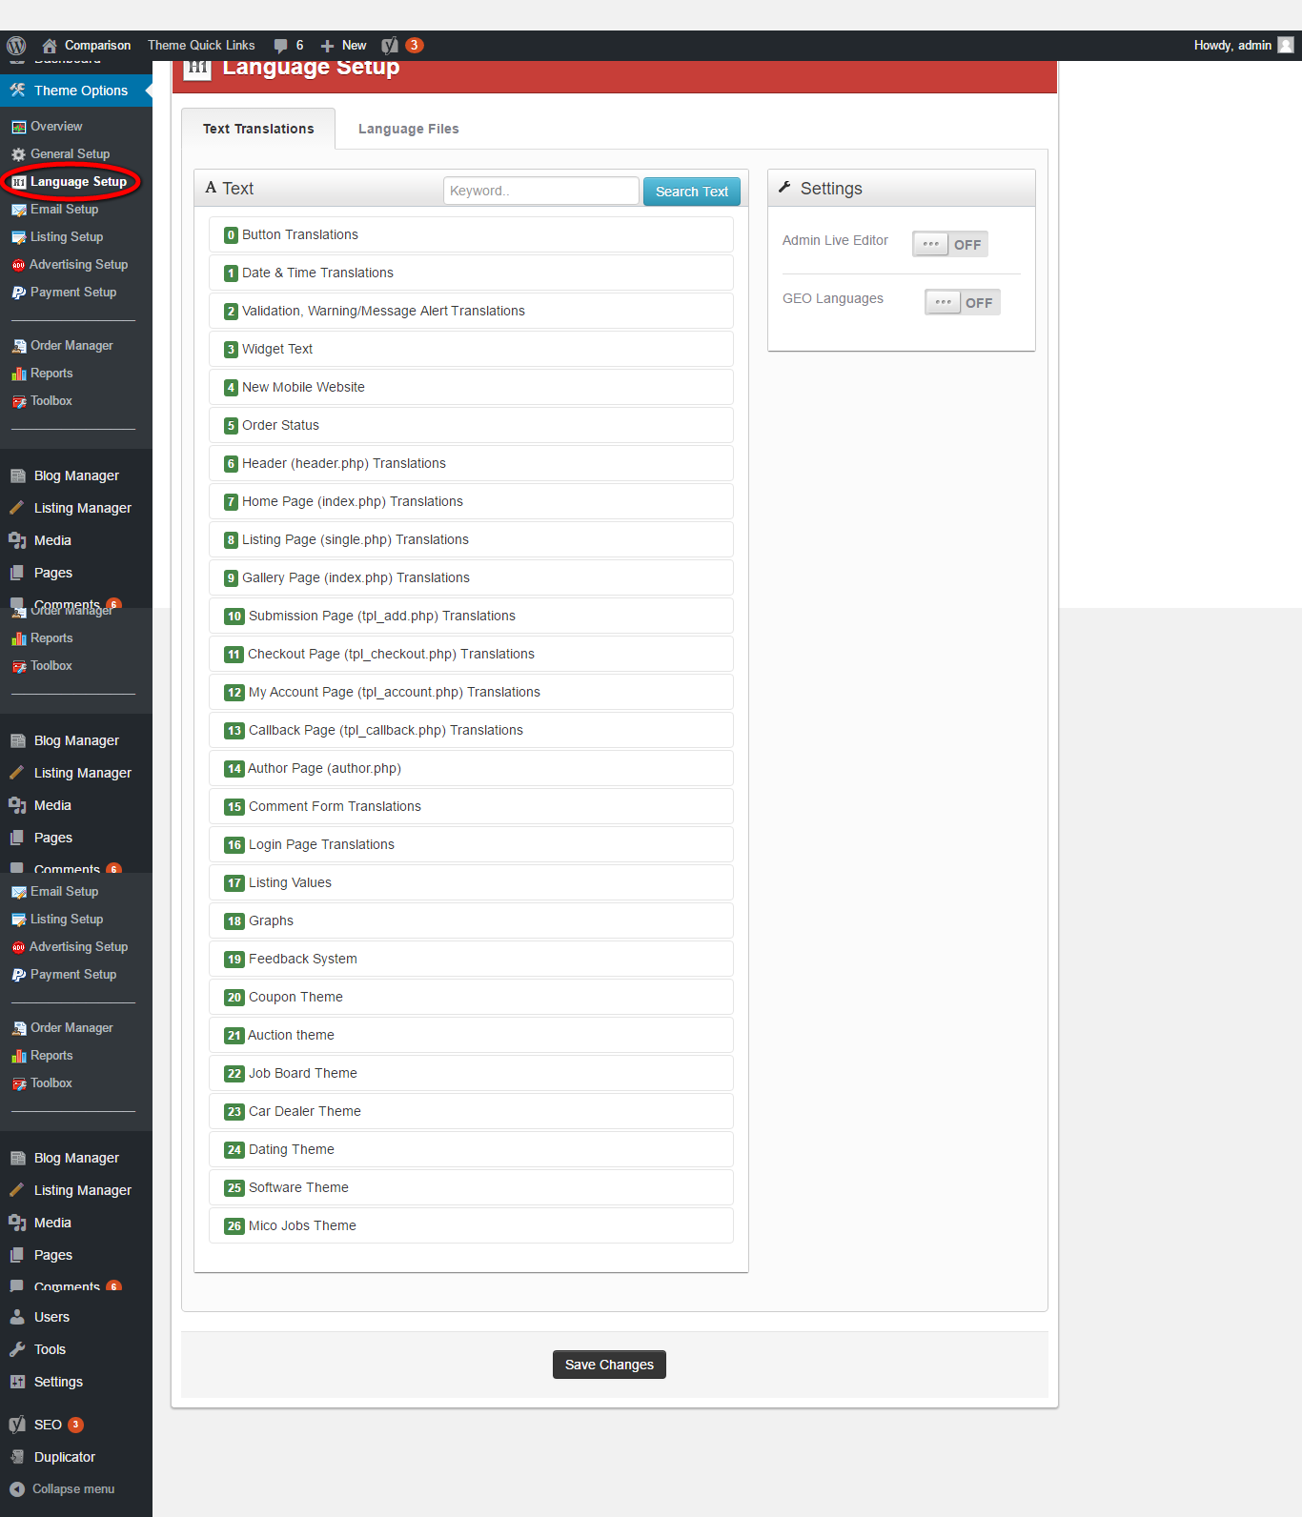
Description:
This page manages the text translation and language files.
Email setup:
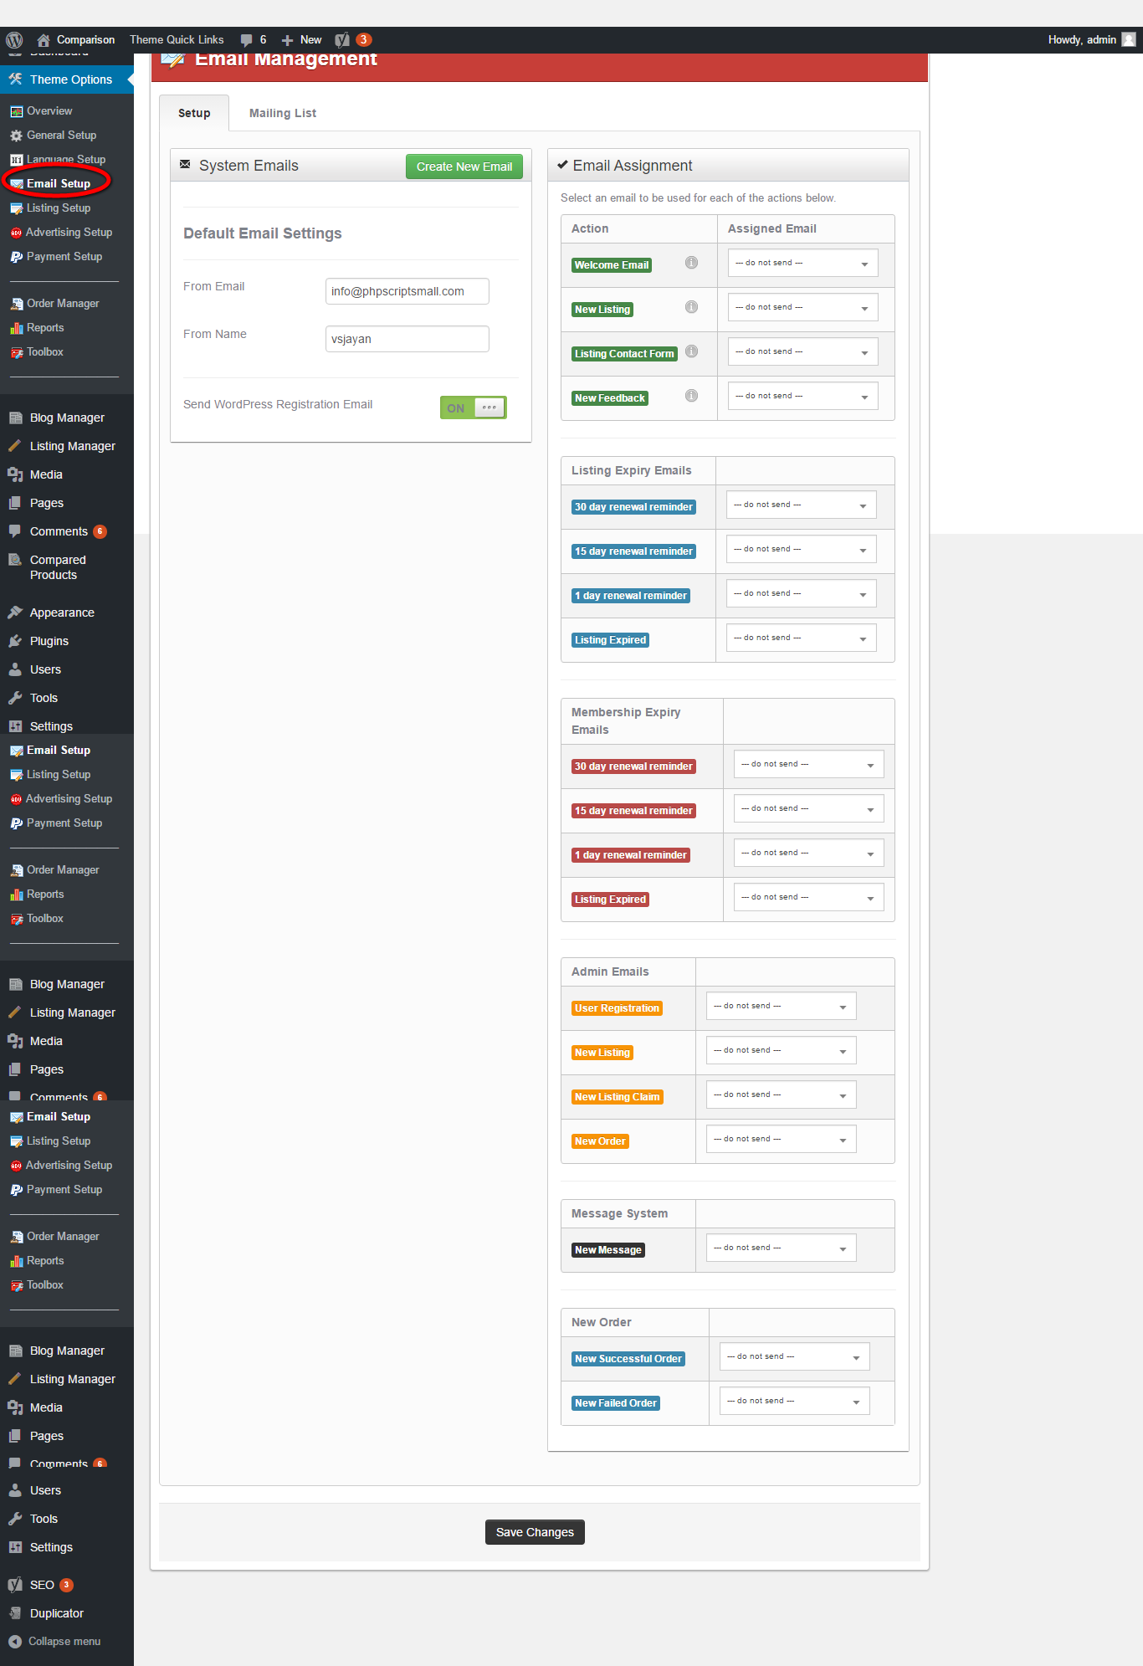
Description:
This page manages the entire email relevant details.

Advertising setup:
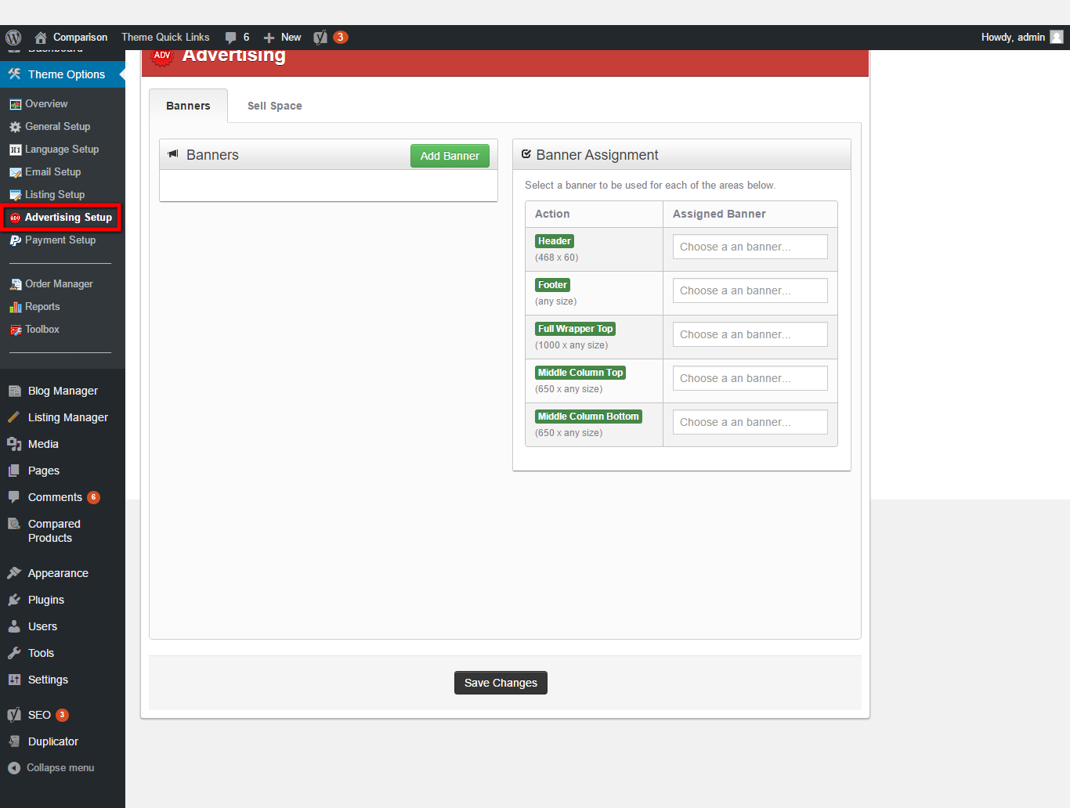
Description:
This page manages the advertising setup details with banner and sell space details.

Order manager:
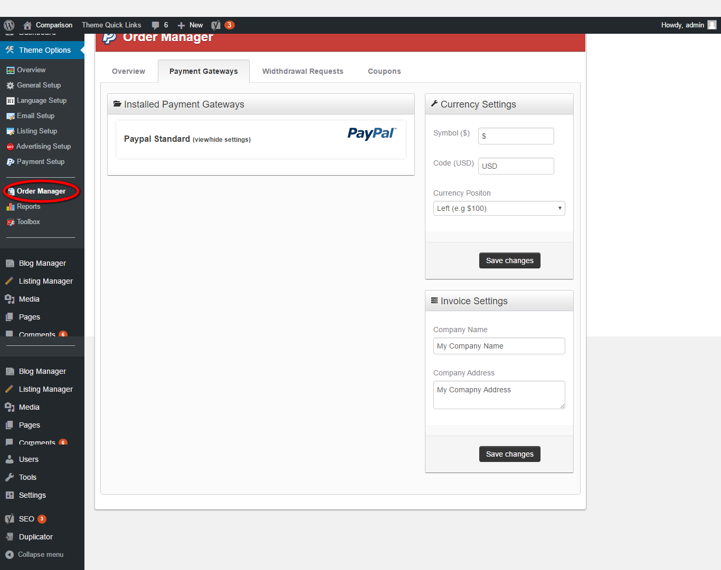
Description:
This page manages the relevant details to the payment such as payment gateway, withdrawal request, coupon detail.

Toolbox:
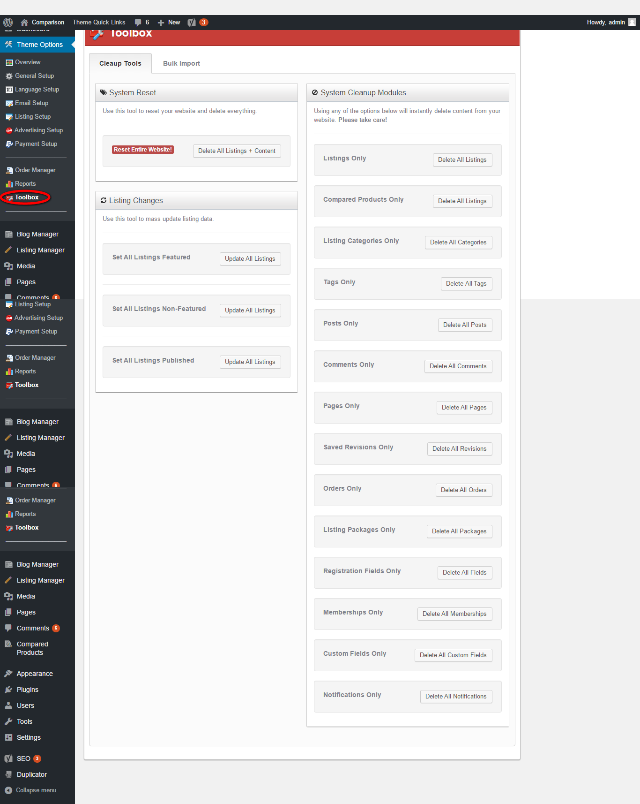
Description:
This page manages the Toolbox details such as cleanup tool and bulk import.
Blog manager:
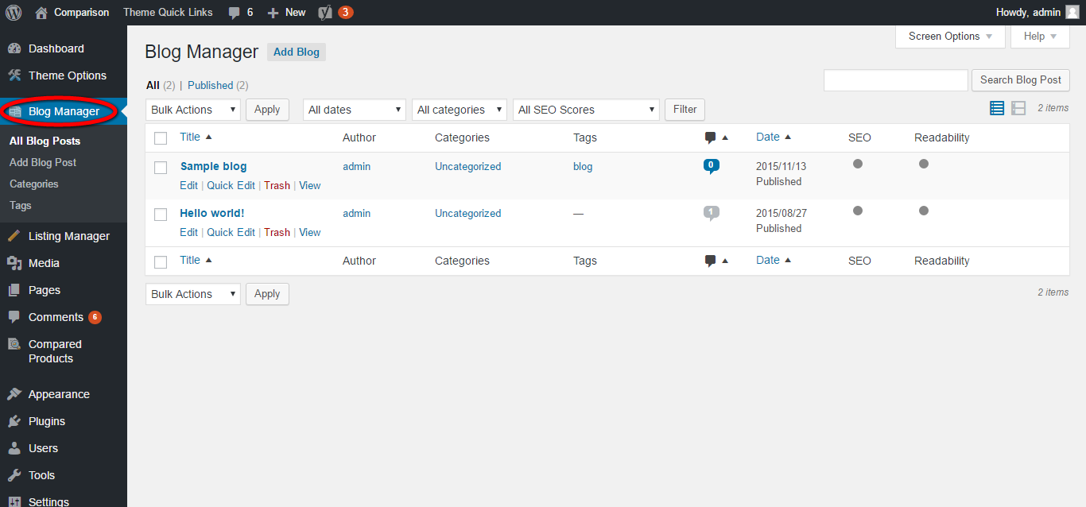
Description:
This page manages the blog details with the option of search, add new blog post, category management, tag management.

Listing management:
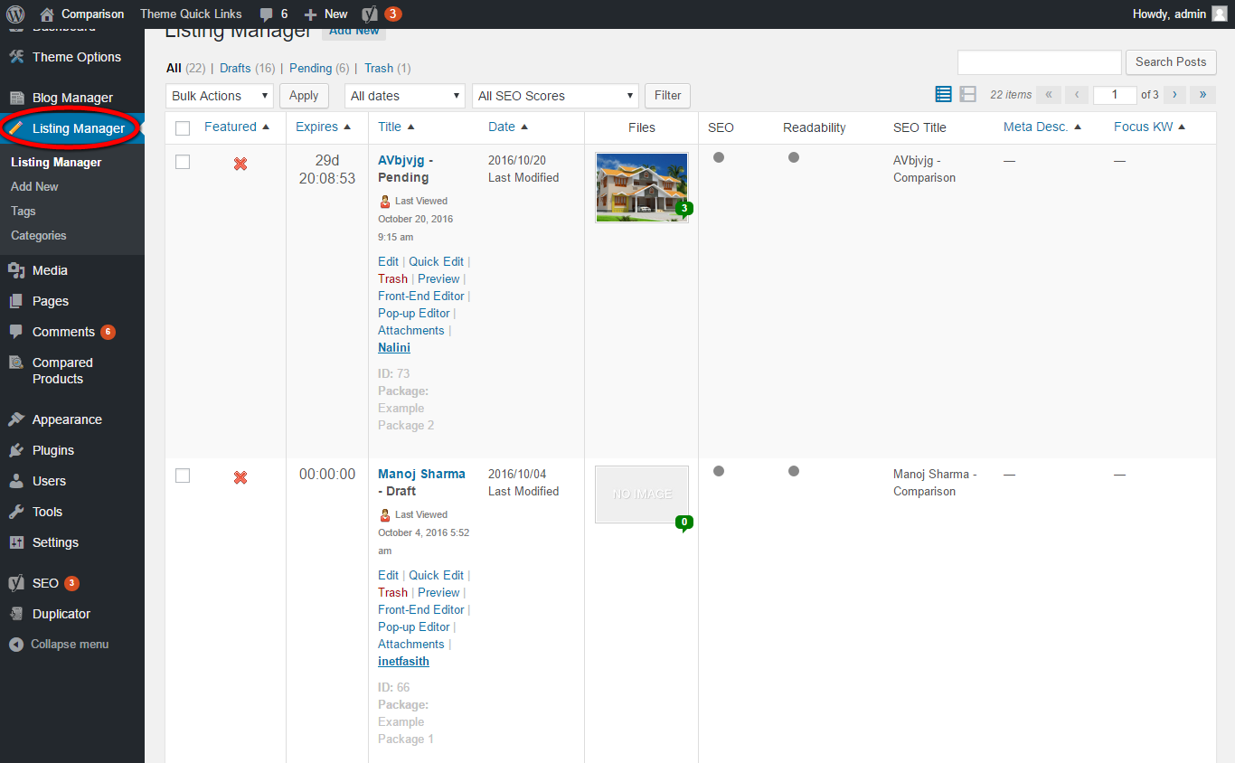
Description:
This page manages the listed product details with search option, add new listing ddetails option, tag and category management.

Media:
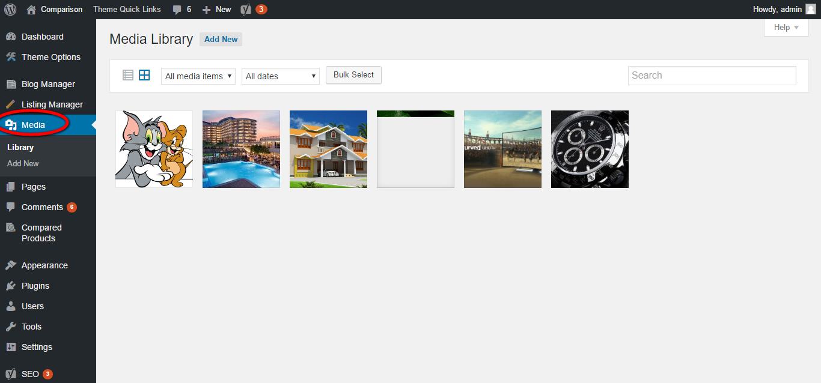
Description:
This page manages the media details in the entire posts with options of search, fitration, add new list.

Pages:
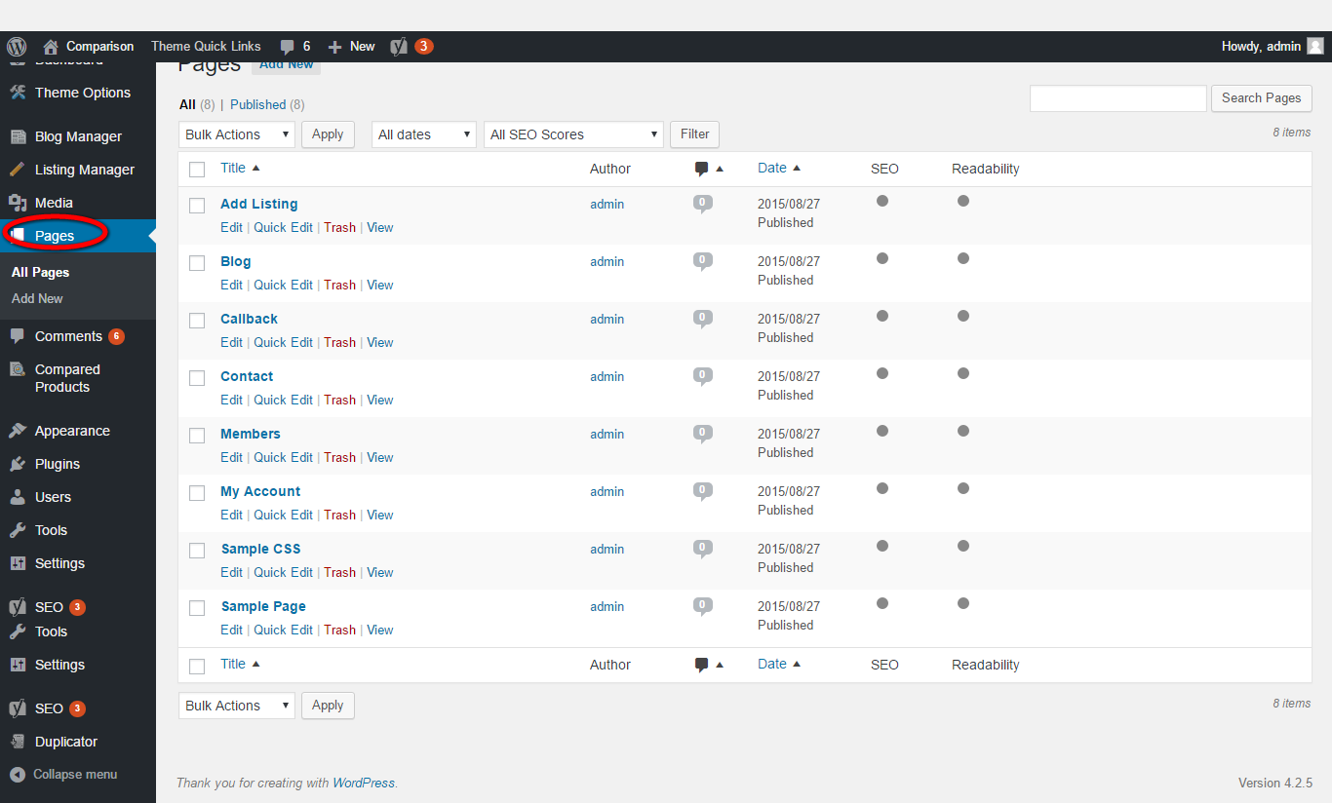
Description:
This page manages the page details with the options of search, filtration, add new page detail.

Comments:
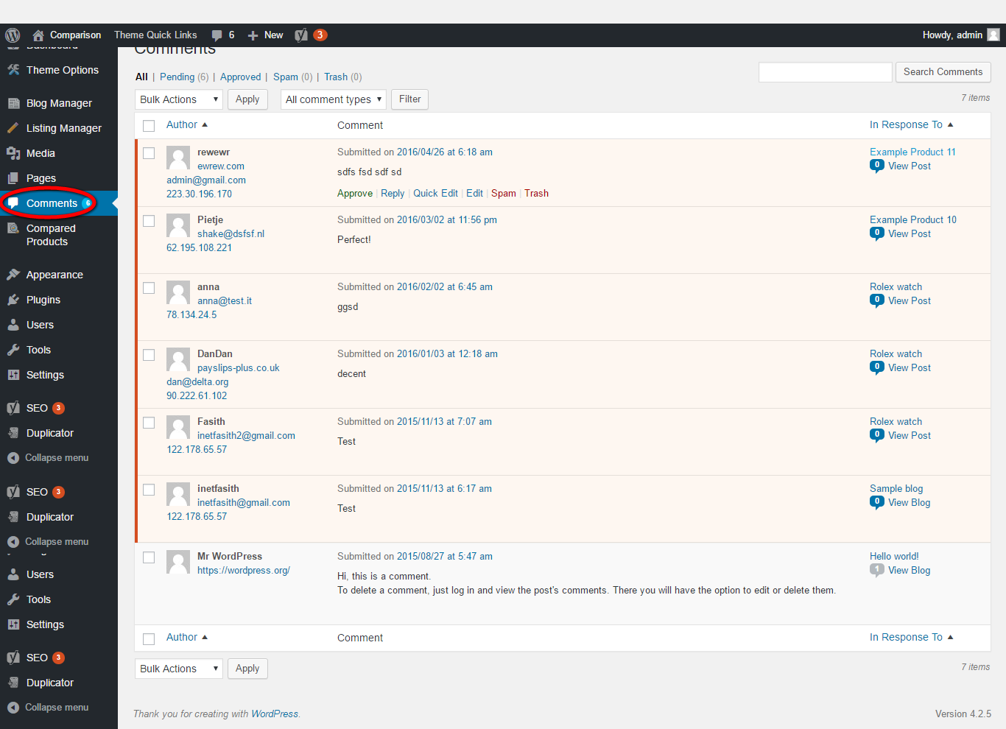
Description:
This page manages the comment details with option of search, add new comment detail, filtration option.

Compared products:
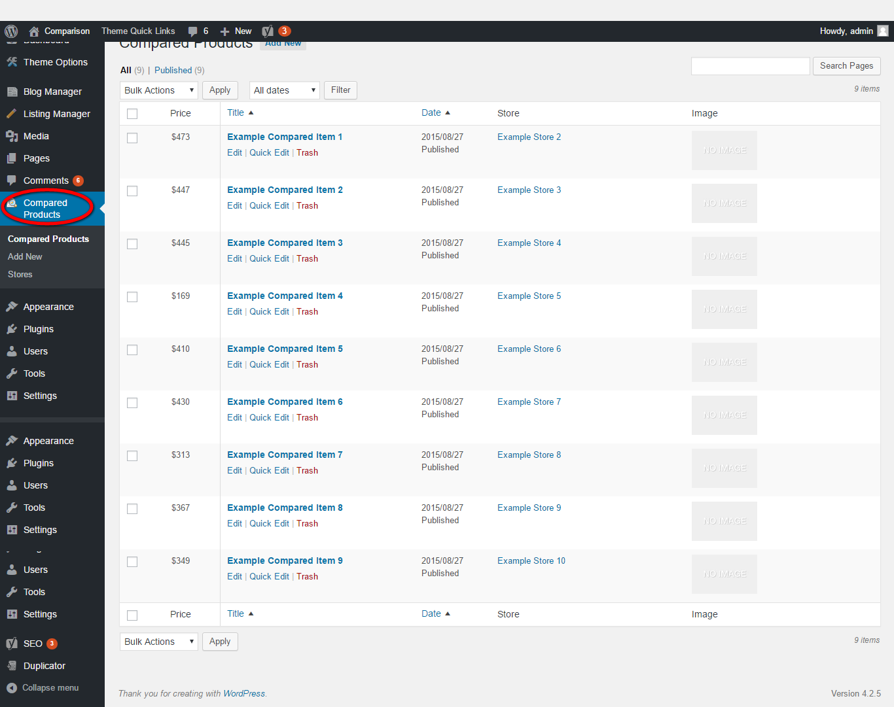
Description:
This page manages the entire compared product details with the option of search, add new compared products and manages the store details.

Appearance:
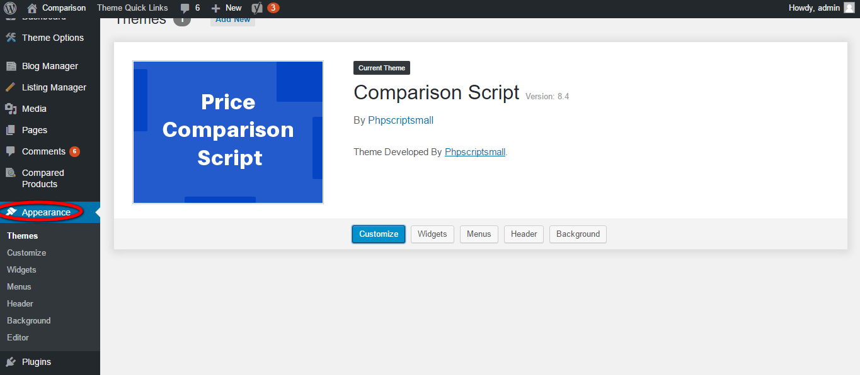
Description:
This page serves to maintain the appearance of the entire script such as theme, customize, widgets, menus, header and background.

Plugins:
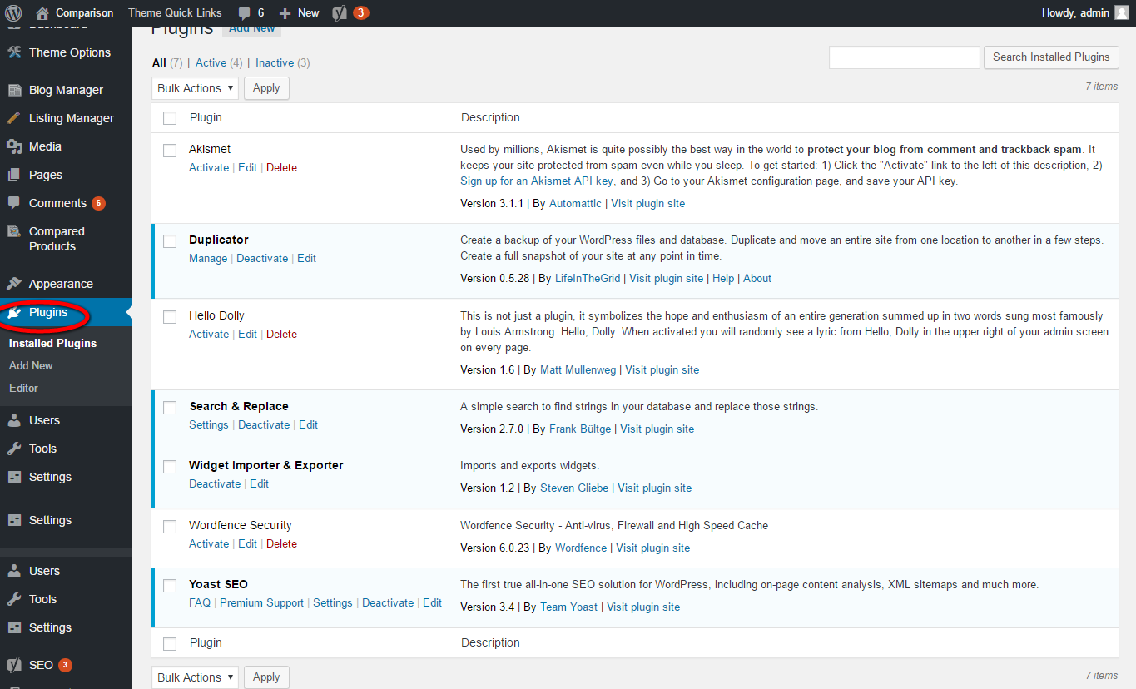
Description:
This page manages the installed plug-in details with the option of search, add new plug-in.

Users:
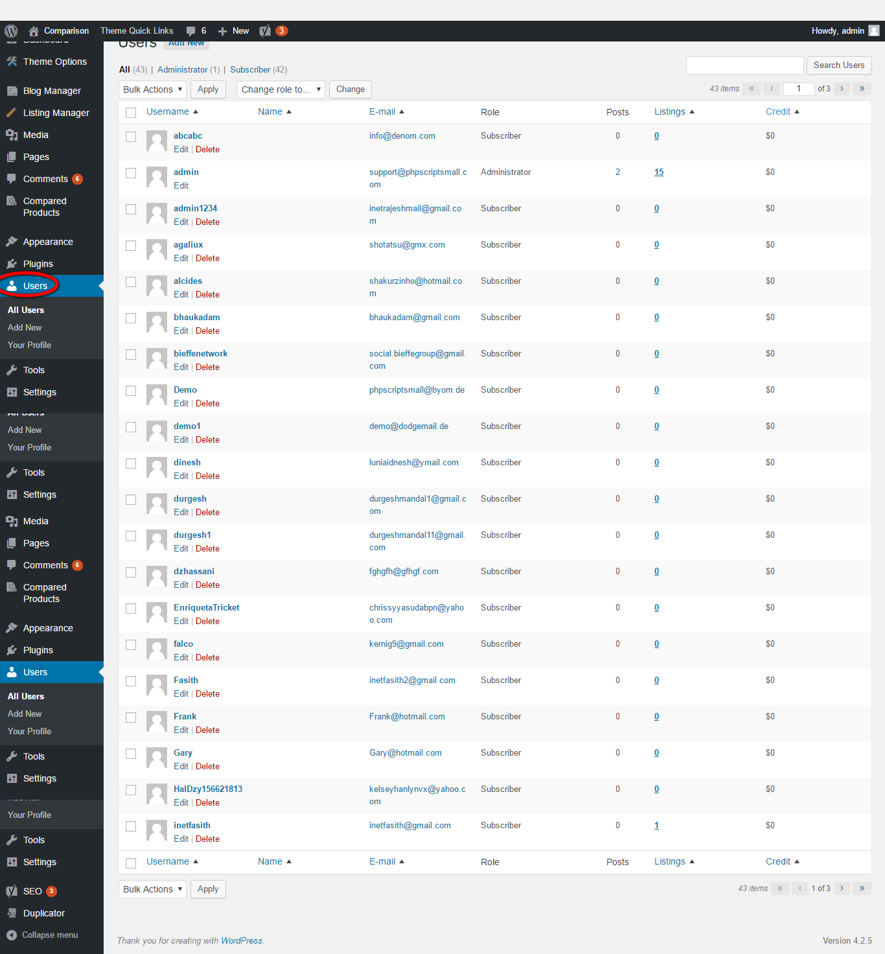
Description:
This page manages the user details with option of add new user detail, view profile detail, search for a particular user option.

Tools:
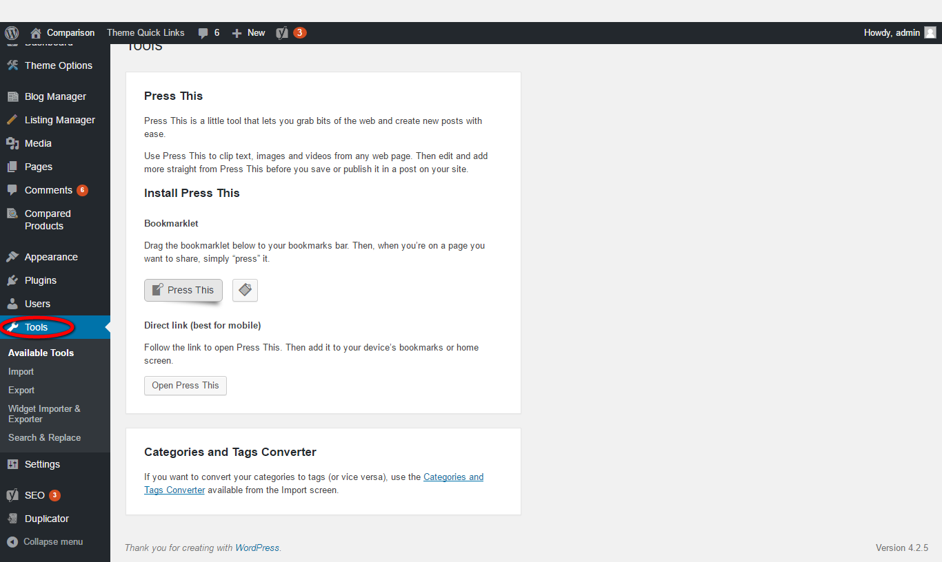
Description:
This page manages the available tool details with the option of import, export, search and replace, widget importer and exporter.

Setting:
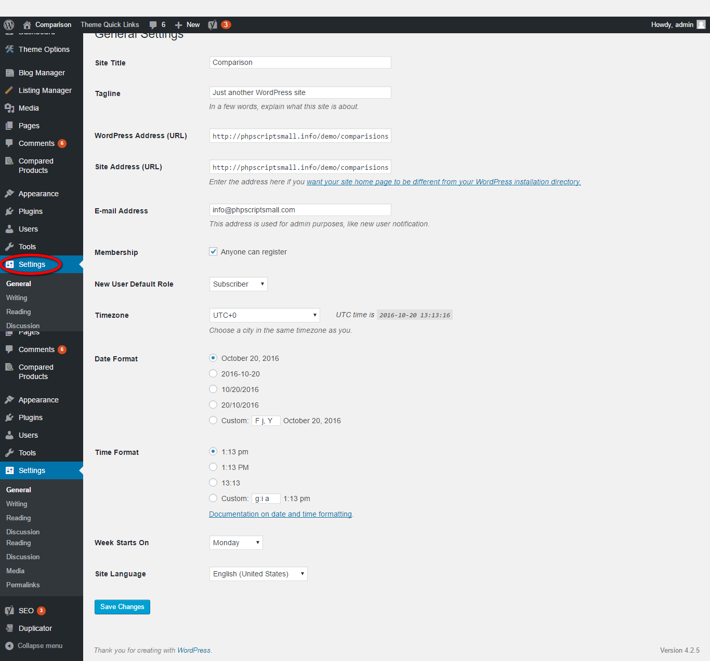
Description:
This page manages the setting details that controls the writing, reading, discussion, media and perlink settings.

SEO:
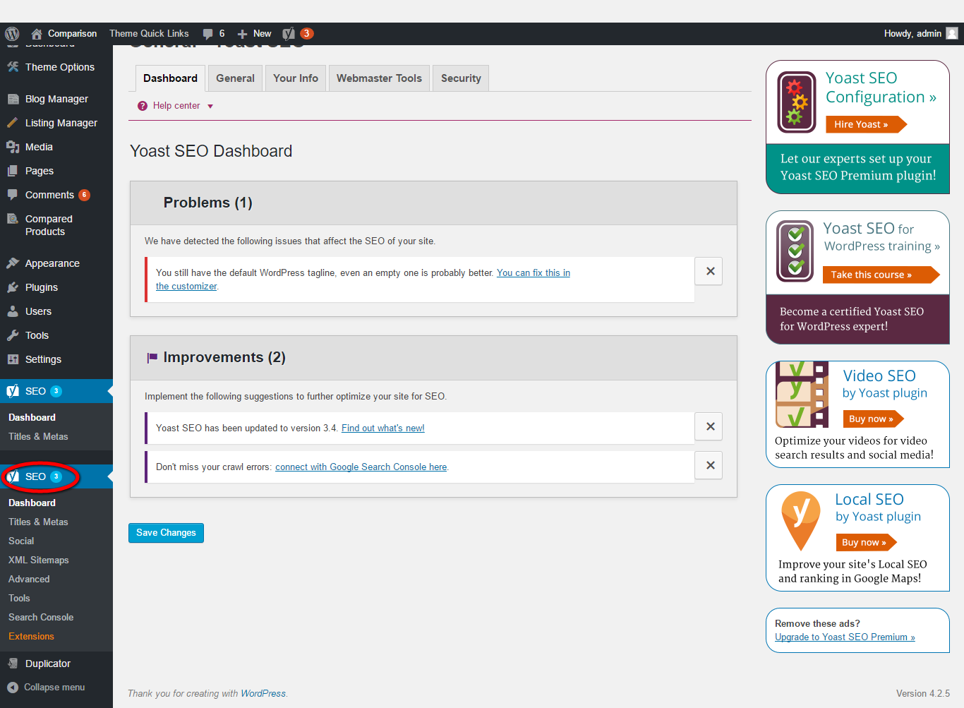
Description:
This page manages the entire SEO relevant details.

