PHP classified script
User view
Register:
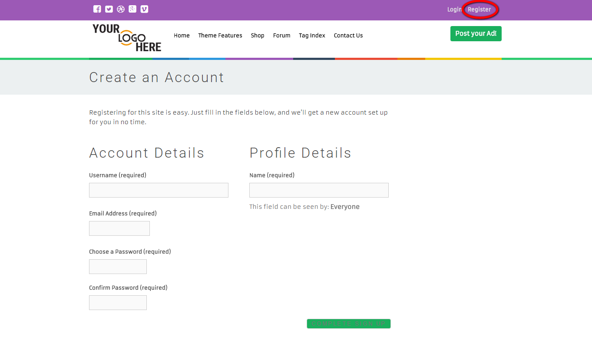
Description:
This page contains the fields that required for registration.

Login:
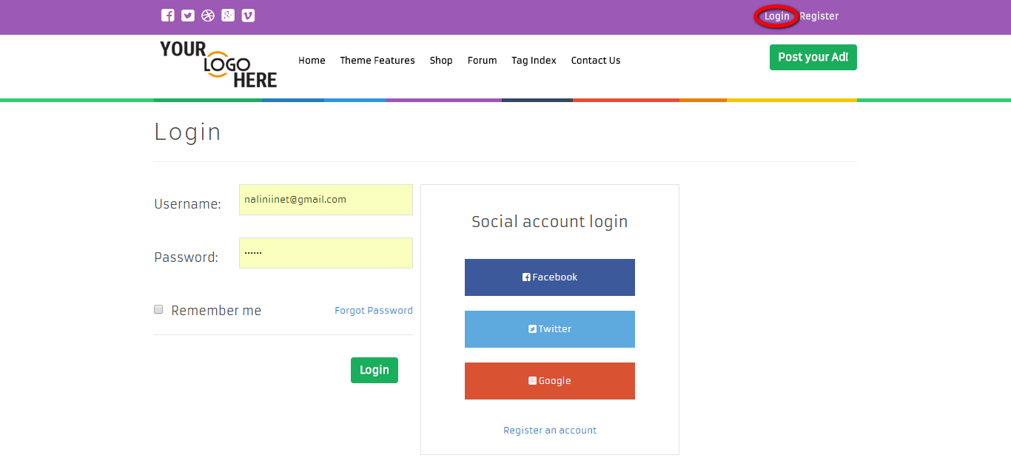
Description:
This page serves to login via valid user name and password. User can login via social media (currently disable). User has the forget password option to recover their account.

Home:
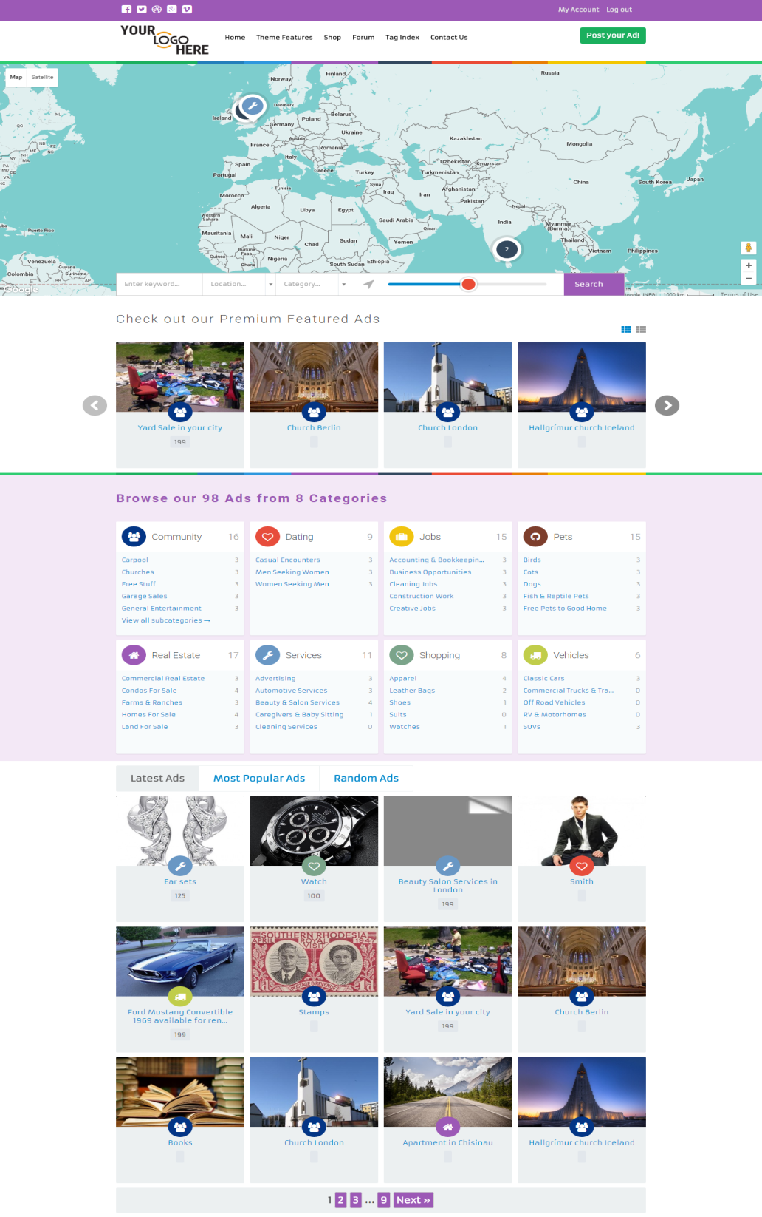
Description:
User can view the map view and search option. User can view the latest ads detail. User can view the premium featured ads.

Search:
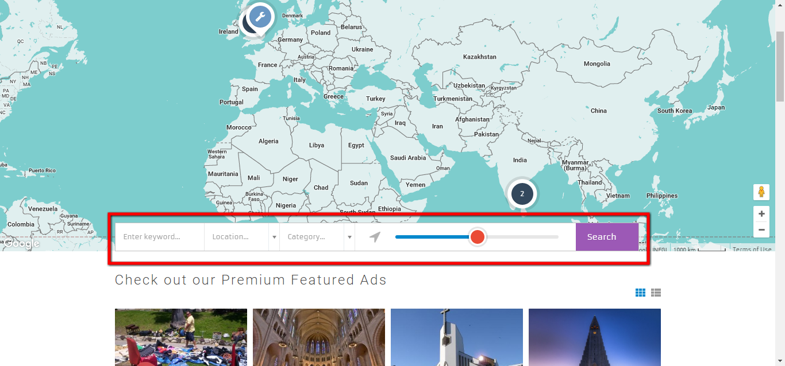
Description:
This page serves to search for the required field and filter the search option.

My account:
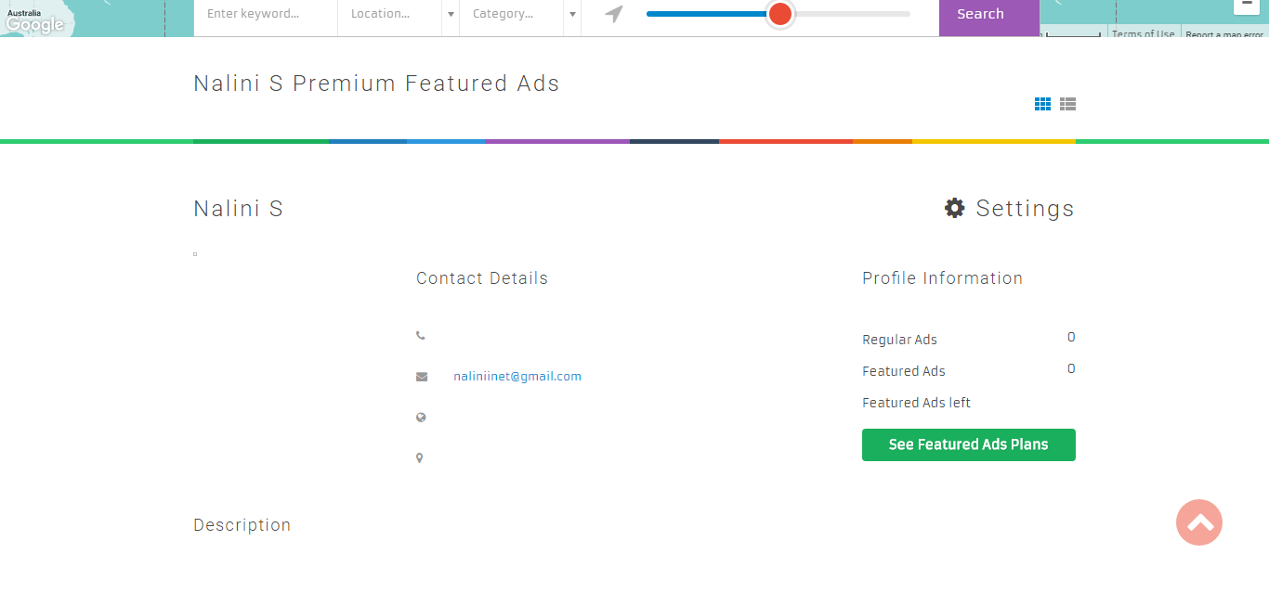
Description:
This page contains the profile details of the user.

Dashboard:
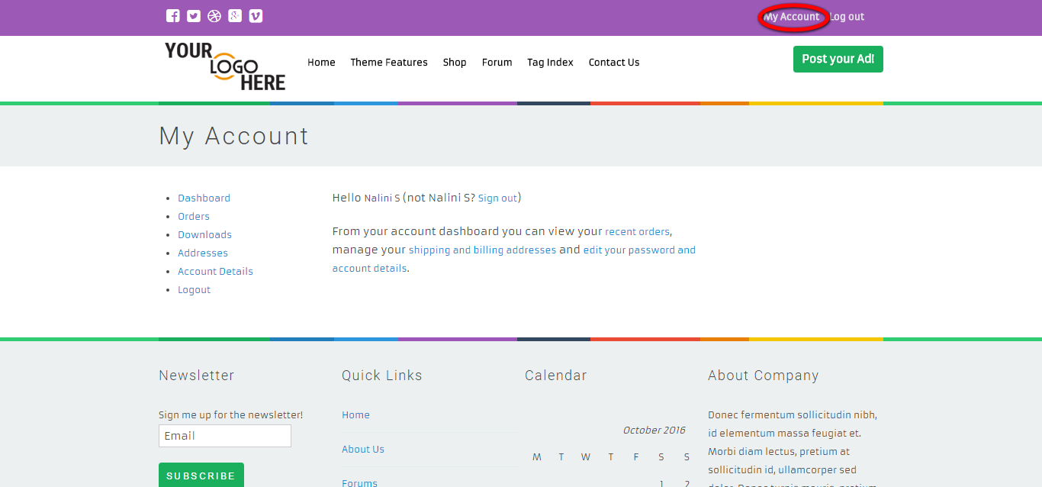
Description:
This page contains the shopping history details.

Order:
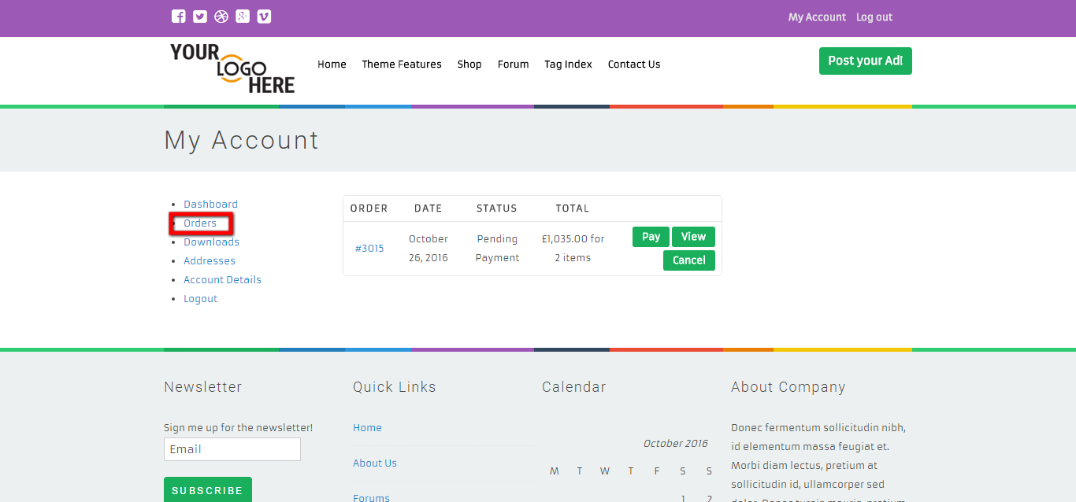
Description:
This page contains the order details with the status. User can view, pay or cancel the order.

Downloads:
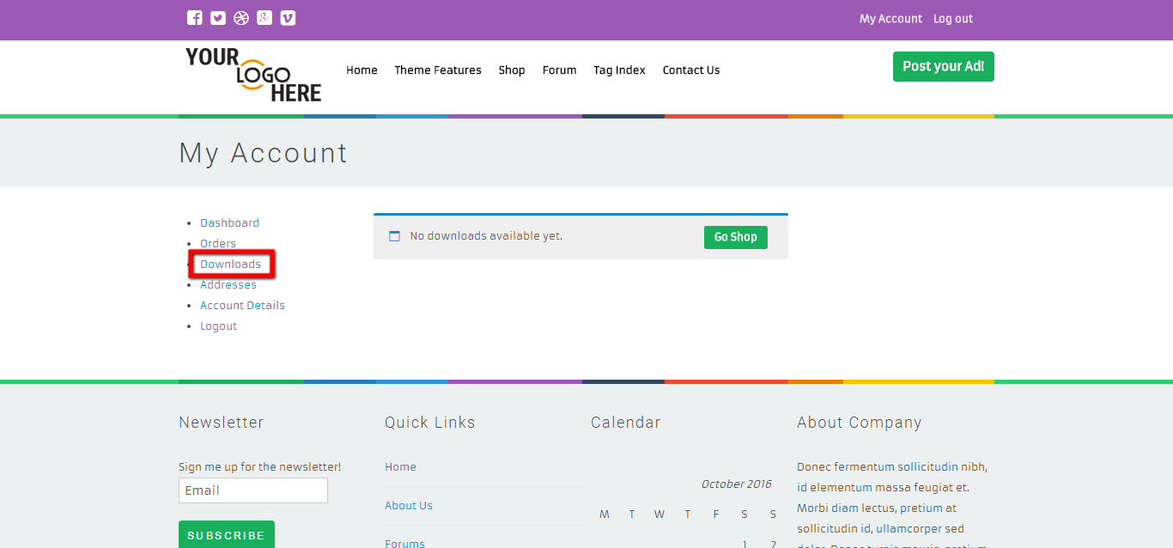
Description:
This page contains the download details.

Address:
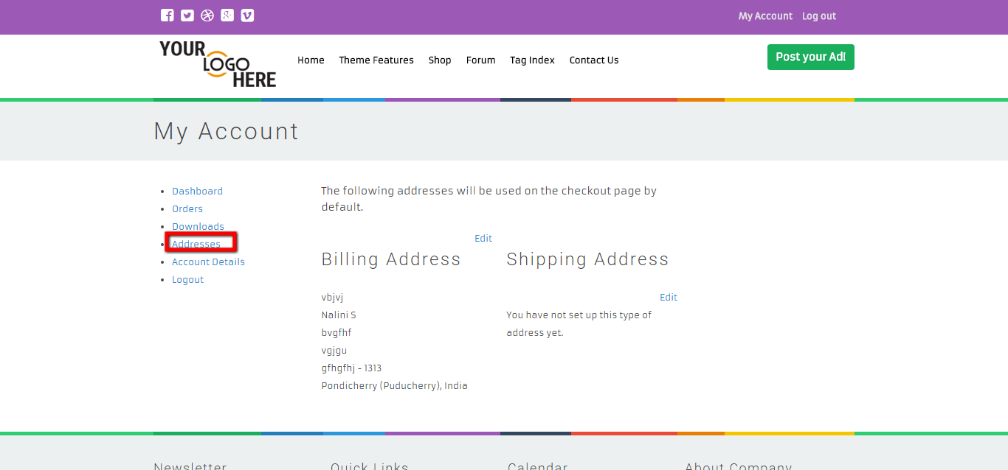
Description:
User can view and edit the billing and shipping address details.

Account details:
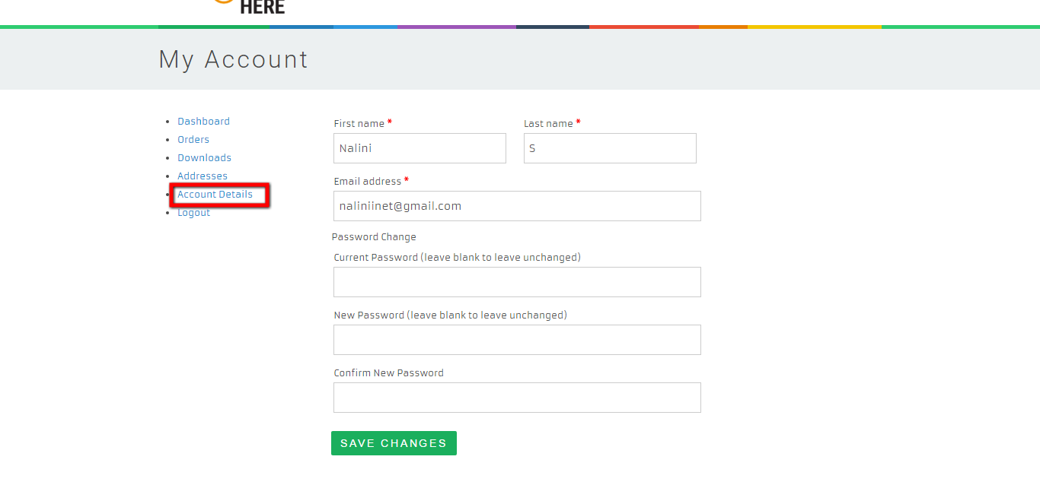
Description:
This page serves to view and edit the account details of the user. User can vary the mail id user name and password.

Post an ad:
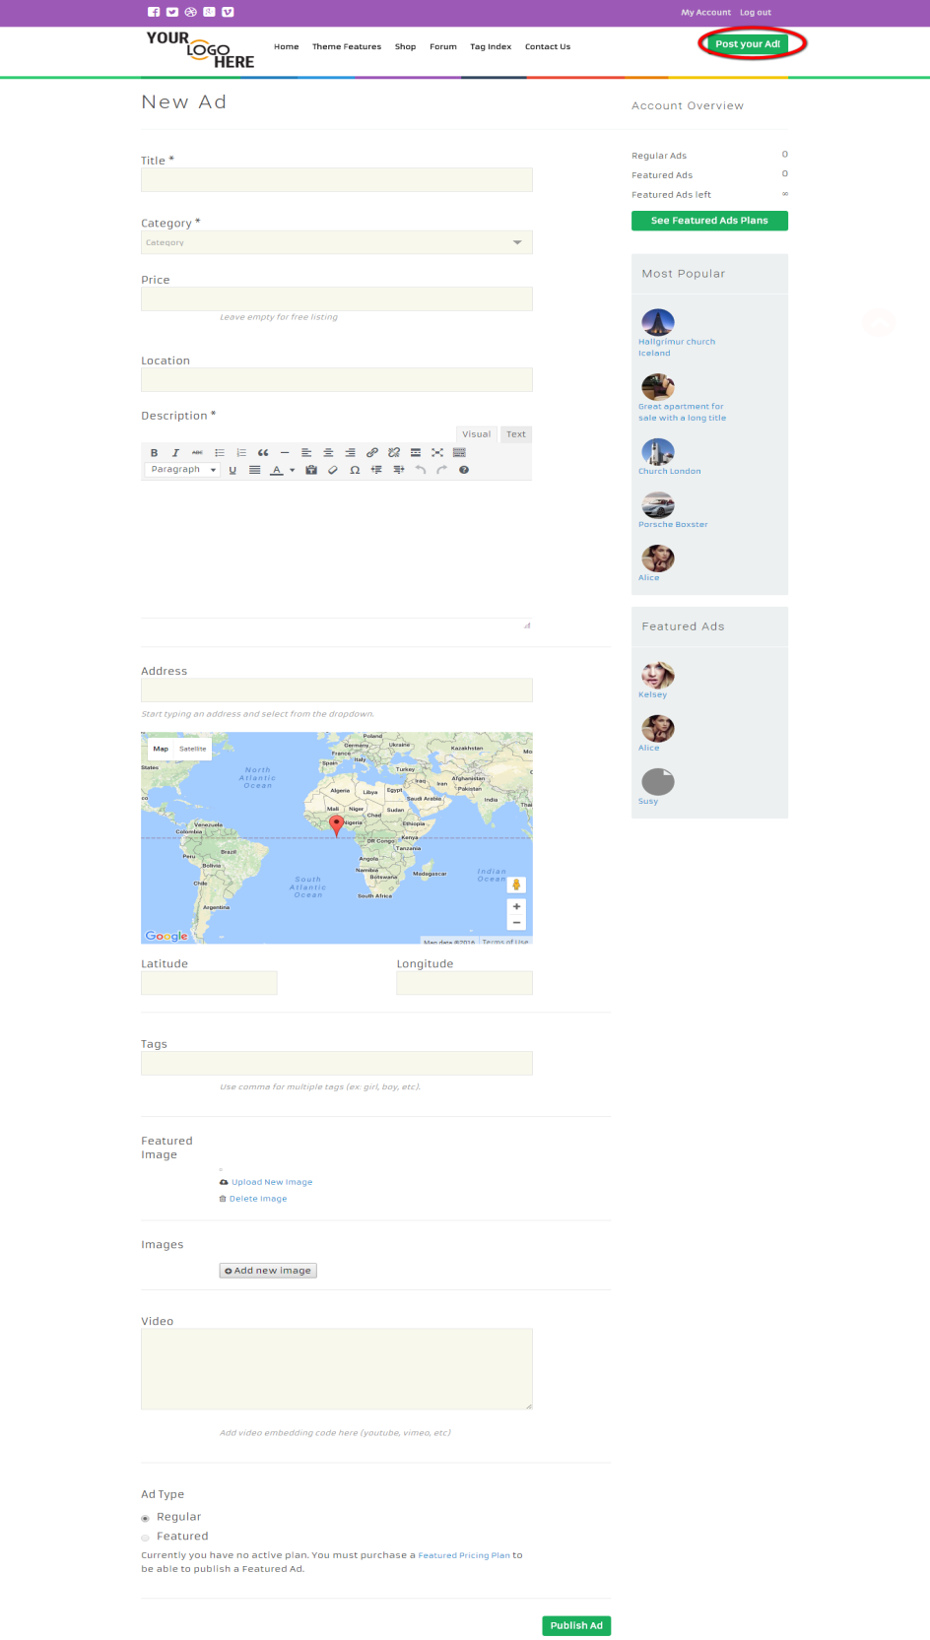
Description:
This page serves to manage the ad posting details. User can post an ad by entering entire required details.

Product:
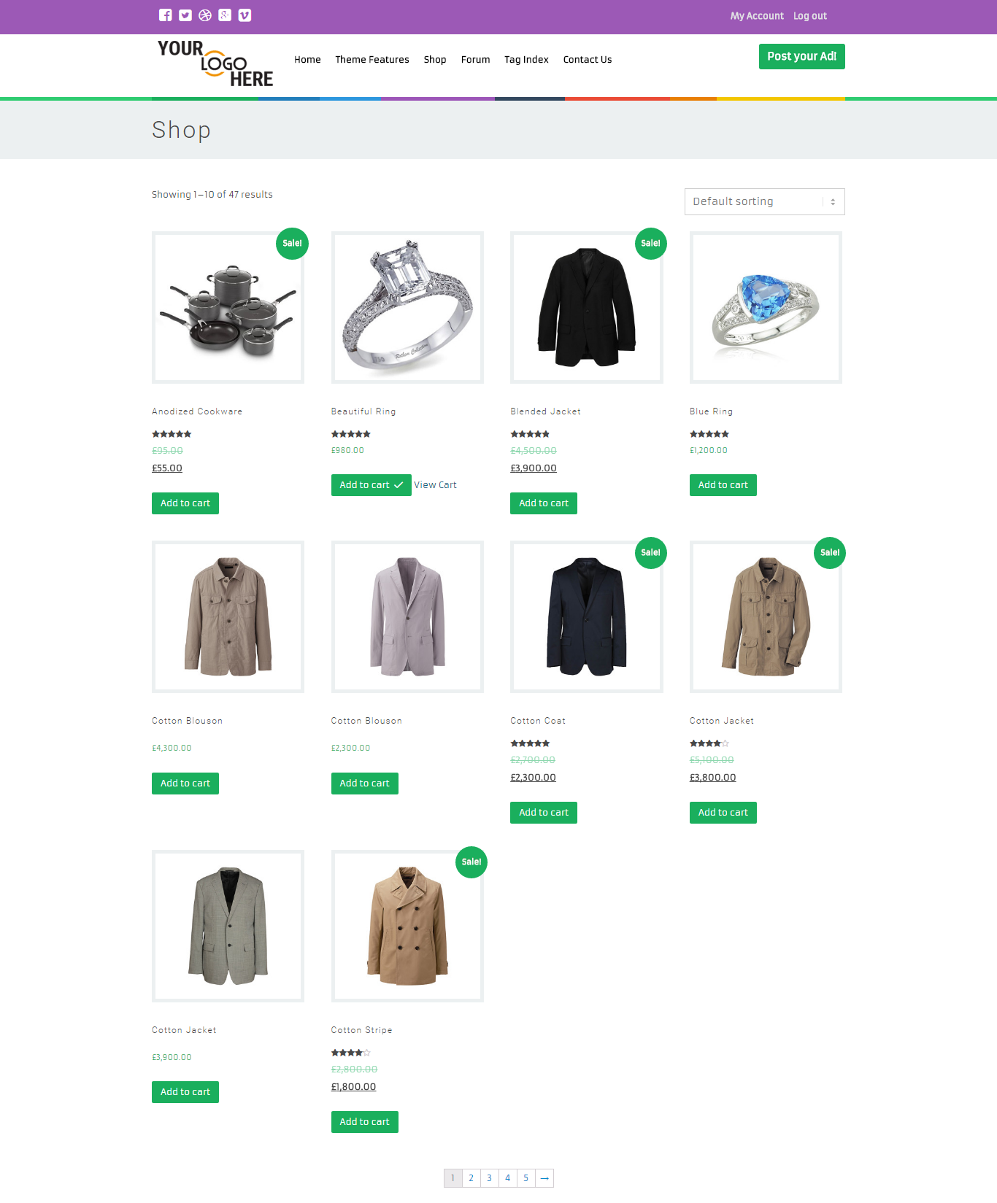
Description:
This page contains the entire product details with the name, price, tag details and addto cart option.

Product details:
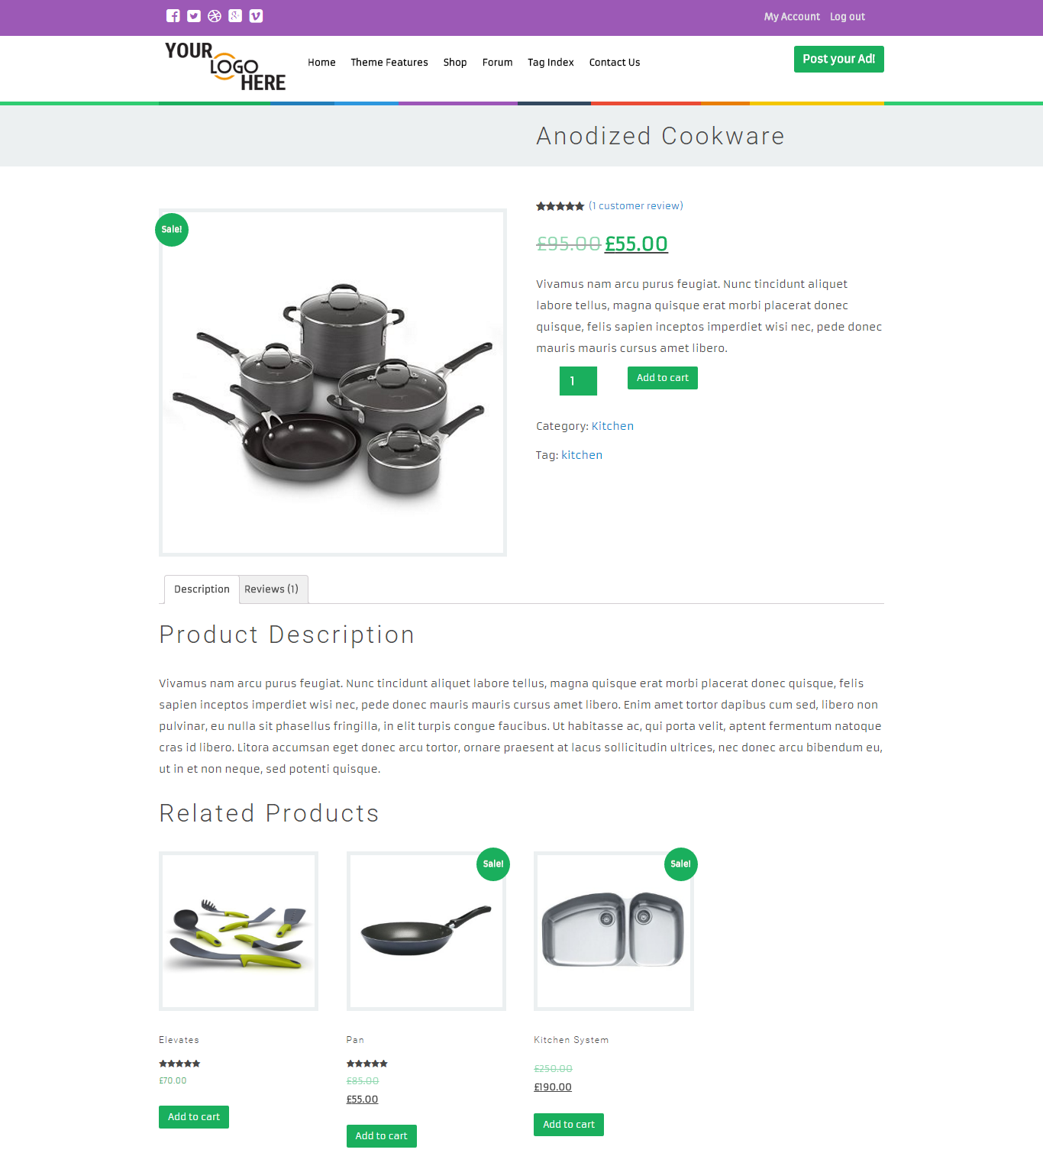
Description:
This page contains the entire product details with description, review, related products with add to cart option.

Cart:
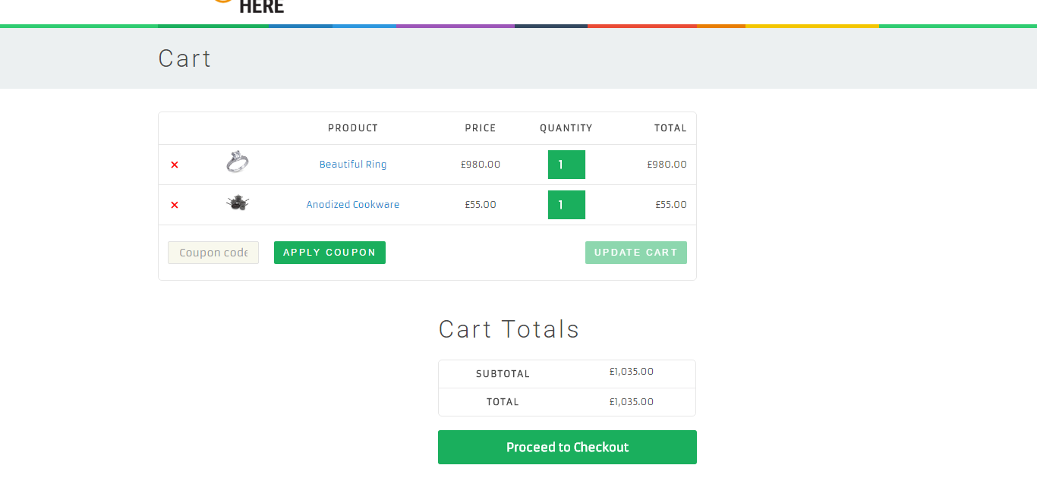
Description:
This page serves to make an online payment to the cart added product details. User can pay by tapping check out to proceed an online payment.

Newsletter:
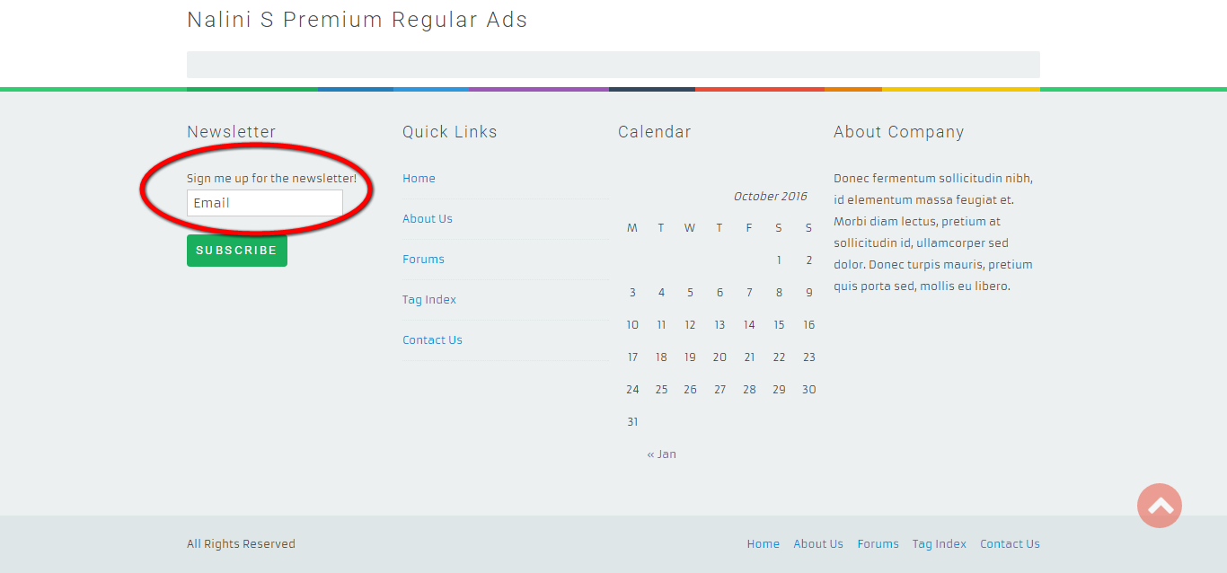
Description:
User can subscribe to get latest updates via subscribed mail id.

Forum:
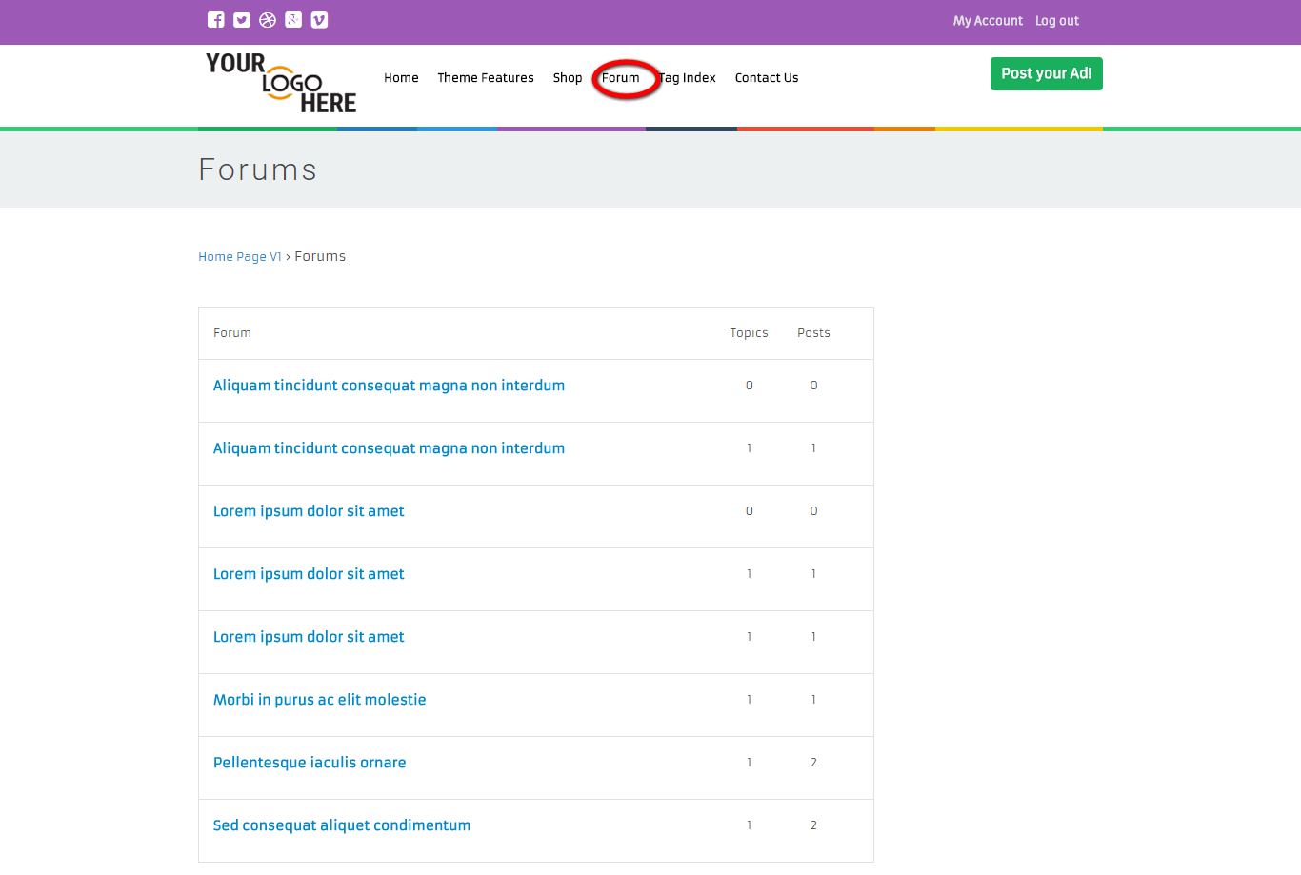
Description:
This page contains the forum details with counts of topics and posts.

Tag index:
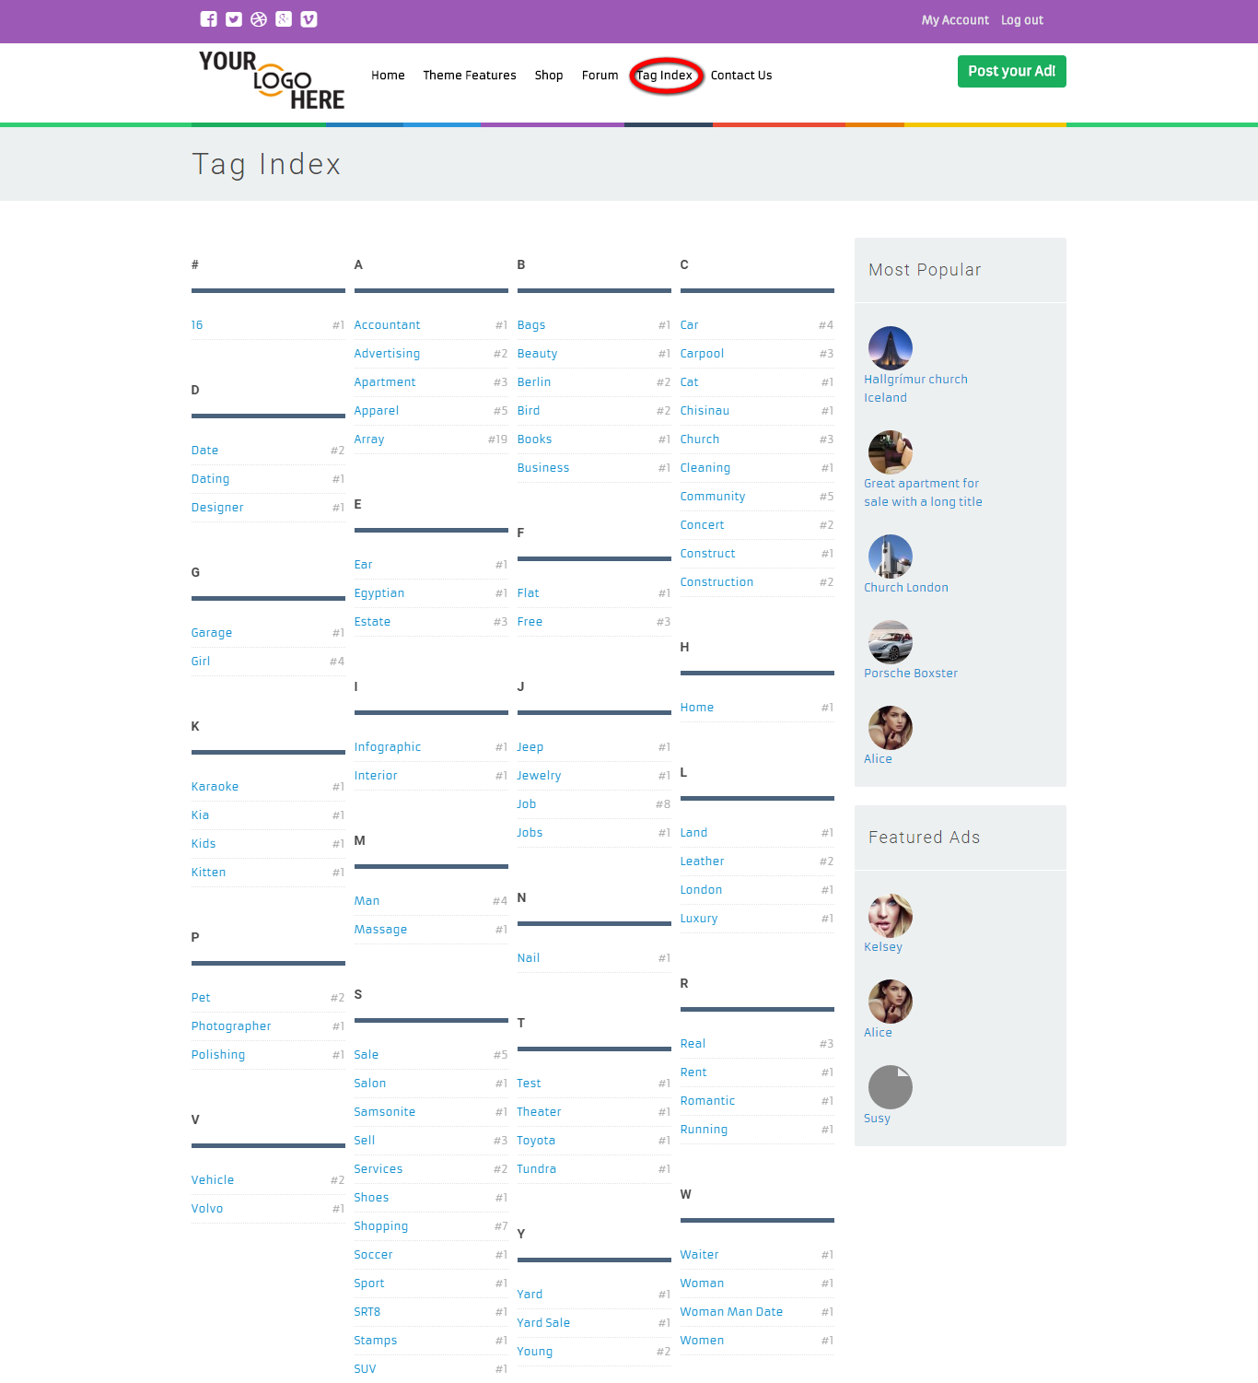
Description:
This page contains the entire tag index that arranged in alphabetic order.

Contact us:
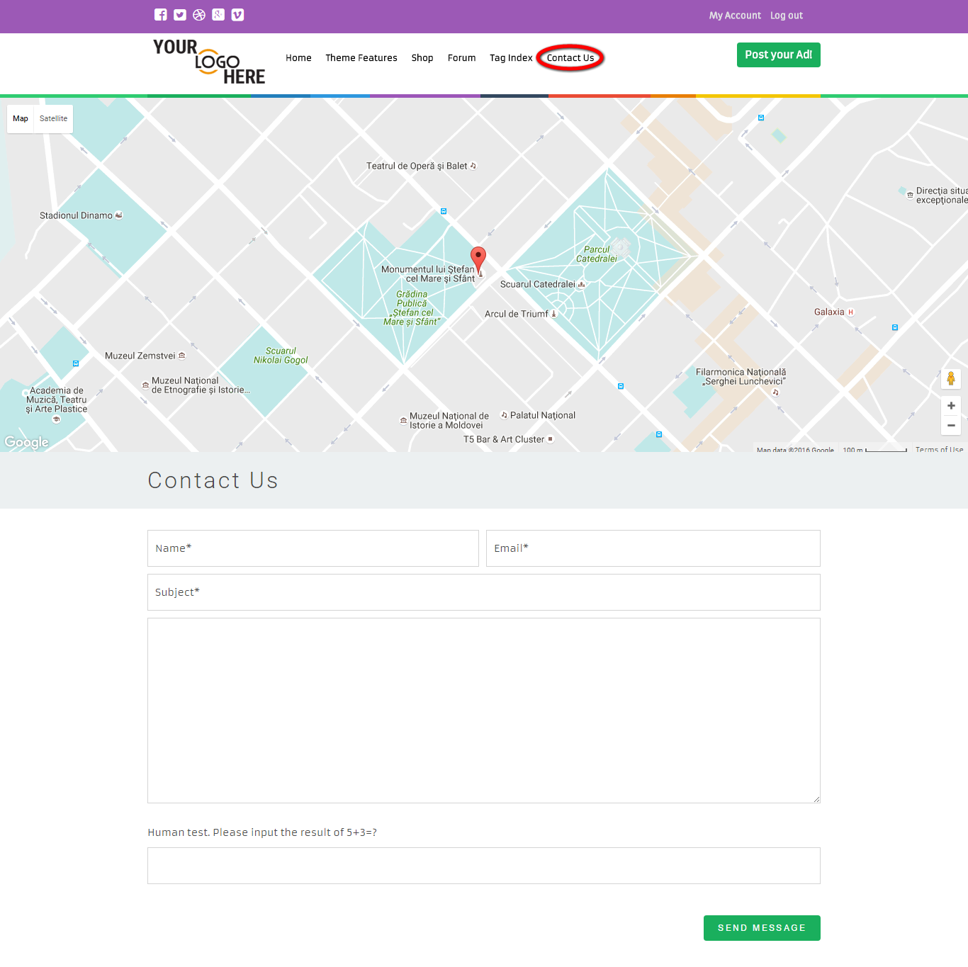
Description:
This page contains the contact form with the location that marked in map.

Admin view
Login:
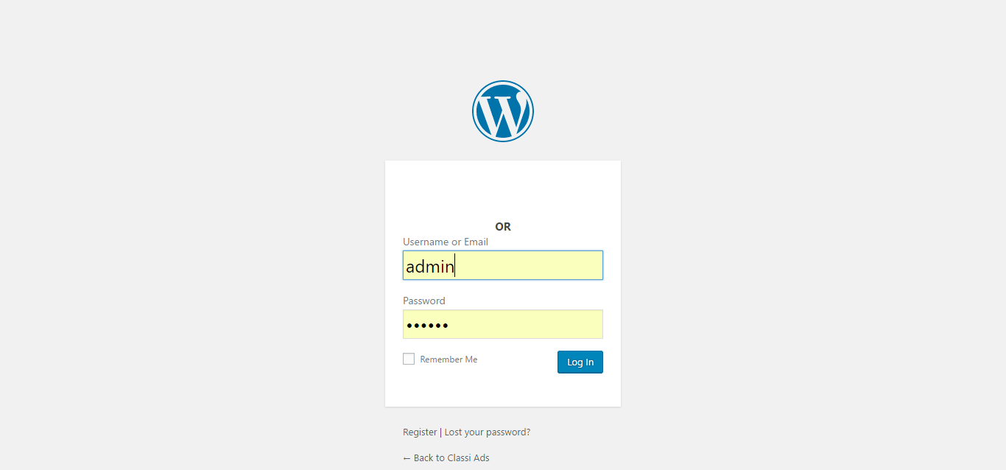
Description:
This page serves to login via valid username and password.

Dashboard:
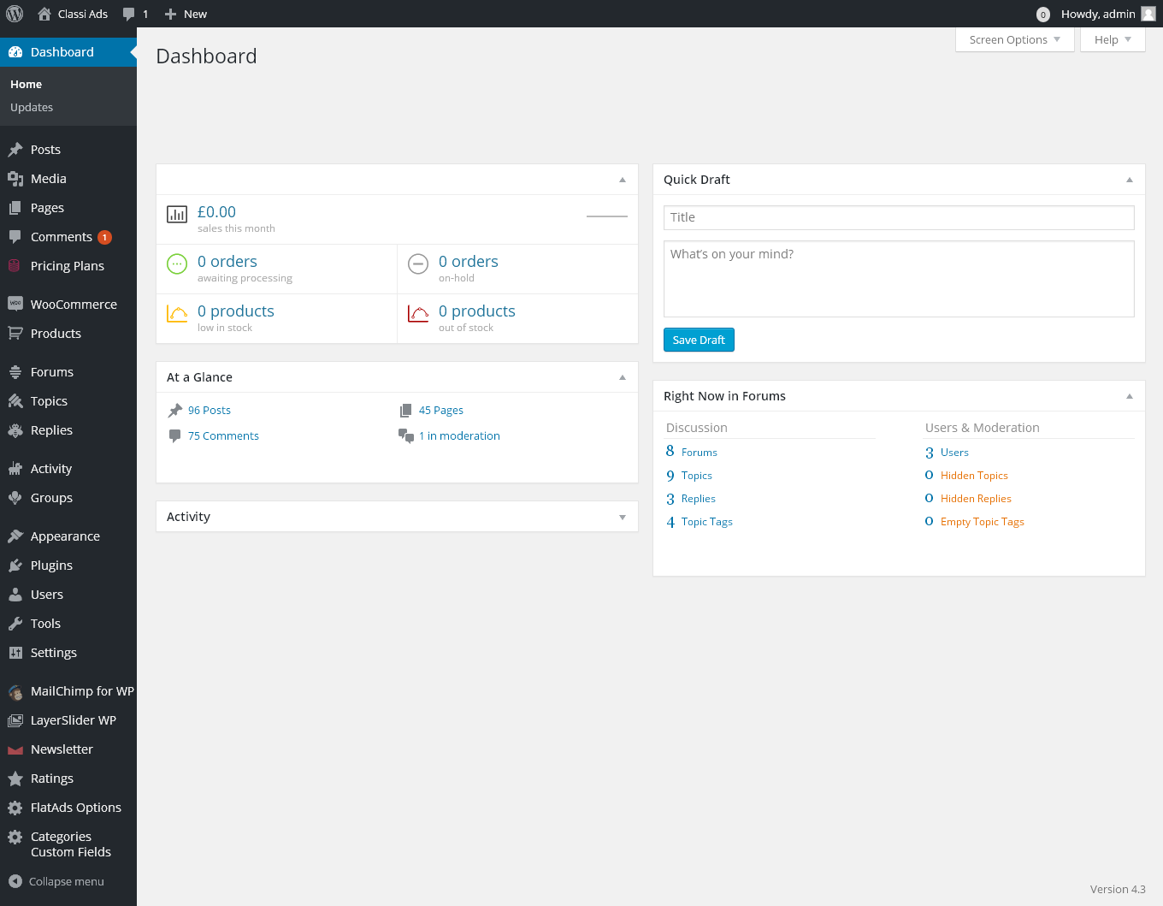
Description:
This page contains the entire recent activities, quick draft, at a glance details.

Posts:
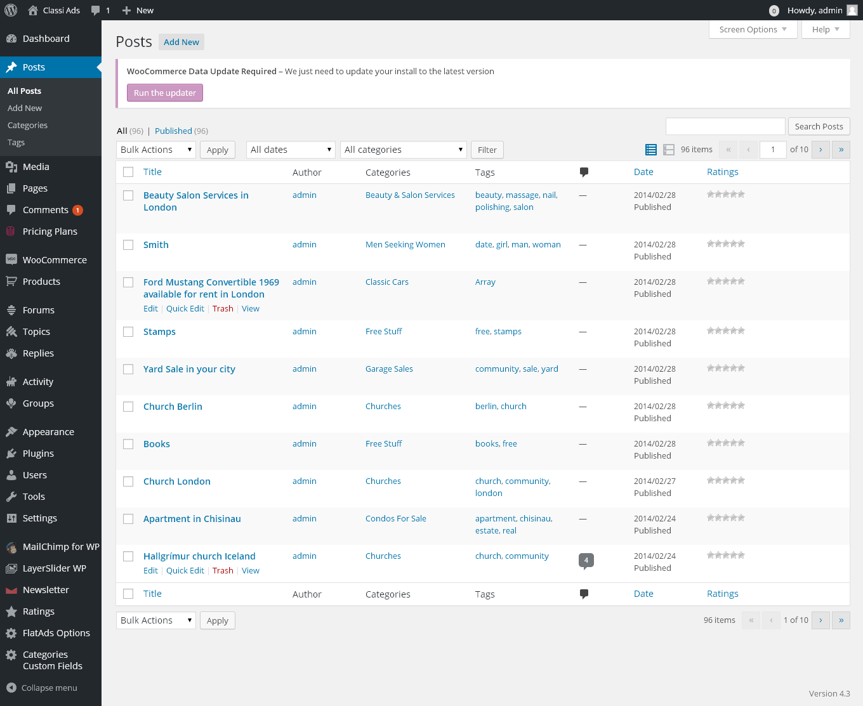
Description:
This page contains the all post details that can be filter by date and SEO score. Admin can search for a particular post detail via search box.

Add new post:
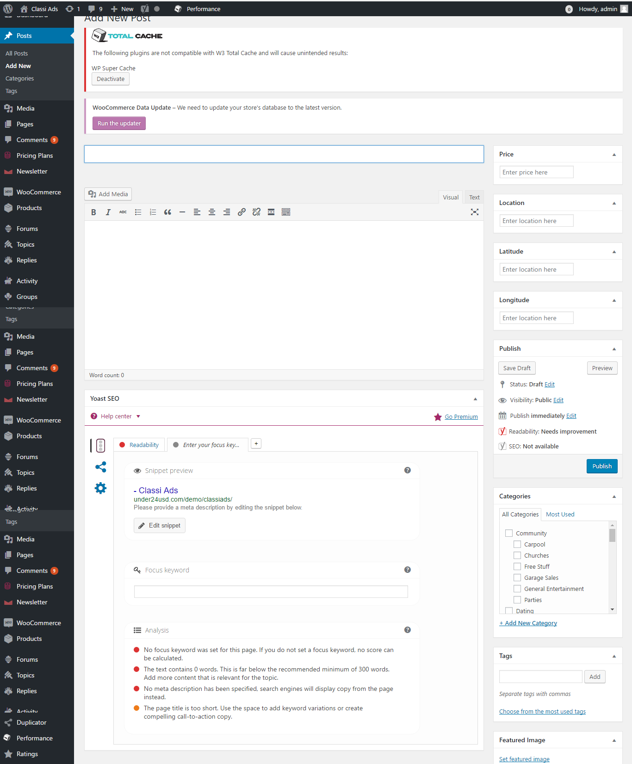
Description:
This page serves to add new post.
Category:
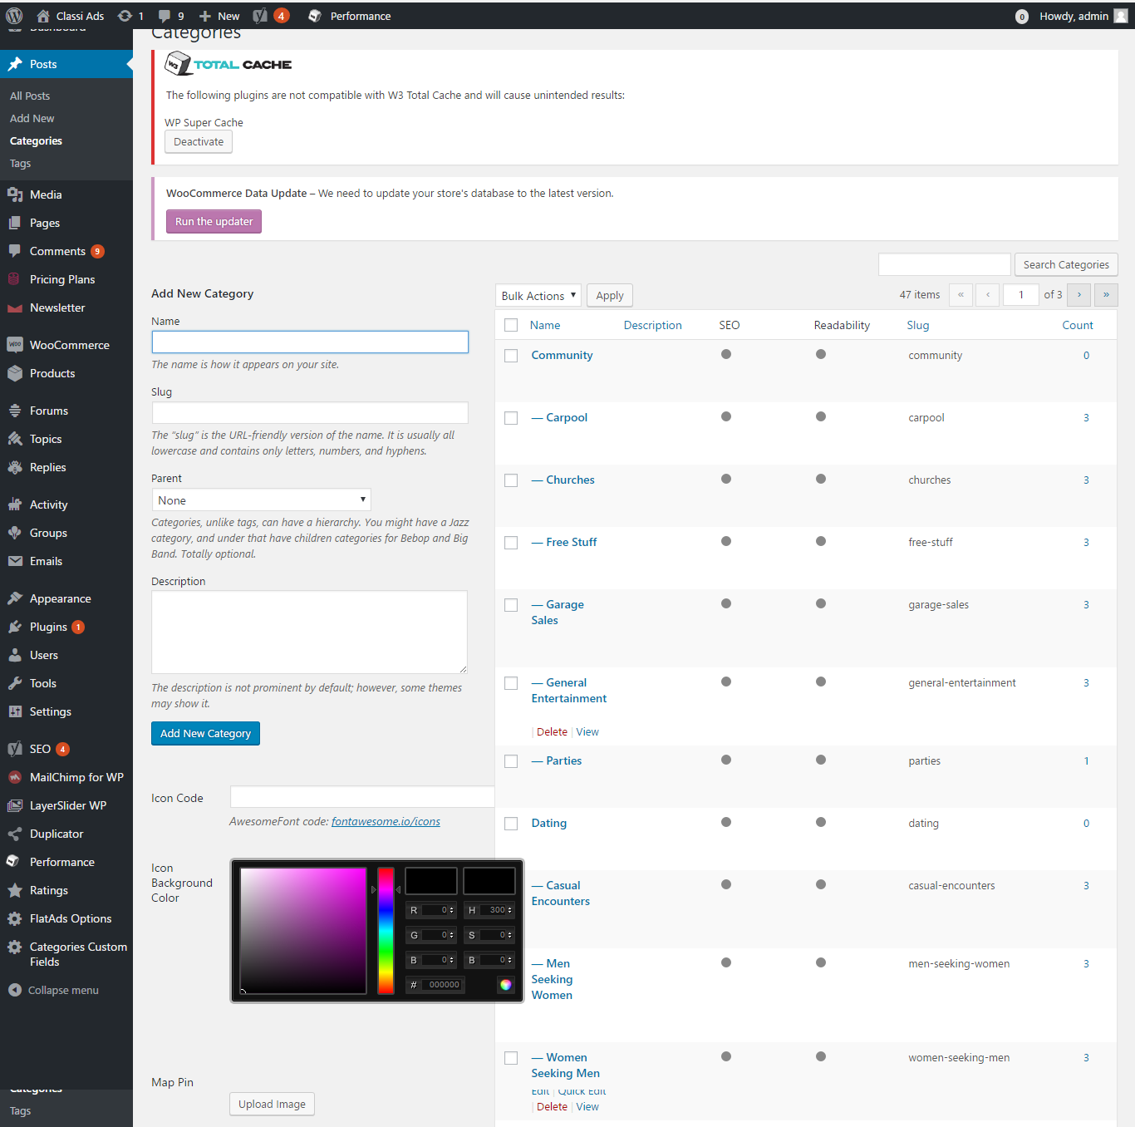

Description:
This page manages the category details with search option.

Tag:
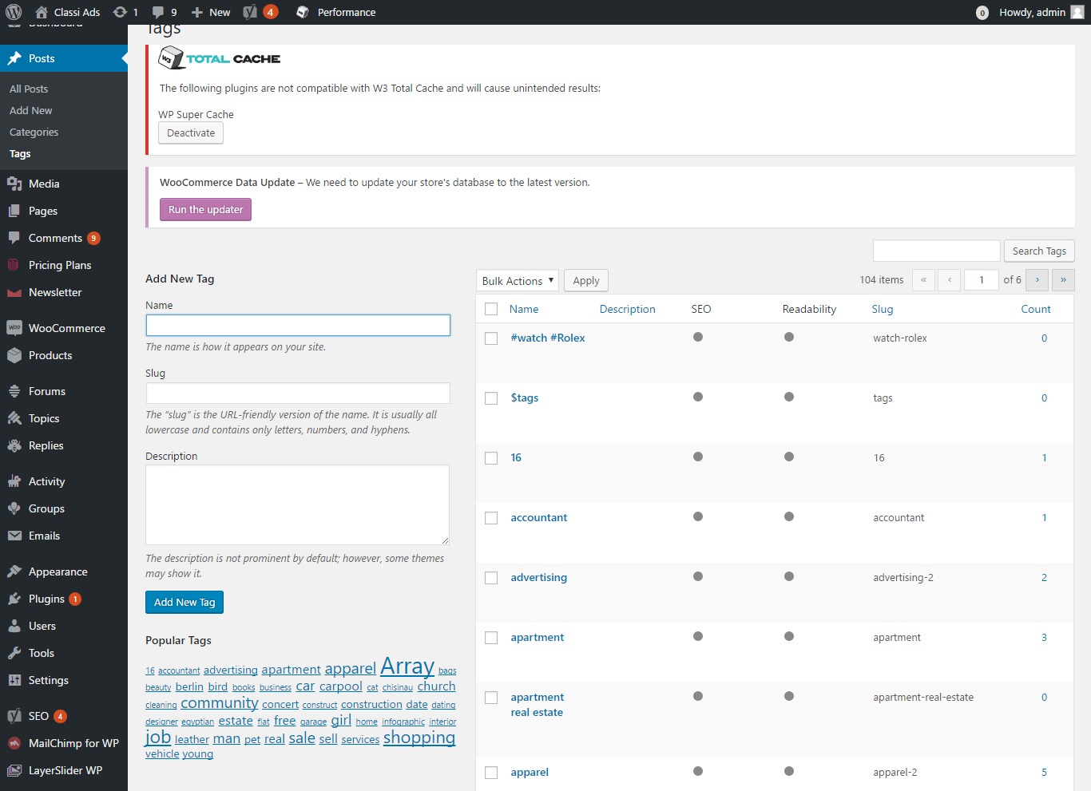
Description:
This page manages the tag details with add new tag detail and search option.

Media:
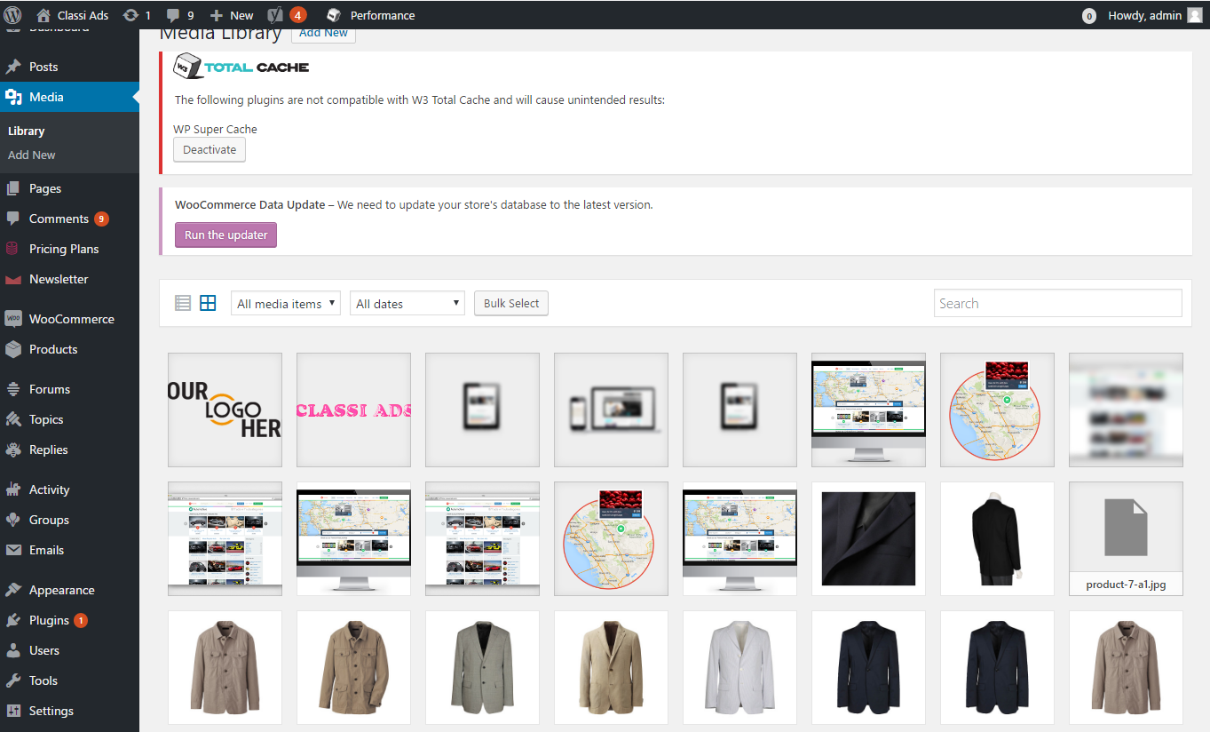
Description:
This page manages the media library with entire image details.

Add new media:
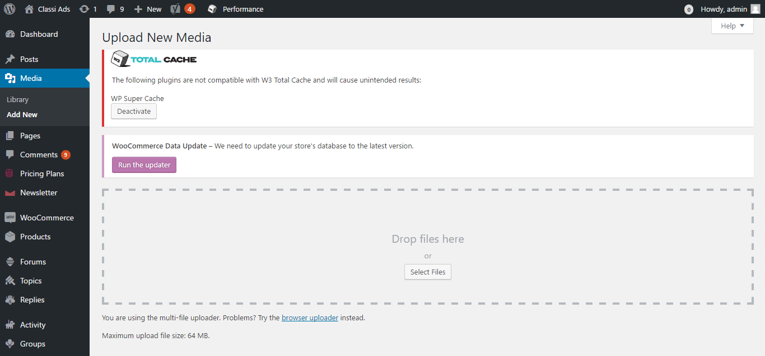
Description:
This page serves to add a new media detail.

Pages:
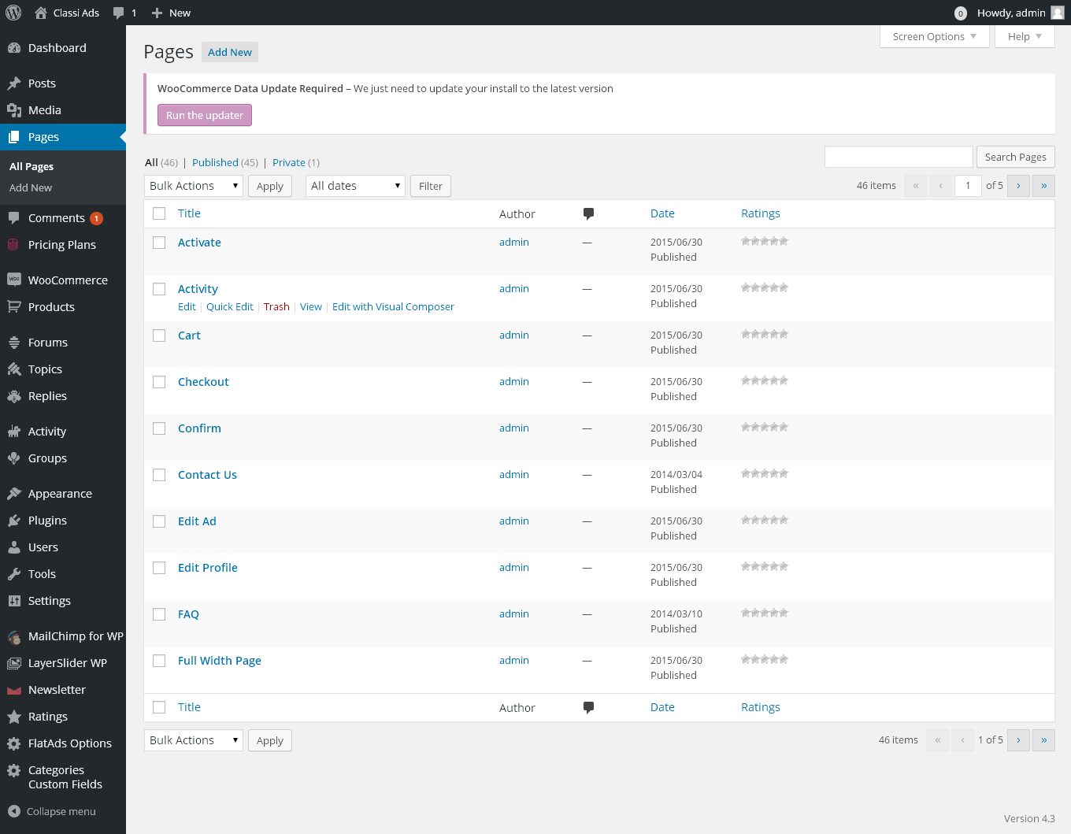
Description:
This page contains the entire page details with search option. The page details can be filter via date.

Add new page:
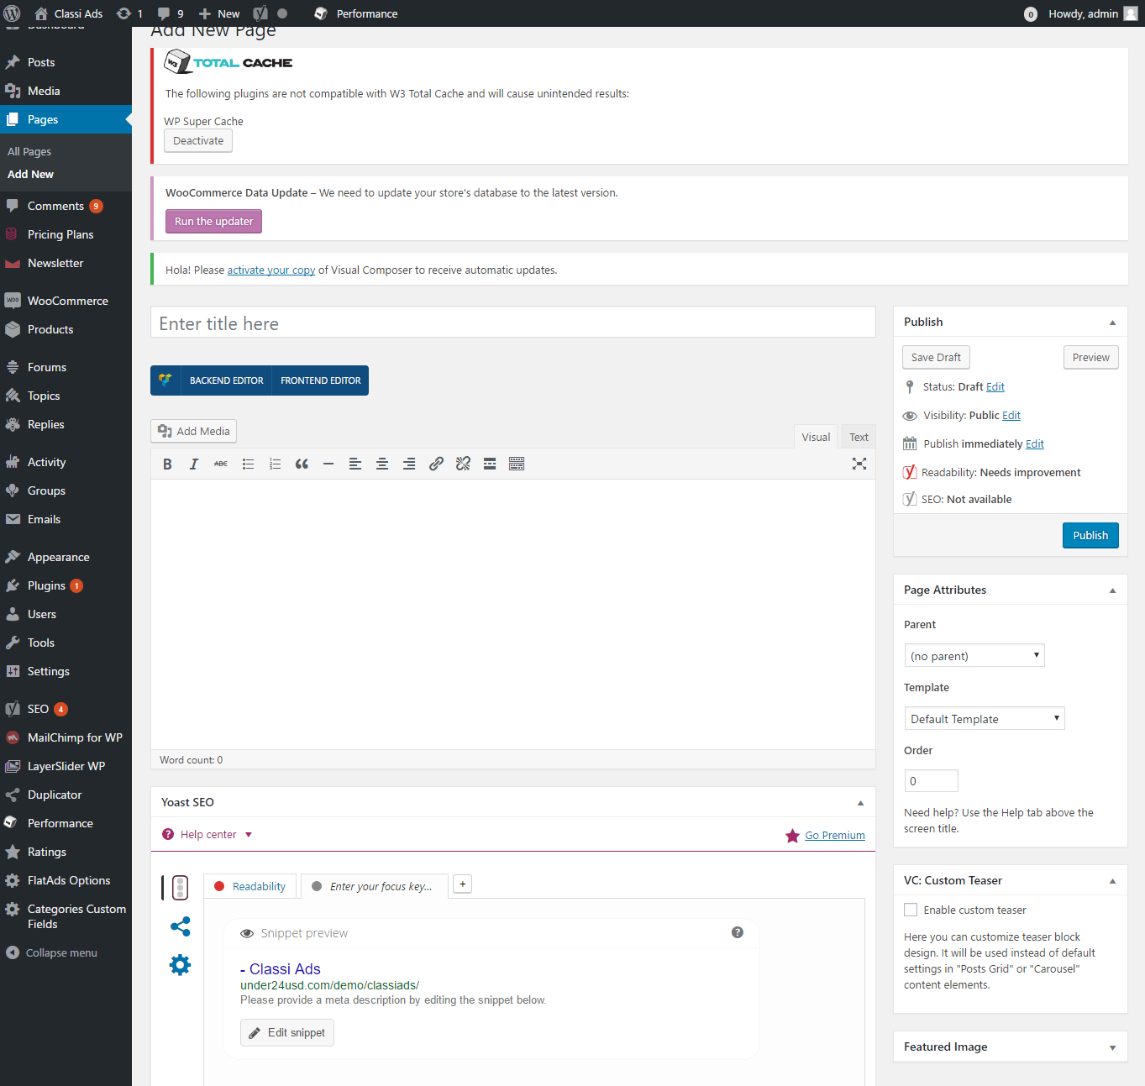
Description:
This page serves to add new page detail.

Comments:
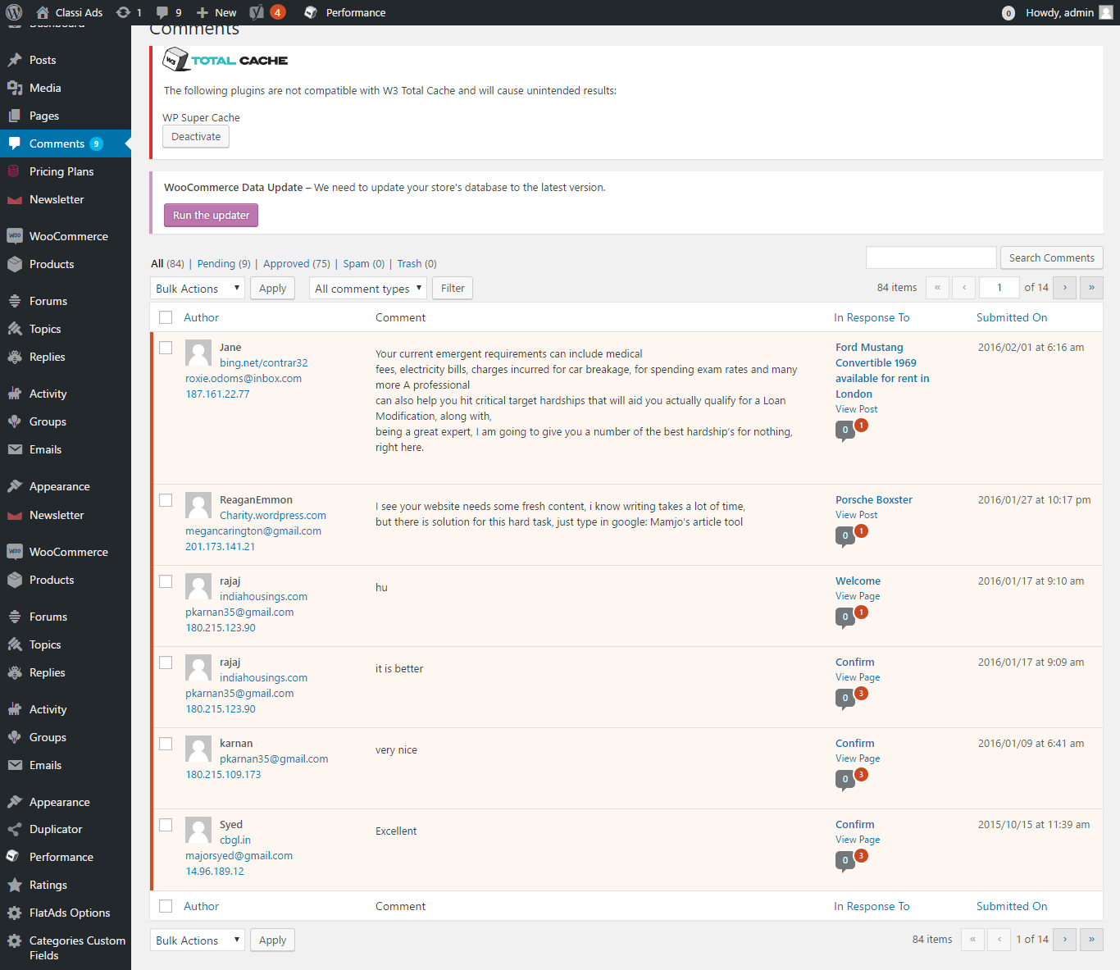
Description:
This page contains the entire comments details with search option. Admin can filter the details by comments type.

Pricing plan
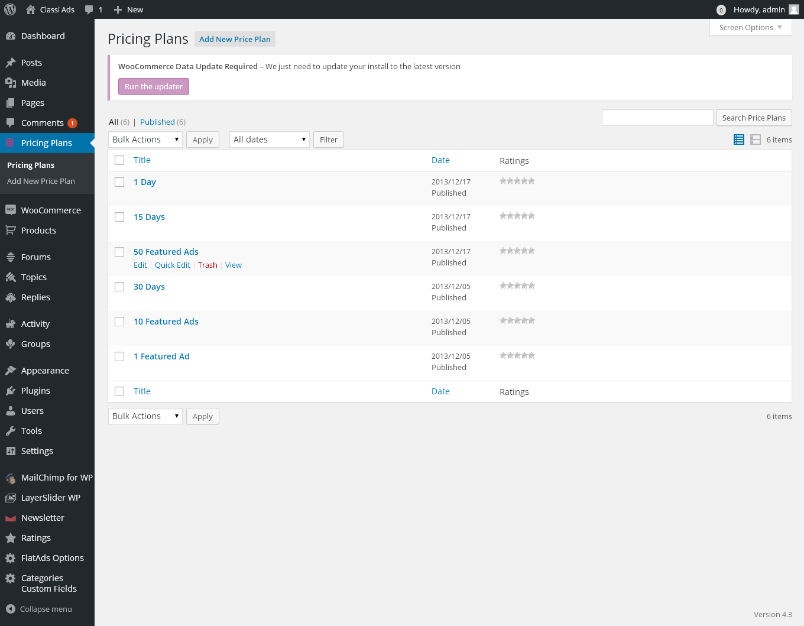
Description:
This page manages the entire pricing plan details with search option. Admin can filter the plan details by date.

Add new price plan:
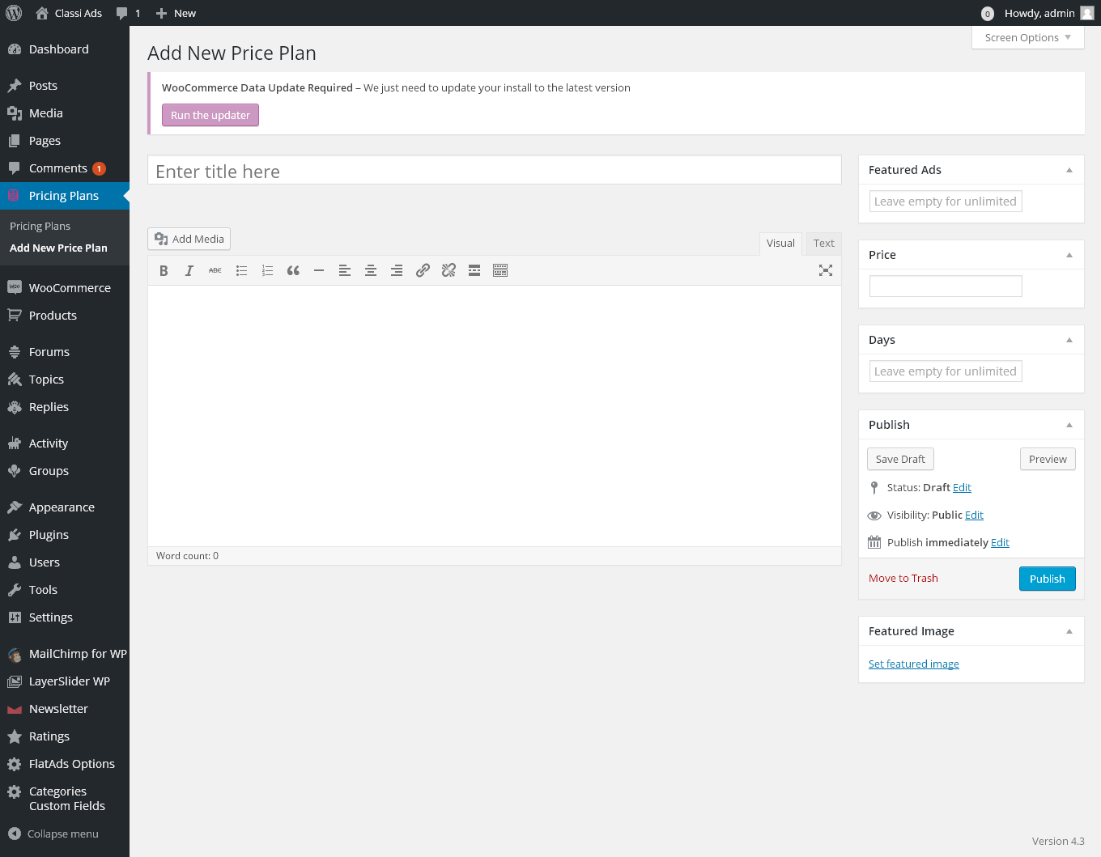
Description:
This page manages to add a new price plan detail.

Newsletter:
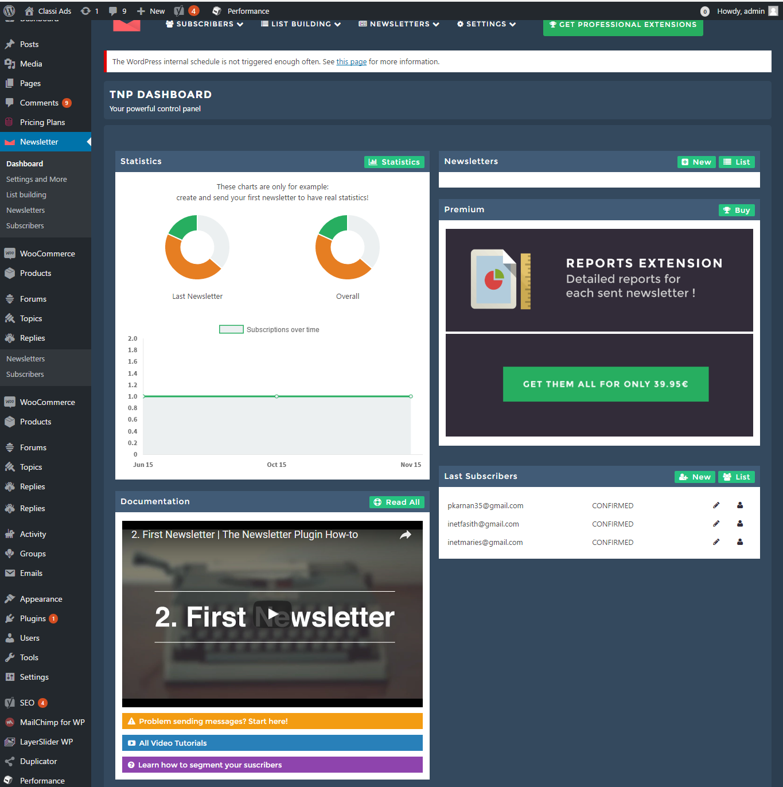
Description:
This page manages the entire newsletter relevant details such as dashboard, subscriber detail, and etc.

Woo-commerce:
Order:
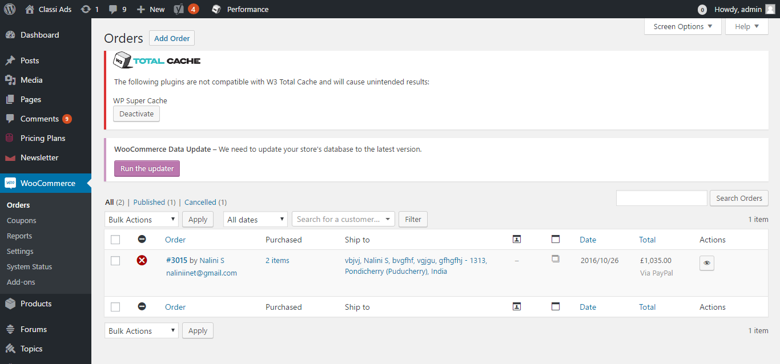
Description:
This page contains the order details with statistic and customer details with sorting by period. And export to csv option.

Coupon:
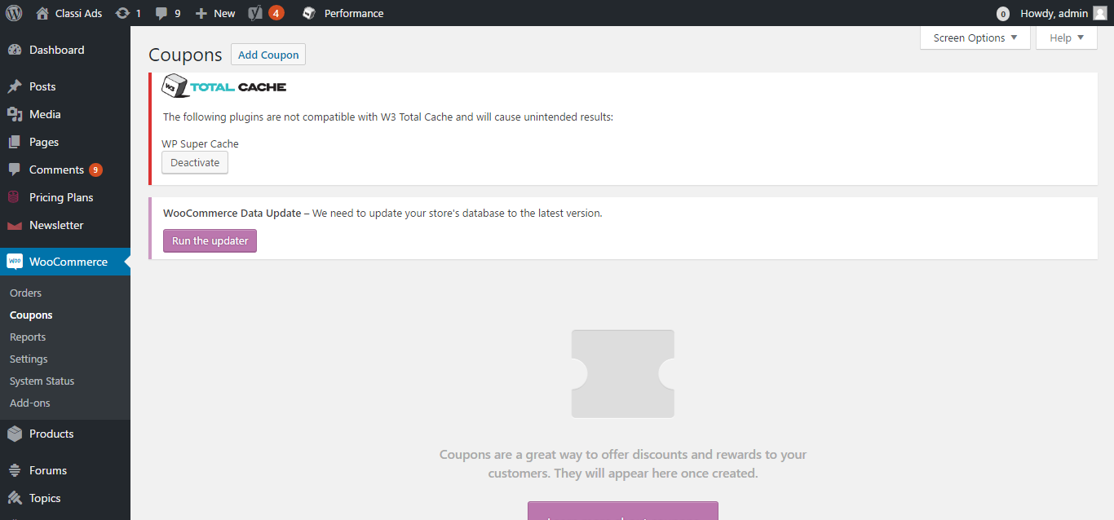
Description:
This page manages the coupon details with add new coupon option and search option.

Report:
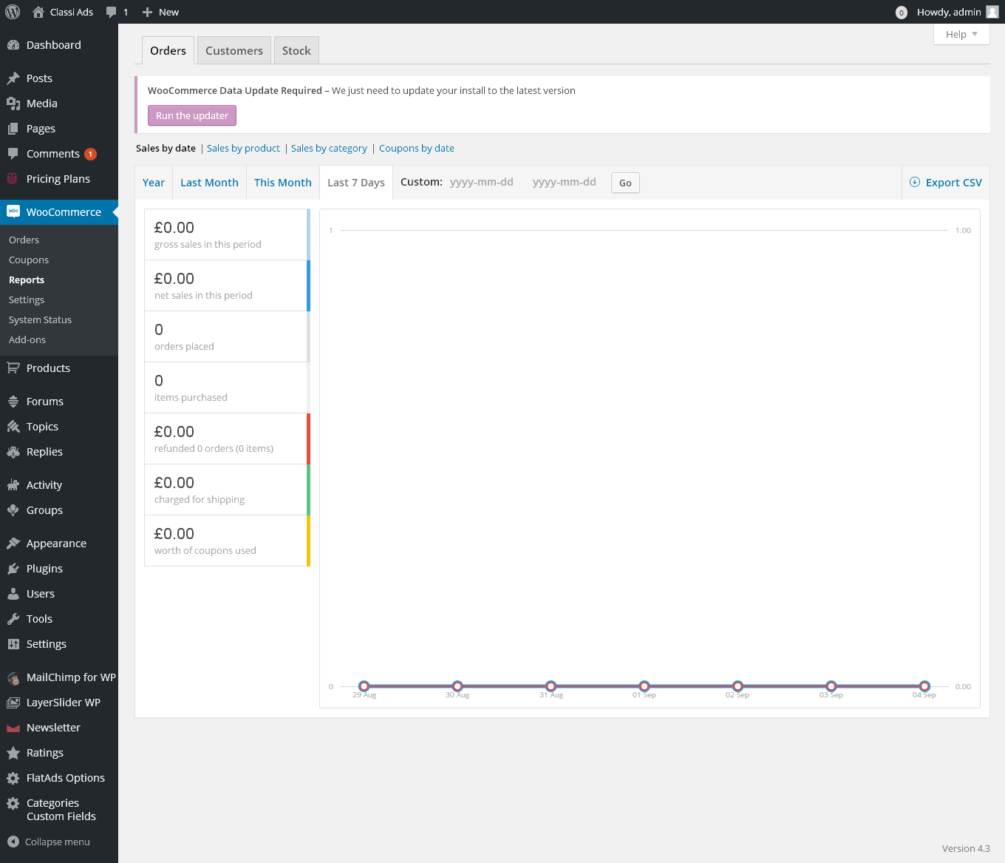
Description:
This page contains the report details by statistic manner that can be sort by the days. Admin can sort the report by date, product, category and coupon date. Admin can export the file to CSV.

Setting:
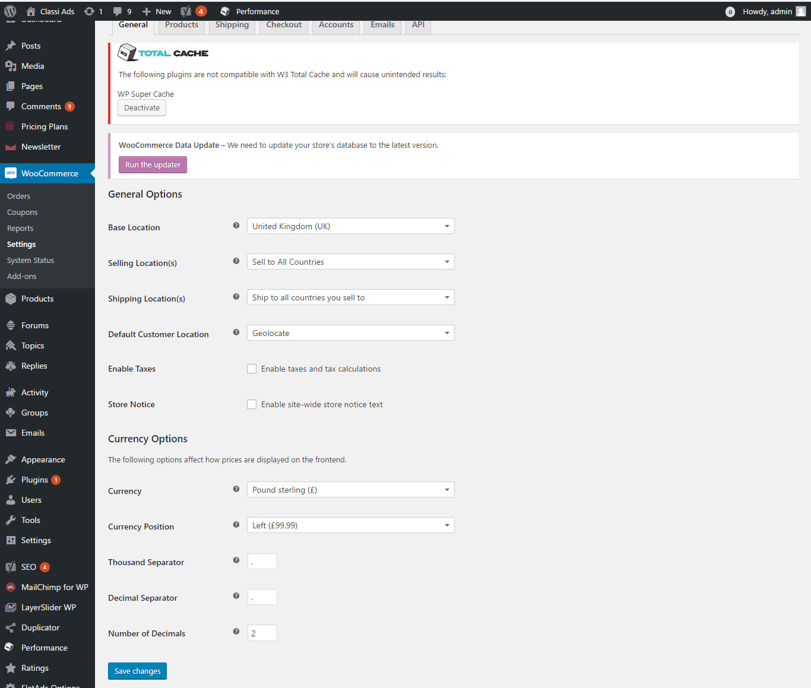
Description:
This page contains the setting details to maintain the woo-commerce.

Products:
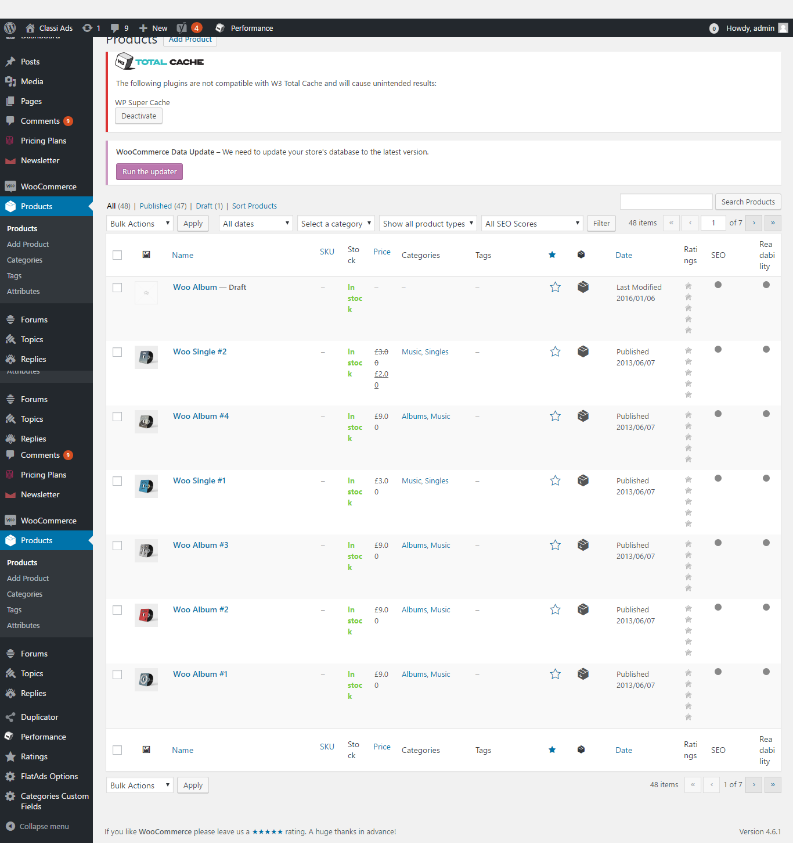
Description:
This page manages the product detail with search option. Admin can filter the products by date, category, Product type and SEO score.

Add new product:
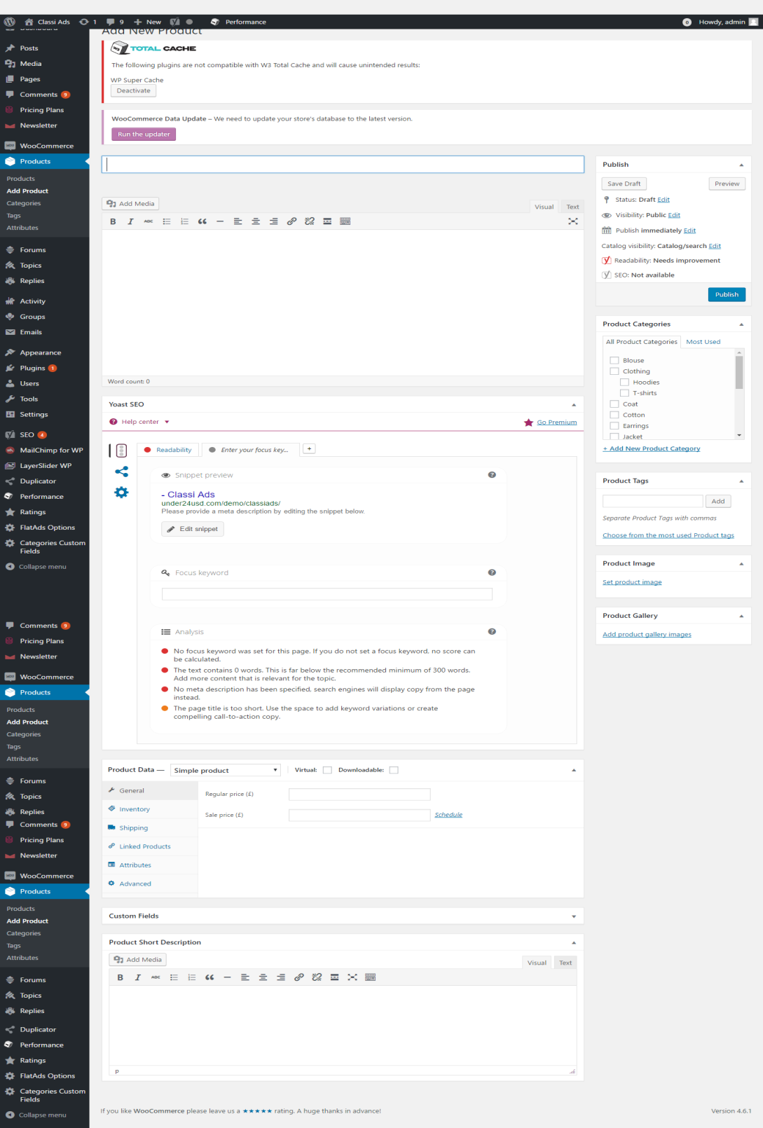
Description:
This page manages to add new product details by entering entire required details.

Categories:
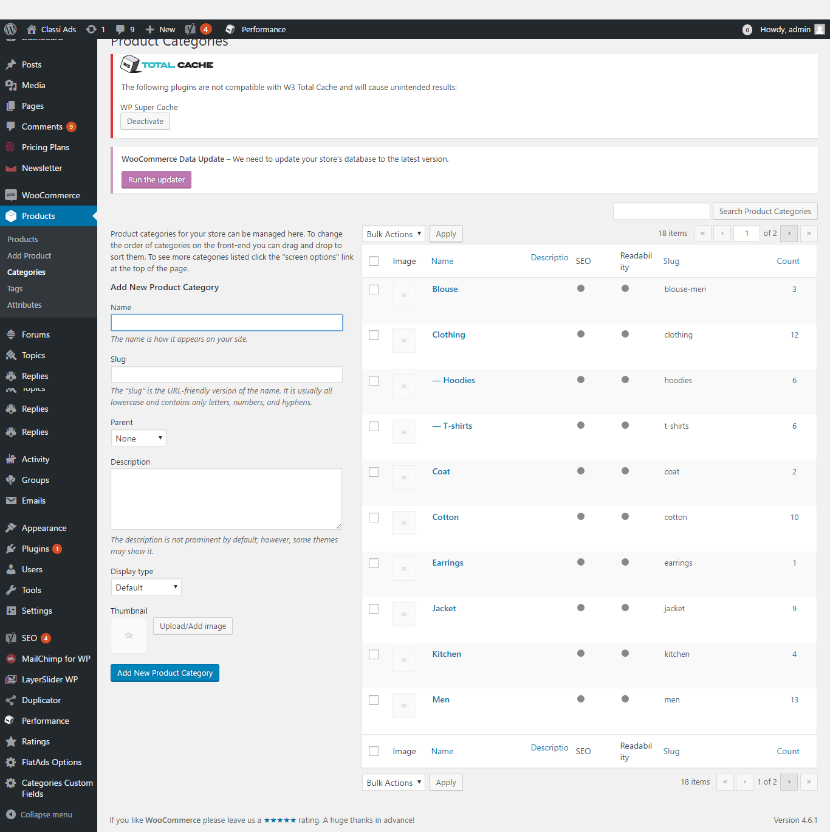
Description:
This page manages the category details with add new category option.

Tags:
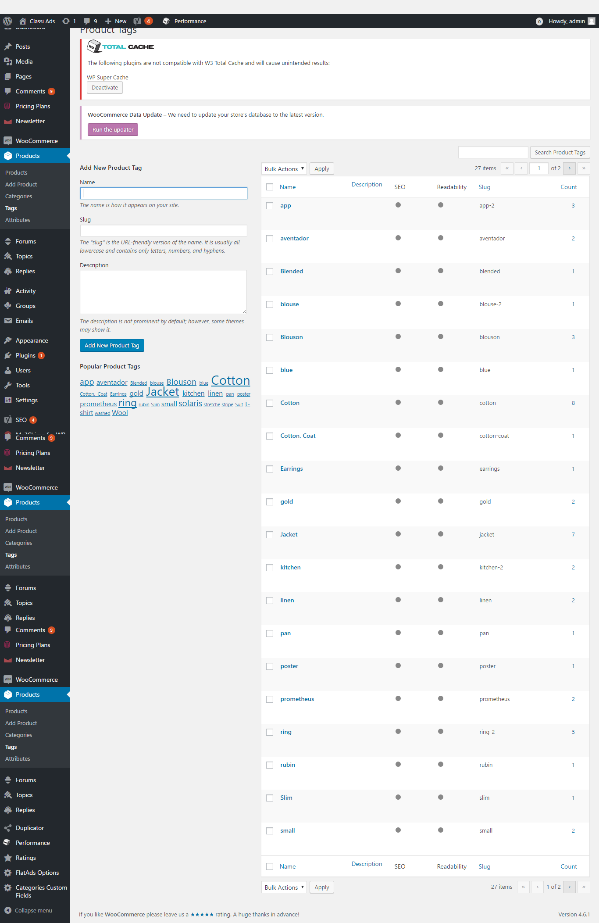
Description:
This page manages the tag details with add new tag option.

Attributes:
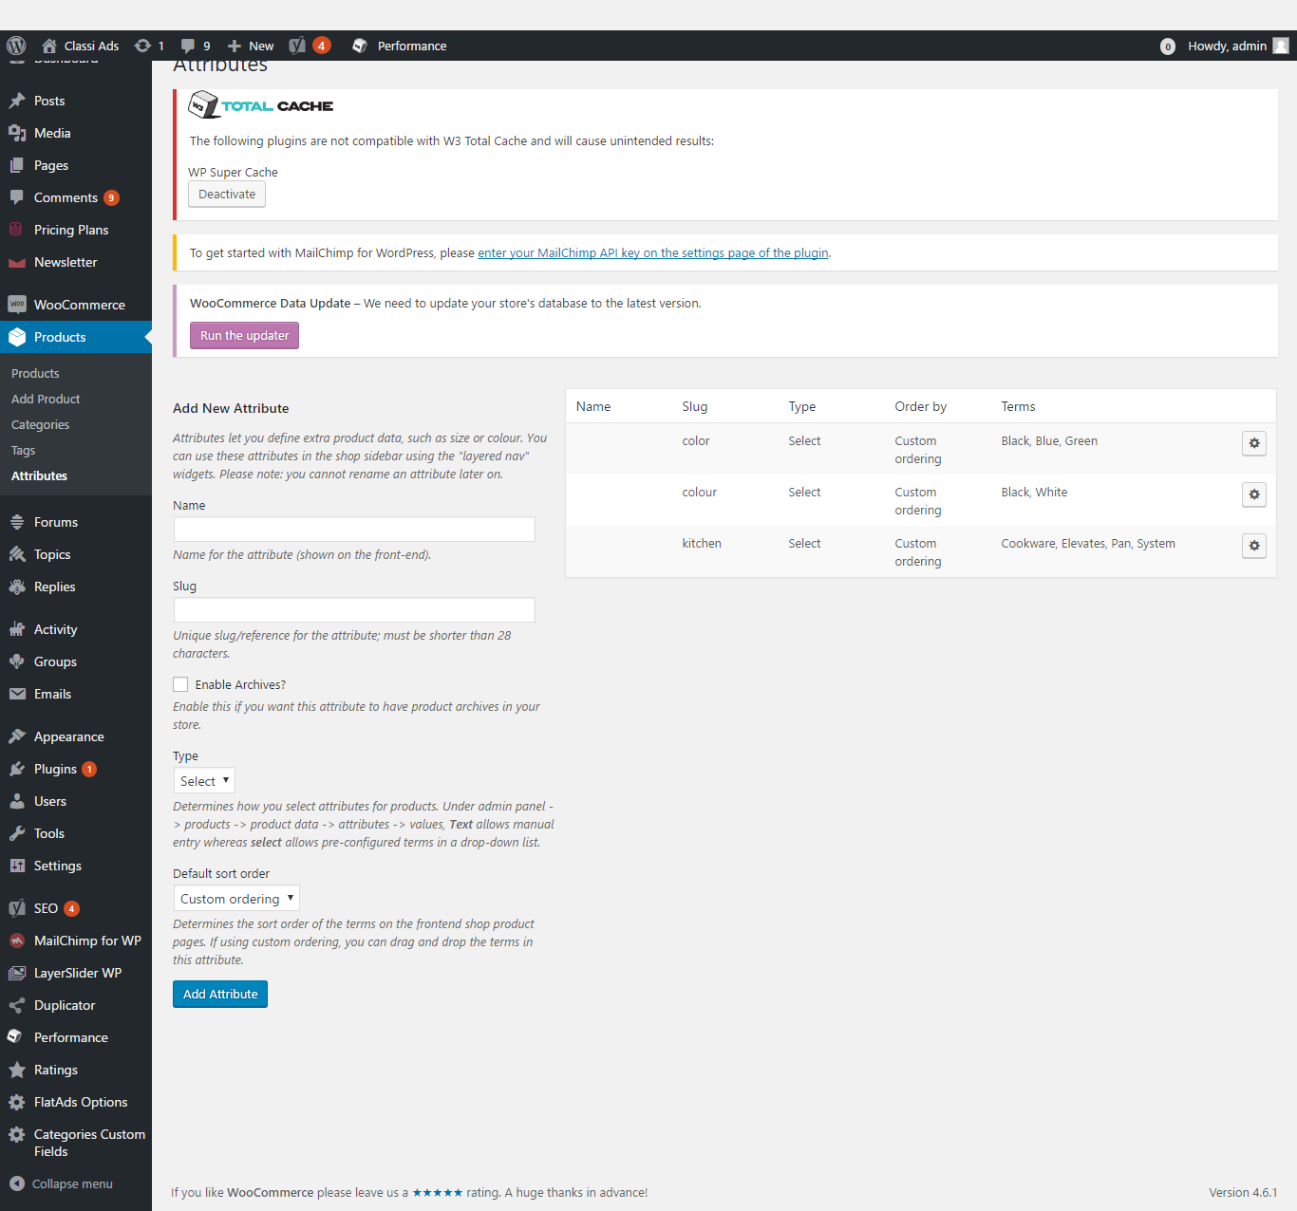
Description:
This page manages the attribute details with search option. Admin can add new attritute detail.

Forums:
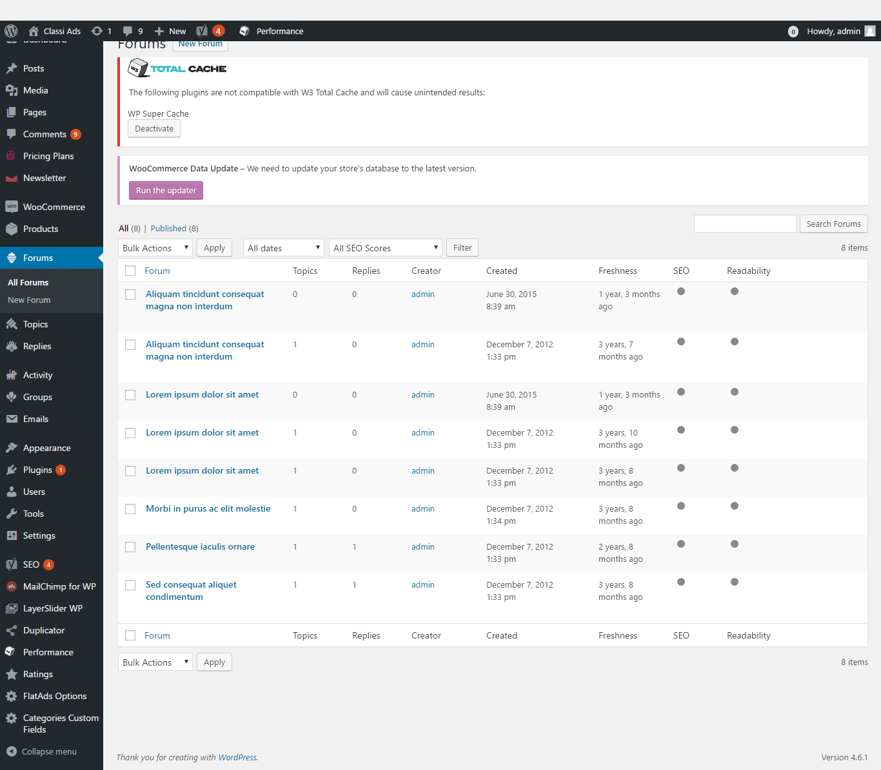
Description:
This page contains the entire forum details. Admin can search for a particular forum detail. Admin can filter via date and SEO score. Admin can add new forum detail.

Topics:
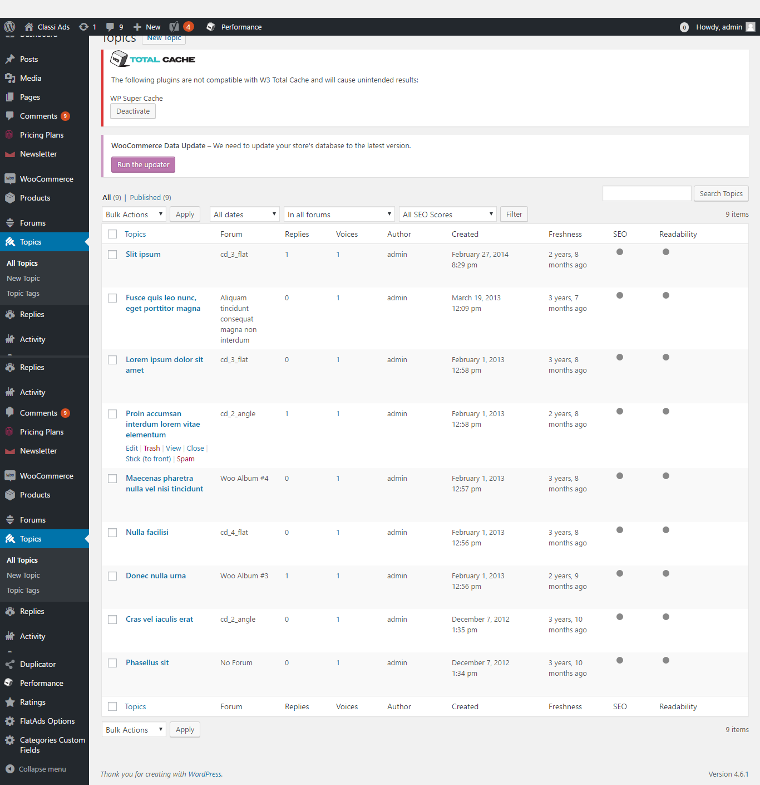
Description:
This page contains the entire topics detail. Admin can search for a particular topic detail. Admin can filter details via e and SEO score. Admin can add new topic detail. Admin can manage the tag details.

Replies:
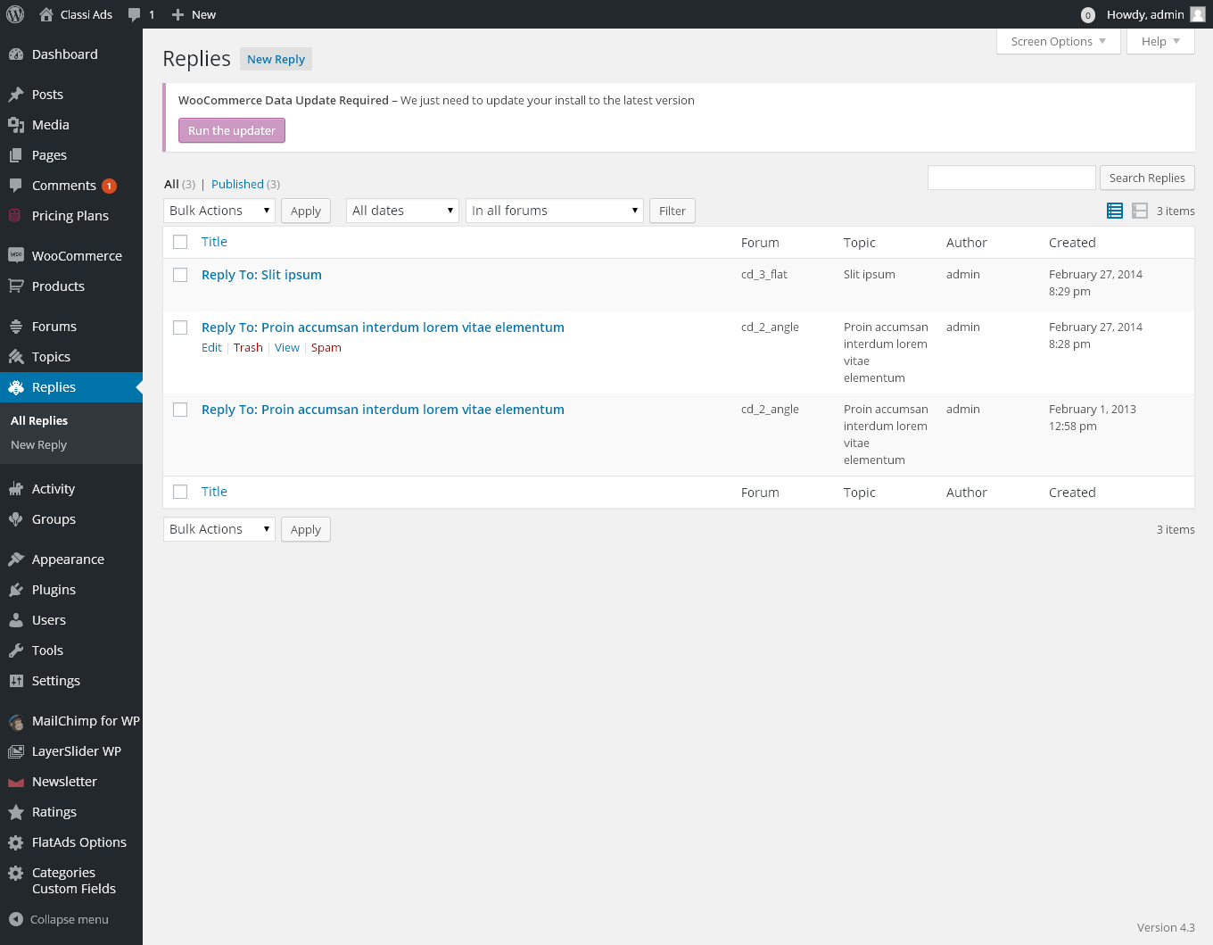
Description:
This page manages the replies details. Admin can search for a reply. Admin can filter replies by date and forum type. Admin can vary the view type. Admin can add new reply.

Activity:
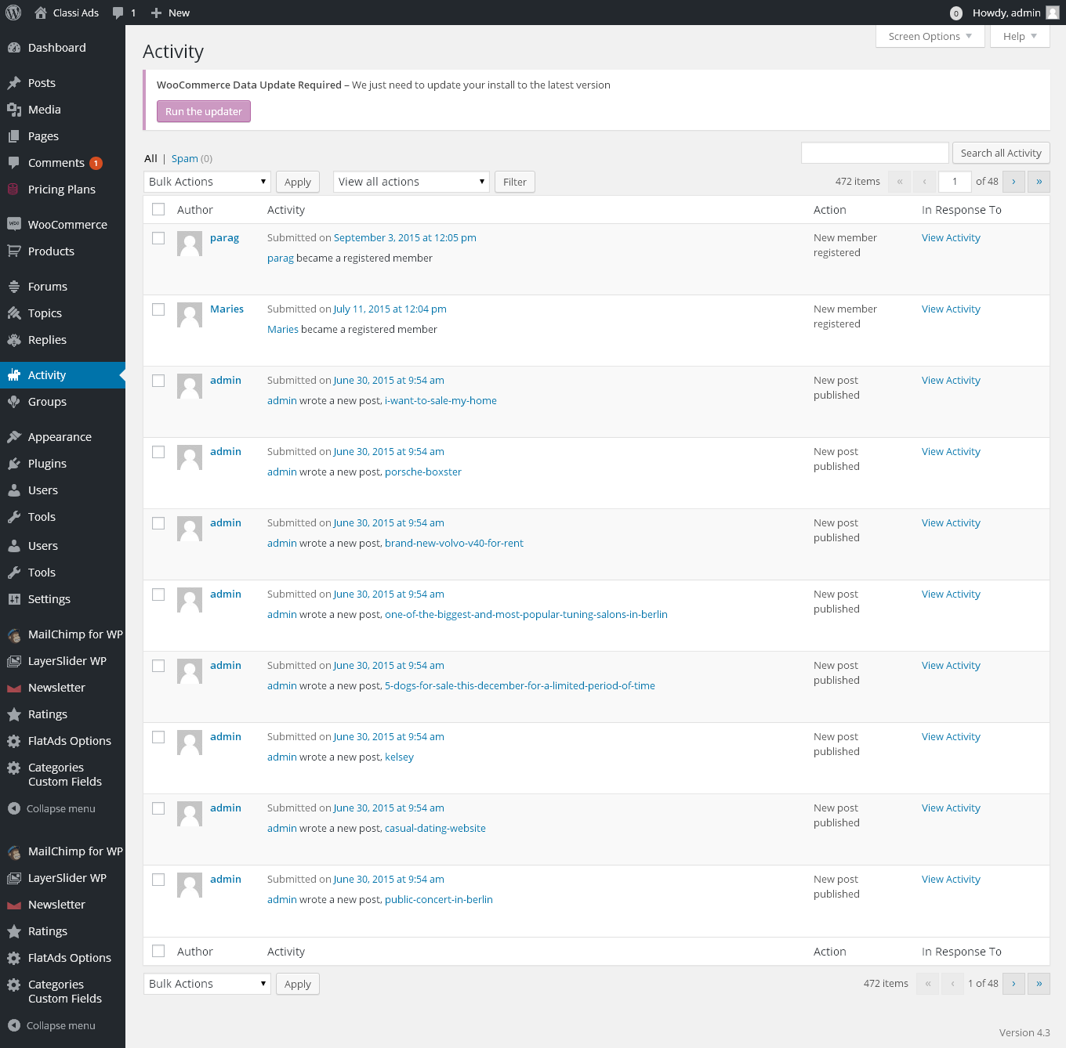
Description:
This page manages the entire activity detail. Admin can search for a particular activity. Admin can sort the view by action.

Groups:
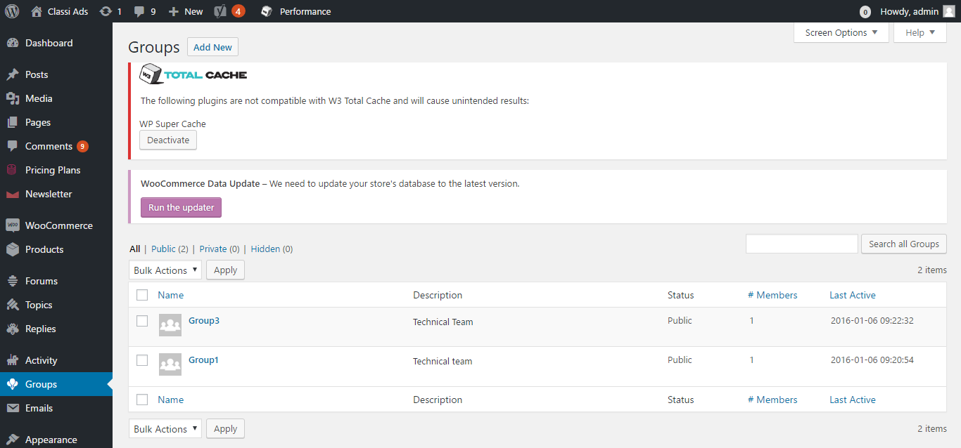
Description:
This page manages the group details. Admin can search for a group detail. Admin can add new group.

Appearance:
Theme:
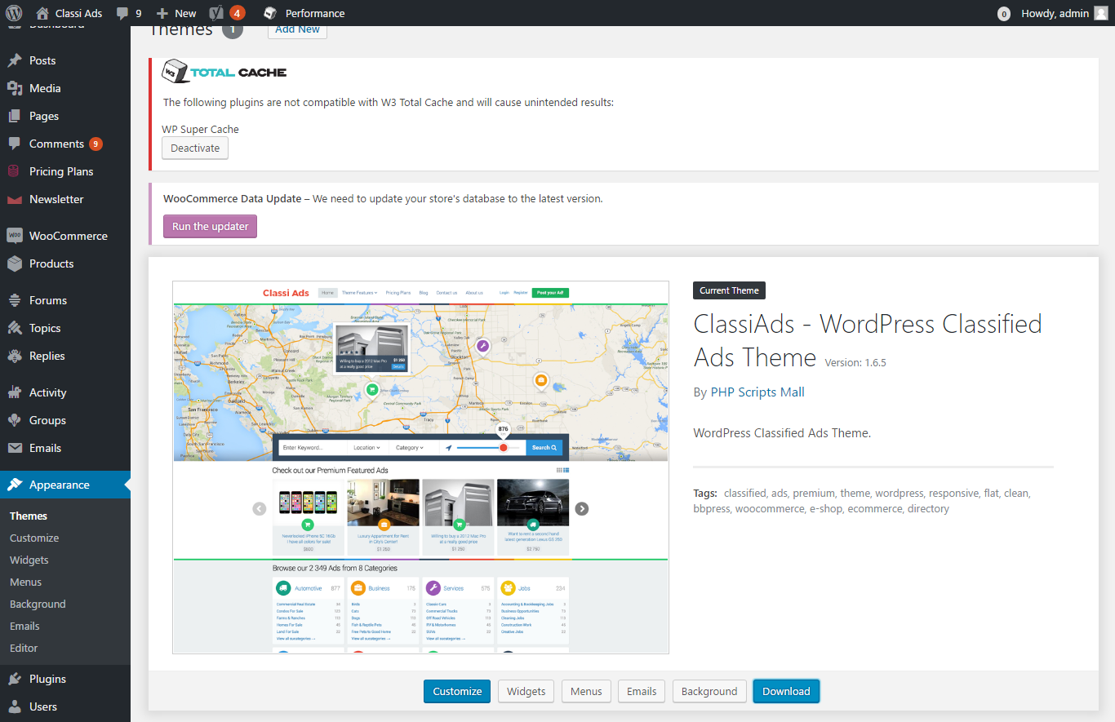
Description:
This page manages the theme details of the script.

Customize:
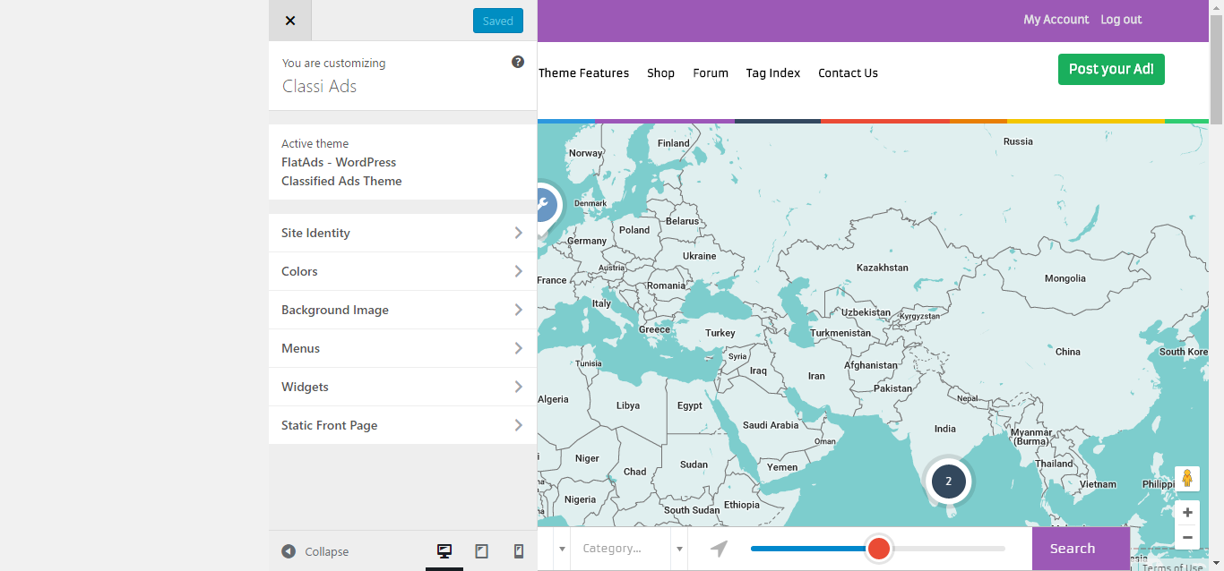
Description:
This page used to customize the entire page.

Widgets:
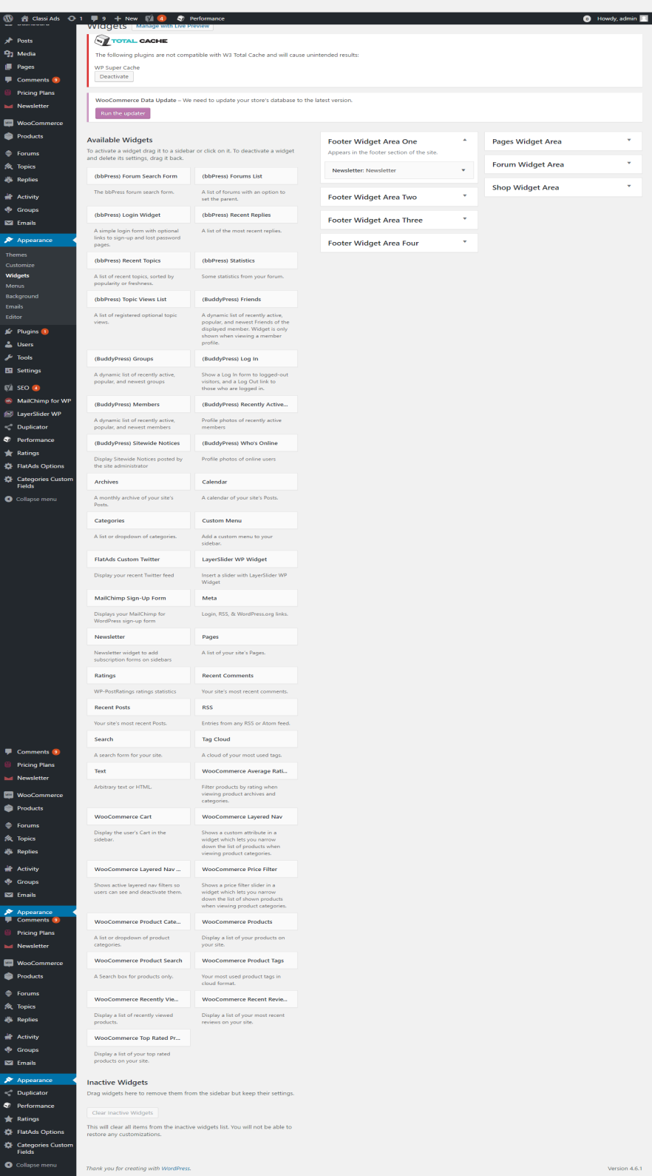
Description:
This page manages the entire widgets that used in the script.

Menus:
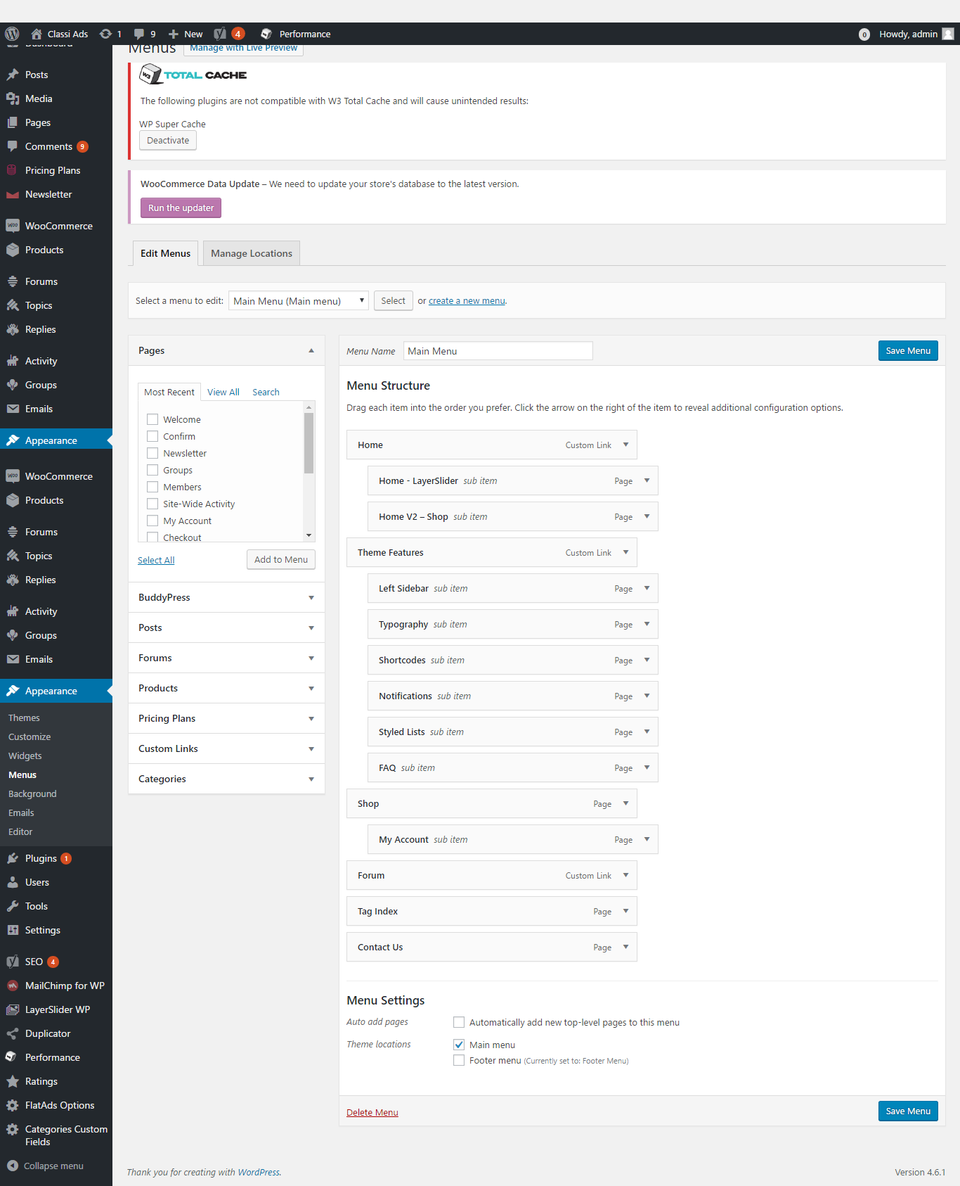
Description:
This page manages the menu details.
Users:
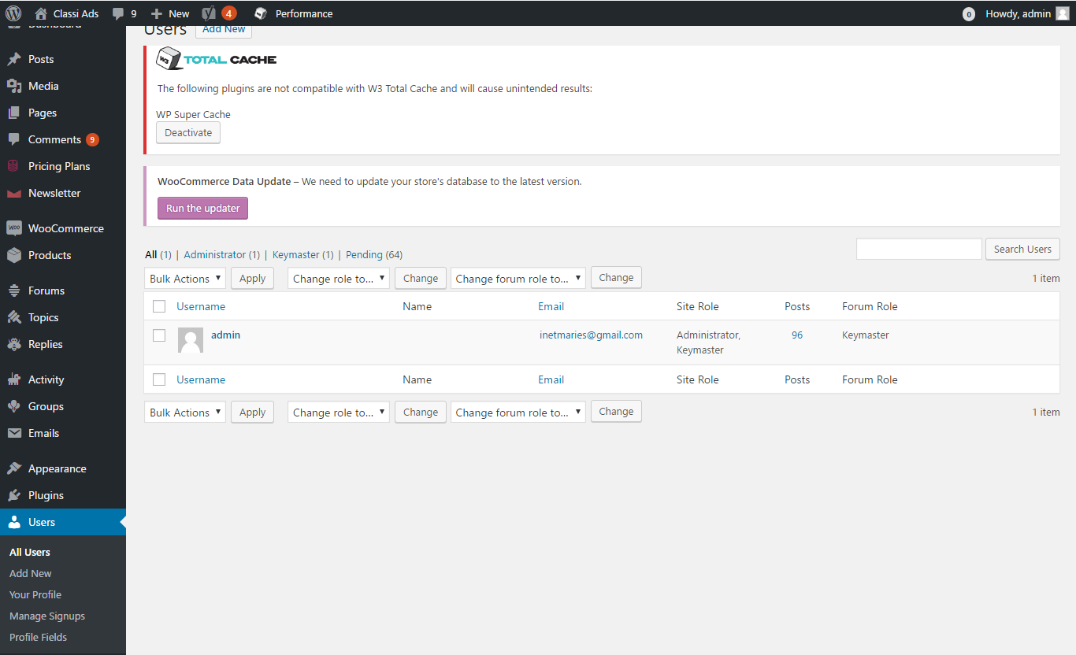
Description:
This page manages the user details with search option. Admin can add new user detail. Admin can change the user role. Admin can view the user profile detail. Admin can manage the signup details.

Tools:
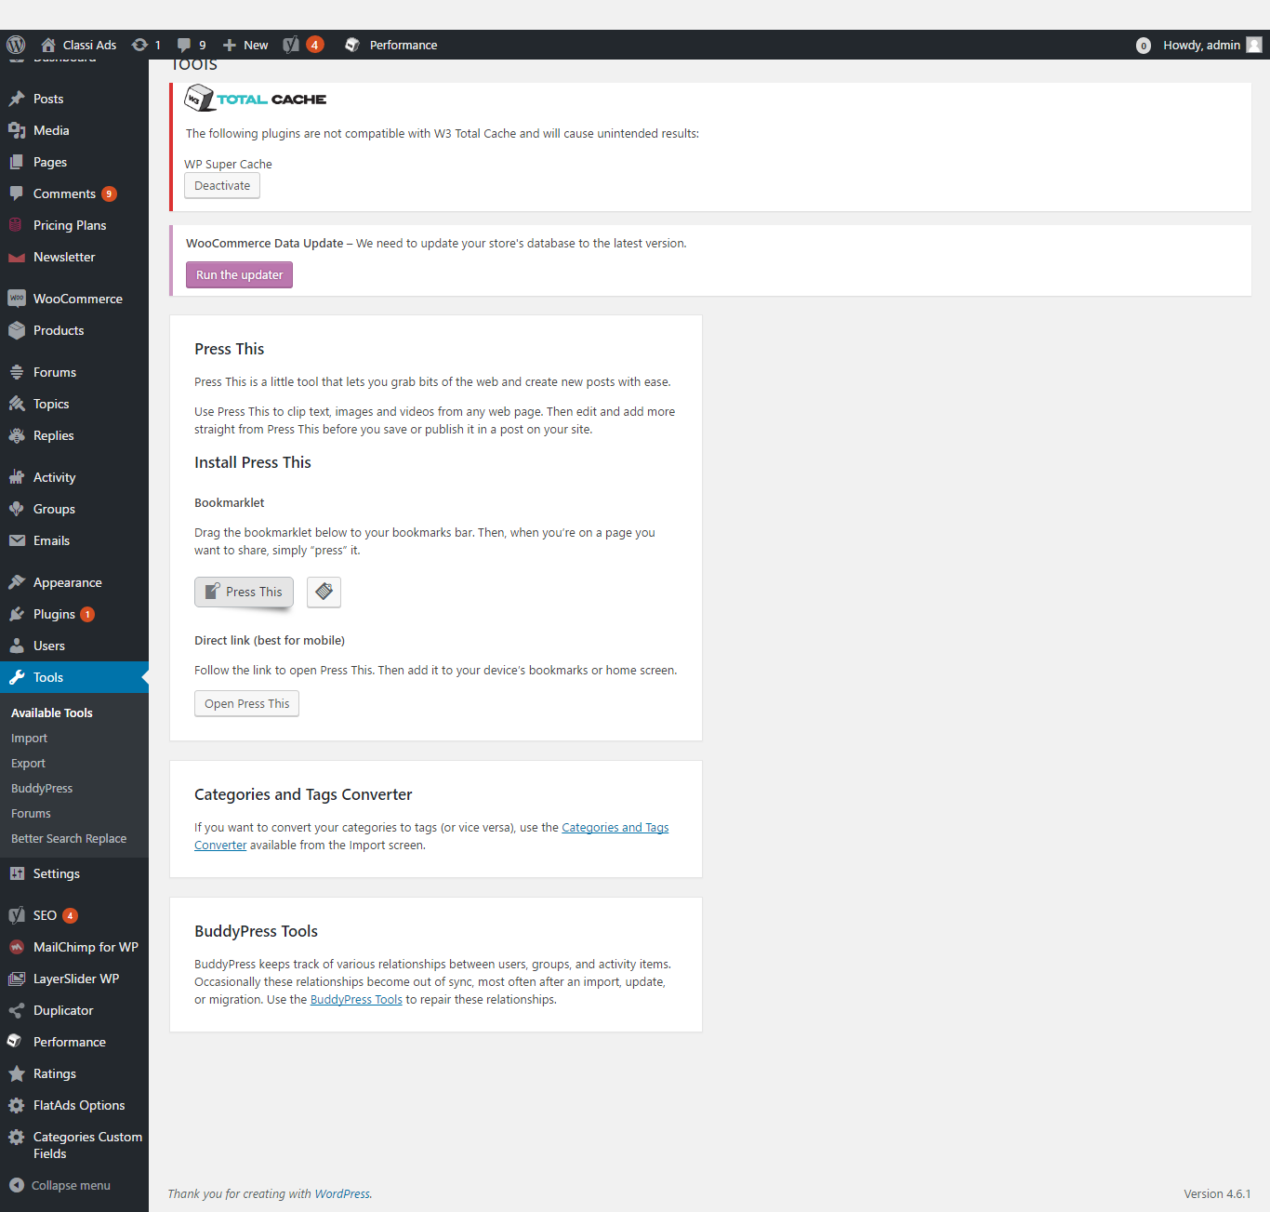
Description:
This page manages the tools detail. Admin can import or export the tool detail.

Buddy press:
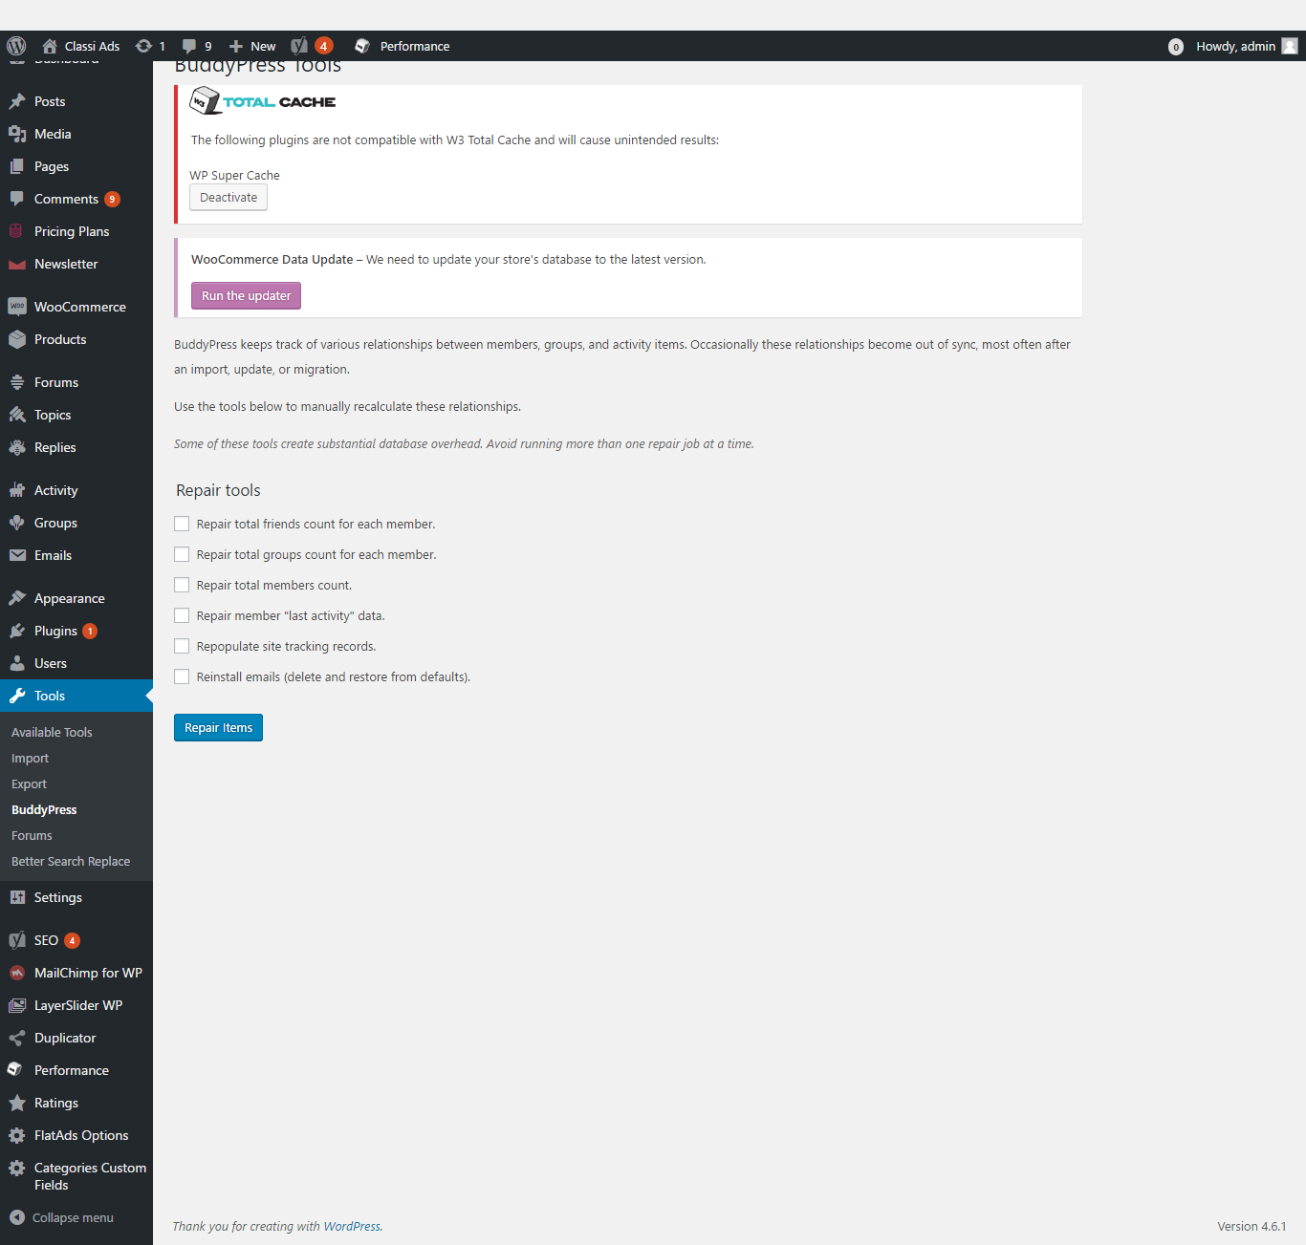
Description:
This page manages the buddypress details. Admin can deactivate the buddypress.

Forums:
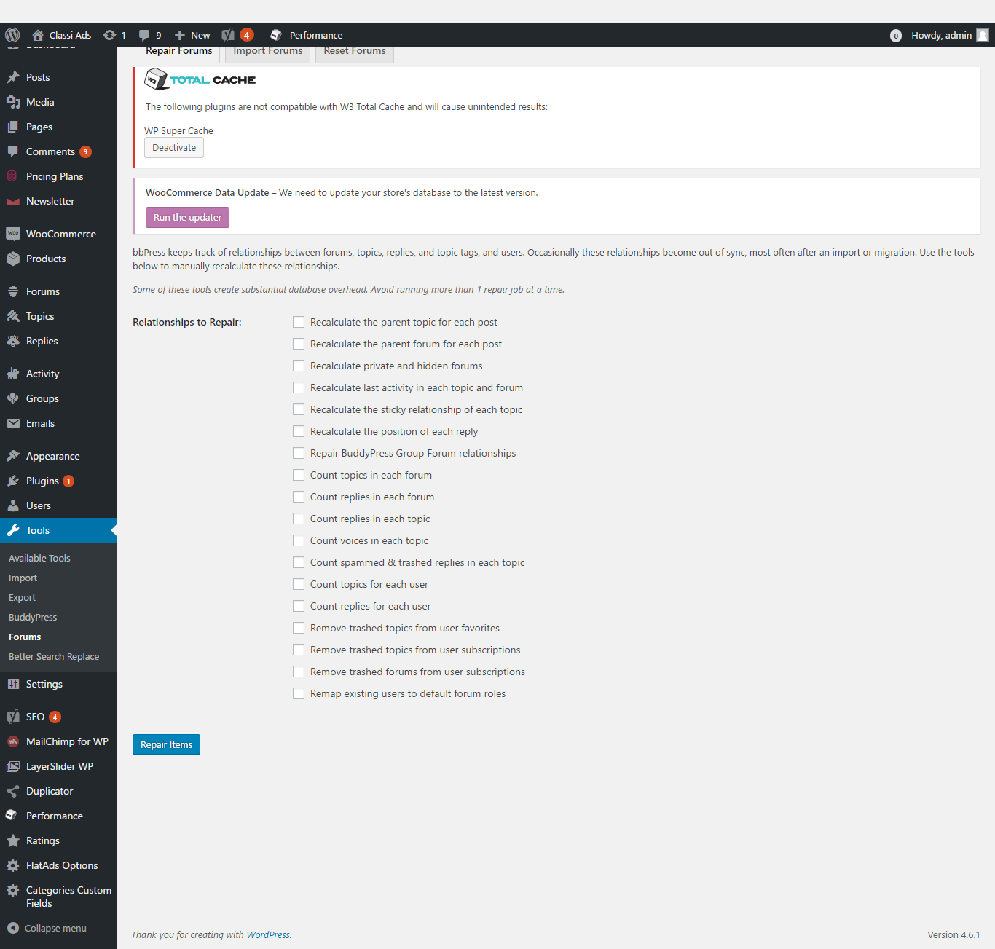
Description:
Admin can deactivate the forum details. Admin can enable and disable the fields.

Setting:
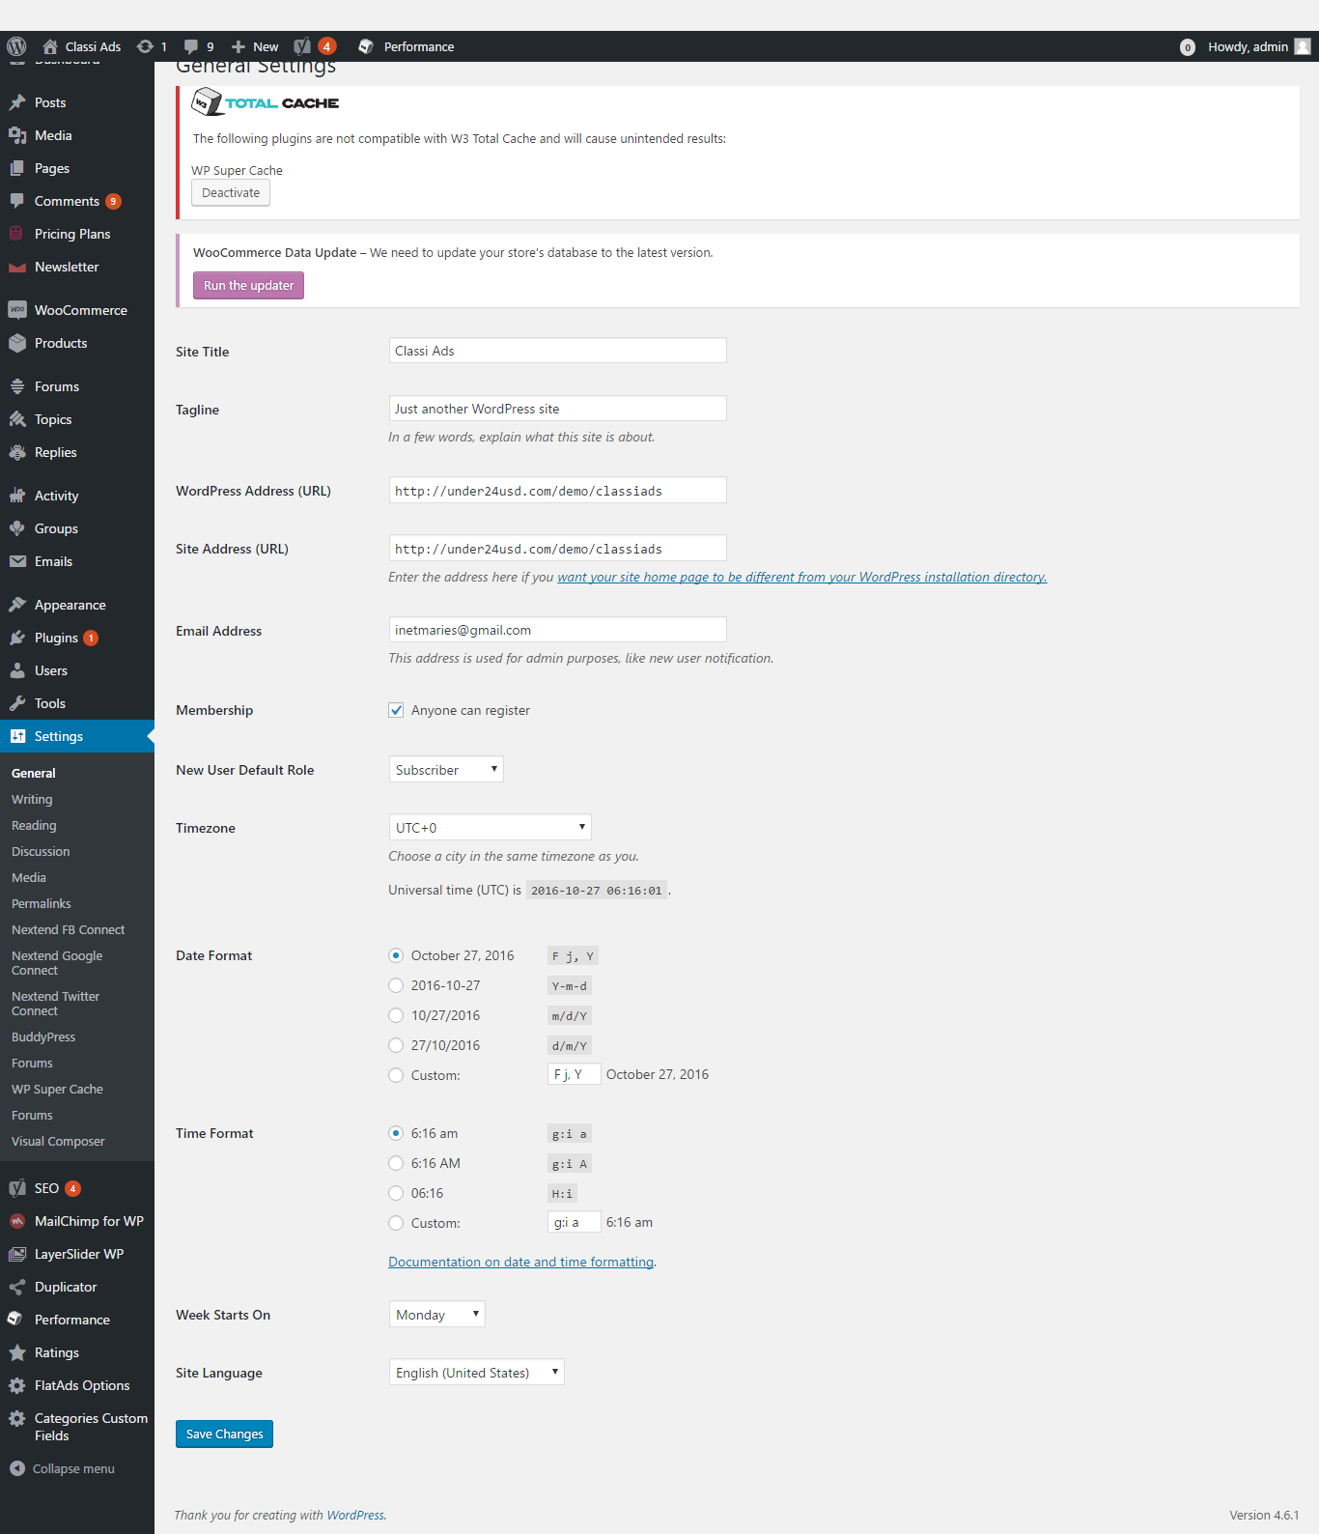
Description:
This page manages the entire settings of the script as general, writing, discussion, media, permalinks, reading and etc.
Ratings:
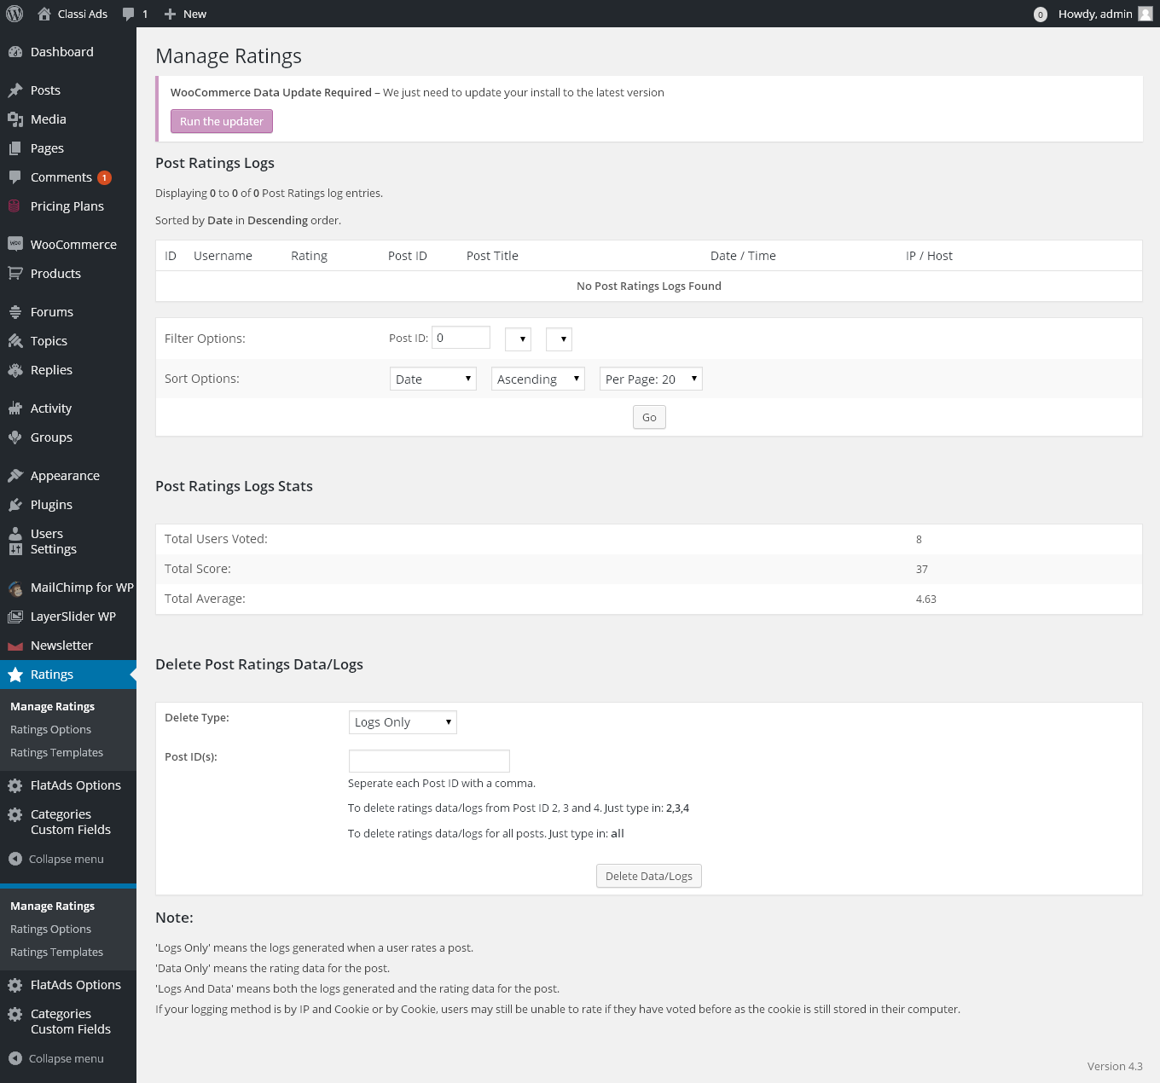
Description:
This page manages the manage details. Admin can manage the ration option. Admin can manage the rating templates.

Categories custom fields:
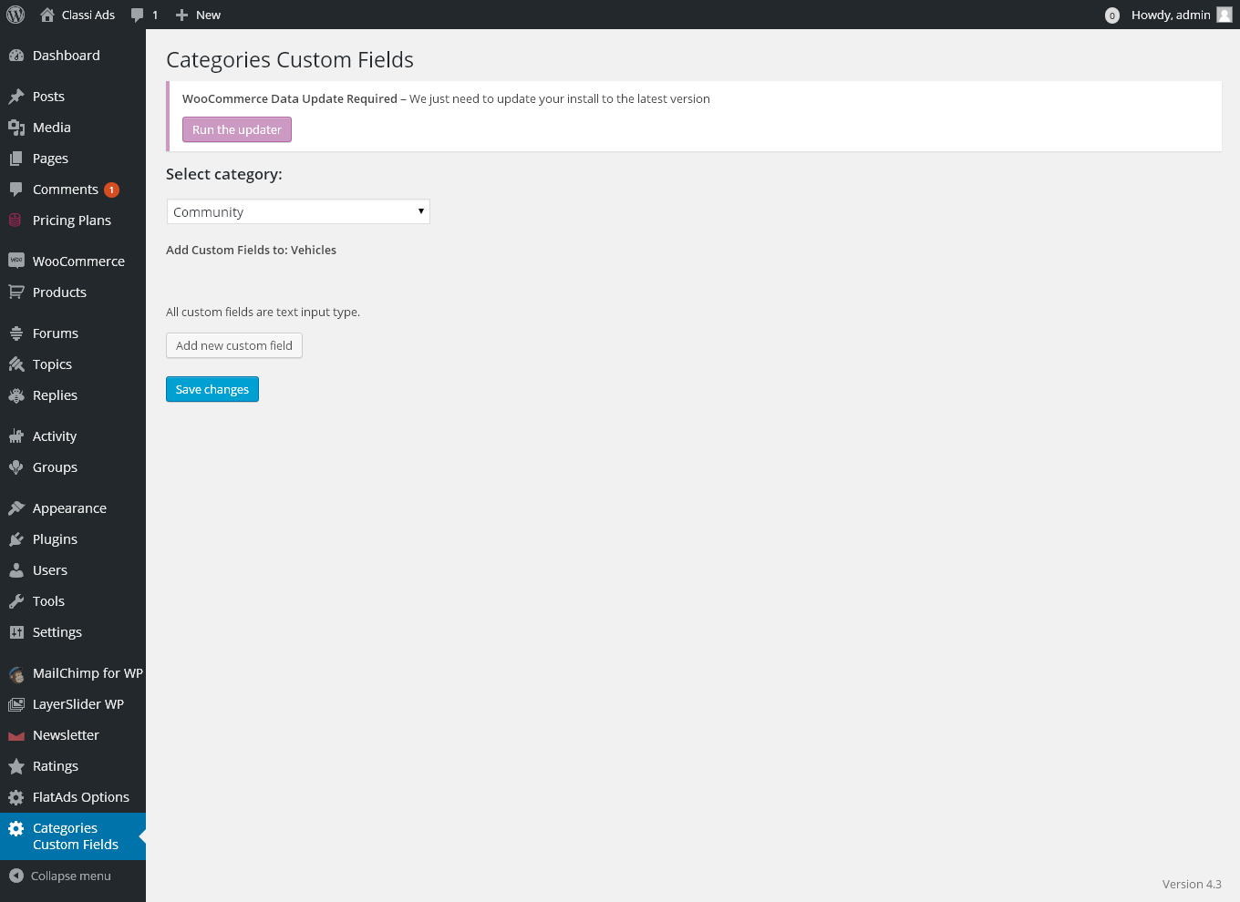
Description:
This page manages the categories custom fields.

