MLM FORCED MATRIX
Manual guide
User view
Registration:
Step 1:
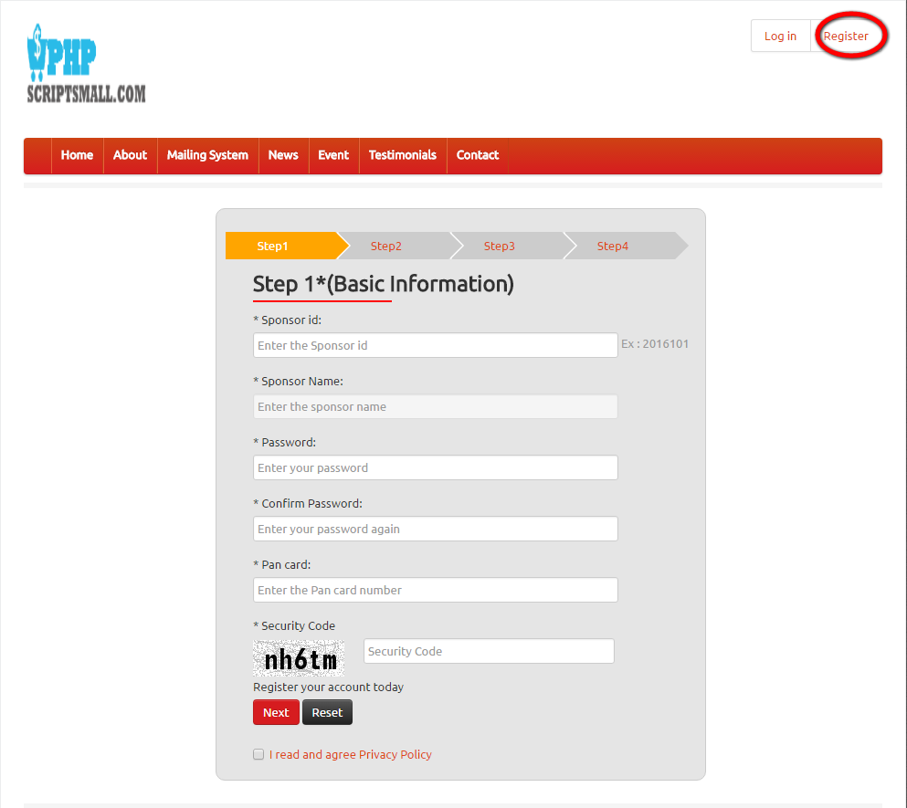
Description:
This page contains the first step registration fields with sponsor id details.

Registration:
Step 2:
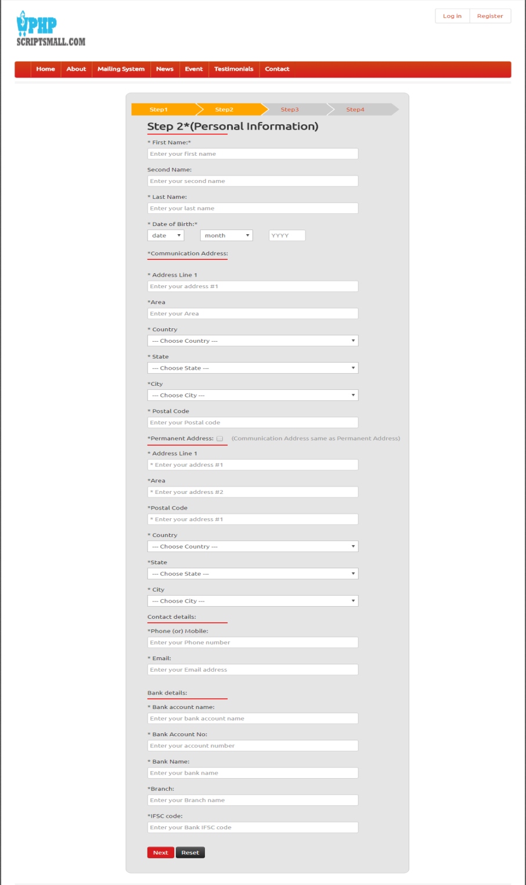
Description:
This page consists of the step 2 registration fields with the communication and bank account details.

Registration:
Step 3:
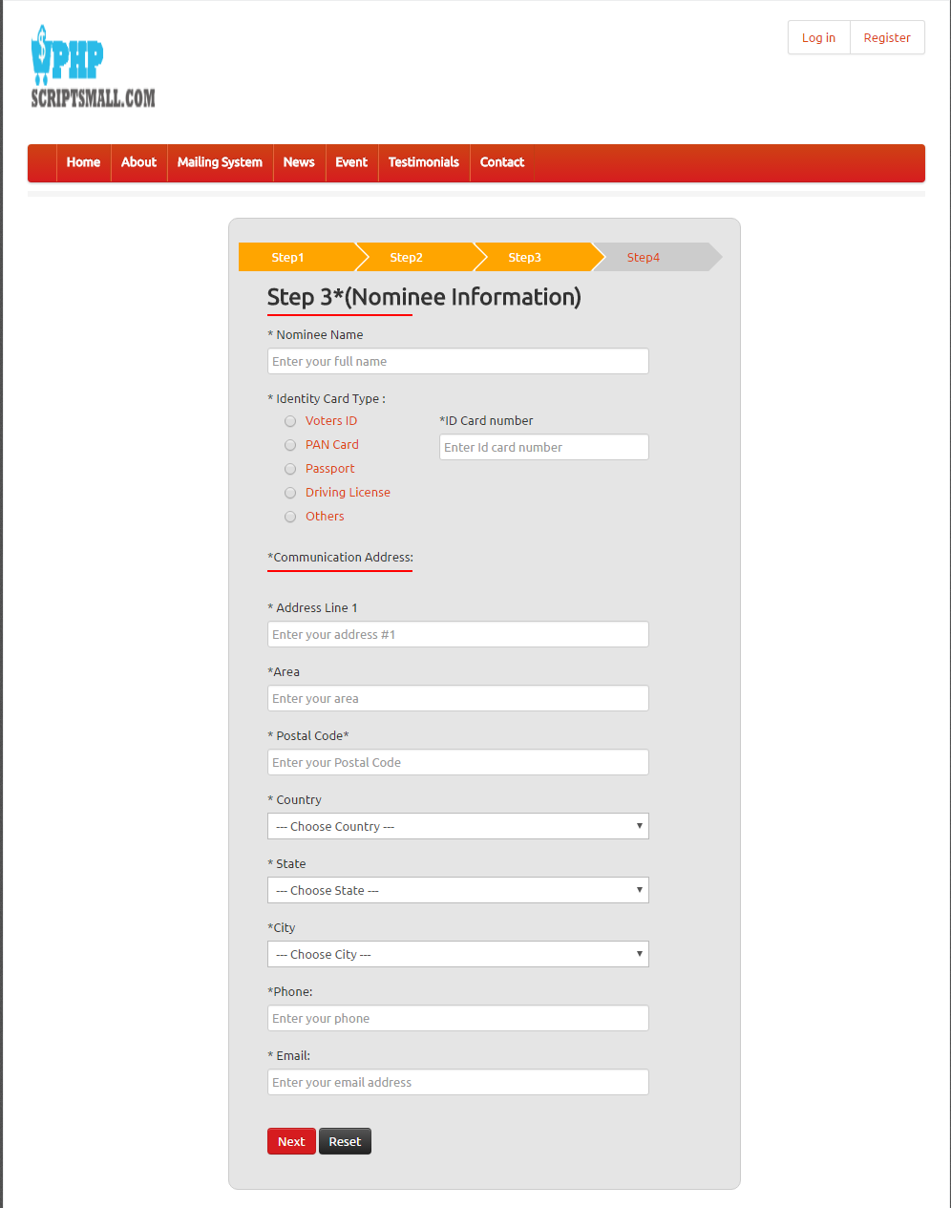
Description:
This page contains the third step registration fields as nominee communication address details.

Registration:
Step 4:
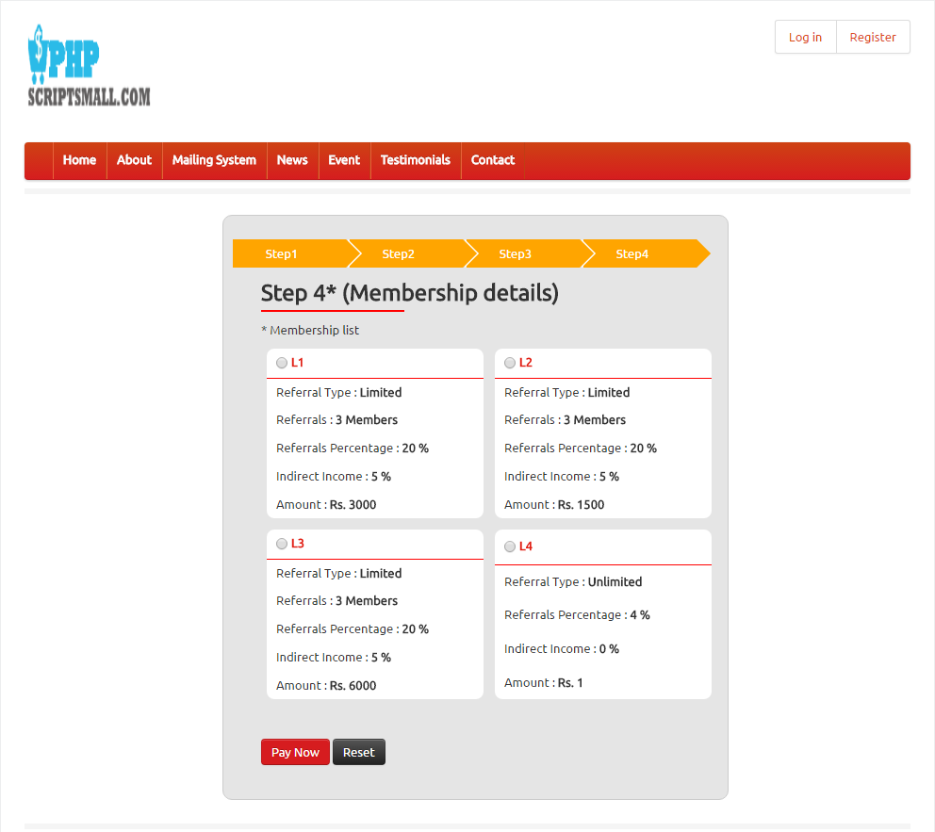
Description:
This page contains membership plan details as fourth step with the detailed list.

Payment gateway page:
Login:
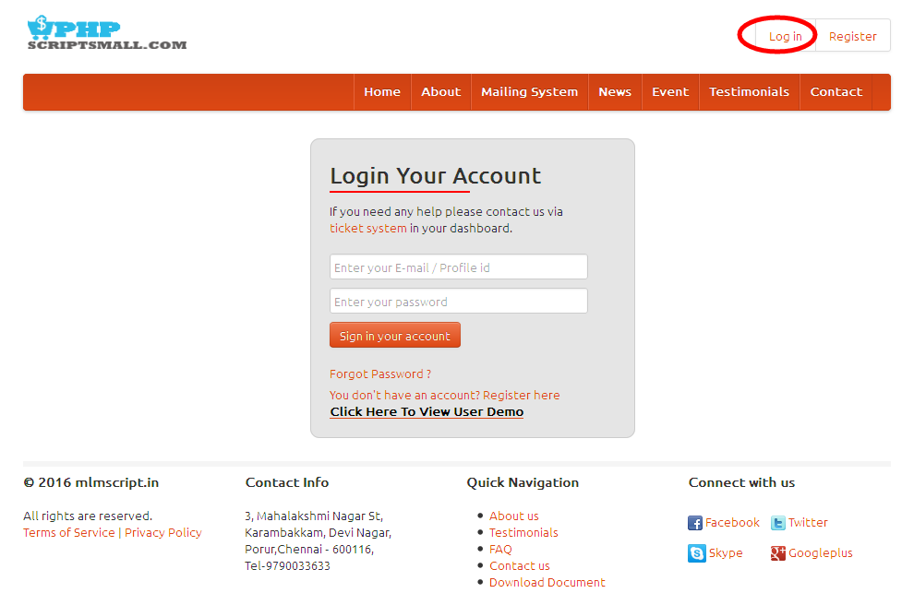
Description:
User can login via valid username and password.

My profile:
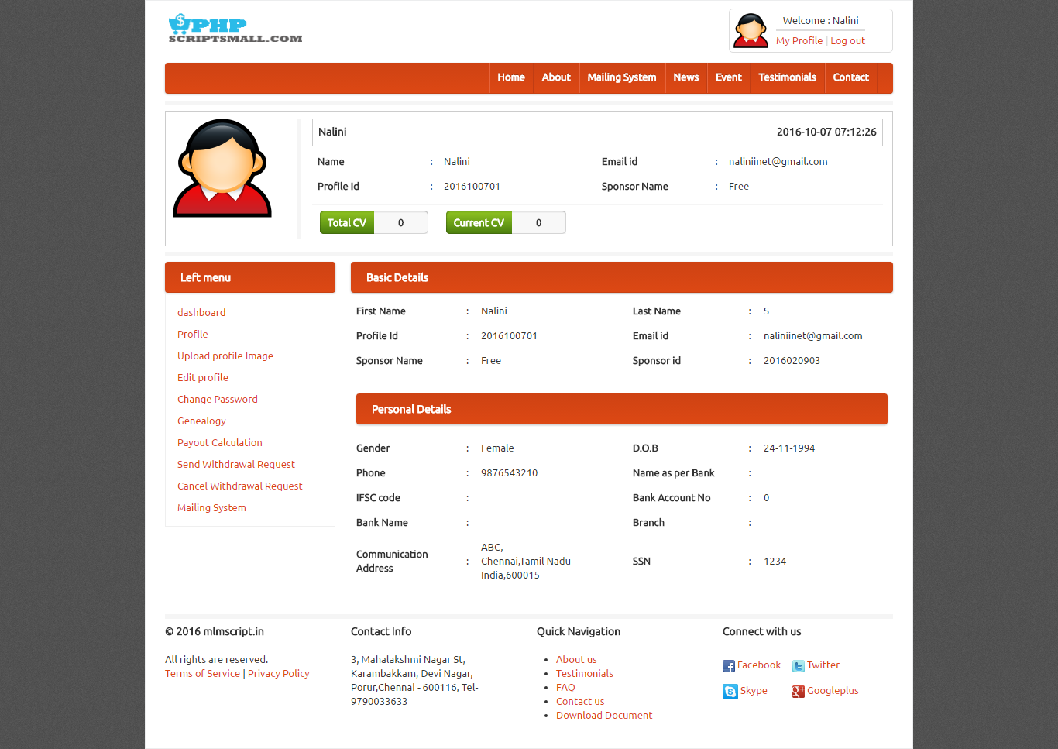
Description:
User can view their profile details with personal and basic details.

Upload profile image:
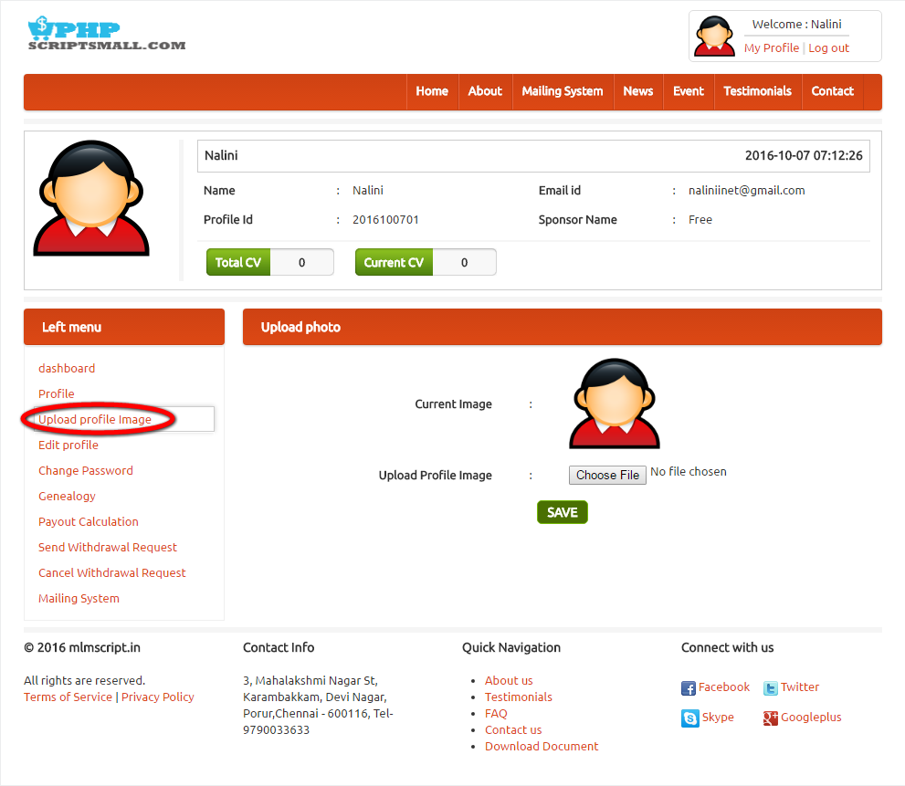
Description:
This page used to change the profile image to the profile.

Edit profile:

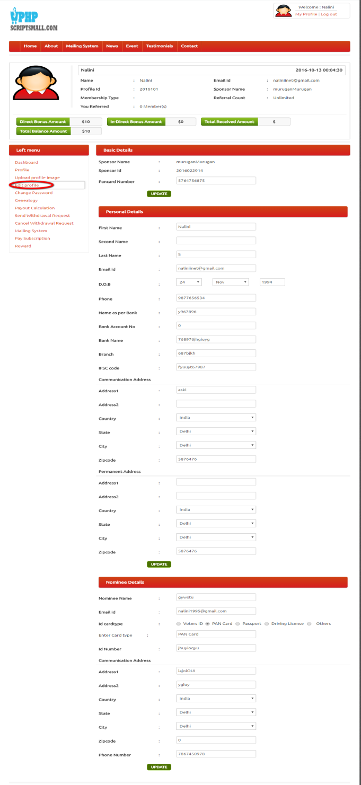
Description:
This page serves to edit the entire details as personal, basic and nominee details.
Change password:
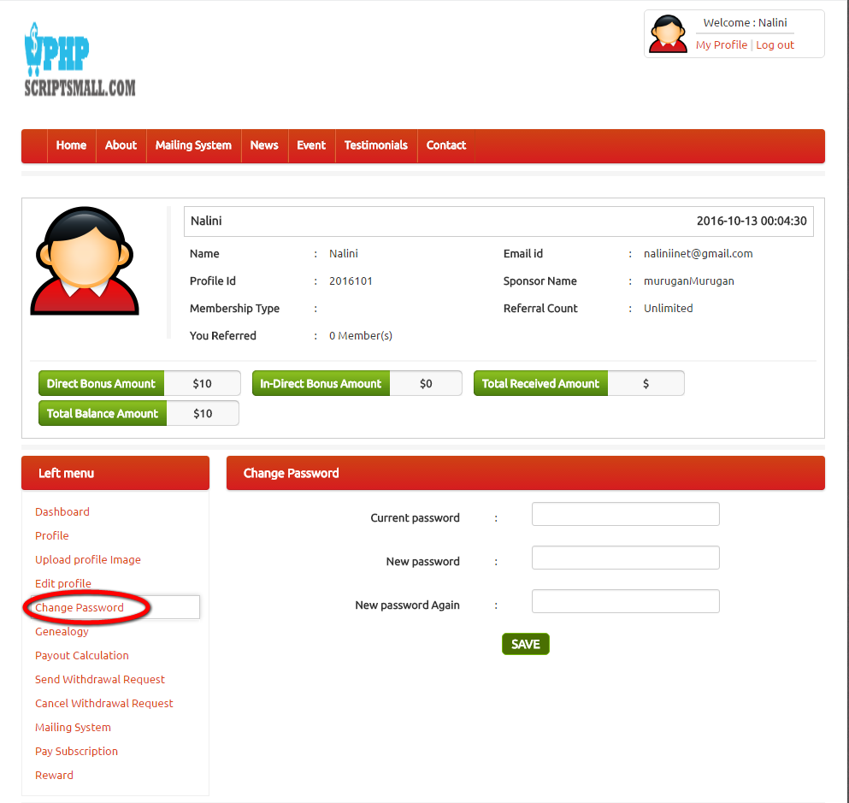
Description:
This page contains the option of change password of the account.

Genealogy:
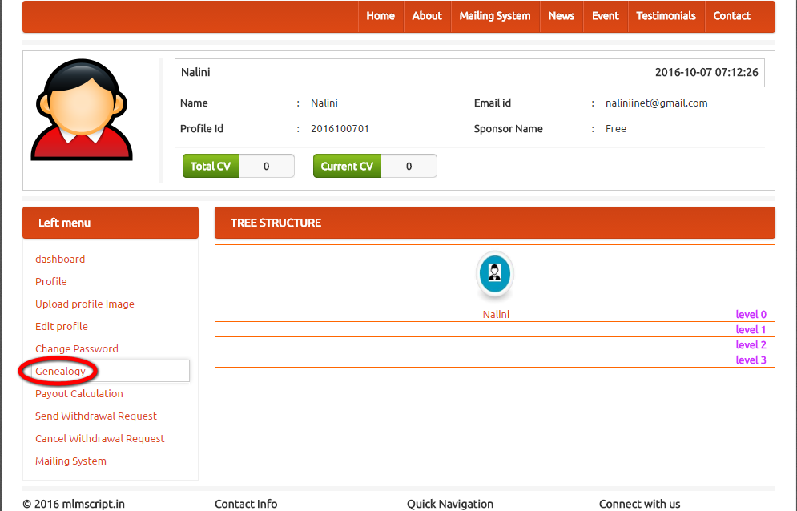
Description:
This page manages the genealogy details with the level.

Payout calculation:
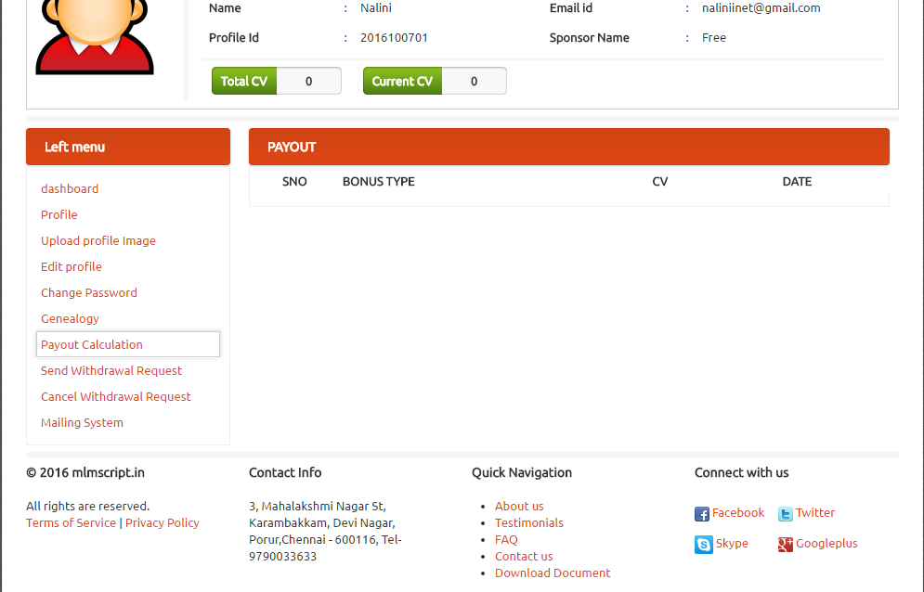
Description:
This page contains the Payout calculation such as

Send withdrawal request:
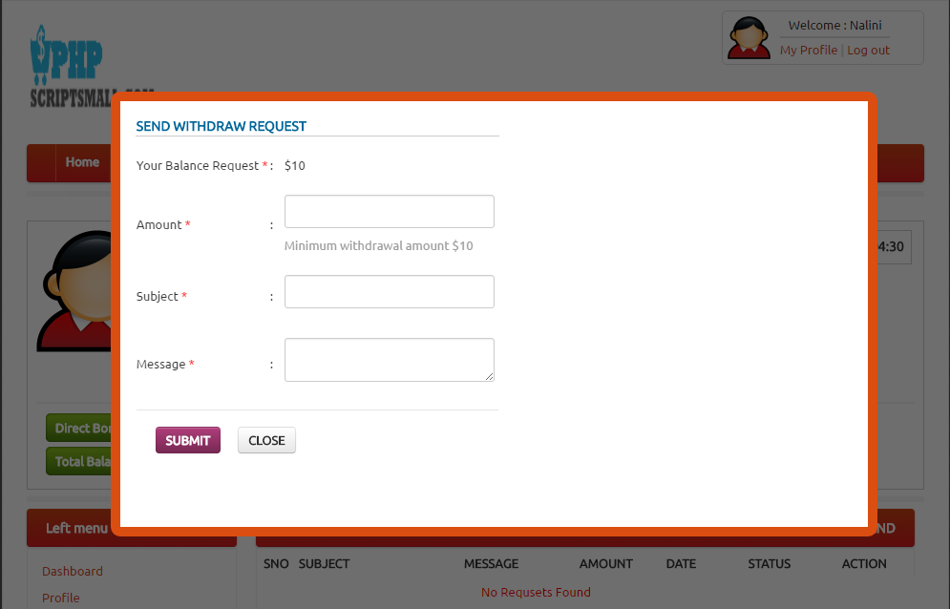
Description:
This page manages the send withdrawal request of their wallet details.

Cancel withdrawal request:
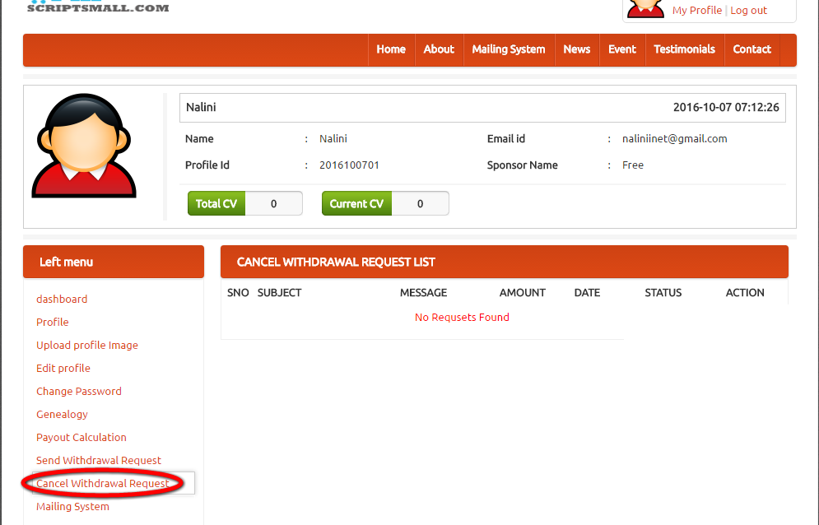
Description:
This page contains the canceled withdrawal request details with the amount, message, date, subject, status and action.

Mailing system:
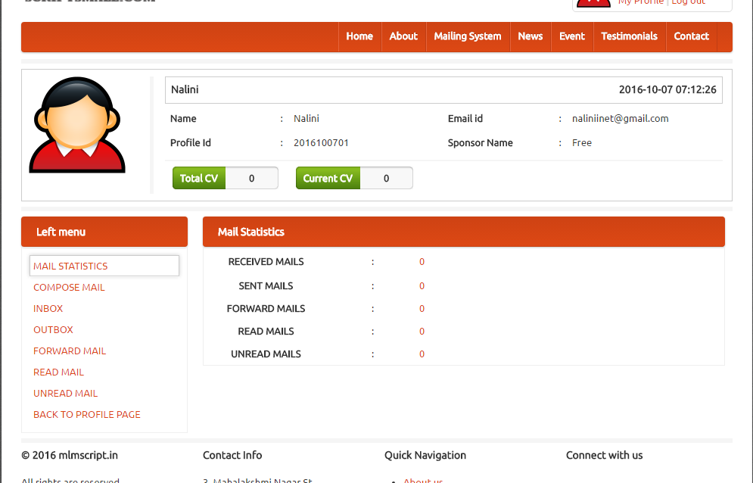
Description:
This page contains the statistic for the mails with the entire counts and the messaging options such as compose mail, inbox, outbox, forward mail, read mail, unread mail details.

Home page:
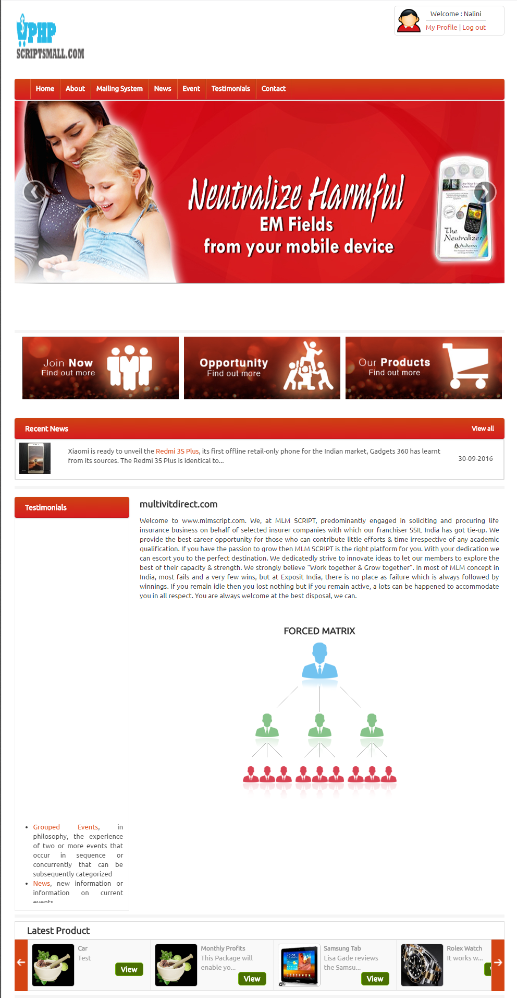
Description:
Home page has latest product details with the testimonial records and brief introduction to the mlm details.

About:
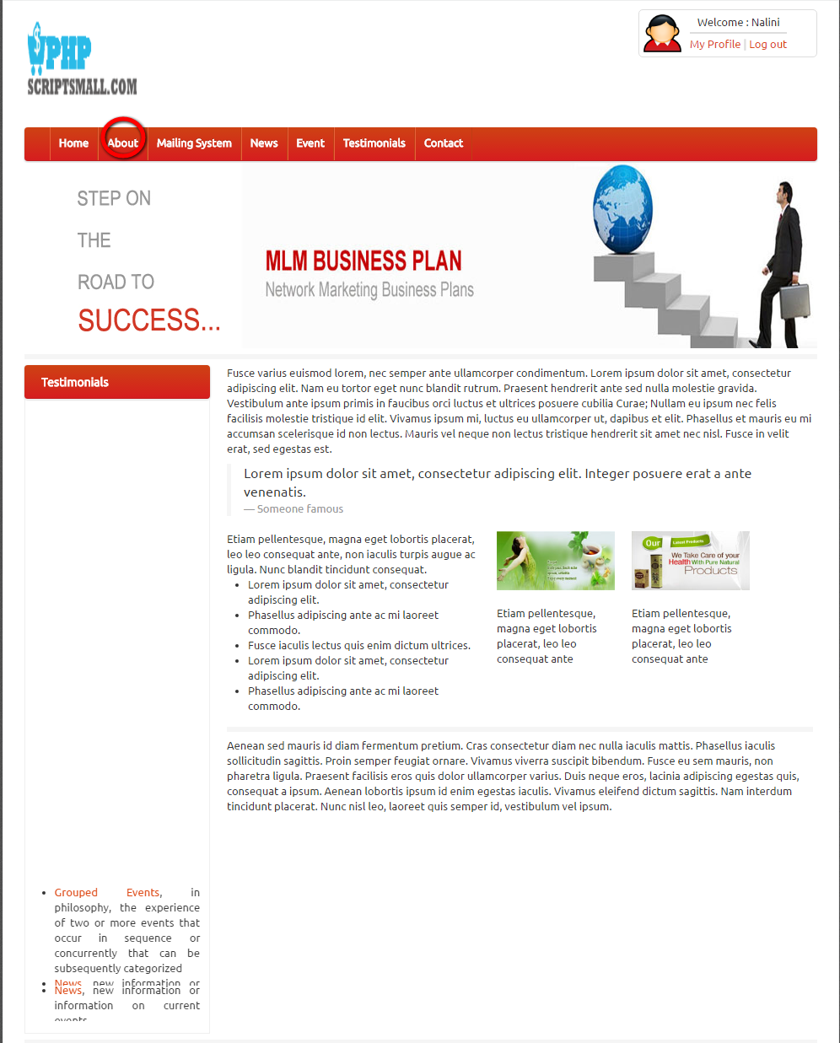
Description:
About page consists of entire details about the company

Mailing System:
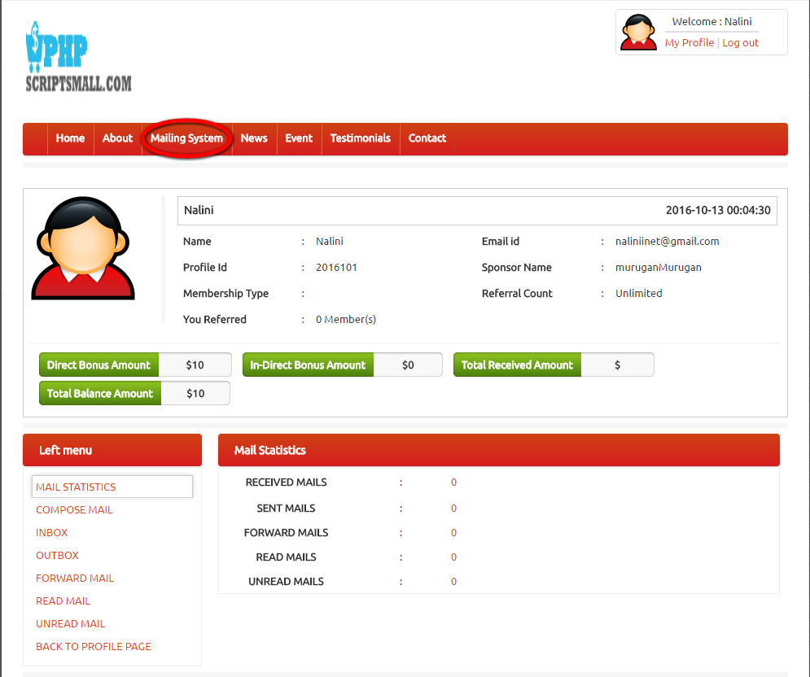
Description:
This page manages the mailing details with counts and messaging details.

News:
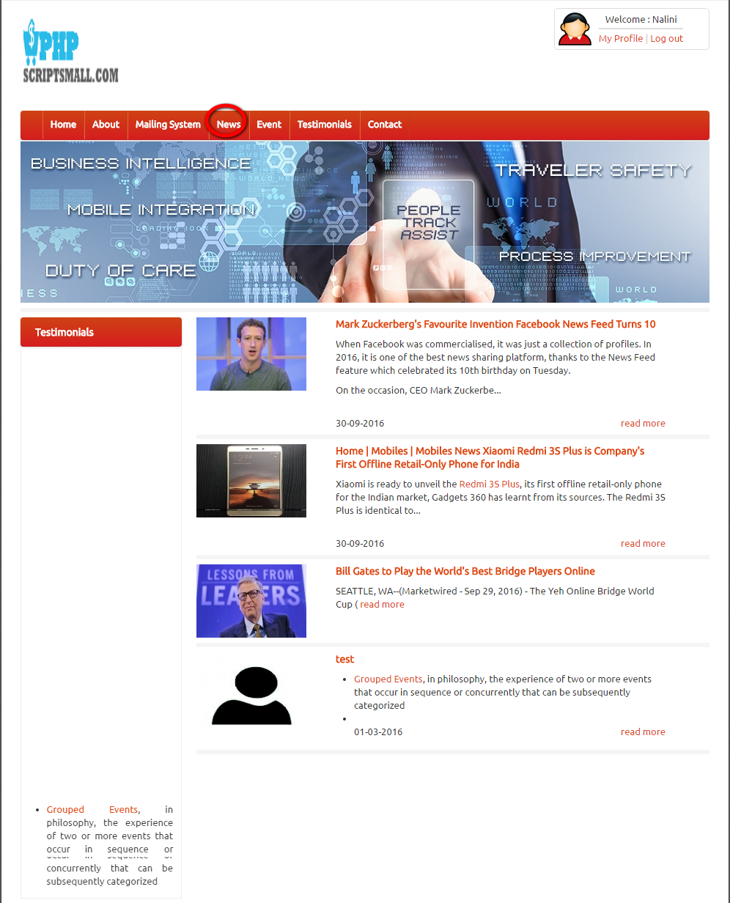
Description:
This page contains the recent news details.

Event:
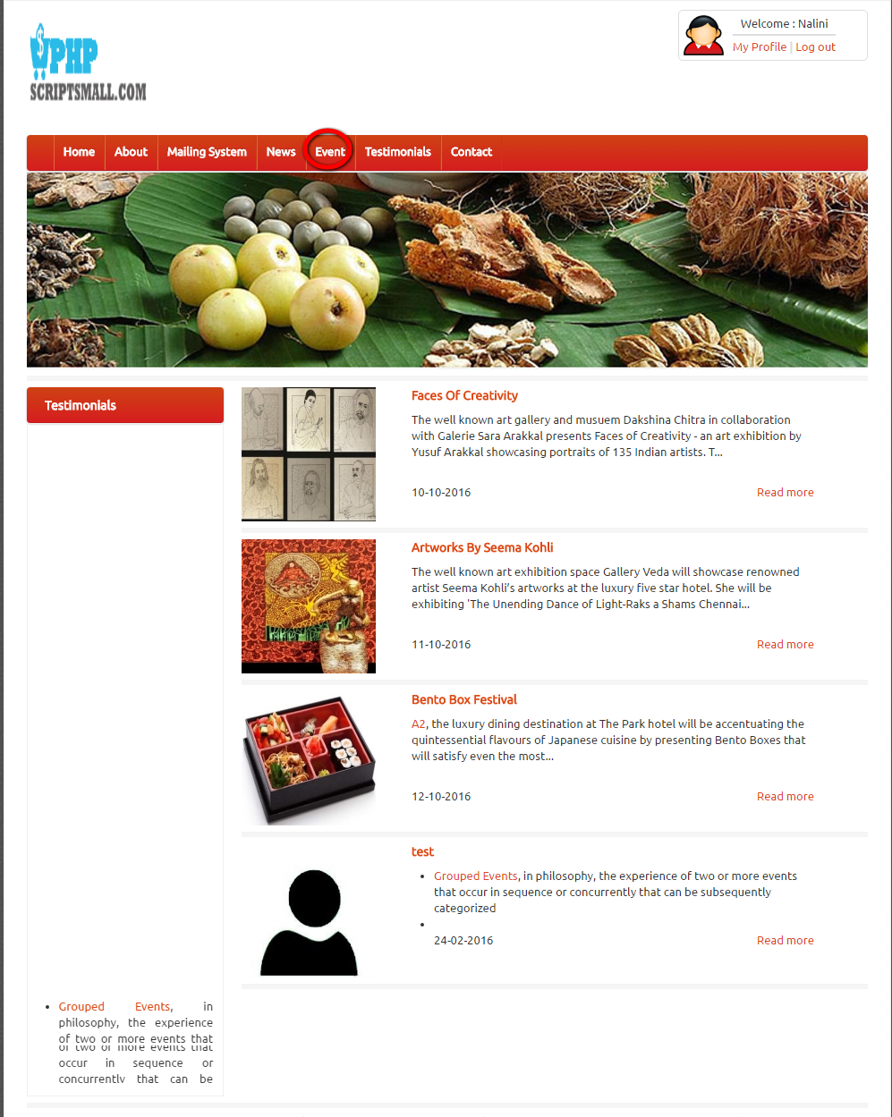
Description:
This page contains the event details.

Testimonial:
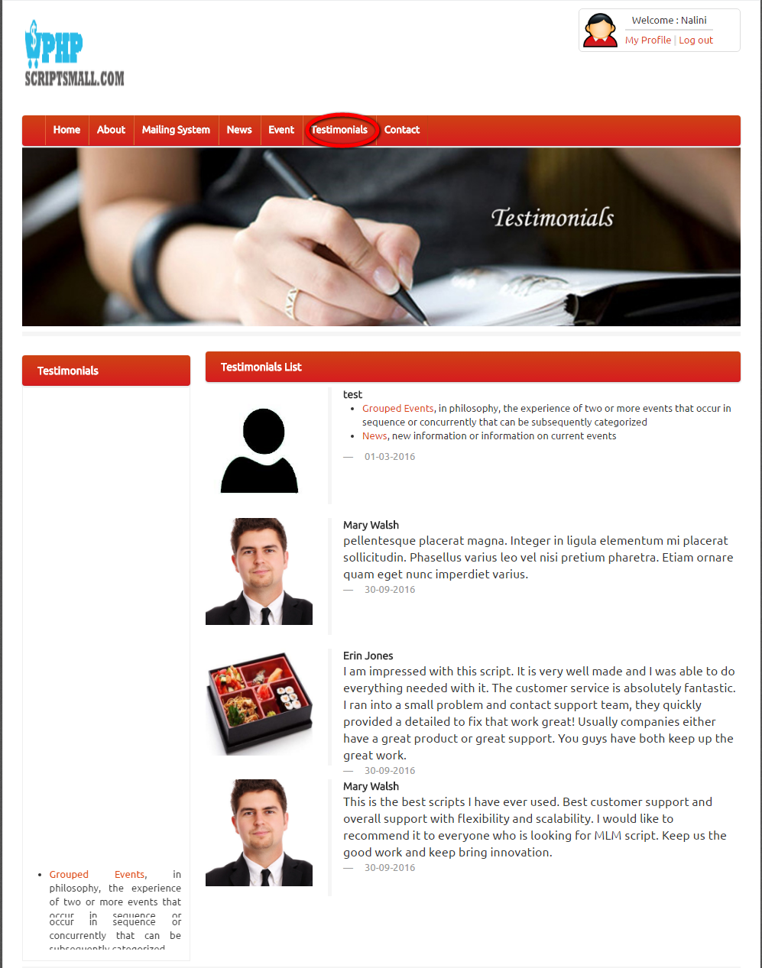
Description:
This page contains the entire testimonial details.

About:
Description:
This page contains the details about the company.

Contact:
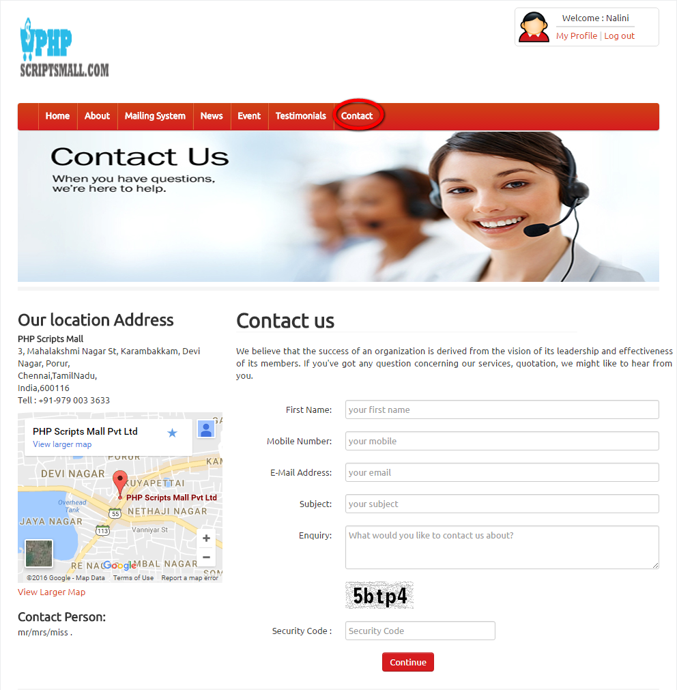
Description:
This page contains the location details with enquiry form.

ADMIN VIEW
Login:
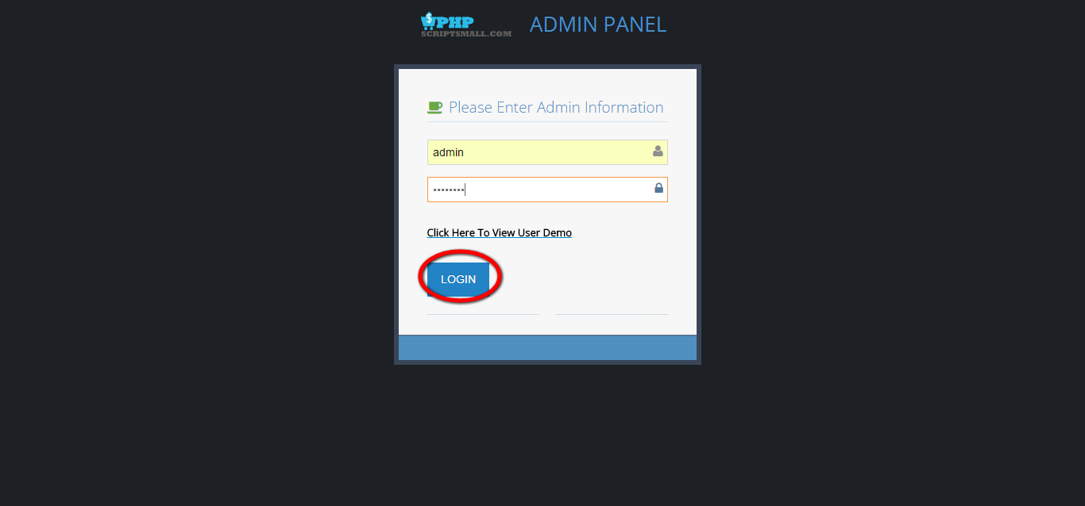
Description:
Admin can login via valid username and password.

Dashboard:
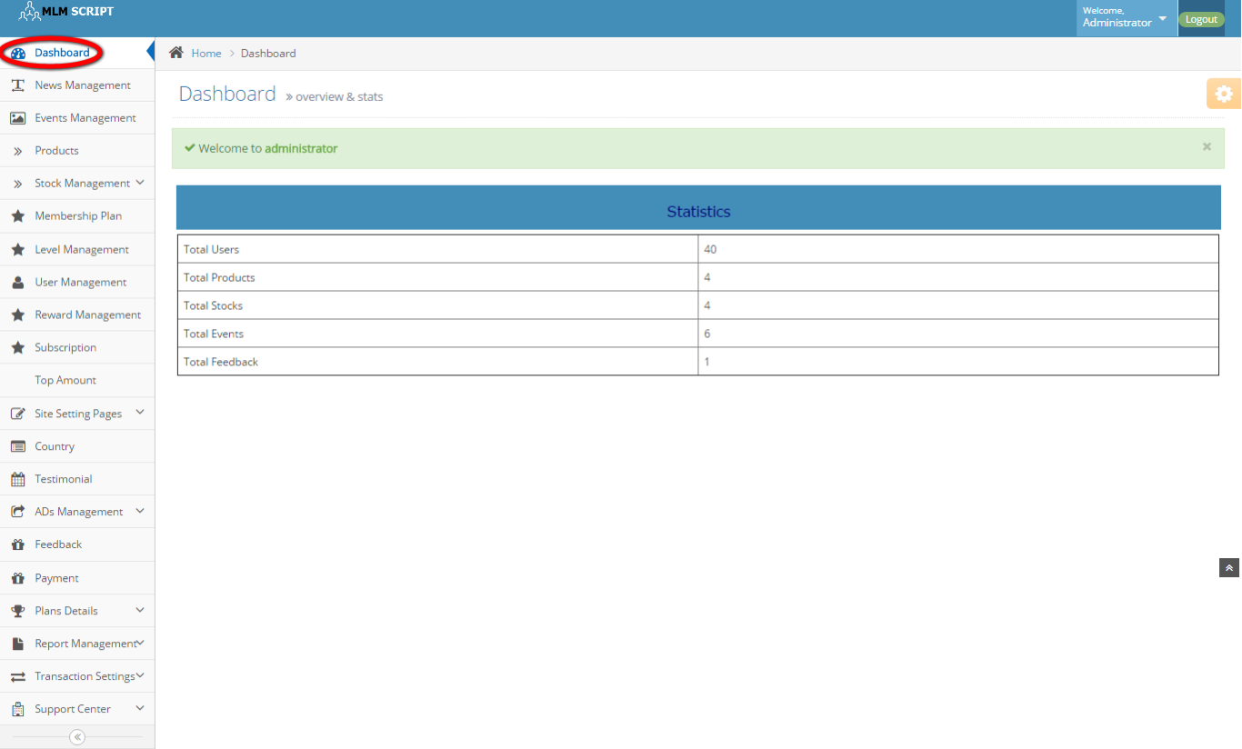
Description:
This page contains the recent activities of the user like count of users, products, stocks, events and feedback.

News management:
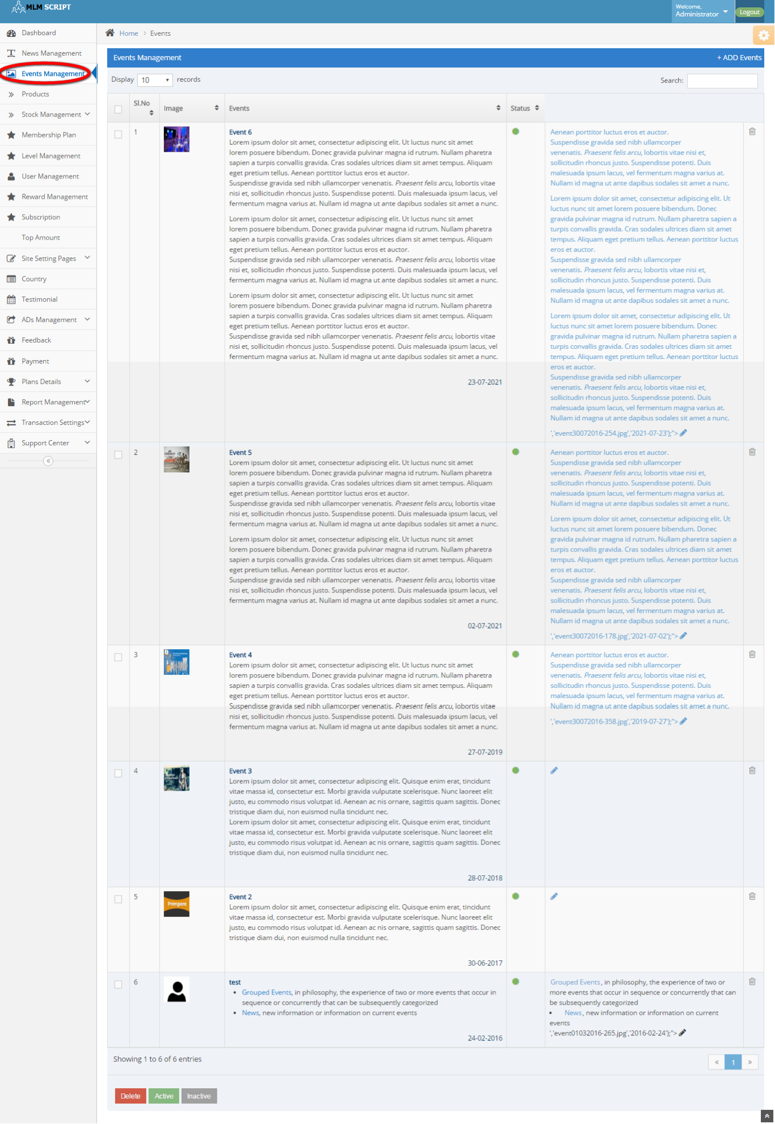

Description:
This page maintains the news details including delete, active and inactive options.

Discount price:
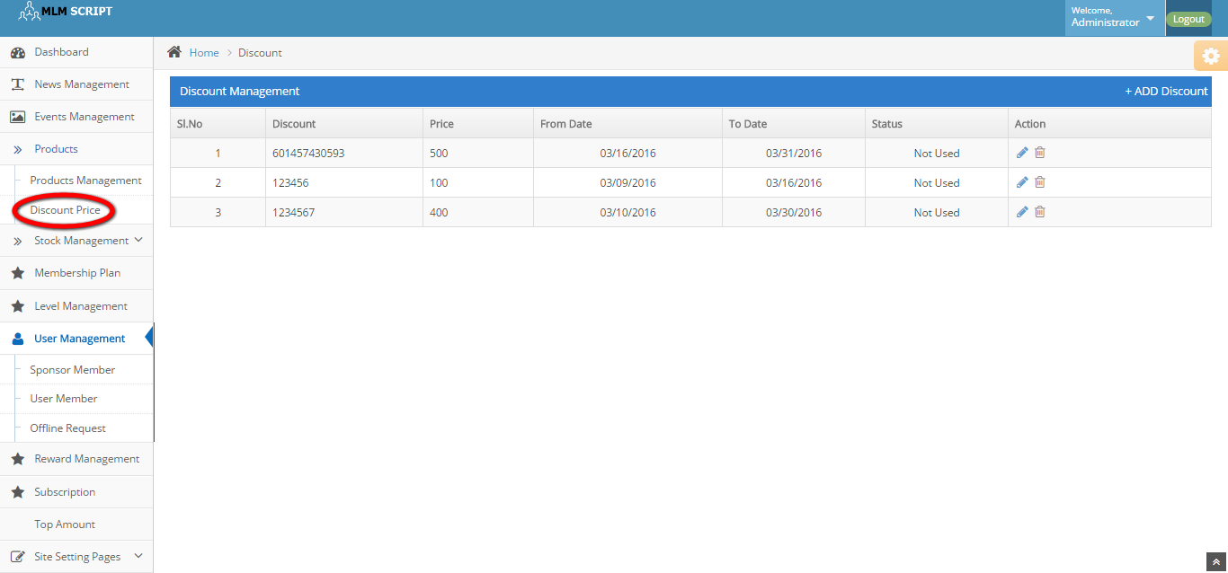
Description:
This page manages the discount details with price, date, status and action details.

Products management:

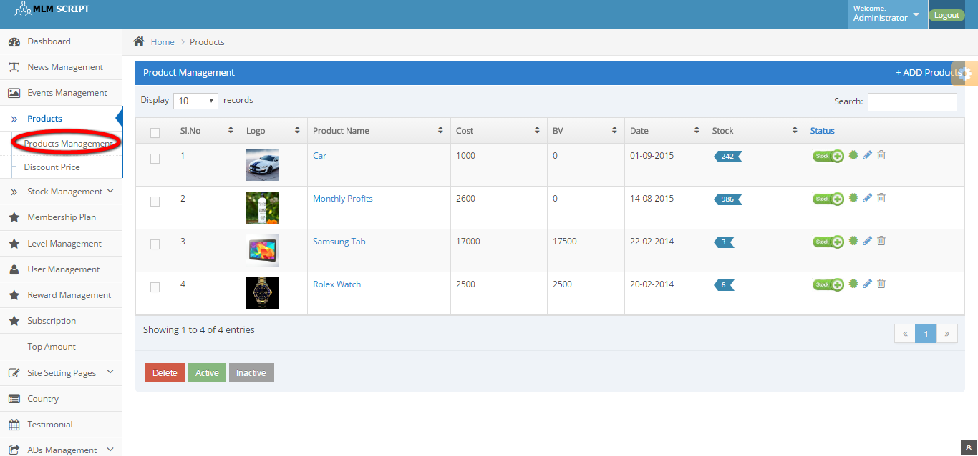
Description:
This page manages the product details like stock, date, cost, product name and status details.

Stock list:

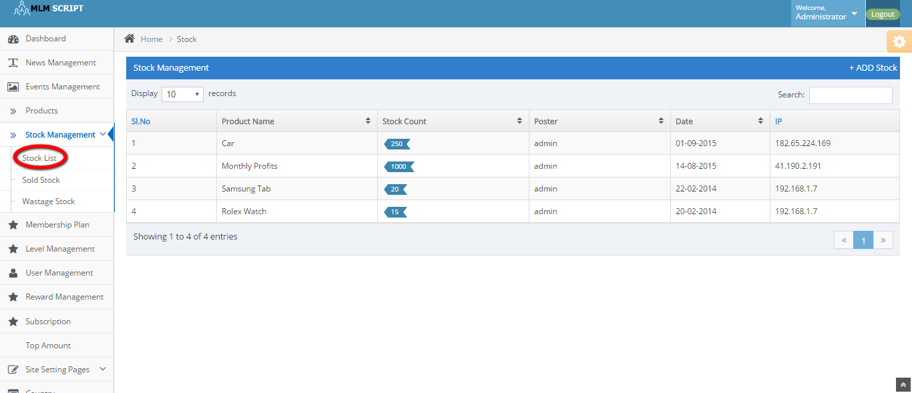
Description:
This page maintains the stock details like product name, stock count, poster, date and IP address details.

Wastage stock:
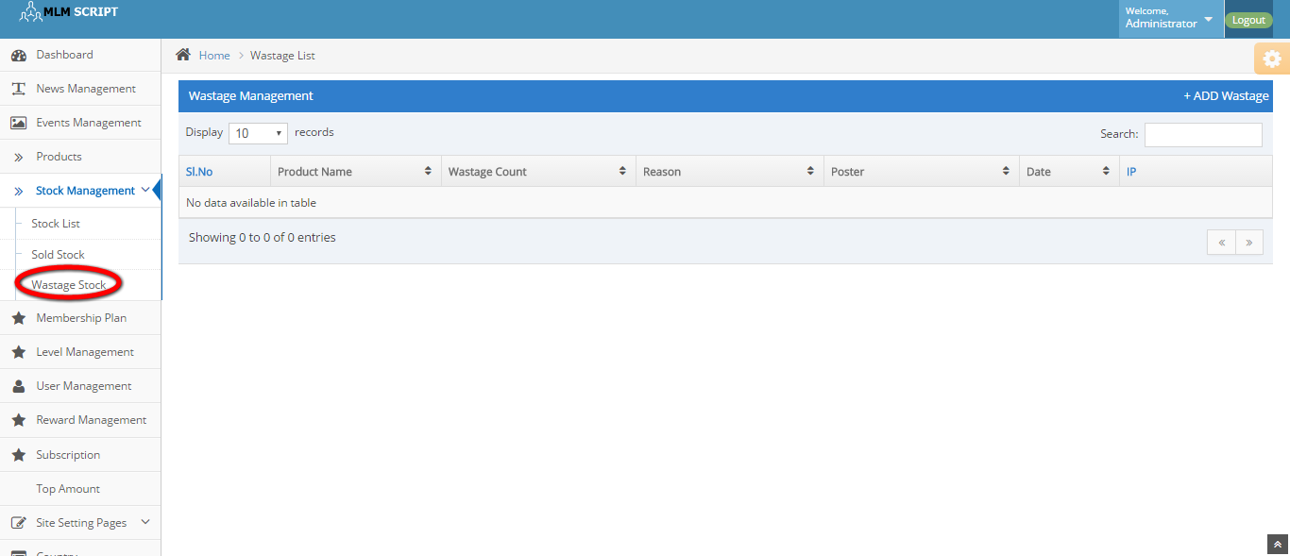
Description:
This page maintains the wastage stock details like product name, wastage count, reason, poster, date and IP address details.

Membership plan:
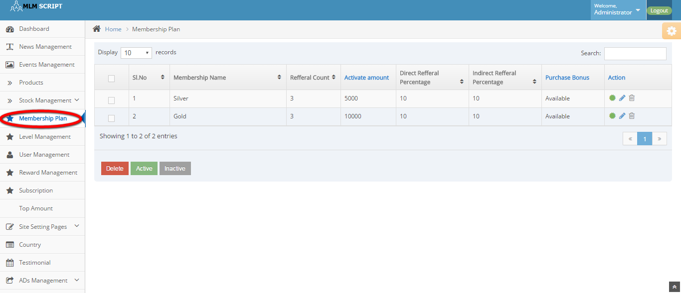
Description:
This page manages the membership plan details and can delete, active and inactive the plan details.
Level management:
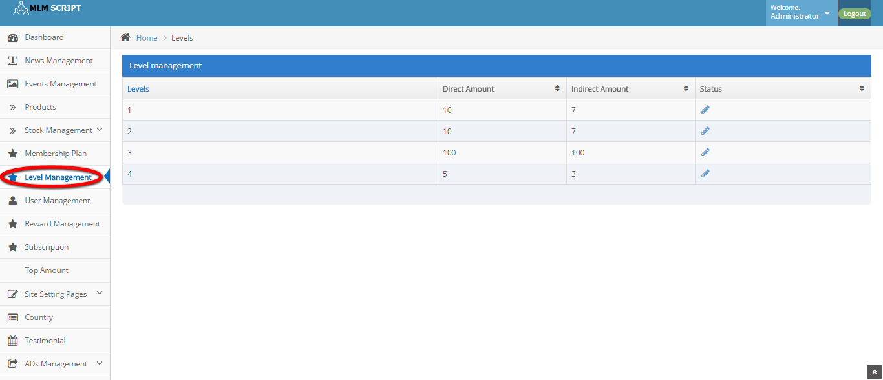
Description:
This page maintains the level details like direct amount, indirect amount and status details.

Sponsor member:

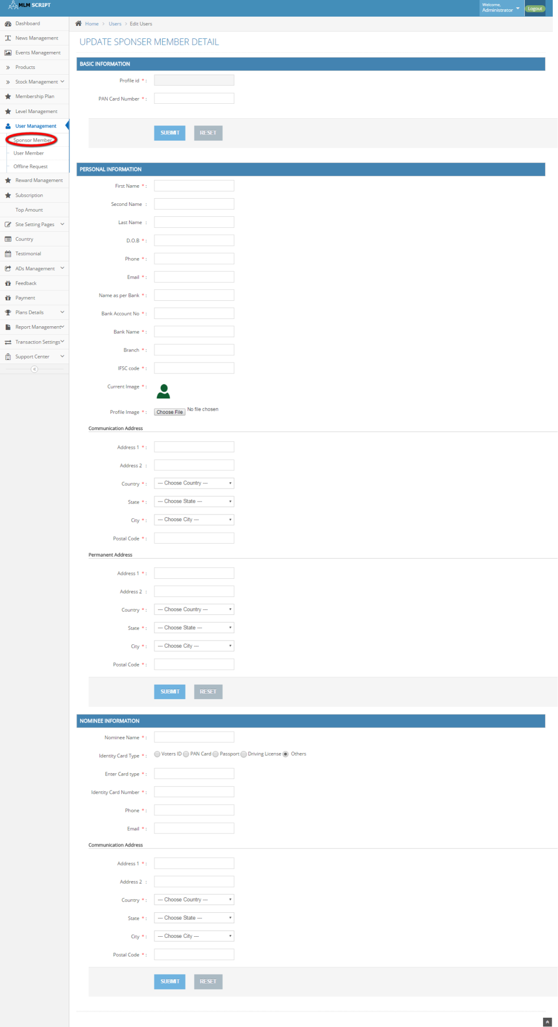
Description:
This page contains the sponsor member details that helps the admin to add new sponsor member.
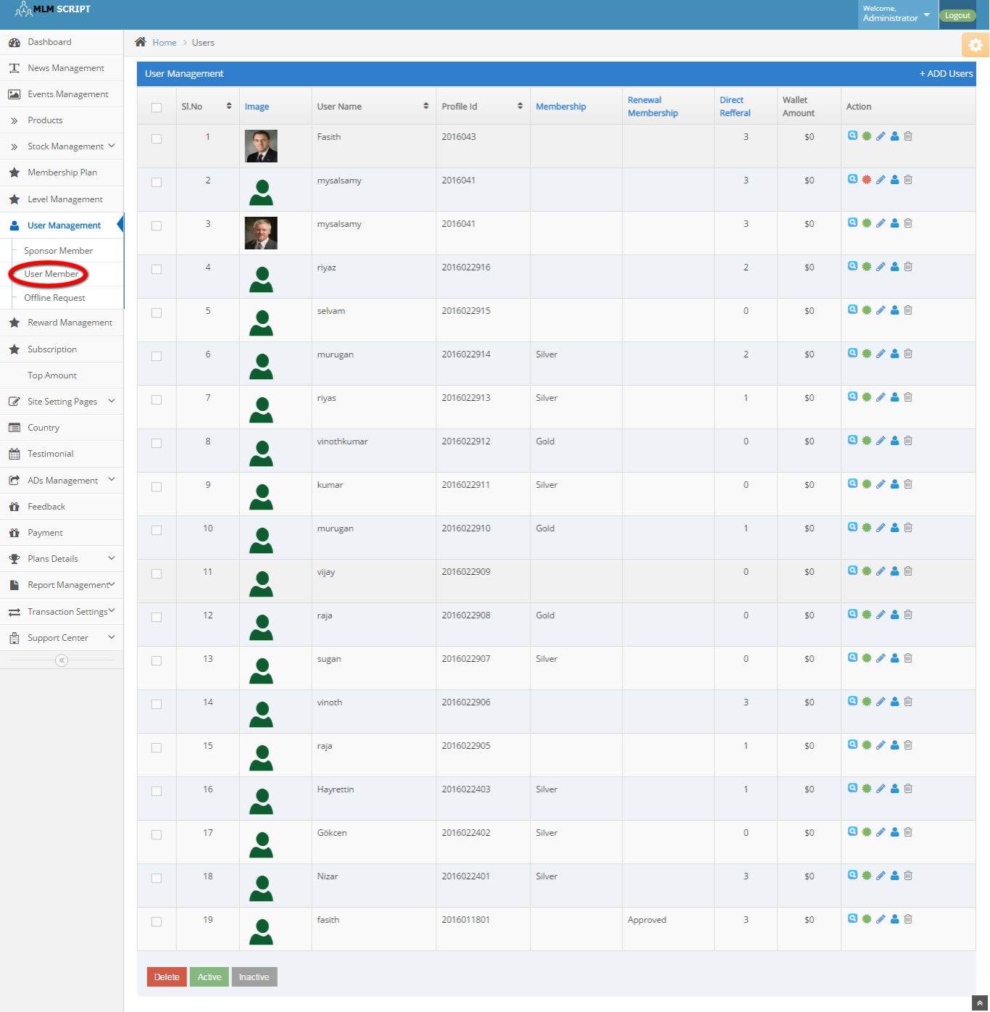
Description:
This page contains the update option for the sponsor member details with basic, personal and nominee information details.

Offline request:
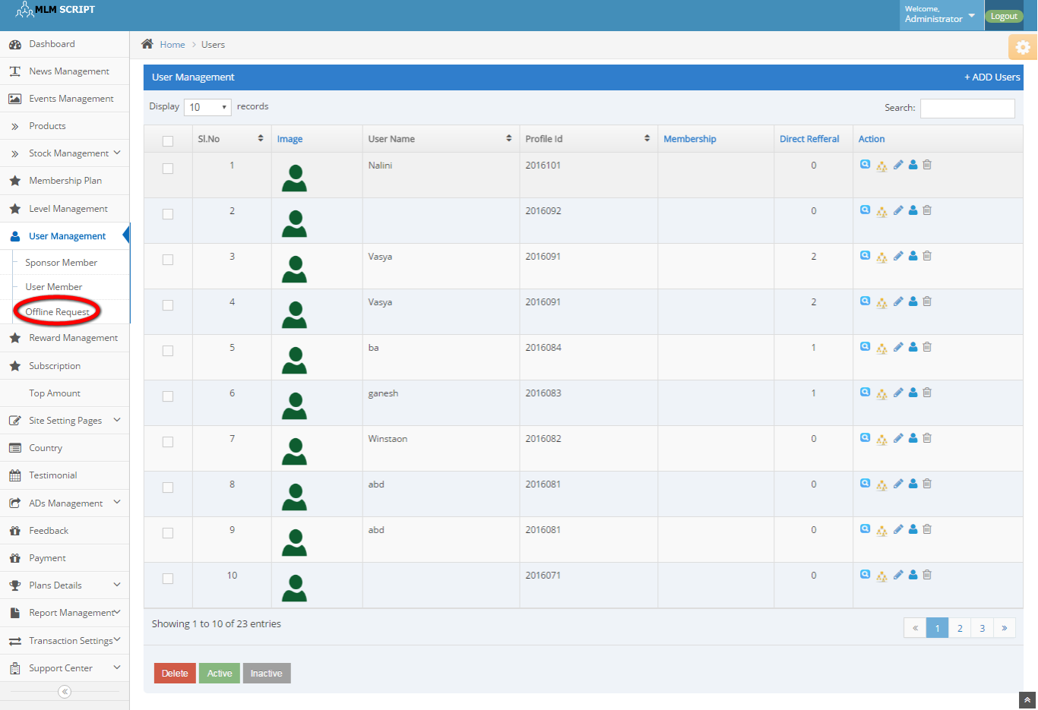
Description:
This page contains the offline request details with maintains the user name, profile id, membership, direct referral and action details.

Subscription:
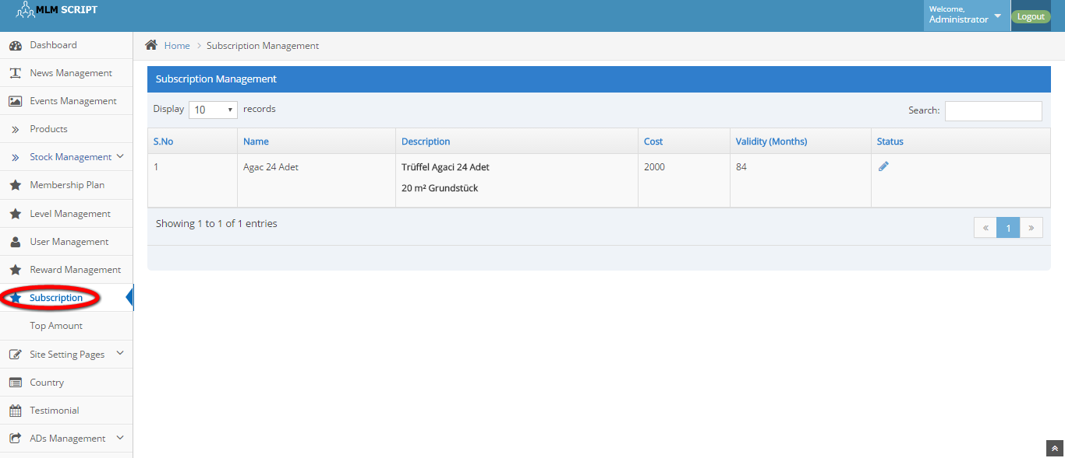
Description:
This page manages the subscription details like name, description, cost, validity and status details.
Top amount:
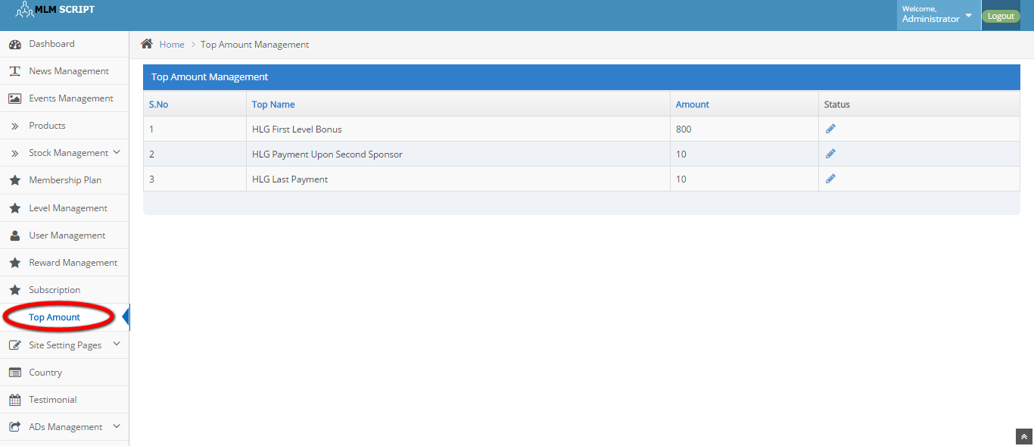
Description:
This page contains the top payable details in increasing order by amount details.

Reward management:

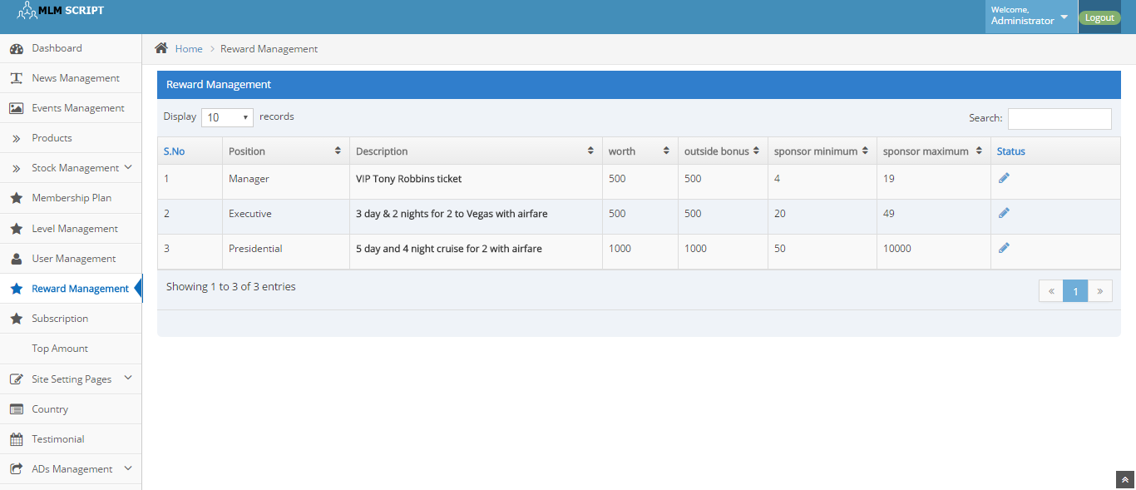
Description:
This page maintains the reward details like worth, outside bonus, sponsor minimum, sponsor maximum and status details.

CMS:
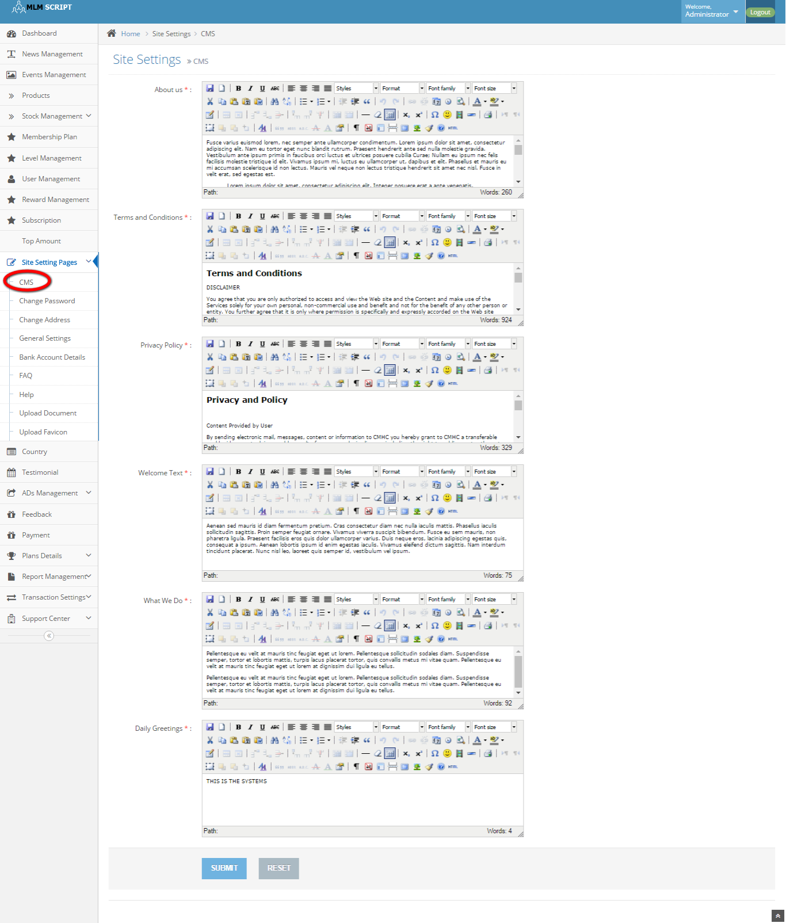
Description:
This page maintains the content of the CMS page.

Change password:
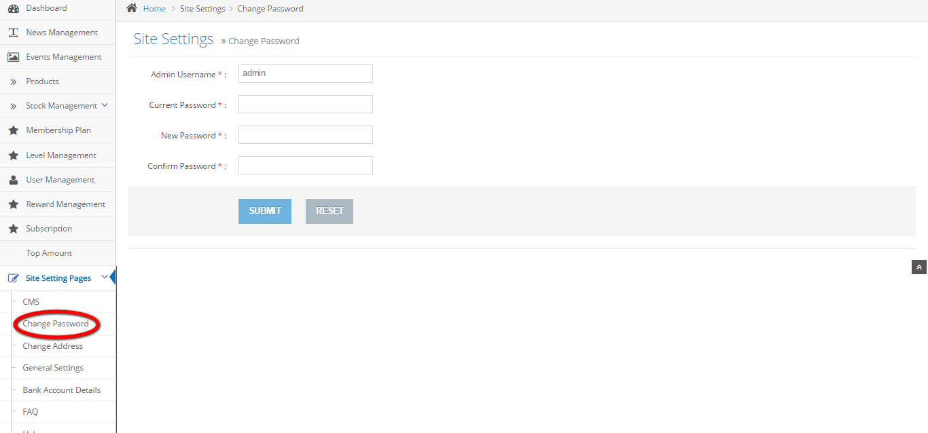
Description:
This page contains the option of change the admin password.

Change admin:

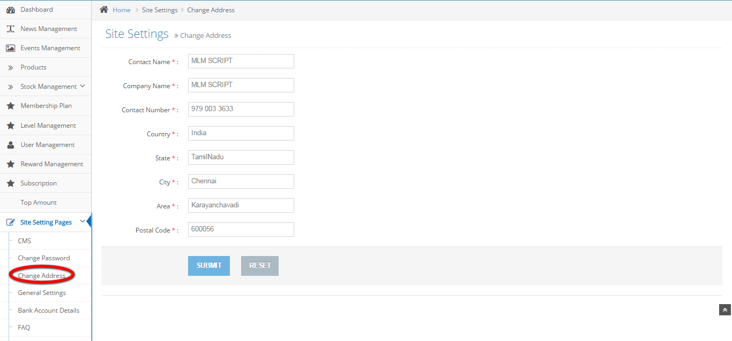
Description:
This page contains the option of change admin details.

General settings:
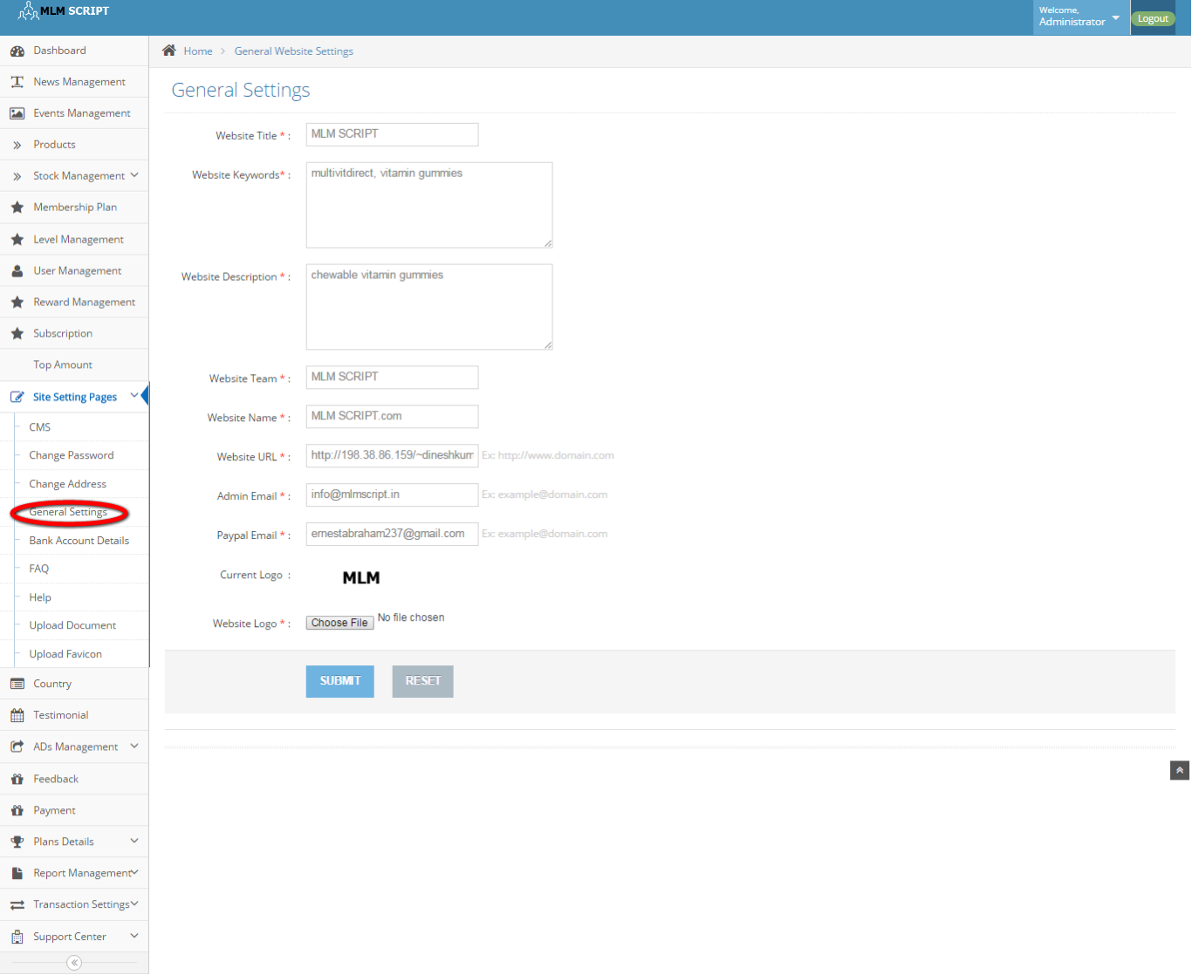
Description:
This page maintains the entire general settings like website title, keywords, description, team, name, URL, admin and PayPal Email details, logo details and website logo details.

Bank account details:
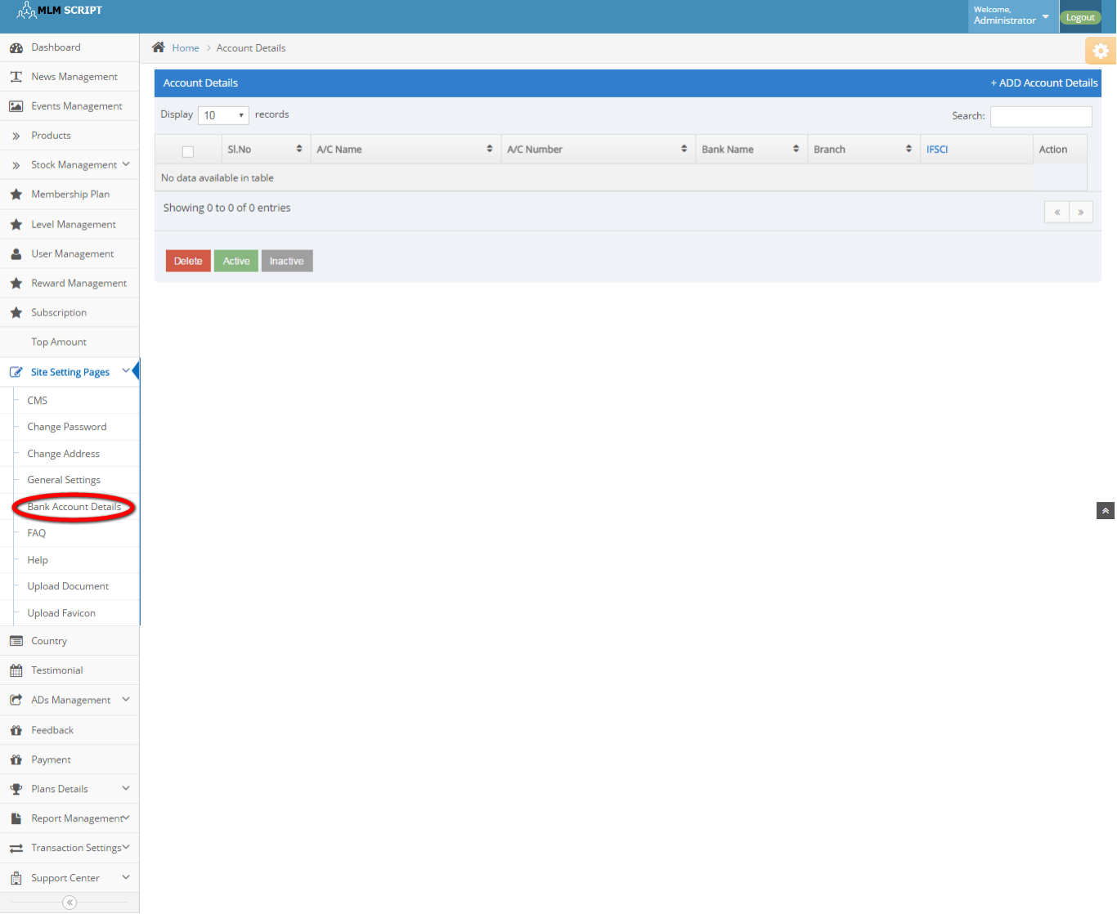
Description:
Admin can manage the bank account details like account name, number, bank name, branch and IFSCI code and action details.

FAQ:
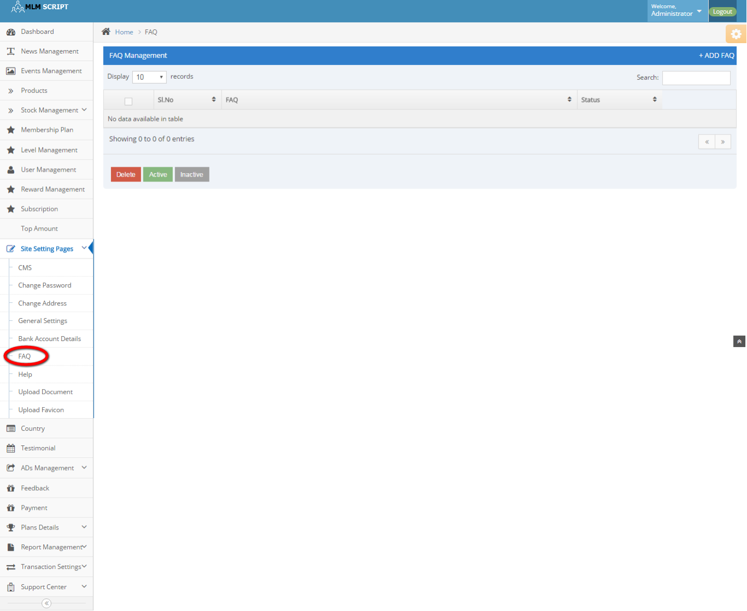
Description:
This page manages the FAQ details.

Help:
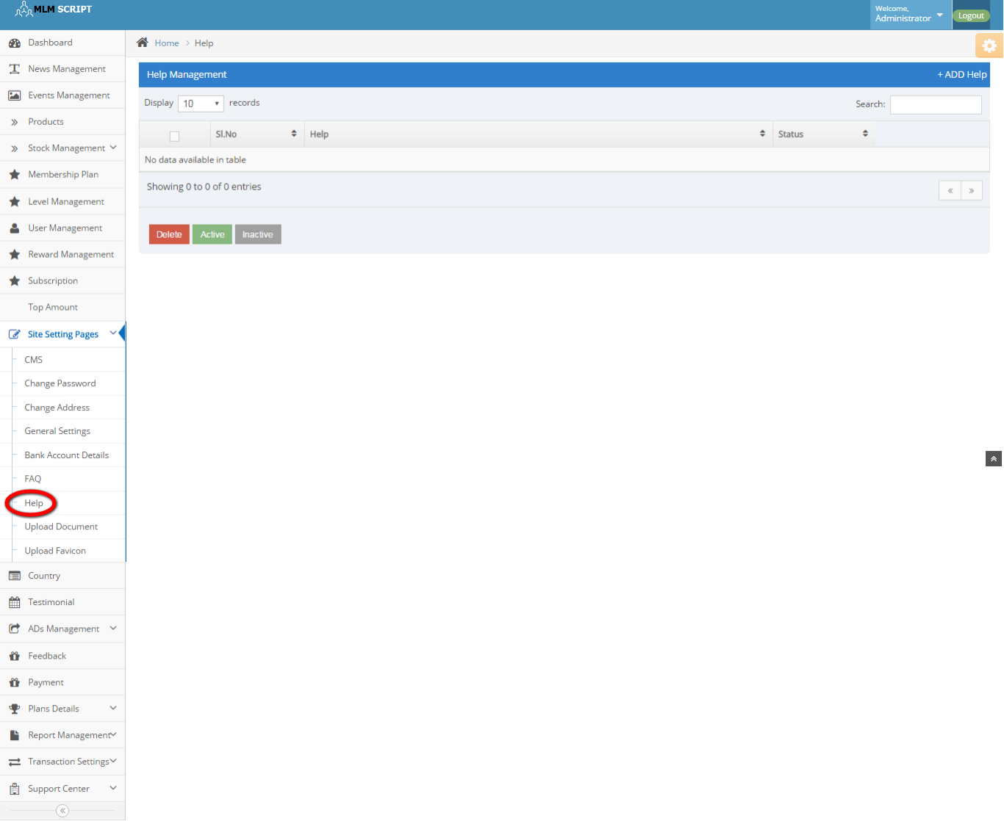
Description:
This page manages some help options.

Upload document:
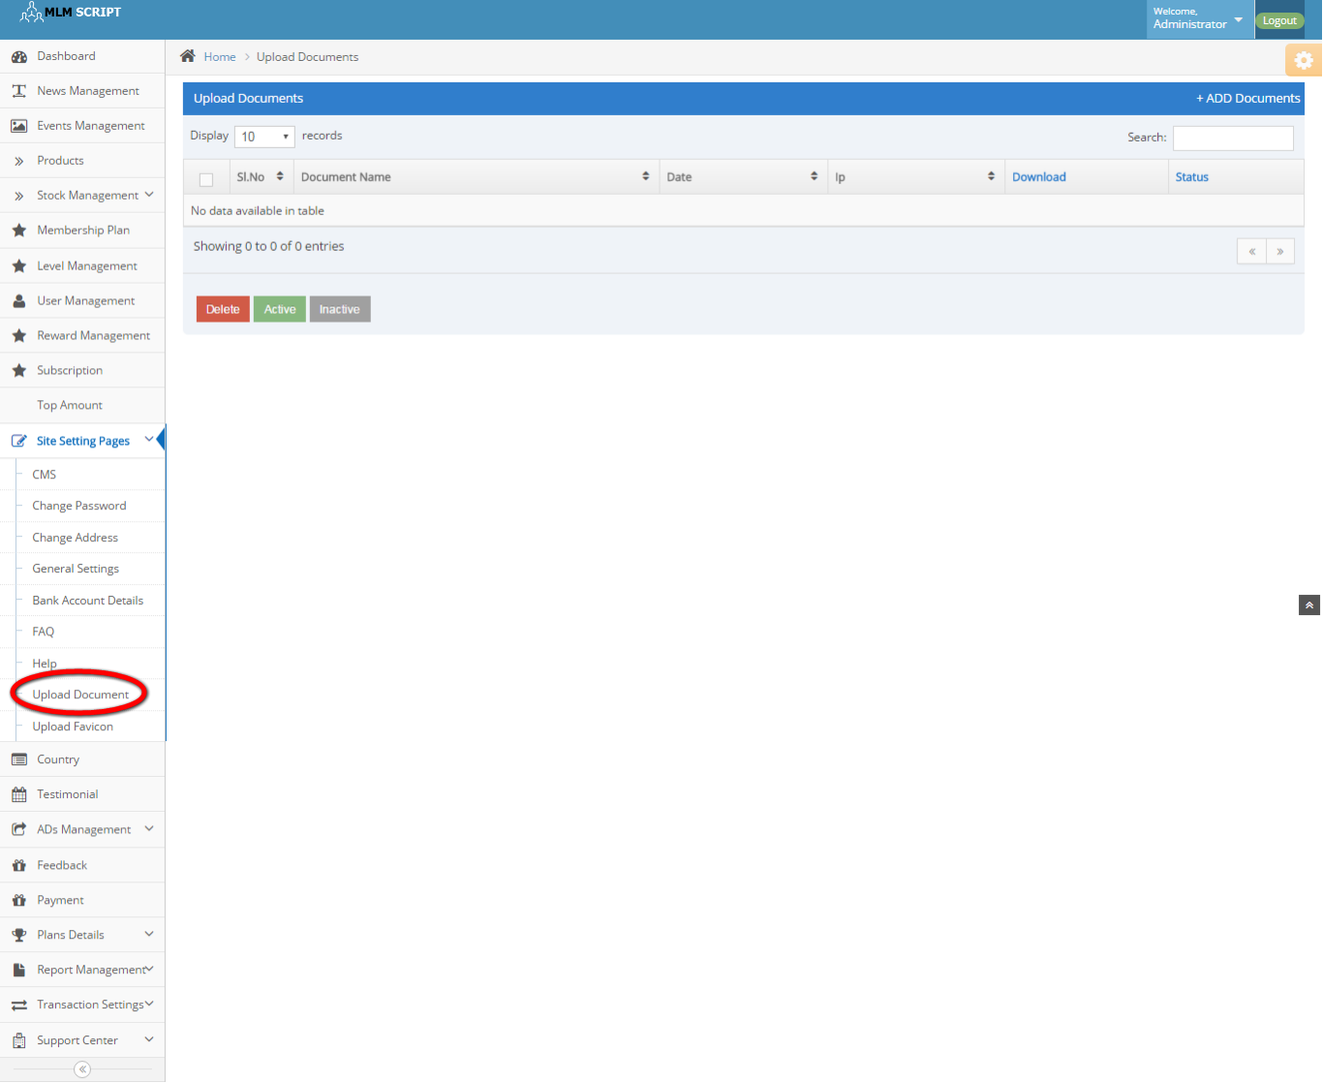
Description:
Admin can upload any document via this page and manage the details like delete, active and inactive details.

Upload favicon:
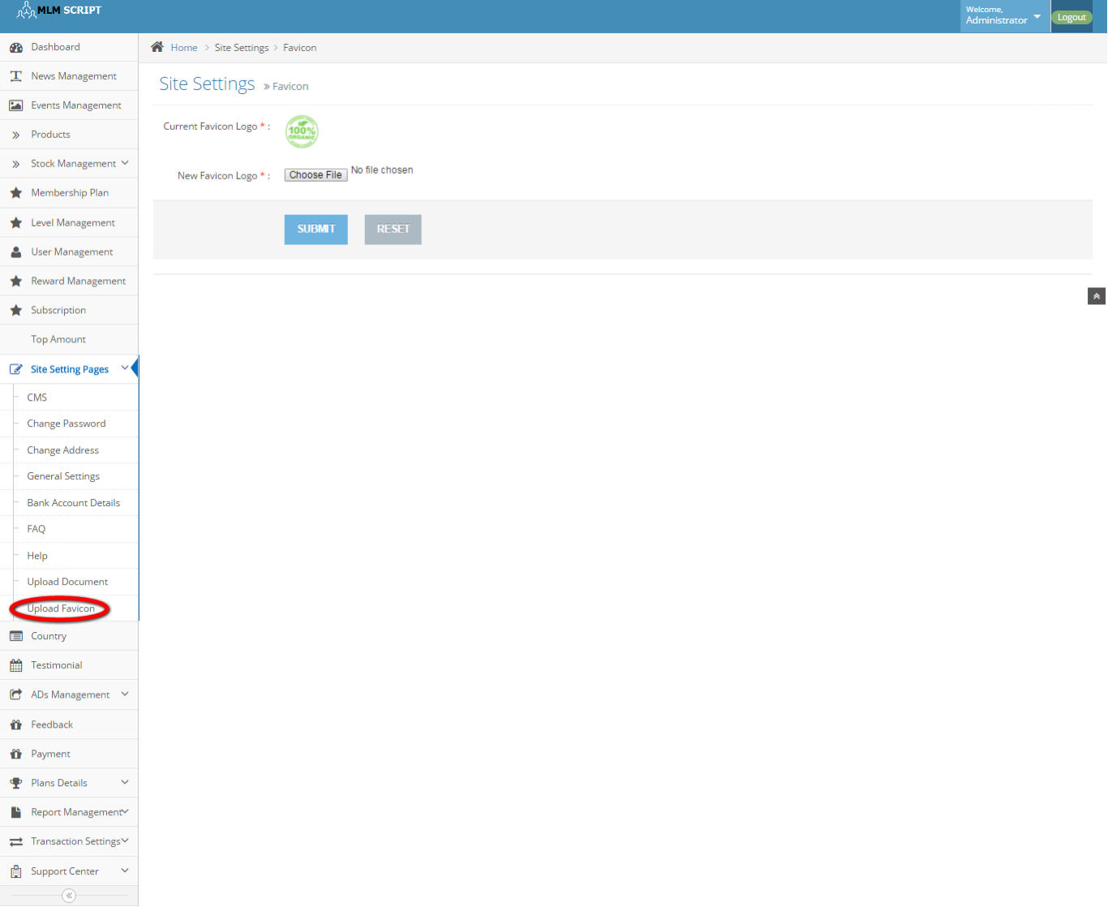
Description:
This page contains the option of upload the favicon.

Country:
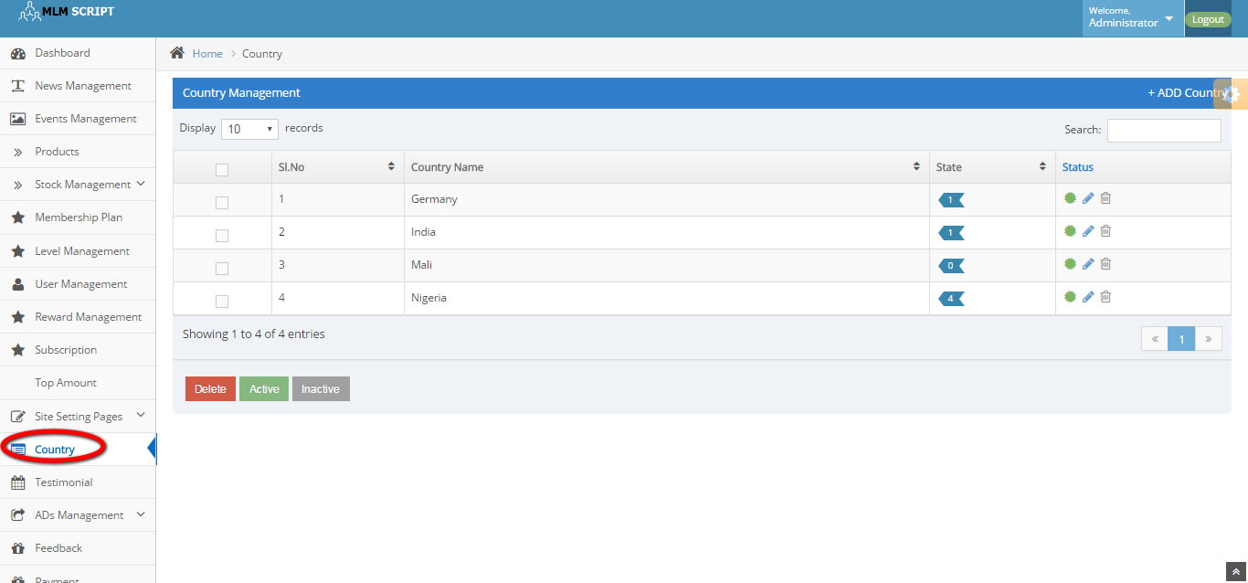
Description:
This page contains the entire country details with state and can manage it bydelec=te, active and inactive.

Testimonial:
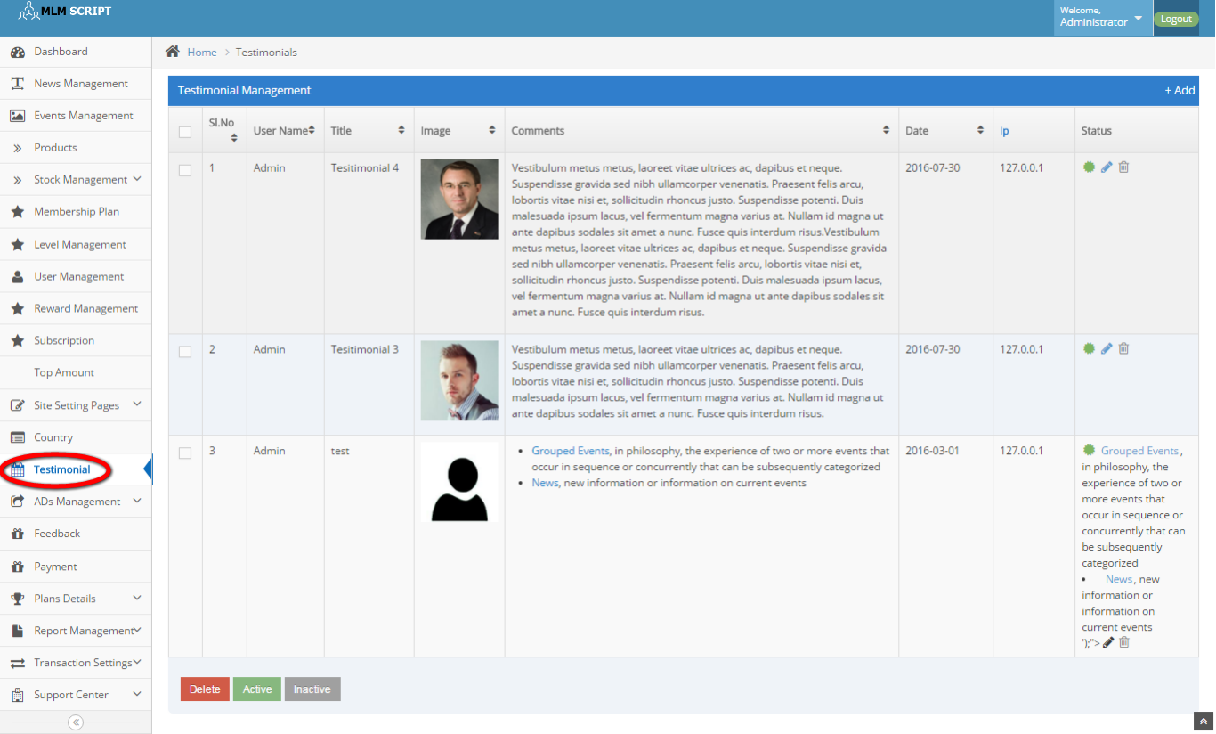
Description:
This page contains the entire testimonial details and manages by delete, active and inactive options.

Banner ads:
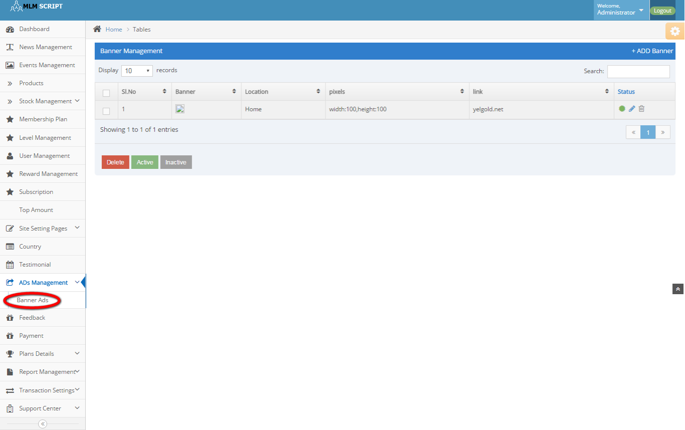
Description:
This page contains the banner ads details with location, pixel size, link and status details.

Feedback:
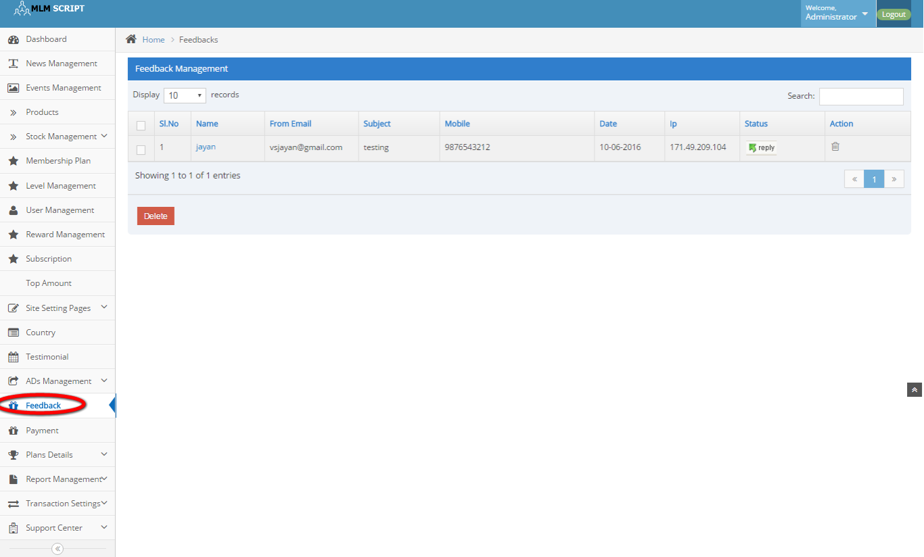
Description:
This page consists of name, subject, contact details, date, IP, status and action details.

Payment:
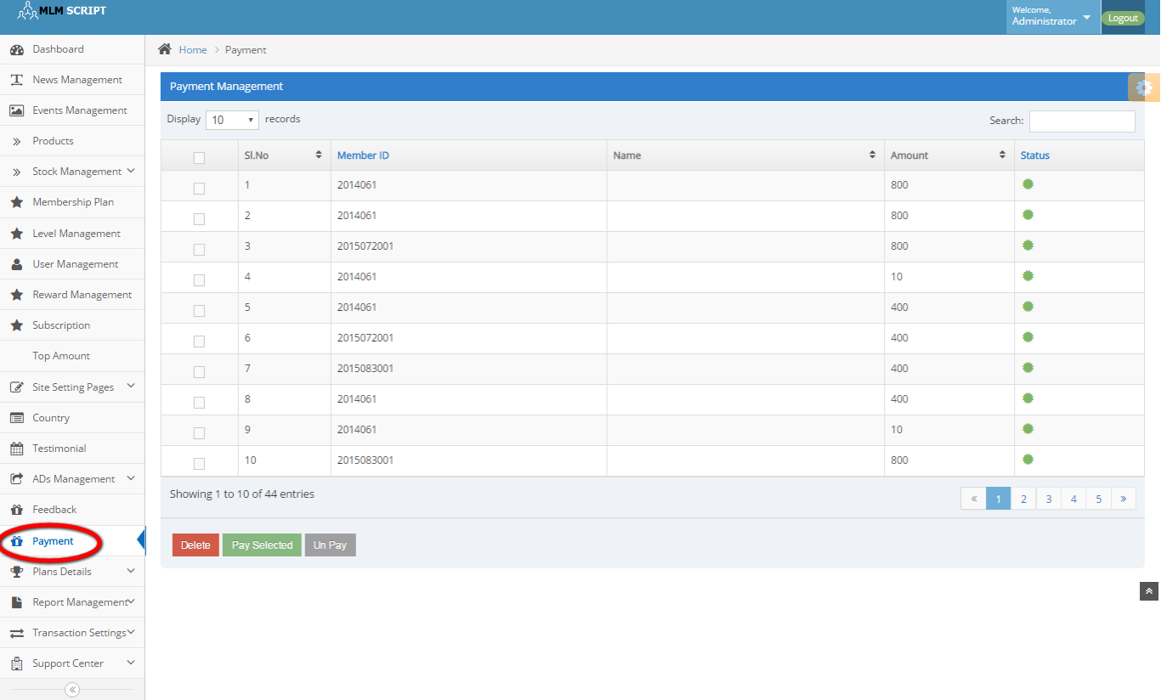
Description:
This page contains the entire payment details with member ID, Name, amount and status details.

General plan details: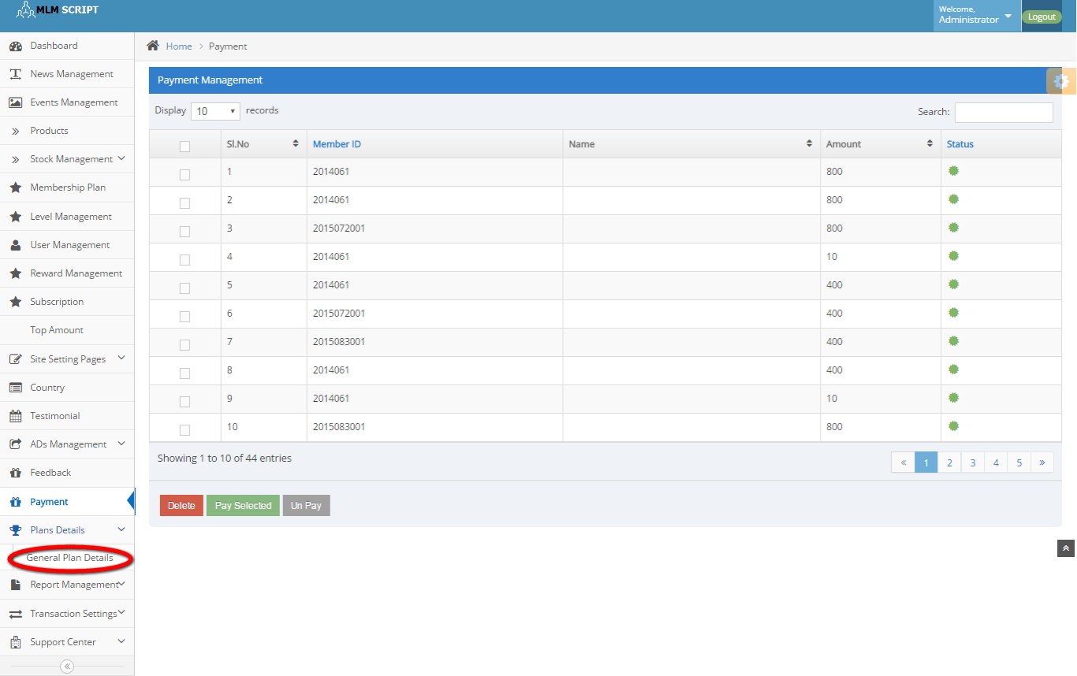
Description:
This page contains the plan details that subsists of minimum withdrawal amount, maximum withdrawal amount and Tax percentage details.

Active members:
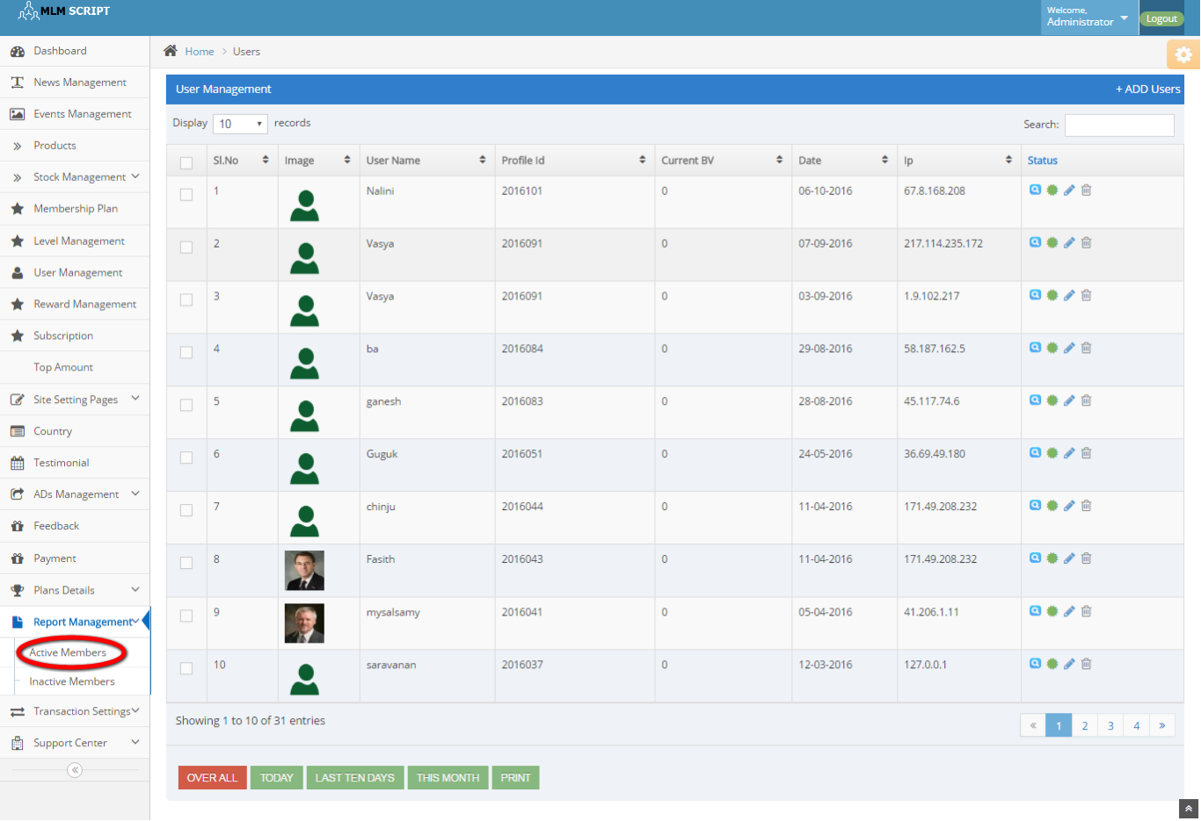
Description:
This page contains the active members detail.

Inactive members:
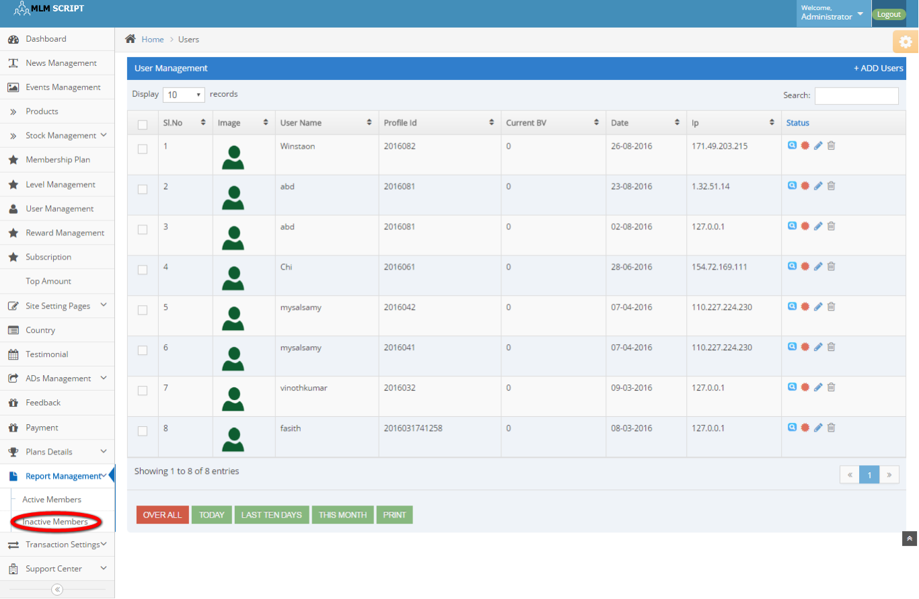
Description:
This page contains the inactive members details.

User withdraw request:
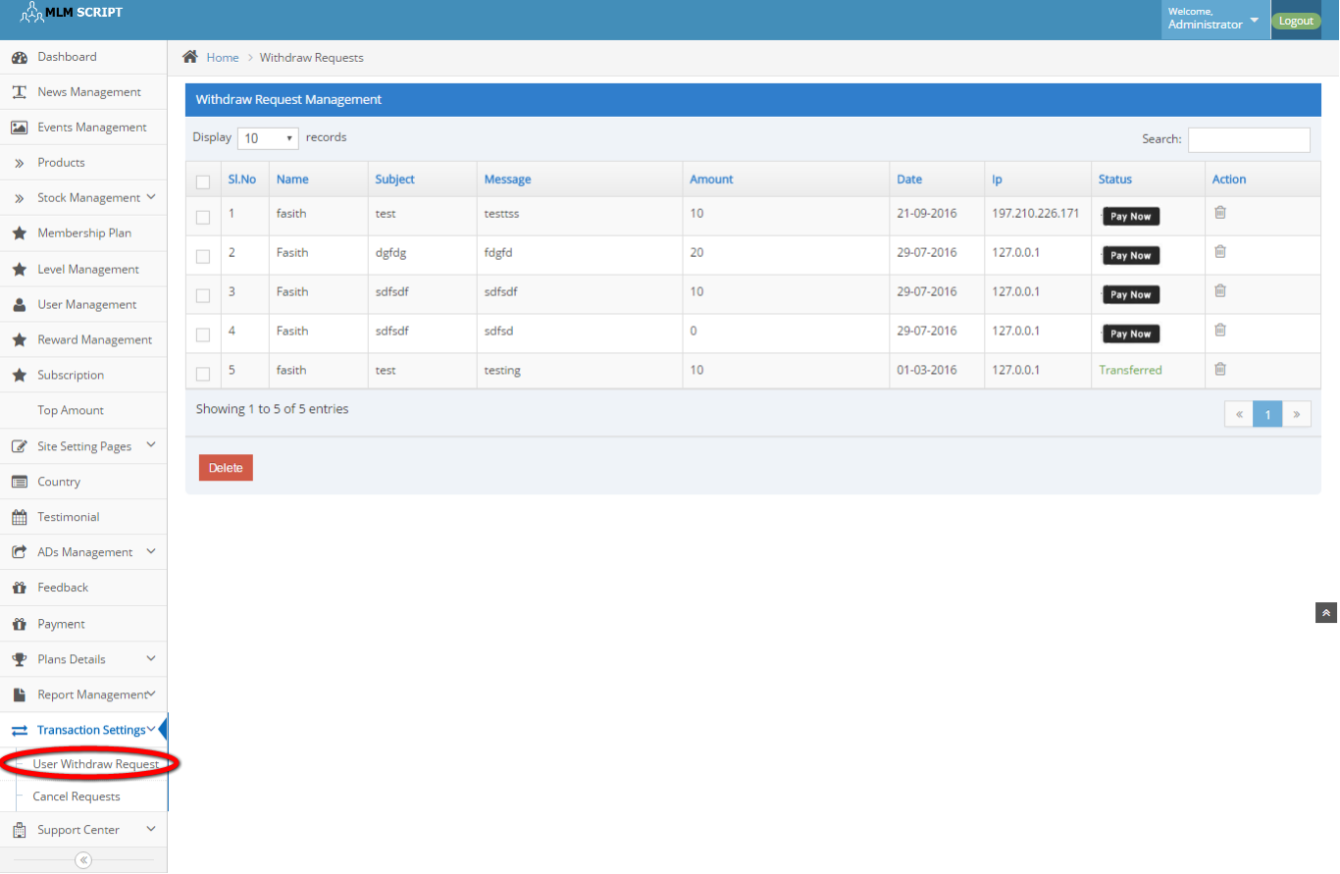
Description:
This page contains the entire withdraw details as amount date, name, message, subject IP, status and active details.

Cancel request:

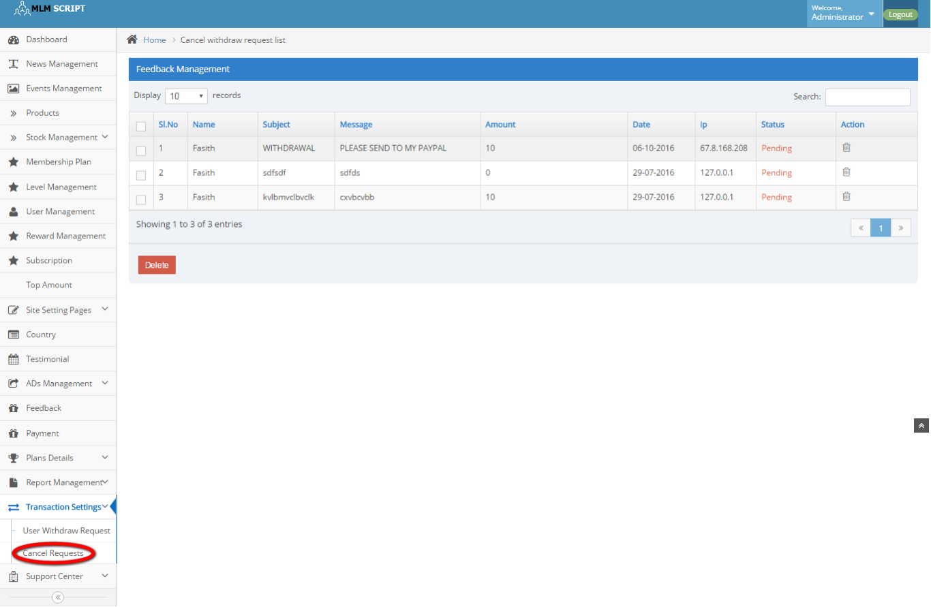
Description:
This page contains the canceled request details.

Support centre:
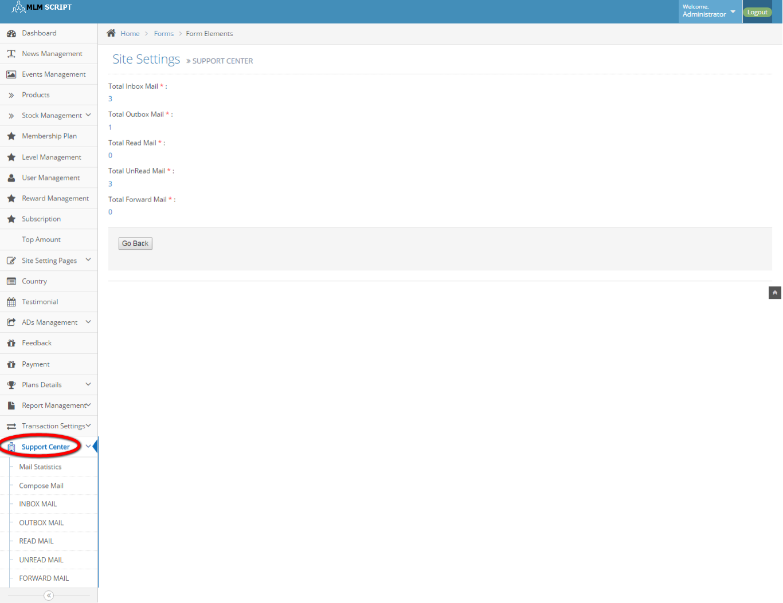
Description:
This page maintains the entire mailing system including mail statistics, compose mail, inbox and outbox mail, read and unread mail, forward mail details.

