FREELANCER SCRIPT
USER VIEW
Register:

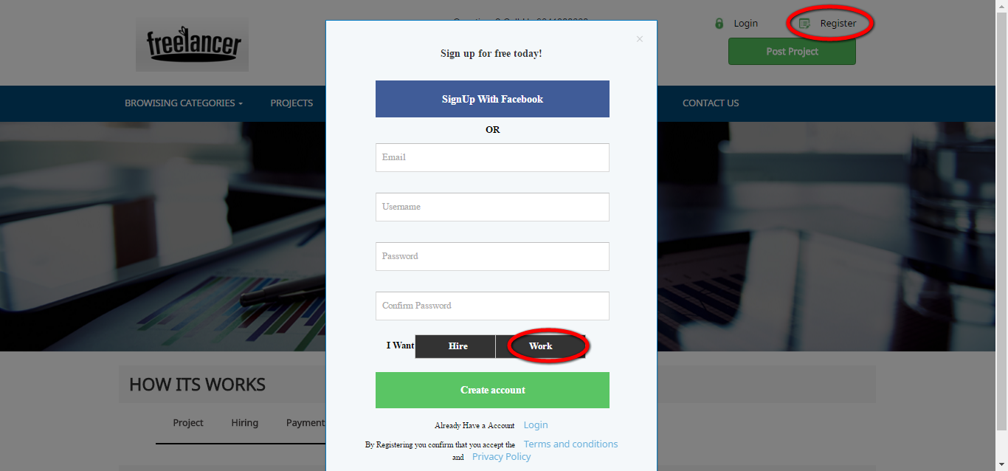
Description:
This page serves to register with the basic information.

Login:
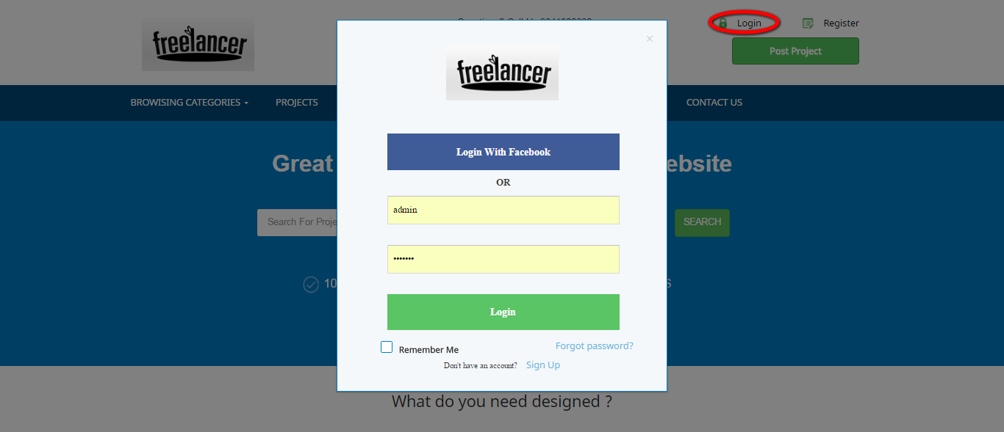
Description:
This page used to login as employee by giving valid username and password.

Home page:
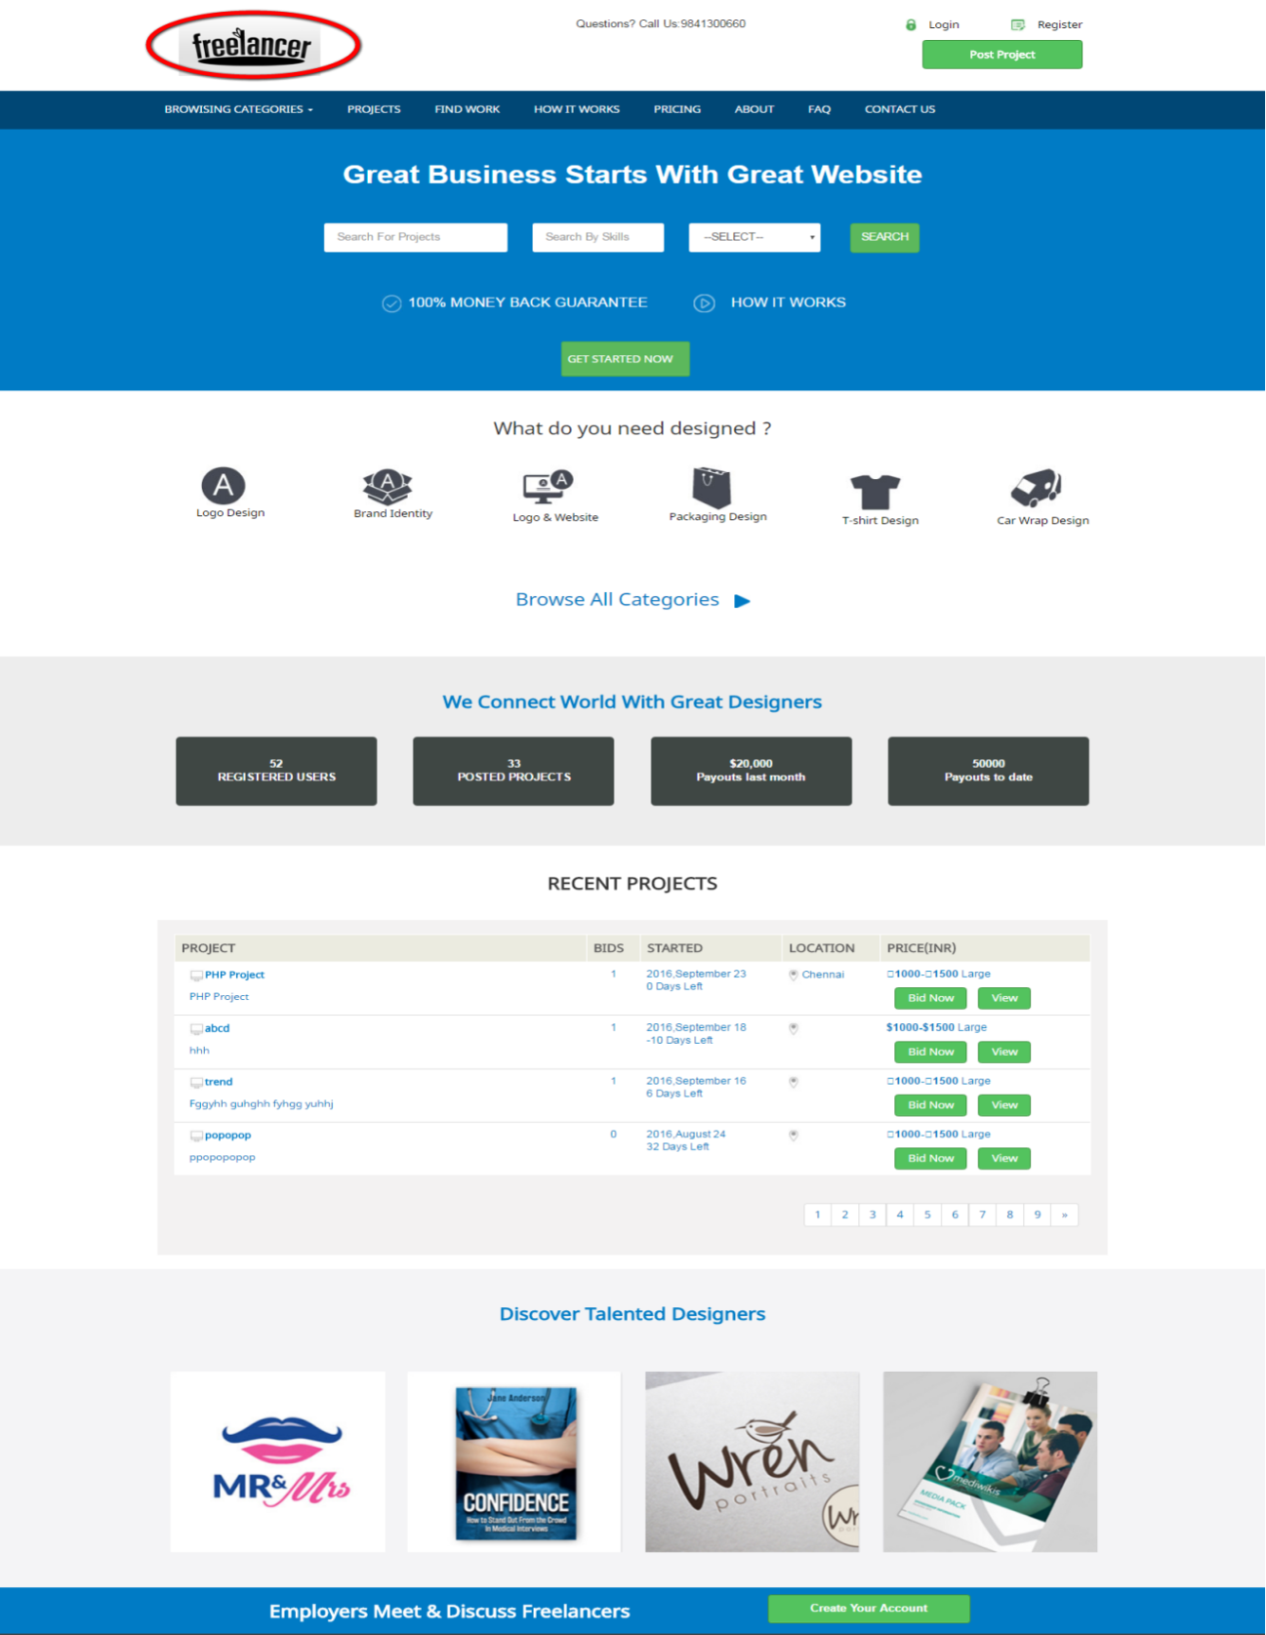
Description:
This page contains the search engine, recent projects and some discovered talented designers.
Category:
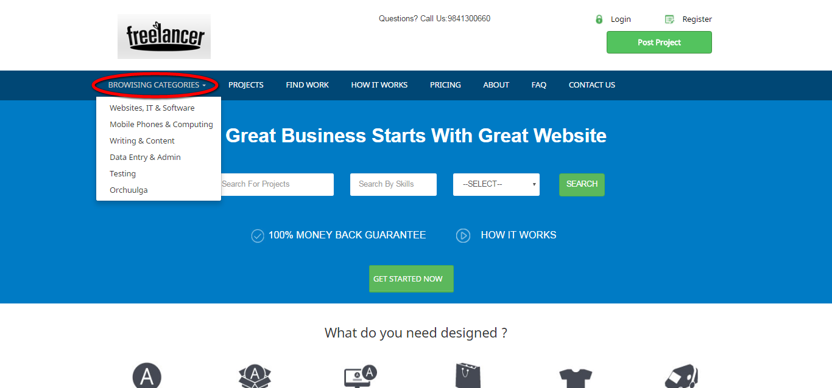
Description:
This option procures the entire categories in drop down list.

Projects:
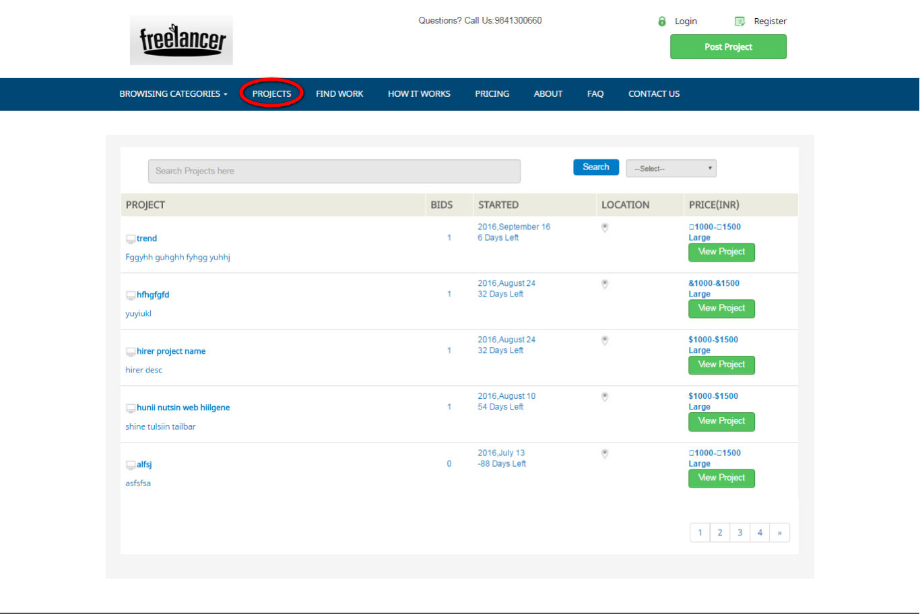
Description:
This page contains the entire projects details with bids count, location, started time, price, search engine and filter option.

Pricing:
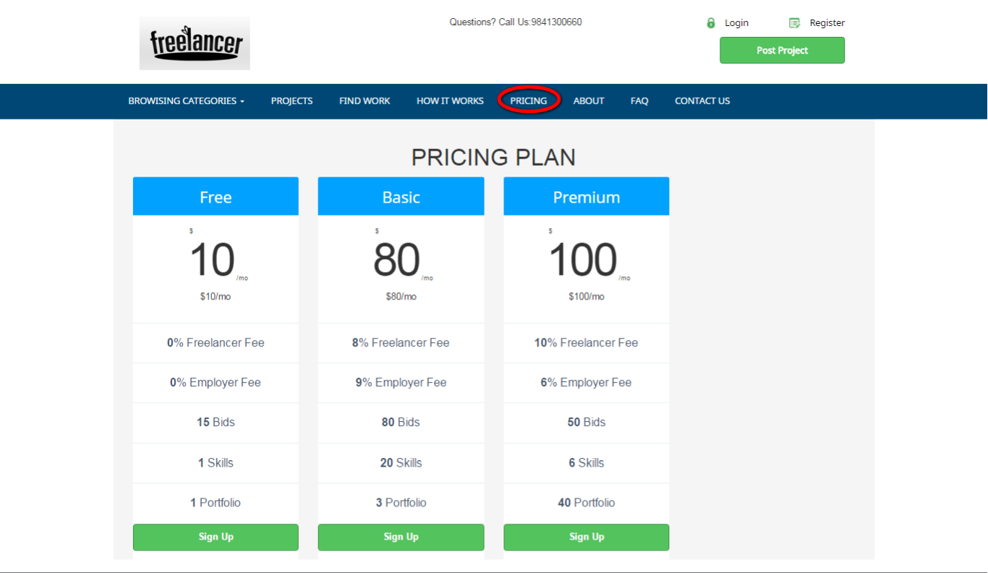
Description:
This page consists of various membership plans.

Post project:
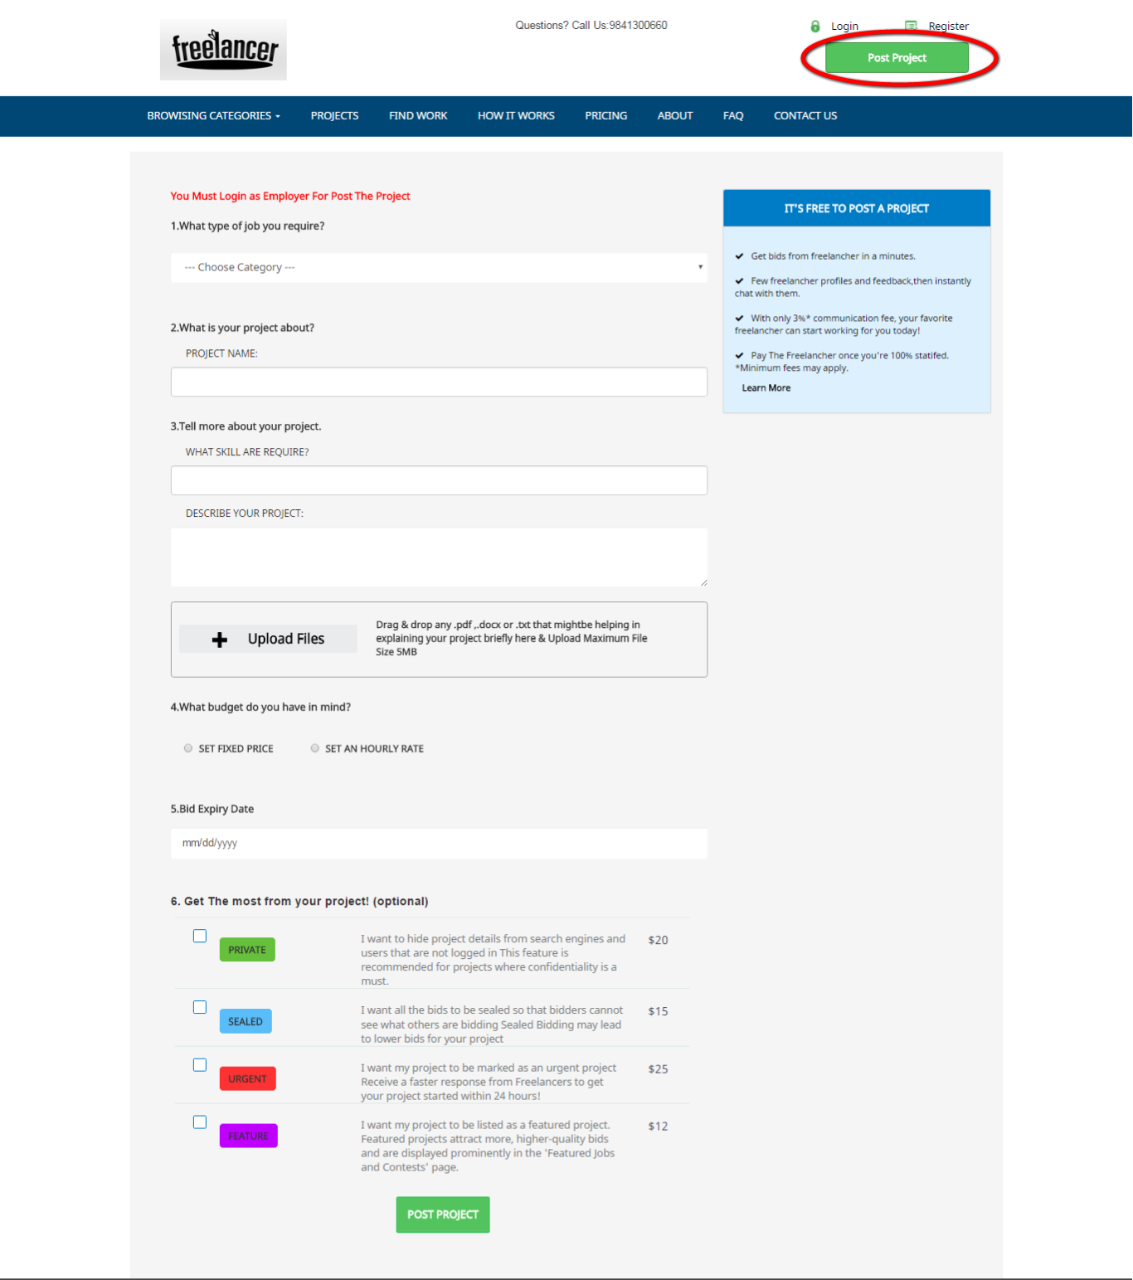
Description:
This page contains the entire field that required to post the project.

Find work:
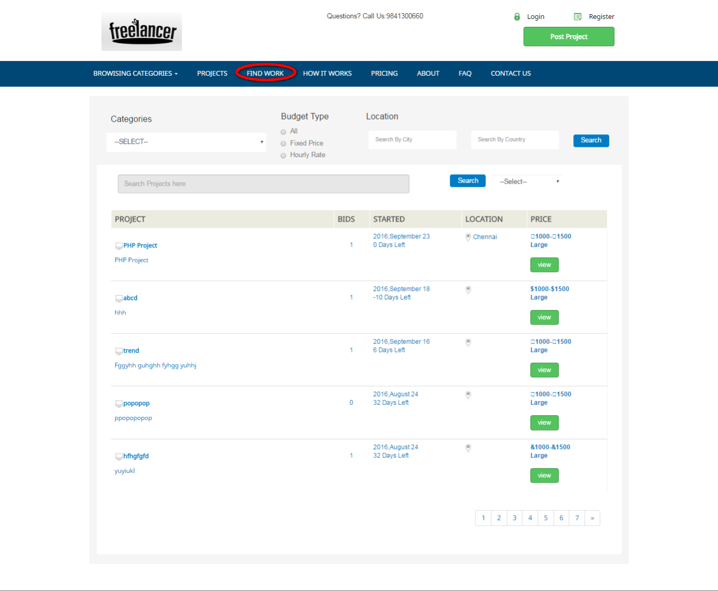
Description:
This page contains the entire posted project details.

How it works:
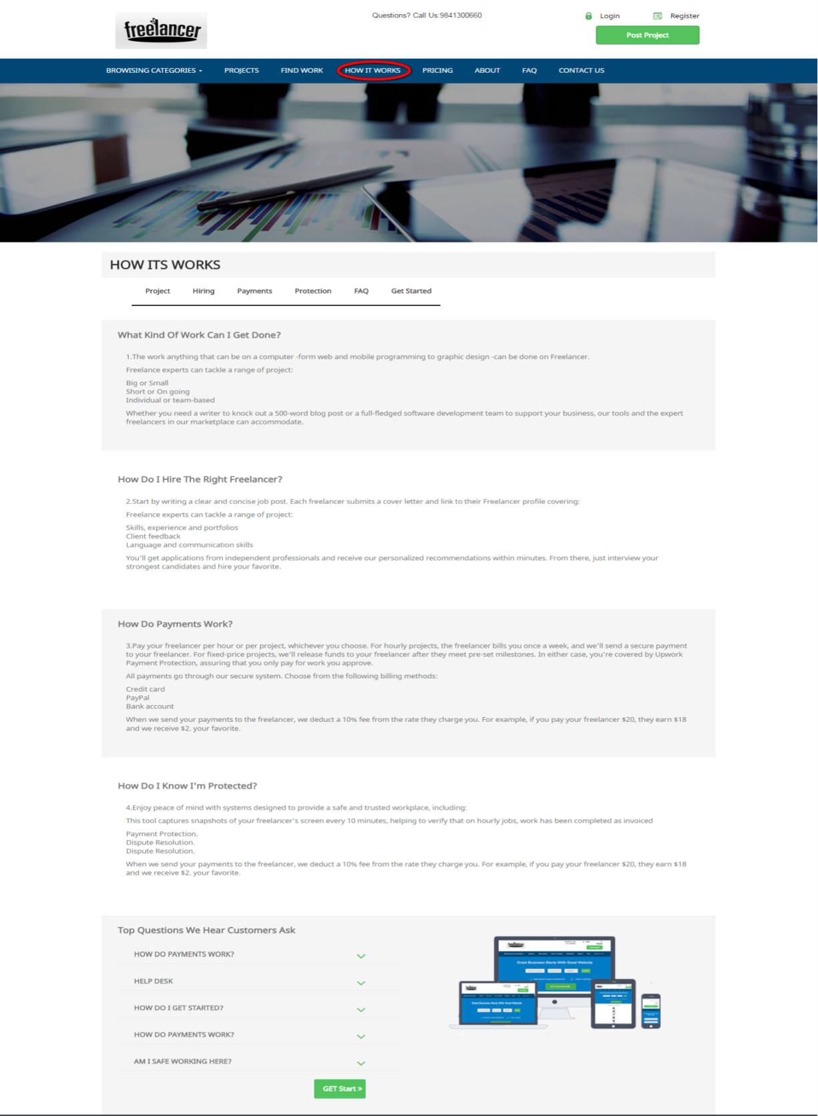
Description:
This page consists the details about the topic how it works.
About:
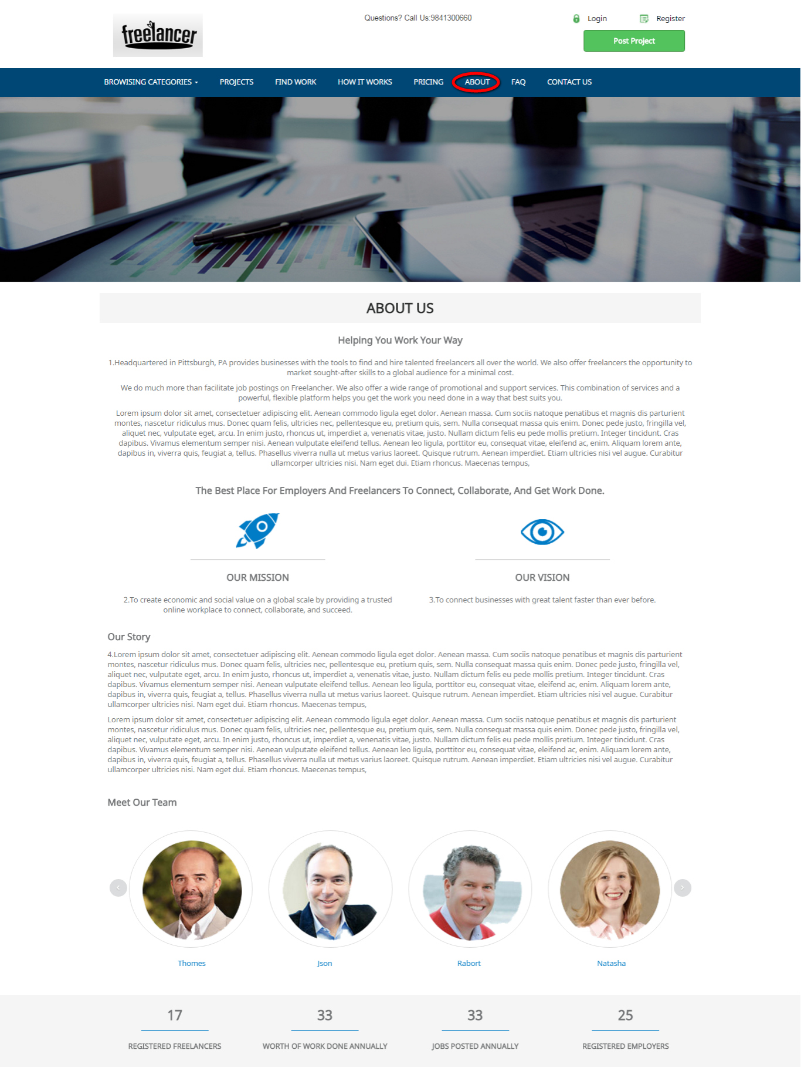
Description:
This page contains the details about the company.

FAQ:
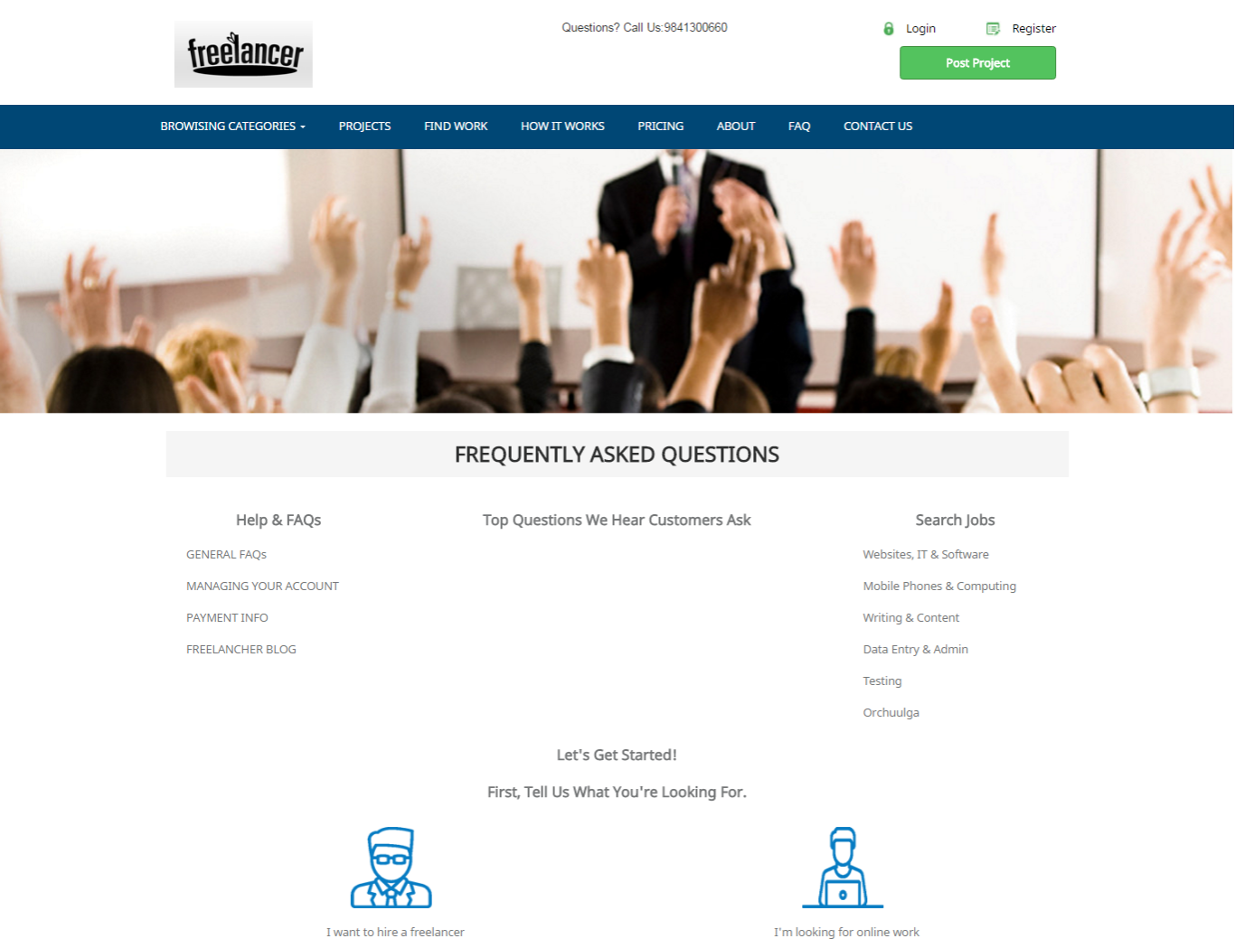
Description:
This page contains some FAQ.

Contact us:
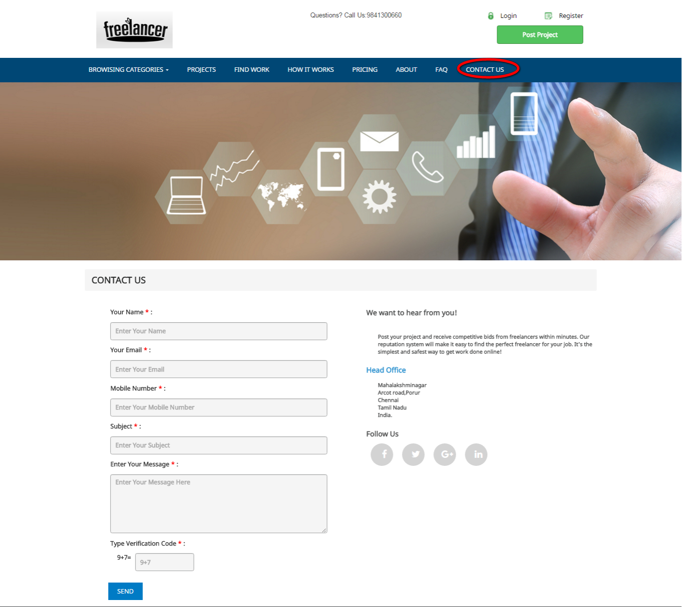

Description:
This page contains the details of contact and has the feedback form with required fields.

Newsletter:
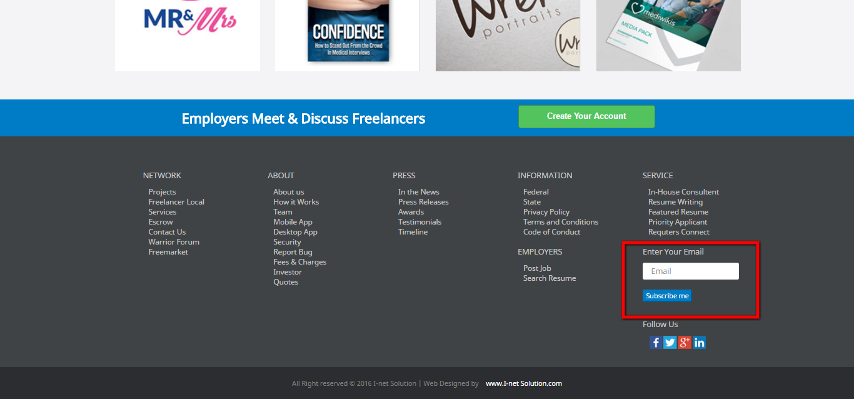
Description:
This footer contains the newsletter where user can subscribe for the latest updates.

Register:
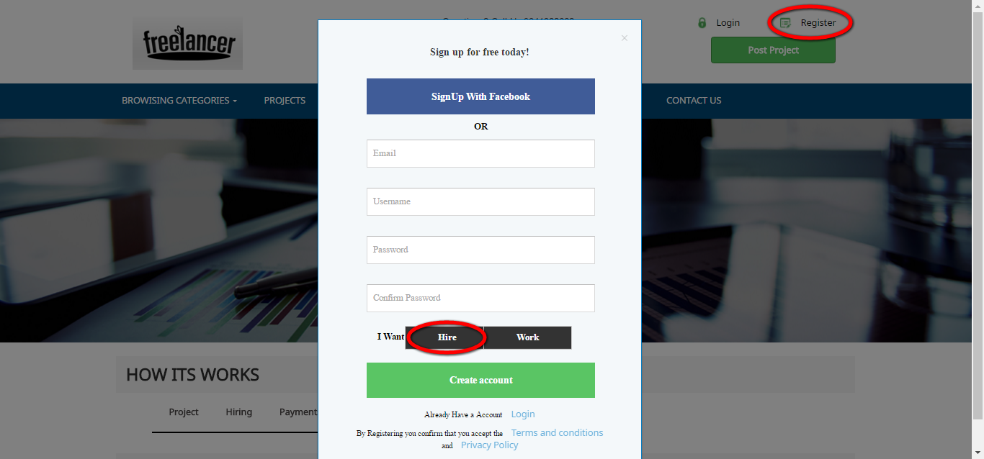
Description:
This page contains the required field for registration.

Login:
Description:
This page serves to login via valid user name and password.

Find work:
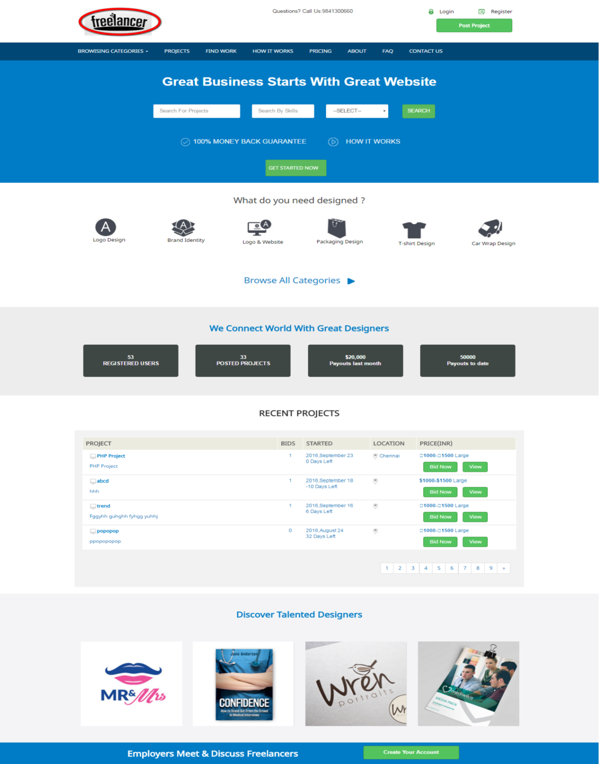
Description:
This page contains the search engine, recent projects and some discovered talented designers.
Category:
Description:
This option procures the entire categories in drop down list.

Projects:
Description:
This page contains the entire projects details with bids count, location, started time, price, search engine and filter option.

Pricing:
Description:
This page consists of various membership plans.

ADMIN VIEW
Login:
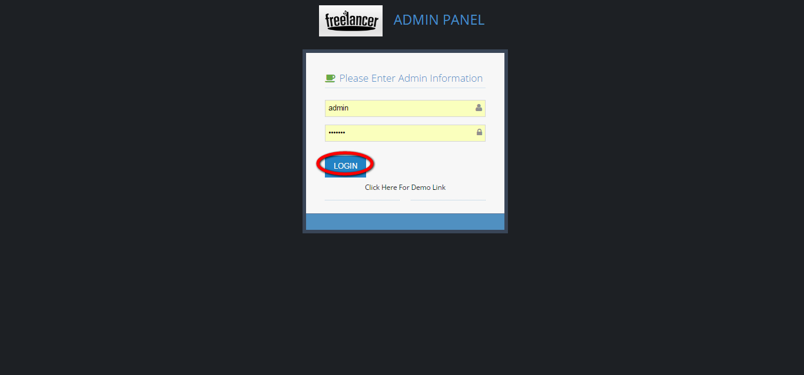
Description:
This page serves to login as admin with valid username and password.

Dashboard:
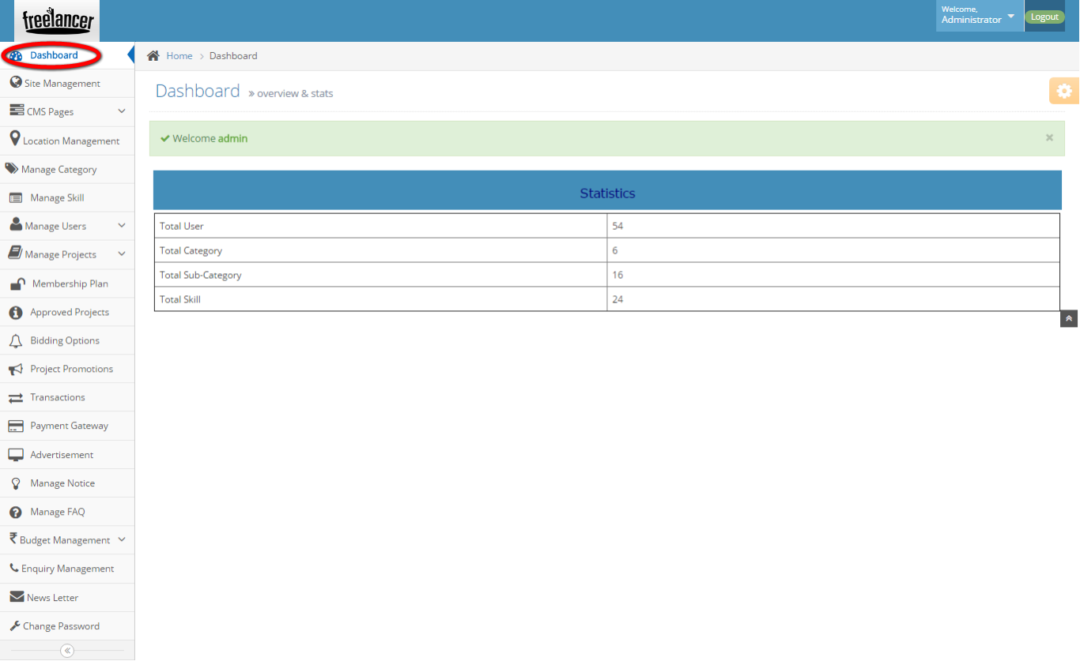
Description:
This page contains the recent activities with counts of user, category, sub-category and skill.
Site management:
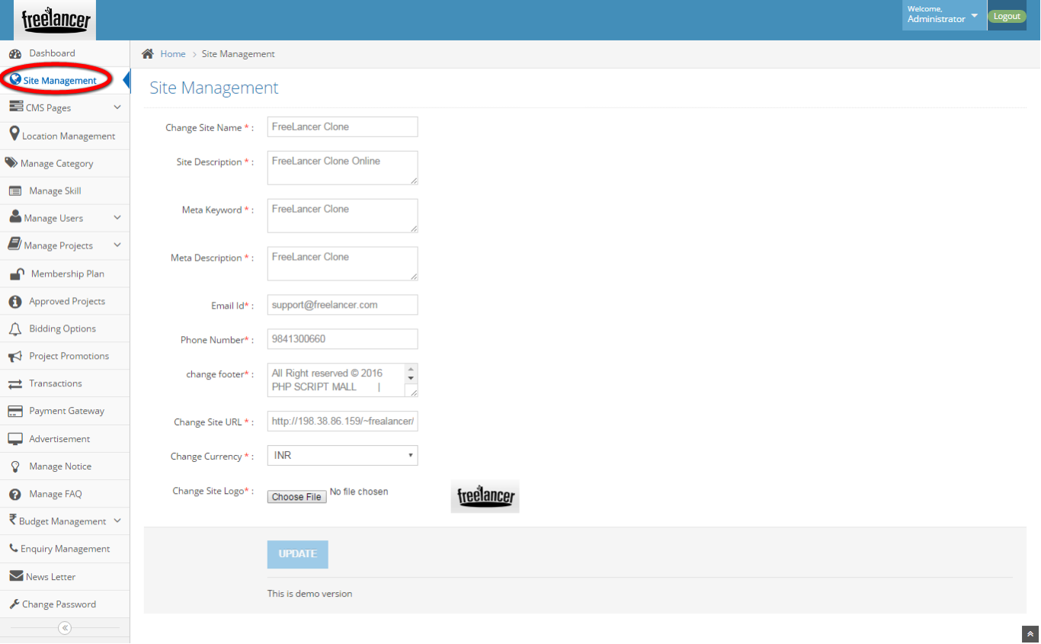
Description:
This page manages the entire site by required fields.

How it works:
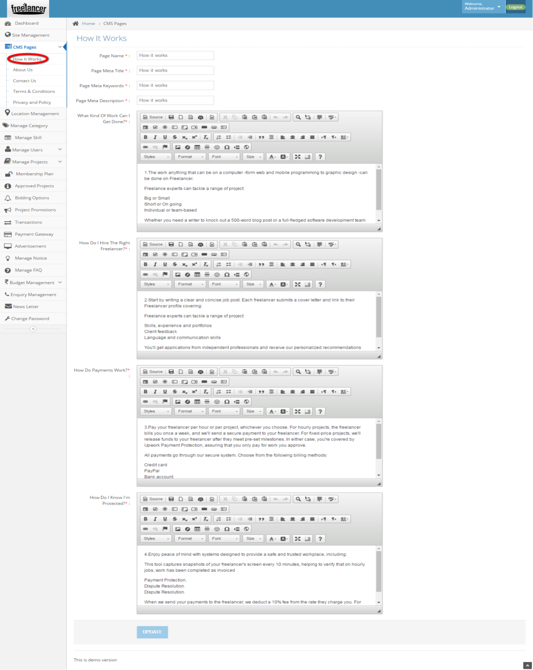
Description:
This page maintains the process description for the process.
About us:
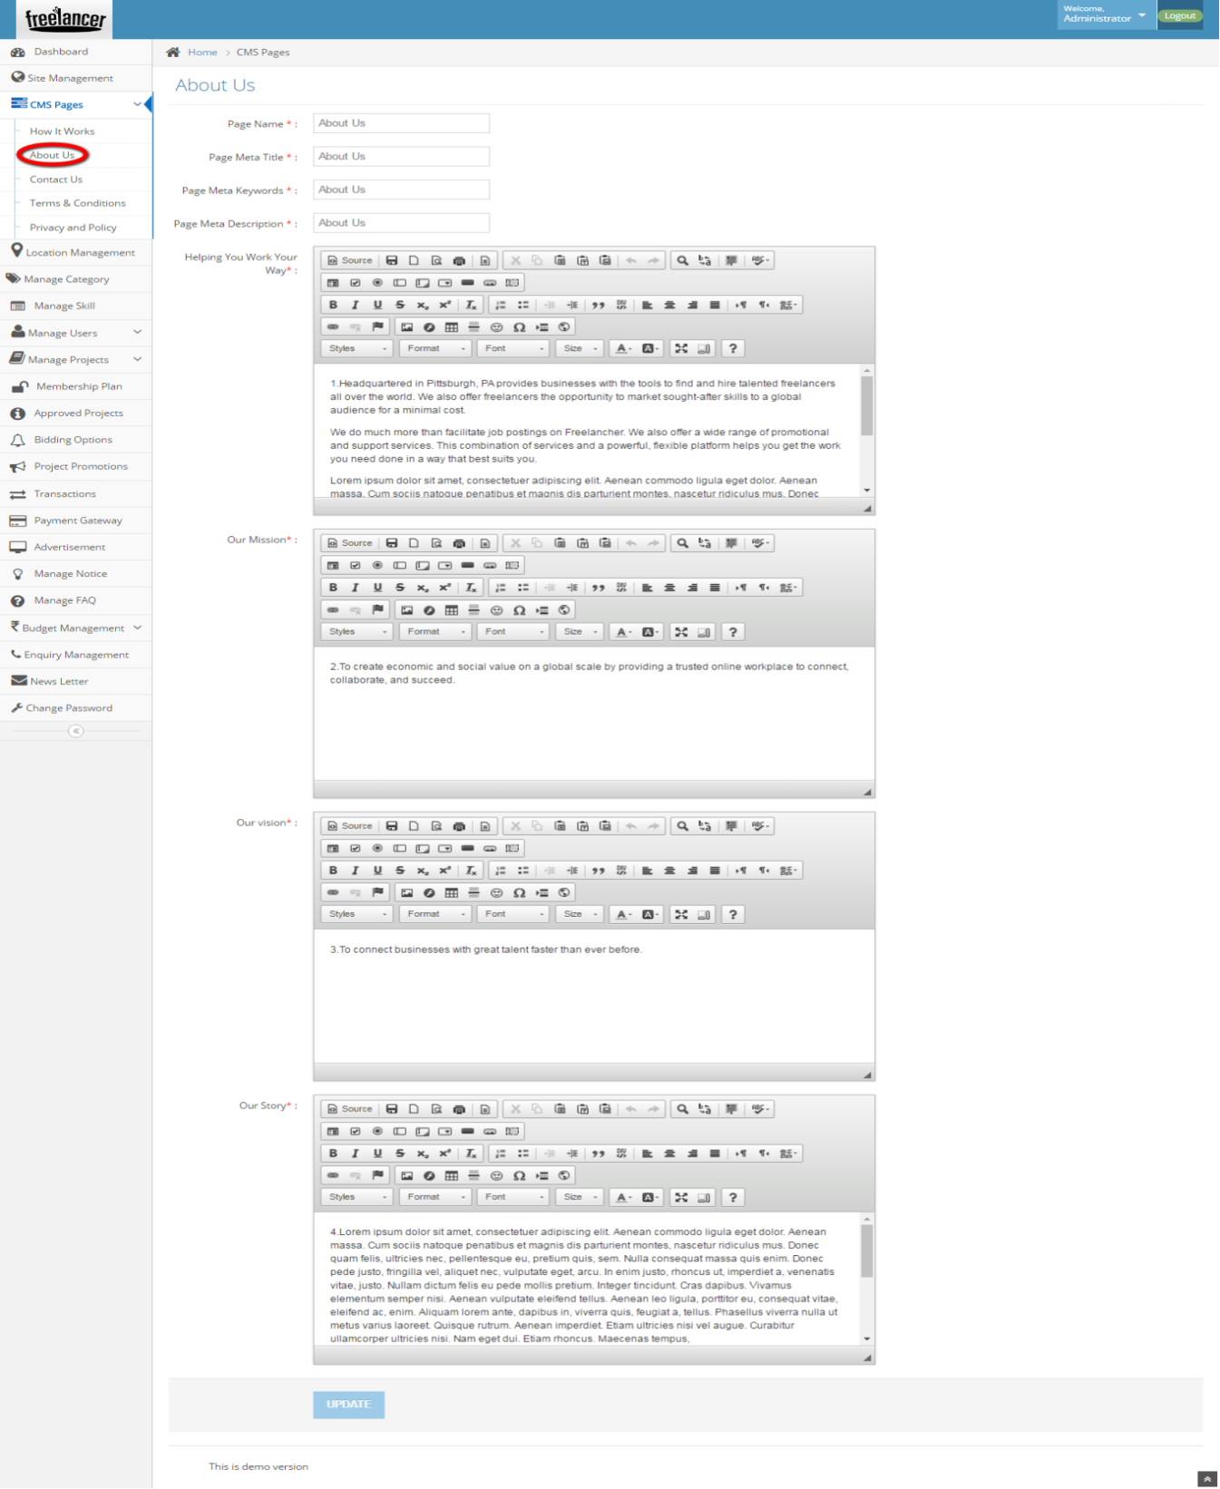
Description:
This page contains the details like vision and story of the company which can be modifiable.

Contact us:
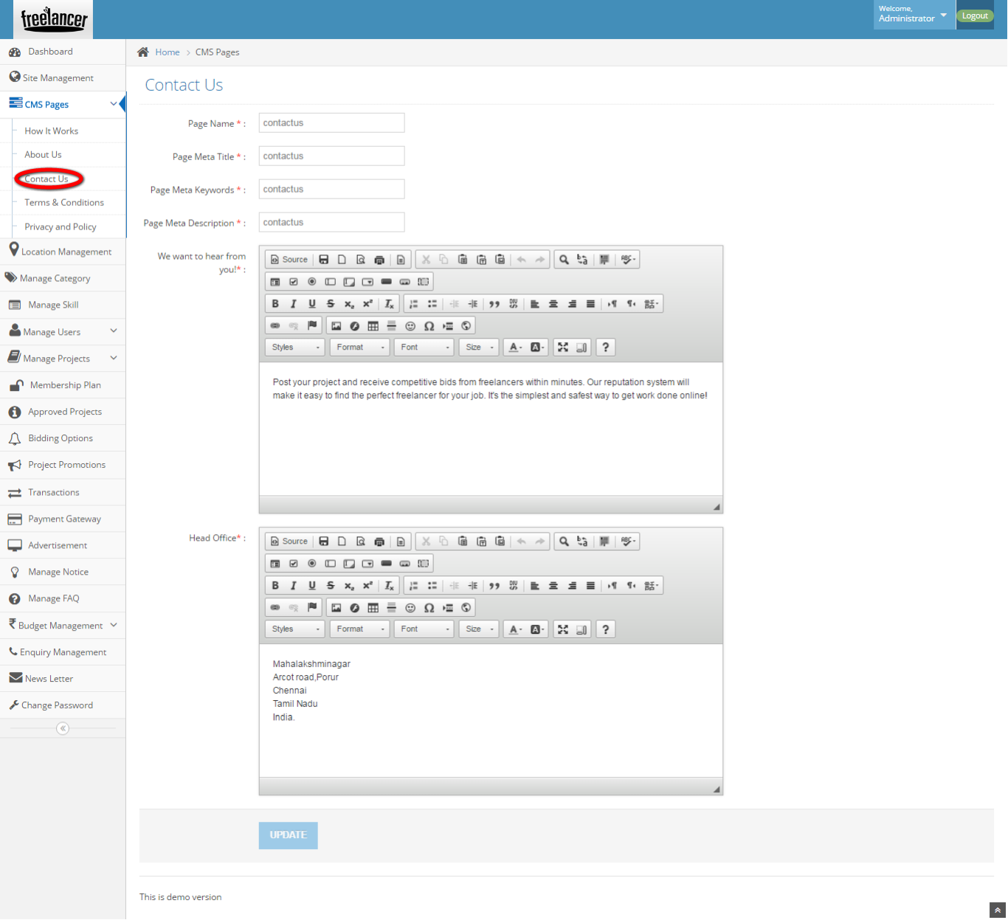
Description:
This page manages the entire contact details.

Terms and condition:
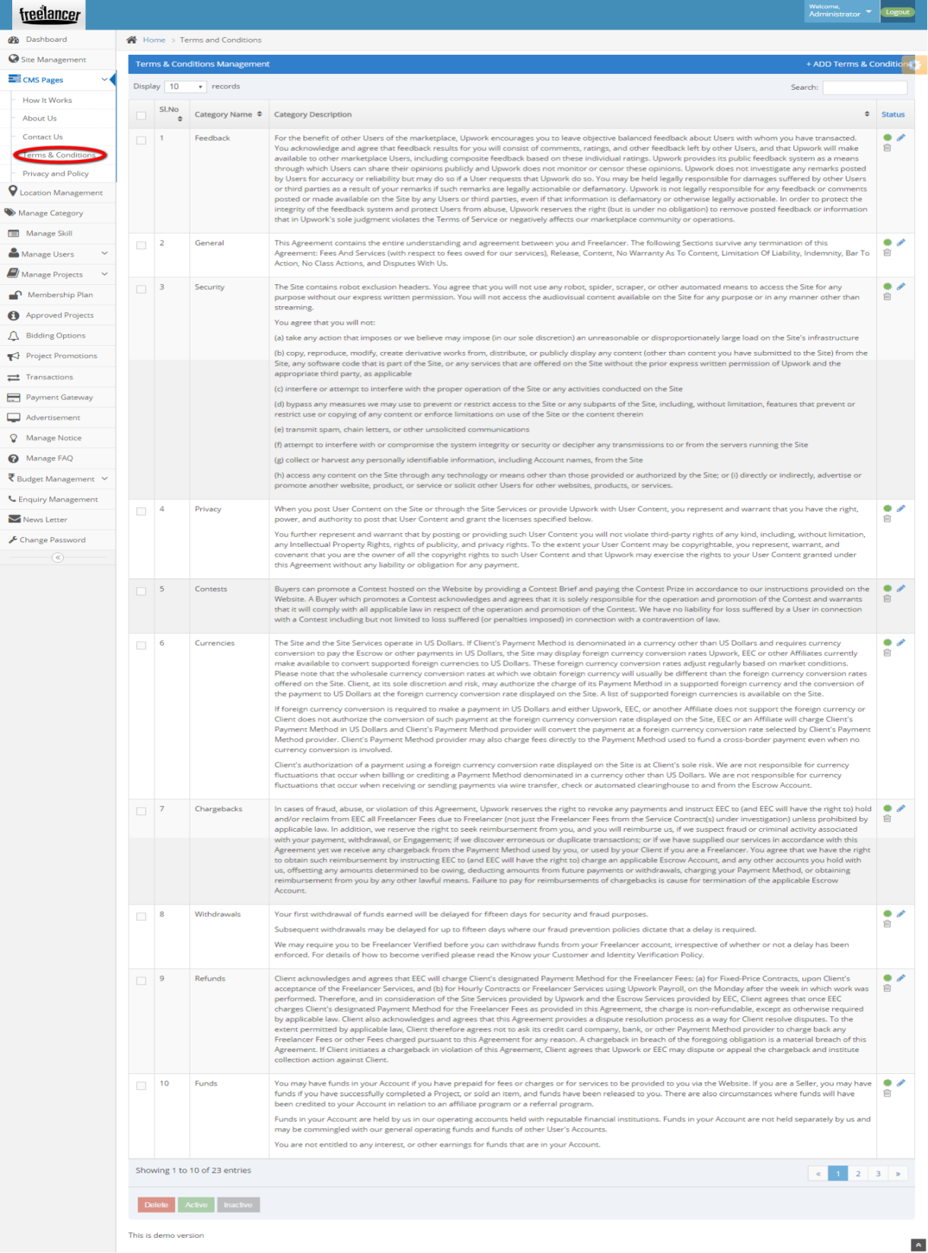
Description:
This page contains the whole terms and conditions which can be editable.

Privacy and policy:
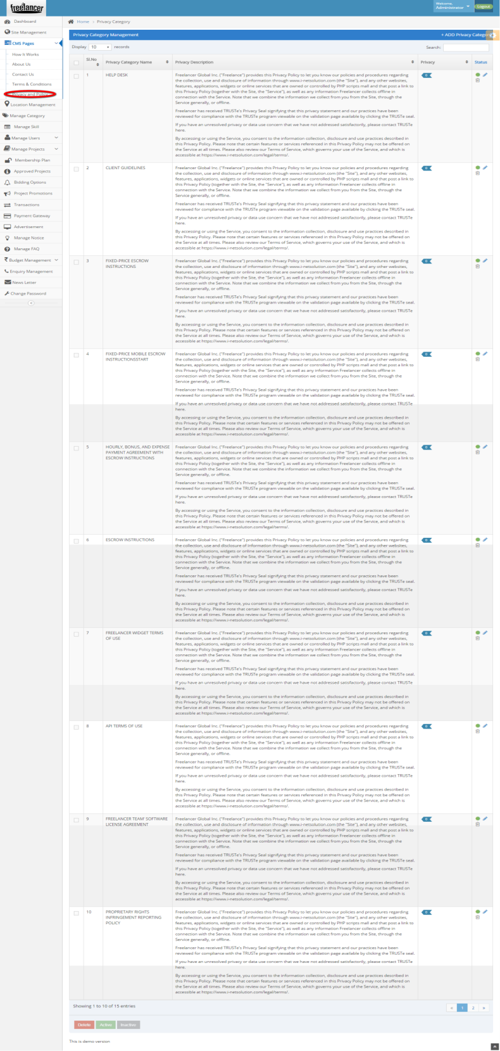
Description:
This page manages the privacy and policy details.

Location management:
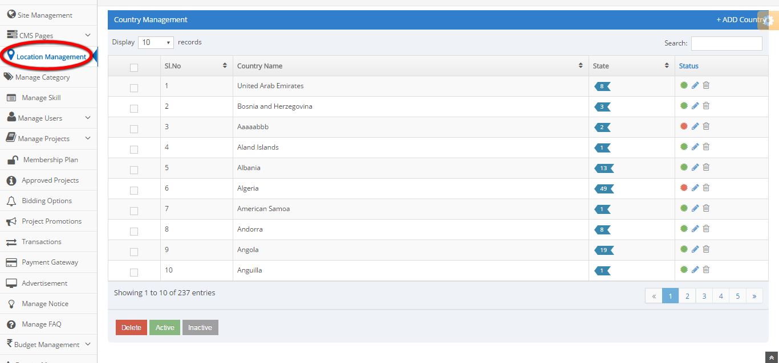
Description:
This page maintains the country, state and city details.

Manage category:
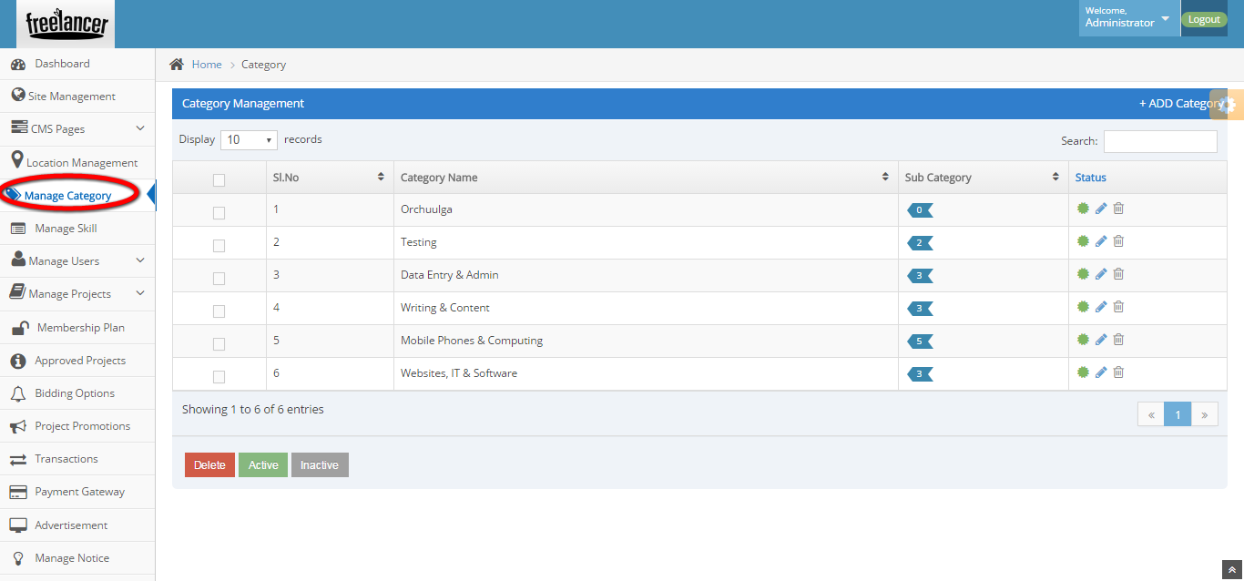
Description:
This page manages the categories and sub-categories details.

Manage skills:
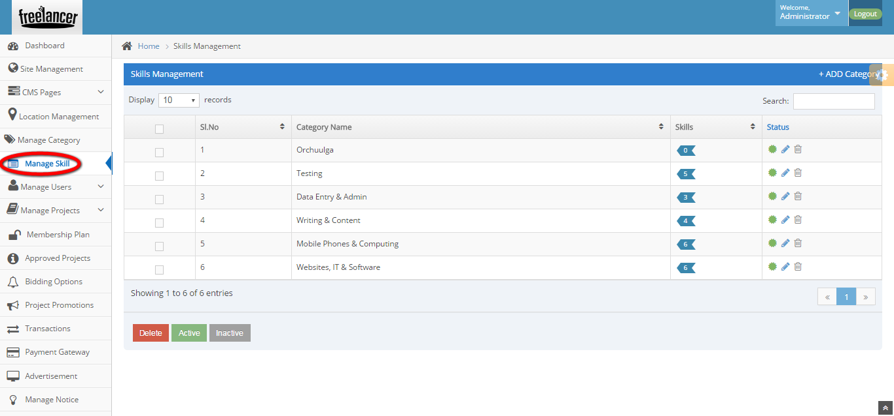
Description:
This page manages the skill details with the option of delete, active and inactive status.

Manage employer:
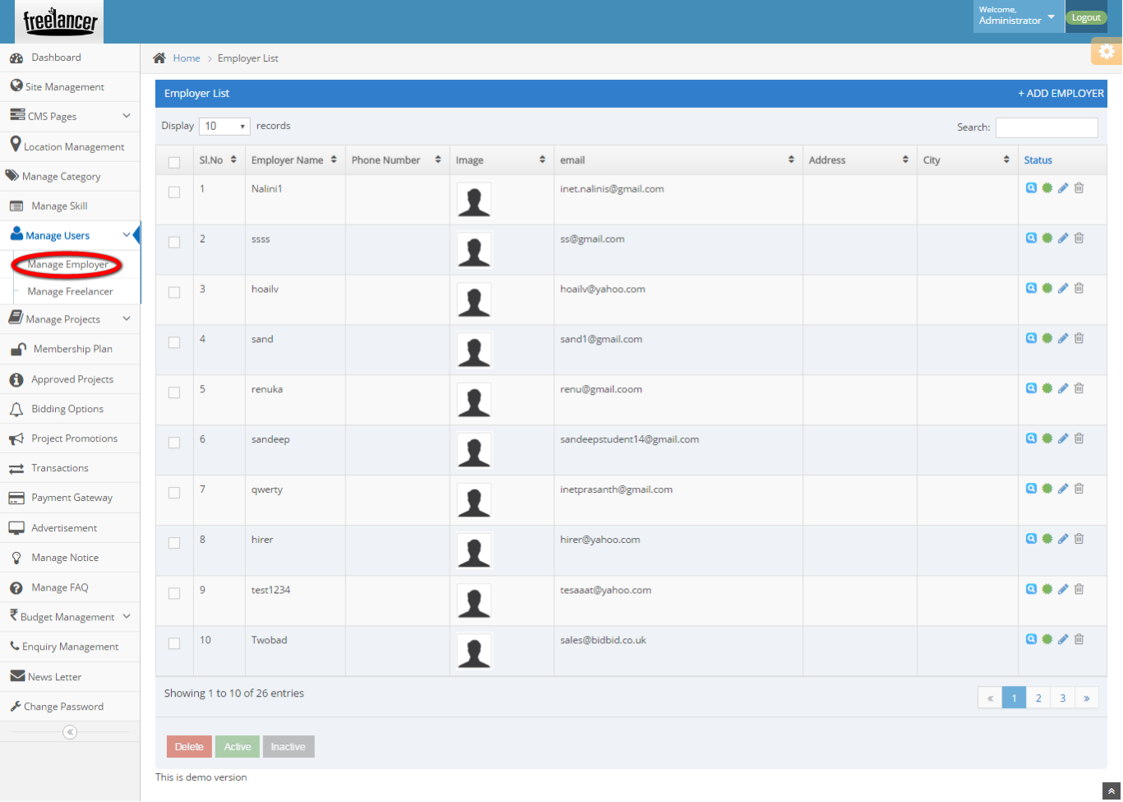
Description:
This page maintains the employer detail with the option of delete, active and inactive status.

Manage freelancer:
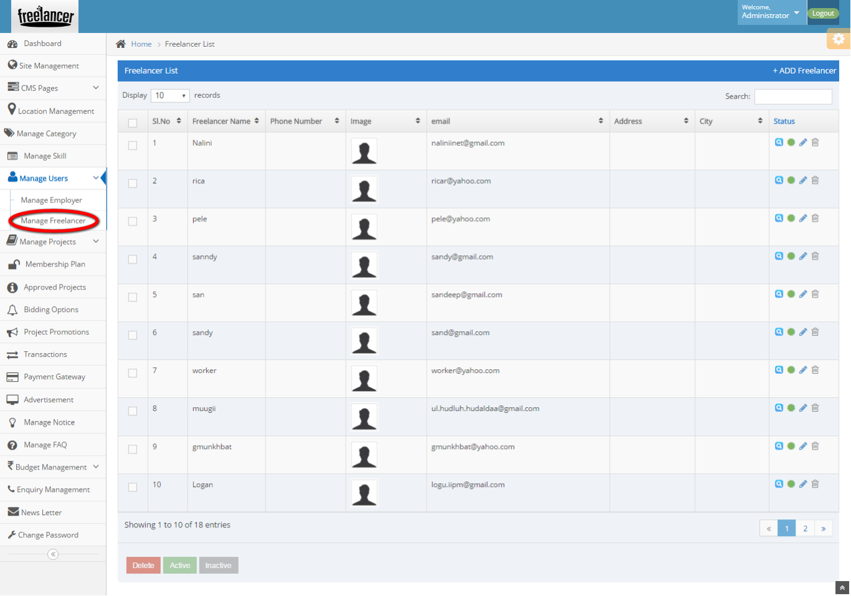
Description:
This page maintains the freelancer details with the option of delete, active and inactive status details.

View projects:
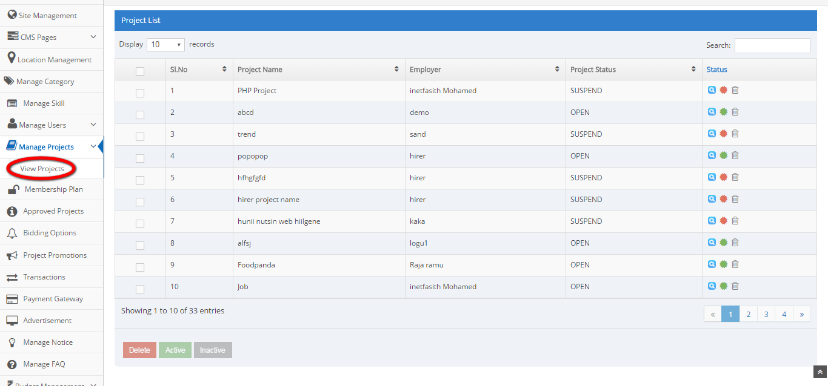
Description:
This page manages the project details with employer name, project status and active details.

Membership plan:
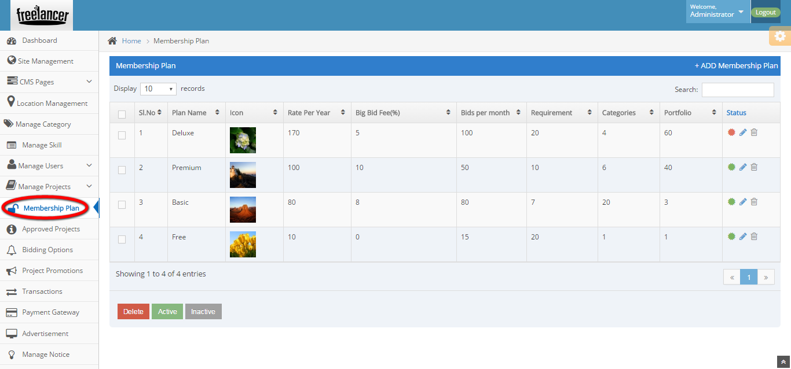
Description:
This page manages the membership plan details with the plan name, rate per year, big bid free detail, bids per month, requirements, categories portfolio and status details.

Approved projects:
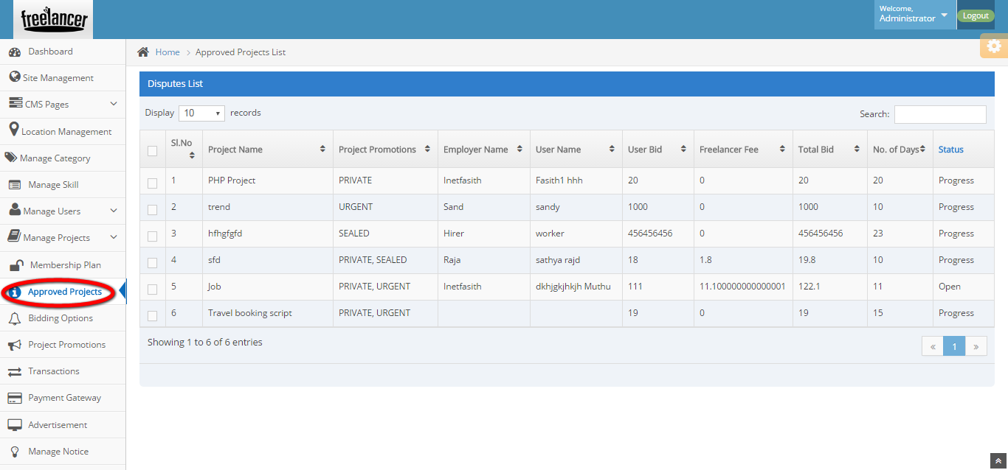
Description:
This page contains the details like project name, promotions, employer name, user name, user bid, freelancer fee, Total bid, counts of days and current status of the bid.

Bidding options:
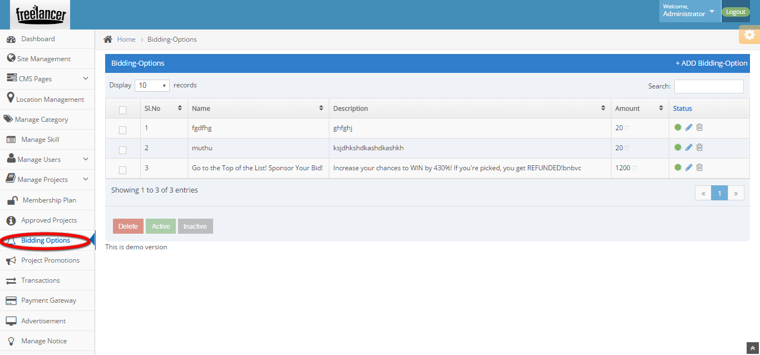
Description:
This page manages the bidding details like name, description, amount and status details with search option.

Project promotions:
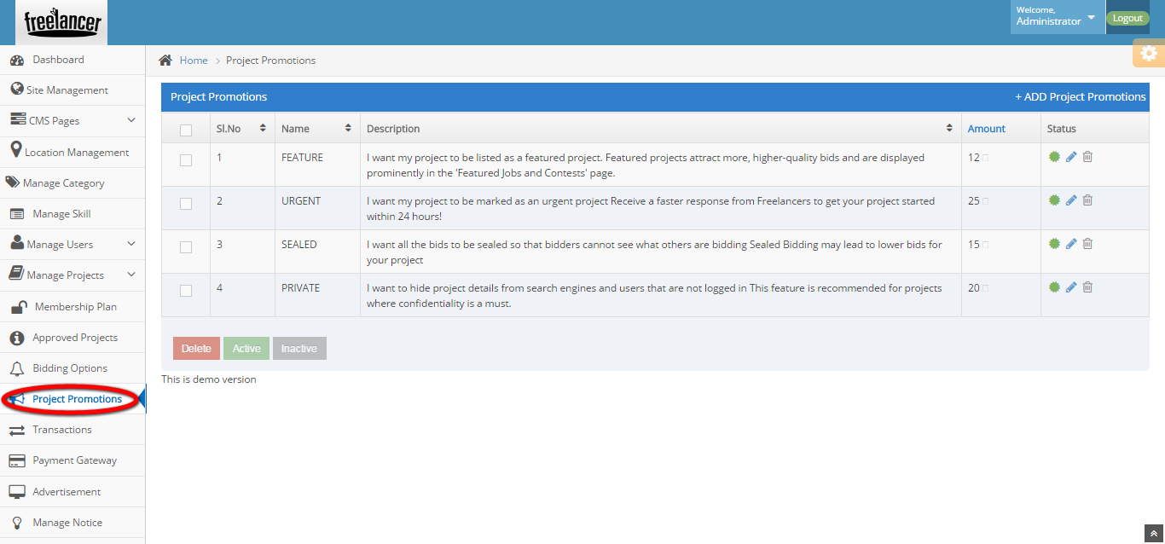
Description:
This page maintains the project promotion details with the option of delete, active and inactive details.

Manage notice:
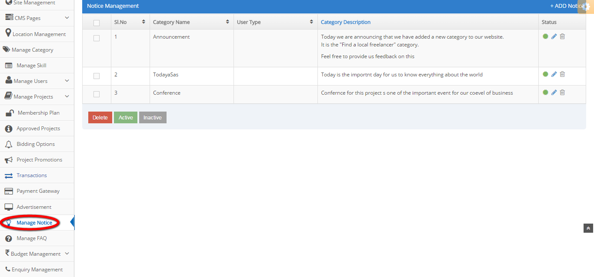
Description:
This page manage the notice details with category name, user type and category description with status.

Manage FAQ:
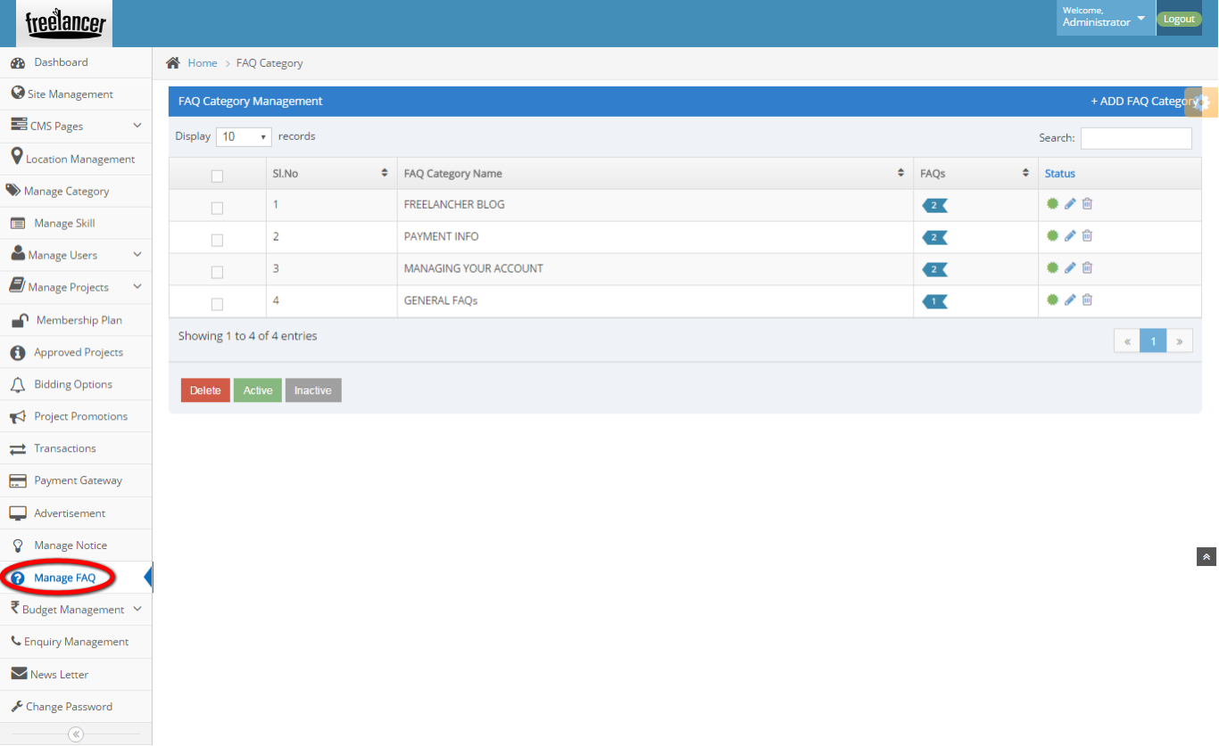
Description:
This page maintains the FAQ category name, counts of FAQs and status details with search option.

Currency management:
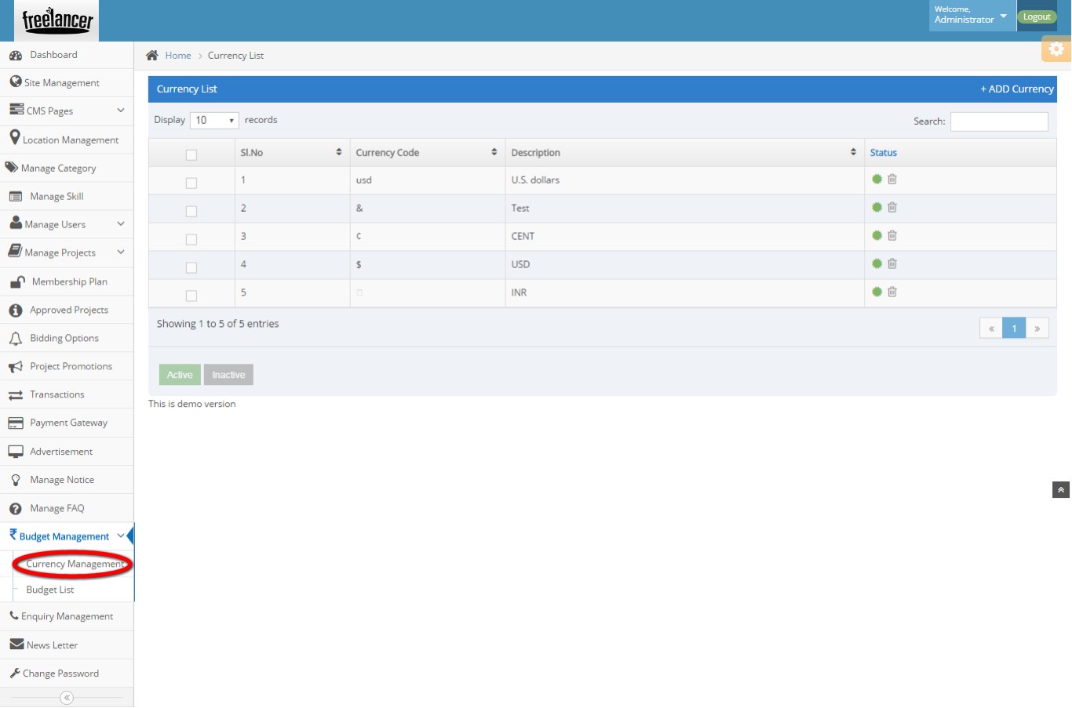
Description:
This page can maintain the currency list details like currency code, description and status details with the option of active and inactive.

Budget list:
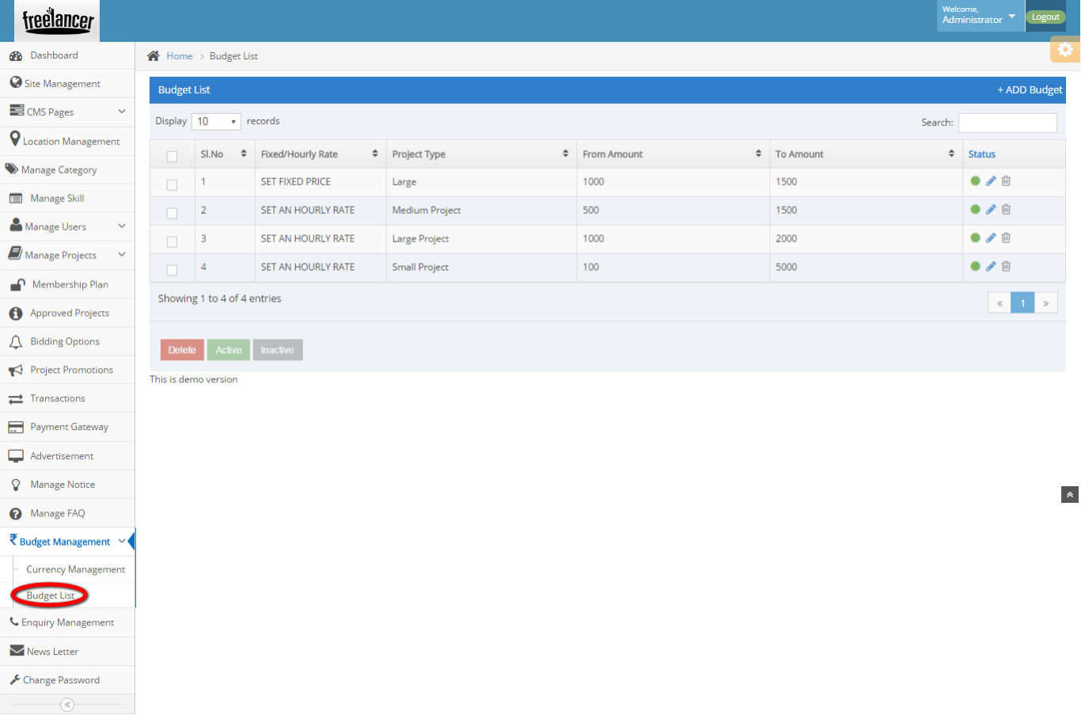
Description:
This page manages the Budget lists with the option of delete, active and inactive option.

Enquiry management:
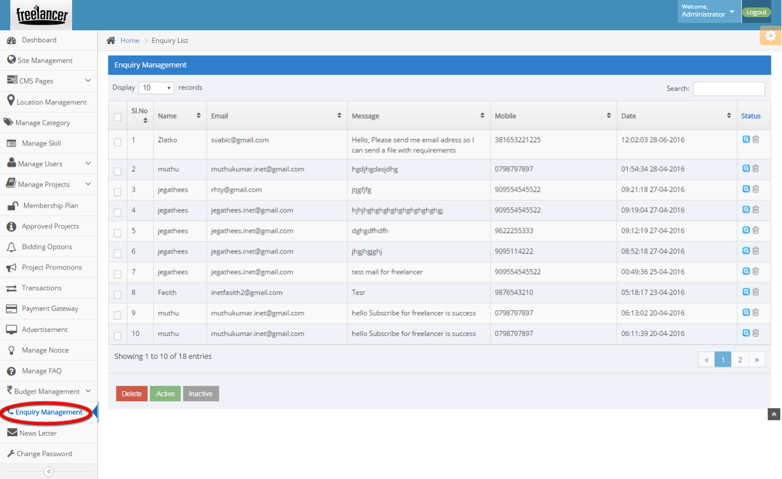
Description:
This page manages the enquiry details with the option of delete, active and inactive.

Newsletter:
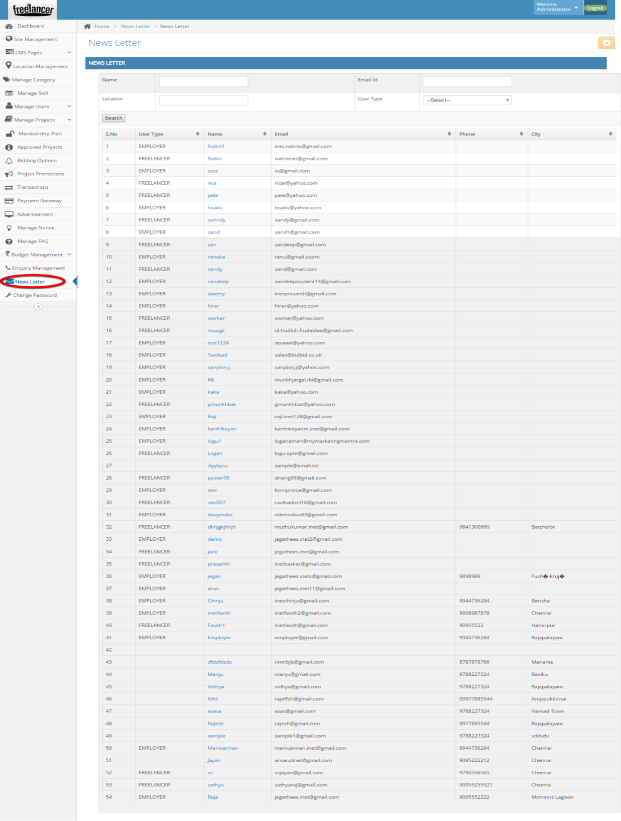
Description:
This page contains the newsletter subscribed users details.

Change password:
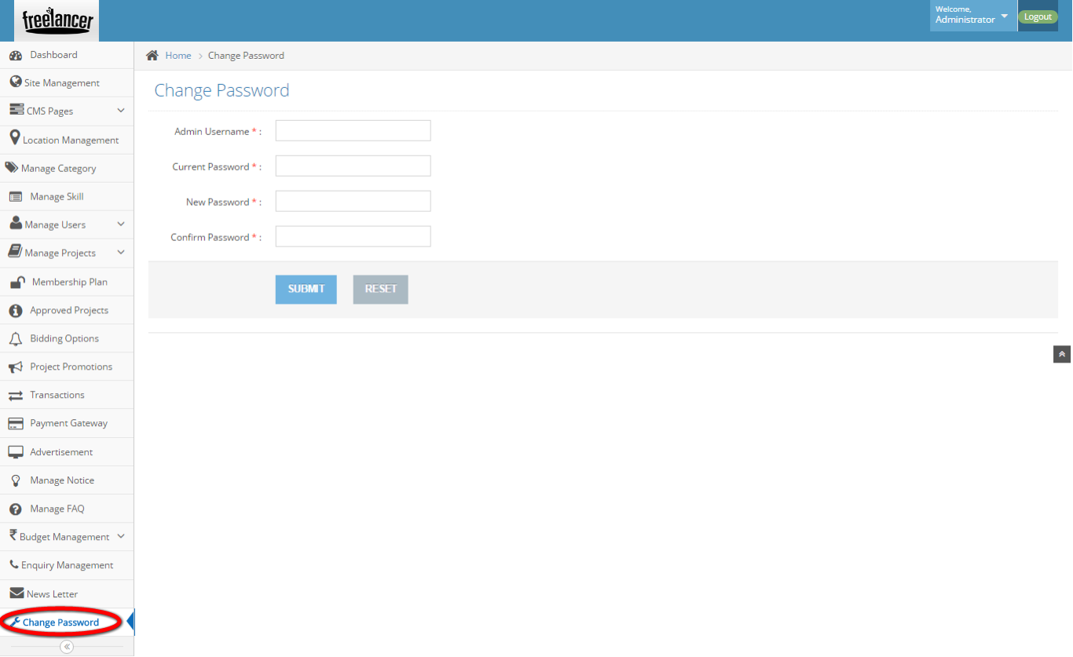
Description:
This page manages to vary the admin password details.

