**MAIL VOICE**

**Customer**

**Create group:**

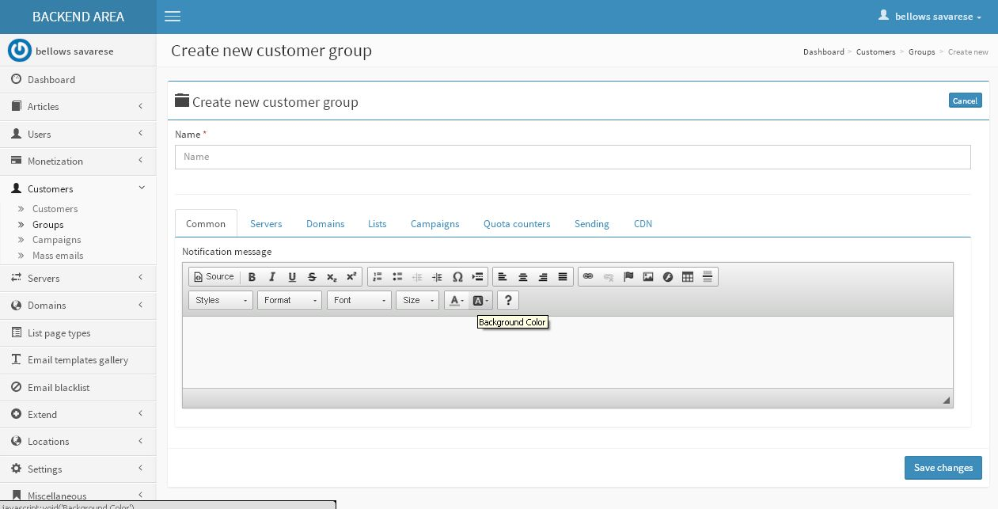

**Description:**

Admin can create new group

**Follow:** Customer-Group-New

**View group:**

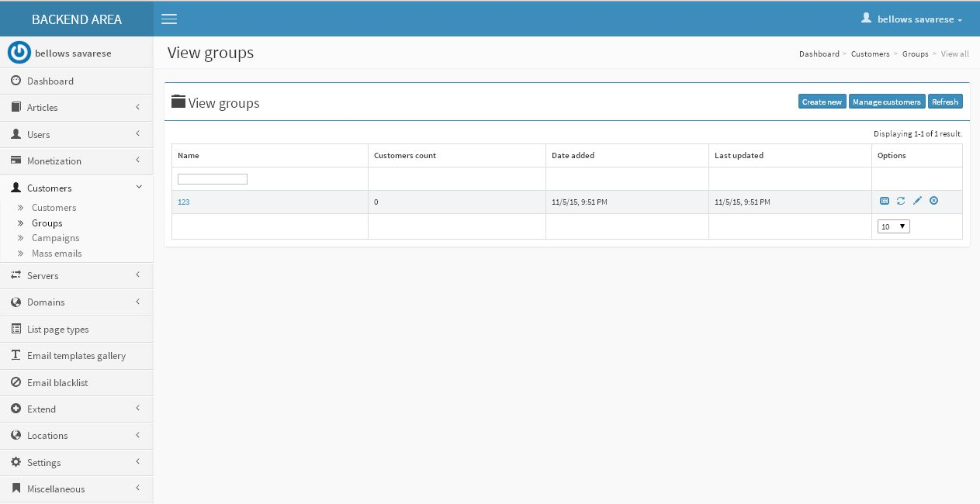

**Description:**

Admin can manage their group and search with filtrations

**Follow:** Customer-Group

**Campaigns:**

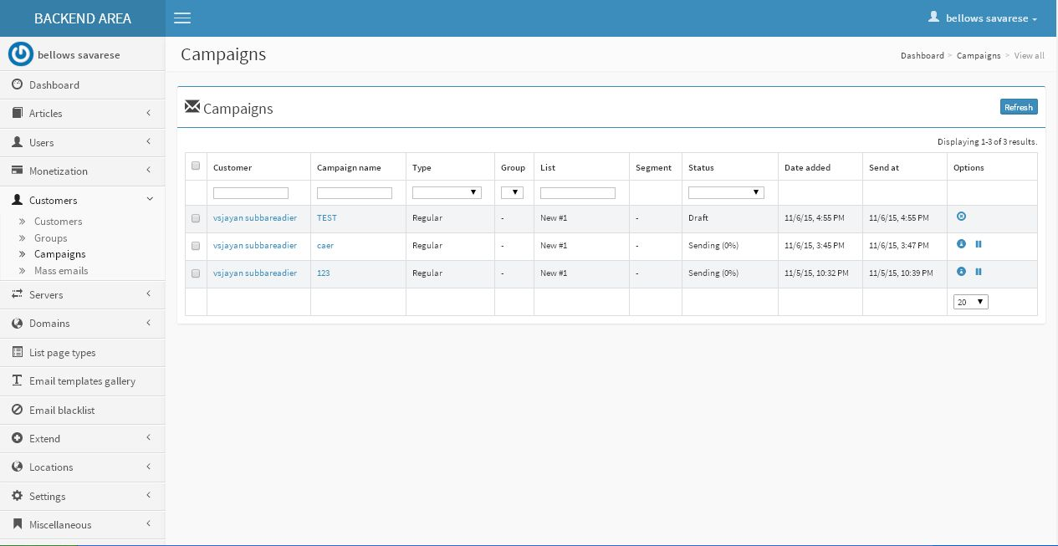

**Description:**

Admin can view campaigns details

**Follow: Customer- Campaign**

**Mass mail:**

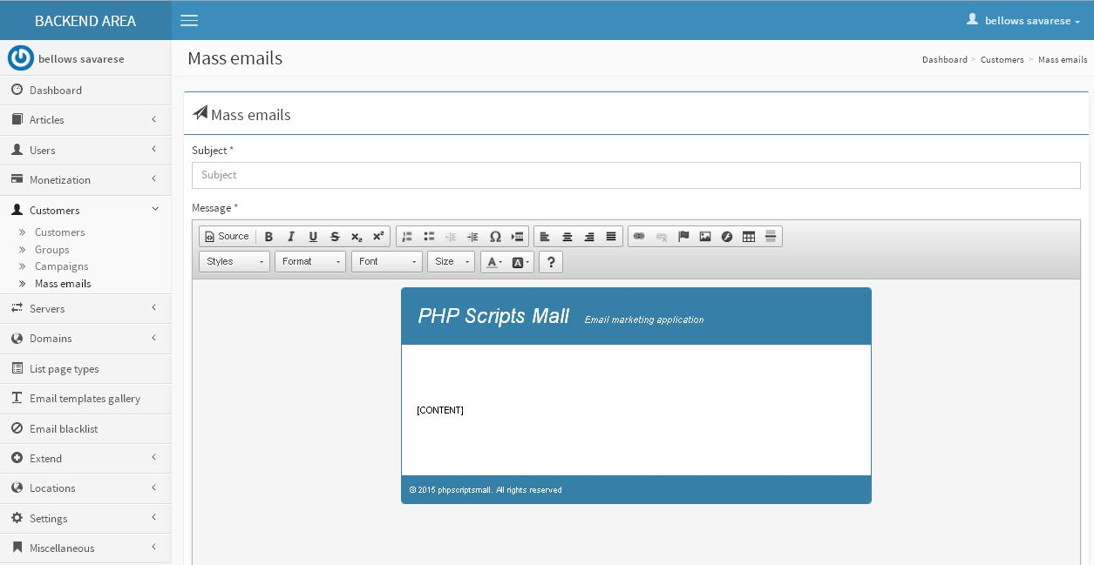

**Description:**

Admin can send mass mail through groups

**Follow:** Customer-Mass mail

**List page type**

**List page:**

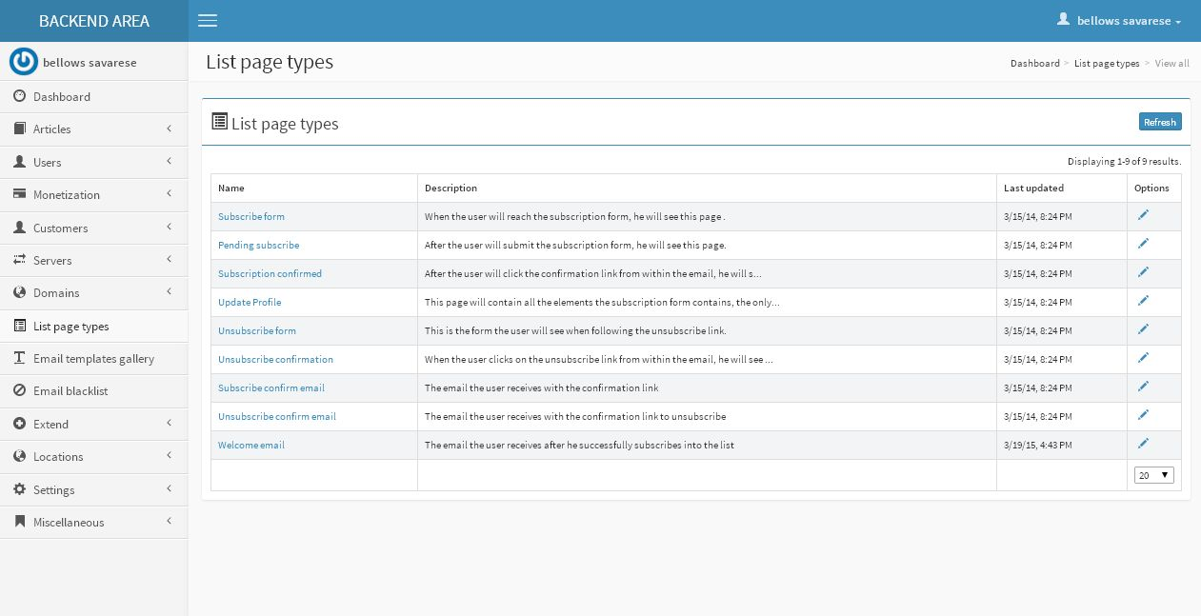

**Description:**

Admin can view saved list page details

**Follow:** List page types

**Email template gallery**

**Create email template gallery:**

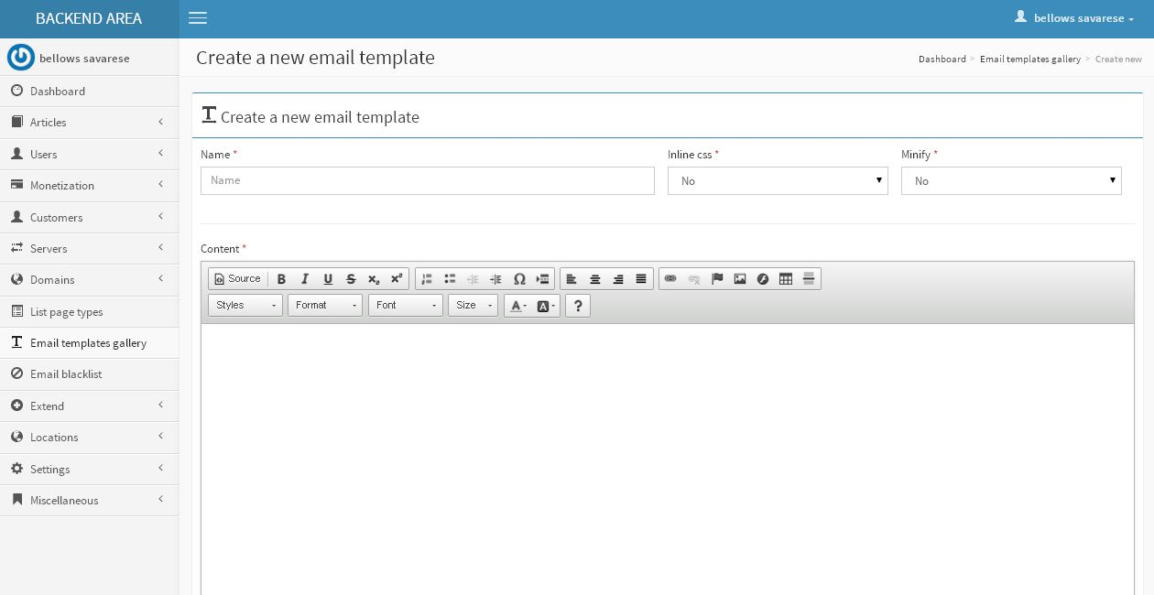

**Description:**

Admin can create email template

**Follow:** Email template gallery-New

**Upload template:**

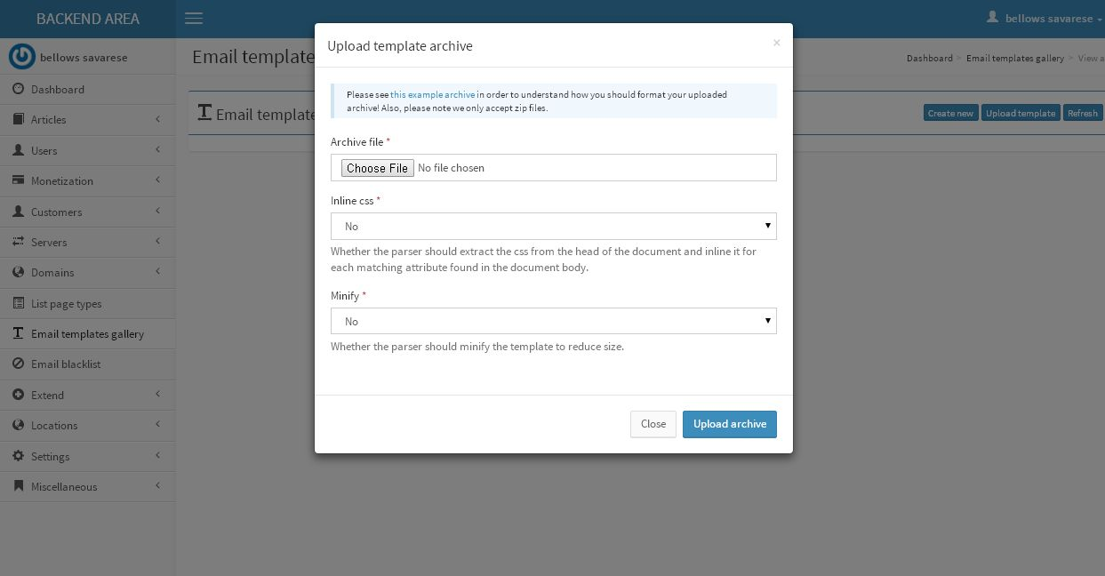

**Description:**

Admin can upload new template

**Follow:** Email template gallery – Upload template

**Email template:**

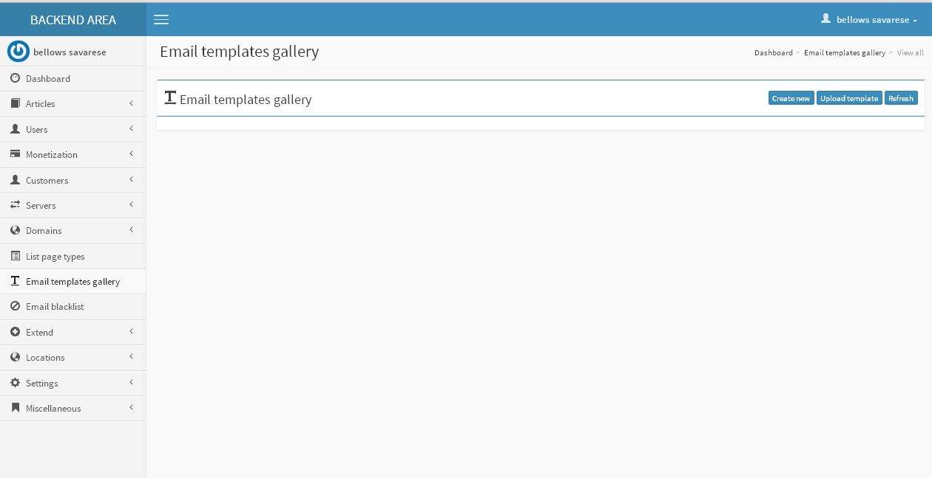

**Description:**

Admin can mange email templates

**Follow:** Email template gallery

**Settings**

**Email template:**

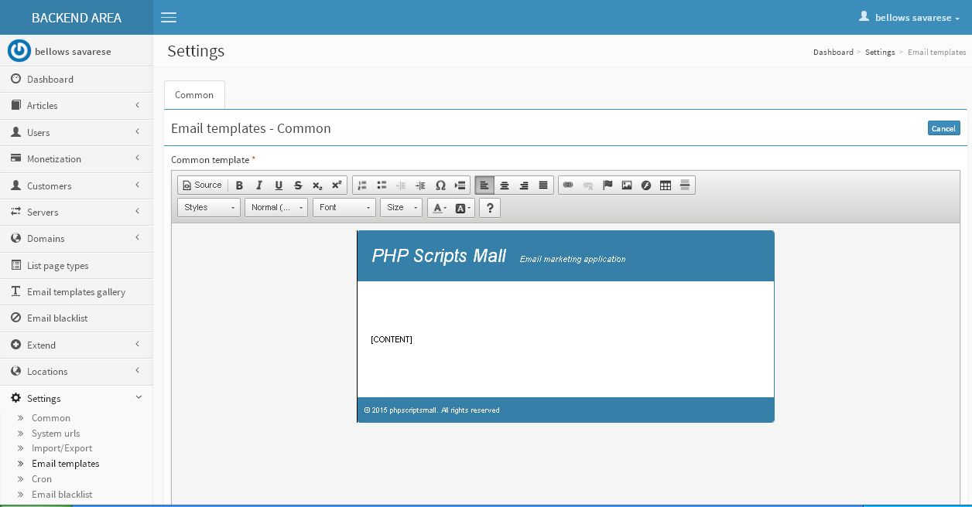

**Description:**

Admin manage email template design

**Follow:** Settings-Email template

**Campaigns:**

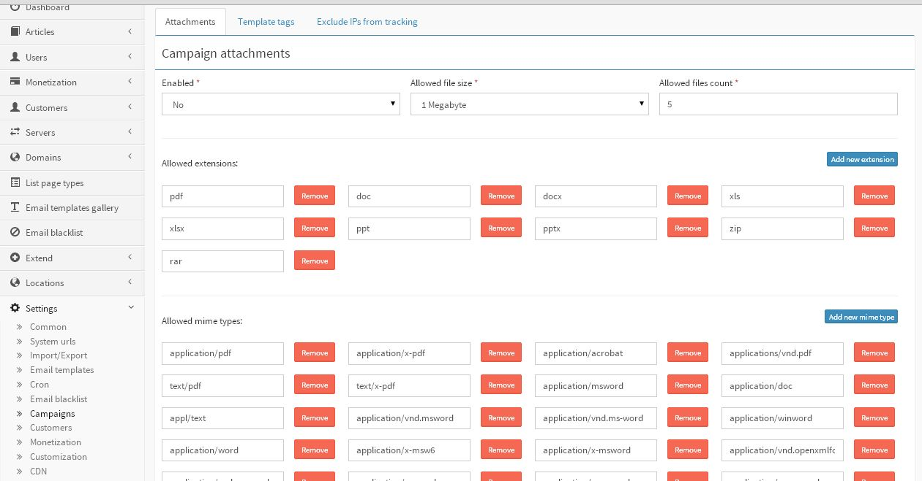

**Description:**

Admin mange campaign following settings attachment type, template tags and IP tracking settings

**Follow:** Setting-Campaign

**Miscellaneous**

**Achieve campaign delivery details:**

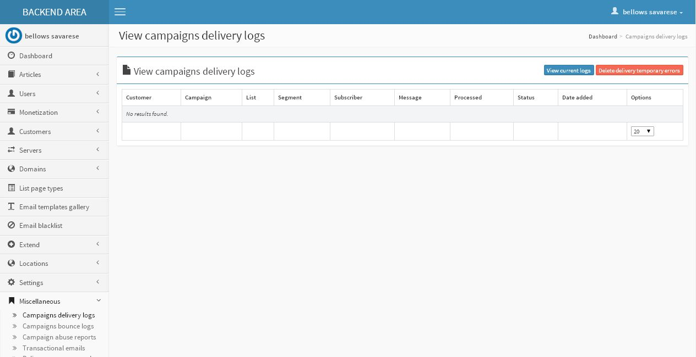

**Description:**

Admin can view archive campaign delivery details

**Follow:** Miscellaneous-Campaign delivery logs

**Campaign delivery logs:**

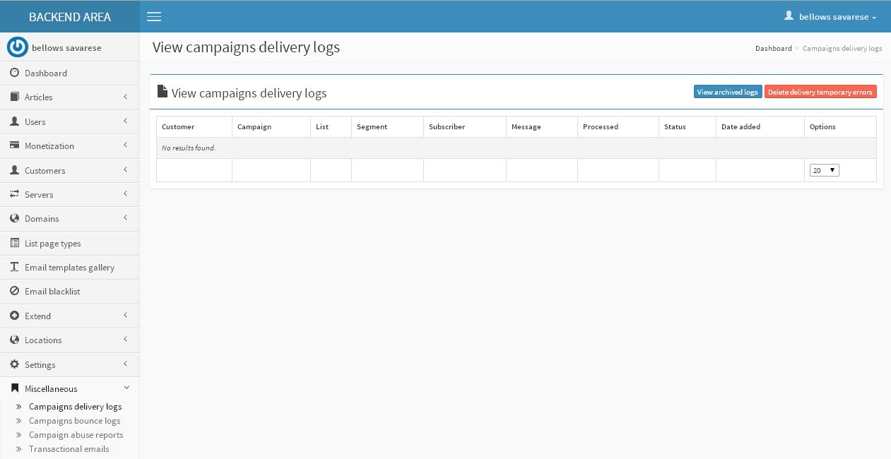

**Description:**

Admin can manage campaign delivery log details

**Follow:** Miscellaneous – campaign delivery log

**Campaign bounce log:**

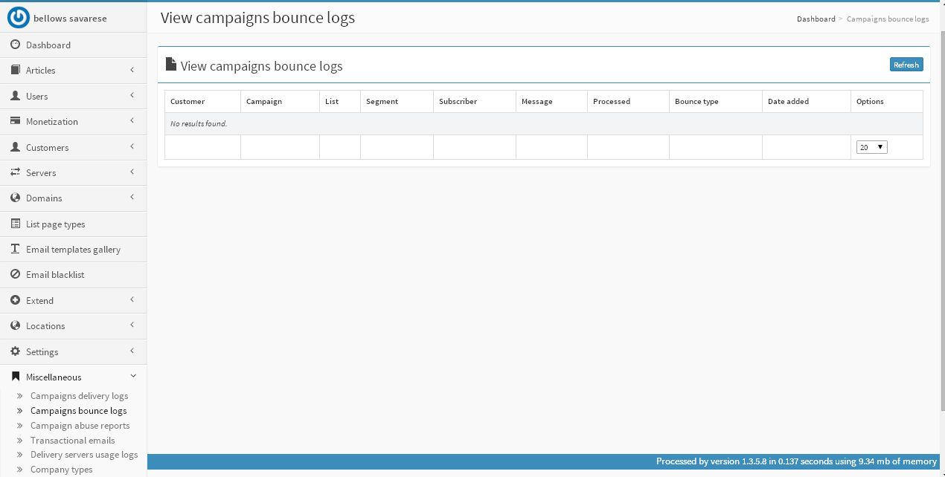

**Description:**

Admin can view campaign bounced log details

**Follow:** Miscellaneous-Campaign bounced logs

**Campaign abuse report:**

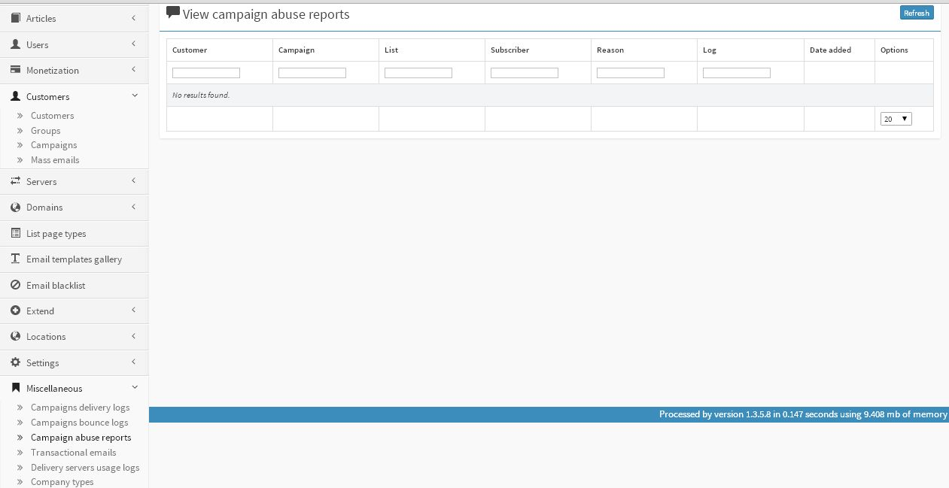

**Description:**

Admin can view campaign abuse report details

**Follow:** Miscellaneous-Campaign abuse report

**Campaign Transactional email:**

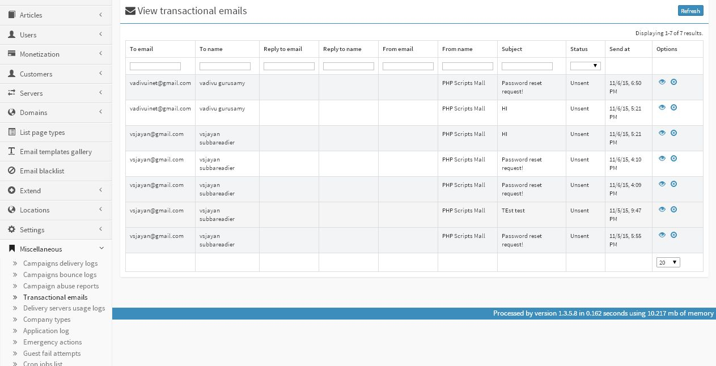

**Description:**

Admin can view transactional email details

**Follow:** Miscellaneous-Translational emails

**Delivery server usage log:**

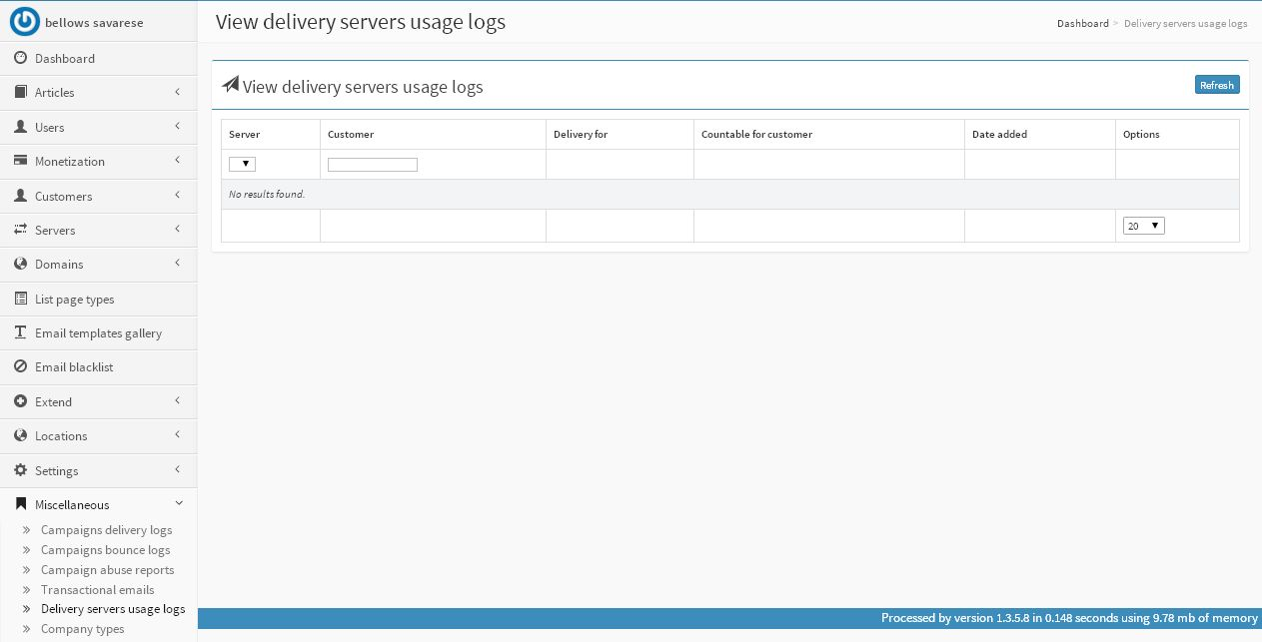

**Description:**

Admin can view details of delivery server usage log

**Follow:** Miscellaneous-Delivery server usage logs