ADVANCE MLM SCRIPT
MANUAL GUIDE
USER VIEW
Registration:
Step 1:
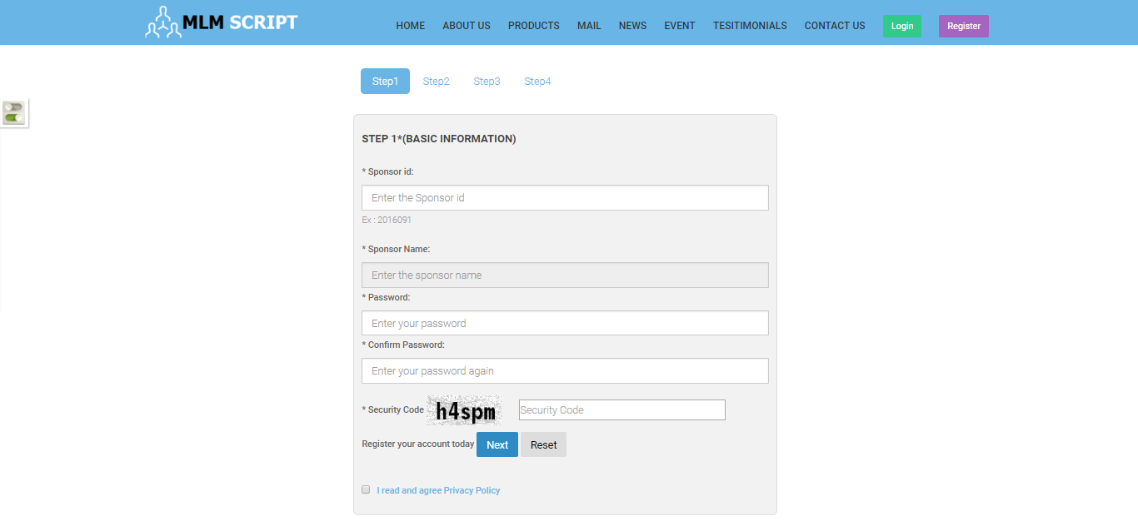
Description:
This page contains the first step registration fields.

Registration:
Step 2:
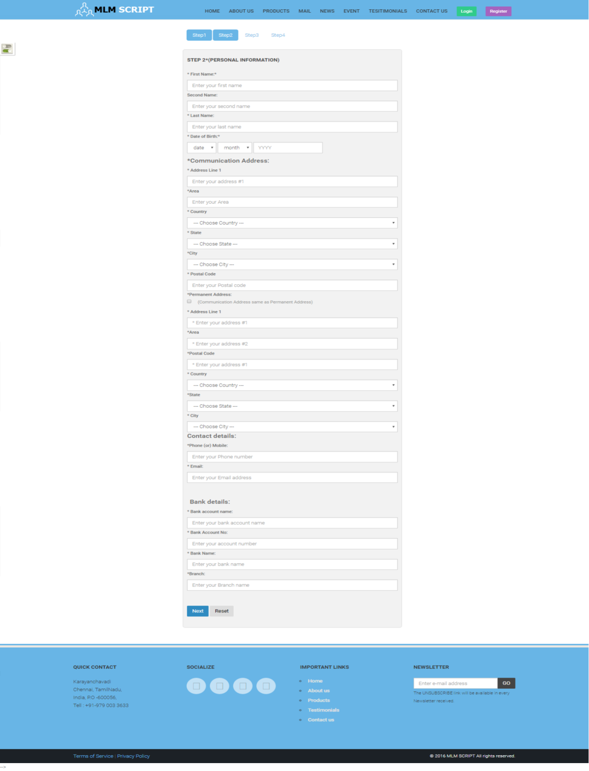
Description:
This page consists of the step 2 registration fields.
Registration:
Step 3:
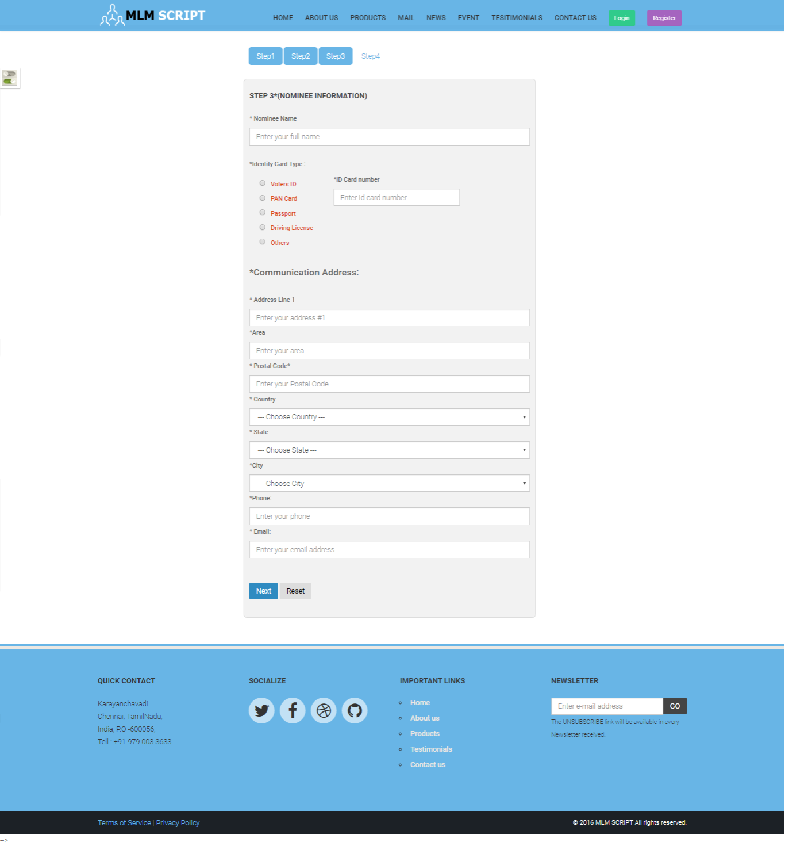
Description:
This page contains the third step registration fields as communication address details.

Registration:
Step 4:
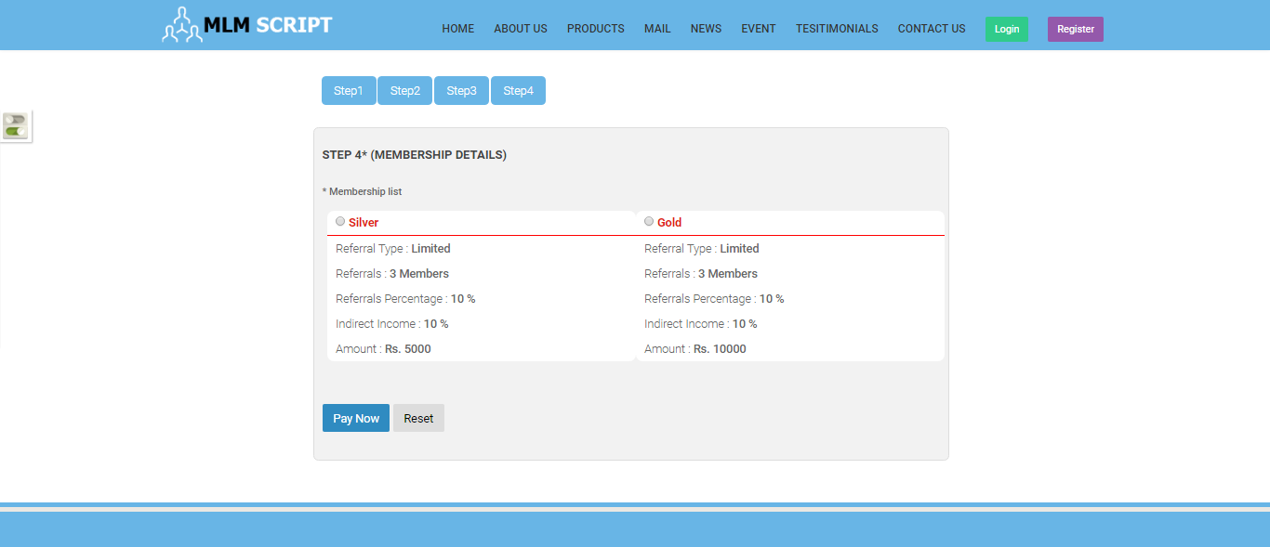
Description:
This page contains membership plan details as fourth step.

Login:
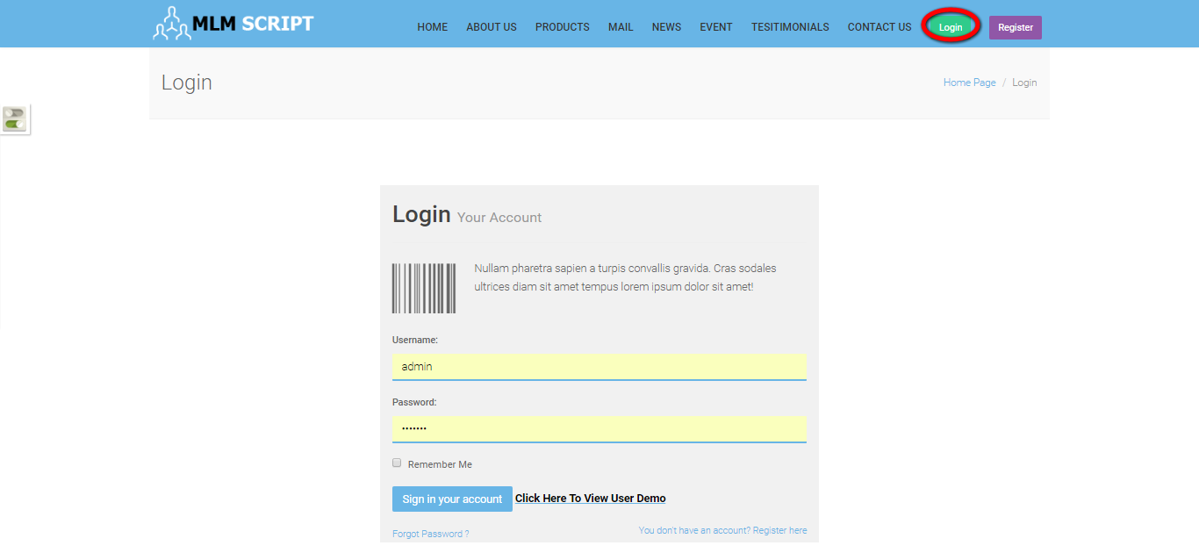

Description:
User can login via valid username and password.

Profile:
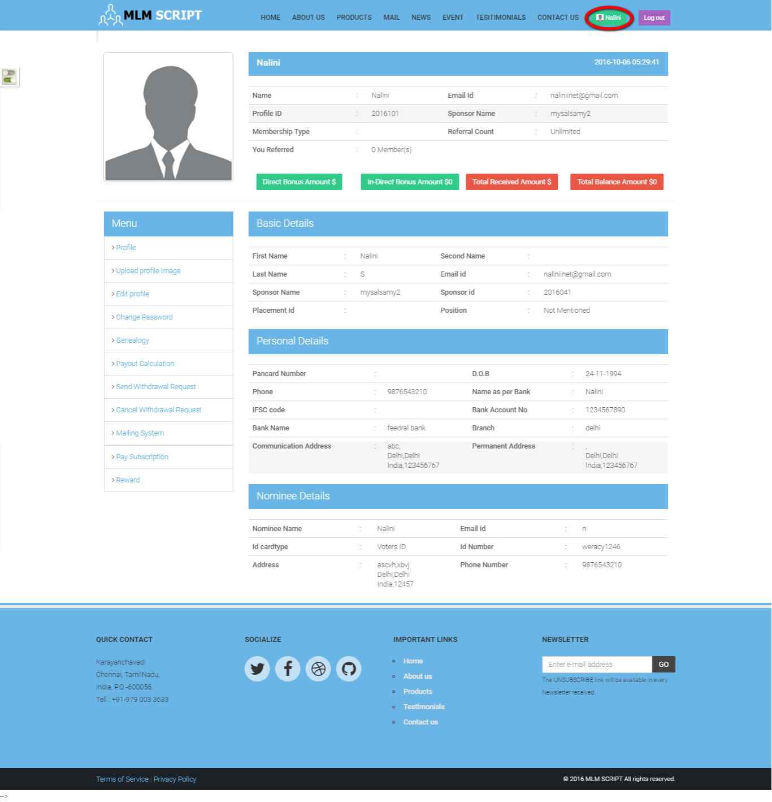
Description:
This page contains the entire profile details like basic, personal and nominee details.

Upload profile picture:
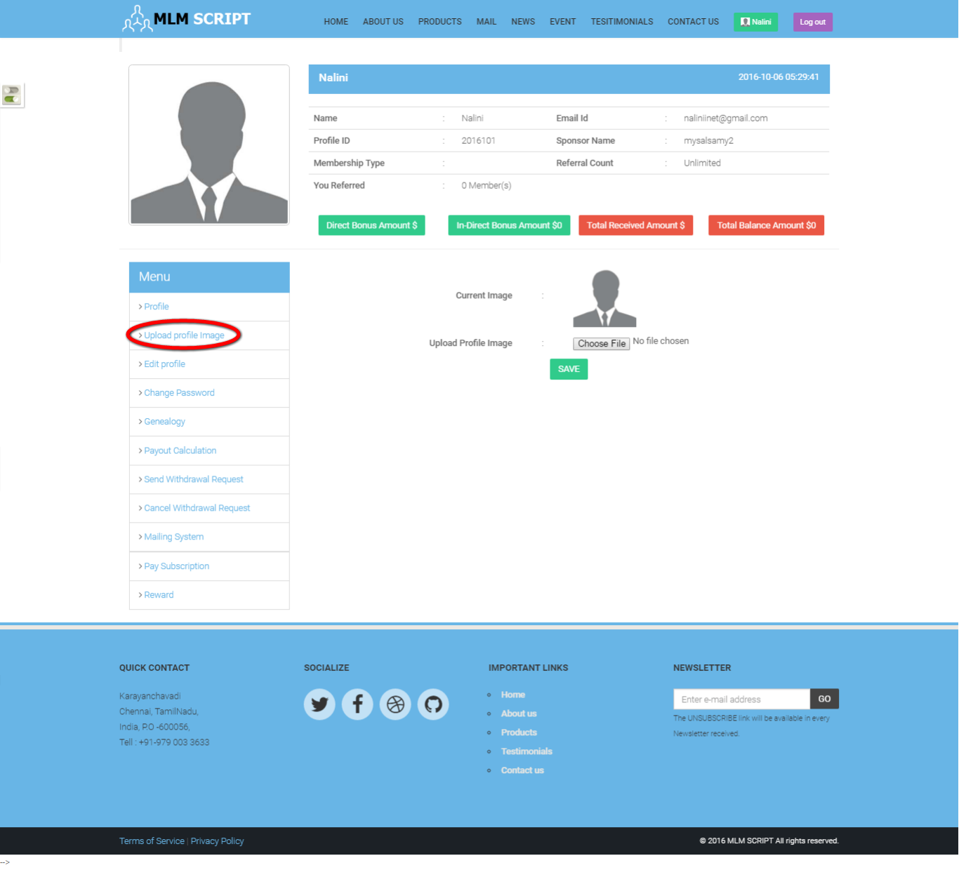
Description:
This page consists of option to upload the profile picture.

Edit profile:
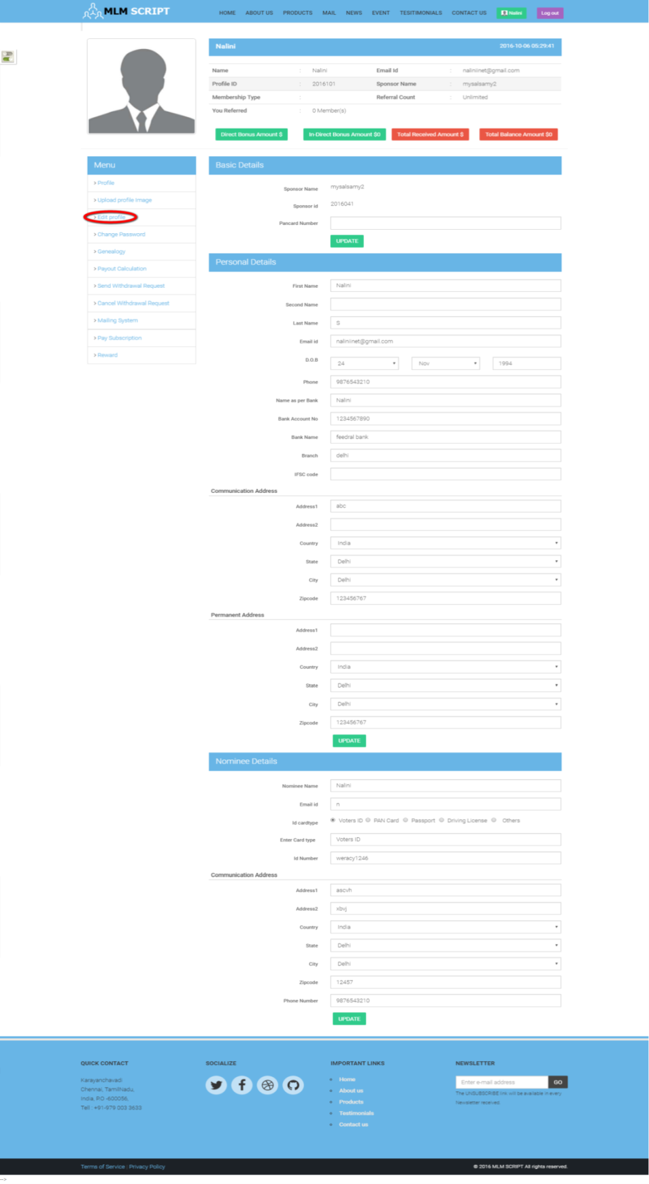
Description:
This page serves as edit the entire profile details.
Change password:
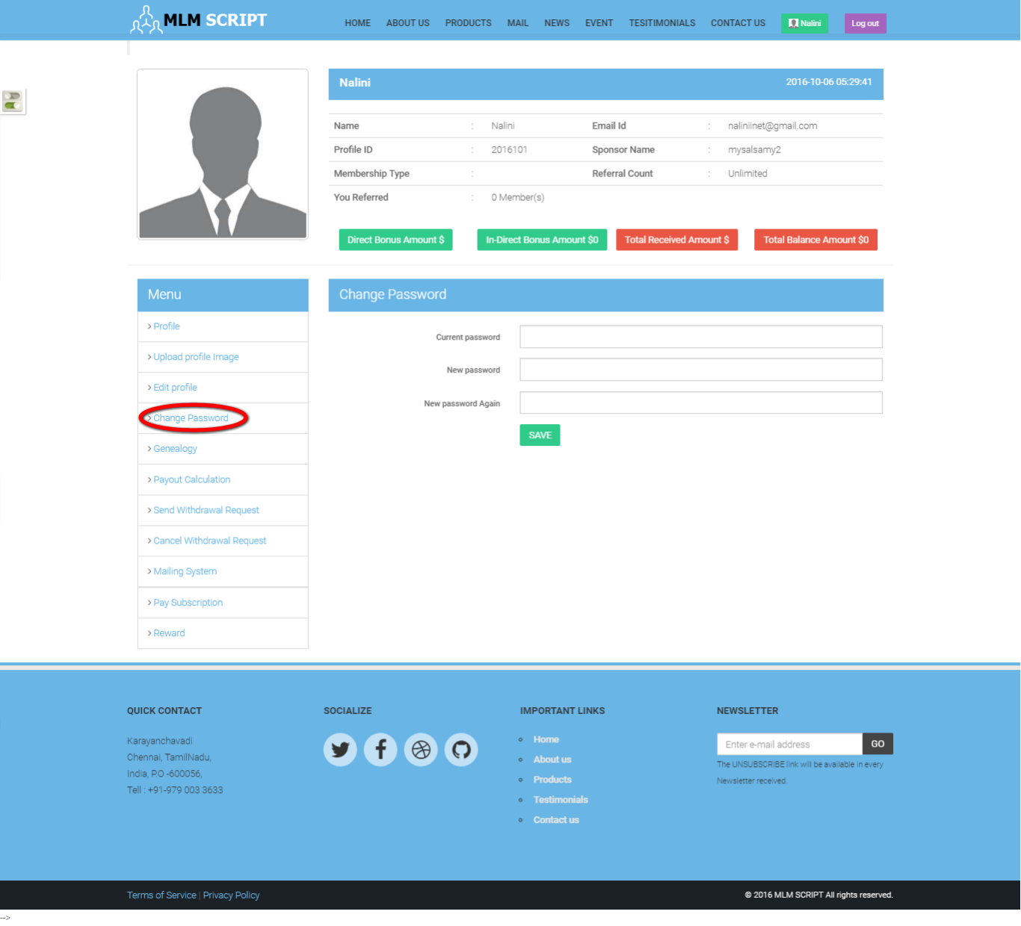
Description:
This page consists of option of change the account password.

Payout calculation:
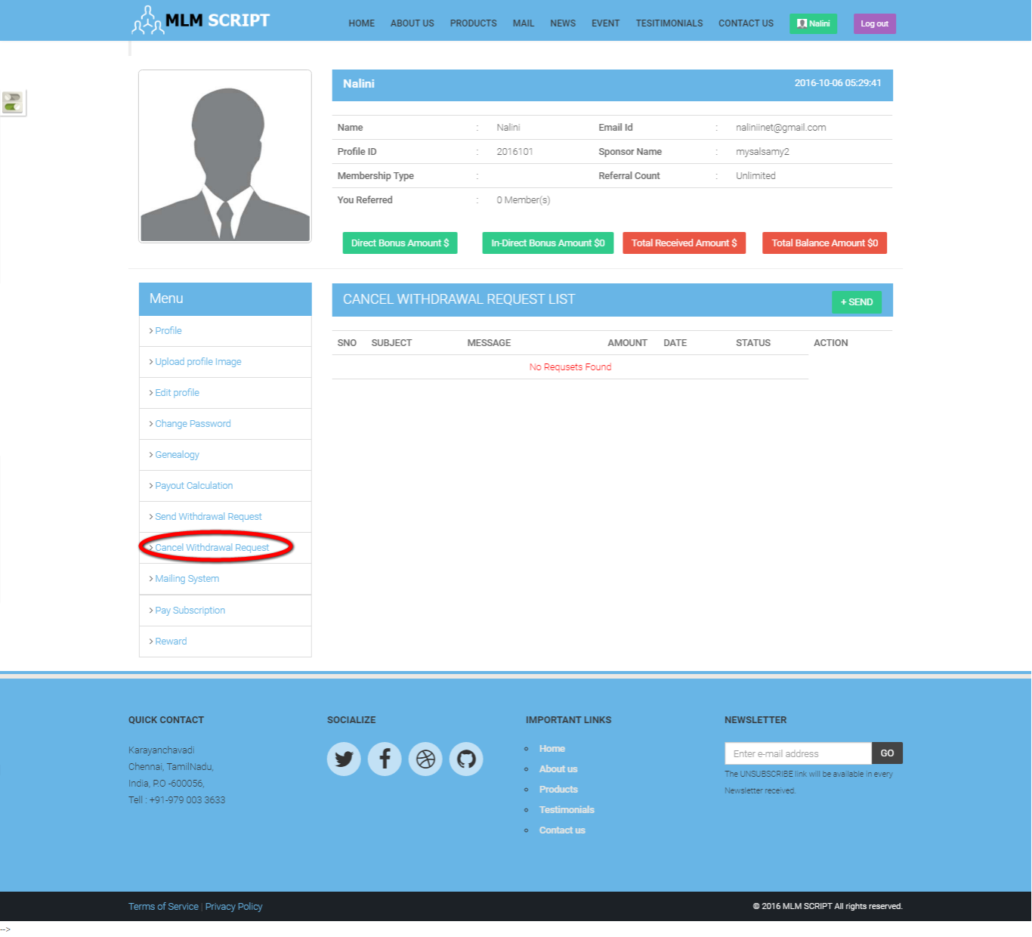
Description:
This page consists of payout calculation details and its status.

Send withdrawal request:
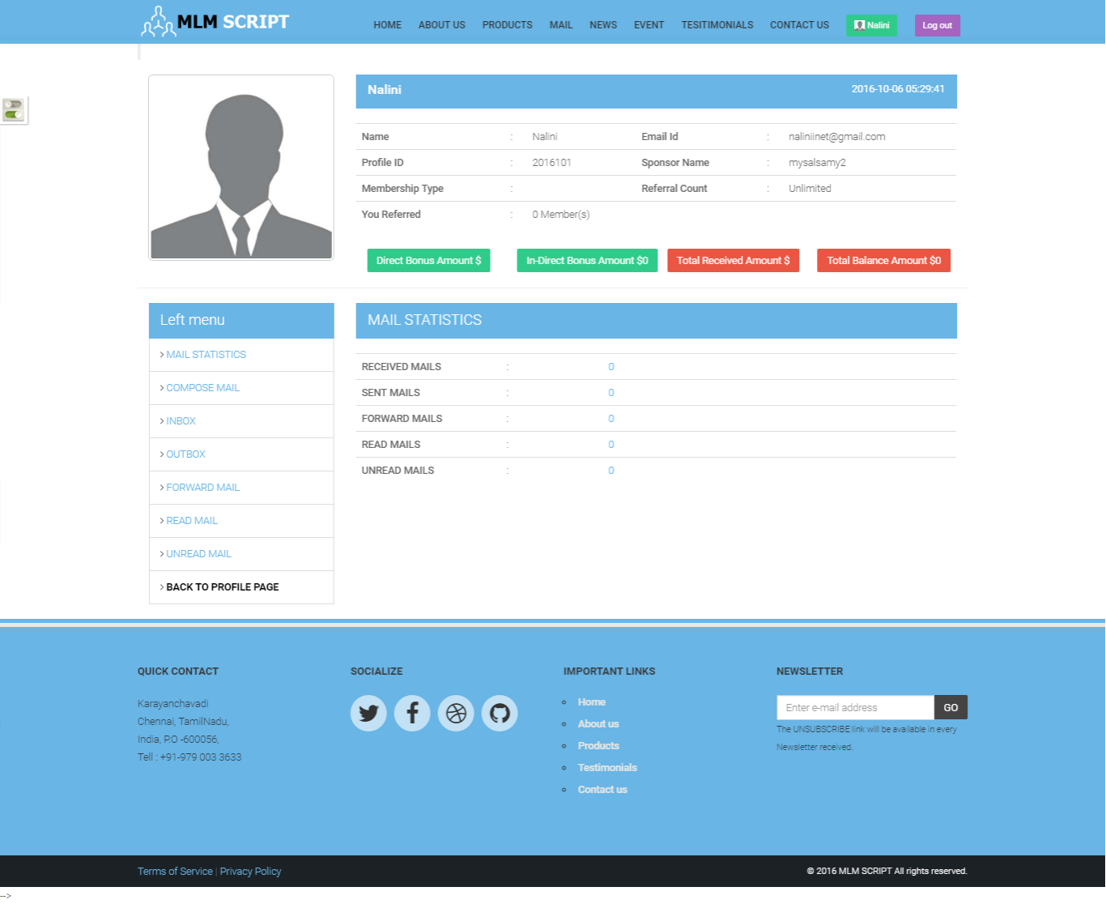
Description:
This page contains the withdrawal request details with date, amount, status and action details.

Cancel withdrawal request:
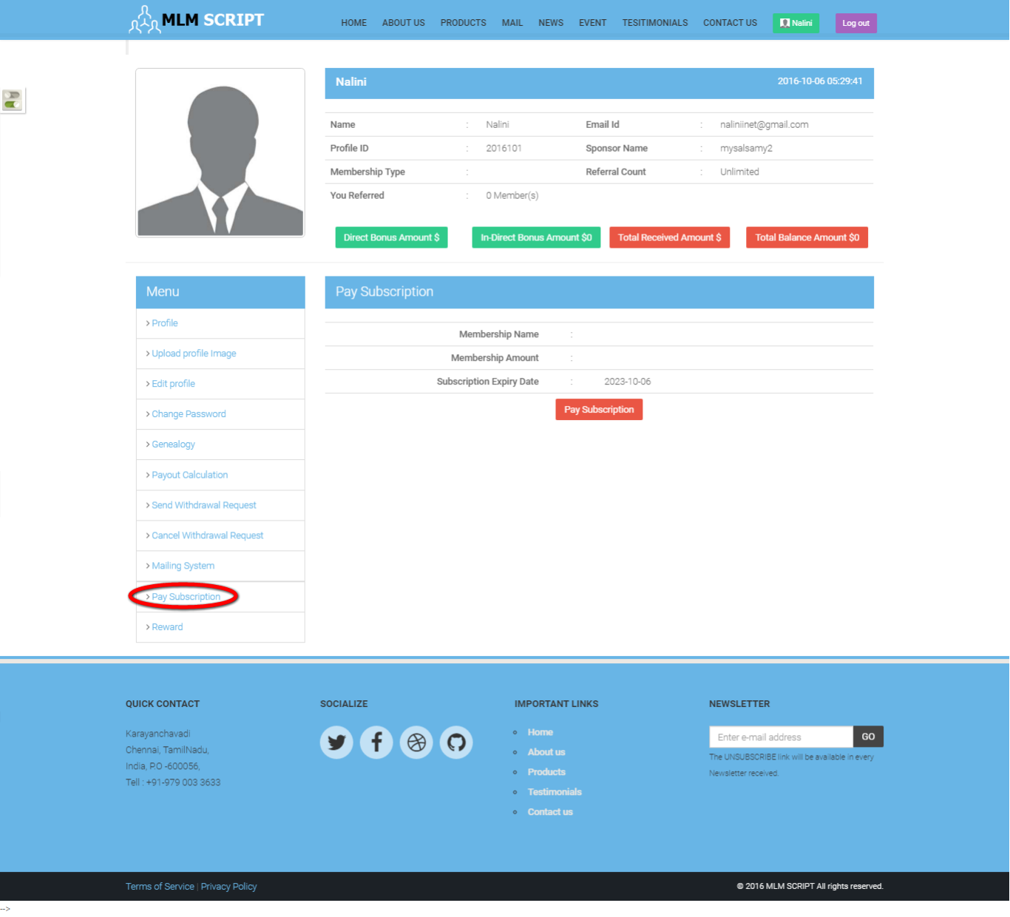
Description:
This page contains cancel withdrawal request list with amount, date, status and action details.

Home page:
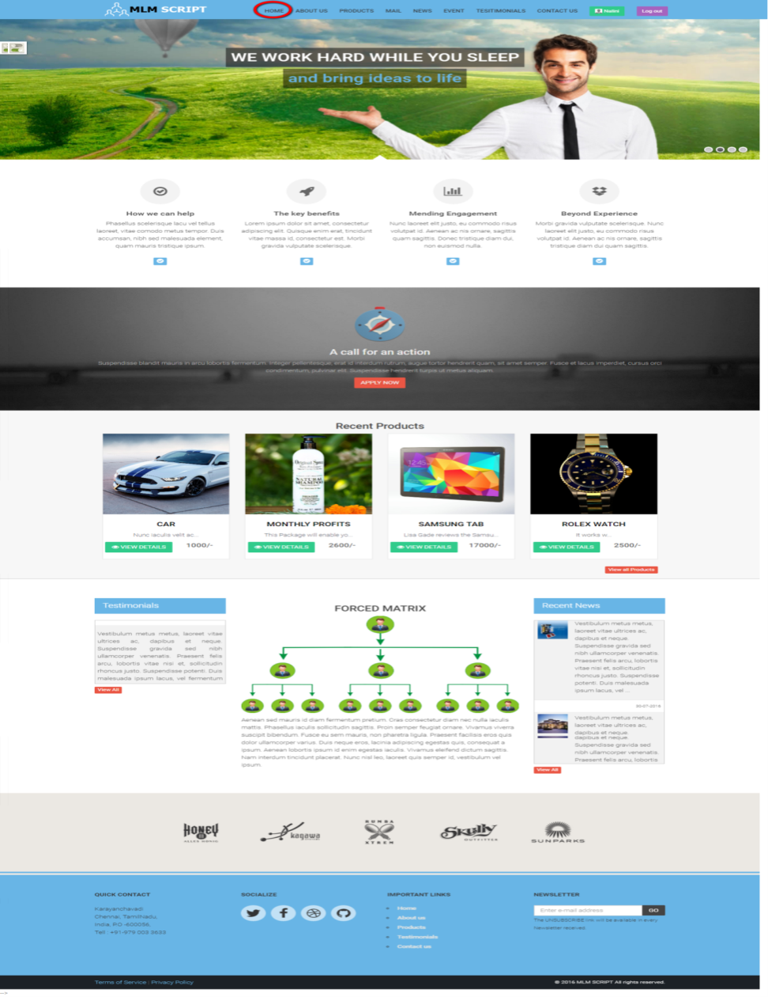

Description:
This page contains the recent product, testimonial and recent news details.

Products:
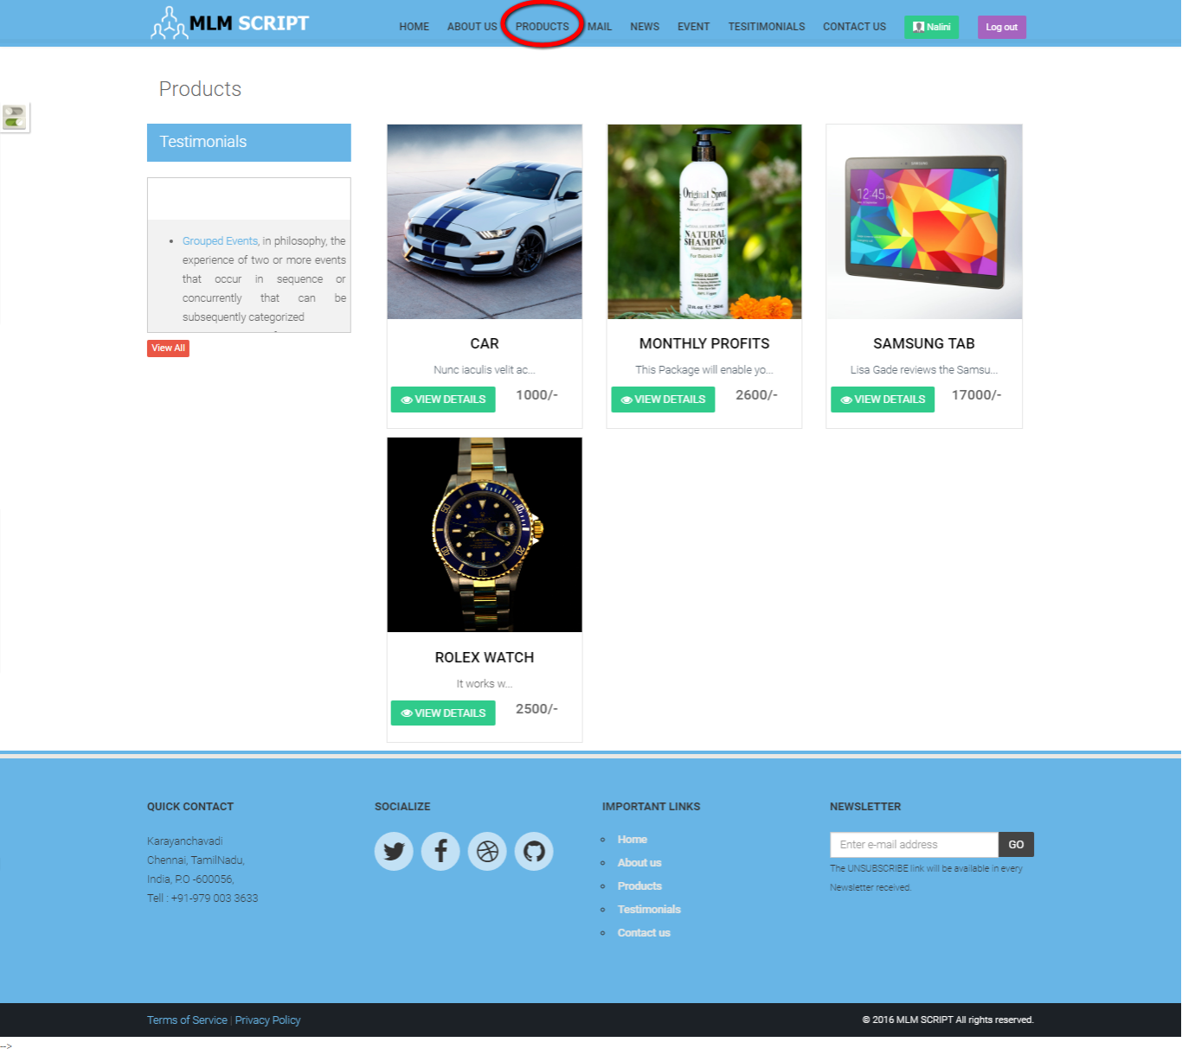

Description:
This page contains entire product details.

Mail:
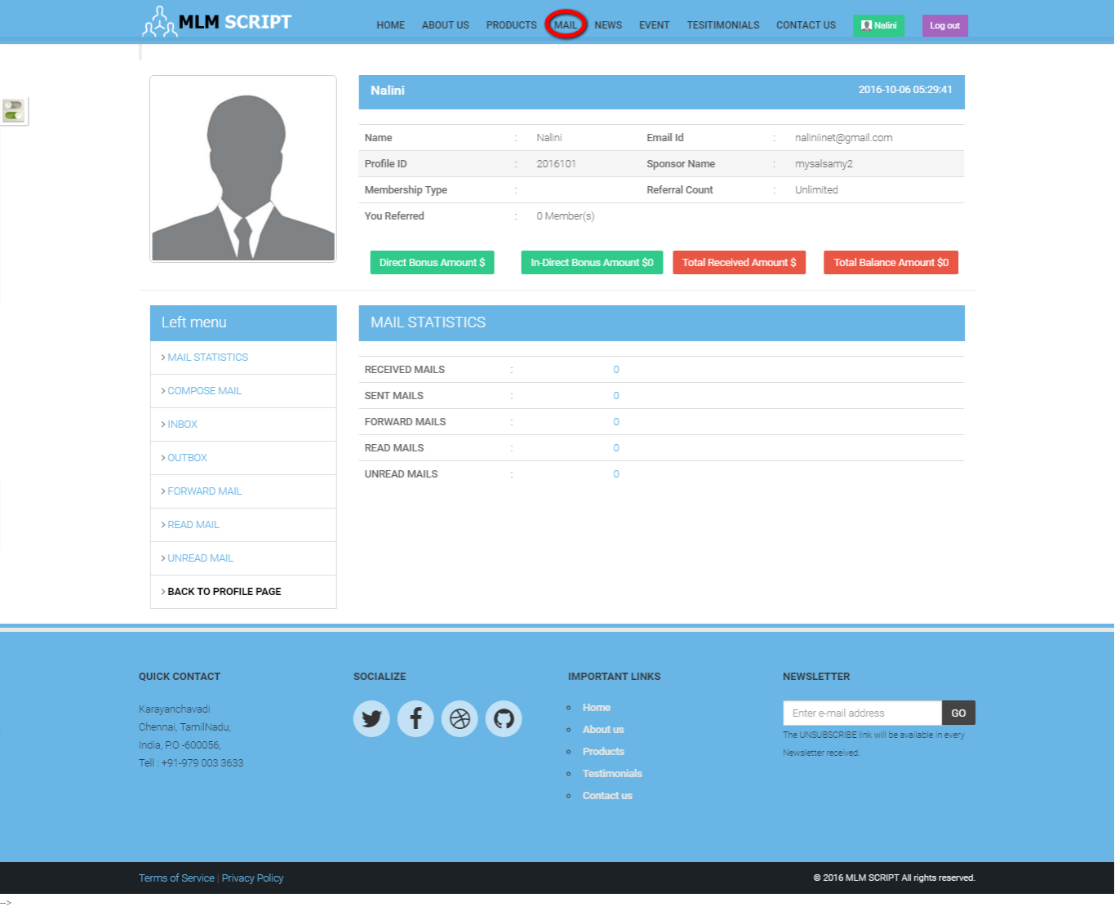
Description:
This page manages the messaging functionality and consists of entire mailing functions like compose, inbox, outbox, forward mail, read mail and unread mail details with its count.

Newsletter:
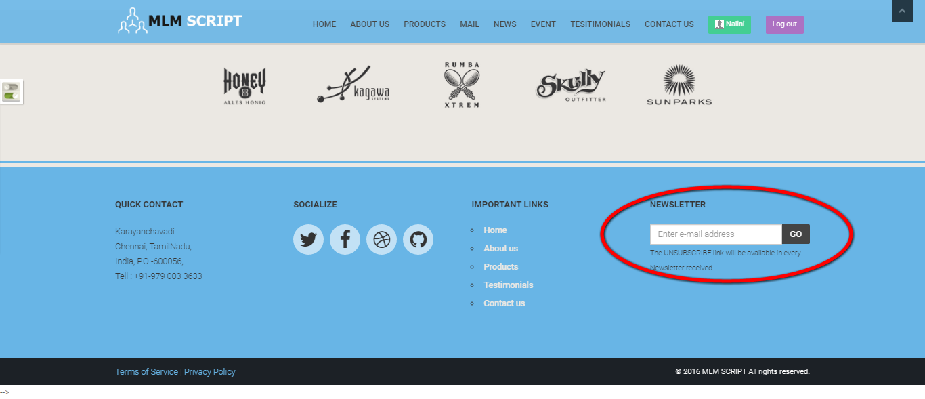
Description:
This footer subsists of the newsletter option that can be subscribed by the user for receive the recent news details.

News:
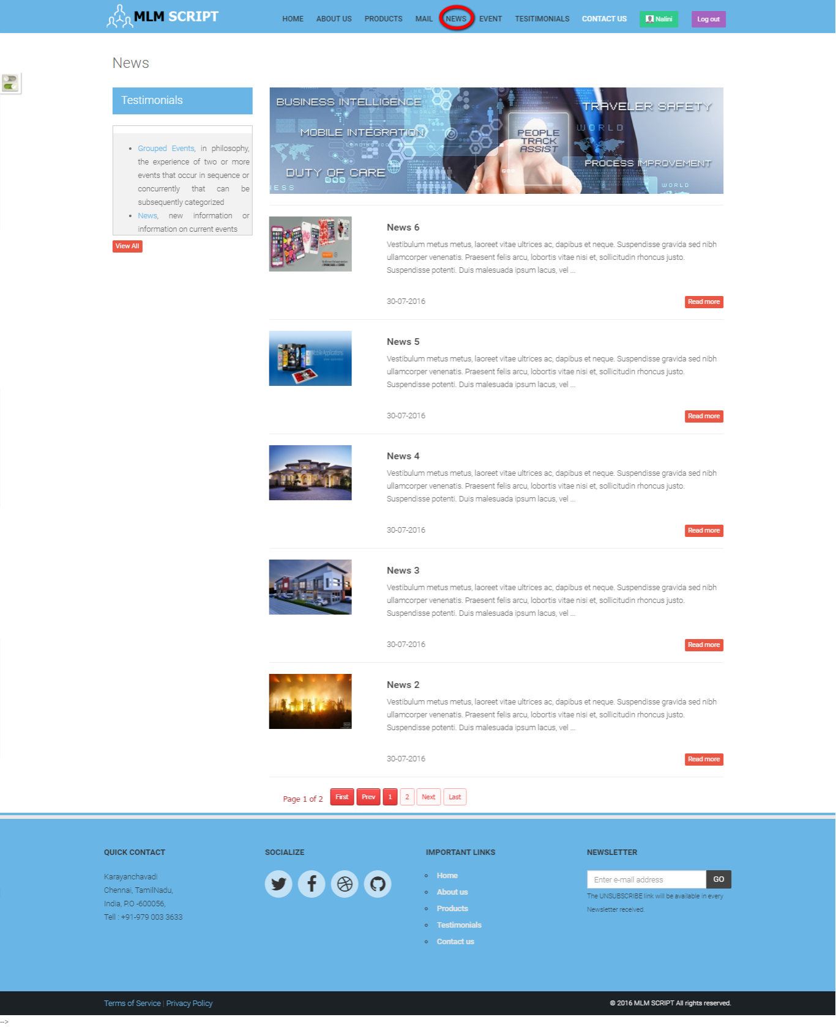
Description:
This page contains the recent news details.

Event:
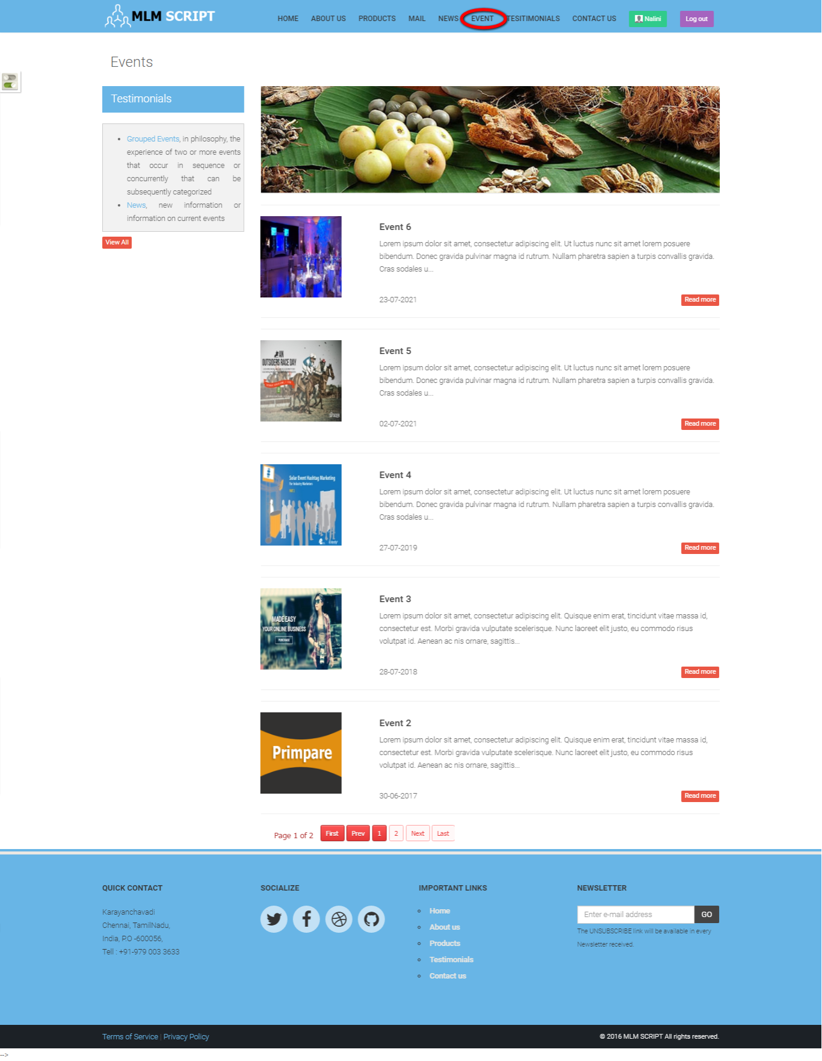
Description:
This page contains the event details.

About us:
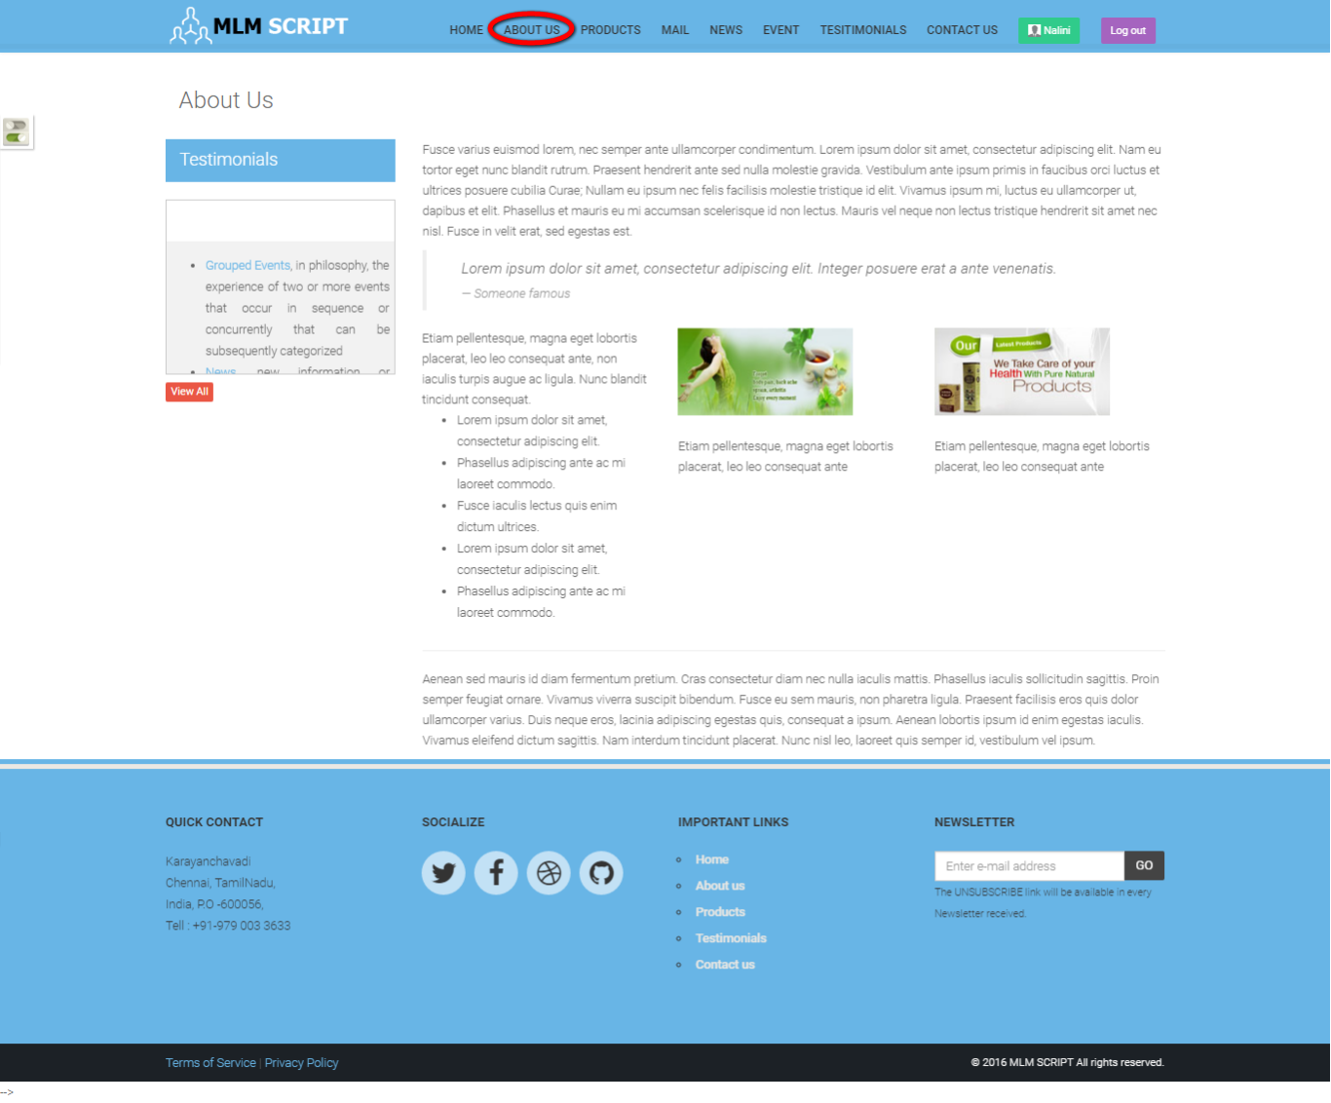
Description:
This page contains the details about the company.

Contact us:
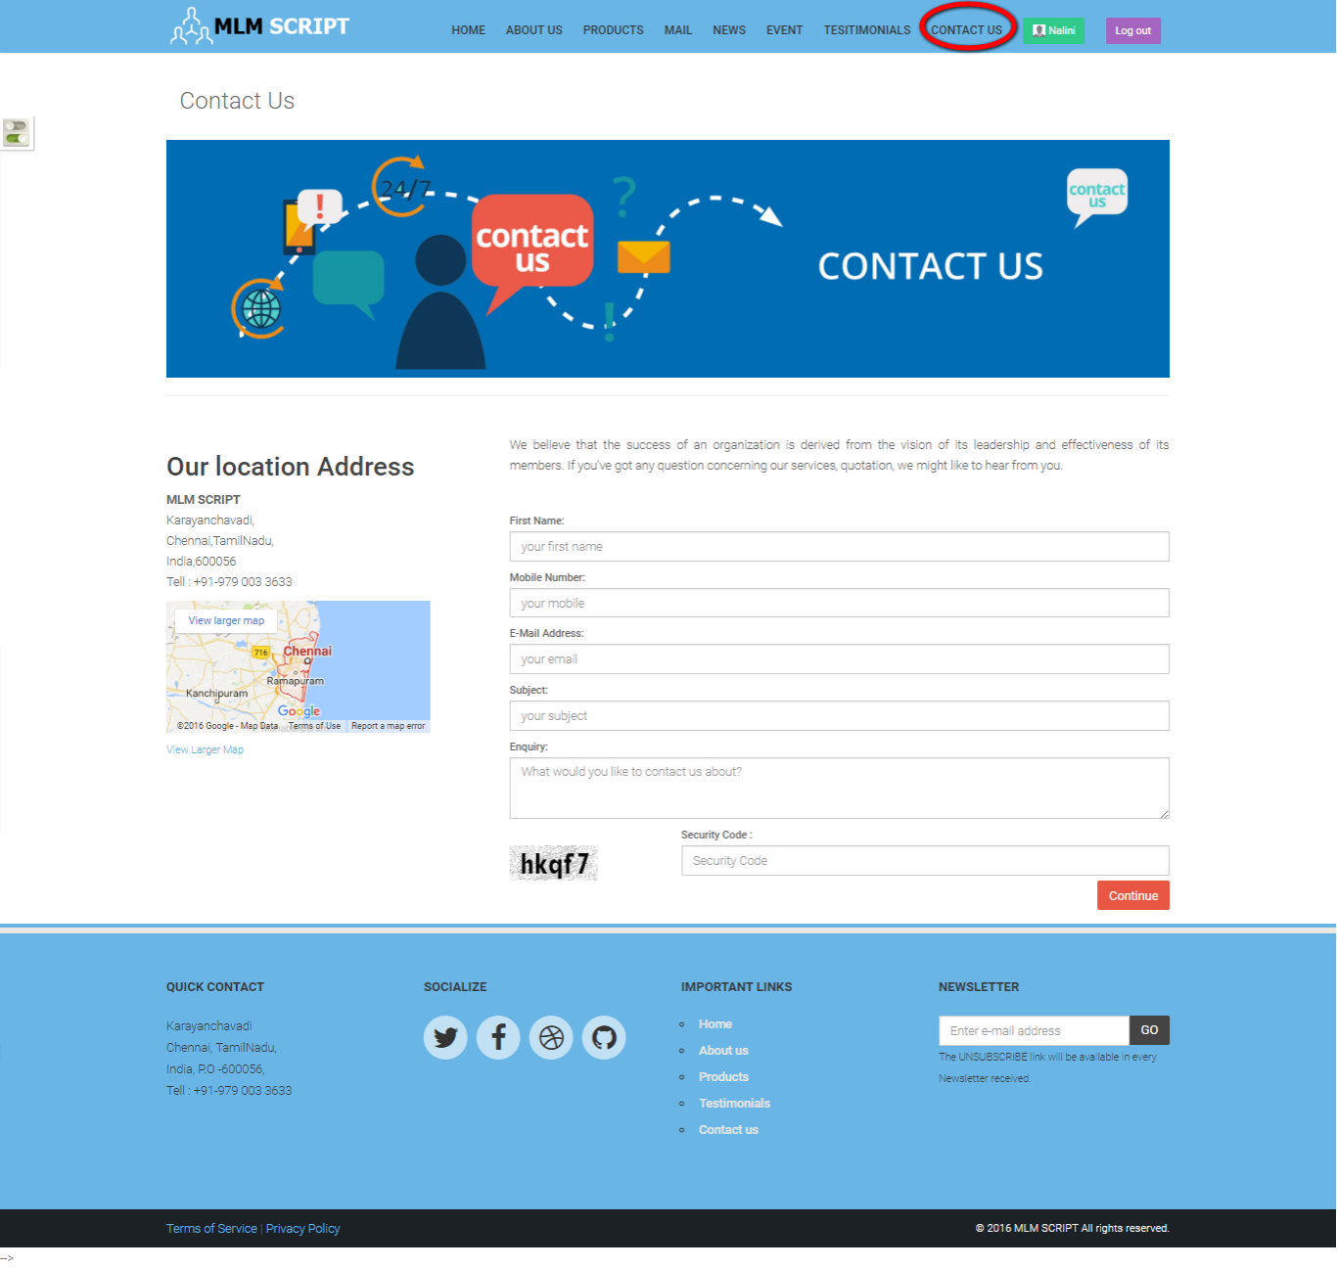
Description:
This page contains the location details with enquiry form.

ADMIN VIEW
Login:
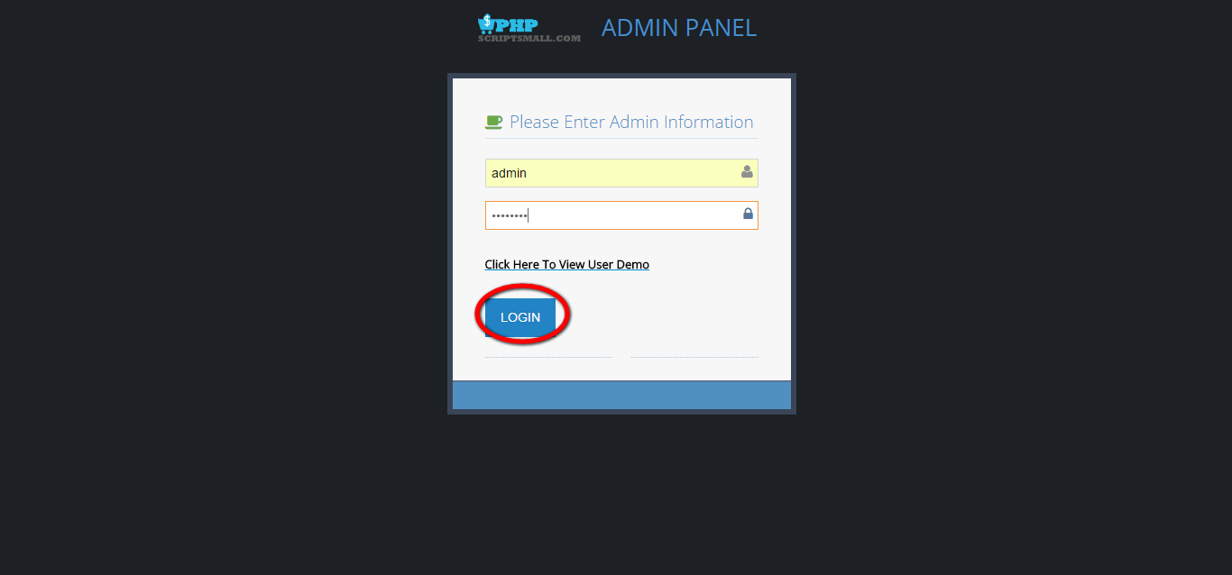
Description:
Admin can login via valid username and password.

Dashboard:
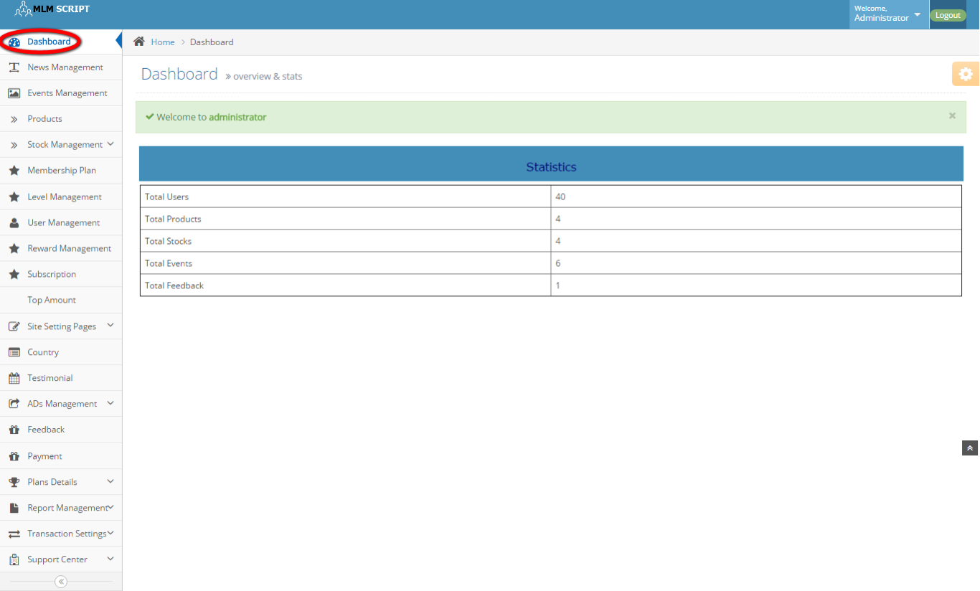
Description:
This page contains the recent activities of the user like count of users, products, stocks, events and feedback.

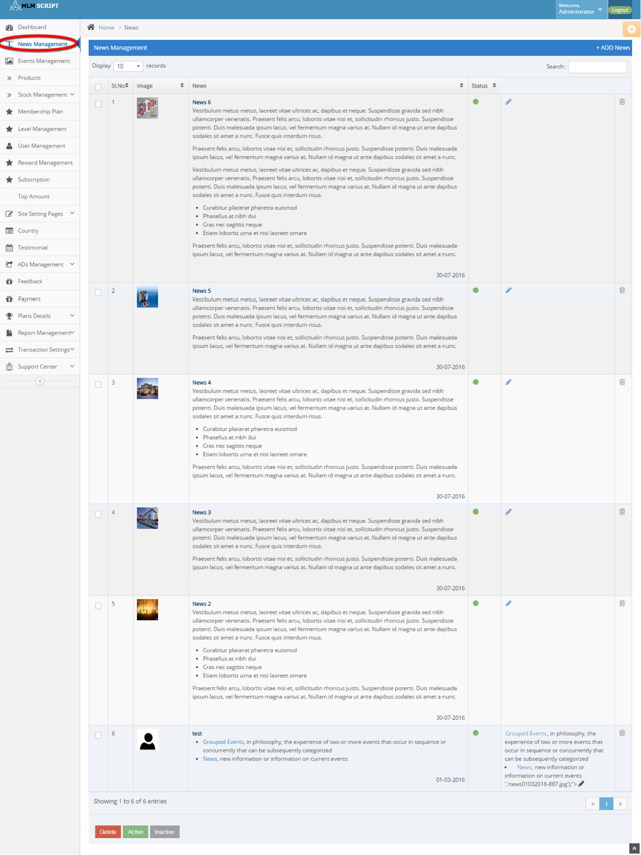
News management:
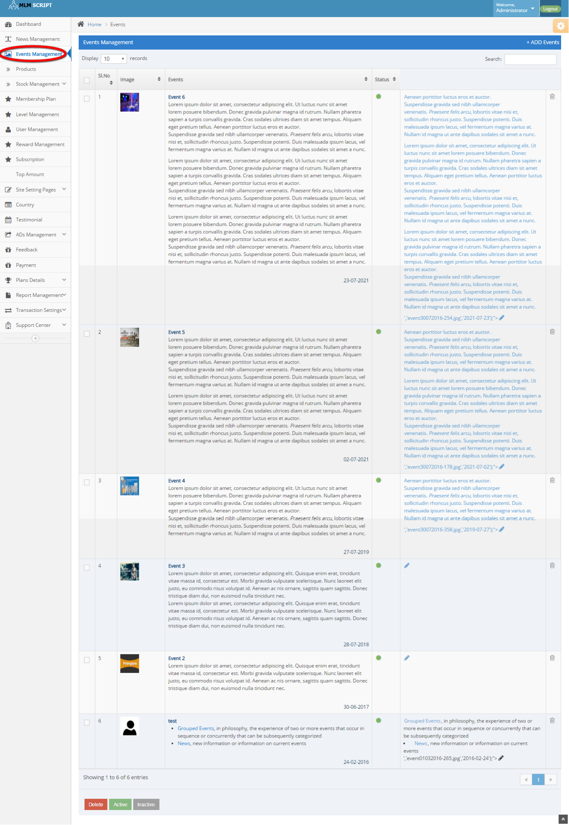

Description:
This page maintains the news details including delete, active and inactive options.

Discount price:
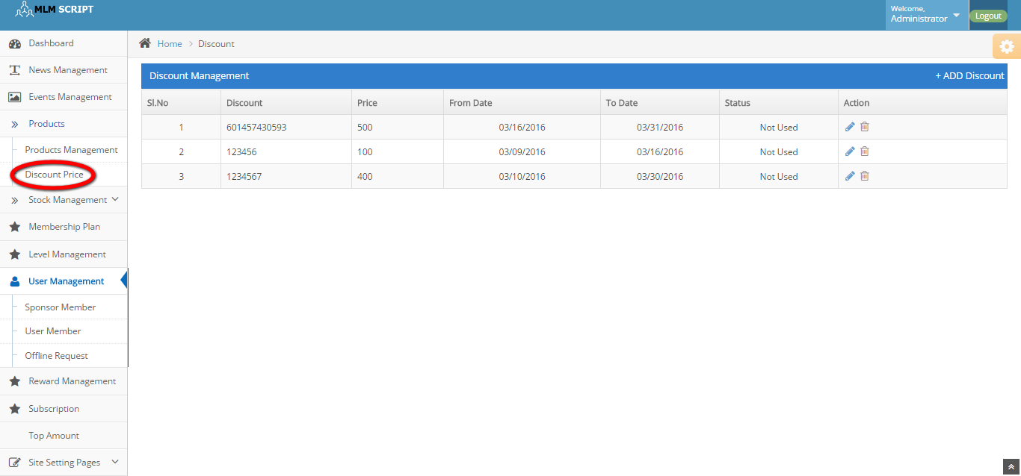
Description:
This page manages the discount details with price, date, status and action details.

Products management:

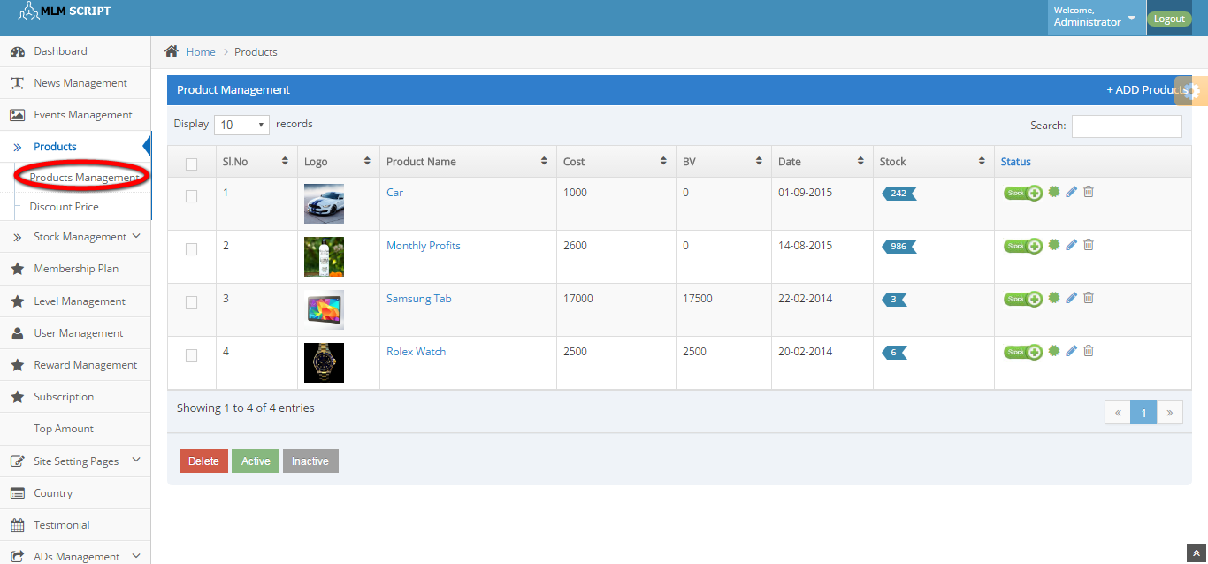
Description:
This page manages the product details like stock, date, cost, product name and status details.

Stock list:

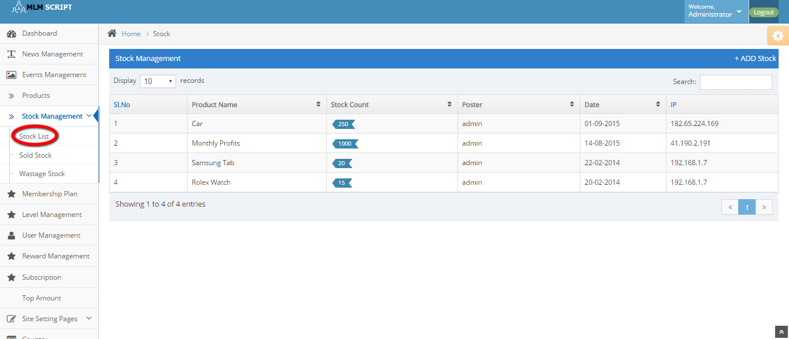
Description:
This page maintains the stock details like product name, stock count, poster, date and IP address details.
Wastage stock:
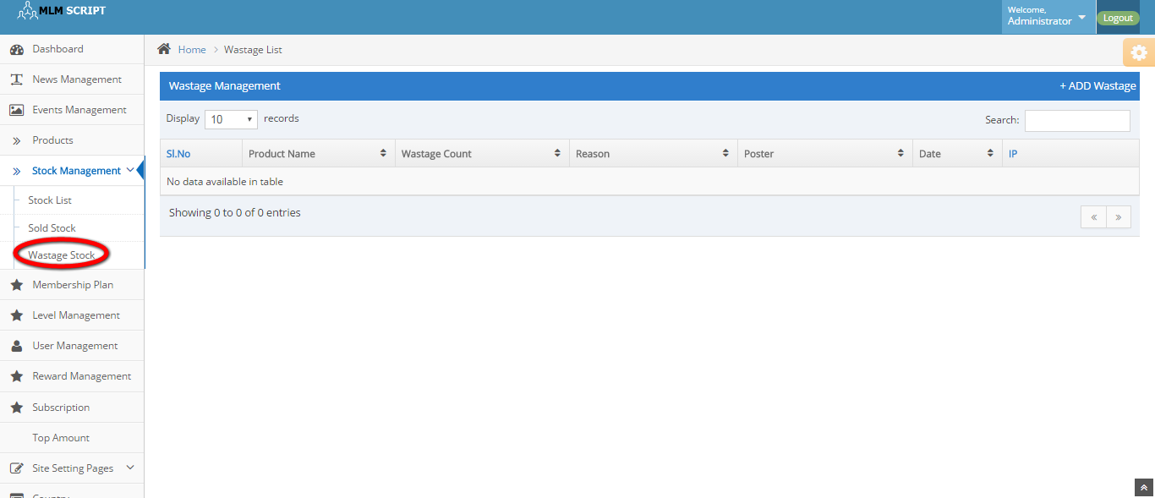
Description:
This page maintains the wastage stock details like product name, wastage count, reason, poster, date and IP address details.

Membership plan:
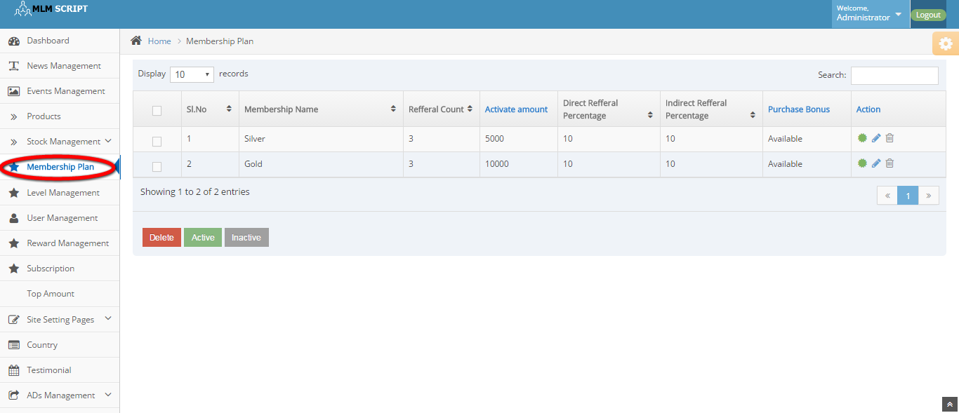
Description:
This page manages the membership plan details and can delete, active and inactive the plan details.
Level management:
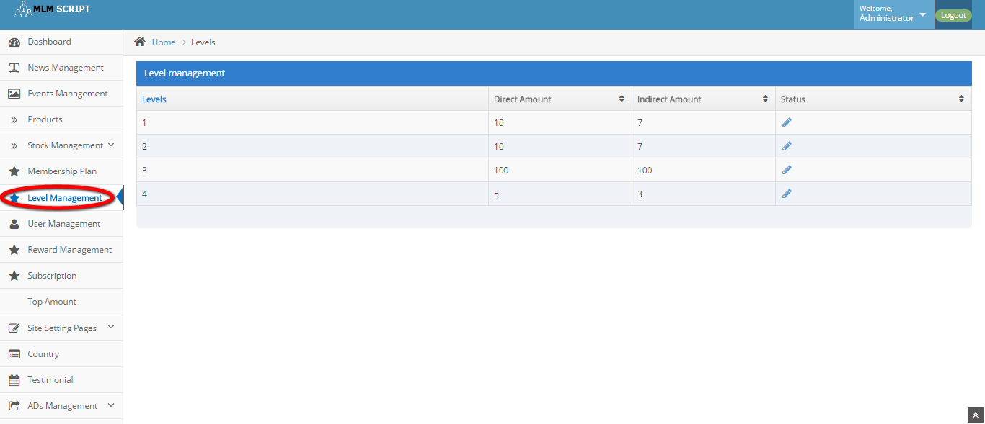
Description:
This page maintains the level details like direct amount, indirect amount and status details.

Sponsor member:

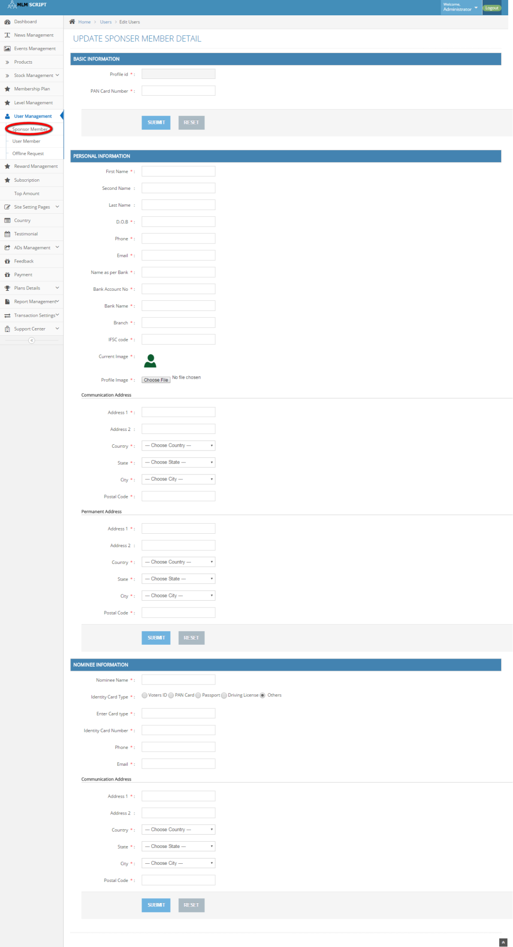
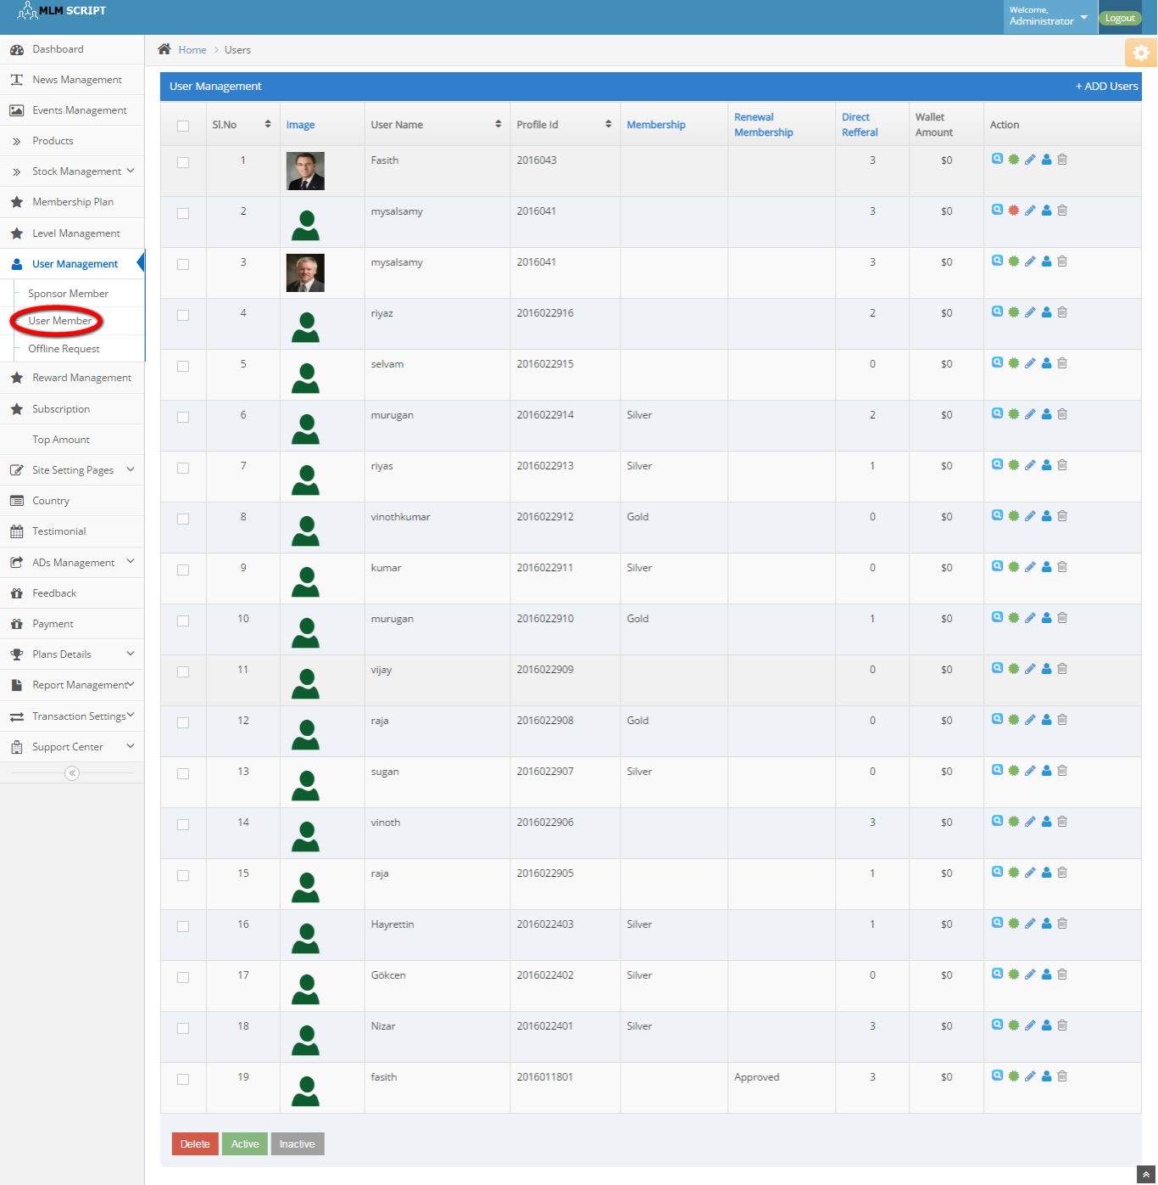
Description:
This page contains the update option for the sponsor member details with basic, personal and nominee information details.

Offline request:
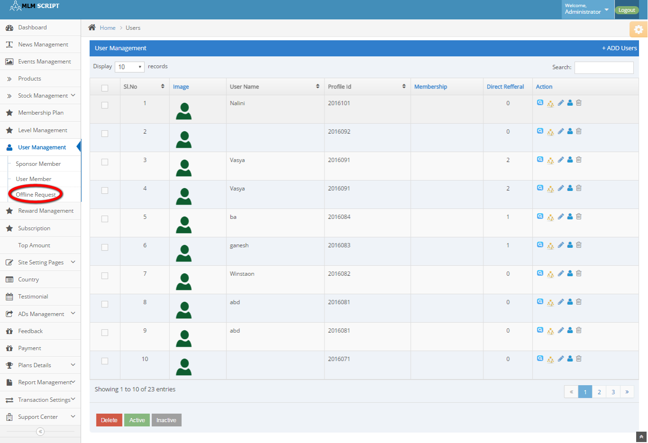
Description:
This page contains the offline request details with maintains the user name, profile id, membership, direct referral and action details.

Subscription:
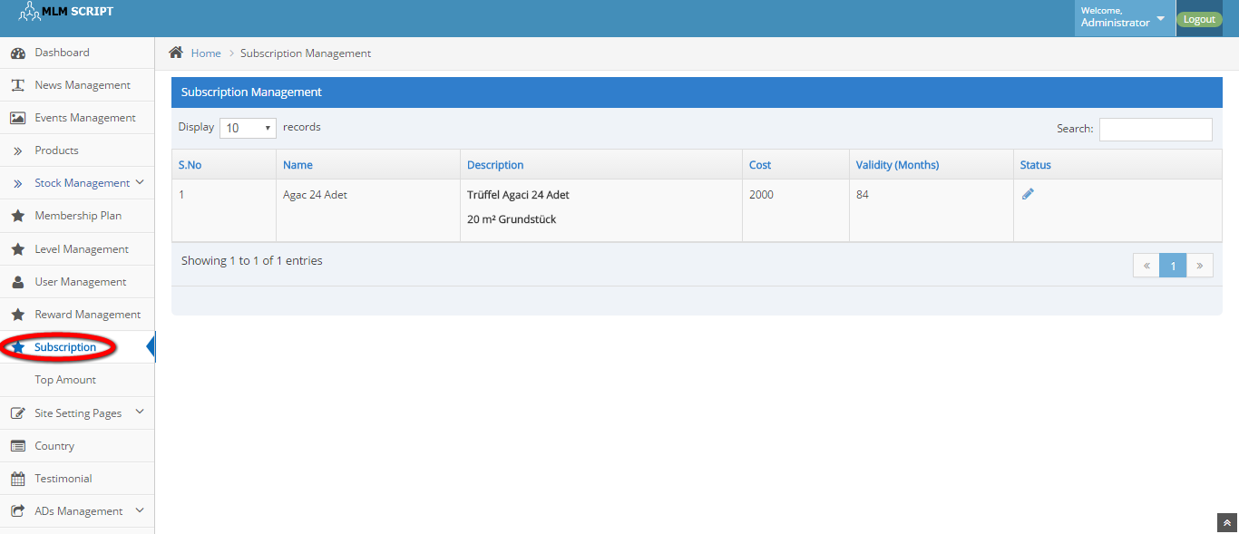
Description:
This page manages the subscription details like name, description, cost, validity and status details.
Top amount:
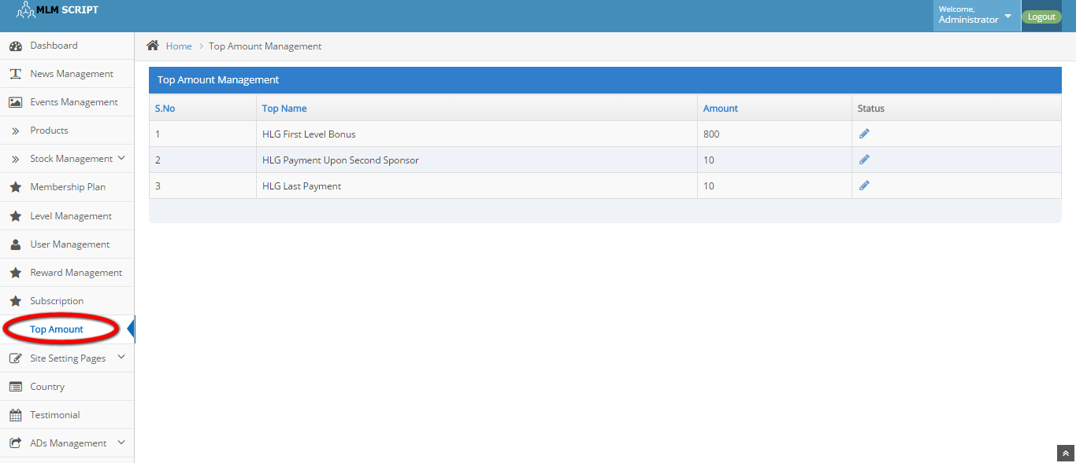
Description:
This page contains the top payable details in increasing order by amount details.

Reward management:

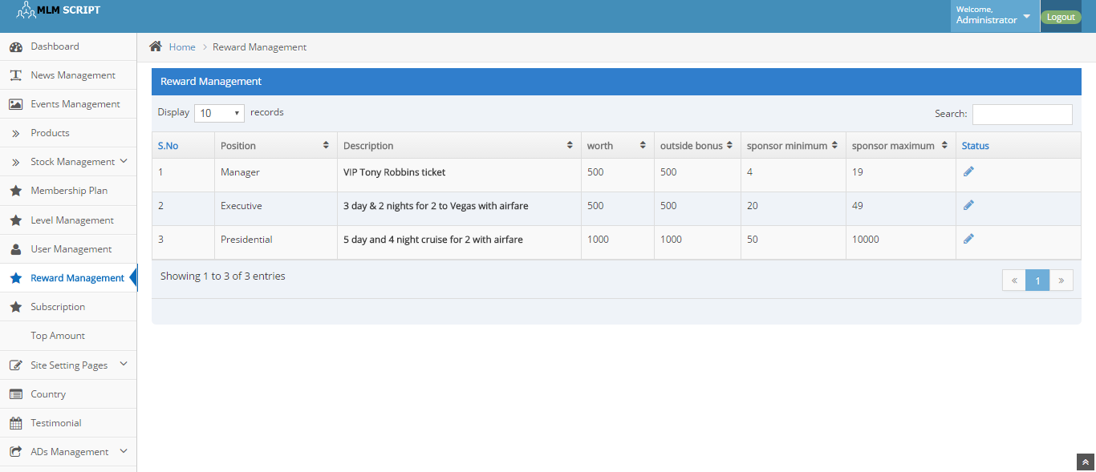
Description:
This page maintains the reward details like worth, outside bonus, sponsor minimum, sponsor maximum and status details.

CMS:
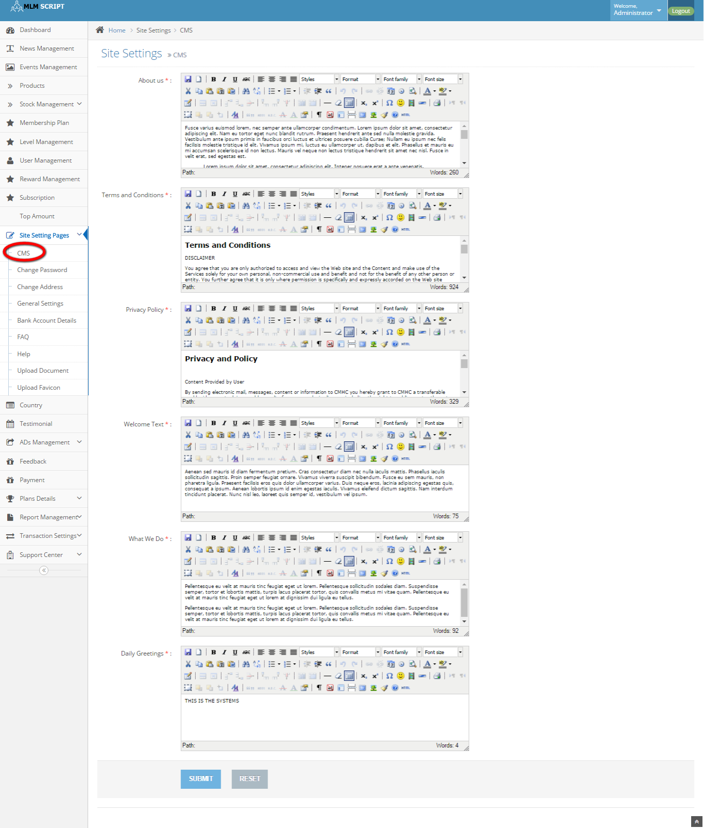
Description:
This page maintains the content of the CMS page.

Change password:
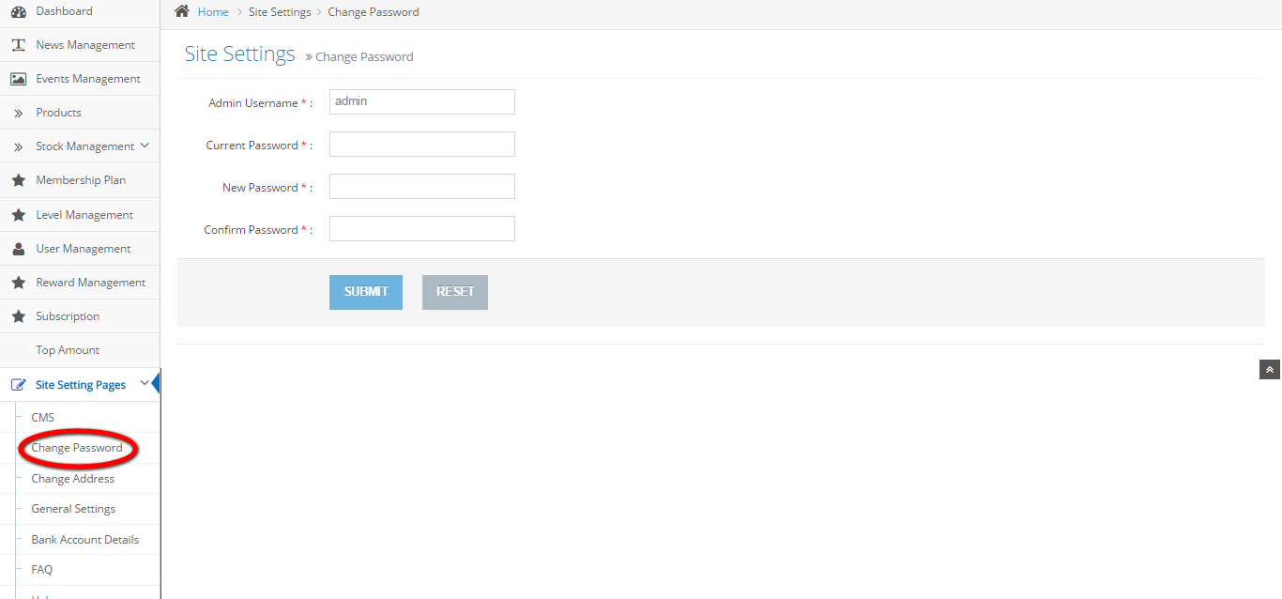
Description:
This page contains the option of change the admin password.

Change admin:

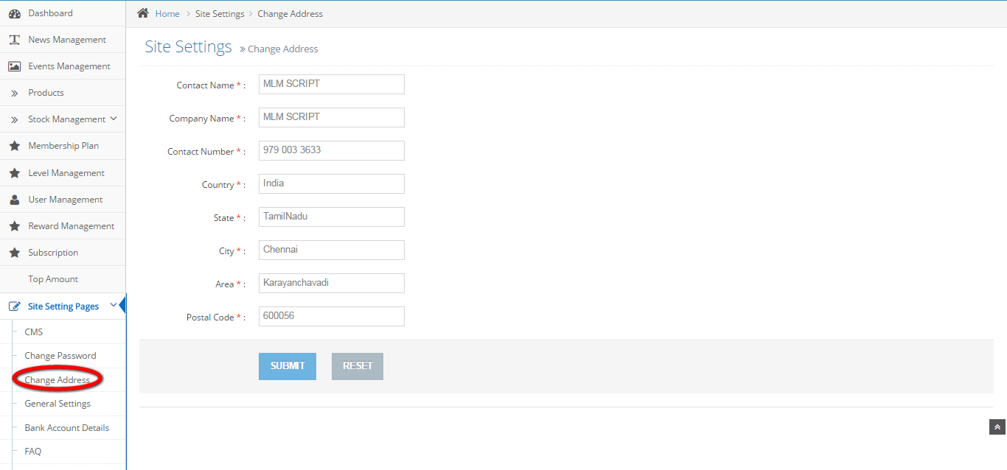
Description:
This page contains the option of change admin details.

General settings:
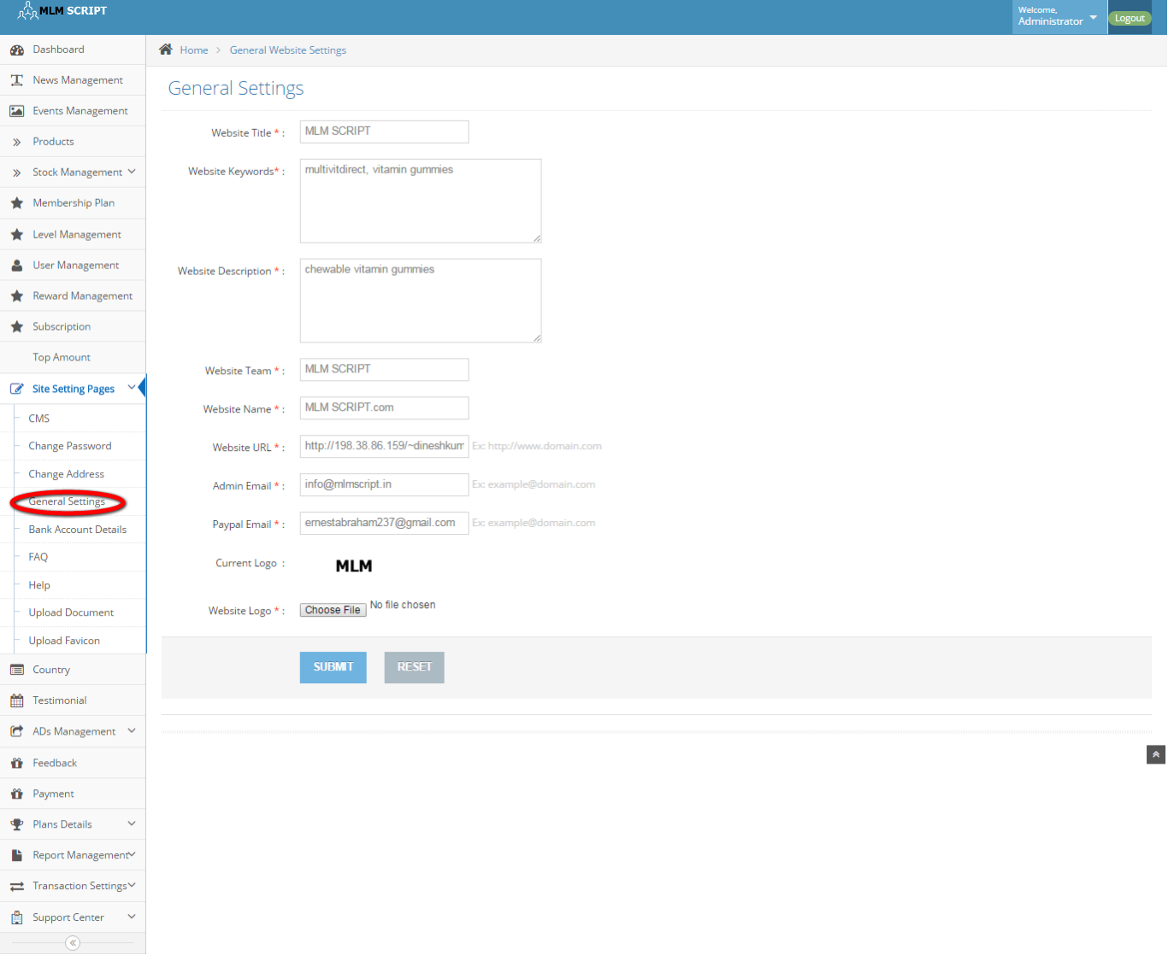
Description:
This page maintains the entire general settings like website title, keywords, description, team, name, URL, admin and PayPal Email details, logo details and website logo details.

Bank account details:
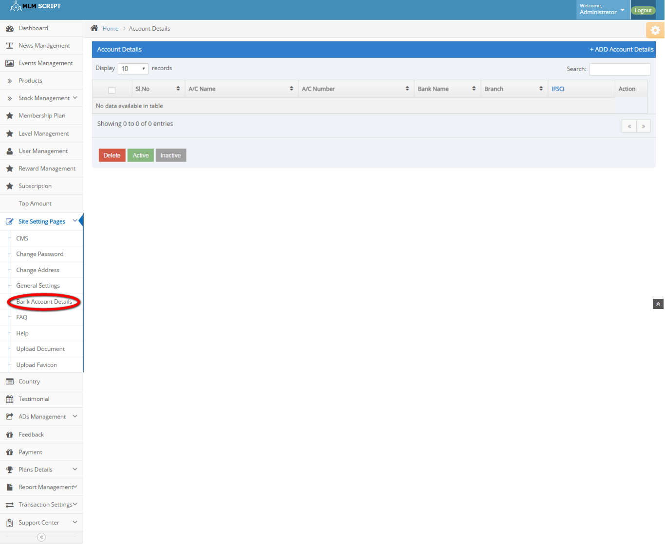
Description:
Admin can manage the bank account details like account name, number, bank name, branch and IFSCI code and action details.

FAQ:
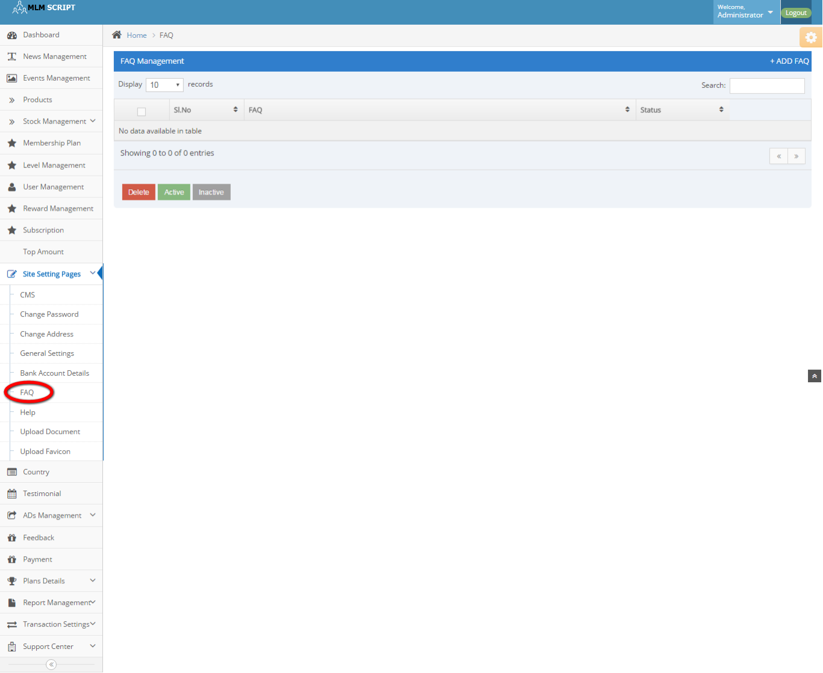
Description:
This page manages the FAQ details.

Help:
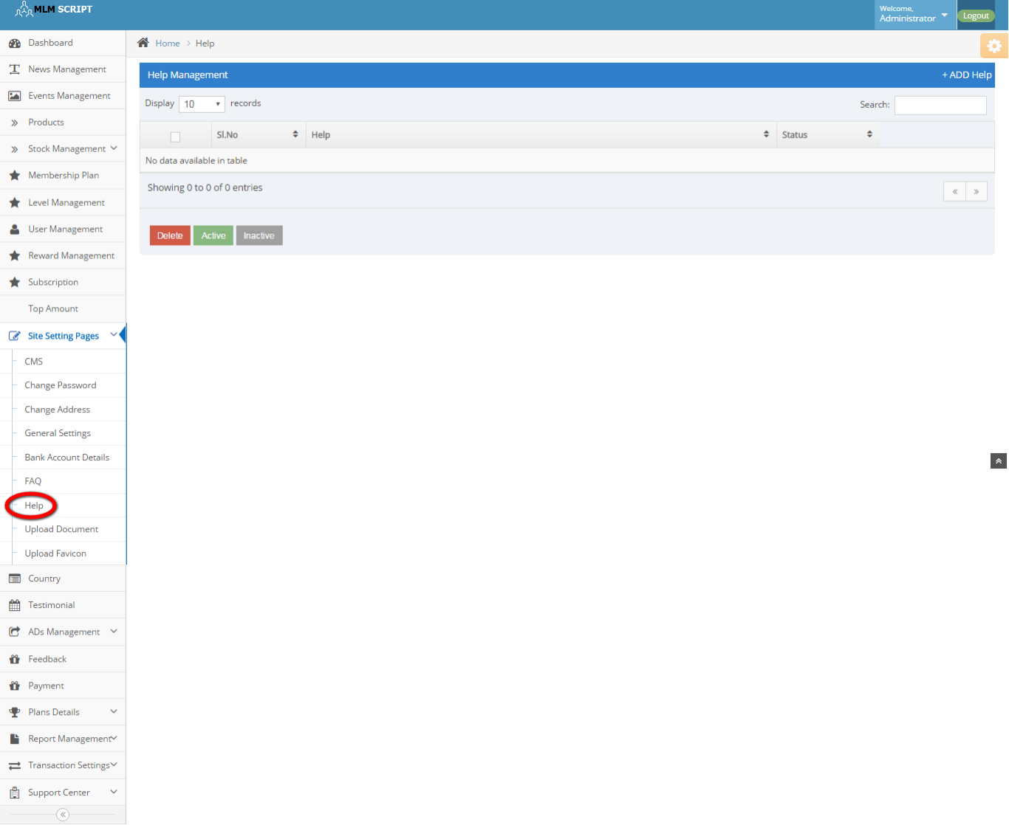
Description:
This page manages some help options.

Upload document:
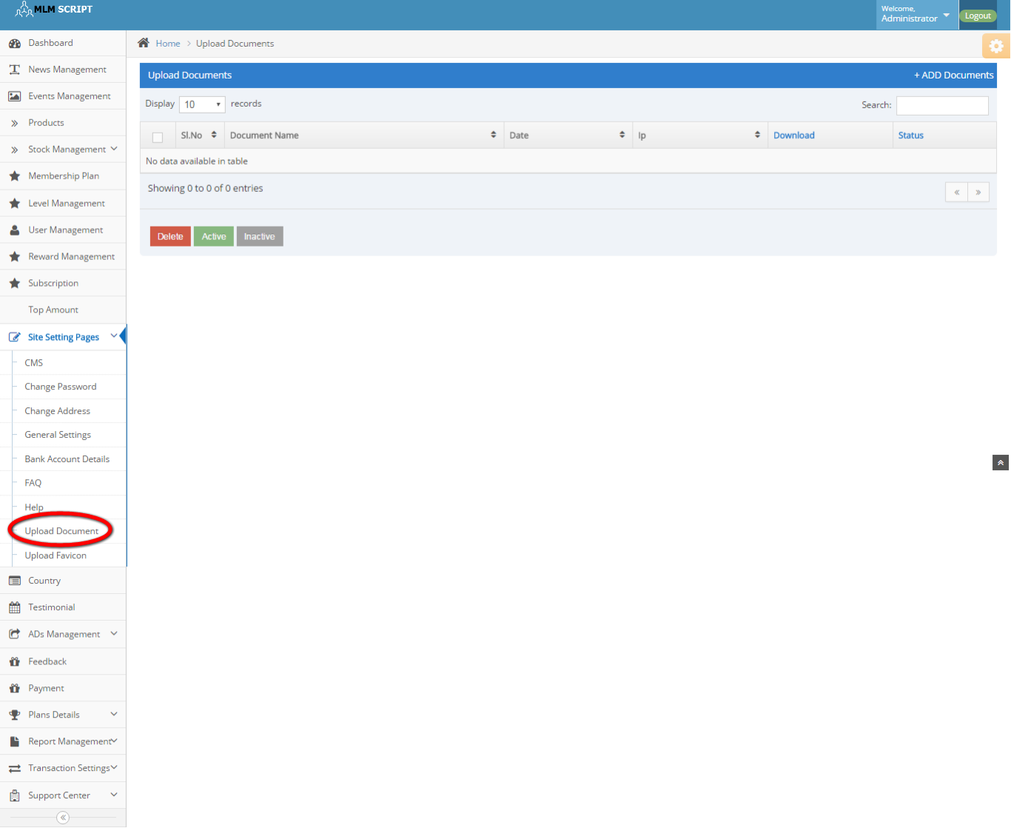
Description:
Admin can upload any document via this page and manage the details like delete, active and inactive details.

Upload favicon:
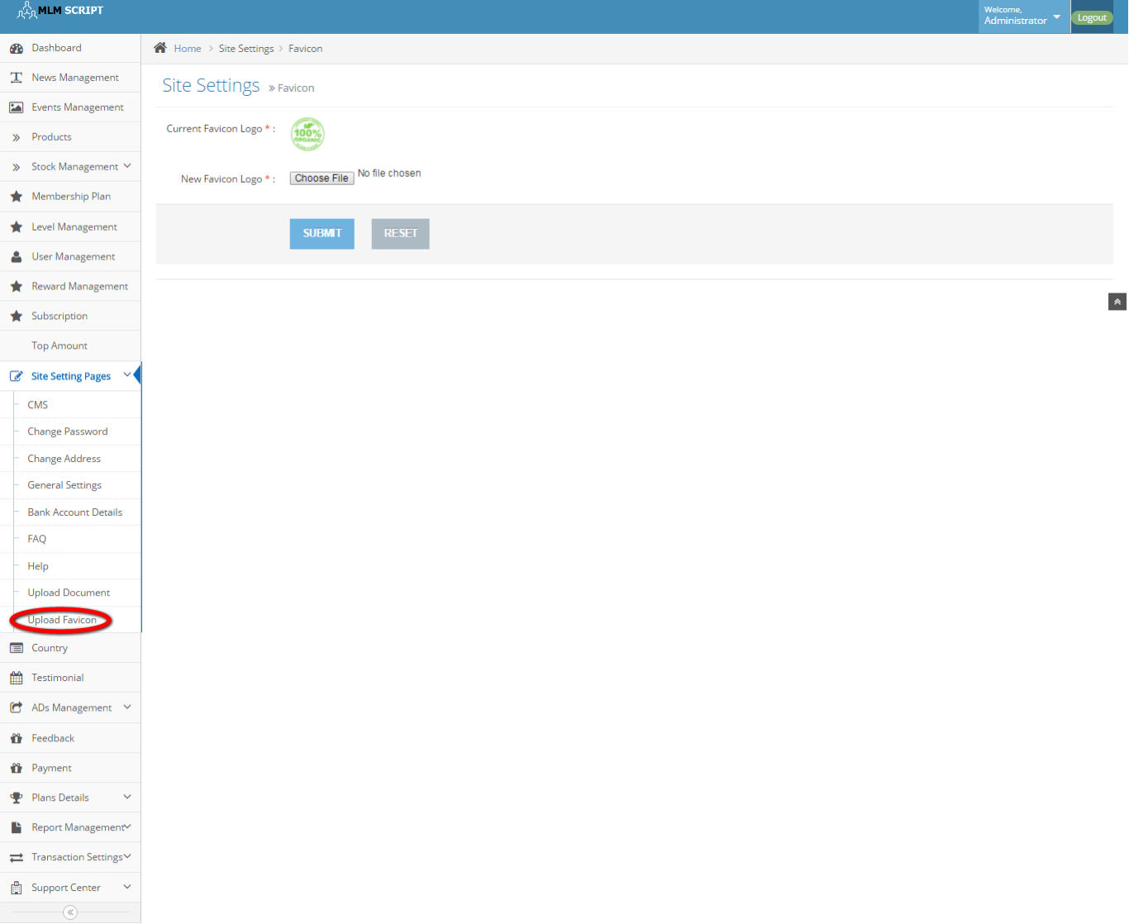
Description:
This page contains the option of upload the favicon.

Country:
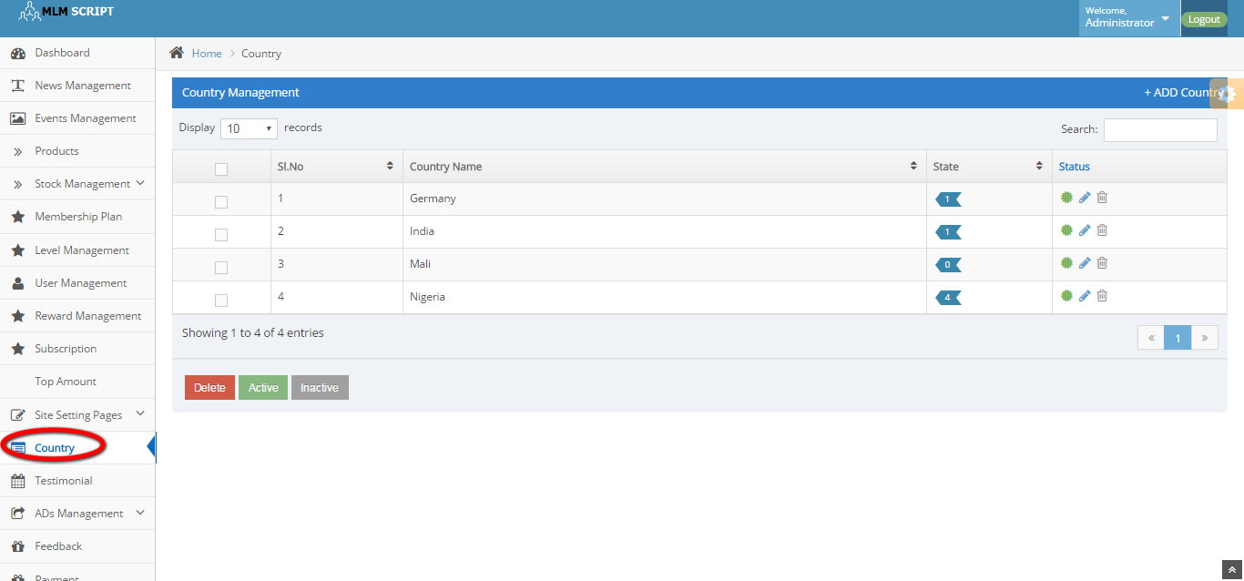
Description:
This page contains the entire country details with state and can manage it bydelec=te, active and inactive.

Testimonial:
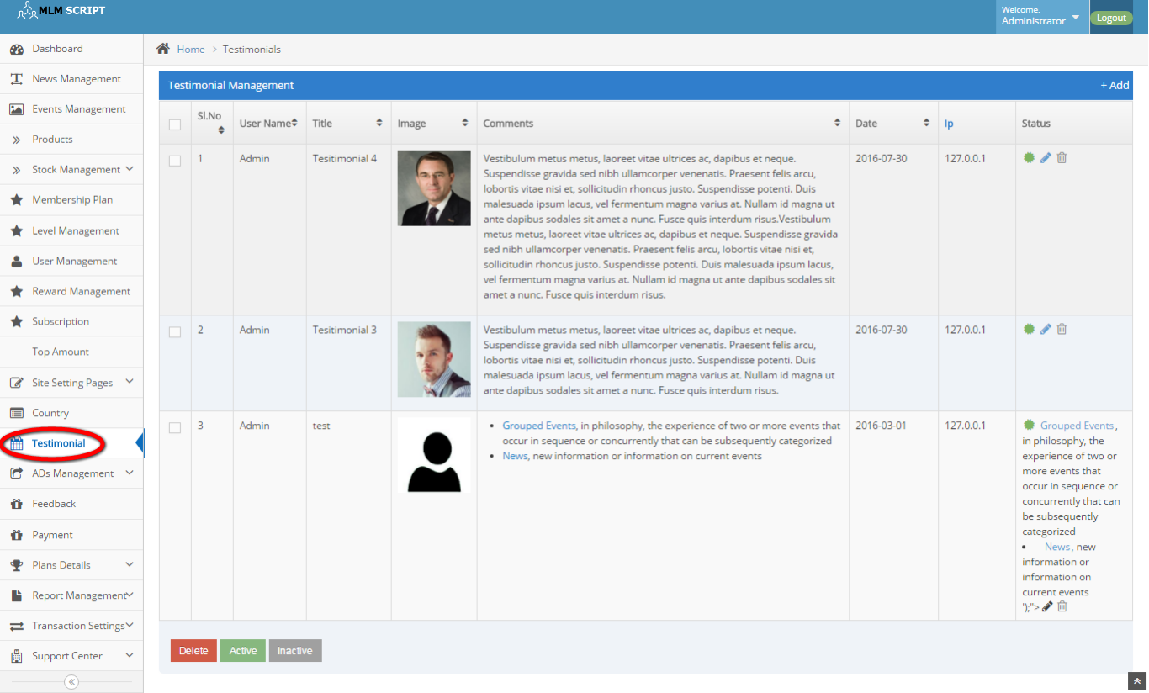
Description:
This page contains the entire testimonial details and manages by delete, active and inactive options.

Banner ads:
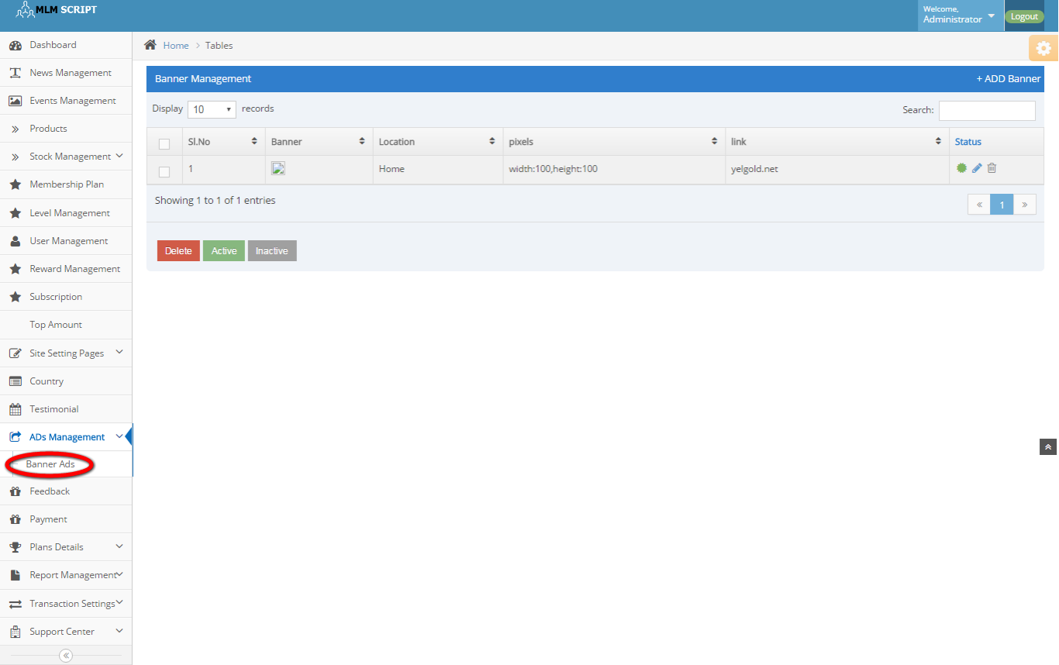
Description:
This page contains the banner ads details with location, pixel size, link and status details.

Feedback:
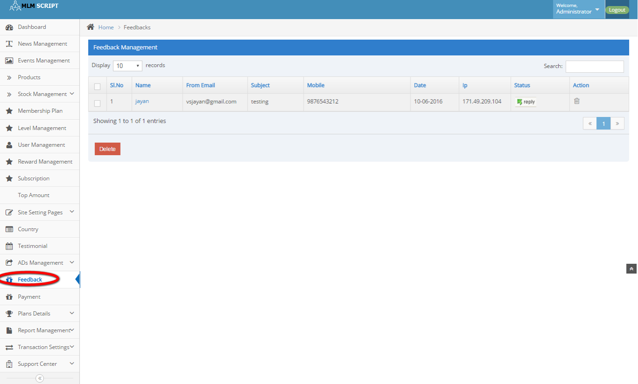
Description:
This page consists of name, subject, contact details, date, IP, status and action details.

Payment:
Description: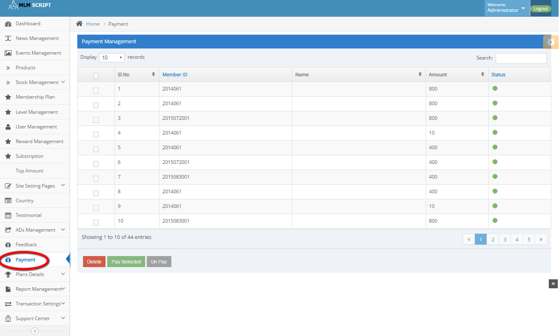
Description:
This page contains the entire payment details with member ID, Name, amount and status details.

General plan details: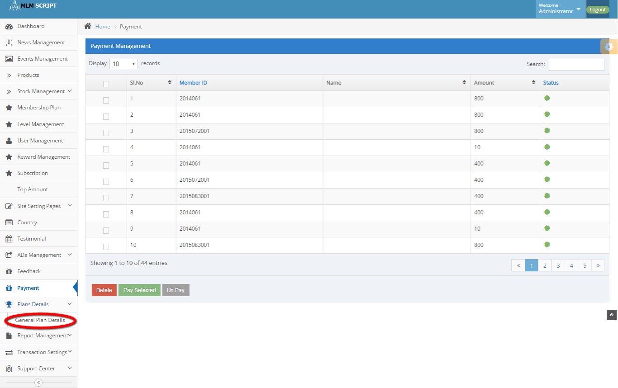
Description:
This page contains the plan details that subsists of minimum withdrawal amount, maximum withdrawal amount and Tax percentage details.

Active members:
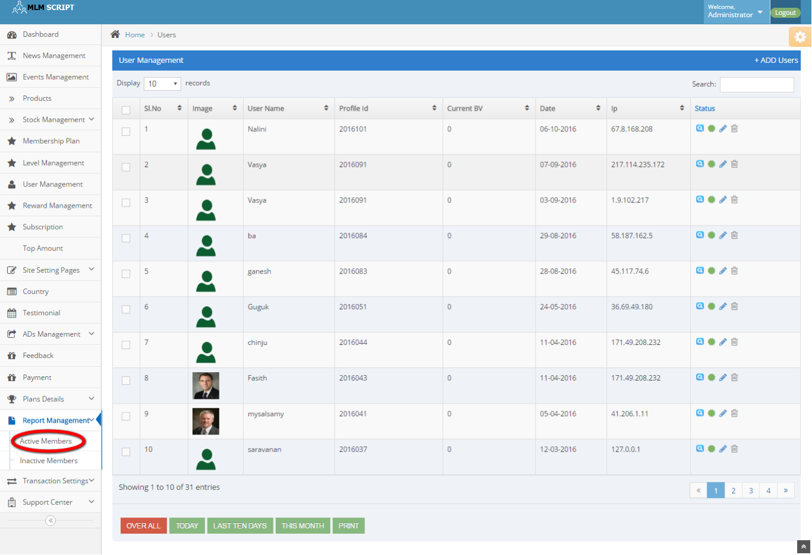
Description:
This page contains the active members detail.

Inactive members:
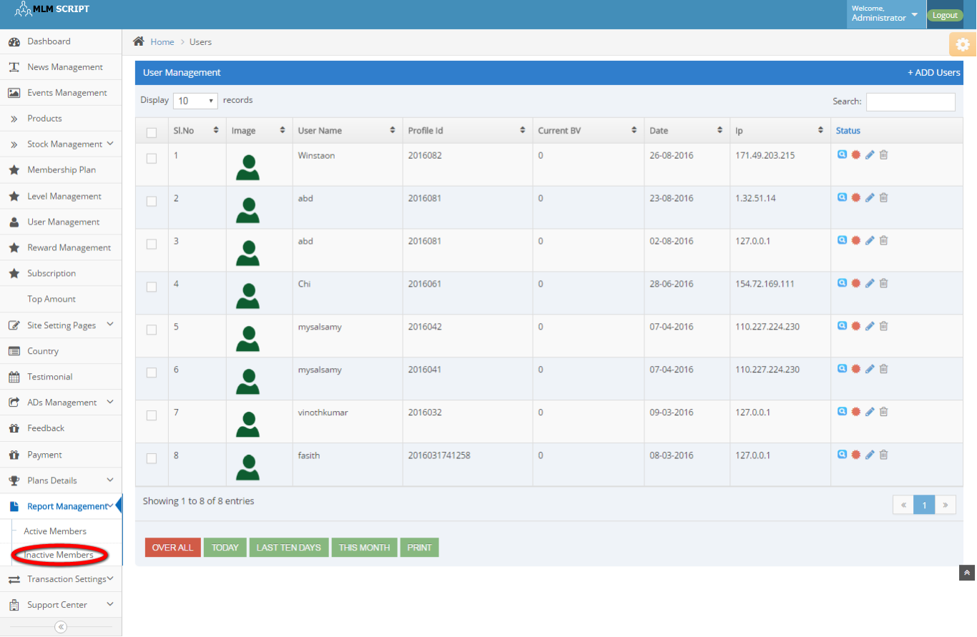
Description:
This page contains the inactive members details.

User withdraw request:
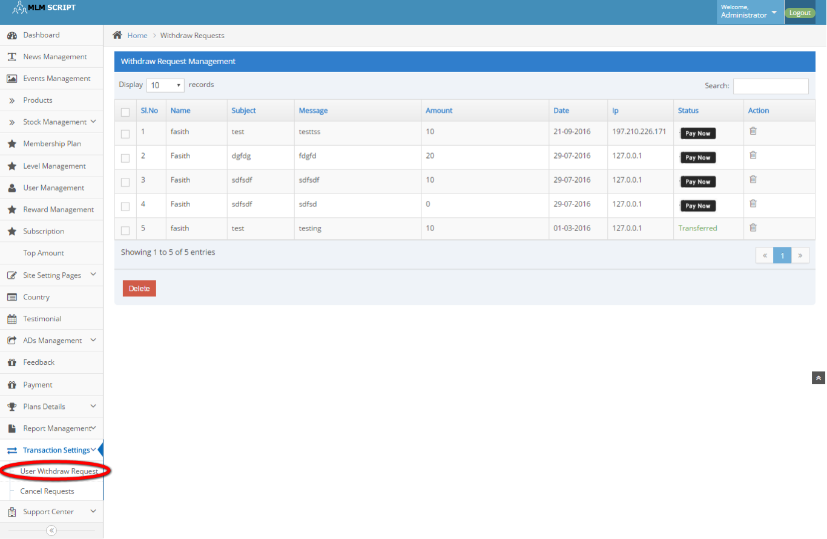
Description:
This page contains the entire withdraw details as amount date, name, message, subject IP, status and active details.

Cancel request:

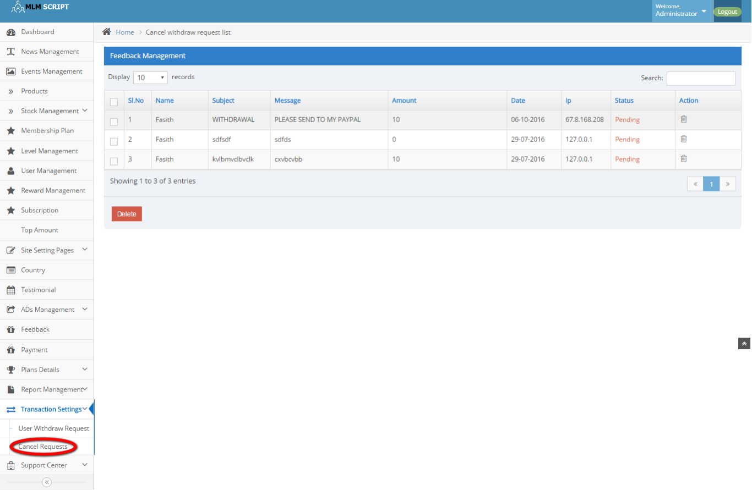
Description:
This page contains the canceled request details.

Support centre:
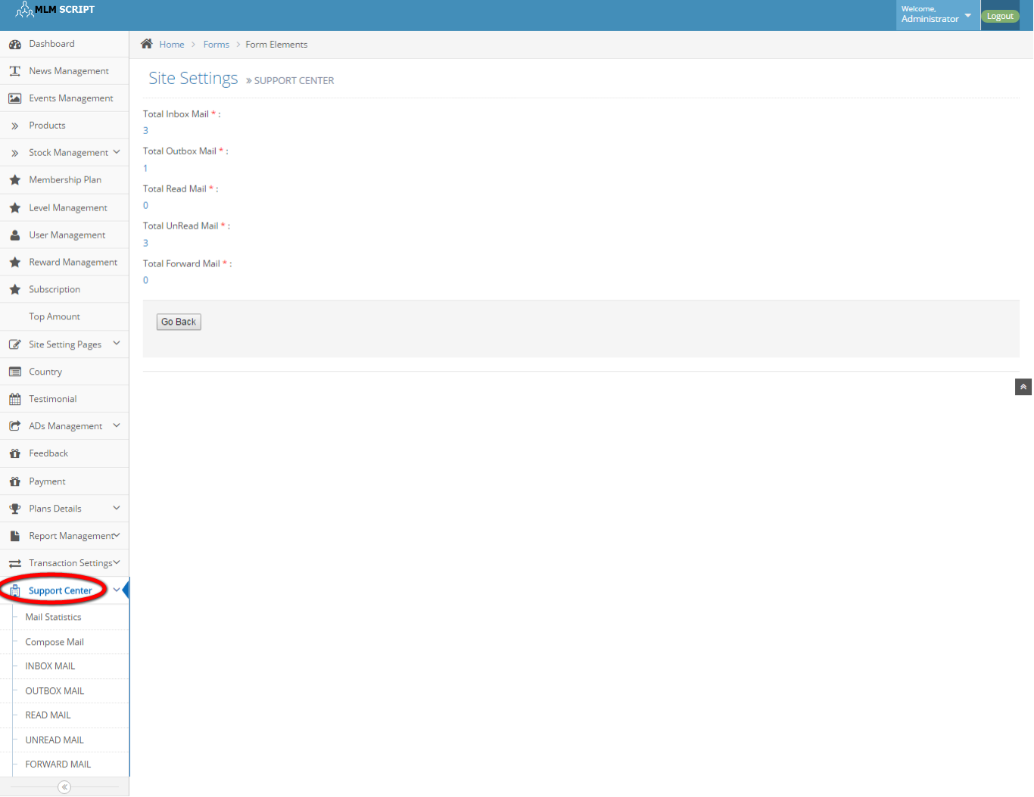
Description:
This page maintains the entire mailing system including mail statistics, compose mail, inbox and outbox mail, read and unread mail, forward mail details.

