THREE IN ONE JOB PORTAL
Theme option
Image slider:
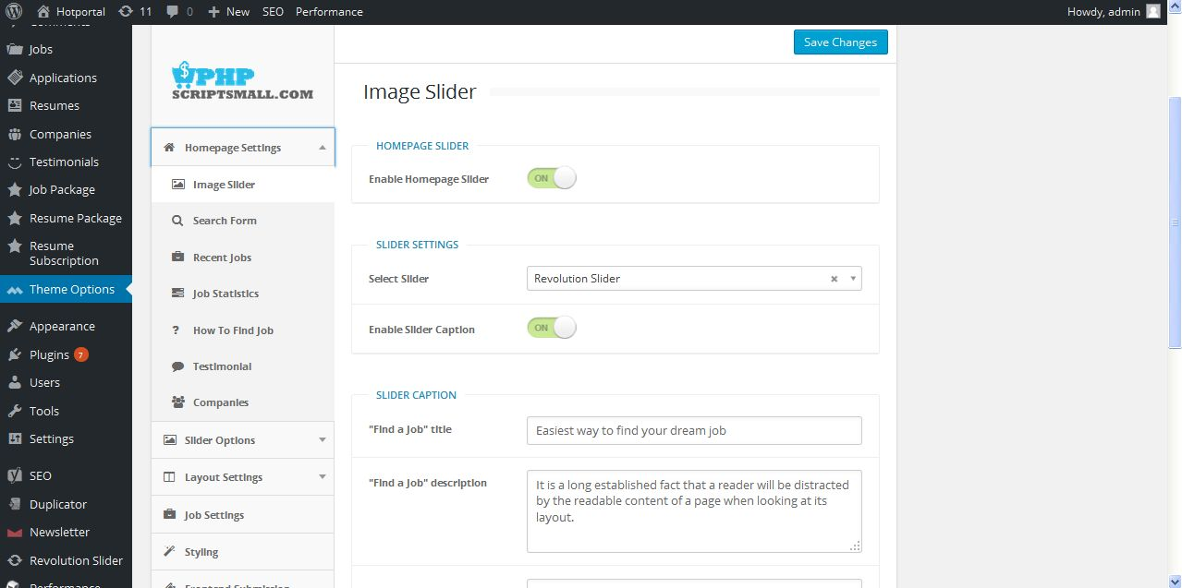
Description:
Admin can manage home page slider layout settings

Search form:
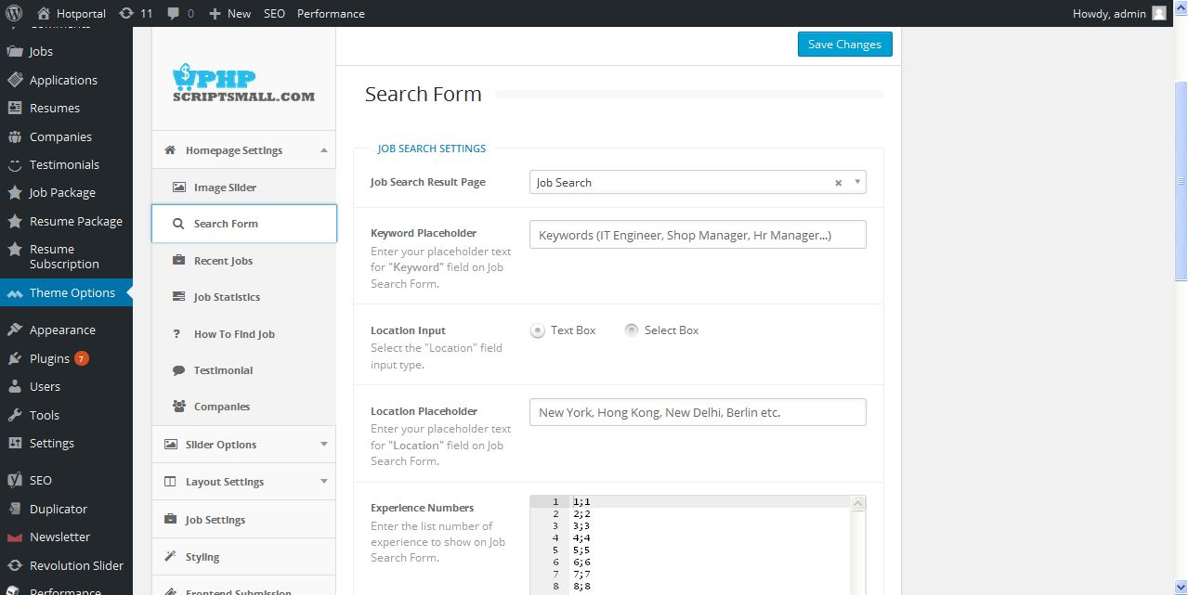
Description:
Admin can manage search form layout settings

Recent job:
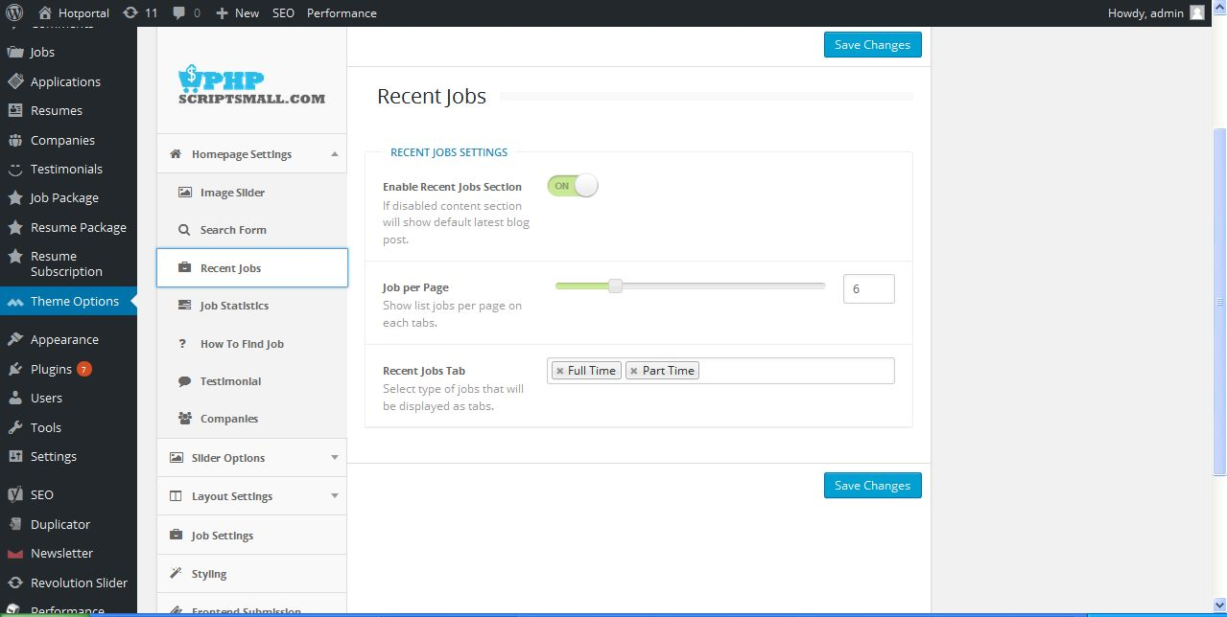
Description:
Admin can manage layout of recent job page settings

Job statistics:
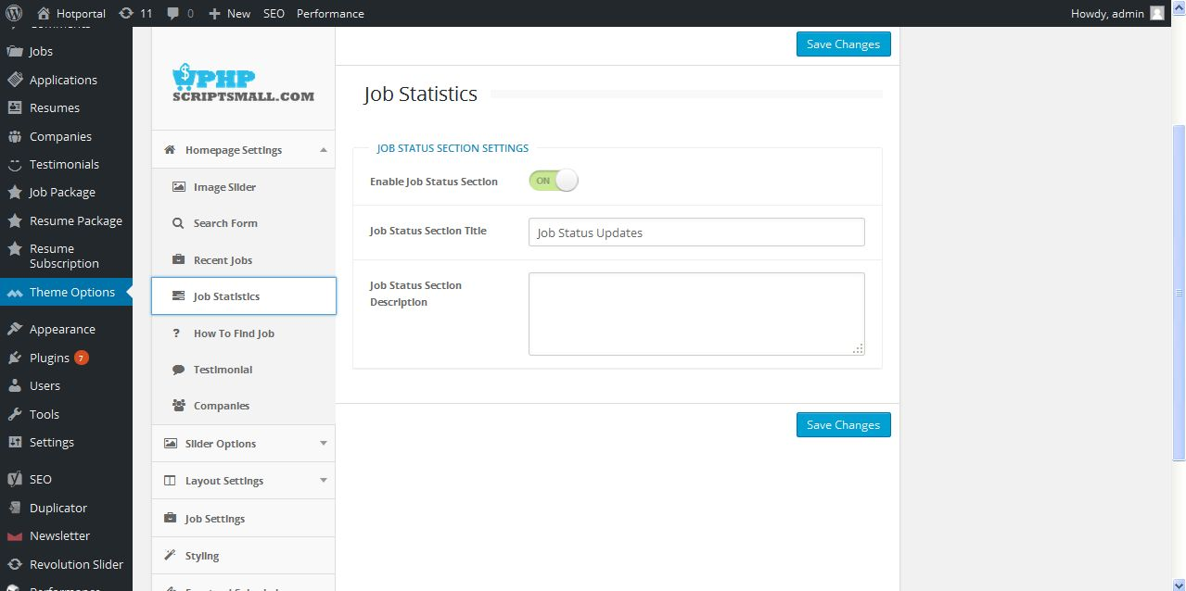
Description:
Admin can manage job statistics layout settings

How to find a job:
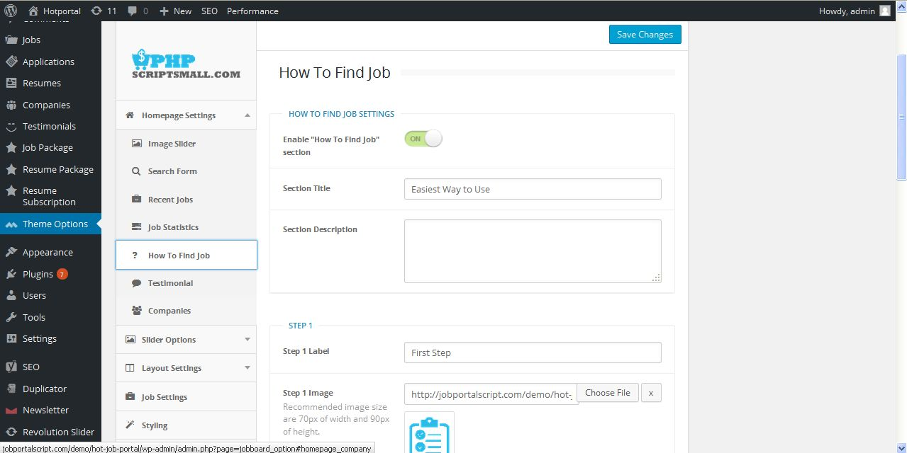
Description:
Admin can manage how to find job page layout settings

Testimonials:
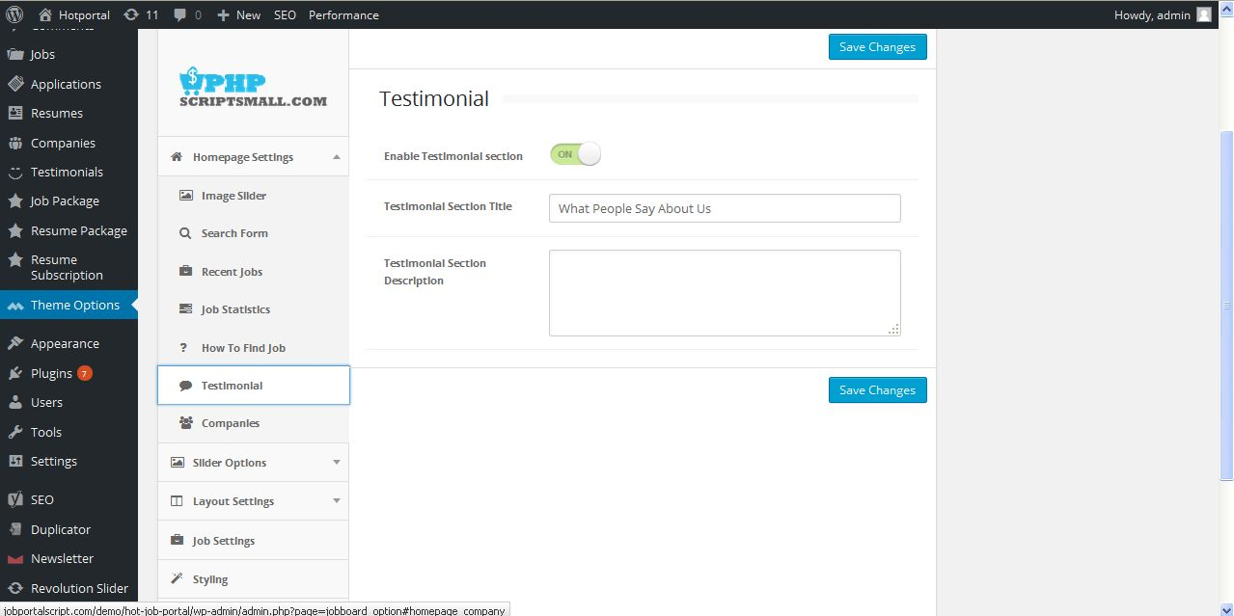
Description:
Admin can manage testimonials page layout settings

Companies:
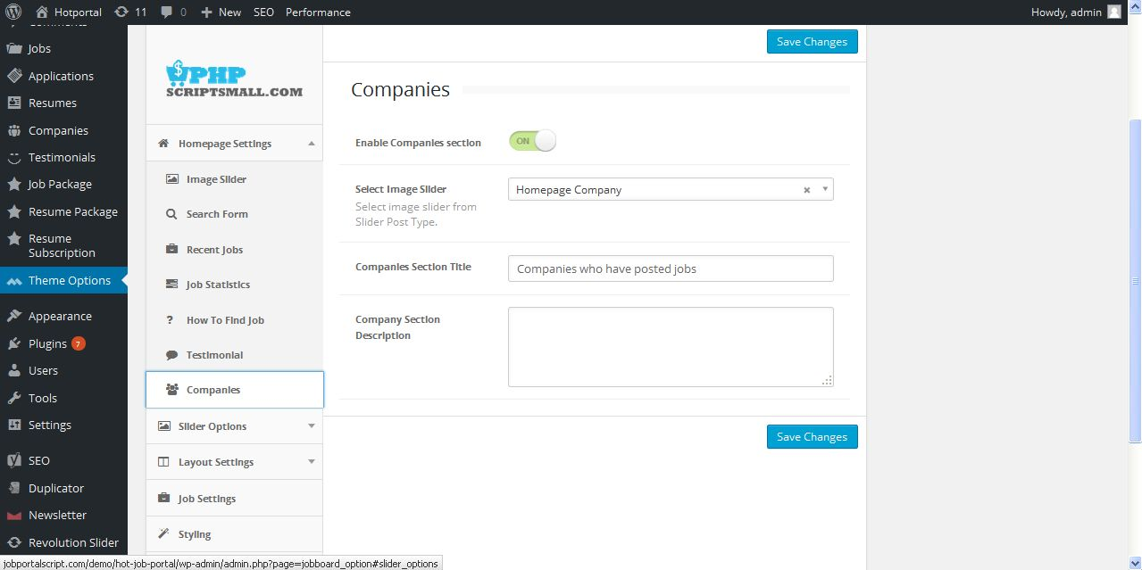
Description:
Admin can manage company page layout settings

Slider
Default:
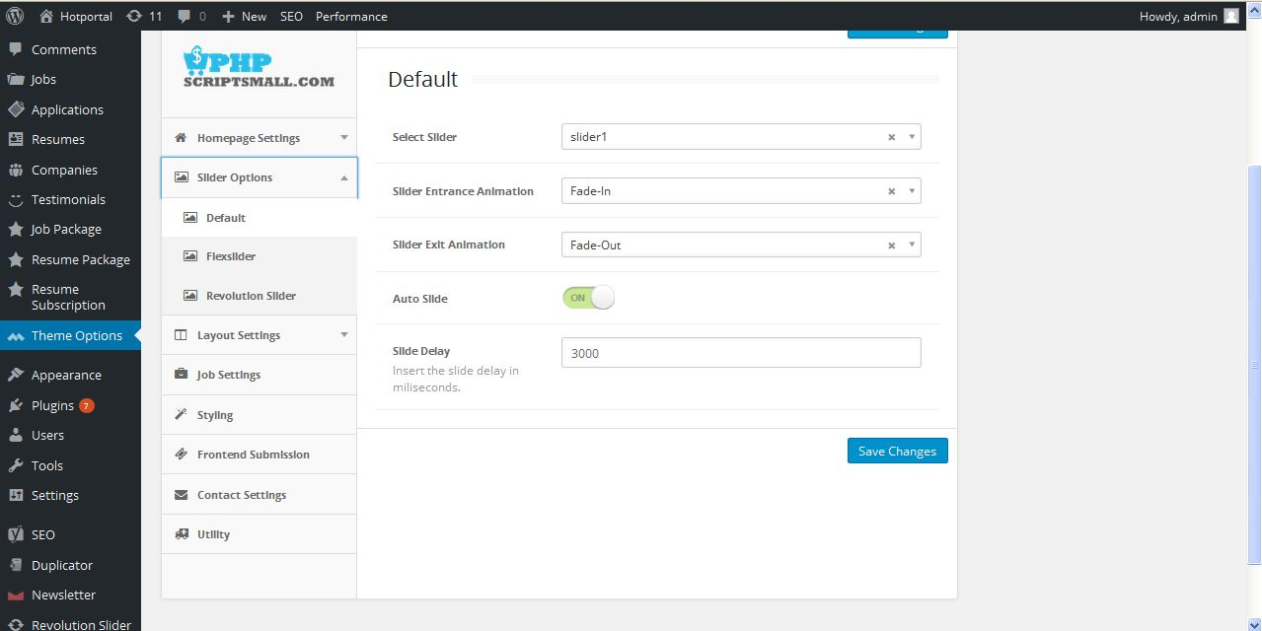
Description:
Admin manage slider default settings

Flex slider:
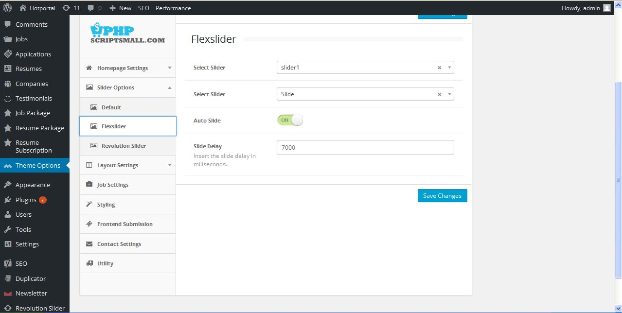
Description:
Admin manage flex slider settings

Revolution slider:
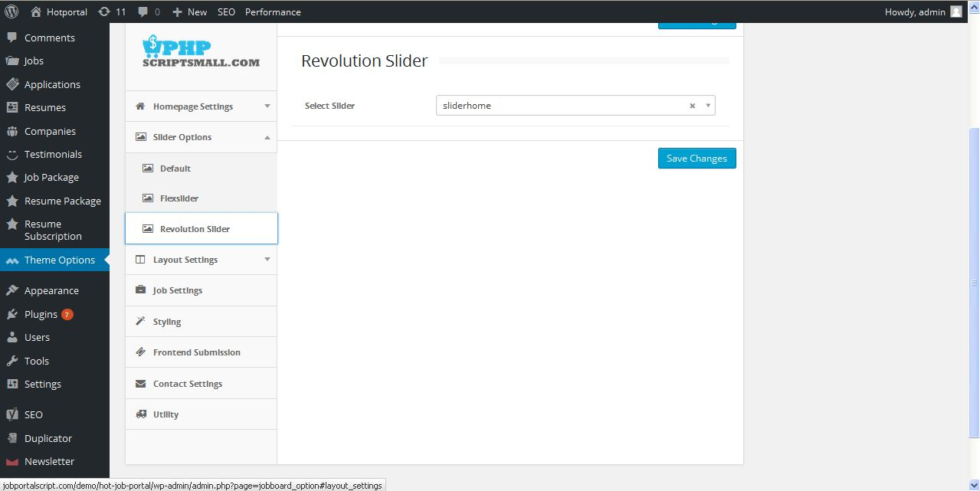
Description:
Admin manage revolution slider settings

Header layout:
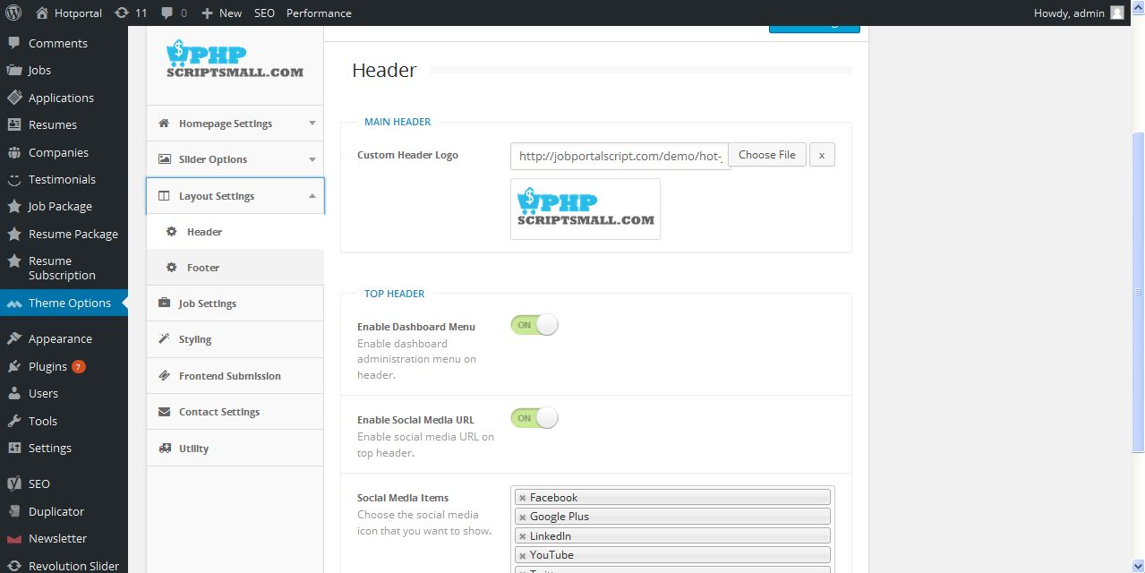
Description:
Admin manage header layout settings

Footer:
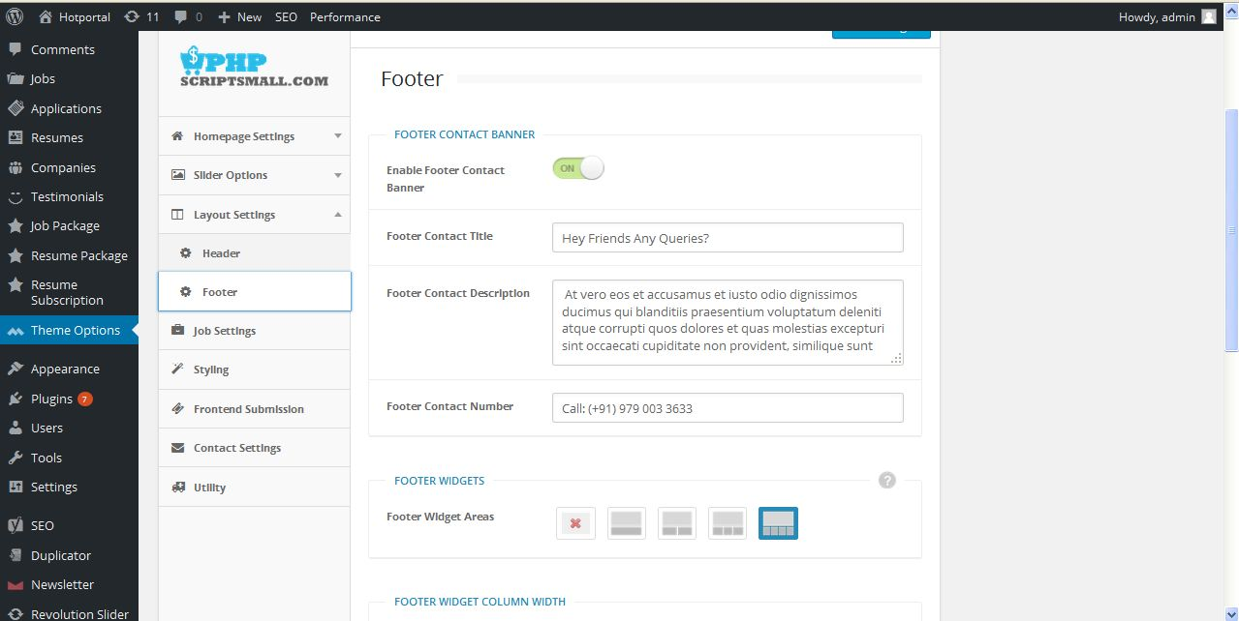
Description:
Admin manage footer layout settings

Job setting:
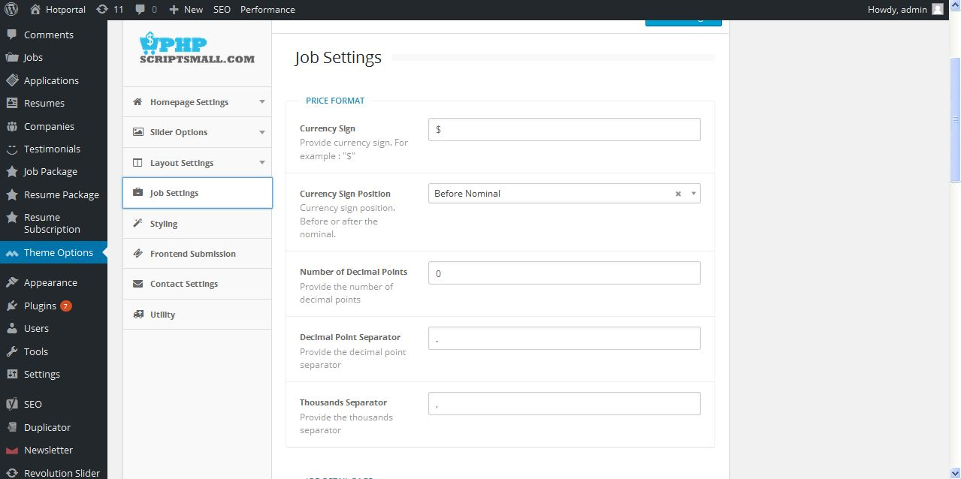
Description:
Admin manage job settings currency type and section buttons color settings

Styling:
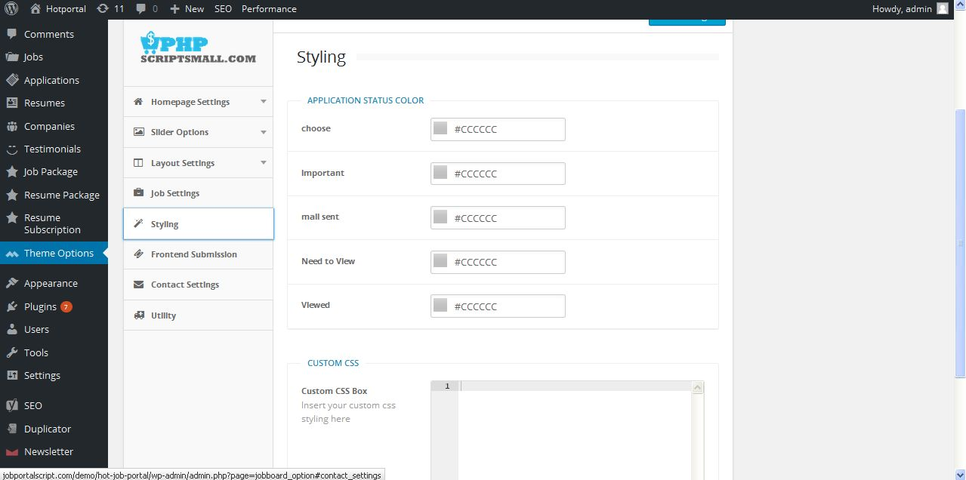
Description:
Admin manage application status color settings

Submission page:
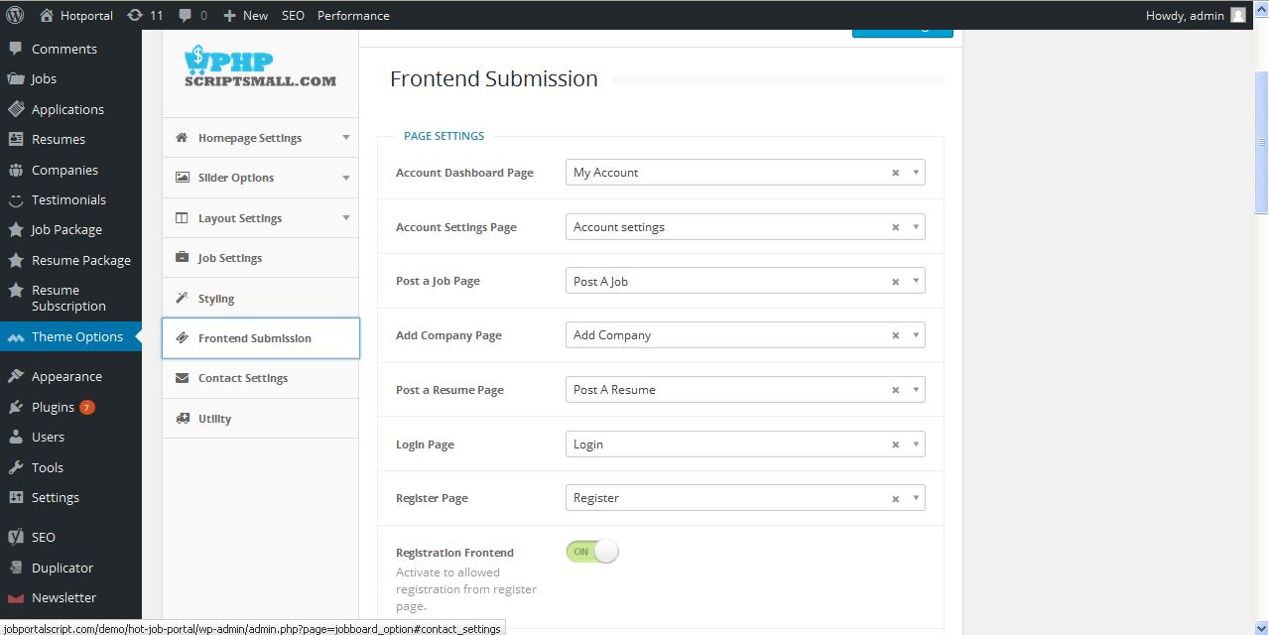
Description:
Admin manage frontend allocated page setup

Contact setting:
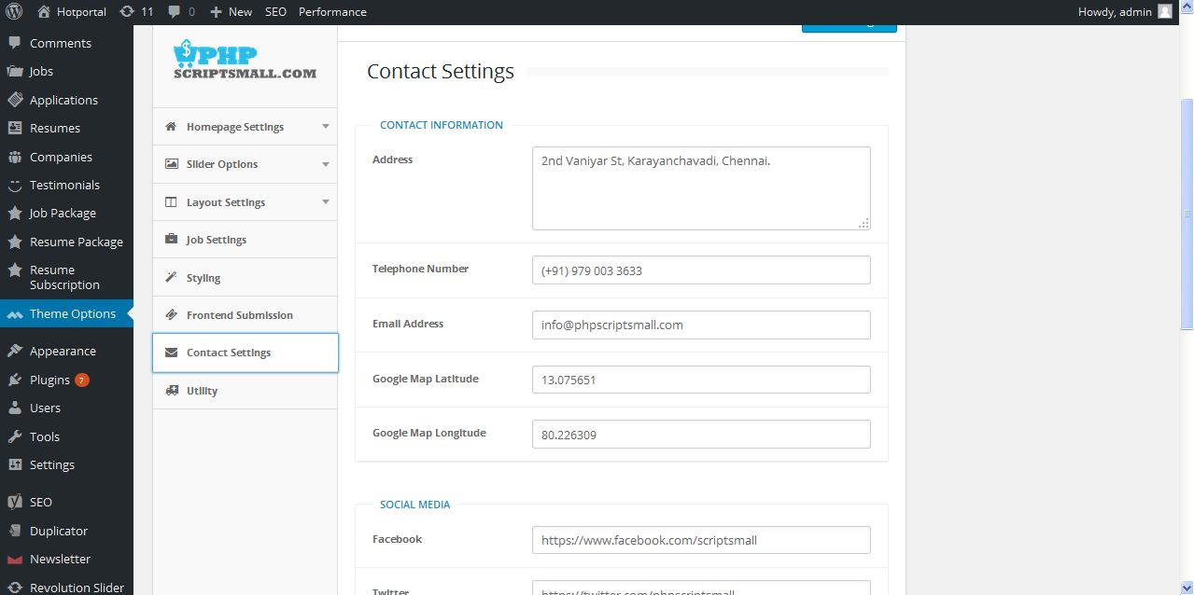
Description:
Admin manage settings of contact page

Utility:
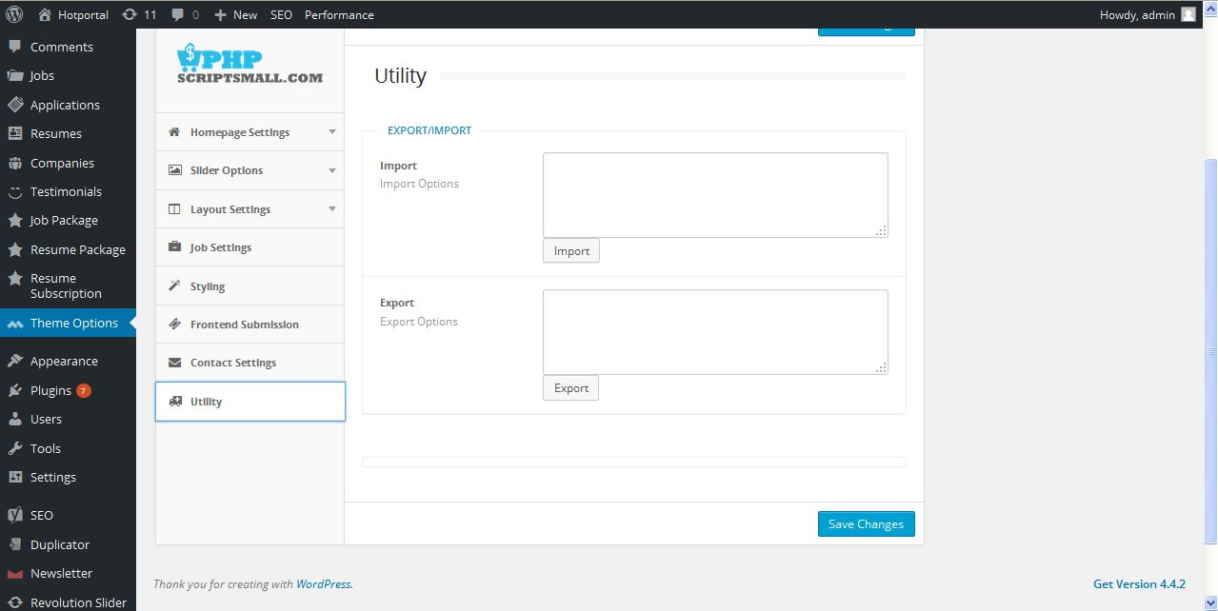
Description:
Admin can import and export theme details with supported file

Appearance
Theme:
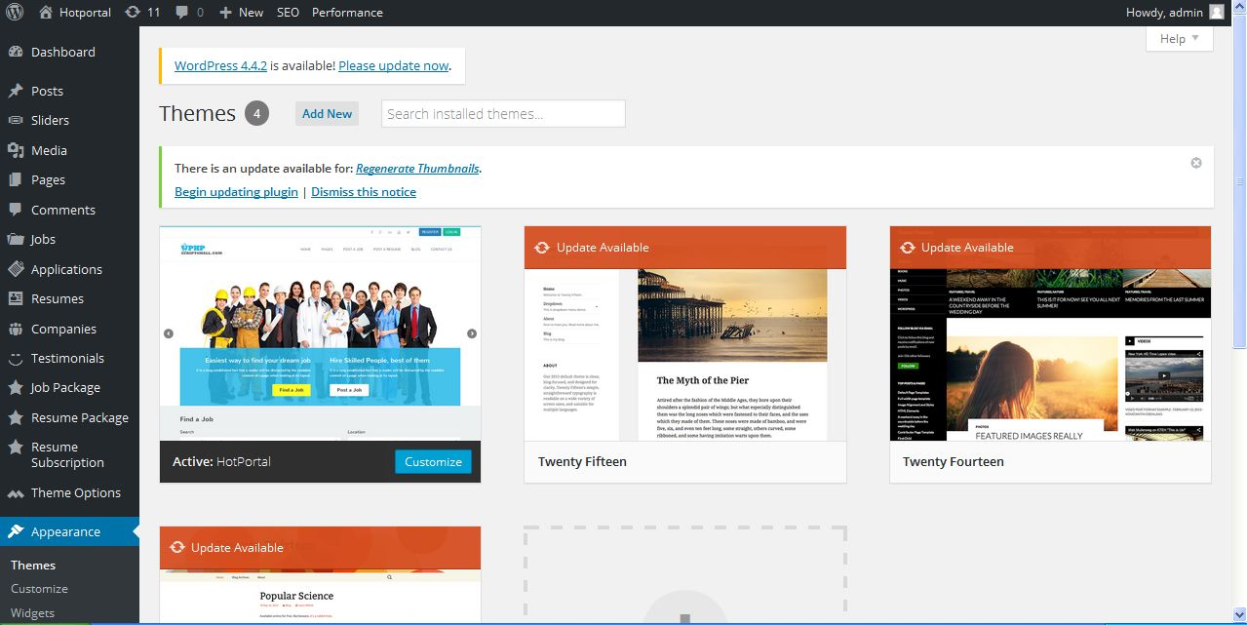
Description:
Admin can manage and change their theme style

Customization:
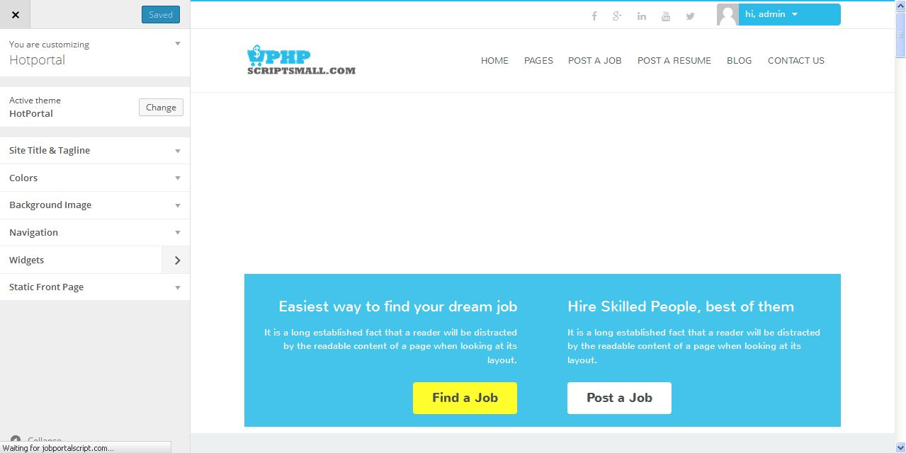
Description:
Admin can view customization options

Site title and tagline:
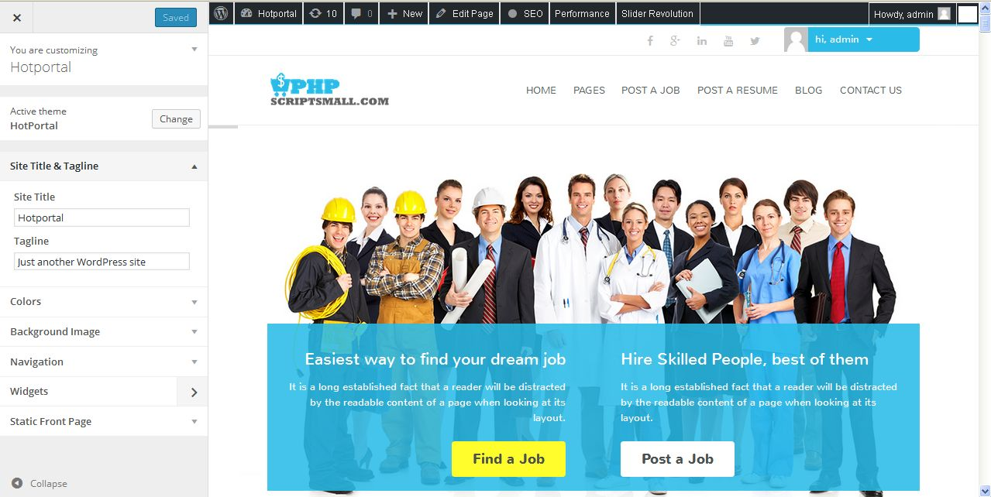
Description:
Admin can manage their site title and tagline

Color:
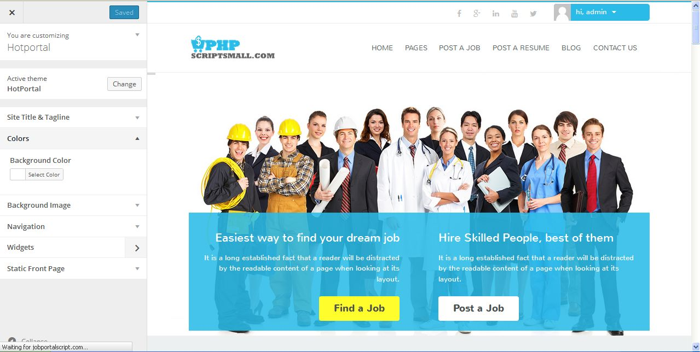
Description:
Admin can change and manage their site color

Background image:
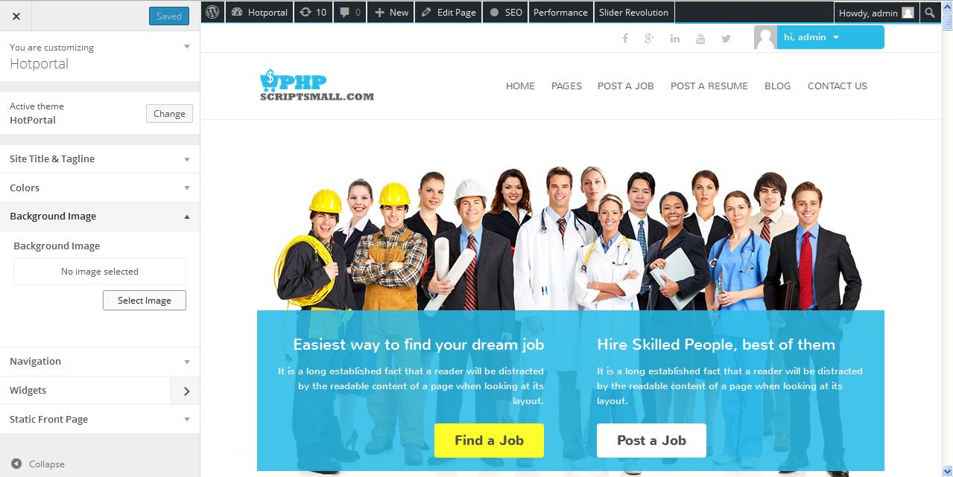
Description:
Admin can manage their background image

Navigation:
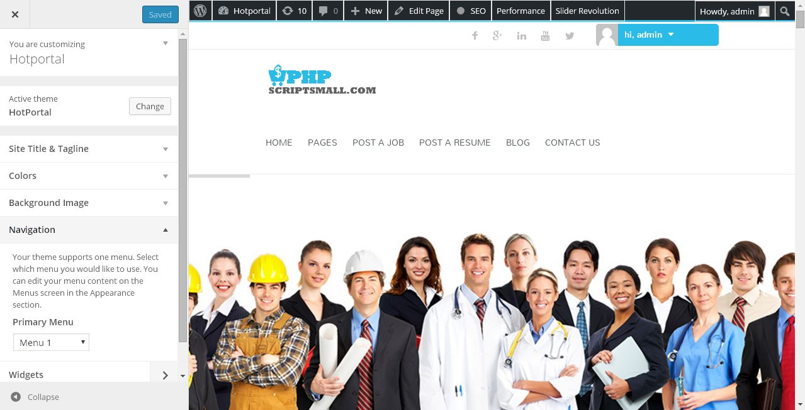
Description:
Admin can manage navigation settings

Widget:
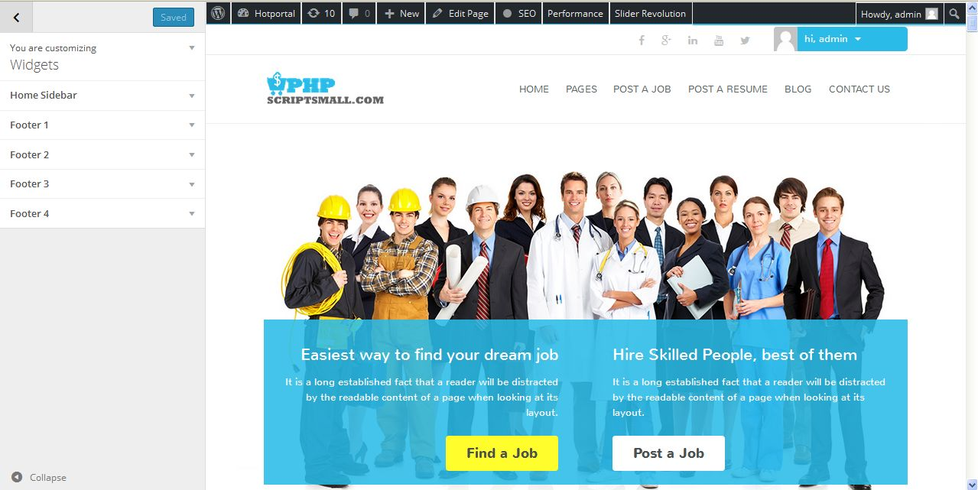
Description:
Admin can manage widget settings

Static front page:
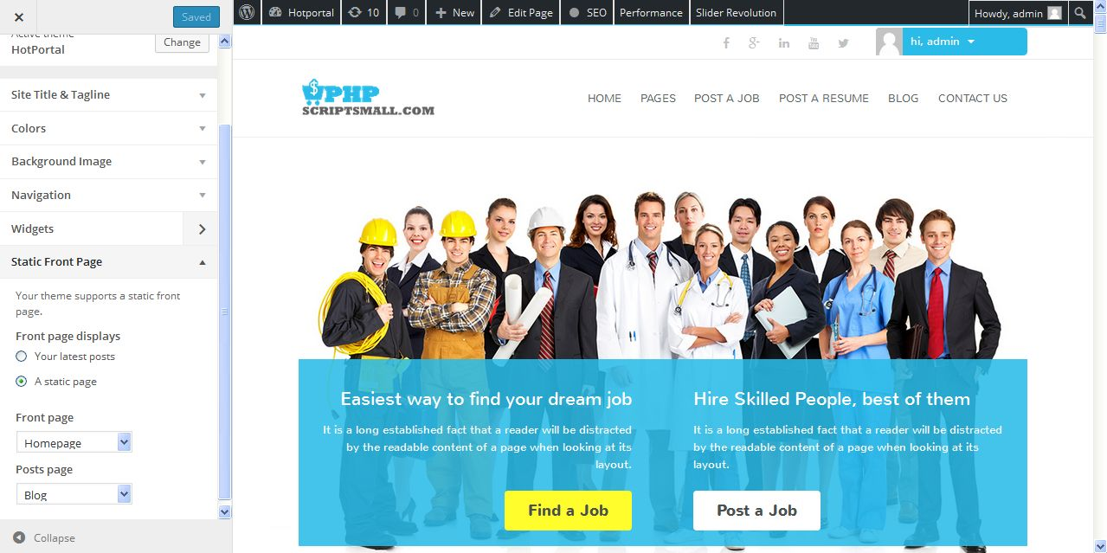
Description:
Admin can manage static front page settings

Widgets:
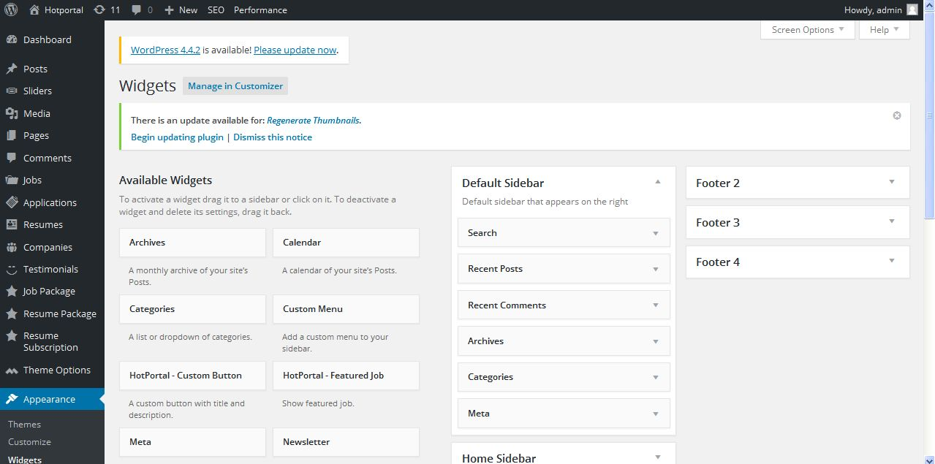
Description:
Admin can manage widgets settings

Menu:
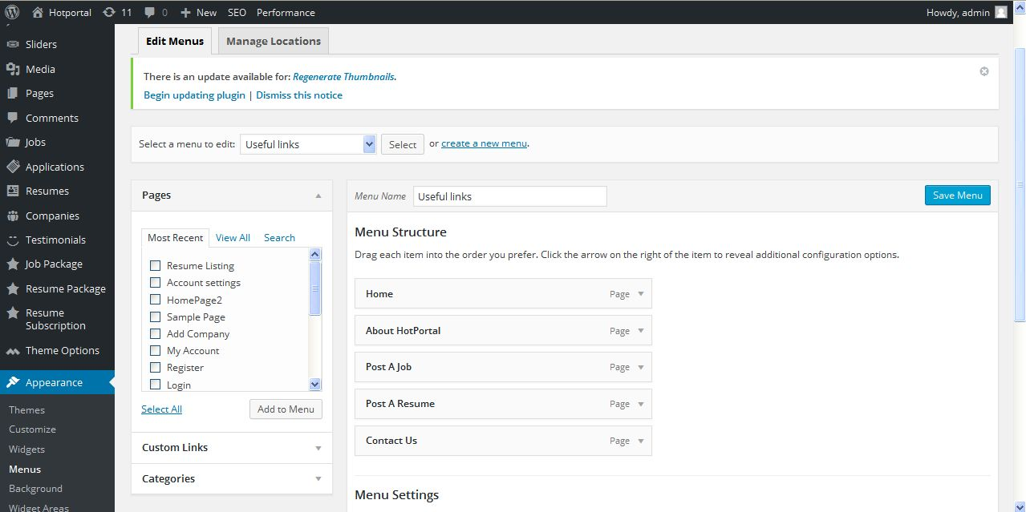
Description:
Admin can manage menu alignment settings

Widget area:
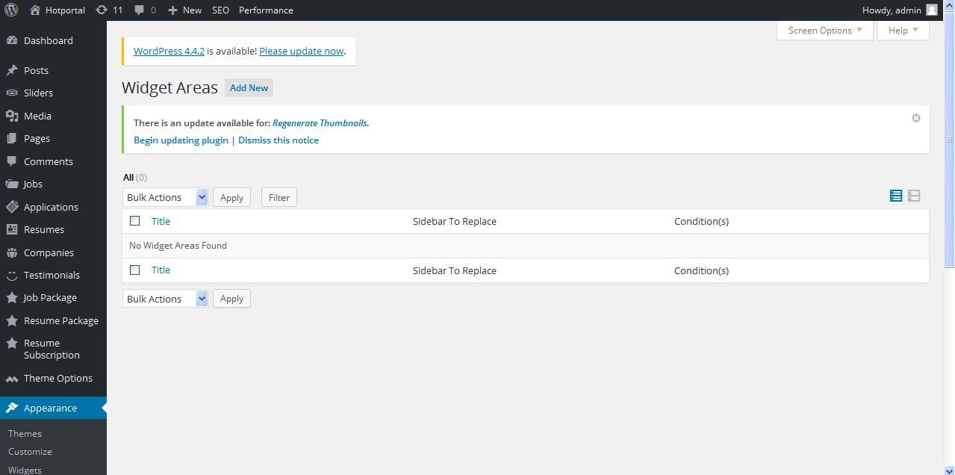
Description:
Admin can add and manage widget area

Editor:
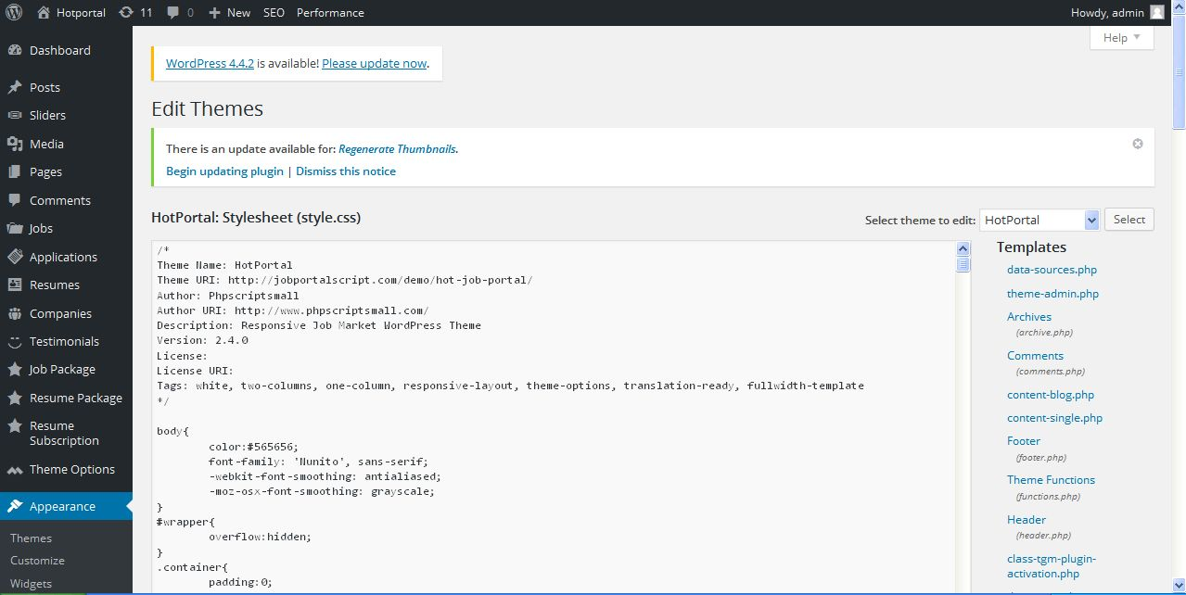
Description:
Admin can customize their script with CSS query

Jobs:
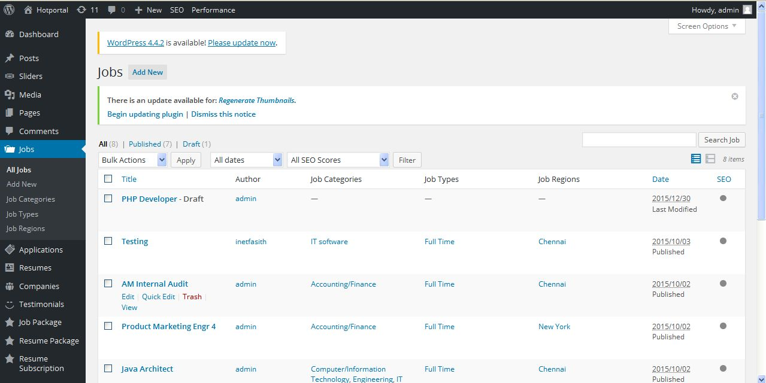
Description:
Admin can view and manage their job details

Add job:
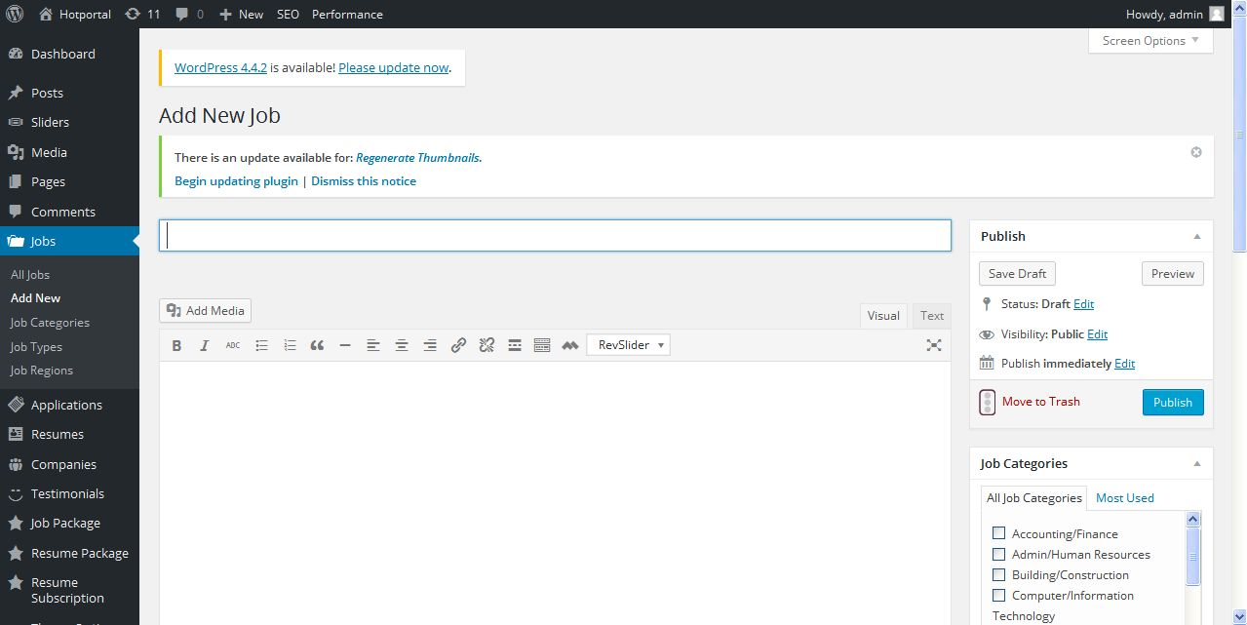
Description:
Admin can add new job with detailed

Job category:
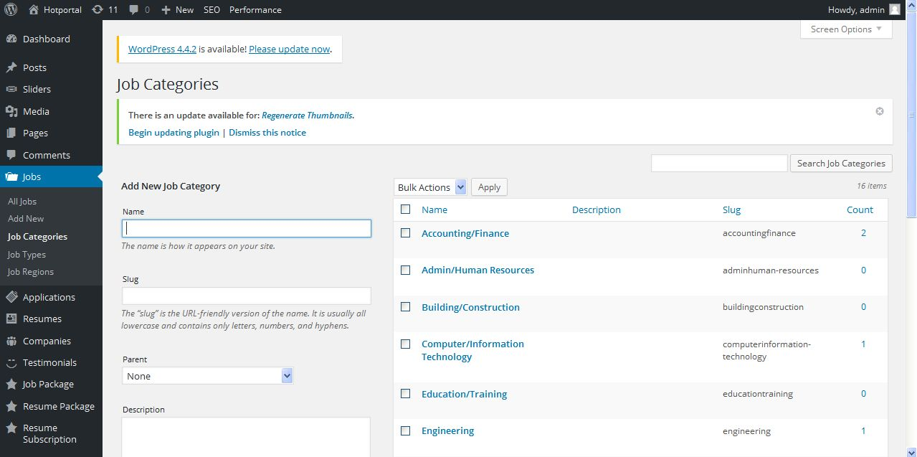
Description:
Admin can add and manage job category

Job type:
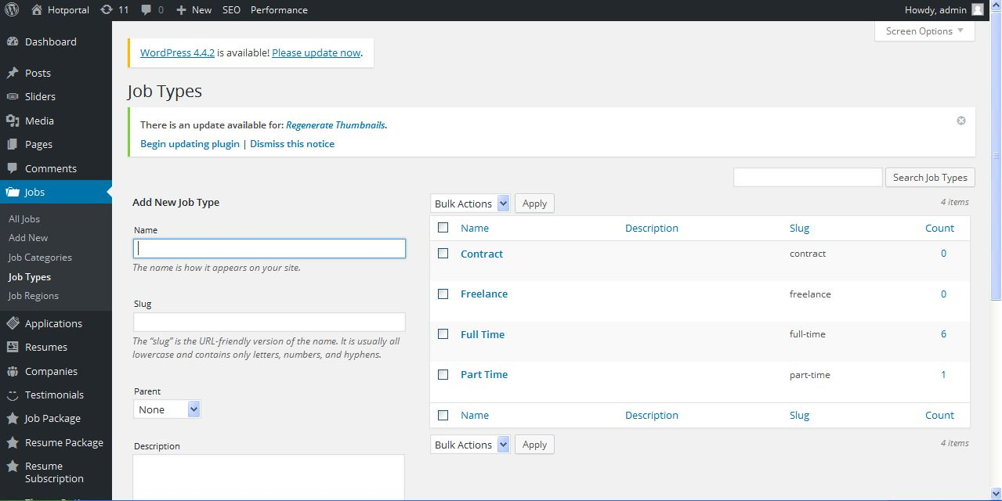
Description:
Admin can add and manage job type

Job religion:
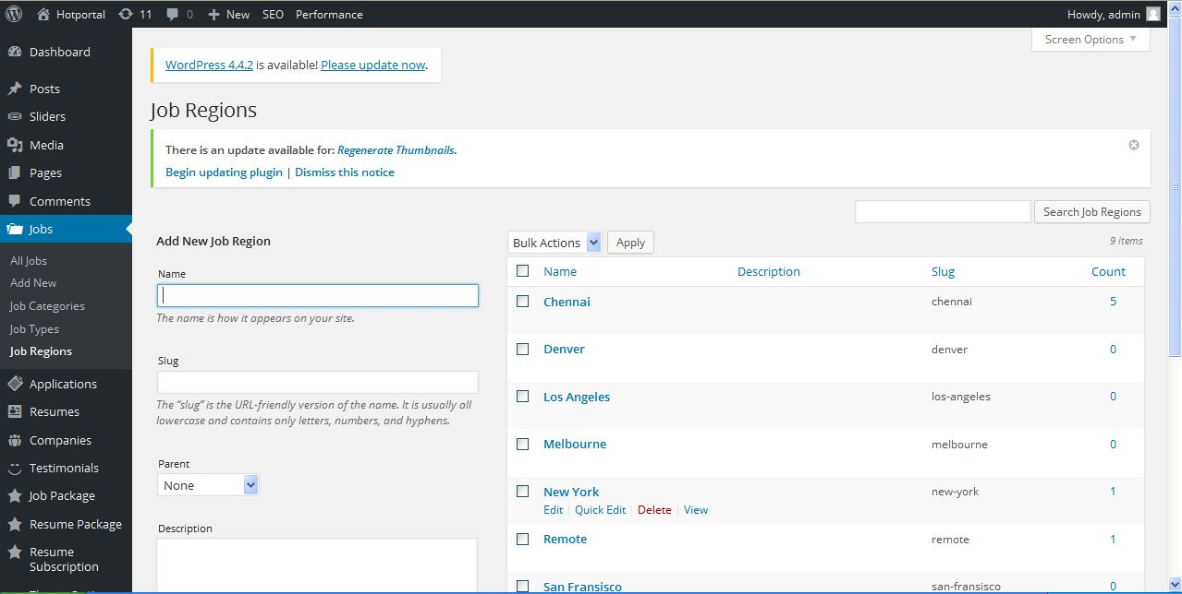
Description:
Admin can add and manage job religion

Application:
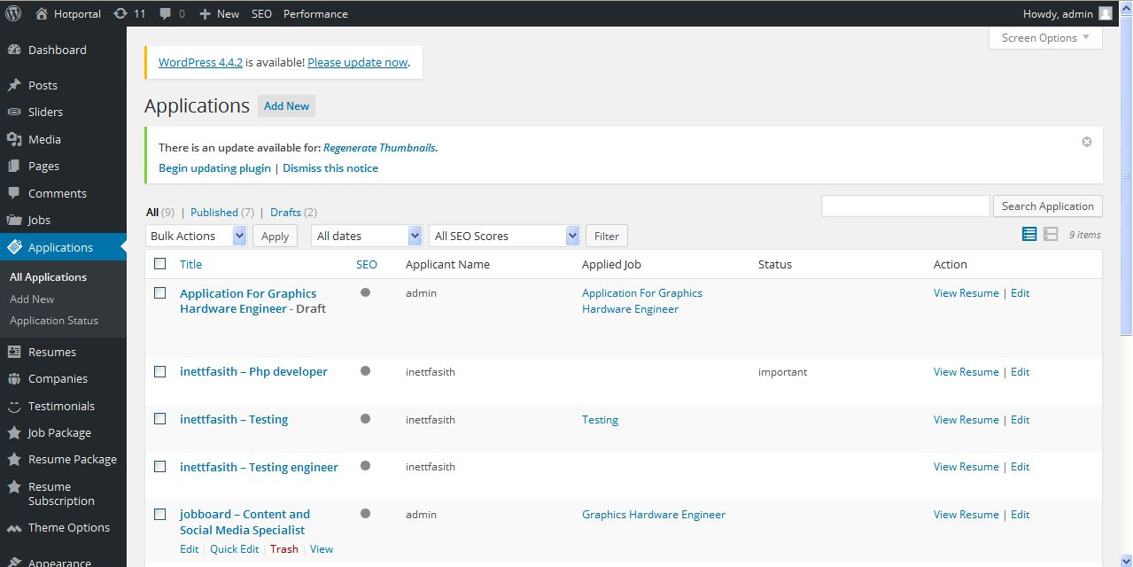
Description:
Admin can view and manage applied job status

Add application:
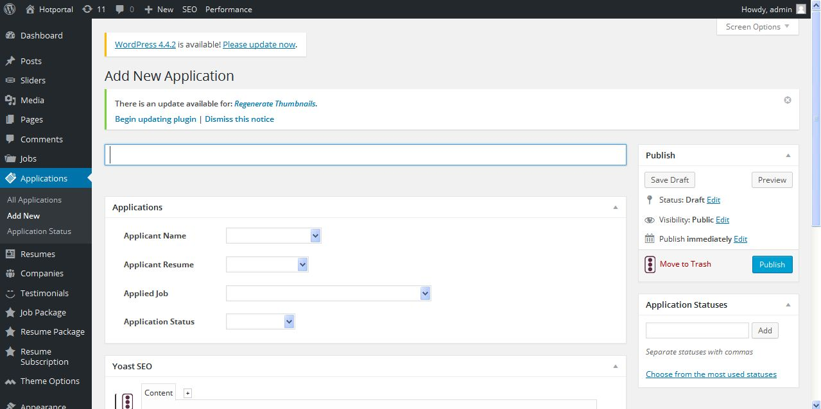
Description:
Admin can add new applicant with detailed

Application statuses:
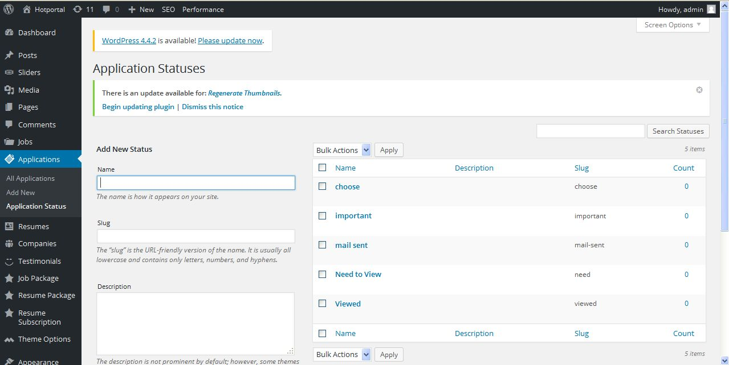
Description:
Admin can add and manage application statuses

Resume:
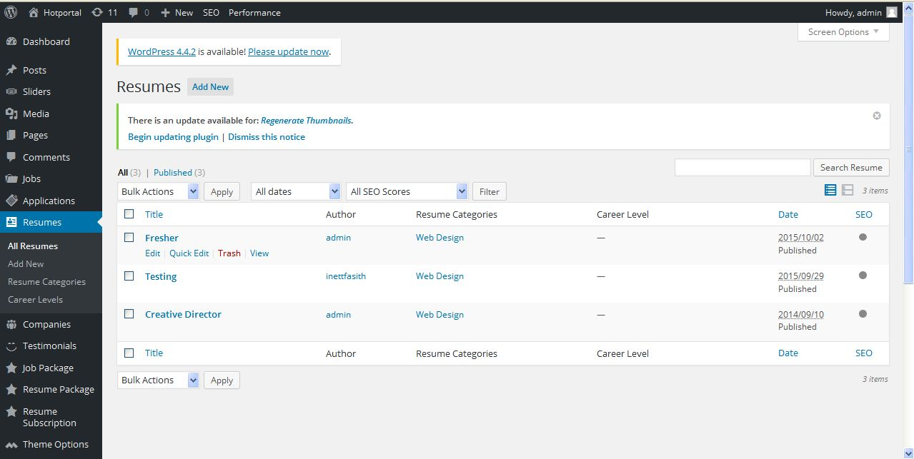
Description:
Admin can view and manage users resume

Add resume:
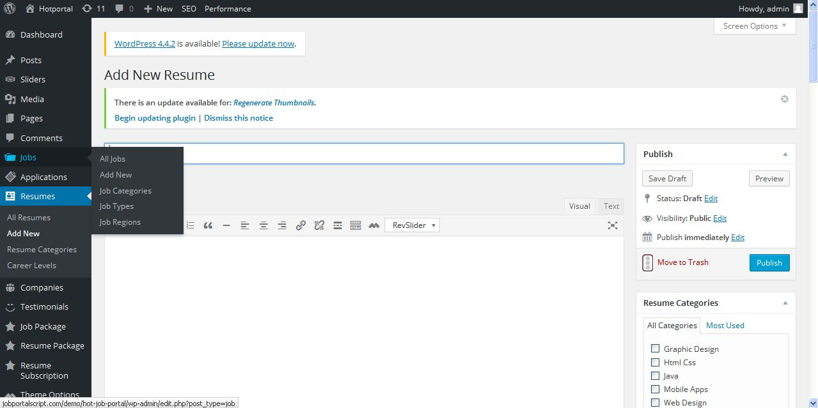
Description:
Admin can add new resume with detailed

Resume category:
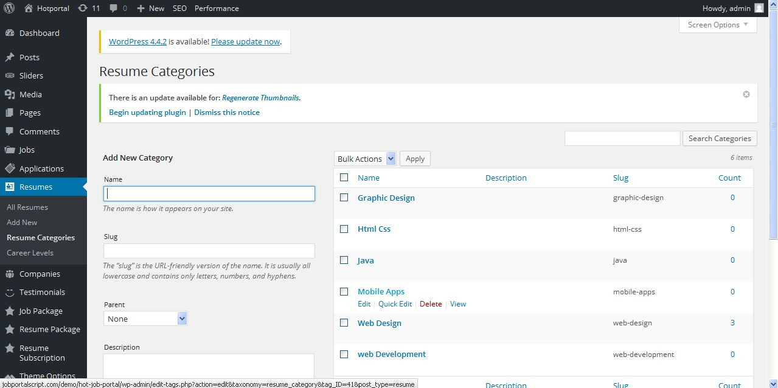
Description:
Admin can add and manage resume category

Career level:
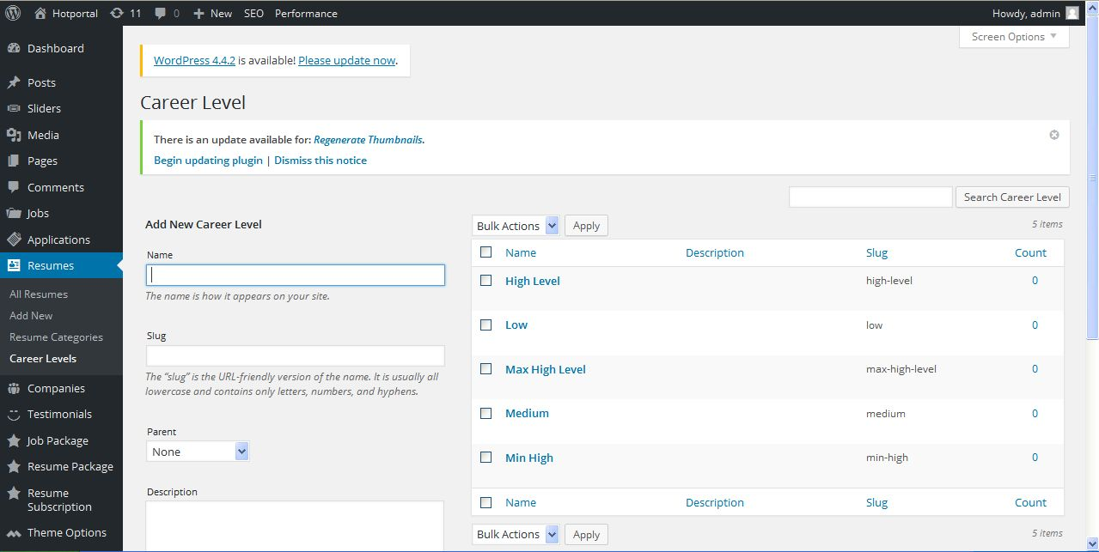
Description:
Admin can add and manage career level

Company:
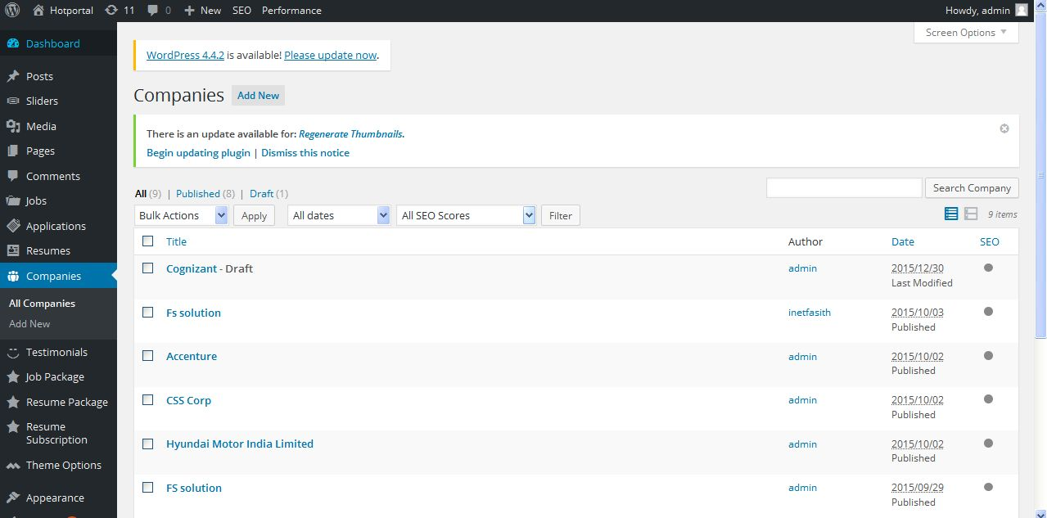
Description:
Admin can view and manage company detail

Add company:
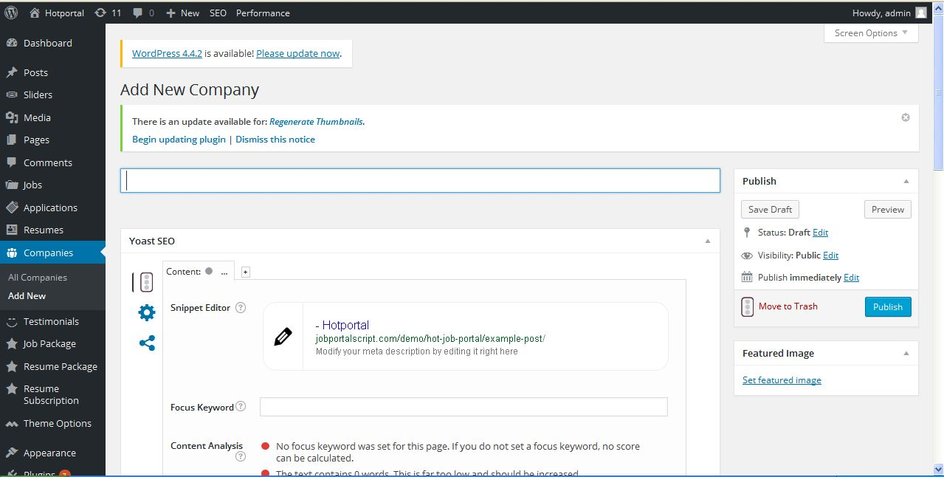
Description:
Admin can add new company with detailed

Resume package:
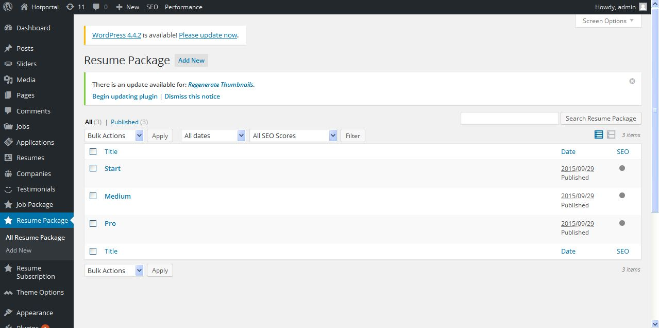
Description:
Admin can view and manage resume package details

Add resume package:
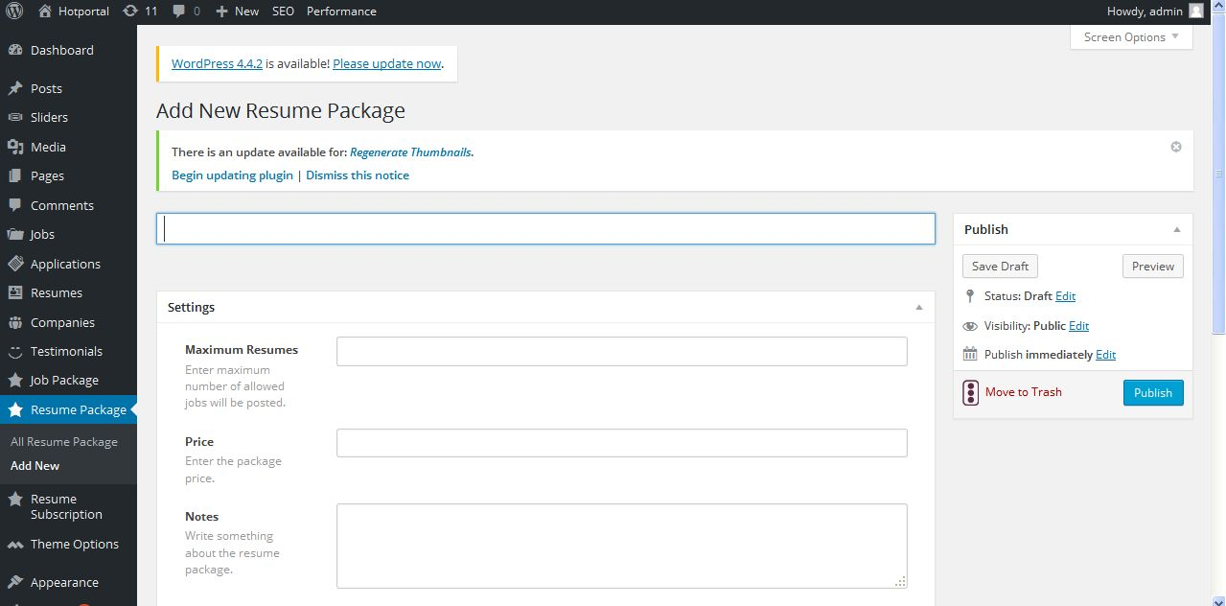
Description:
Admin can add new resume package with detailed

Add job package:
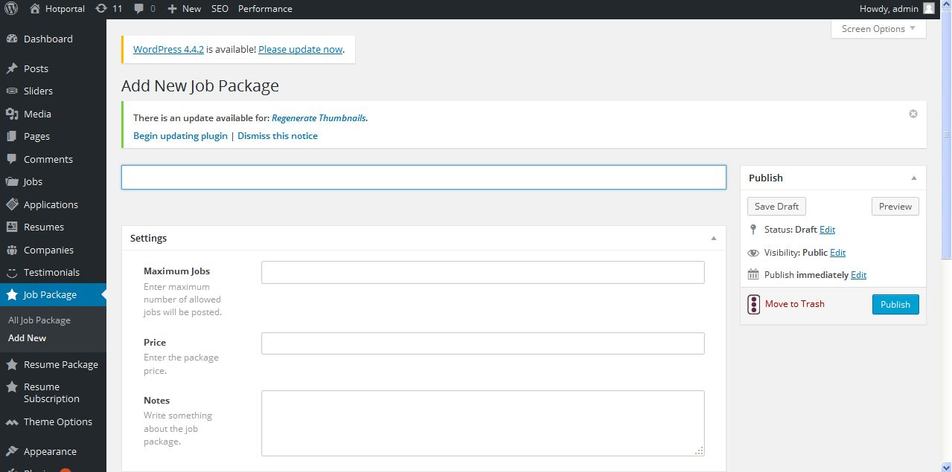
Description:

Resume subscription:
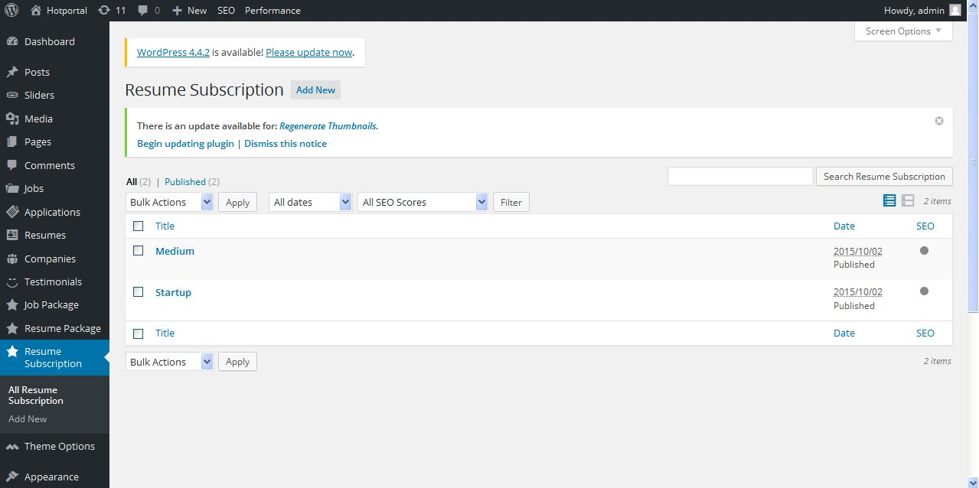
Description:
Admin can view and manage resume subscription

Add resume subscription:
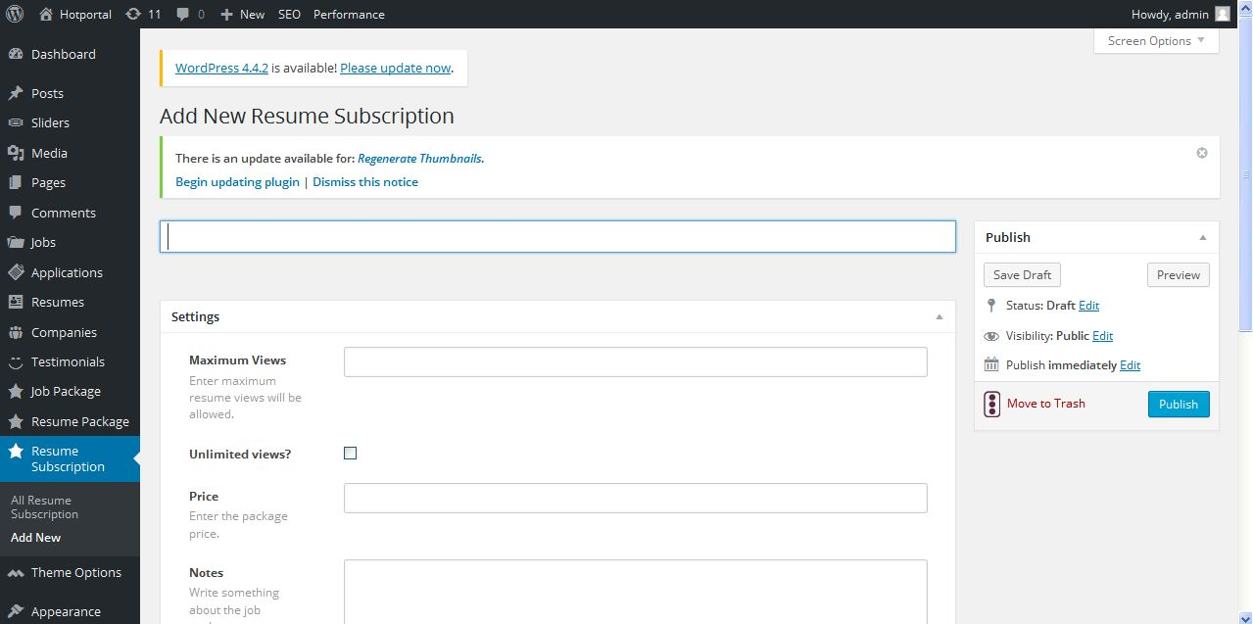
Description:
Admin can add new resume subscription with detailed

Blog
Blog:
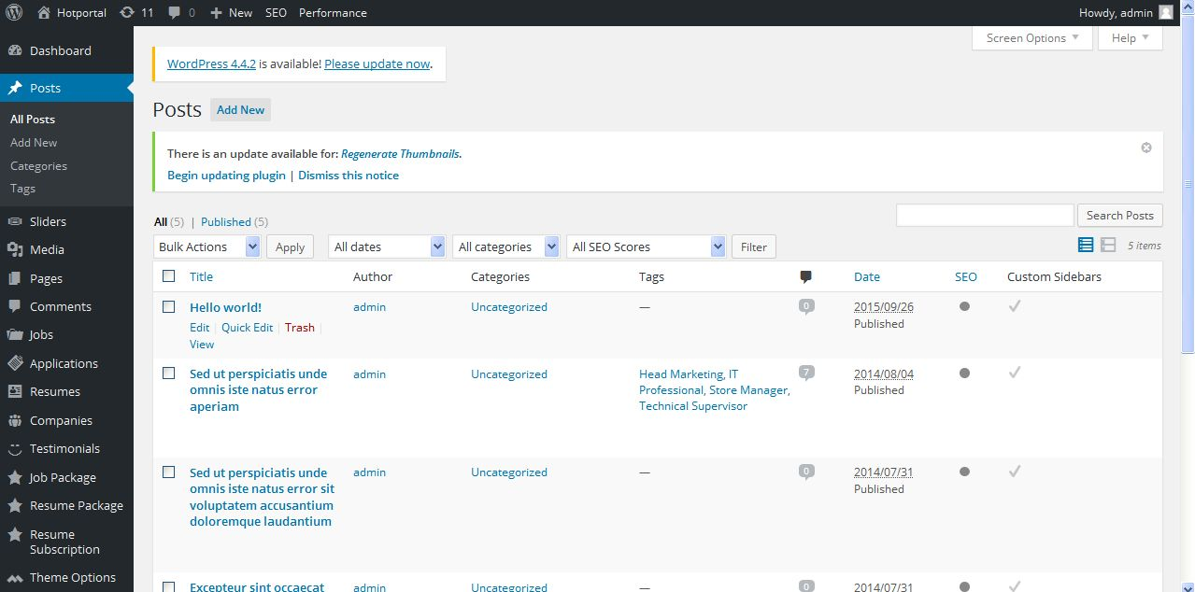
Description:
Admin can view and manage blog also search option

Add blog:
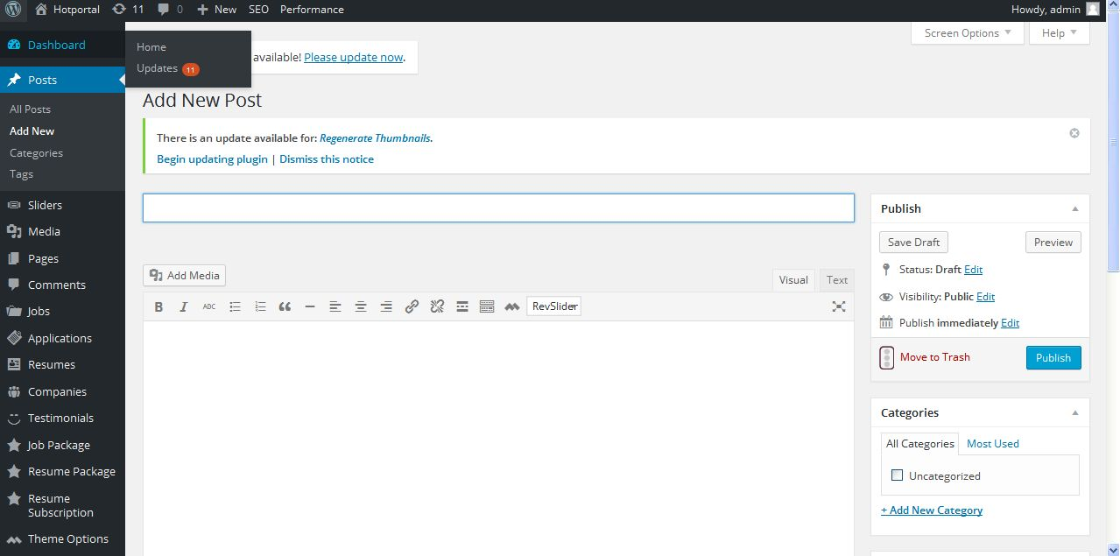
Description:
Admin can add new blog with detail

Blog category:
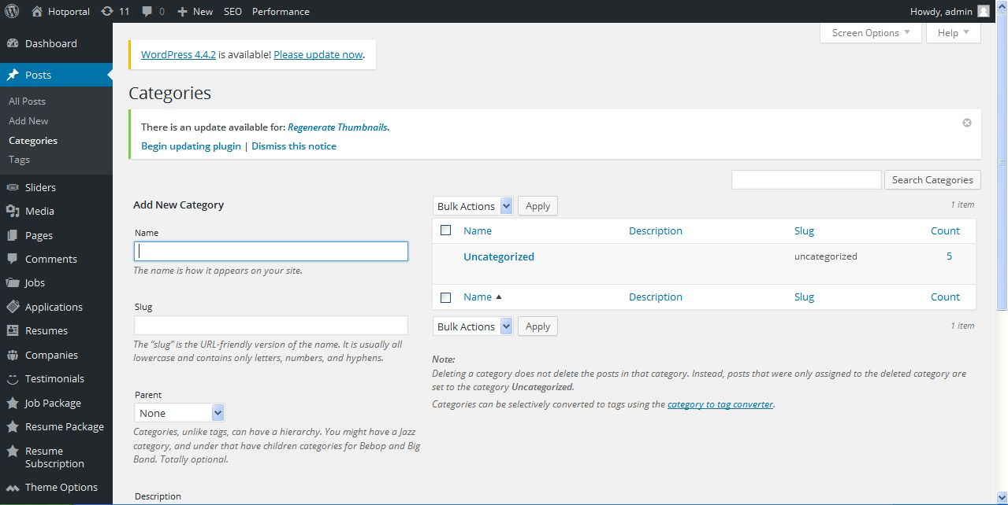
Description:
Admin can add and manage blog category

Blog tag:
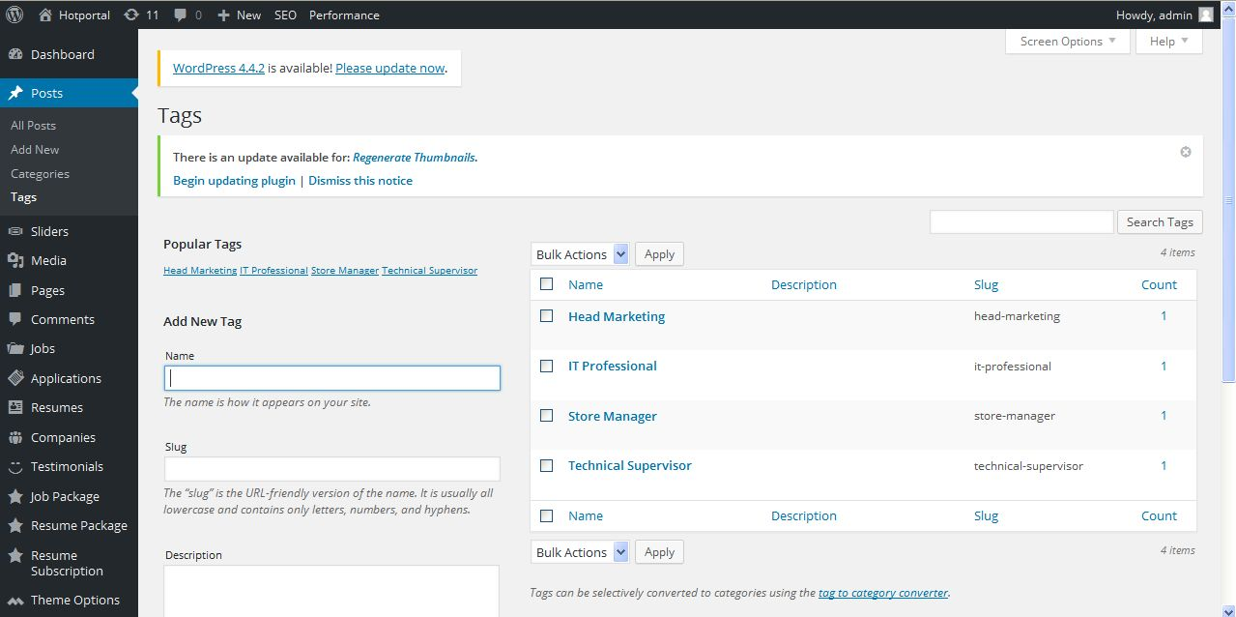
Description:
Admin can add and manage blog tag

Slider:
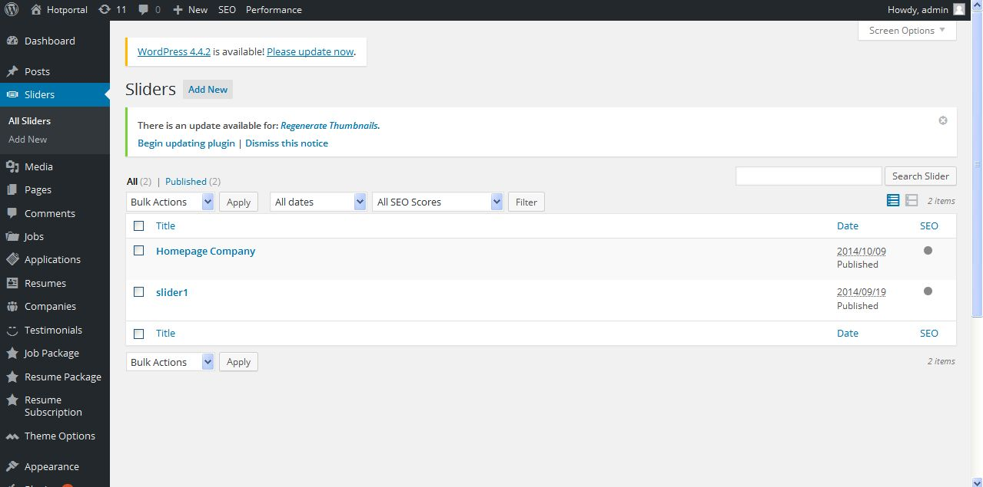
Description:
Admin can view and manage slider

Add slider:
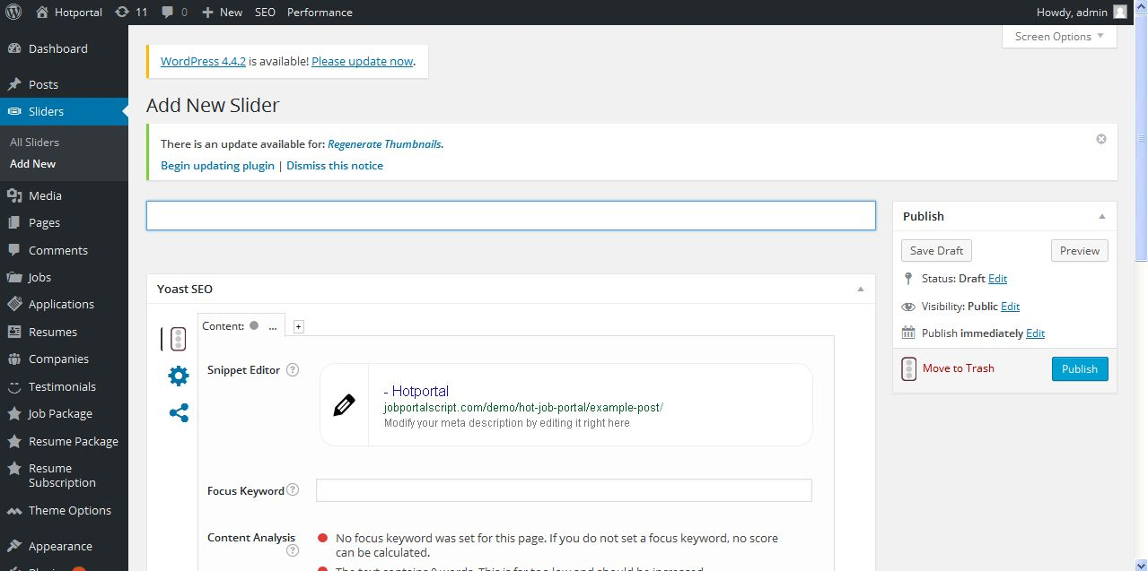
Description:
Admin can add new slider with detailed

Media:
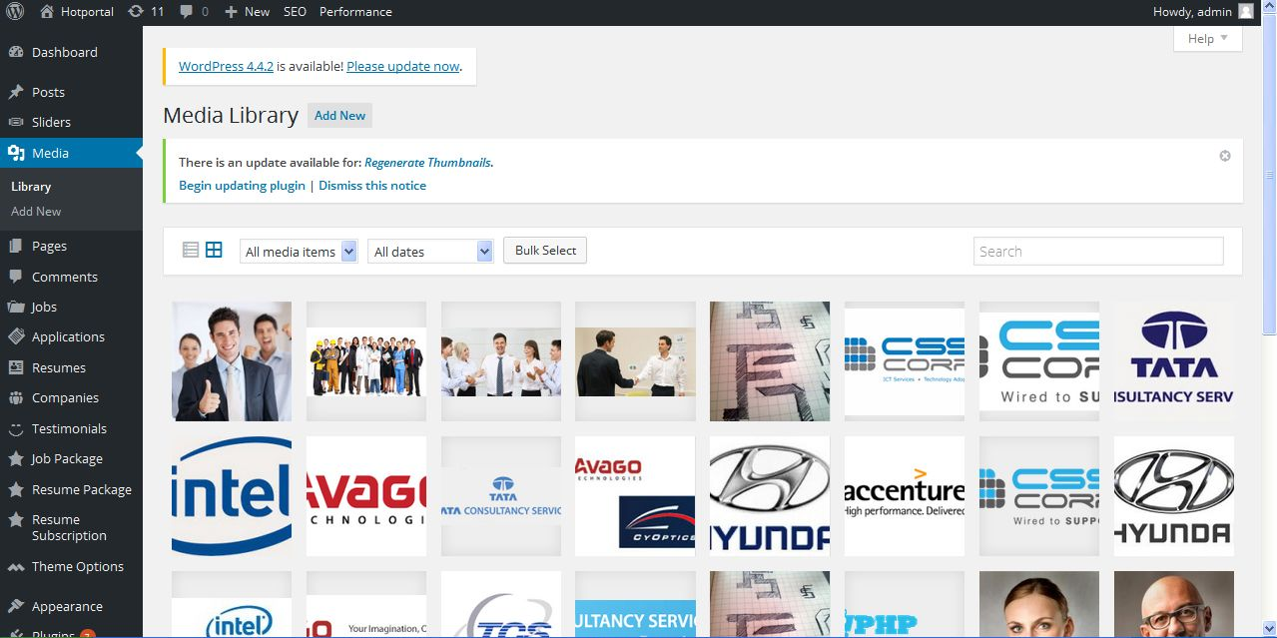
Description:
Admin can view all media related with site

Add media:
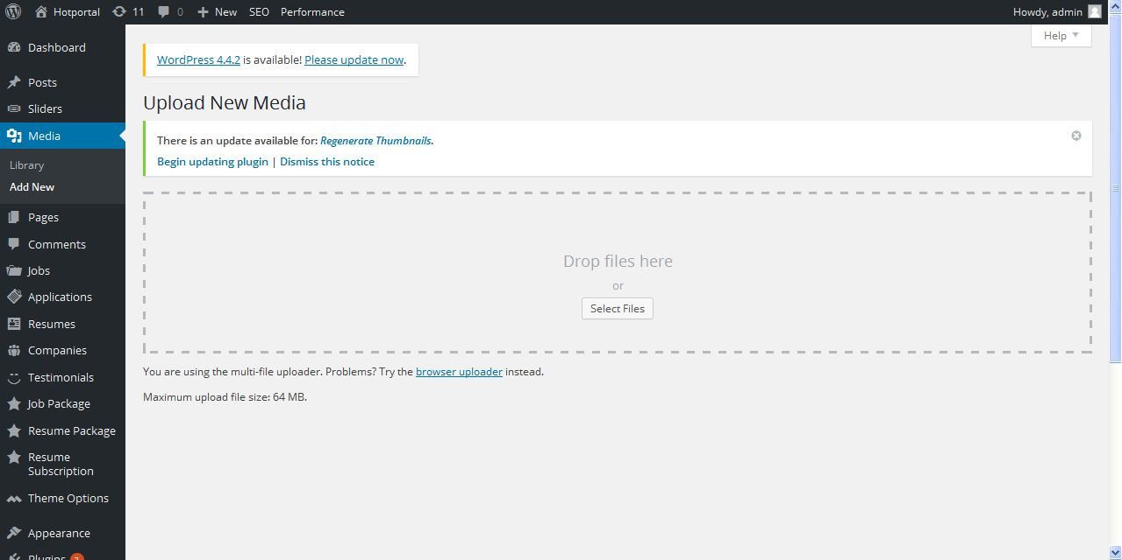
Description:
Admin can add media using this

Page
Pages:
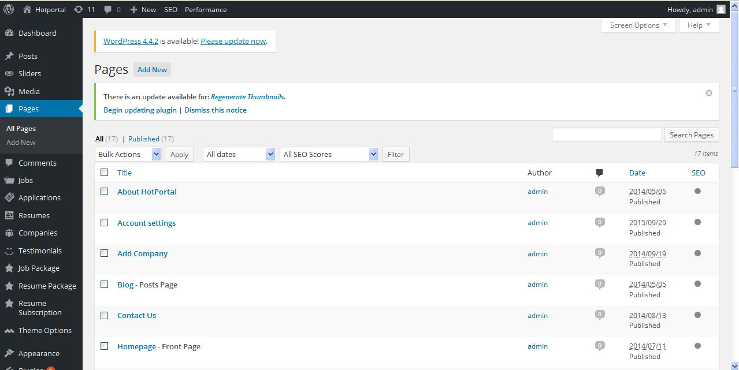
Description:
Admin can view and manage pages

Add page:
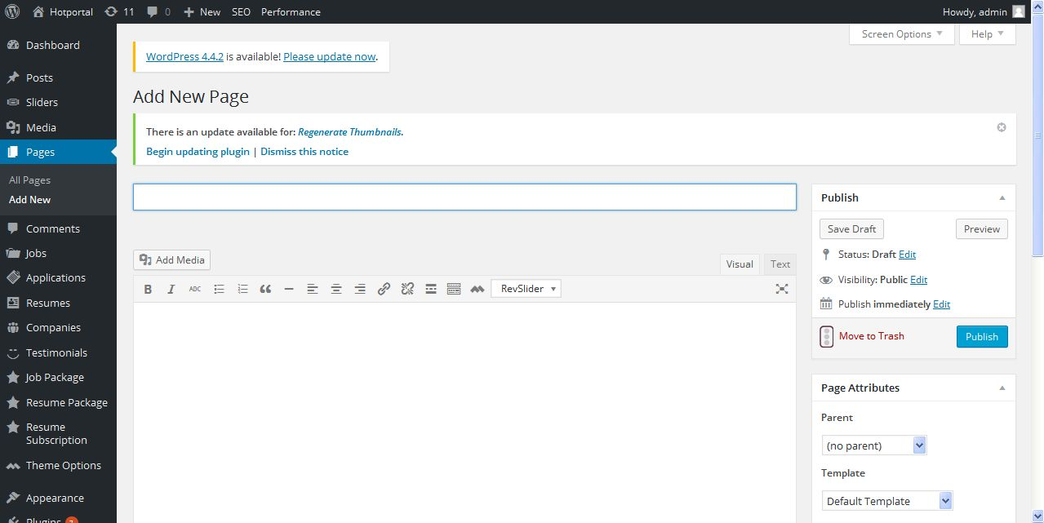
Description:
Admin can add new page with detail

Comments:
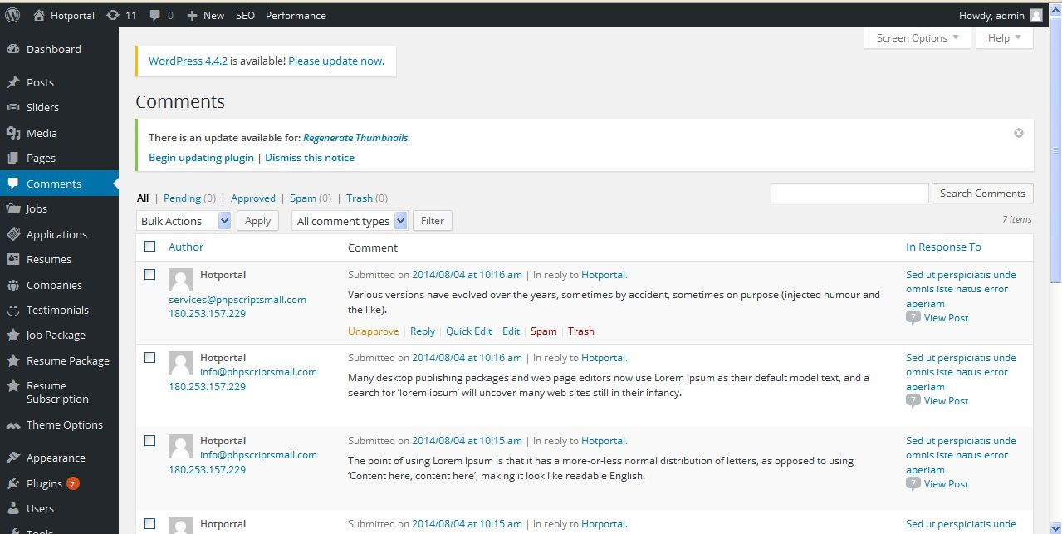
Description:
Admin can manage comments of job

Testimonial
Testimonials:
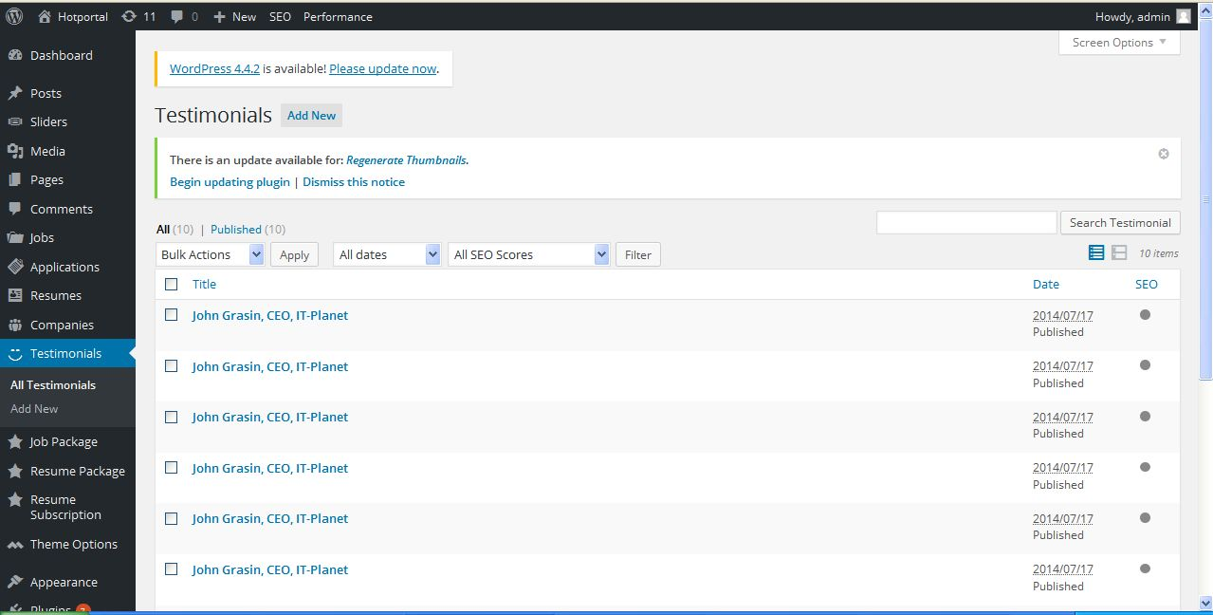
Description:
Admin can view and manage testimonials

Add testimonials:
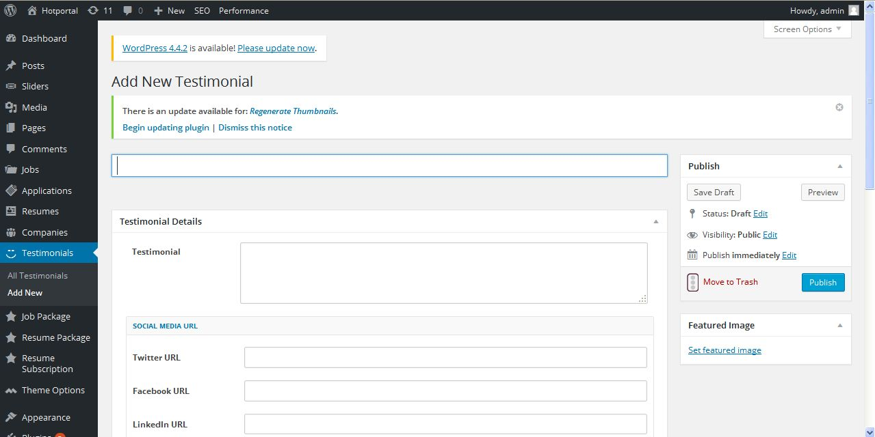
Description:
Admin can new testimonials with detailed

User
User:
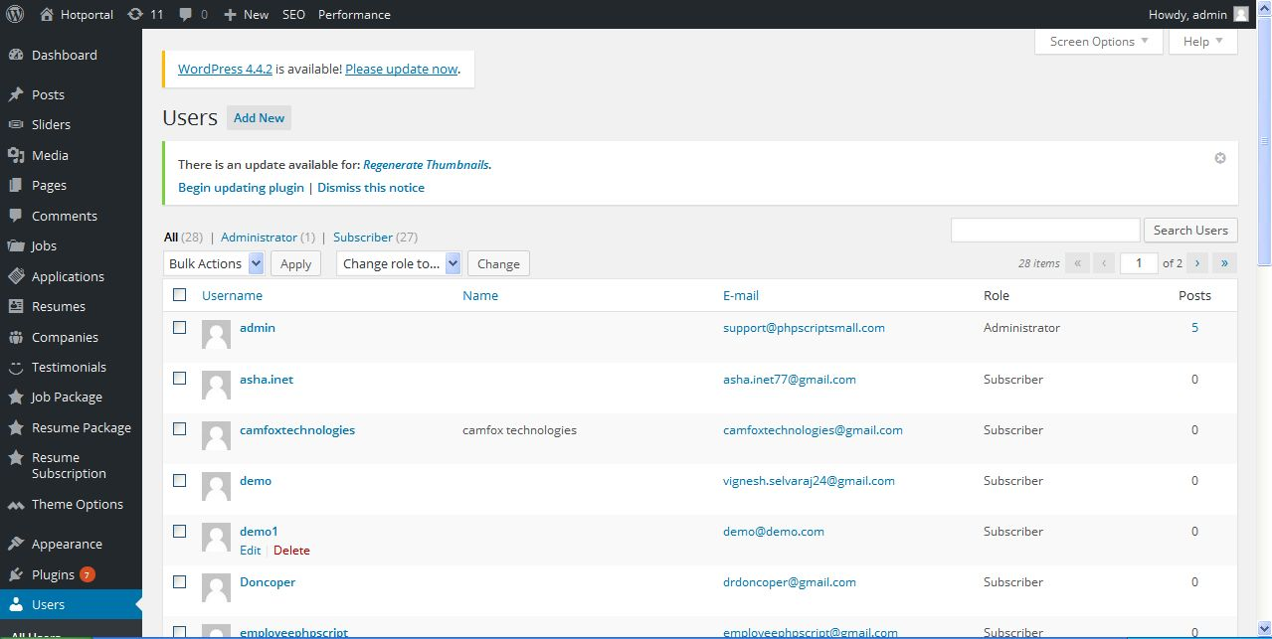
Description:
Admin can view and manage user details

Add user:
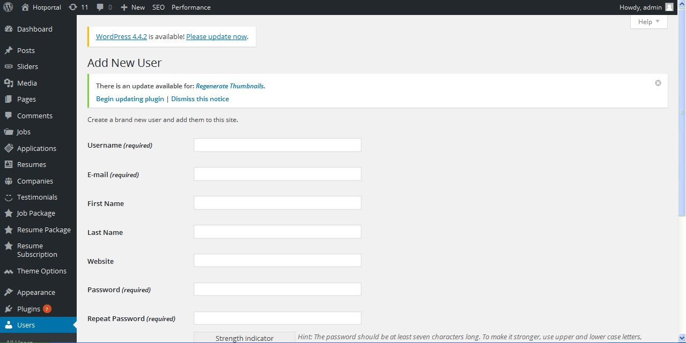
Description:
Admin can add new user with detail

Profile:
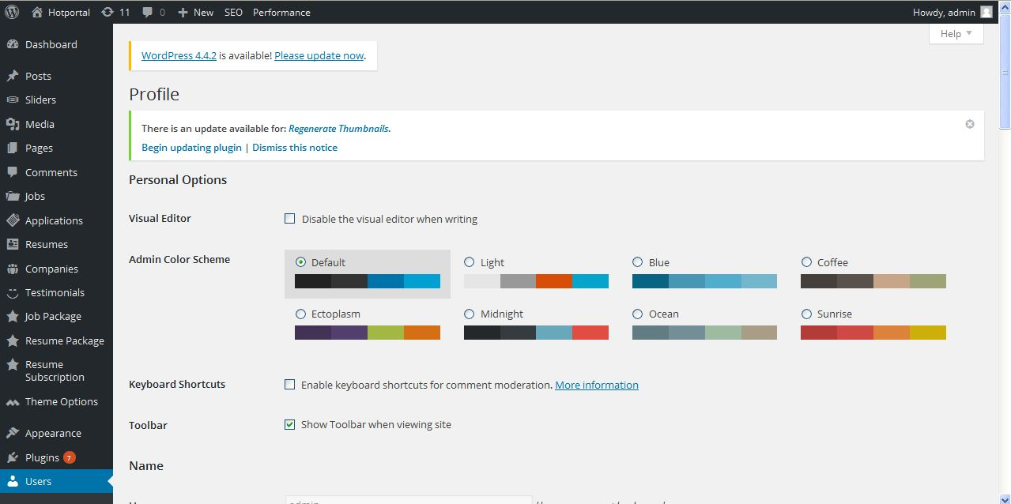
Description:
Admin can manage their profile details

Tools
Import:
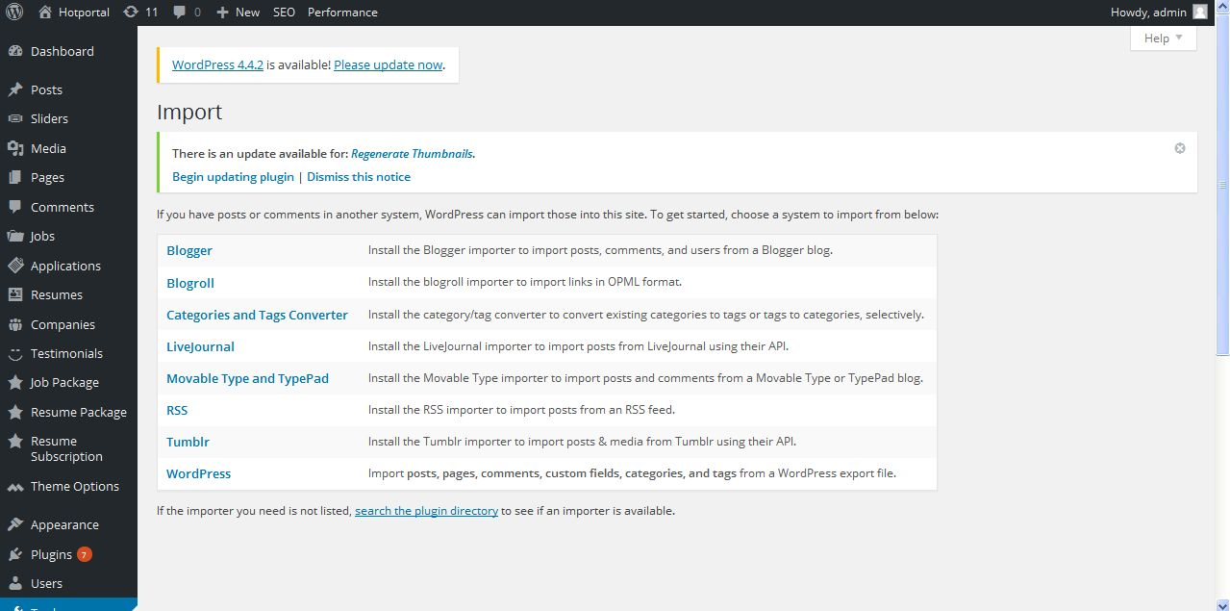
Description:
Admin can import following

Export:
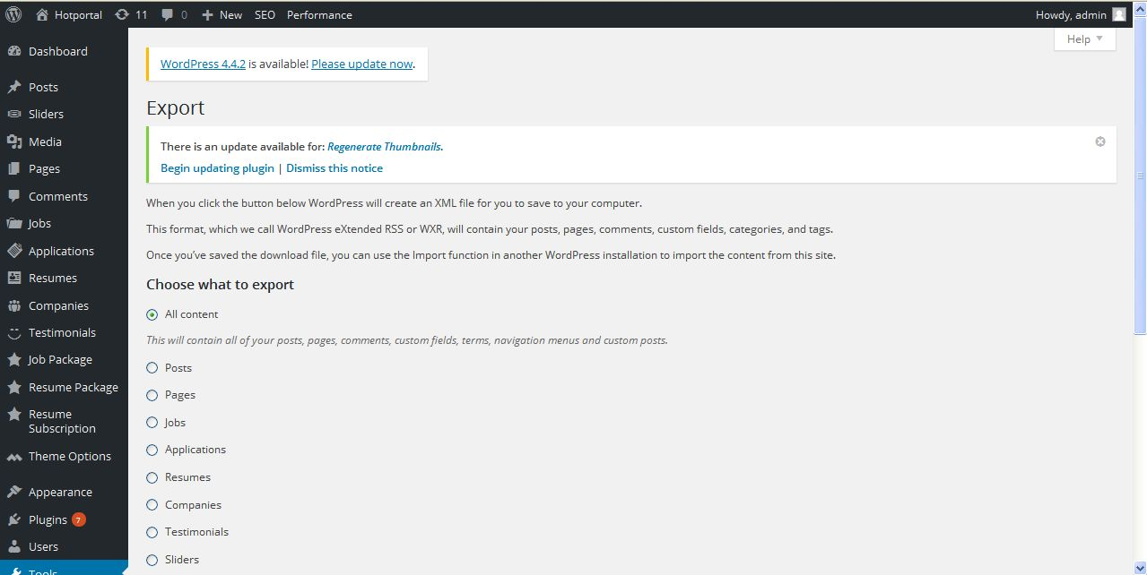
Description:
Admin can export following fields

Widget importer and exporter:
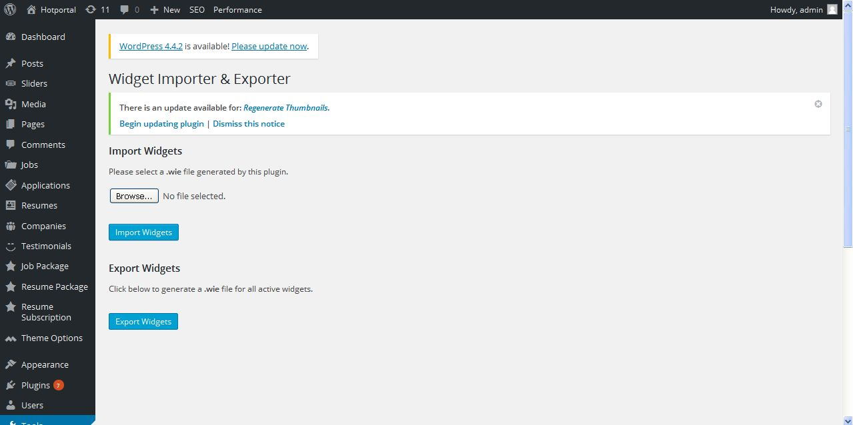
Description:
Admin can import and export widgets

Search & replace:
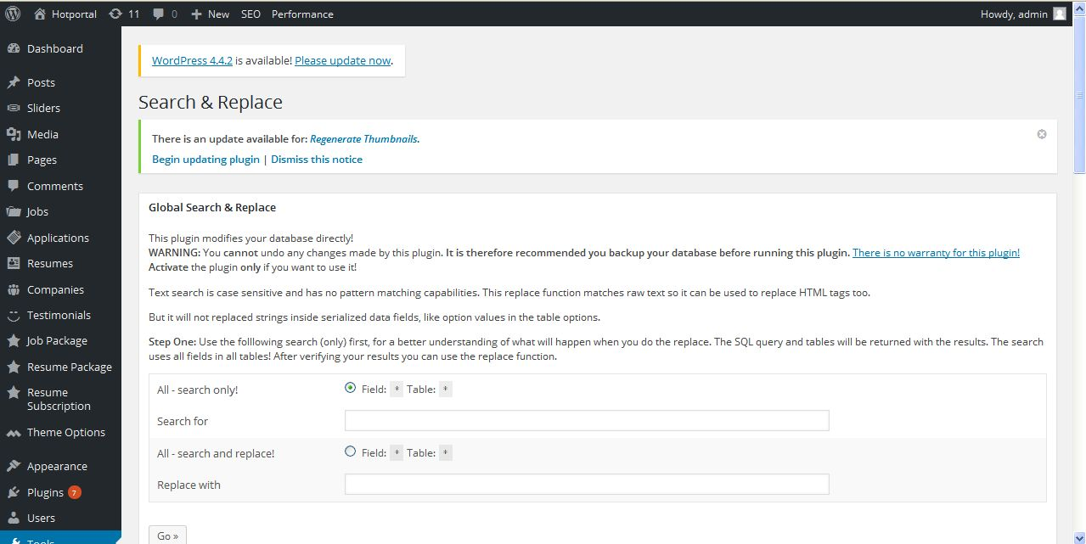
Description:
Admin can search and replace following using database

Regenerate thumbnails:
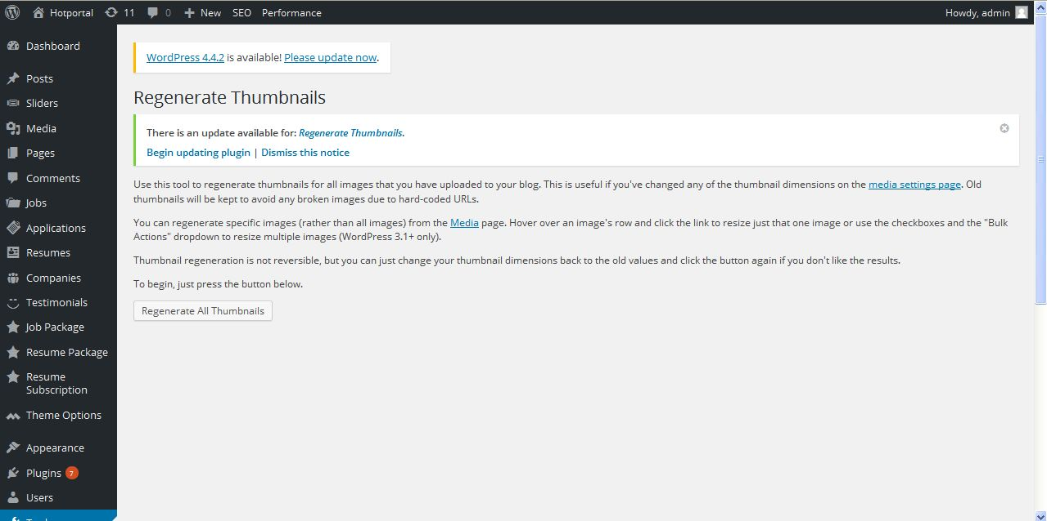
Description:
Admin can re generate all images using this functionality

Newsletter
Newsletter:
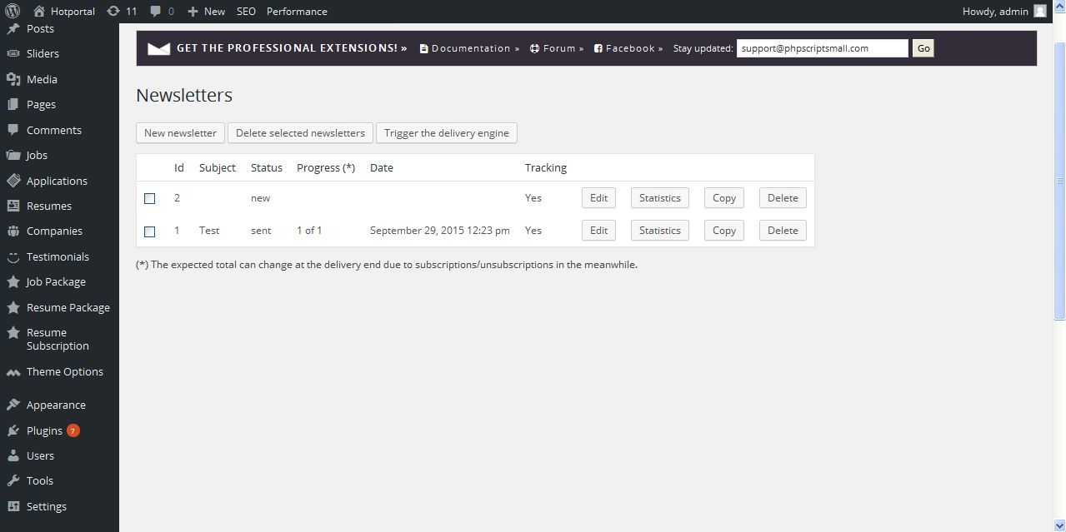
Description:
Admin can view and manage sent history of newsletter

Send newsletter- Theme :
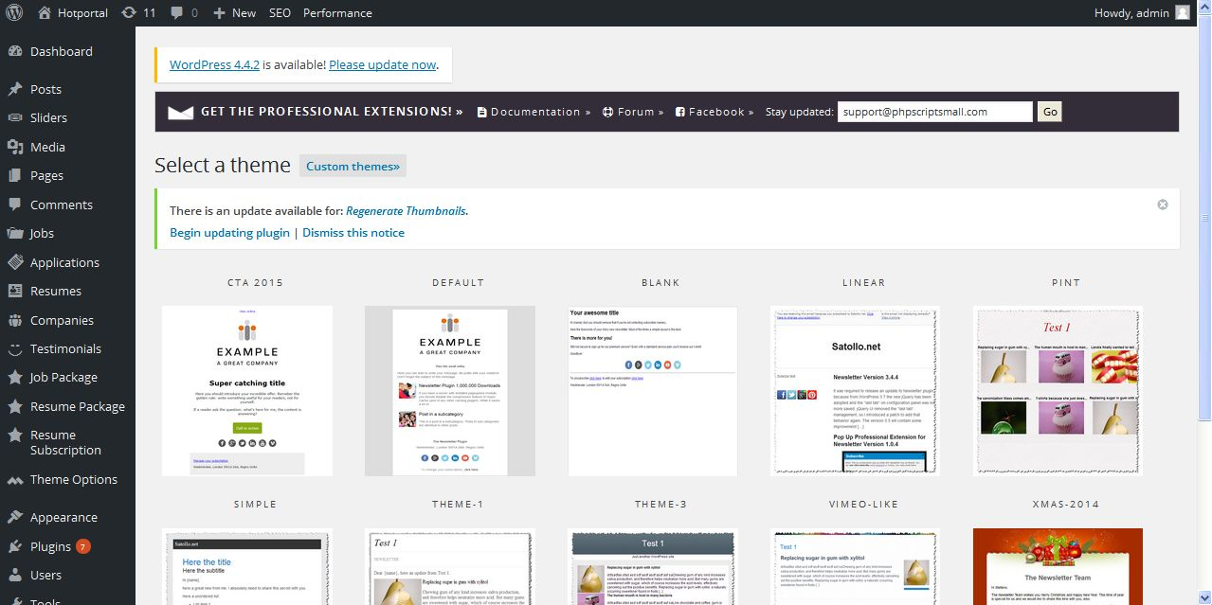
Description:
Admin can choose their newsletter template for sending

Newsletter:
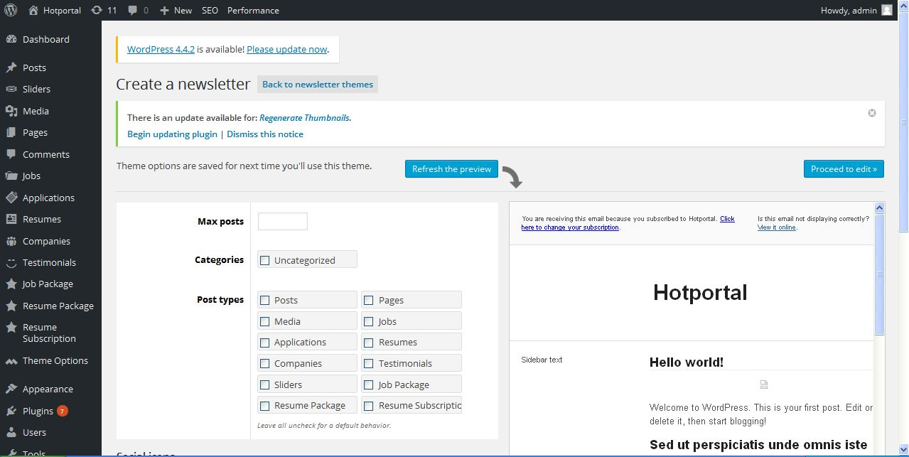
Description:
Admin can enter details about newsletter to send

Subscribers:
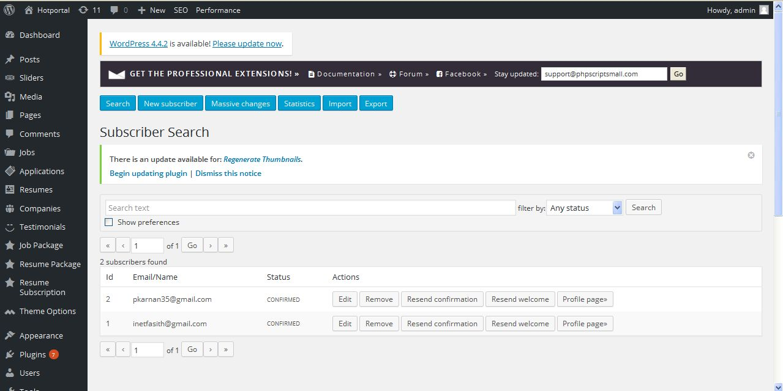
Description:
Admin can view subscribers list

Statistics:
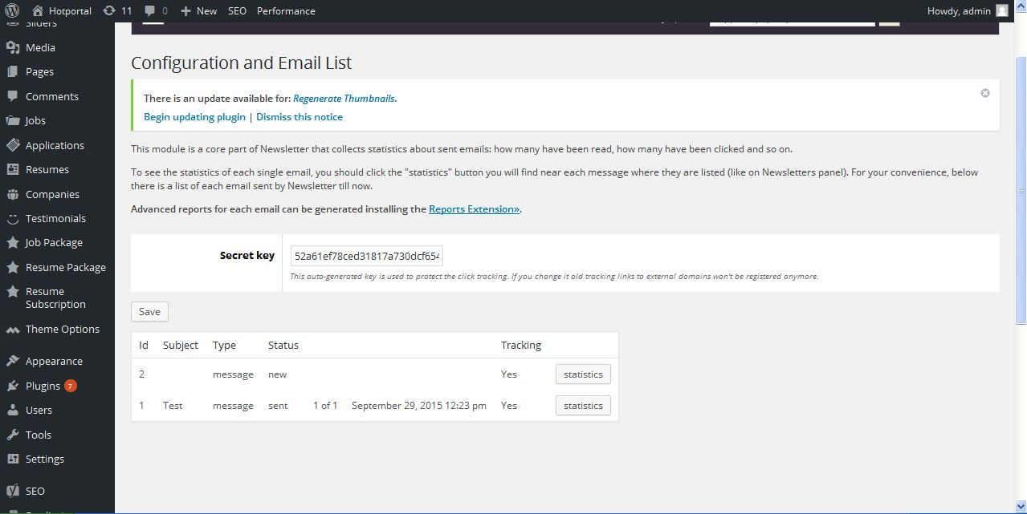
Description:
Admin can view newsletter statistics

Settings
General setting:
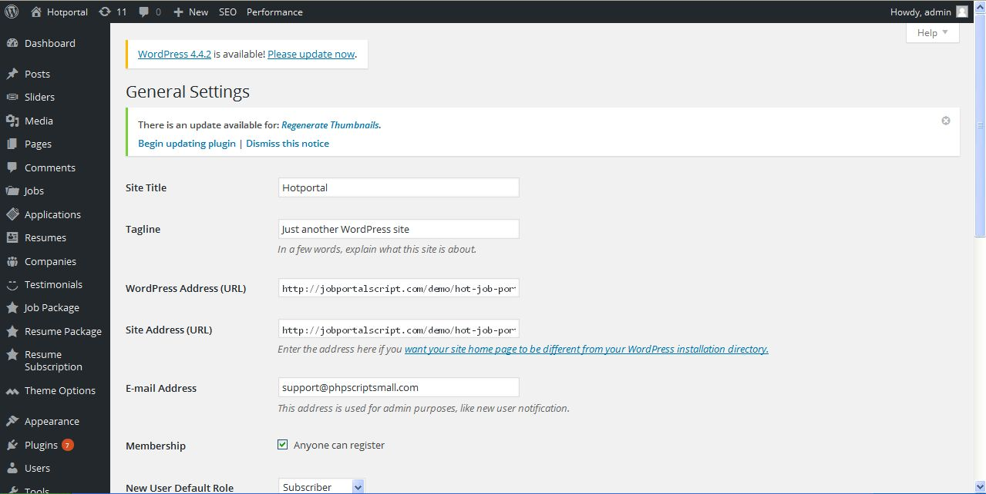
Description:
Admin can manage general settings off the website

Writing setting:
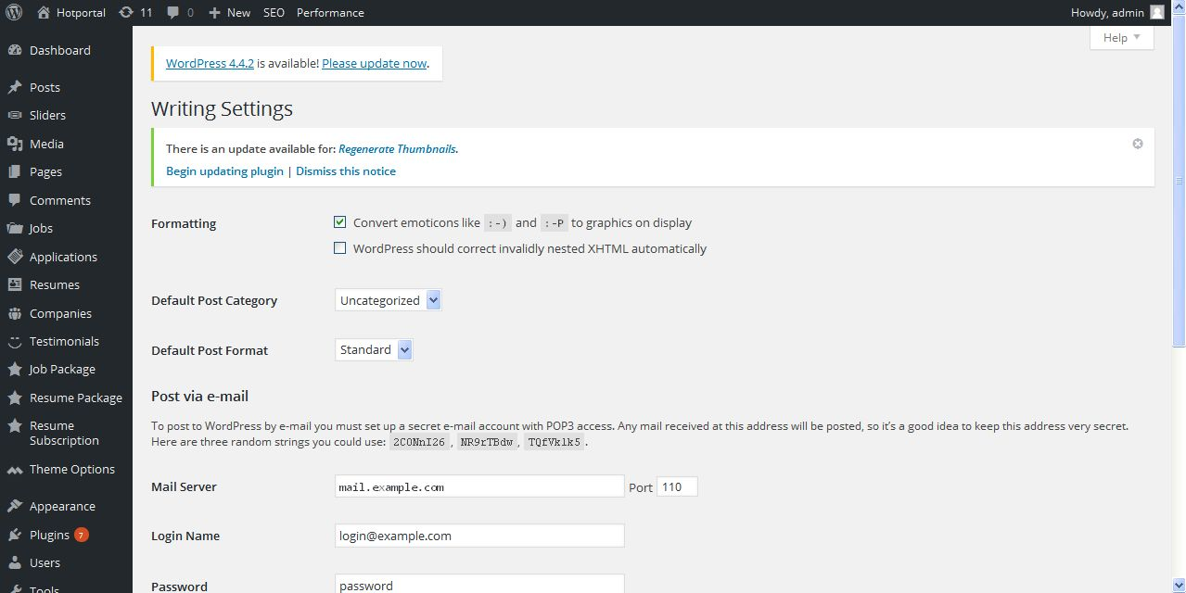
Description:
Admin can manage writing settings

Reading setting:
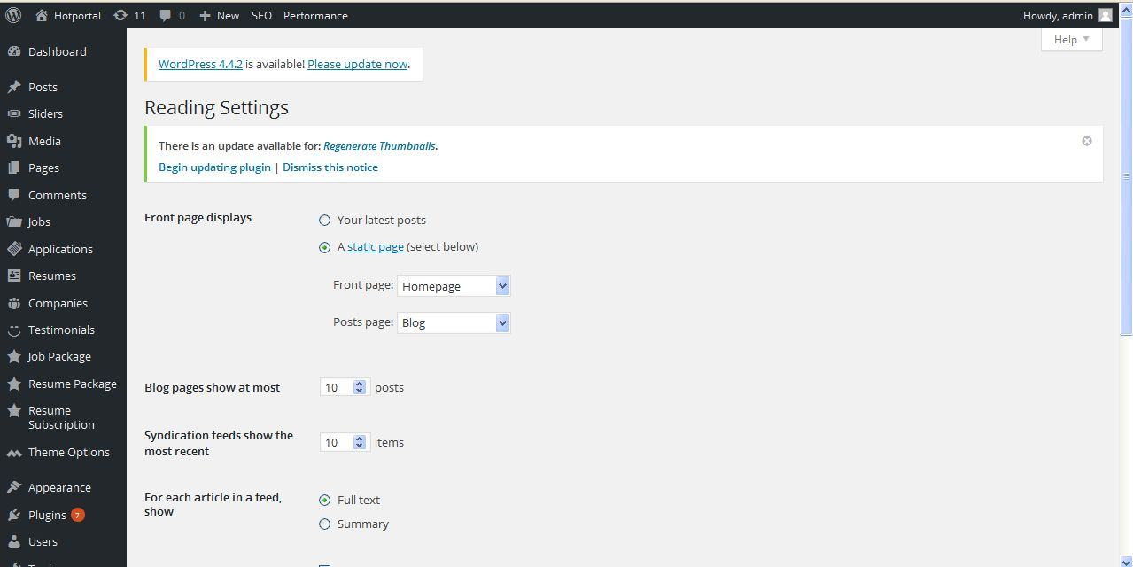
Description:
Admin can manage reading settings

Discussion setting:
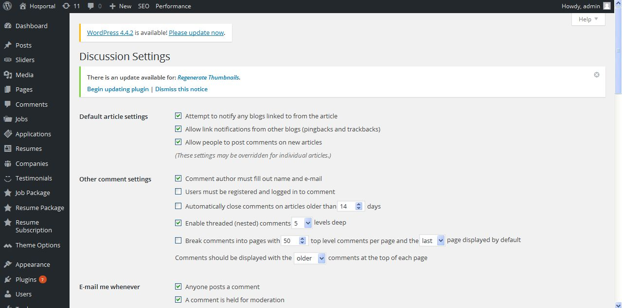
Description:
Admin can manage discussion settings

Media setting:
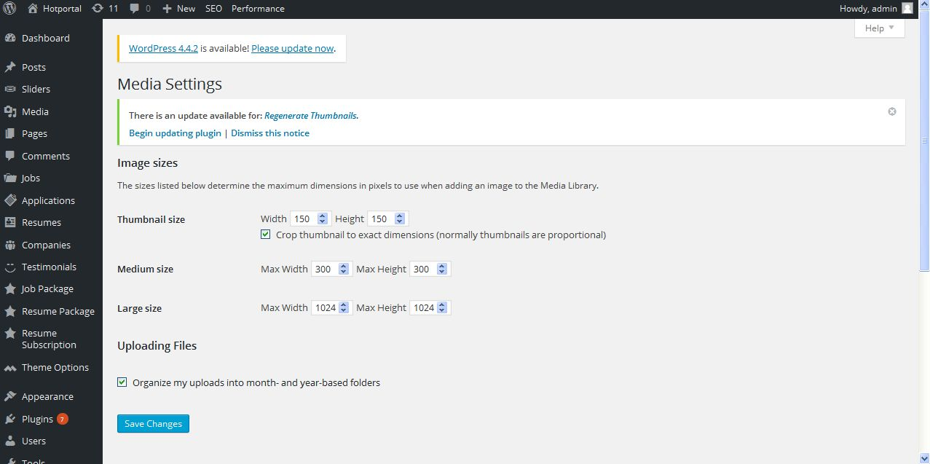
Description:
Admin can manage settings of media

Permalink setting:
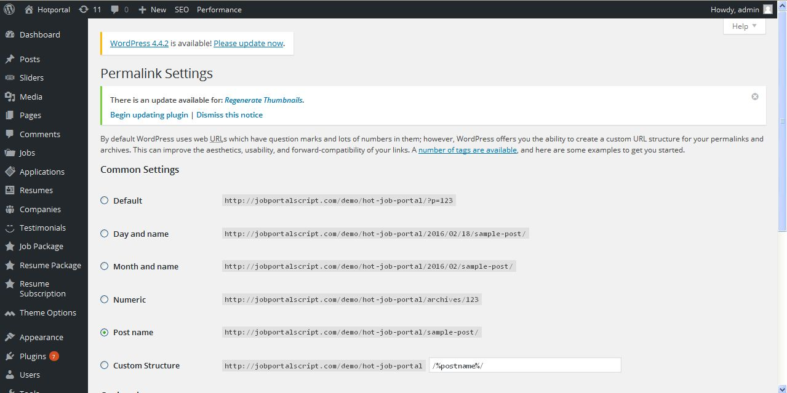
Description:
Admin can manage permalink settings

