Practo, Zocdoc Clone Script

Module: User
Subject: Registration

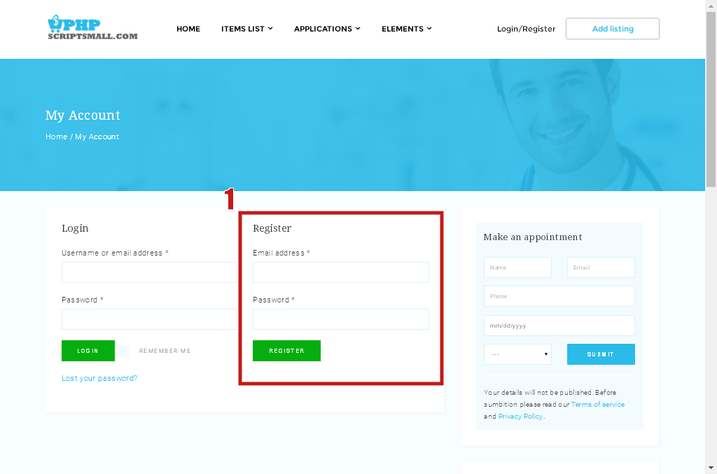

Description:
User can register with valid username and password

Module: User
Subject: Registration

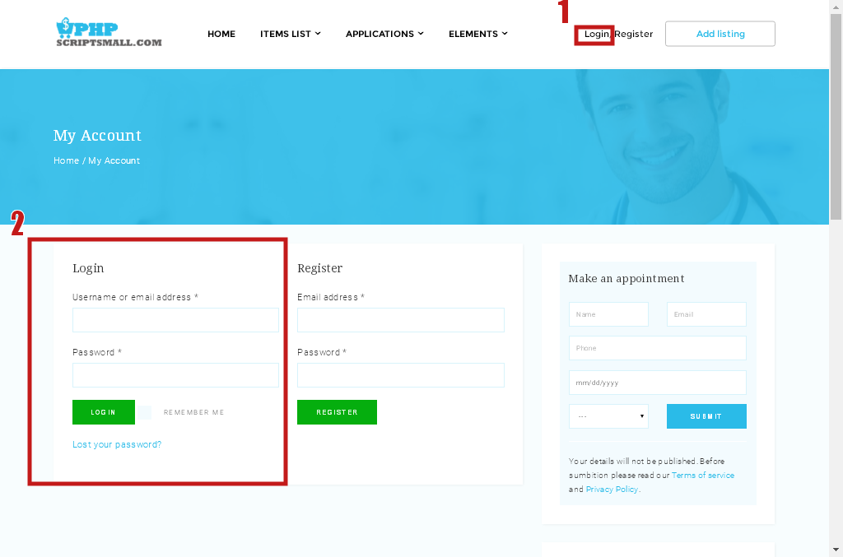

Description:
User can login with valid username and password.

Module: User
Subject: social Login
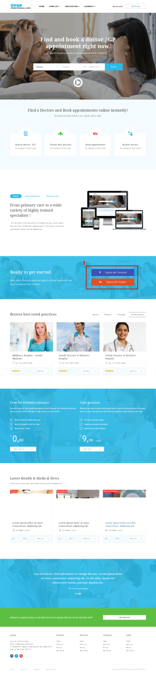
Description:
User can login with Social Media

Module: User
Subject: Home Screen
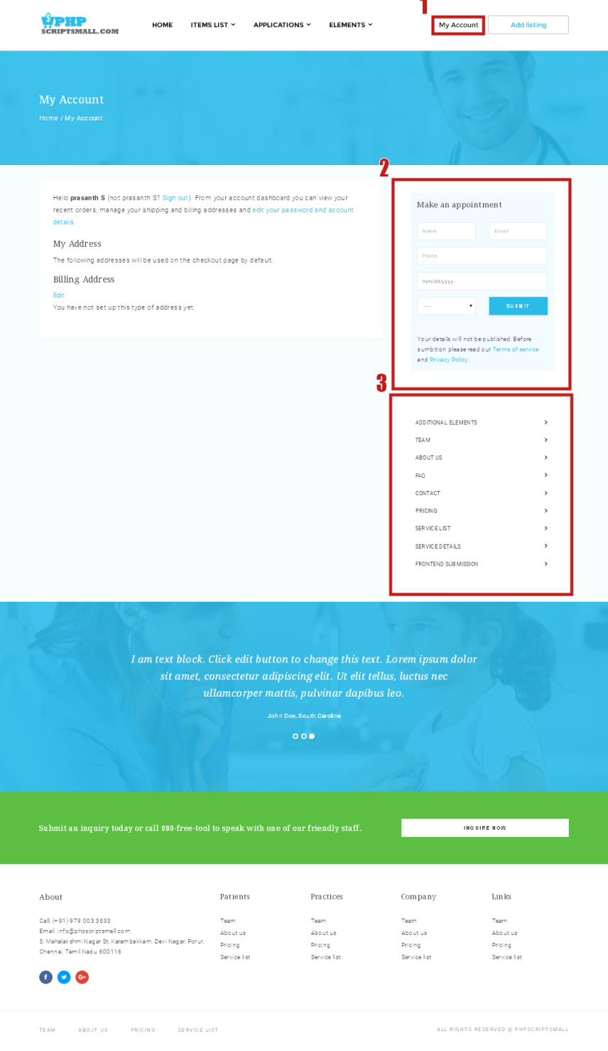

Description:
User Home Screen.
Module: User
Subject: Appoinment

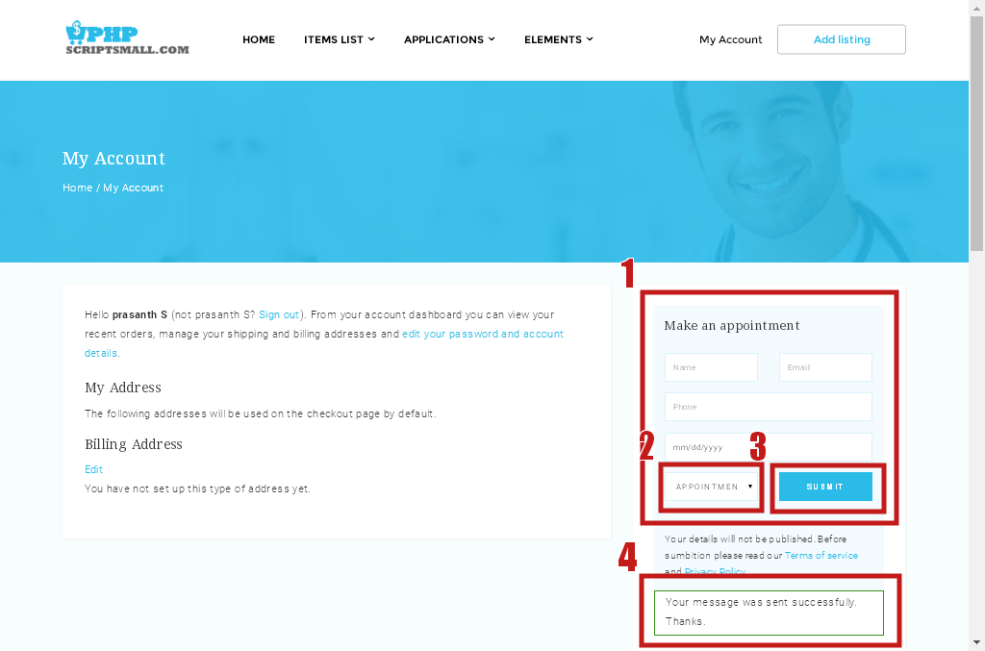

Description:
User Can book the appointment on user home screen

Module: User
Subject: Add Listing

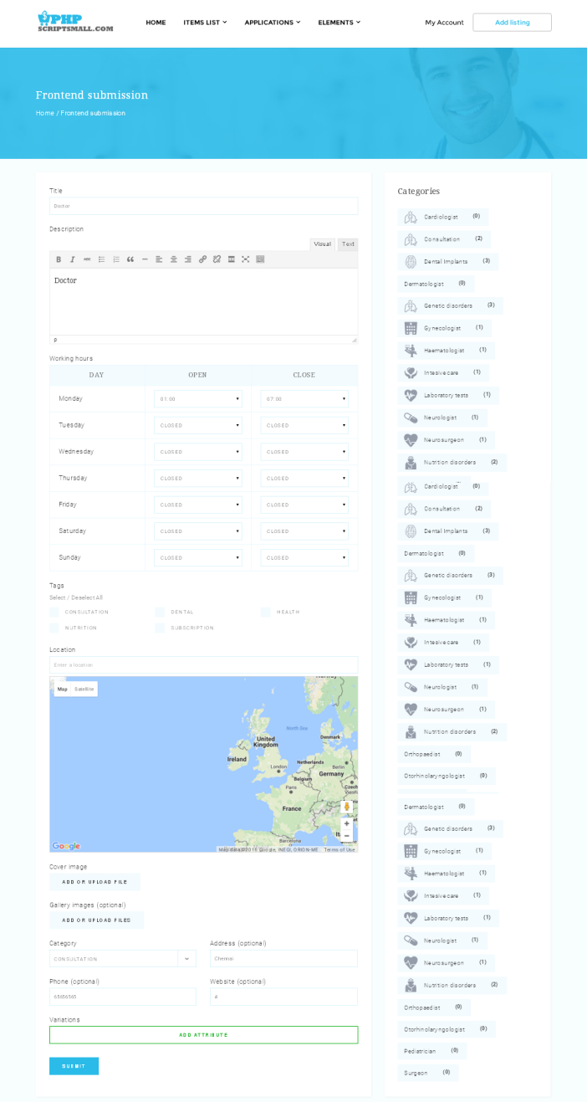

Description:
User Can book Add the new Product or listing

Module: User
Subject: View Listing

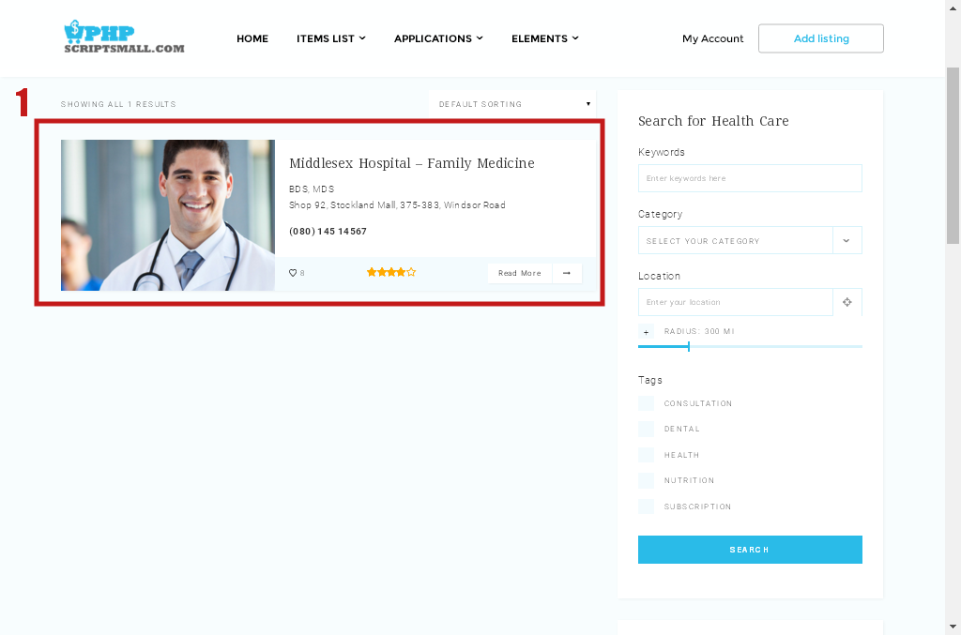

Description:
User Can View their Listing Details

Module: User
Subject: Search Listing
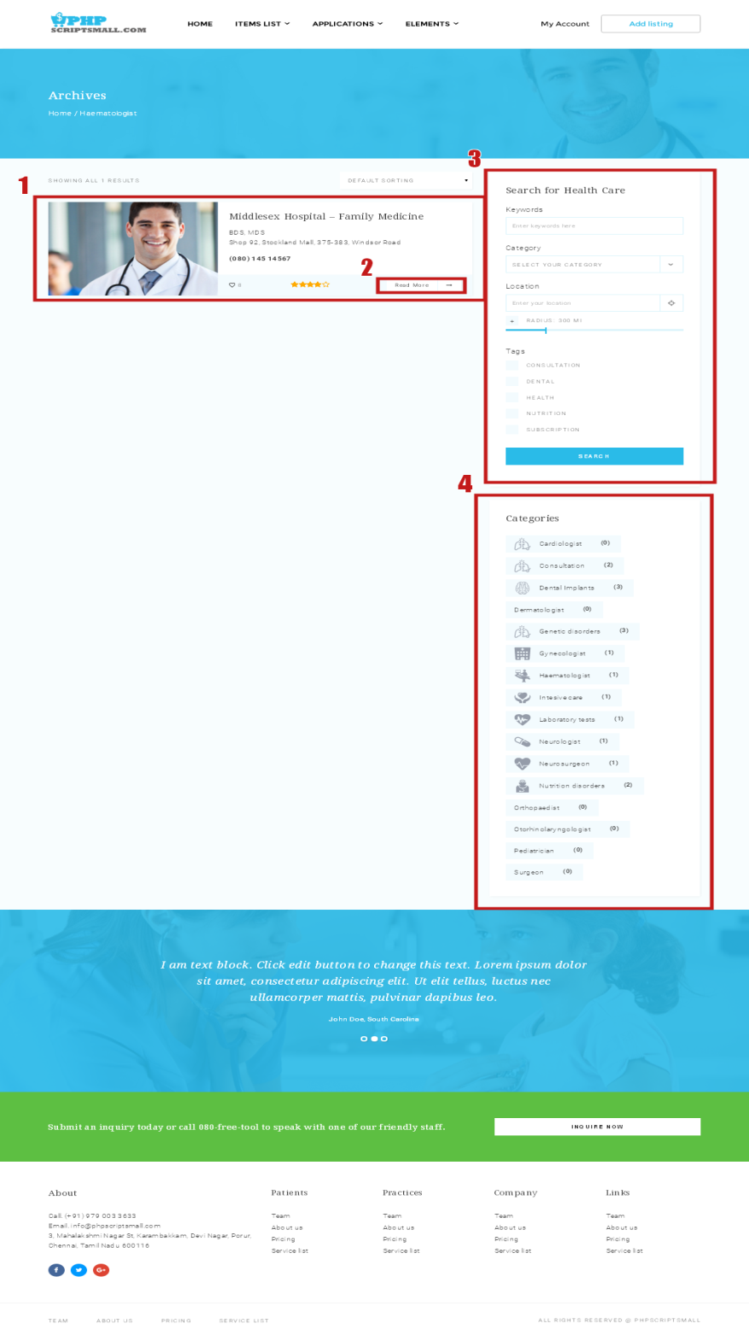
Description:
User Can Search their requirement through the search form and also the categories
Module: User
Subject: Single Listing
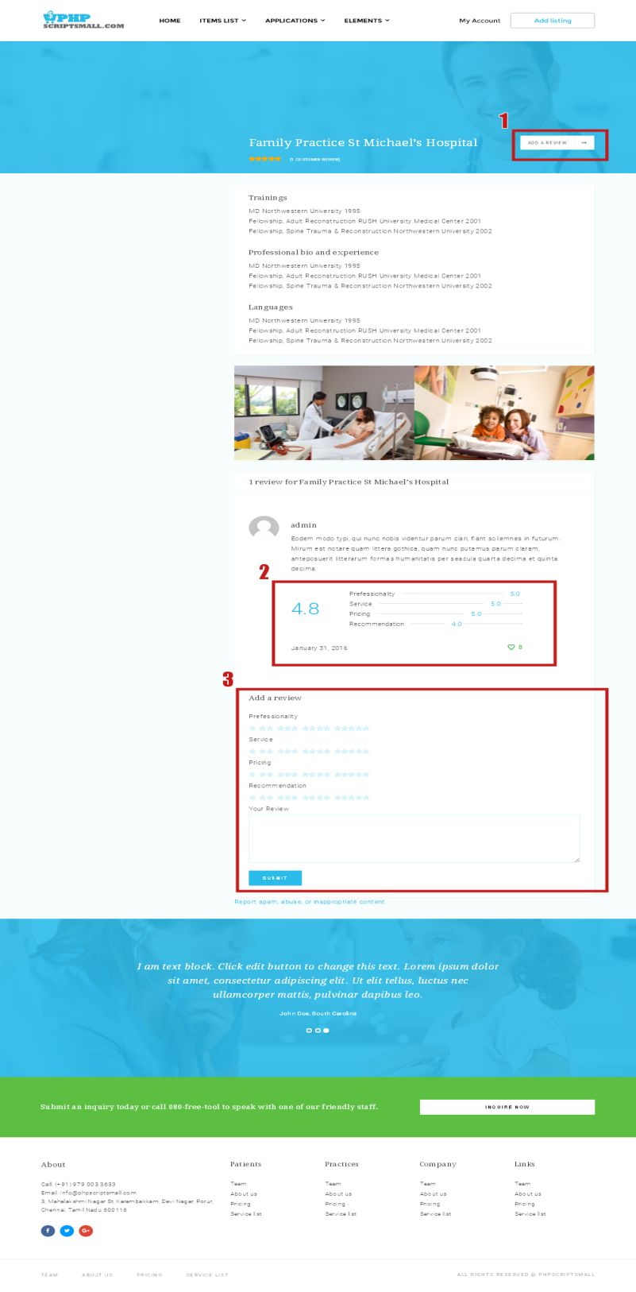
Description:
User Can View searched single Listing Details
Module: User
Subject: Advanced Search

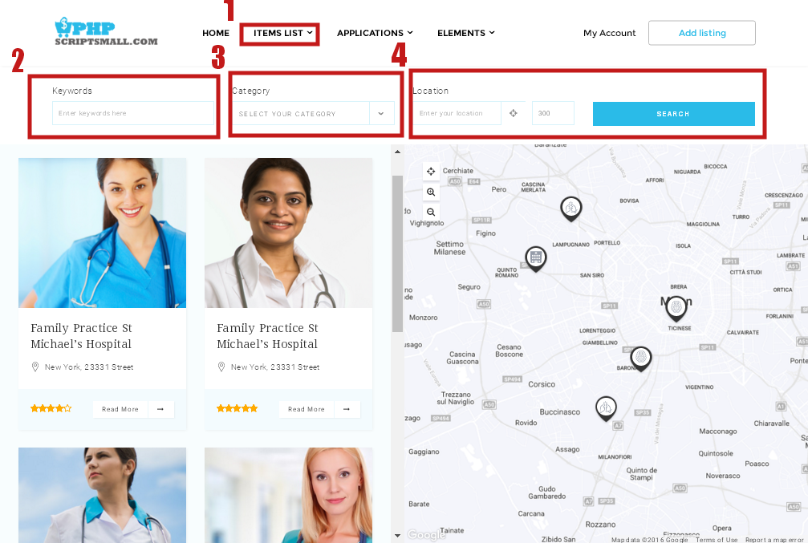

Description:
User Can View make advanced search here for their exact need

Module: User
Subject: Team Members

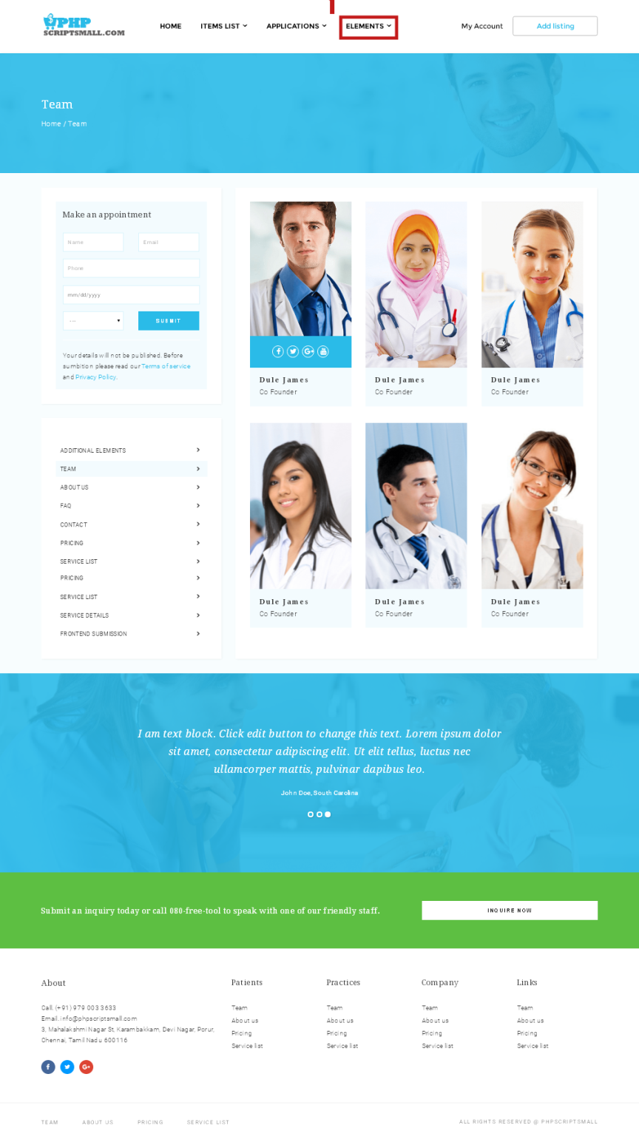
Description:
User Can View make the team members
Module: User
Subject: Service Details
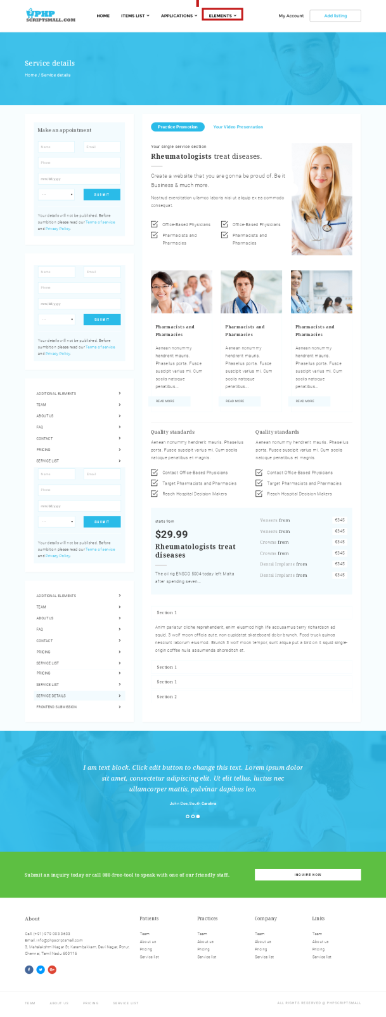
Description:
User Can View View the service details of the single listing
Module: User
Subject: Advanced Search

Description:
User Can View make advanced search here for their exact need

Module: User
Subject: Pricing Table

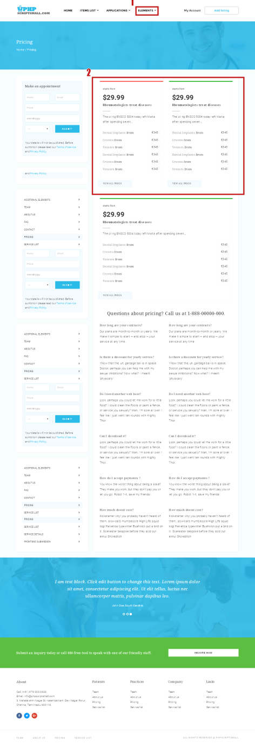

Description:
User Can View the pricing details of their service
Module: User
Subject: Affiliate Shop
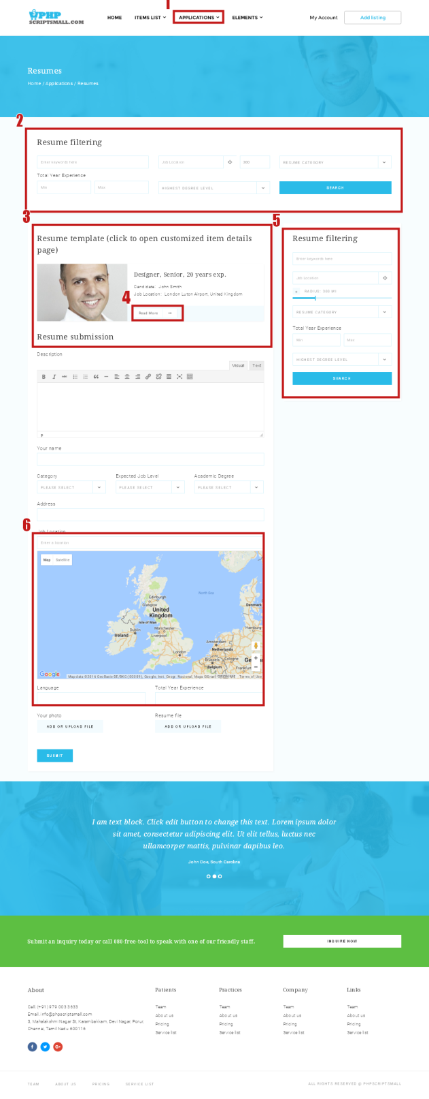
Description:
User Can View their related Products

Module: User
Subject: FAQ

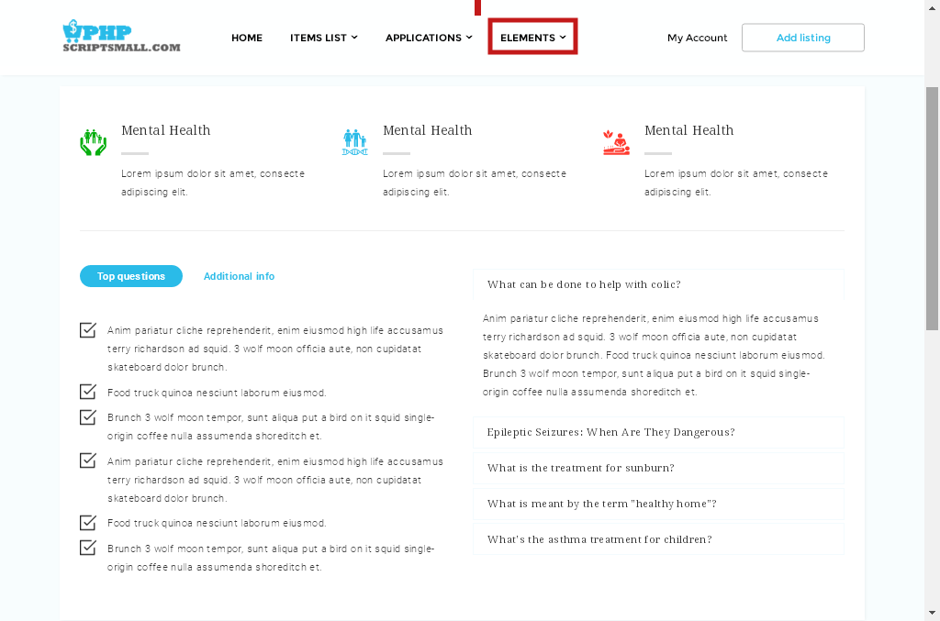

Description:
User Can clarify their doubts on here
Module: User
Subject: About Us
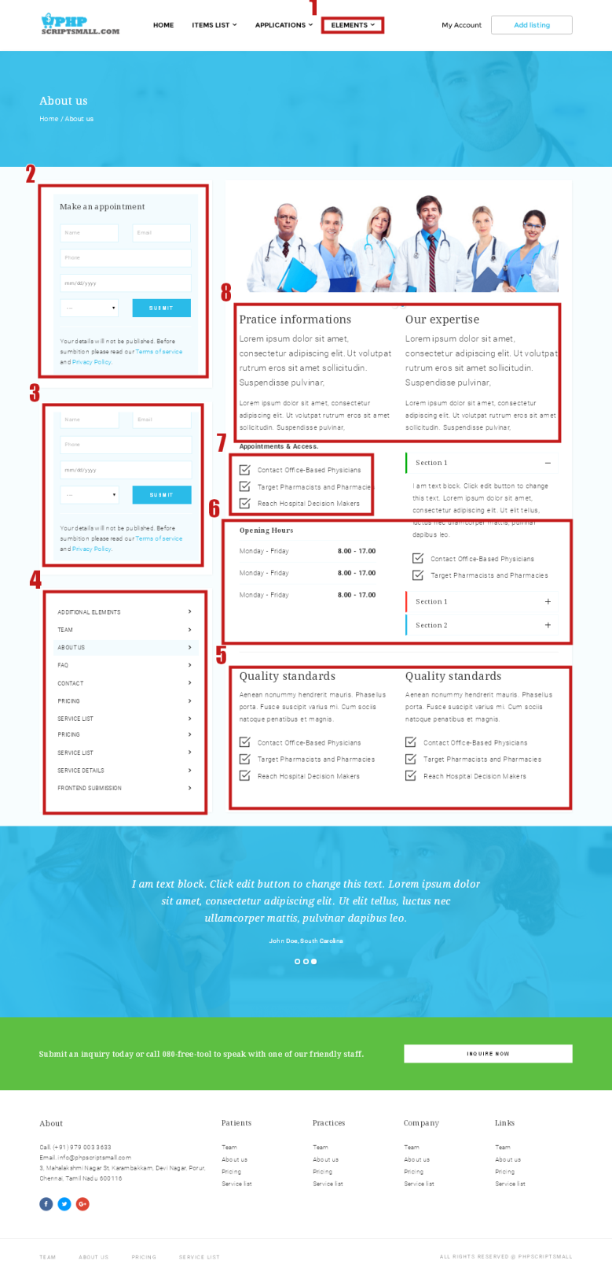
Description:
User Can View their details
Admin Side

Theme Control Panel Setting

Plugin Installation
Right after the theme was activated, a notification at the top of the screen will suggest continuing with the installation of the plugins recommended for getting the best out of your theme.
Follow steps to install:
Step 1 Click Begin installing plugins and select the plugins you need to install from the list.

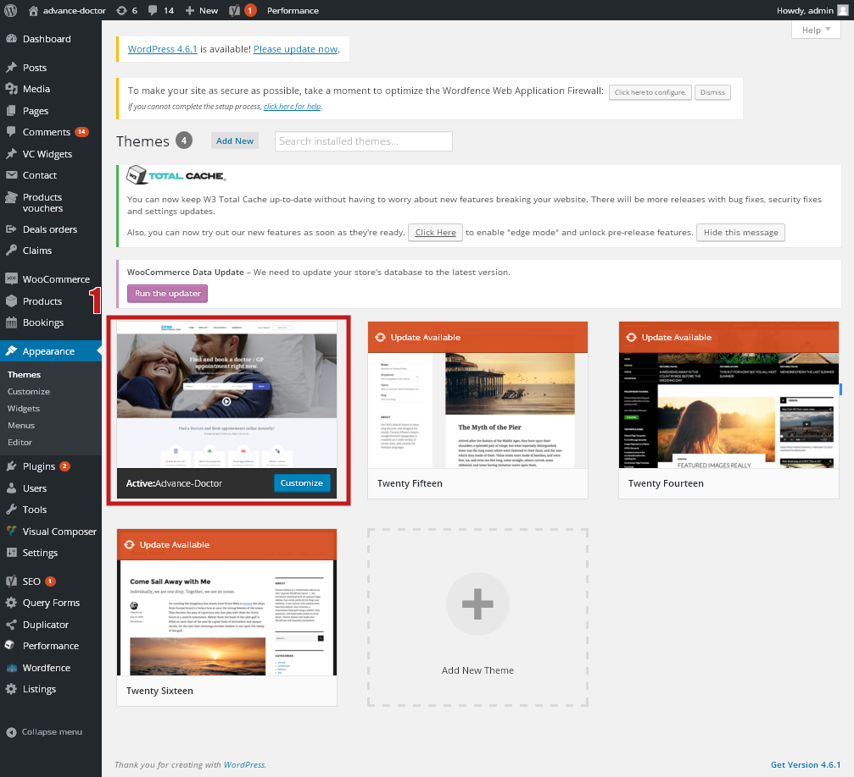
Step 2 Select all plugins then choose Install, click Apply to install all plugins

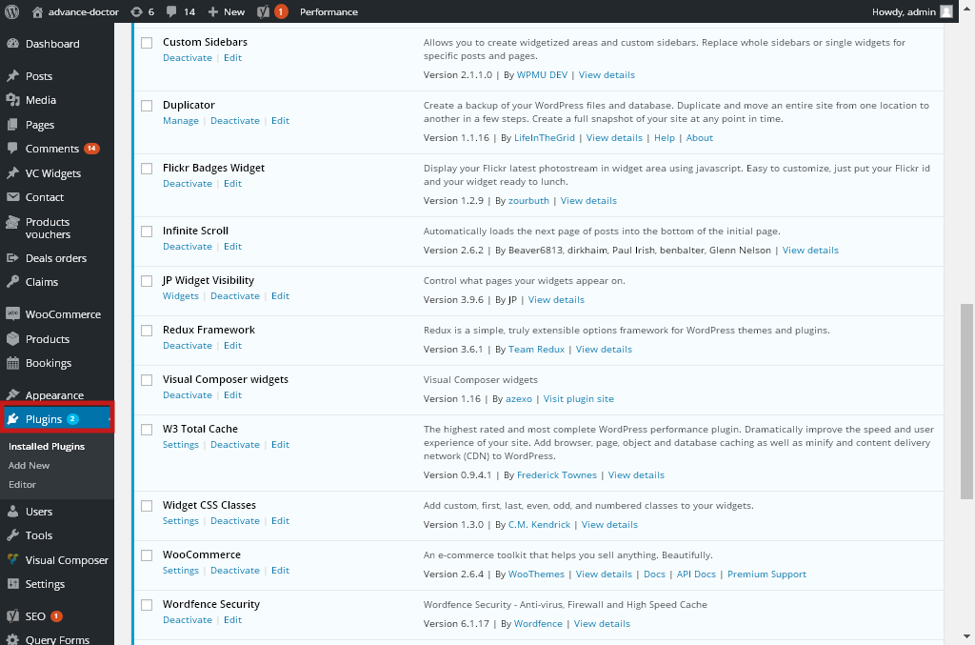

Widgets Setting:

Go to Admin Panel -> Appearance -> Widgets.
You can see all our widgets, easy to configure by drag and drop Widgets to sidebar.
Then you can use sidebars to position you want. Even you can use sidebar for MegaMenu.
More over you can search and add more plugins for your purpose by searching on the internet.
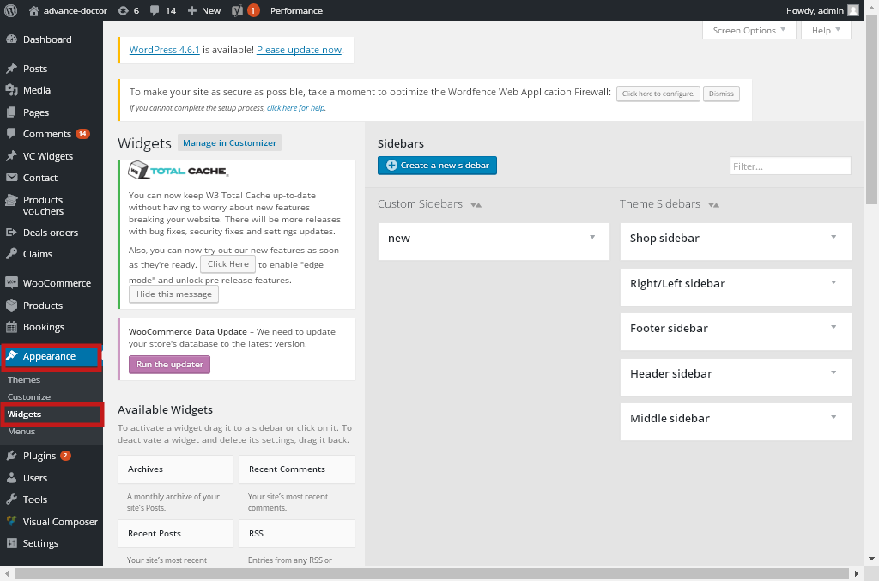

Menu Setting:
The following steps will guide you to define your menus by using the WordPress menu editor
In each menu, you can add as many items you need: links, pages, posts, custom links, and shop categories, direct links to products, internal or external link even sidebars

1. Use WordPress menu editor

a. Main Menu

- Navigate to Appearance → Menus and click the “Create a new menu” link.
- Enter a name for it the “Menu Name” box and click the Create Menu button.You can add as many items you need. Drag and drop to set sub menu or position of them.
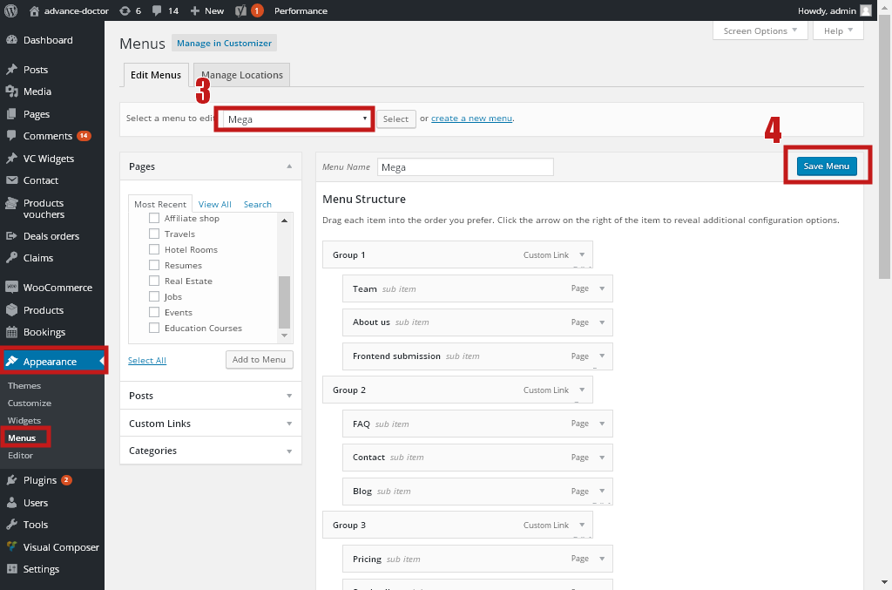

c. Manage Locations
- That tab allows you set menu location you want.

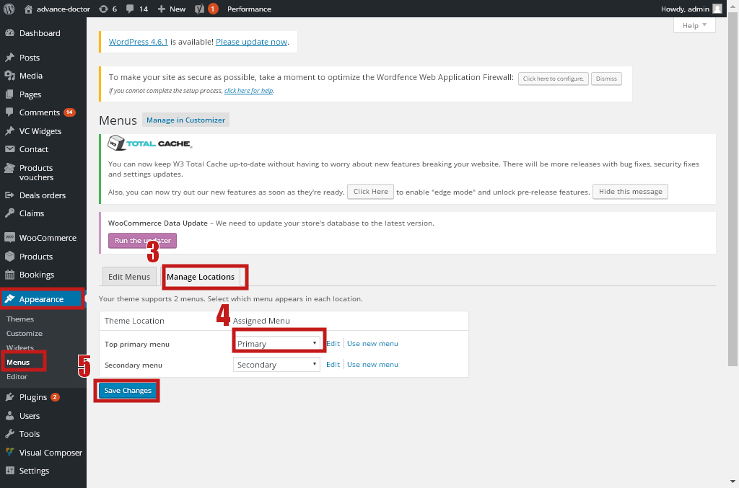

Home Page Setting:You can quickly build a home page using Visual Composer for WordPress that is drag and drop frontend and backend page builder plugin that will save you tons of time working on the site content. You will be able to take full control over your WordPress site, build any layouts you can imagine – no programming knowledge required
From your Dashboard admin Navigate to Pages
- Select All Pages to see all page then click edit one page you want
- Select Add New to create new page
One page always includes a lot of parts like Header, Main Page, Widget Sidebar and Footer. In that section we guide you create Main page by using Visual Composer.

Set a page as Home Page
To set one of the pages you already have created as the Home page for your site, from your WordPress dashboard, navigate to Settings → Reading.
Select “A static page” and choose “Your Homepage” as the Front Page.
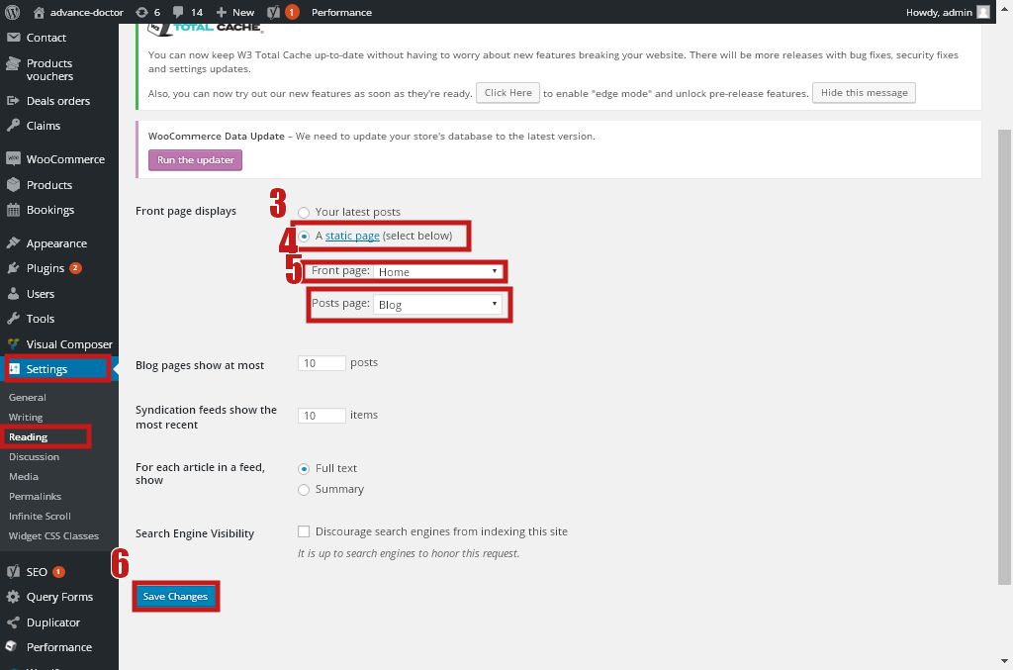
Subject: Dashboard

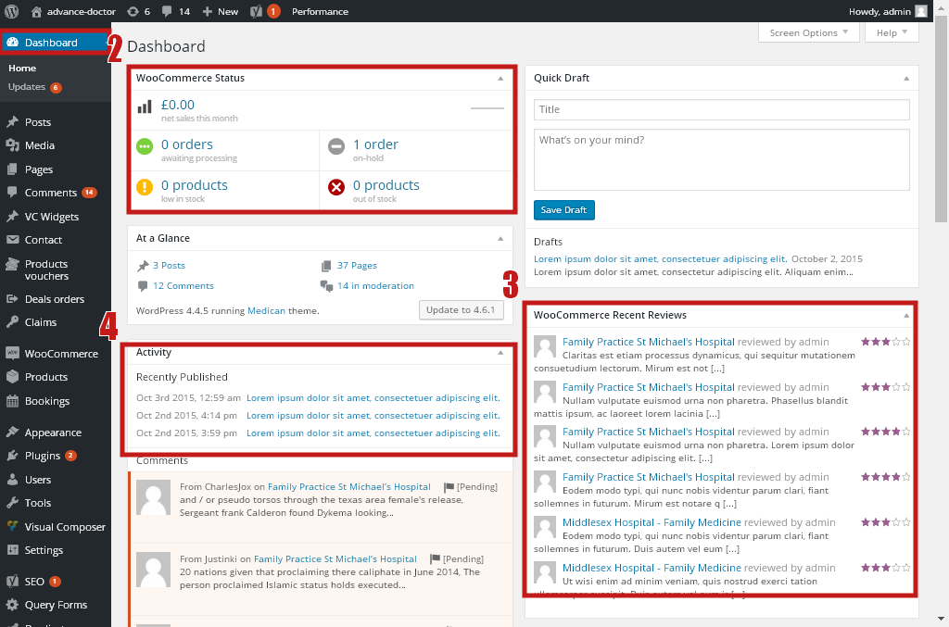

Description:
Admin can overview the website in Dashboard

Subject: Appointment Settings
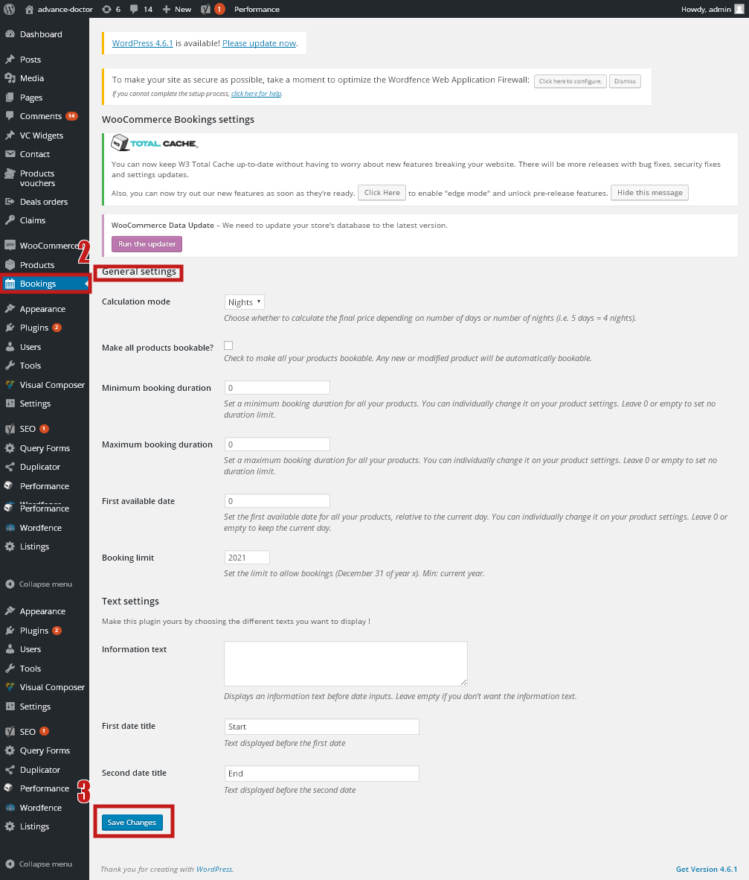
Description:
Admin can Manage the appointment settings
Subject: Products Management
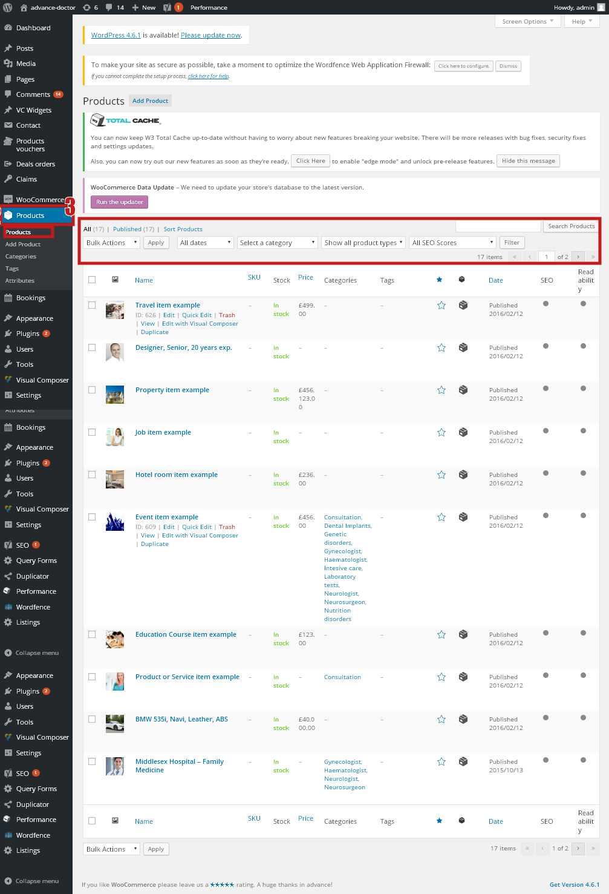
Description:
Admin can manage the product details

Subject: Category Management
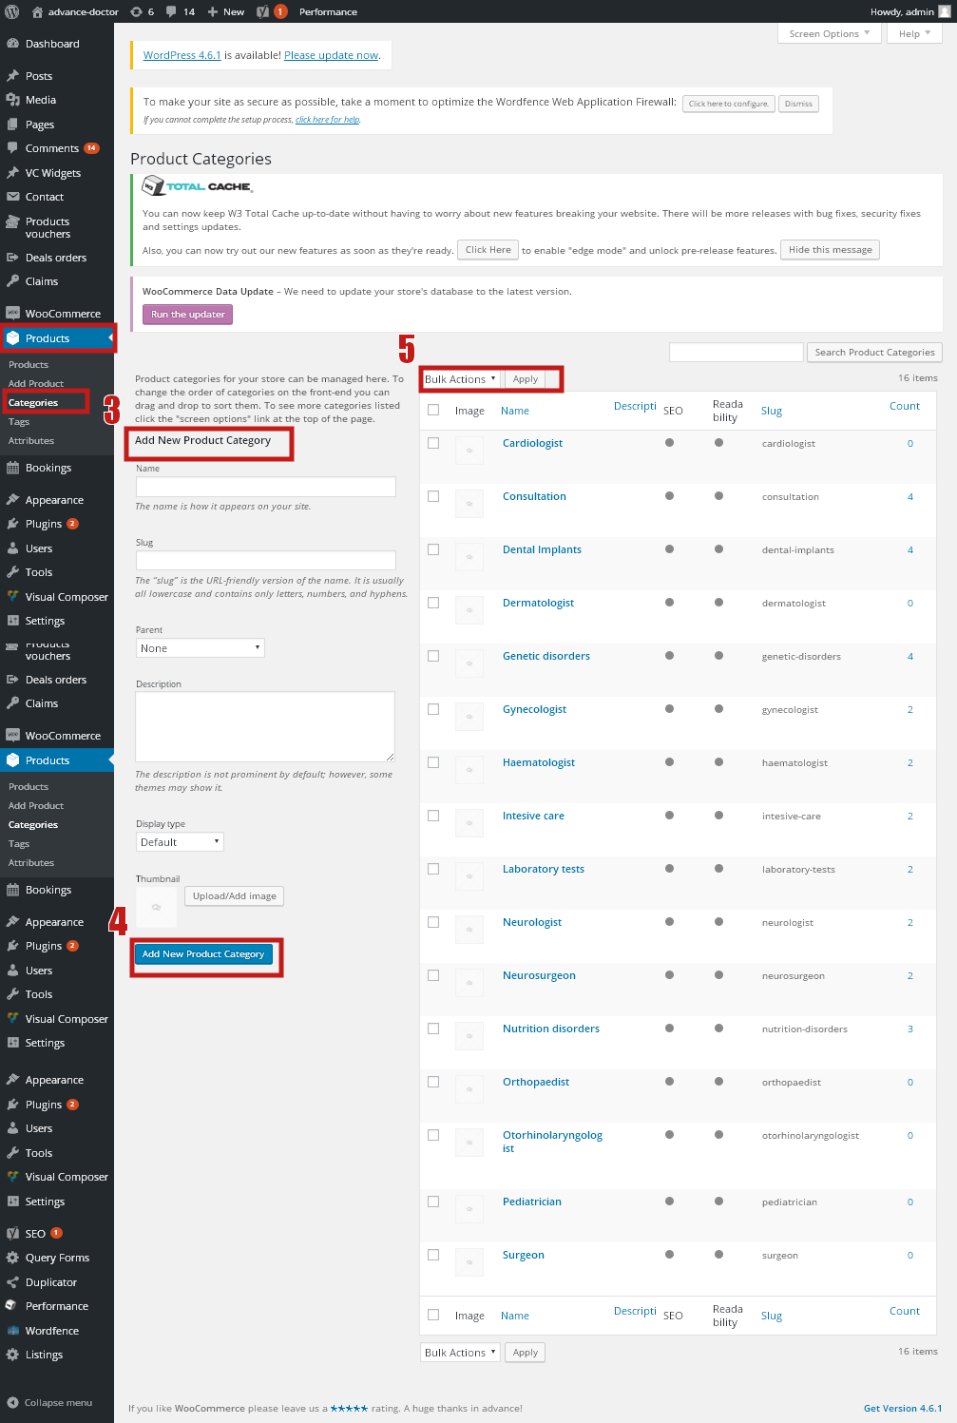
Description:
Admin can manage the Category details
Subject: Listing Management

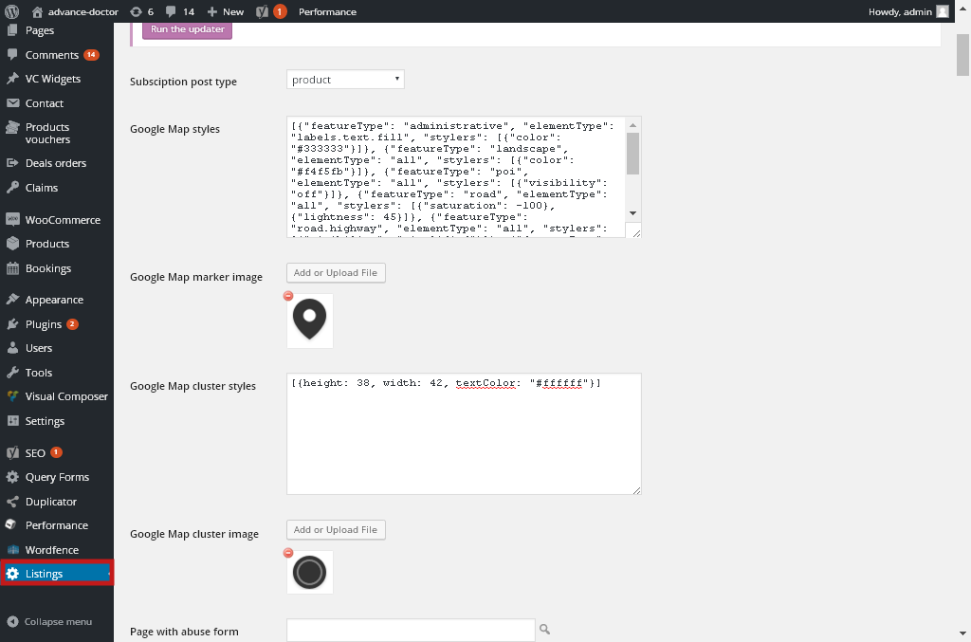

Description:
Admin can manage the Listing Management

Subject: General Settings
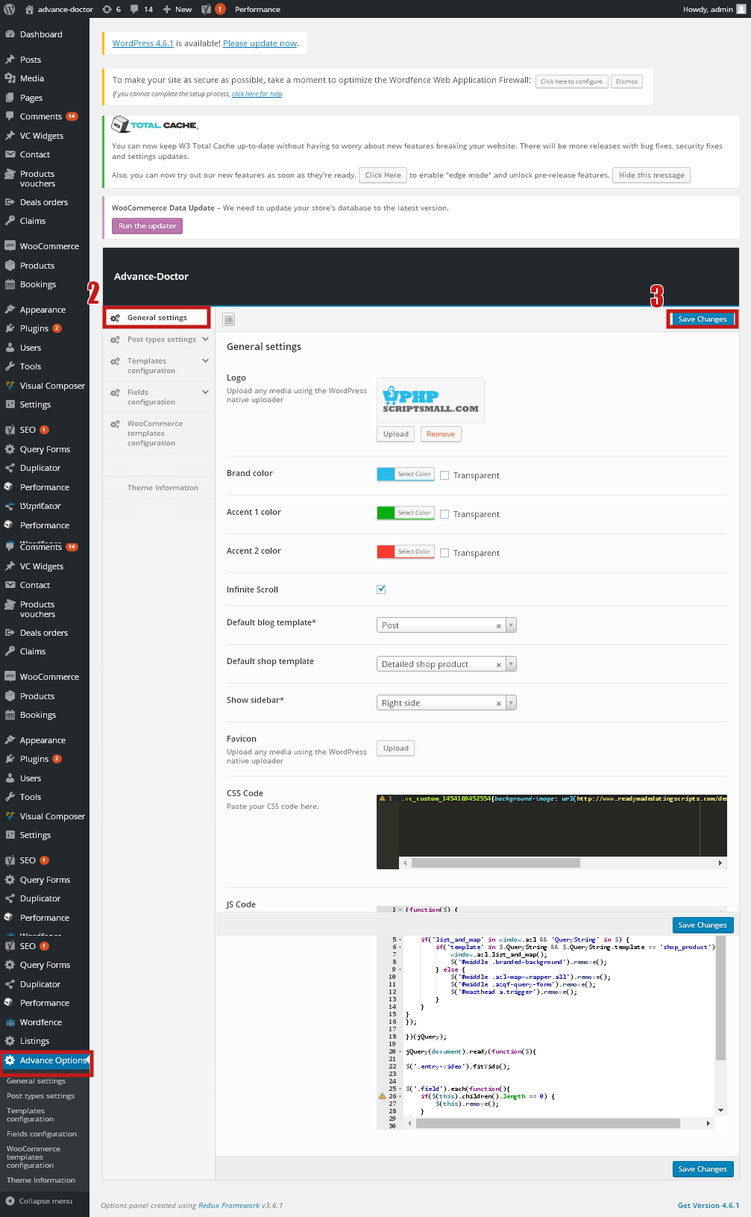
Description:
Admin can Moderate the Script Settings in here
Subject: User Management

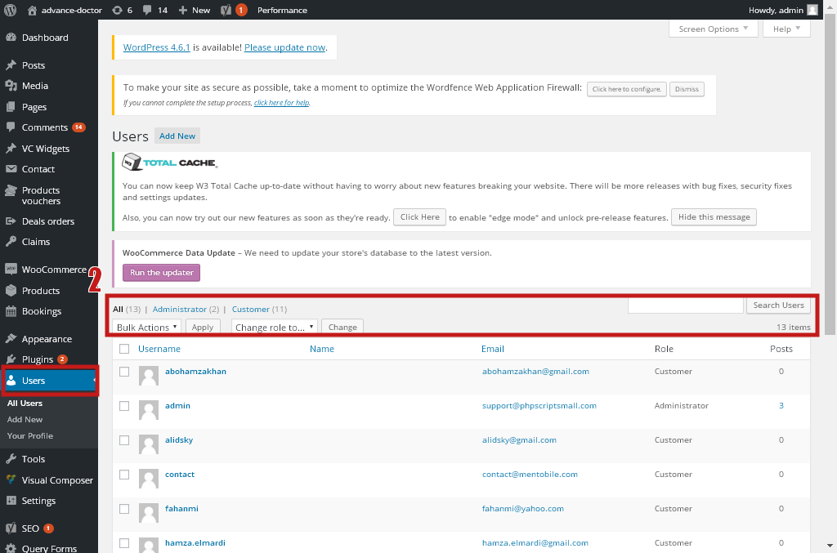

Description:
Admin can manage User Details

Subject: Deal Orders

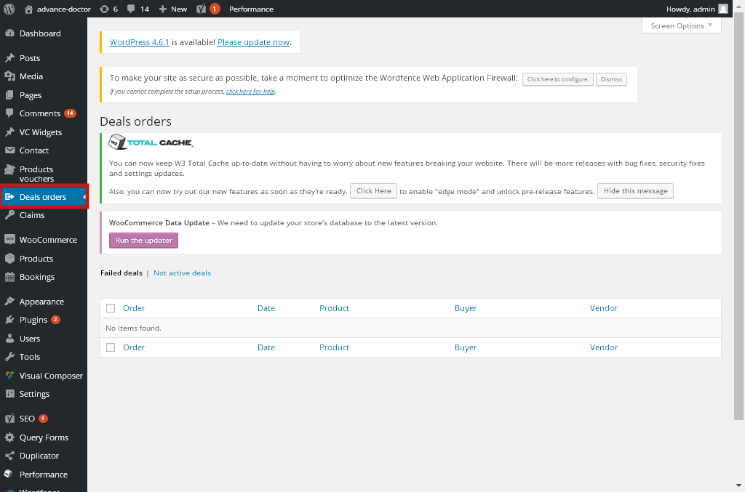

Description:
Admin can manage the Deal orders

Subject: Claim Management

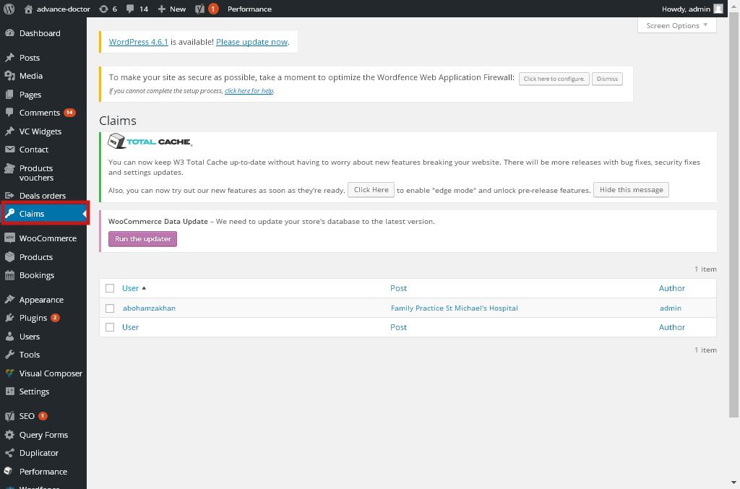

Description:
Admin can manage the Claim Details

Subject: Voucher Management

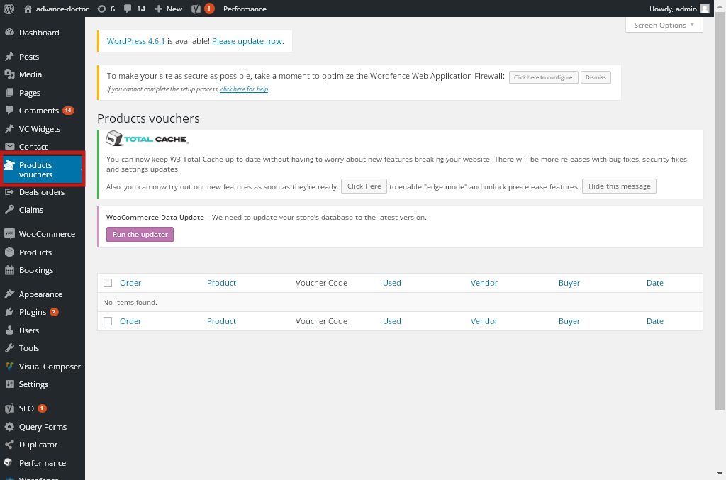

Description:
Admin can manage the voucher details

Subject: Contact Form Management

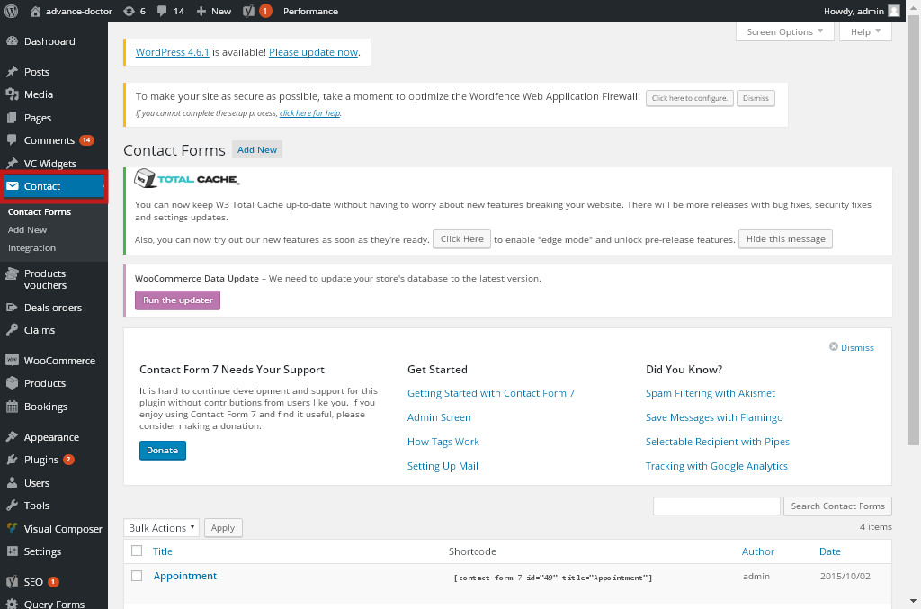

Description:
Admin can manage the Contact From Details

