**OLX CLONE MANUAL GUIDE**

**Theme options:**

**Over view**

**Activity:**

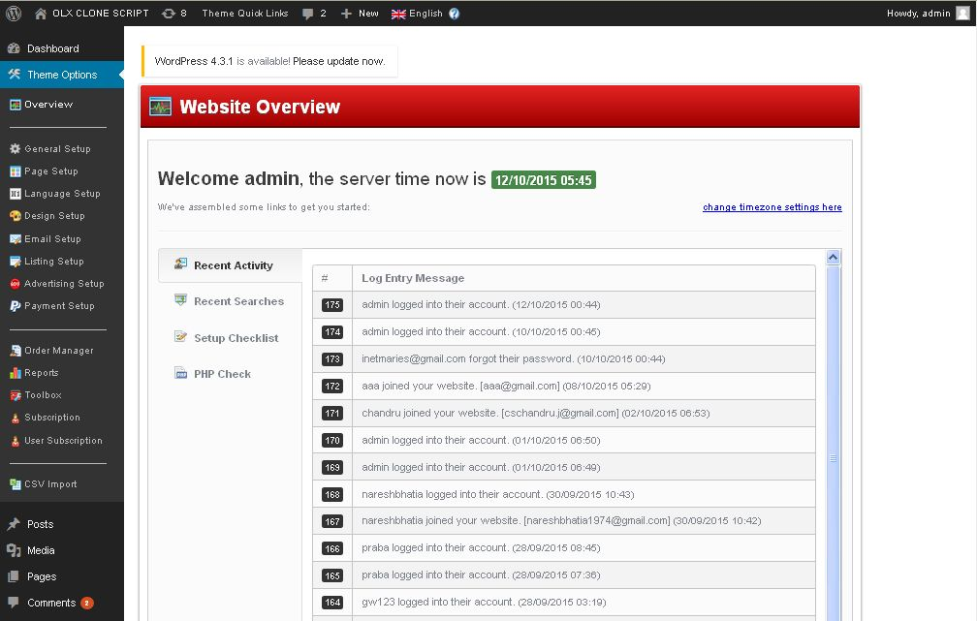

**Description:**

Admin can view recent activity of their website. Admin can check all logged details

**Recent search:**

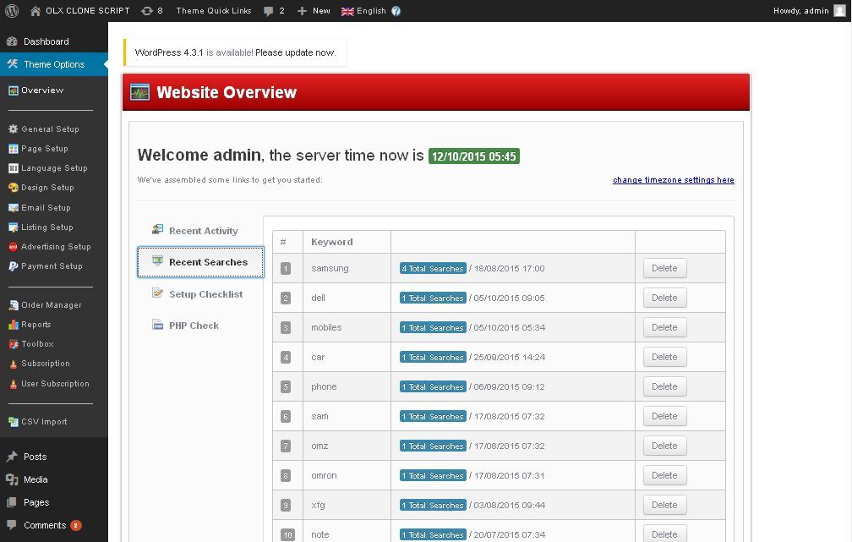

**Description:**

Admin can view their site search details with their keyword

**Setup checklist:**

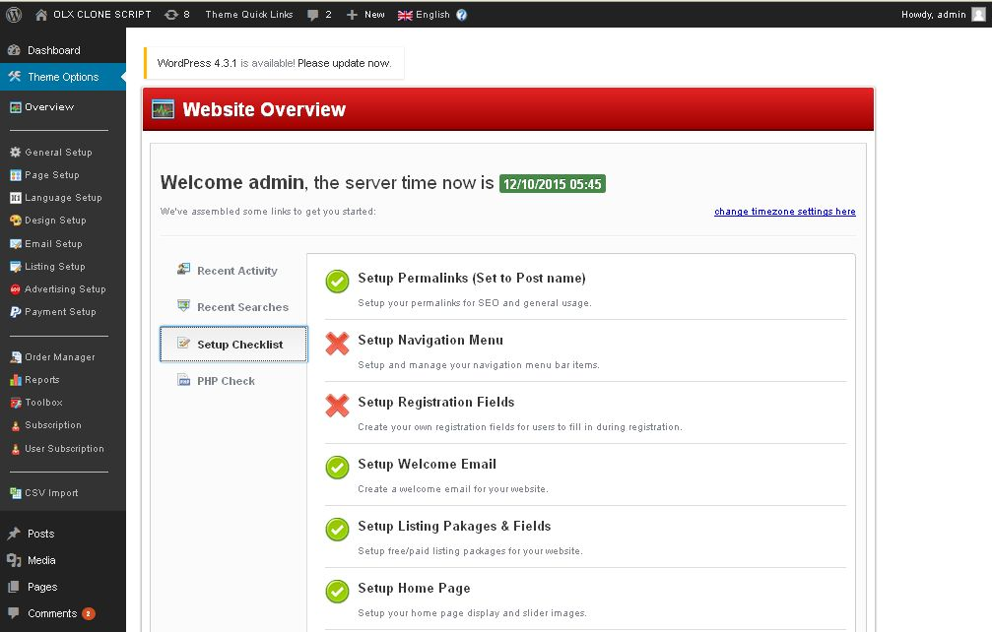

**Description:**

Admin can check all the navigation setups and all the feature functionality setup status

**PHP Check:**

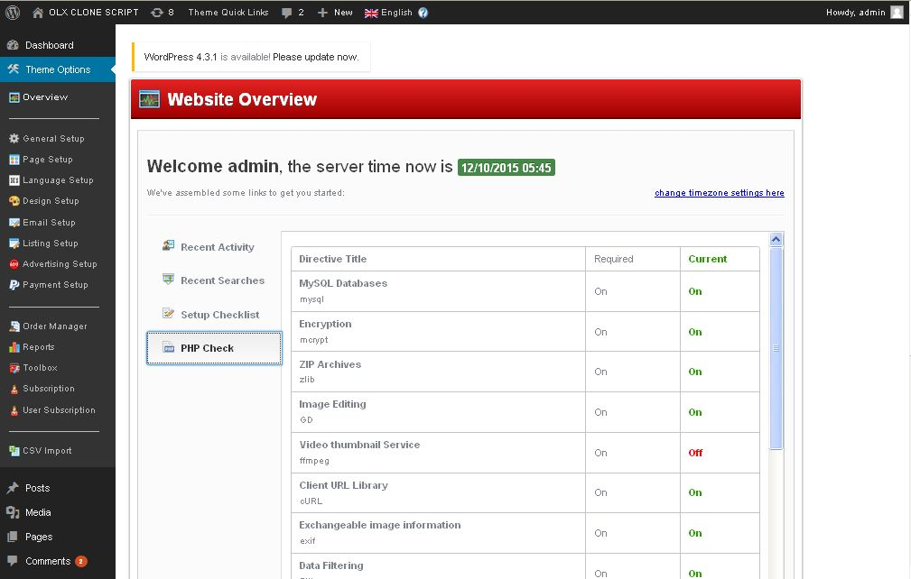

**Description:**

Admin checks PHP setup status and working modes

**General settings:**

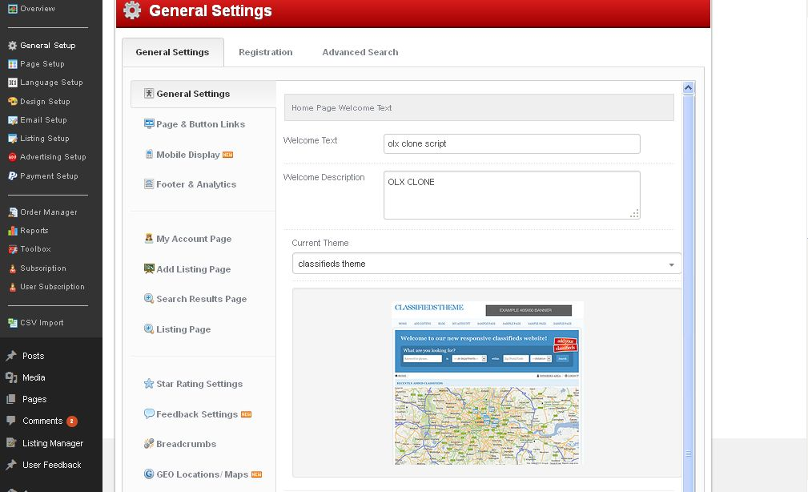

**Description:**

Admin can mange home page welcome text and description and LOGO and image display settings

**Page and button link:**

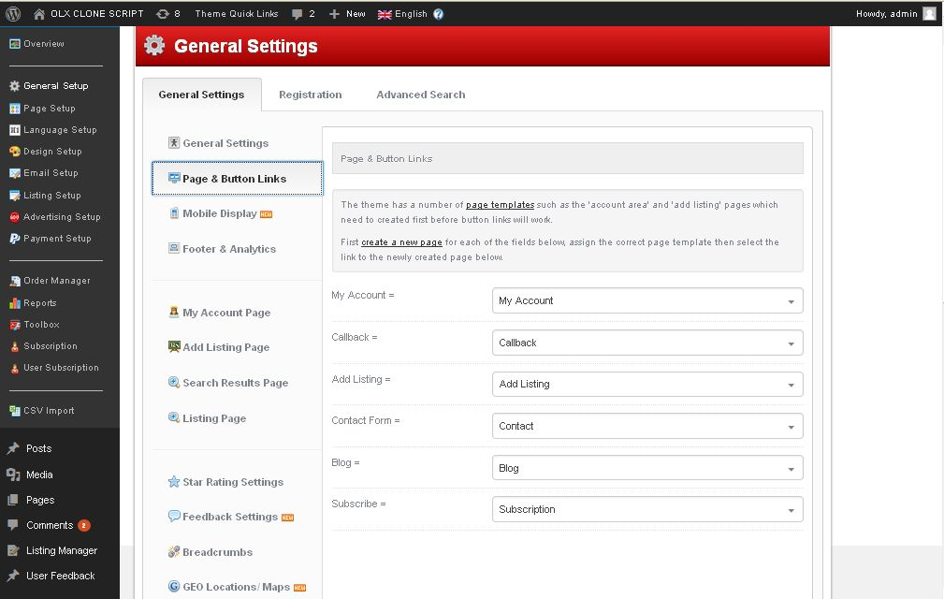

**Description:**

Admin can manage link for the pages

**Mobile display:**

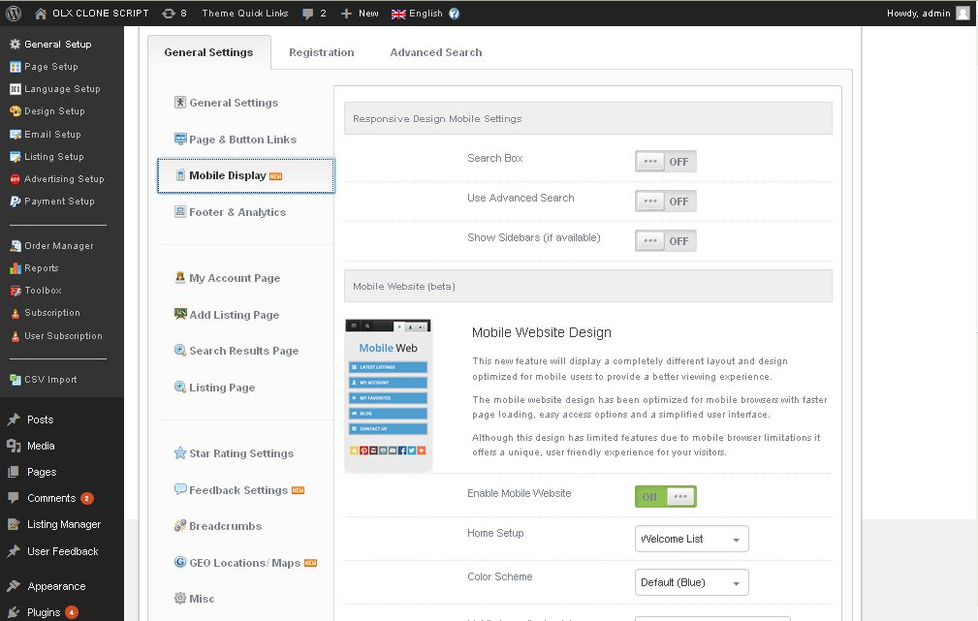

**Description:**

Admin manage settings of mobile appearance and design settings

**Footer analysis:**

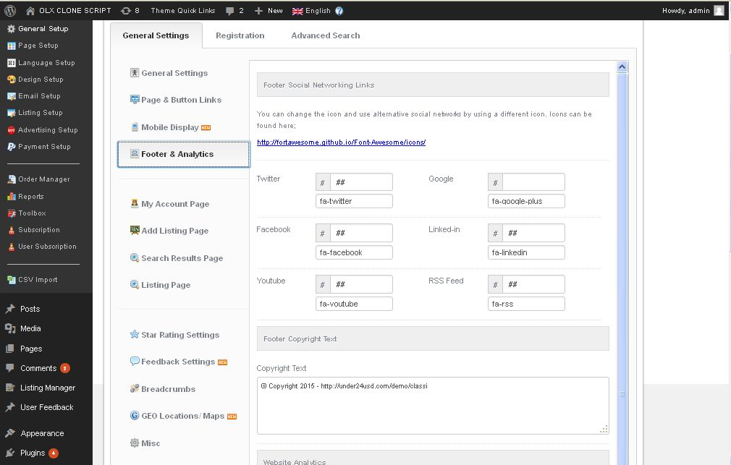

**Description:**

Admin manage footer social network links settings and footer descriptions

**My account page:**

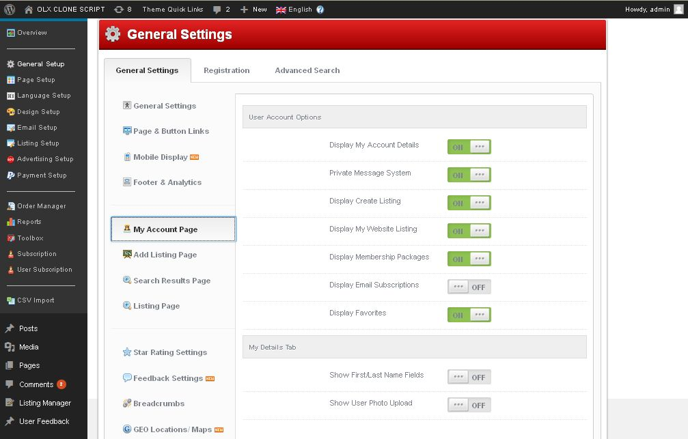

**Description:**

Admin manage their account appearance settings in their sites

**Add listing page:**

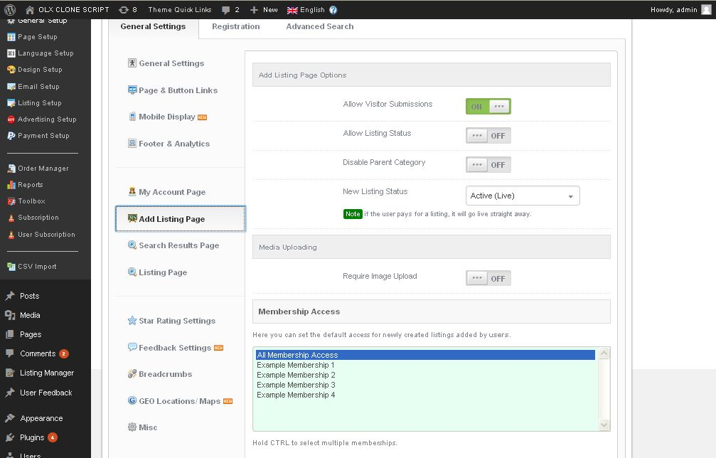

**Description:**

Admin manage add listing page visibility settings on their site and allow who all are can apply settings

**Search result page:**

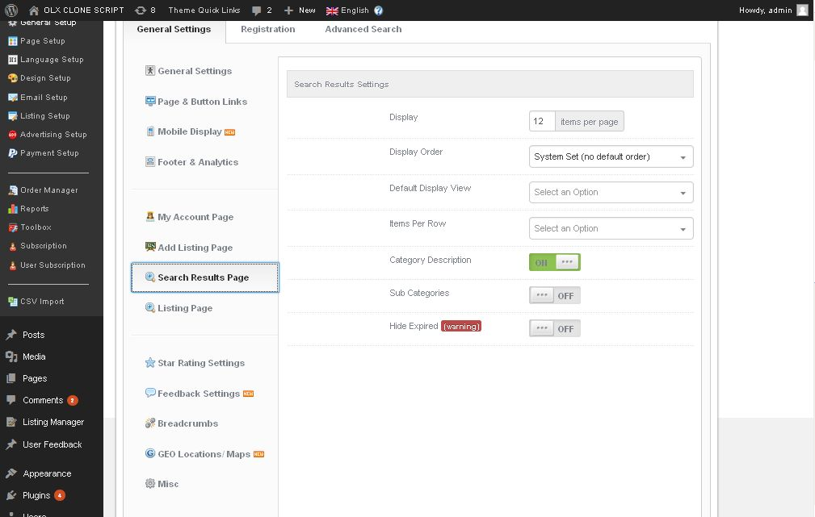

**Description:**

Admin manage search result page appearance settings

**Listing page:**

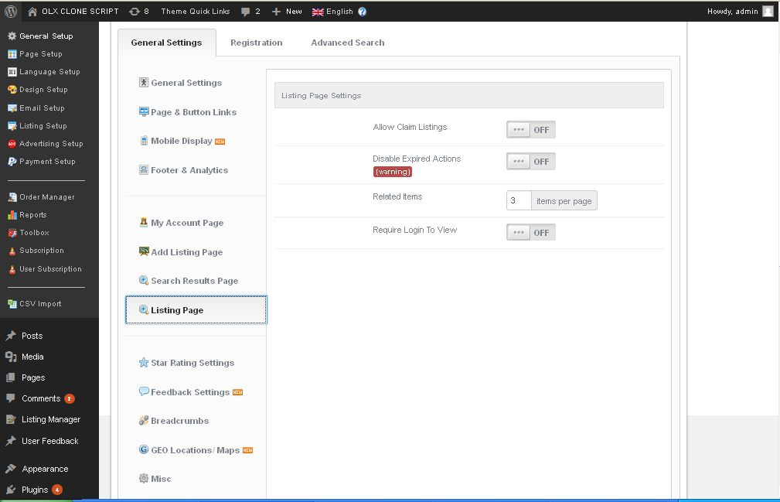

**Description:**

Admin manage display settings of listing page

**Star rating page:**

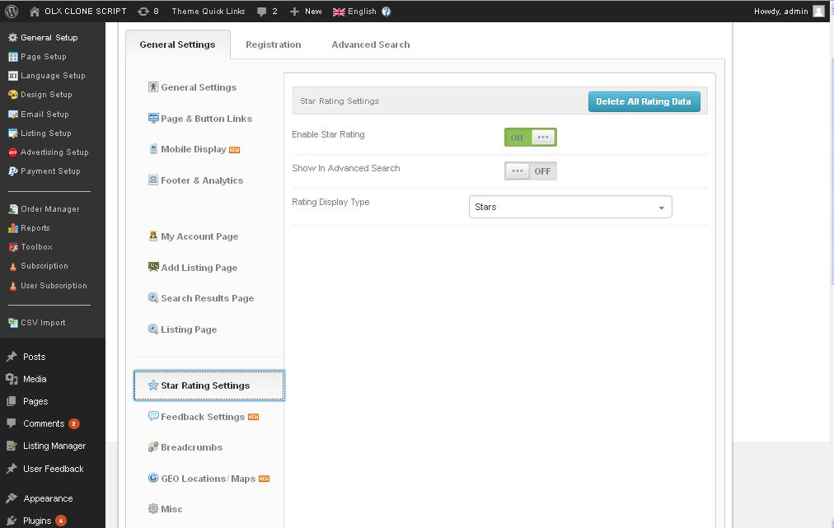

**Description:**

Admin allow permission for star rating settings and manage delete options

**Feedback settings:**

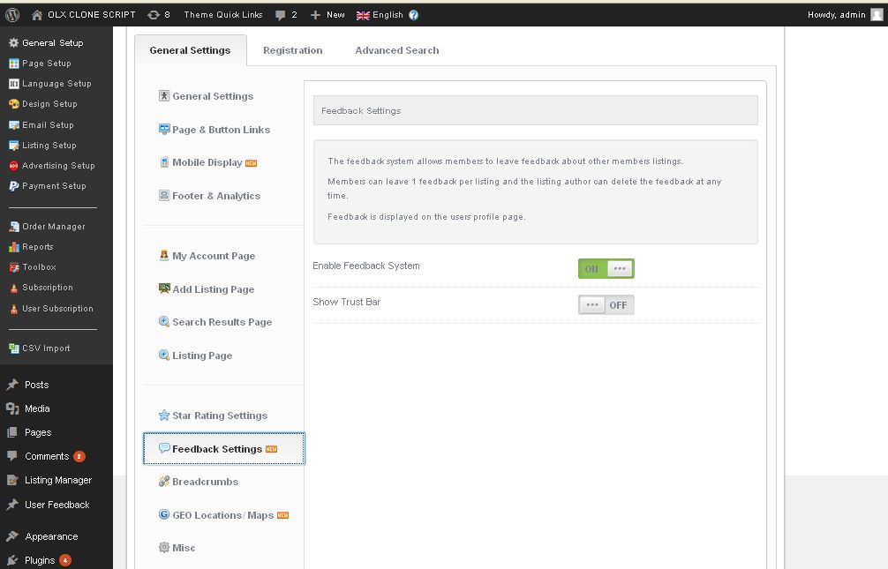

**Description:**

Admin manage settings of feedback option available on user site

**Breadcrumb settings:**

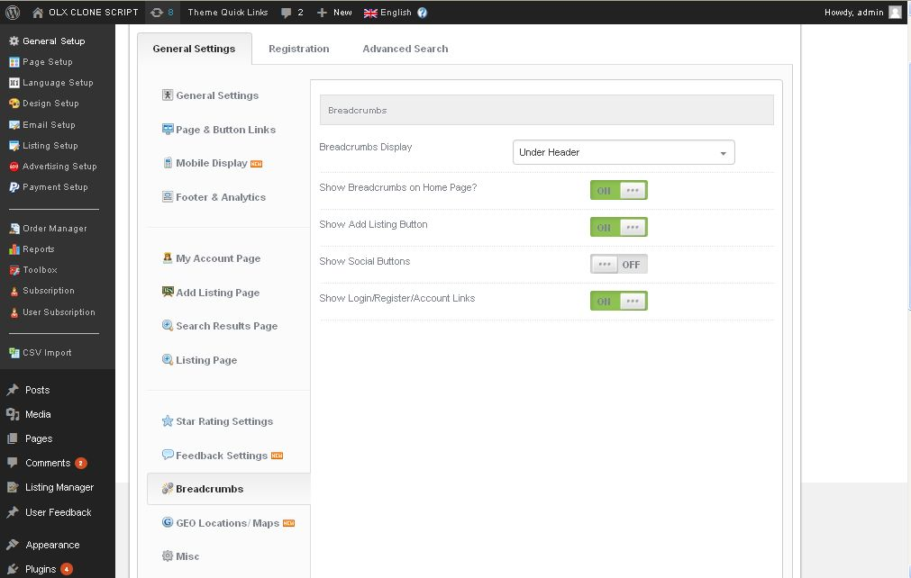

**Description:**

It’s using navigation tool that allows users to see where the current page is in relation to the website

**GEO location and map settings:**

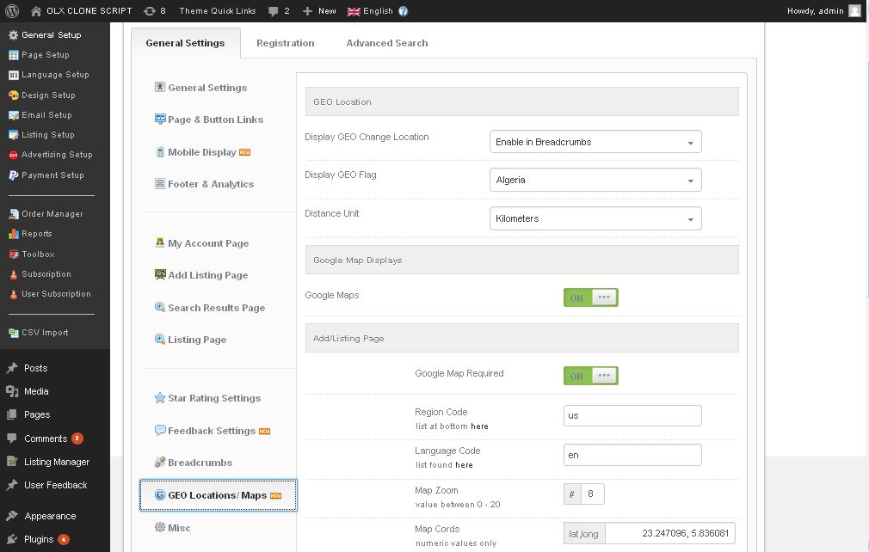

**Description:**

Admin manage settings of map and geo location

**Misc settings:**

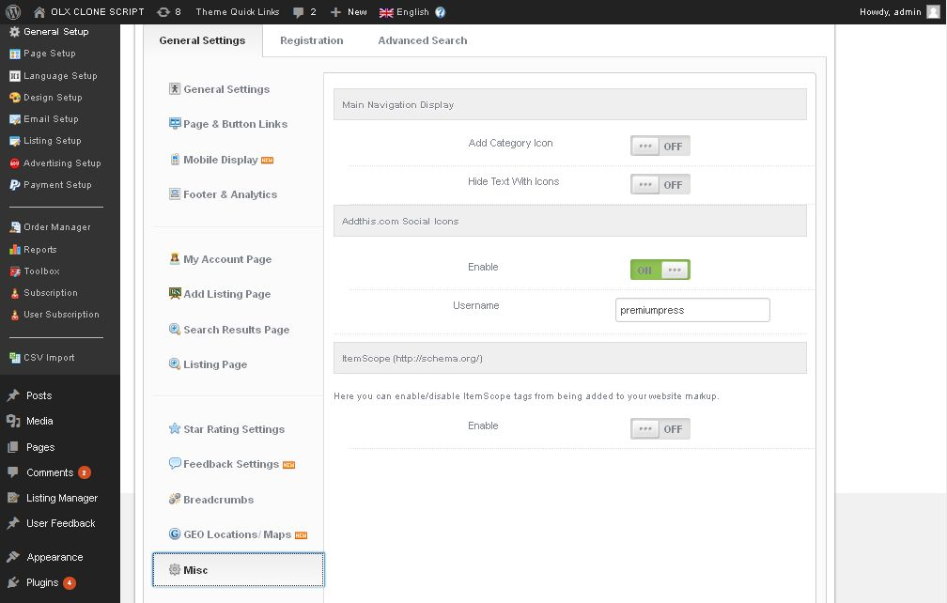

**Description:**

Admin manage navigation page settings and social icons settings

**Registration settings:**

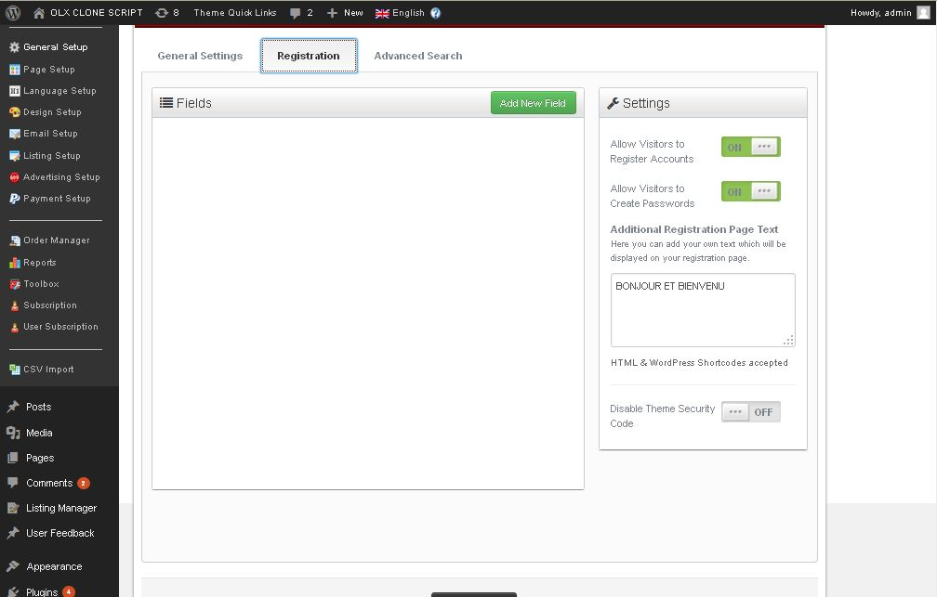

**Description:**

Admin give permission for user registrations and allow to create own password

**Advance search settings:**

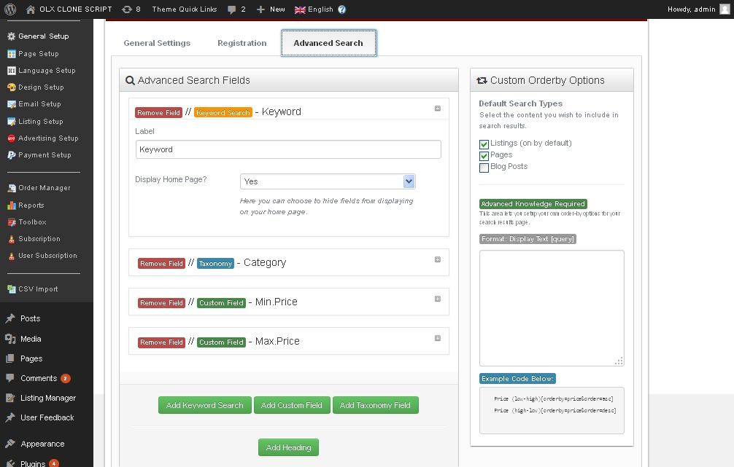

**Description:**

Admin manage keyword, custom field, taxomony fields in this page

**Page setup:**

**General layout settings:**

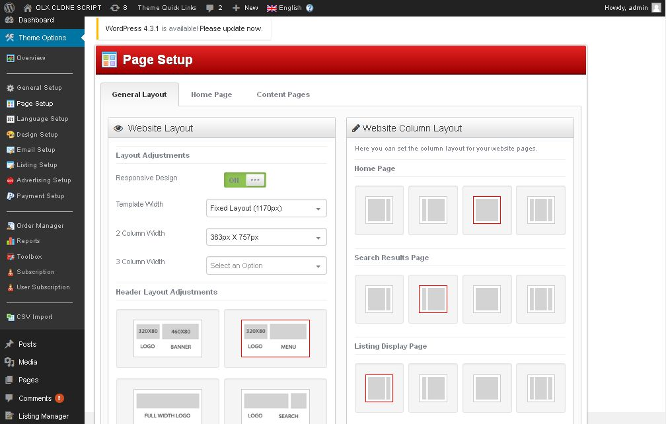

**Description:**

Admin manage layout settings of home page, result page, listing display page, menu and header layout settings

**Display settings:**

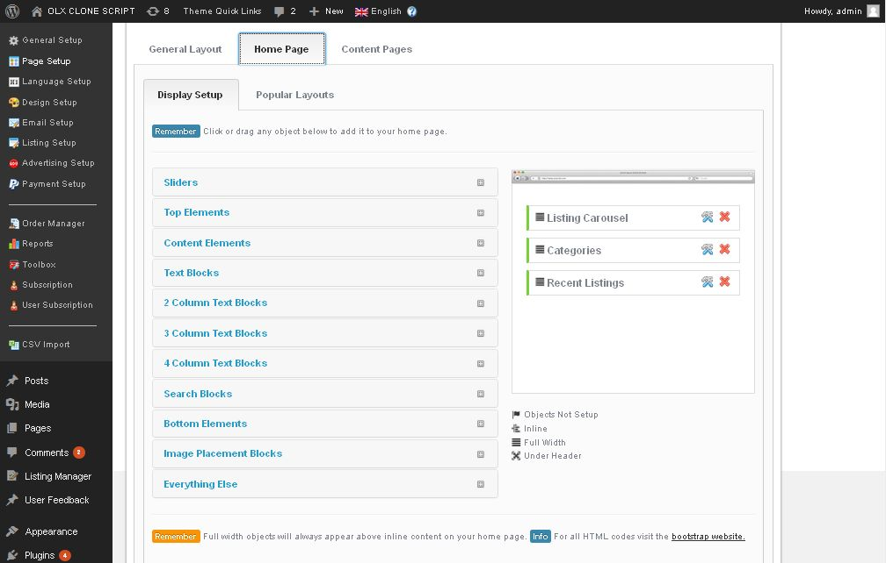

**Description:**

Admin manage settings of bootstrap settings

**Popular layout settings:**

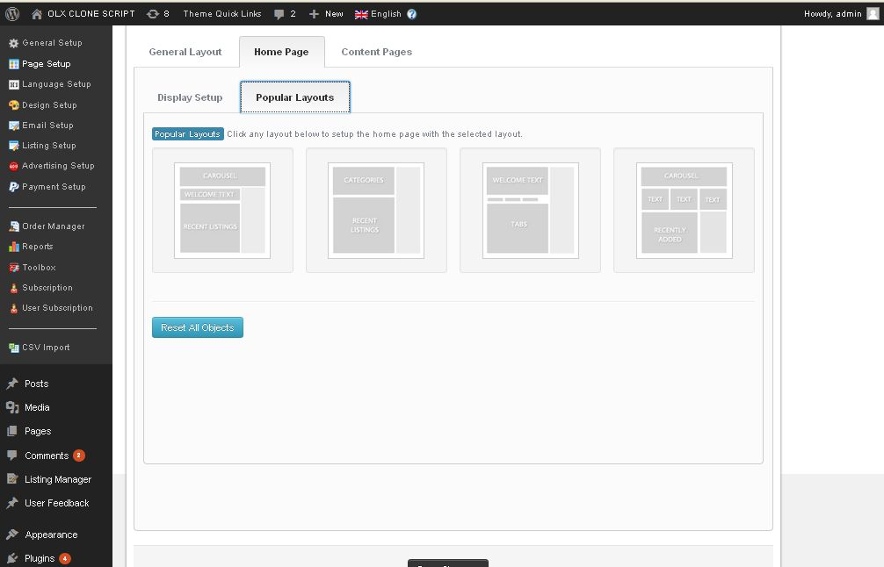

**Description:**

Admin manage home page layout settings

**Content page settings:**

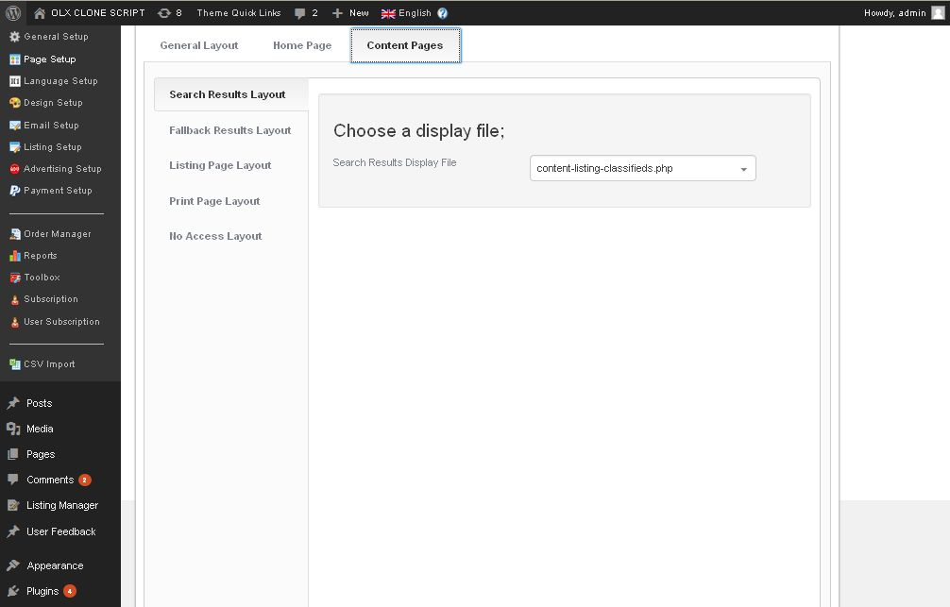

**Description:**

Admin manage following pages layout search result , fallback result, listing page, print page, no access page layouts

**Language settings:**

**Text translation settings:**

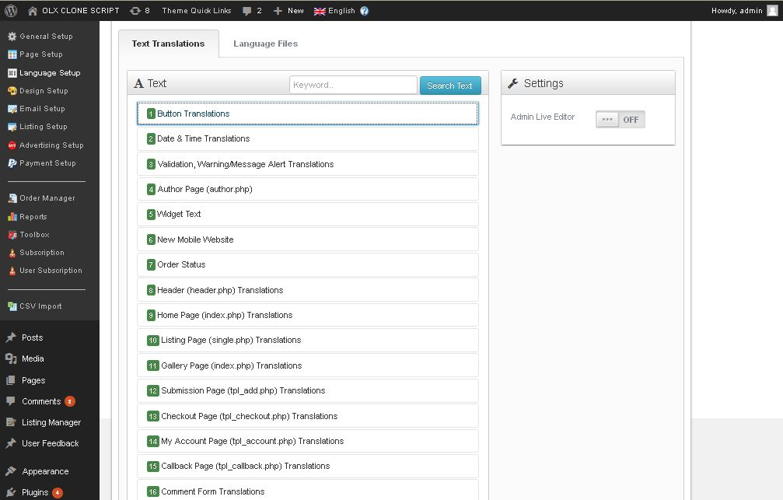

**Description:**

Admin manage settings of translation

**Add language settings:**

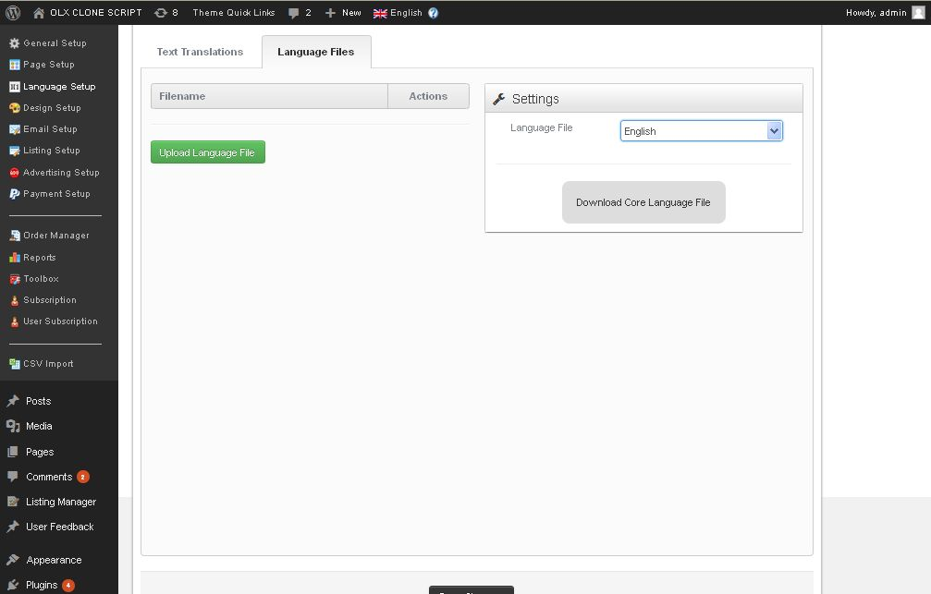

**Description:**

Admin can add and manage language

**Design settings:**

**Button color settings:**

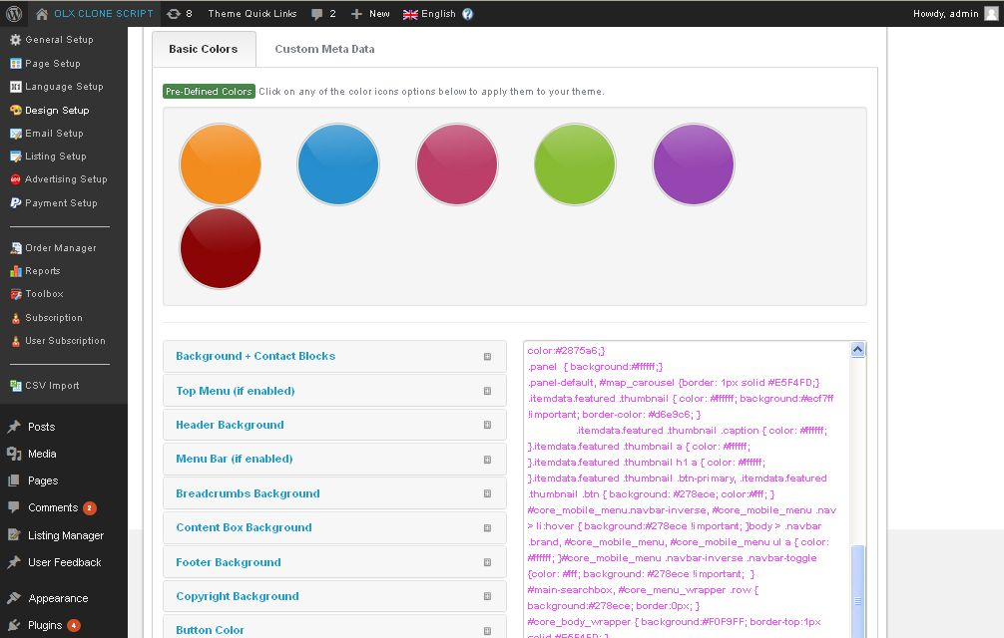

**Description:**

Admin manage settings of basic color of all fields

**Custom design settings:**

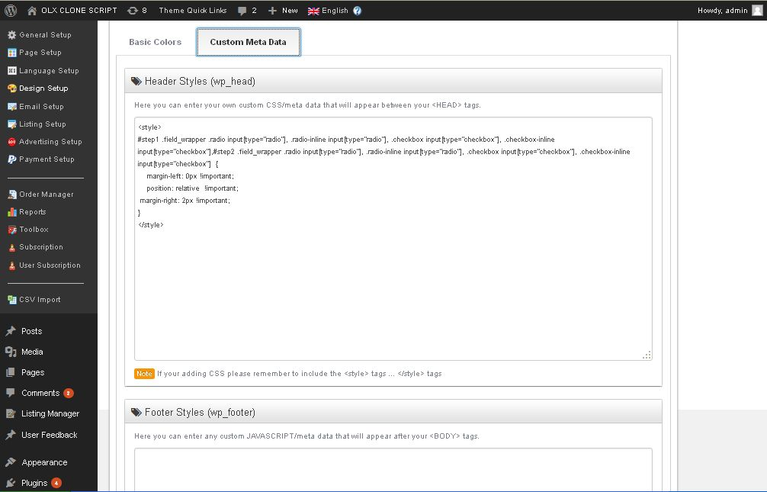

**Description:**

Admin can add design using CSS

**Email settings:**

**Setup of Emails:**

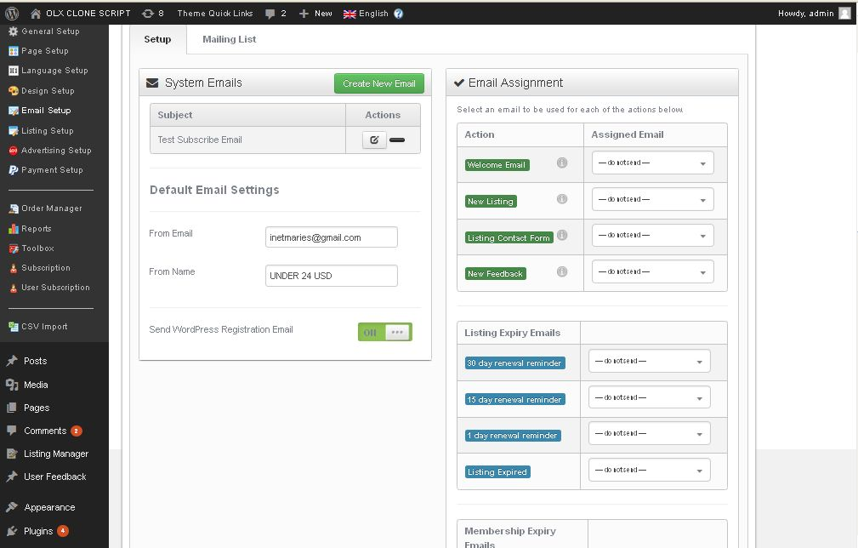

**Description:**

Admin manage settings of admin email address and following functionality mails

**Mailing list settings:**

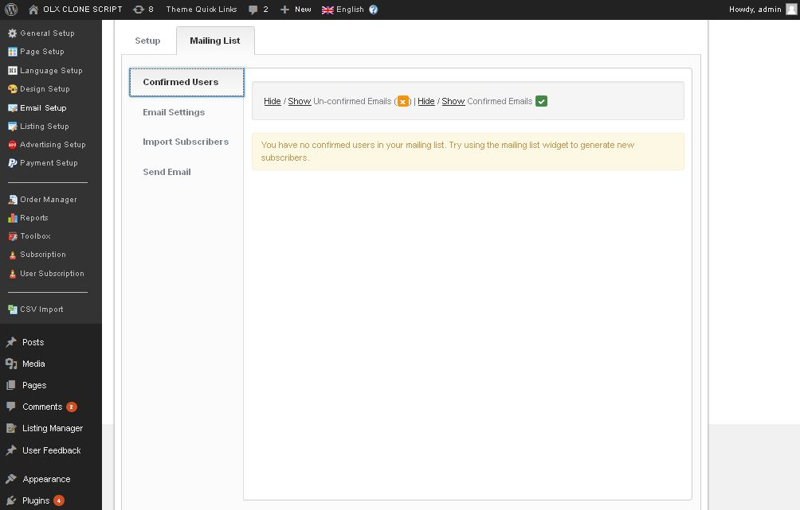

**Description:**

Admin manage list of conformed user list, email settings, import subscribes and send emails list

**Listing settings:**

**Custom field settings:**

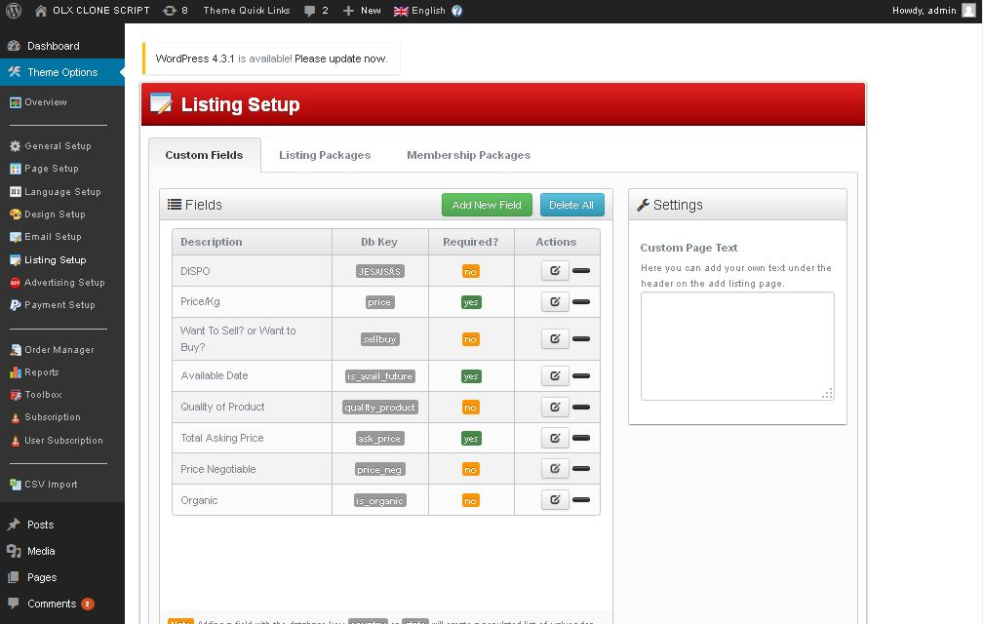

**Description:**

Admin manage add and manage custom field

**Listing package settings:**

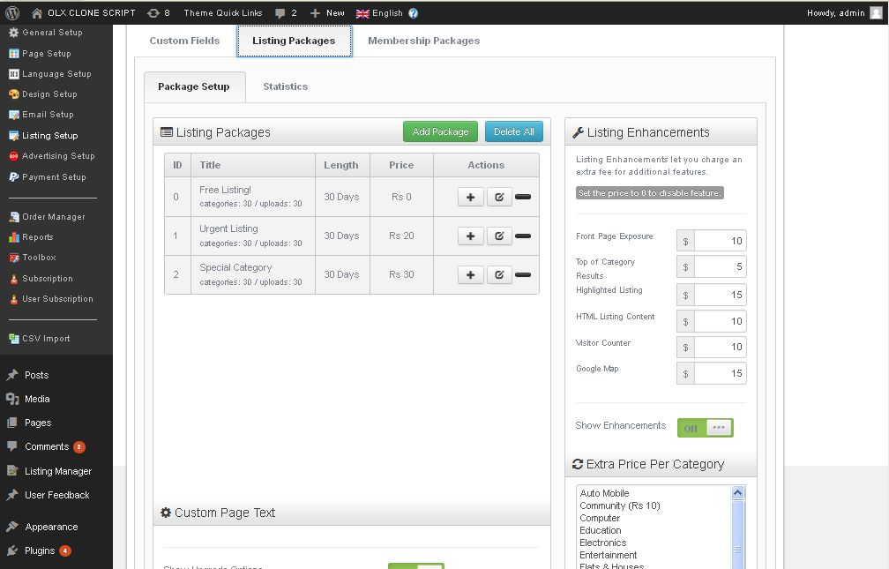

**Description:**

Admin manage listing package list

**Listing statistics settings:**

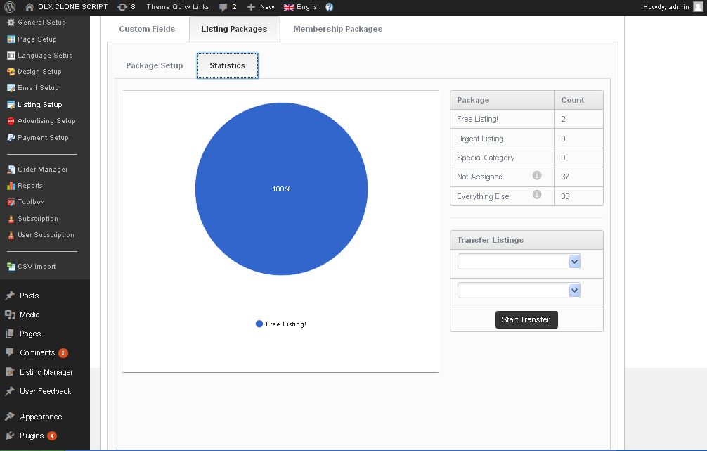

**Description:**

Admin view statistics of listing

**Membership settings:**

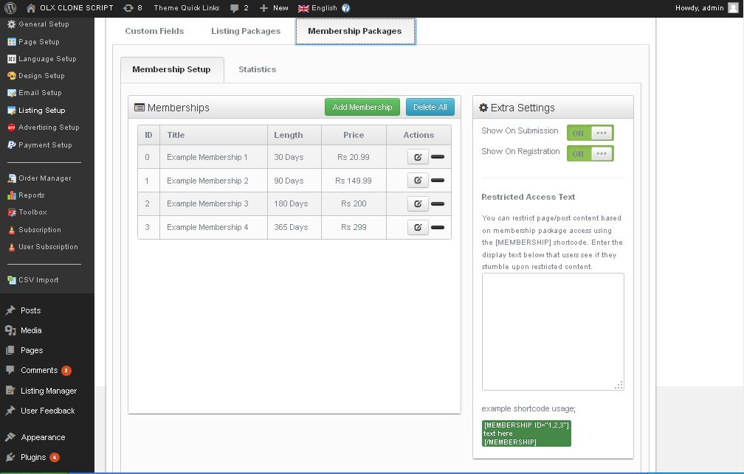

**Description:**

Admin manage list of membership plan

**Membership plan statistics:**

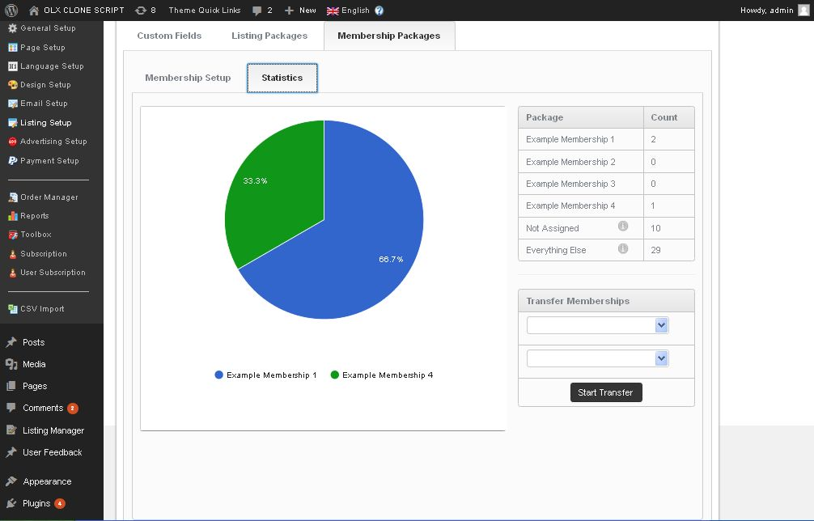

**Description:**

Admin can view membership plan user statistics

**Advertisement settings:**

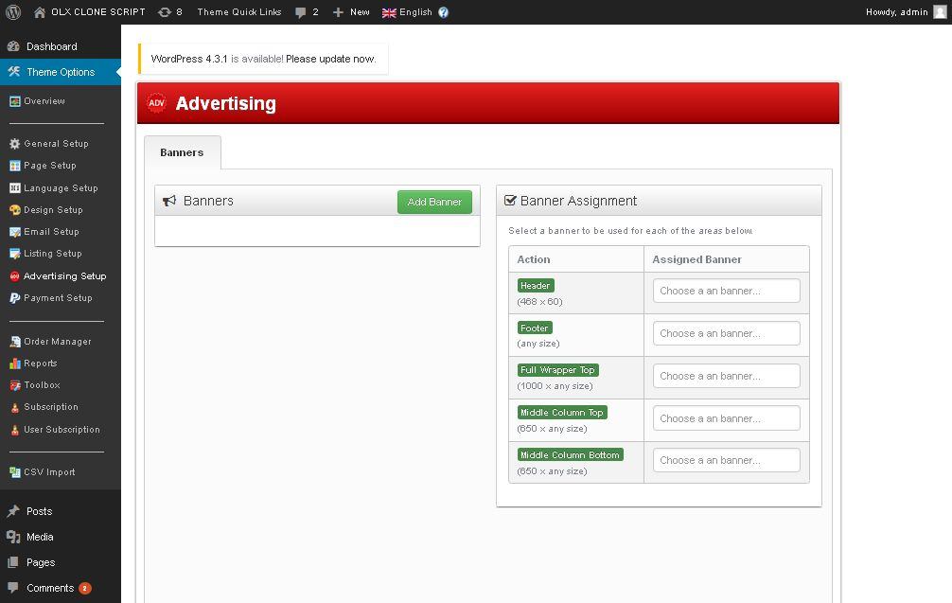

**Description:**

Admin manage settings of advertisement

**Payment settings:**

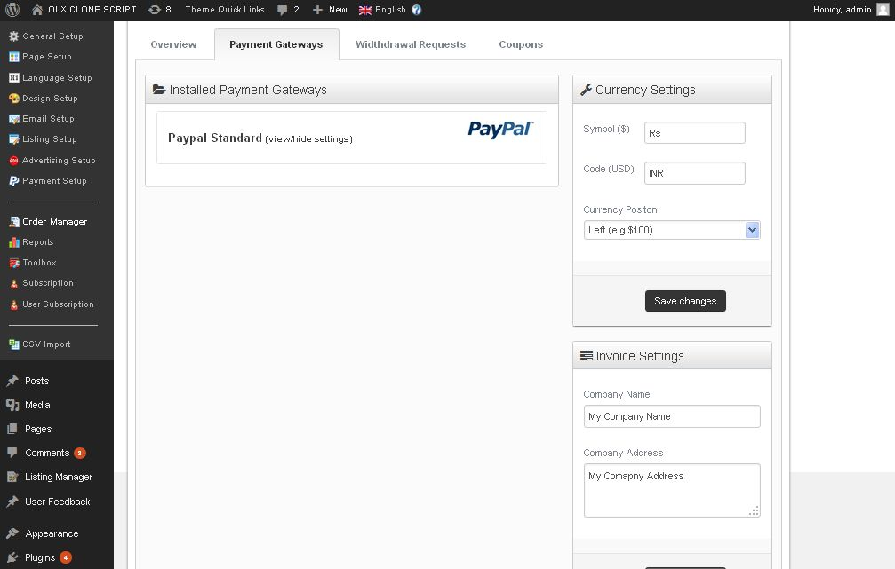

**Description:**

Admin can manage added payment gateway and invoice settings

**Order table:**

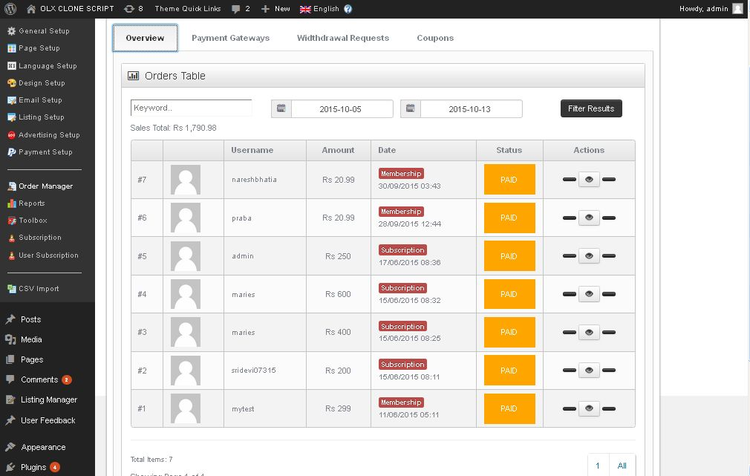

**Description:**

Admin can view order list

**Withdrawn request settings:**

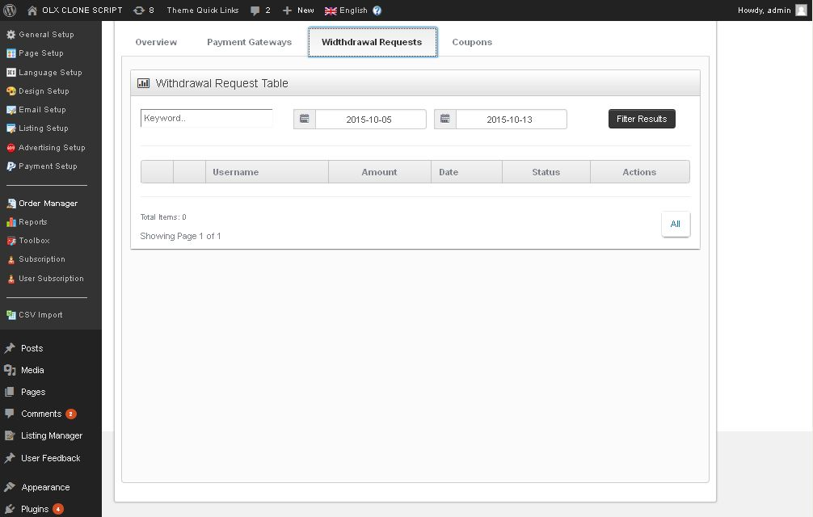

**Description:**

Admin can view withdrawn request table

**Coupon settings:**

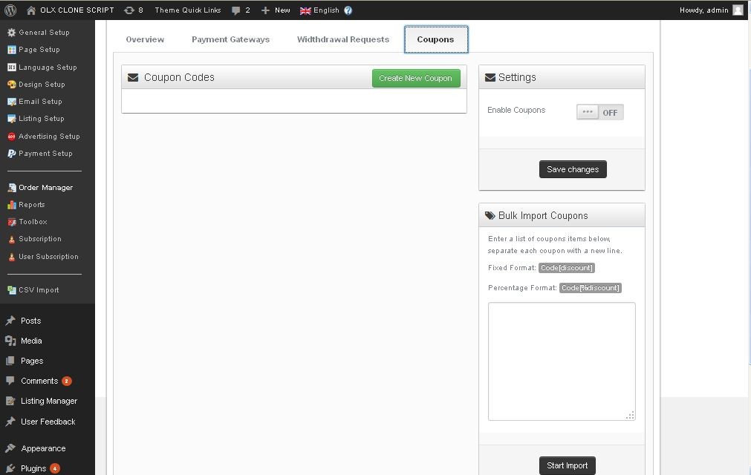

**Description:**

Admin can add and manage coupon

**Report:**

**Website performance report:**

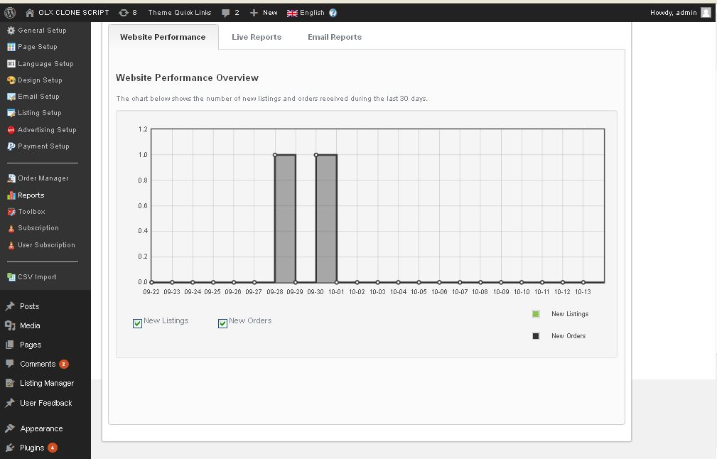

**Description:**

Admin can view website performance report

**Live report:**

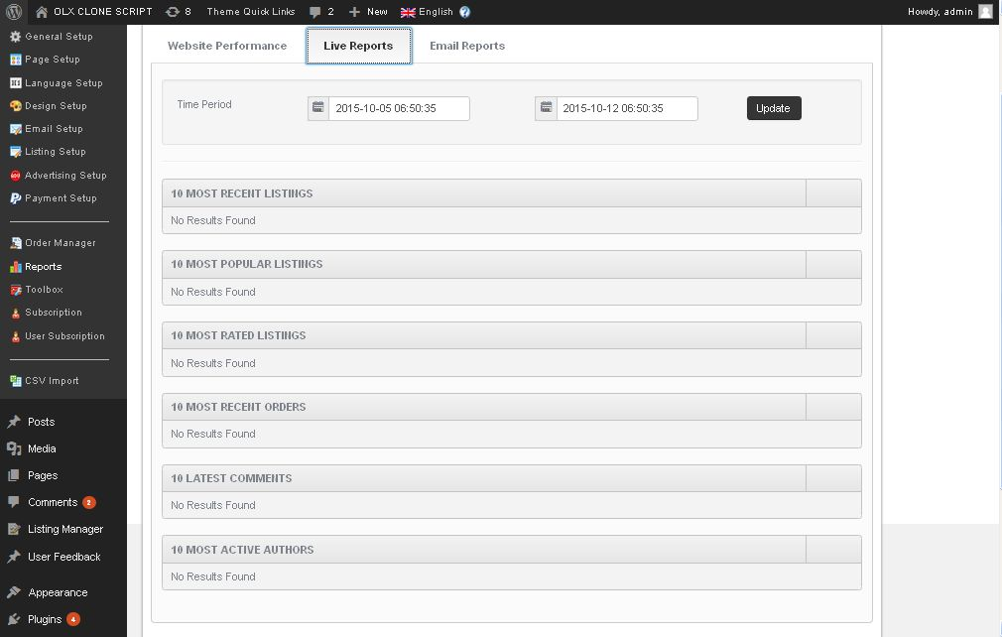

**Description:**

Admin can view report live users

**Email report:**

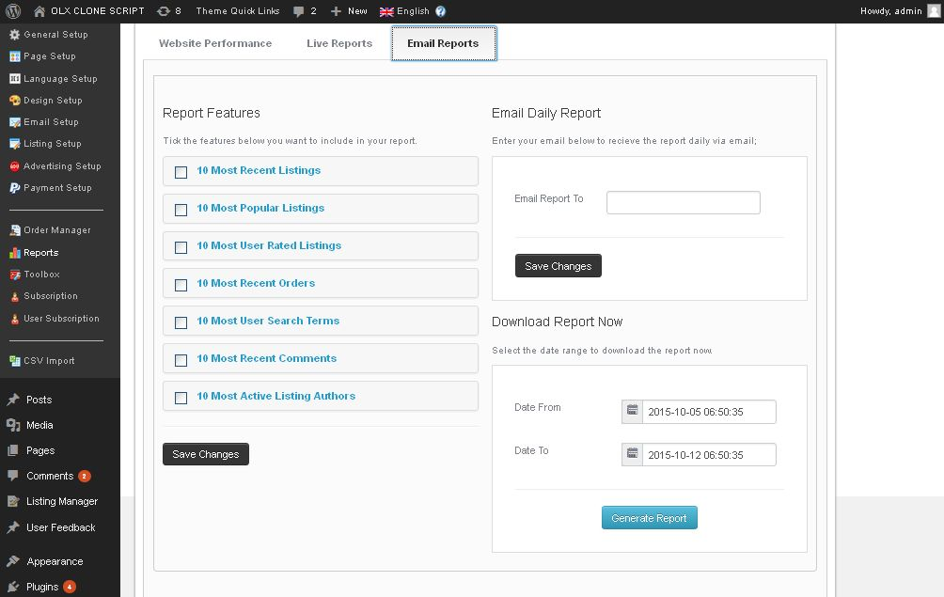

**Description:**

Admin can view Email report

**Toolbox settings:**

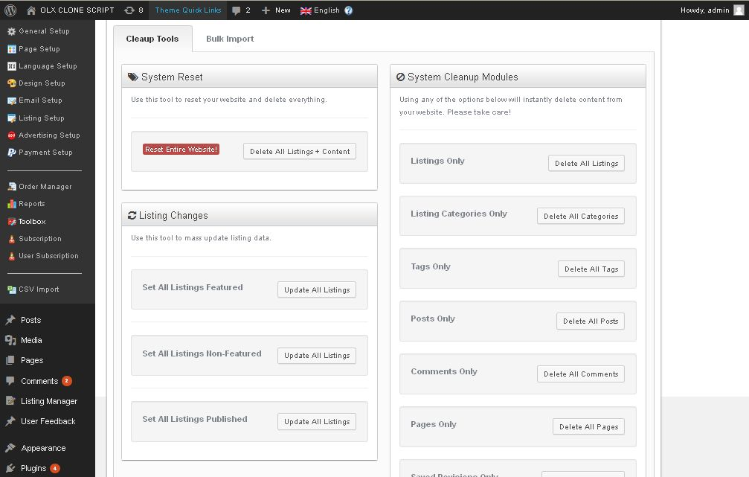

**Description:**

Admin can manage toolbox settings

**Bulk import settings:**

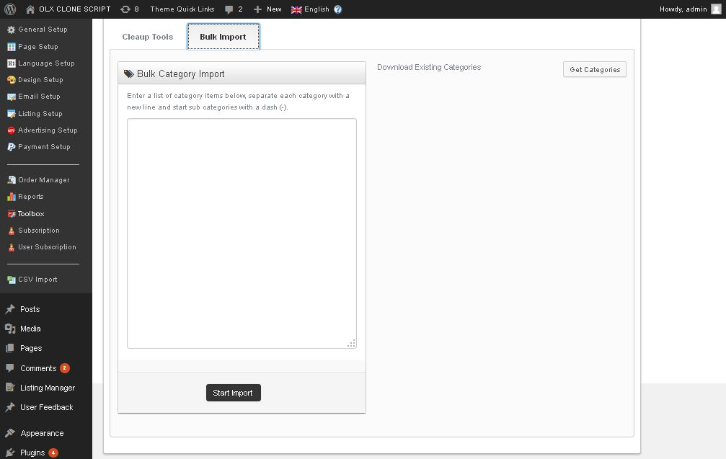

**Description:**

Admin can import everything and get it with category

**Subscriber’s settings:**

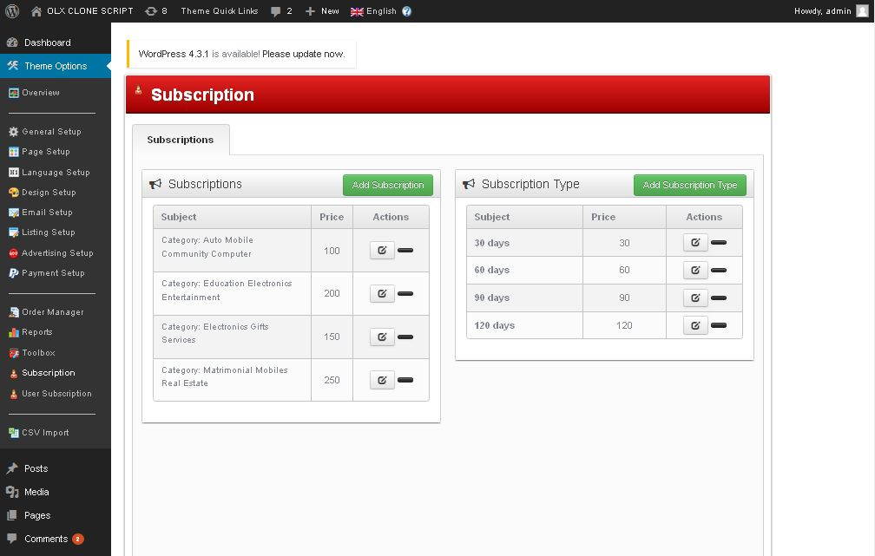

**Description:**

Admin can manage subscriber list and type

**Subscriber’s user settings:**

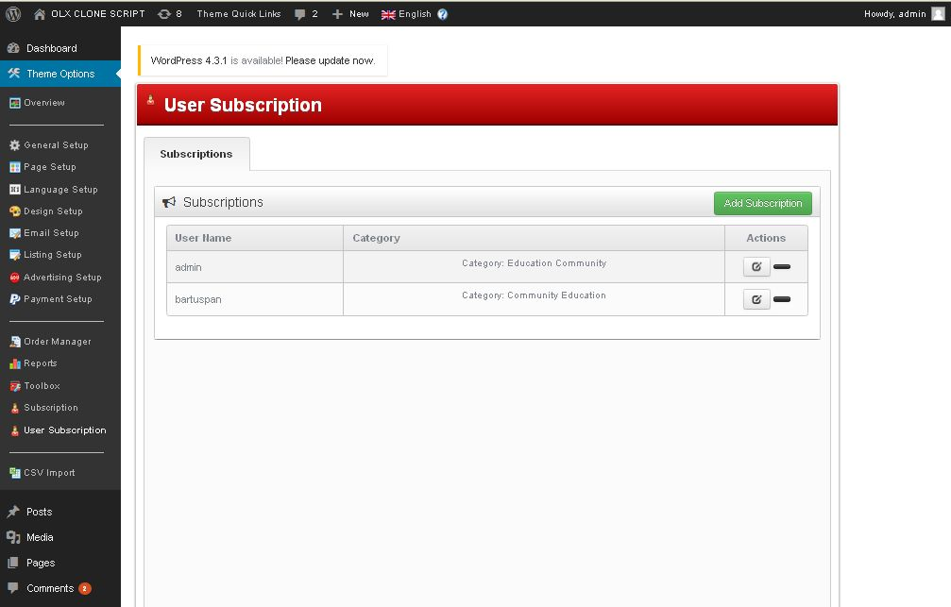

**Description:**

Admin can manage user subscribers list

**Post settings:**

**Manage post settings:**

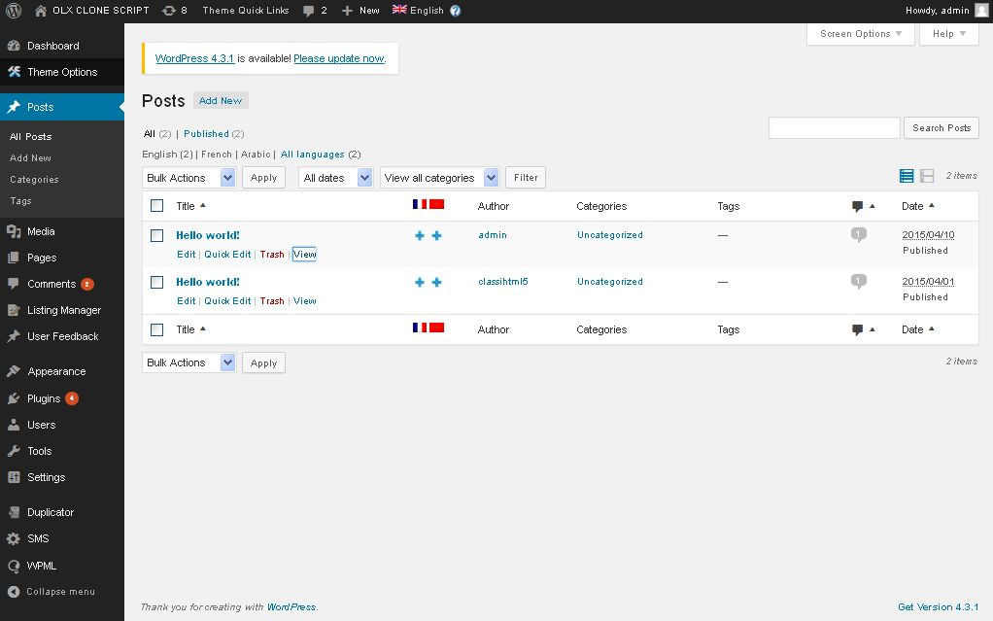

**Description:**

Admin can manage all post and search with filtrations

**Add post:**

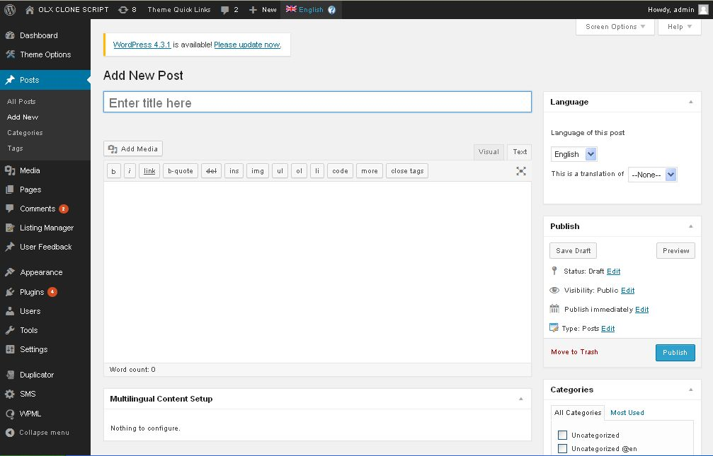

**Description:**

Admin can add post using add post button

**Add category:**

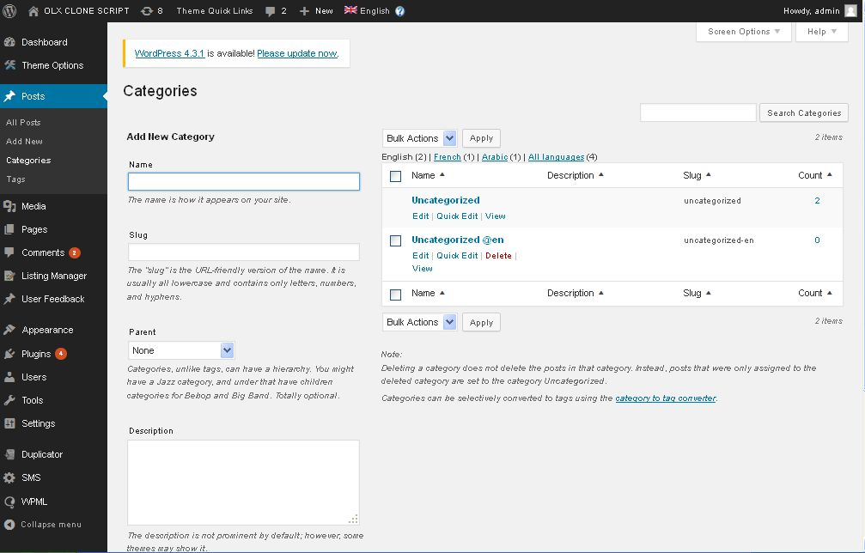

**Description:**

Admin can add and manage category

**Manage tag:**

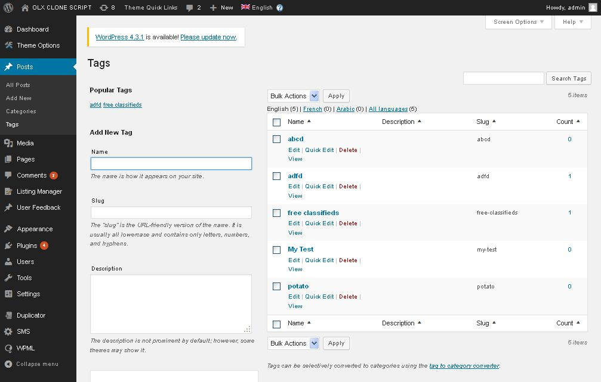

**Description:**

Admin can add and manage tag

**Page settings:**

**Manage pages:**

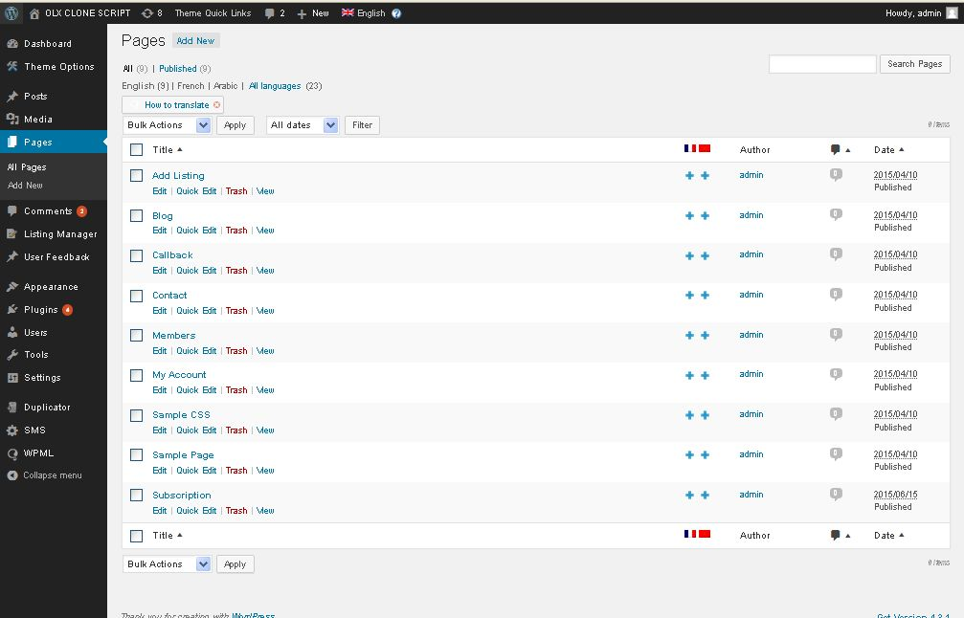

**Description:**

Admin can manage all the pages

**Add page:**

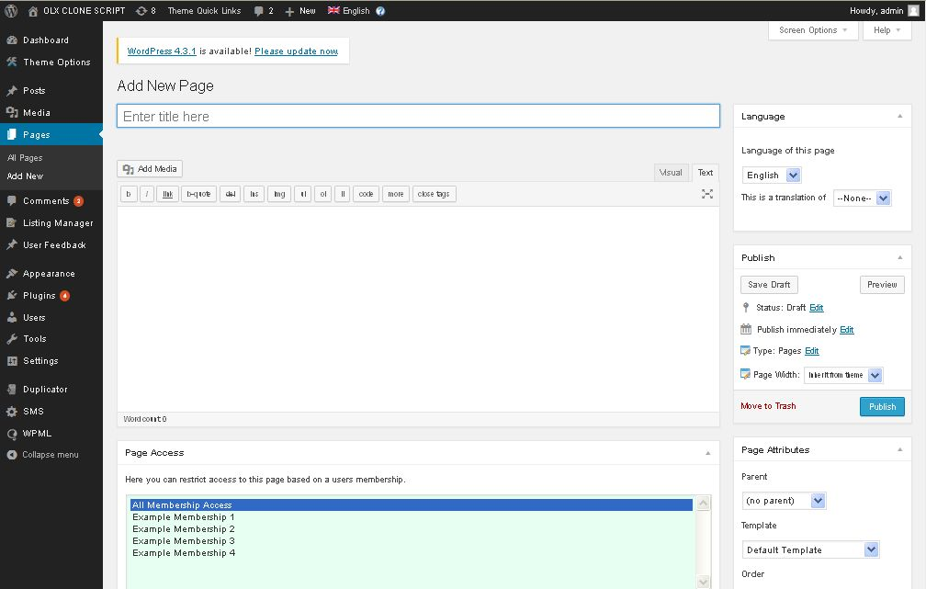

**Description:**

Admin can add new page using add page button

**Comment settings:**

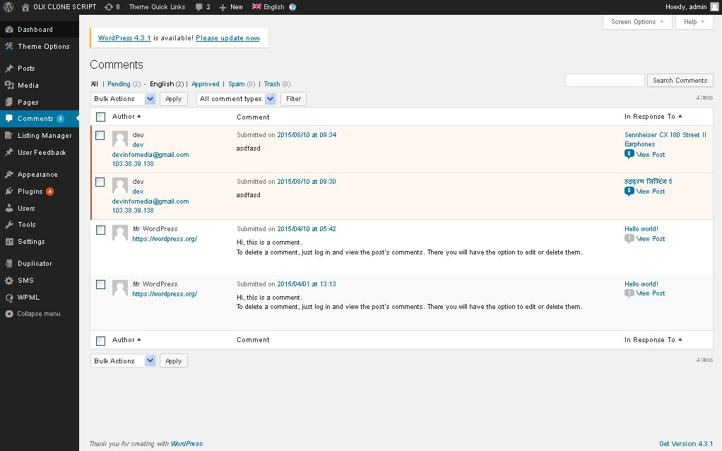

**Description:**

Admin mange a\comment and approve comment to publish

**Listing settings:**

**Manage listing:**

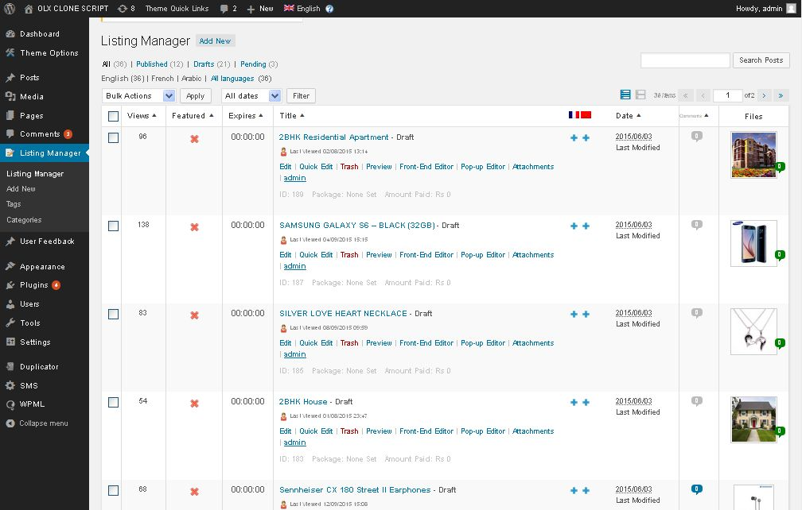

**Description:**

Admin manage all the listing

**Add listing:**

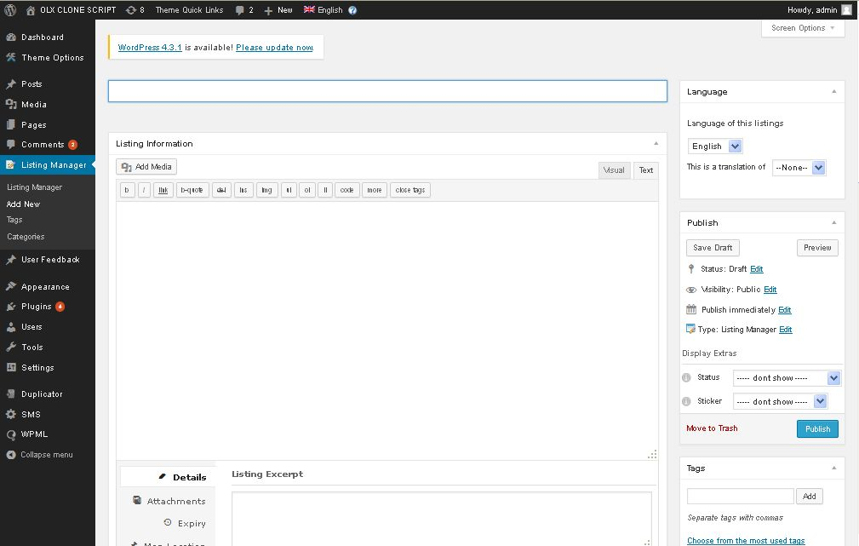

**Description:**

Admin can add new listing using add button

**Manage category:**

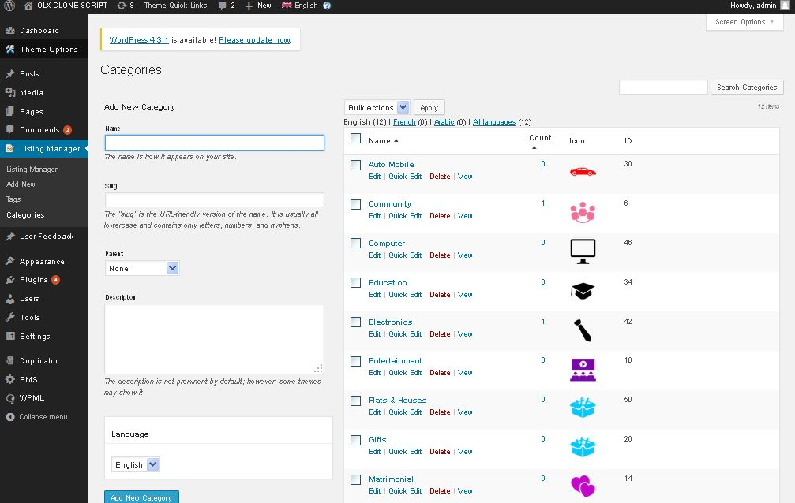

**Description:**

Admin can add and manage category

**Manage tag:**

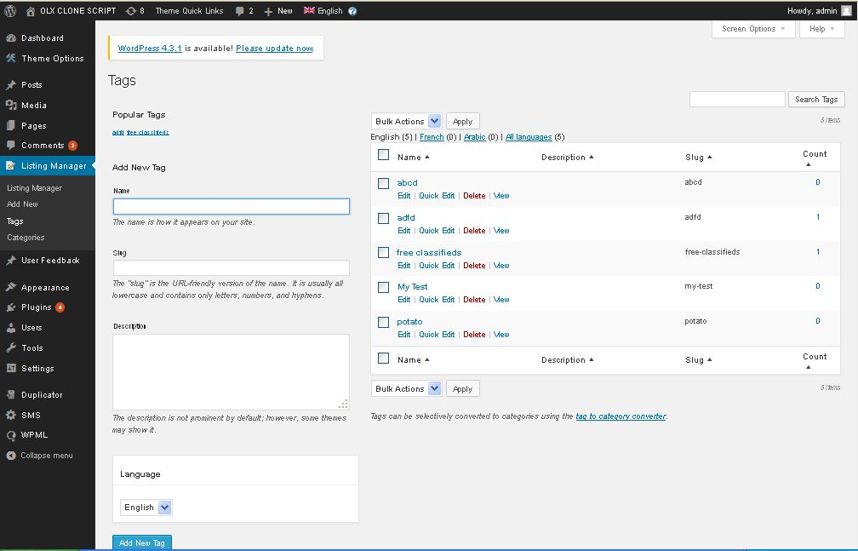

**Description:**

Admin can add and manage tag

**User feedback settings:**

**Manage feedback:**

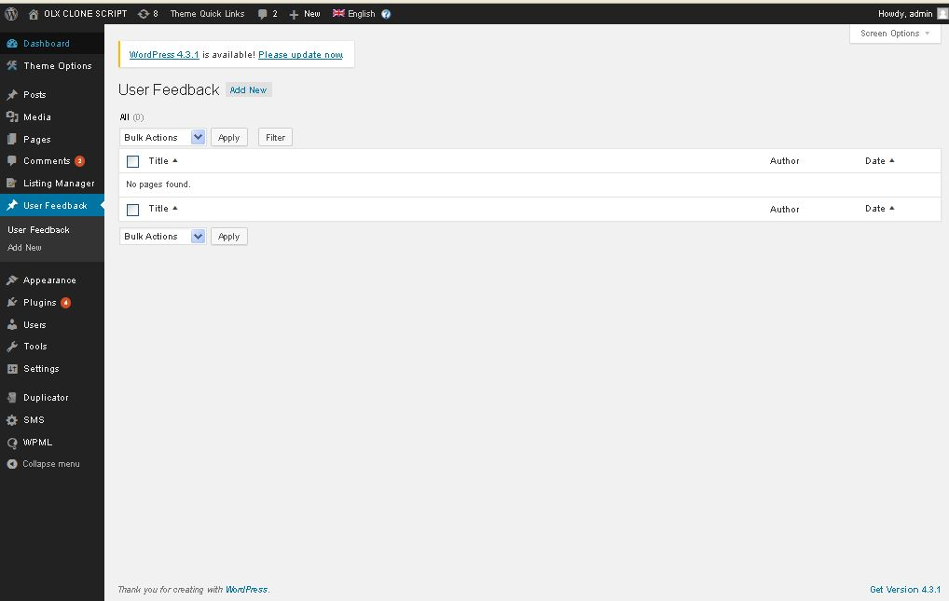

**Description:**

Admin can manage all feedbacks

**Appearance settings:**

**Theme settings:**

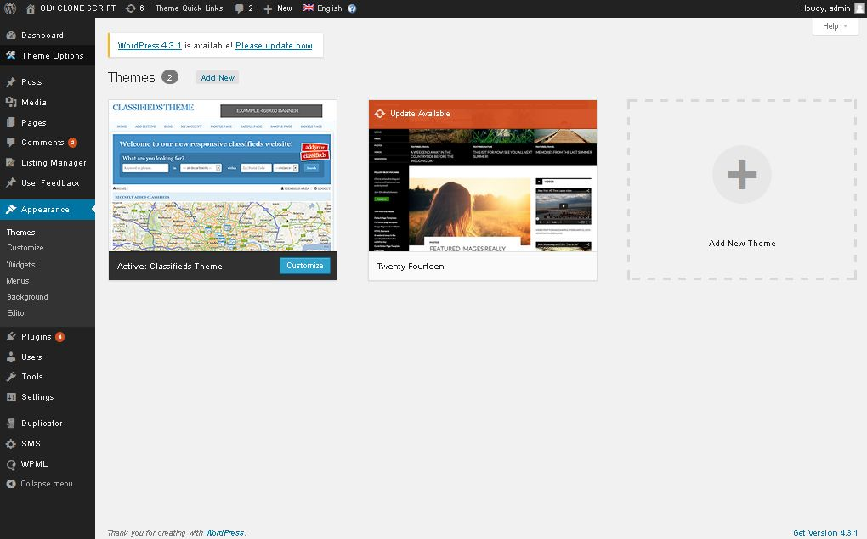

**Description:**

Admin can choose their theme

**Background settings:**

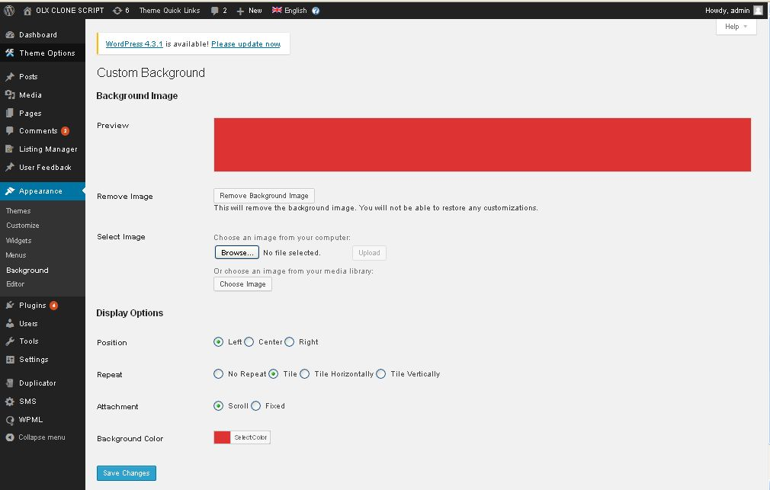

**Description:**

Admin can manage settings of background color and appearance settings

**Widgets settings:**

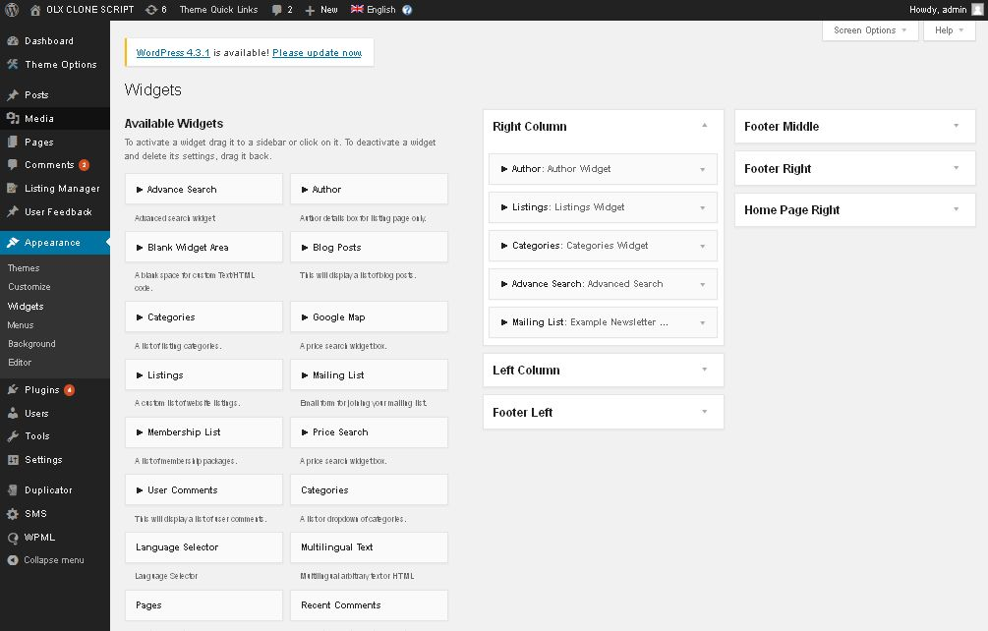

**Description:**

Admin can mange widgets settings

**Menu settings:**

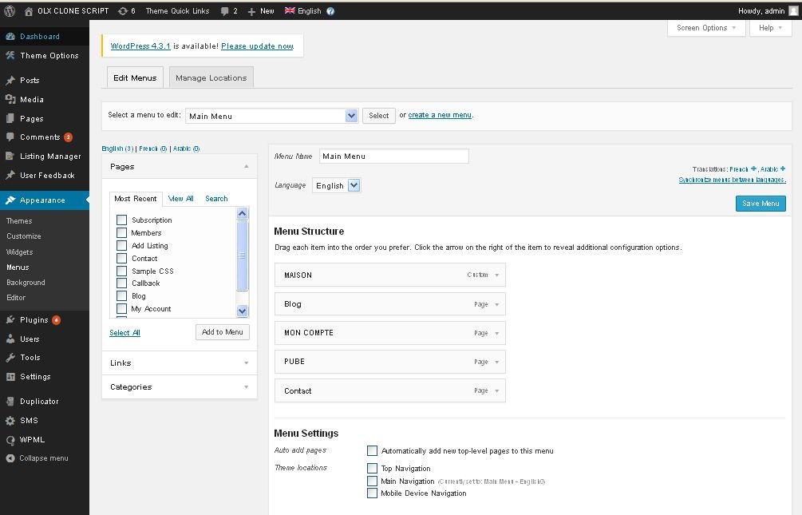

**Description:**

Admin can manage menu settings

**Customization settings:**

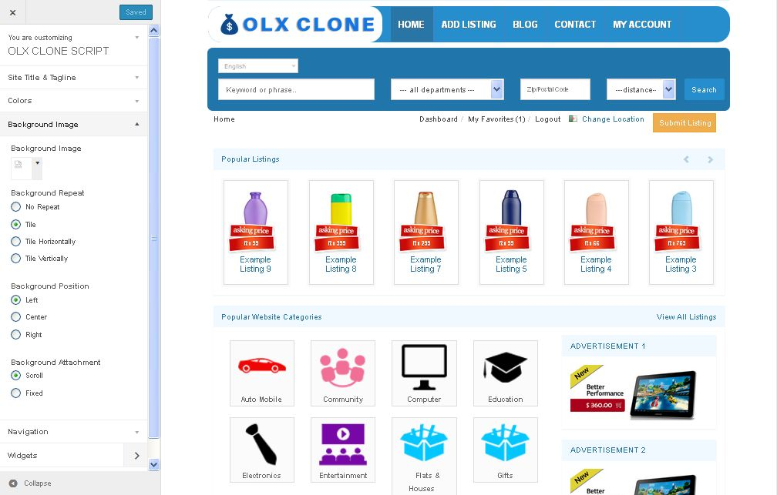

**Description:**

Admin can modify their design using CSS

**Editor settings:**

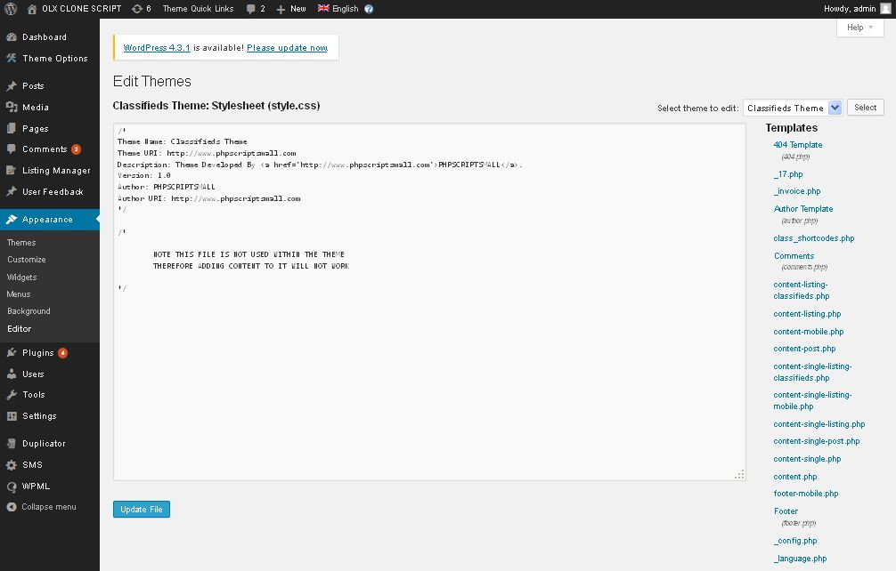

**Description:**

Admin customize their design using CSS and PHP

**Plugins settings:**

**Manage plugin:**

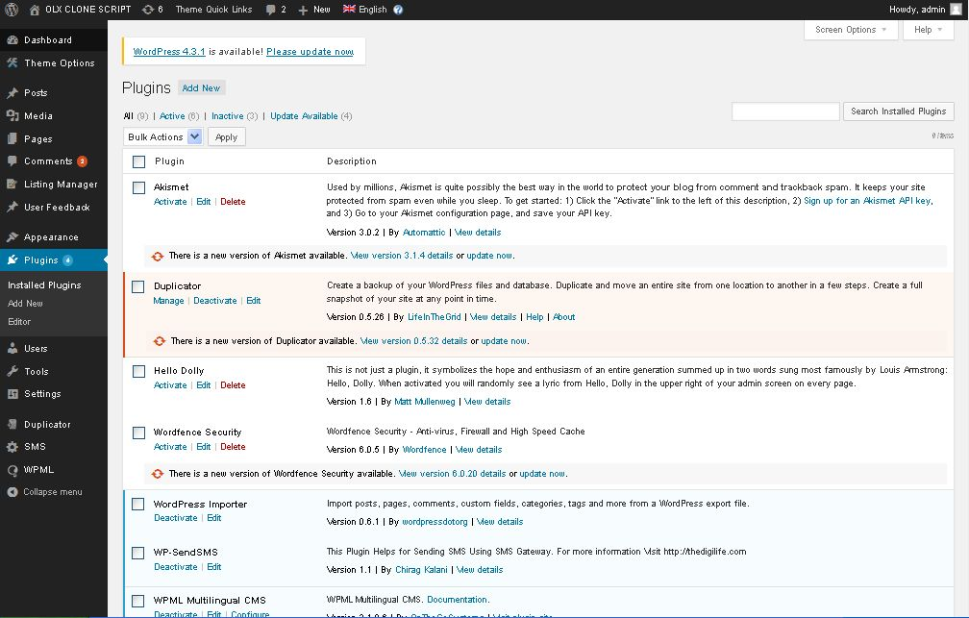

**Description:**

Admin can manage all the plugins

**Add plugins:**

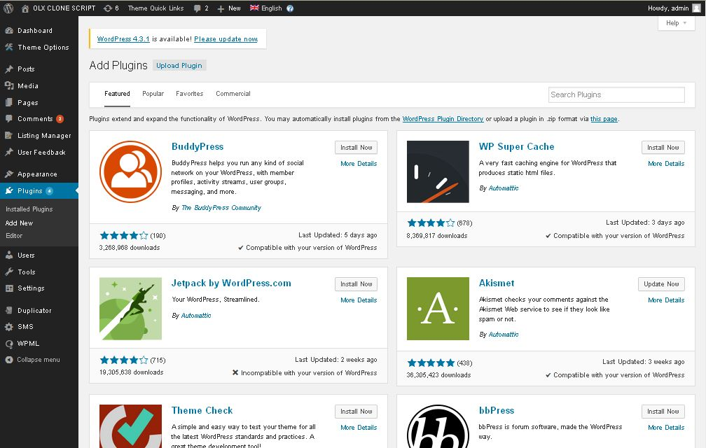

**Description:**

Admin can add plugin using add plugin button

**User** **management settings:**

**Manage users:**

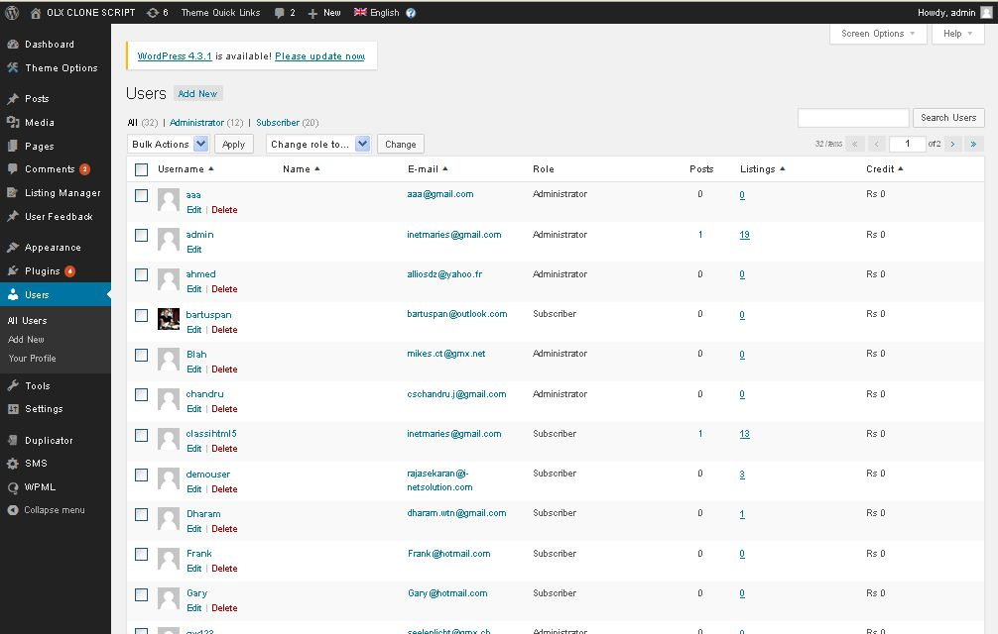

**Description:**

Admin can manage all the users

**Add user:**

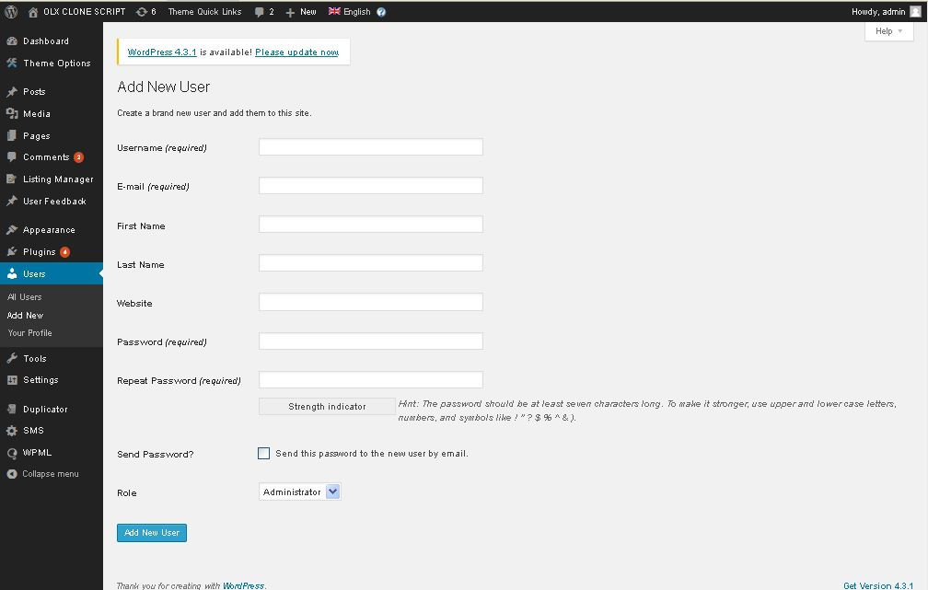

**Description:**

Admin can add new user

**View profile:**

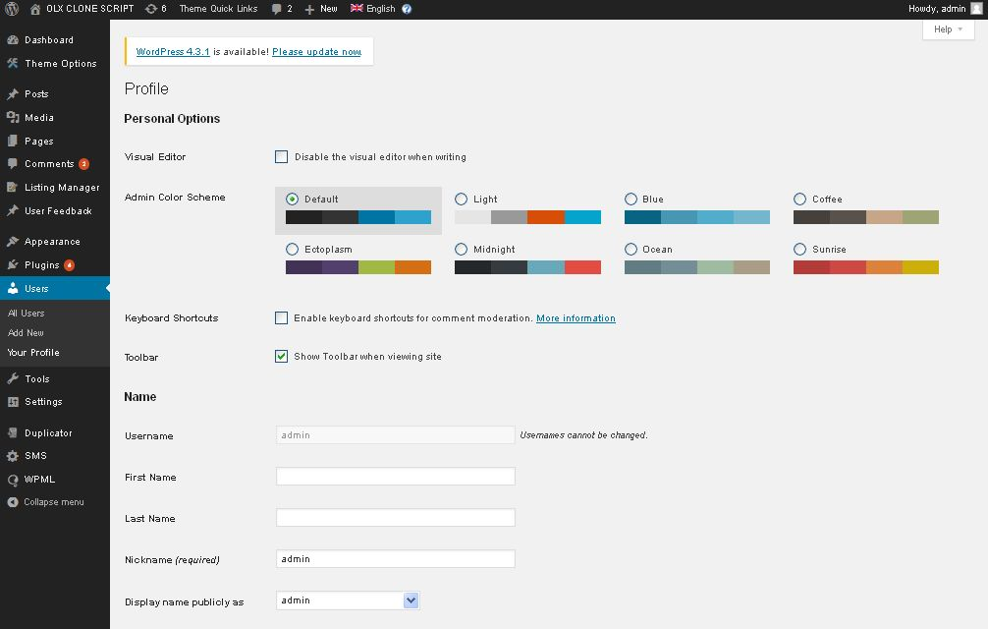

**Description:**

Admin can view admin profile details

**Settings:**

**General settings:**

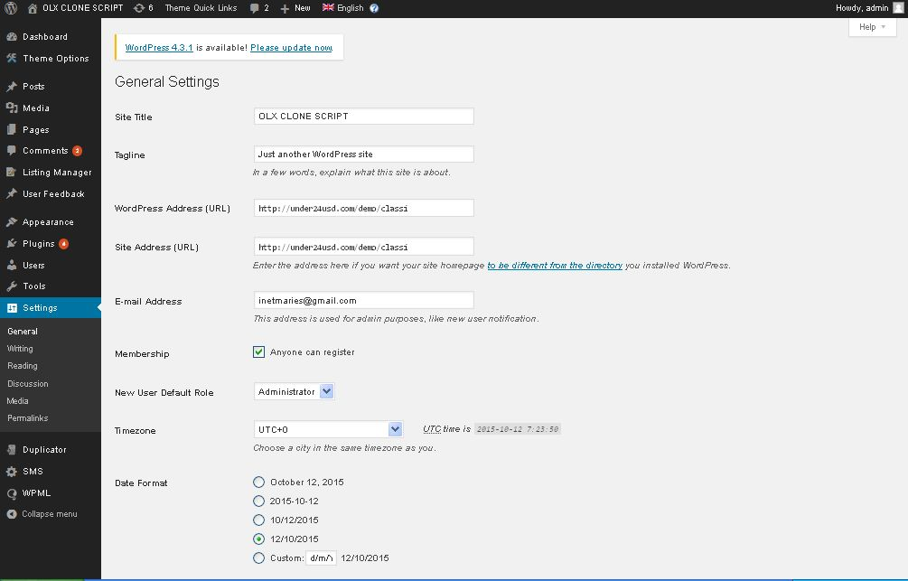

**Description:**

Admin manage general settings of the website

**Writing settings:**

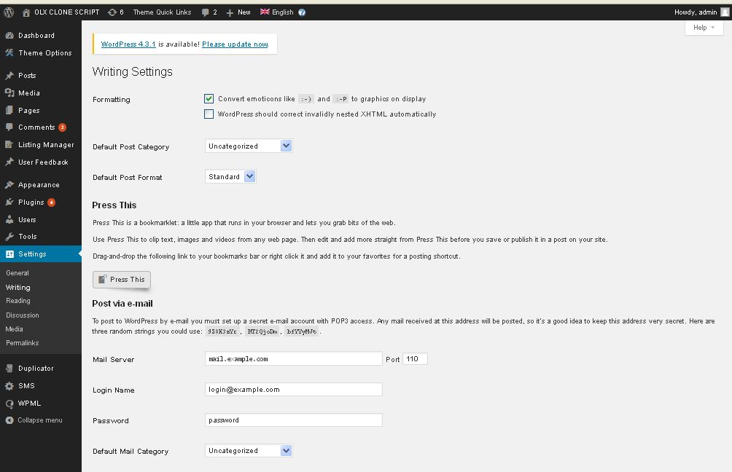

**Description:**

Admin manage settings of writing

**Reading settings:**

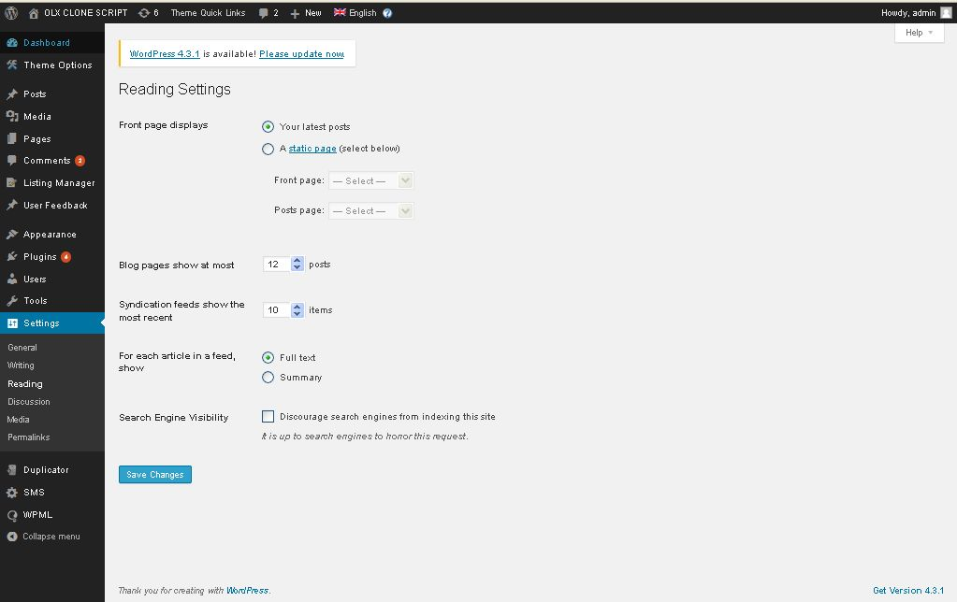

**Description:**

Admin manage settings of reading

**Discussion settings:**

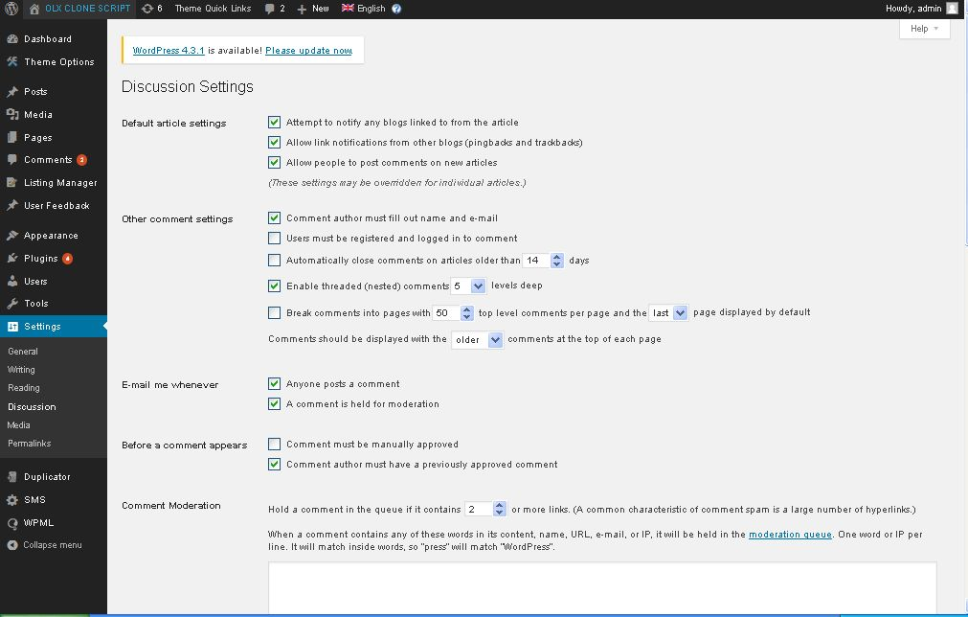

**Description:**

Admin manage settings of discussion

**Permalink settings:**

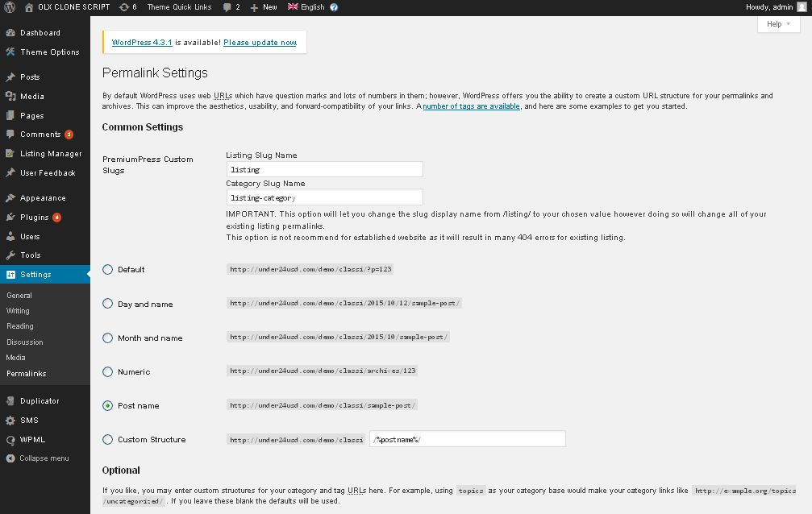

**Description:**

Admin manage permalink settings