**MULTICITY GROCERY STORE**

**MC-Option**

**General**

**Activity:**

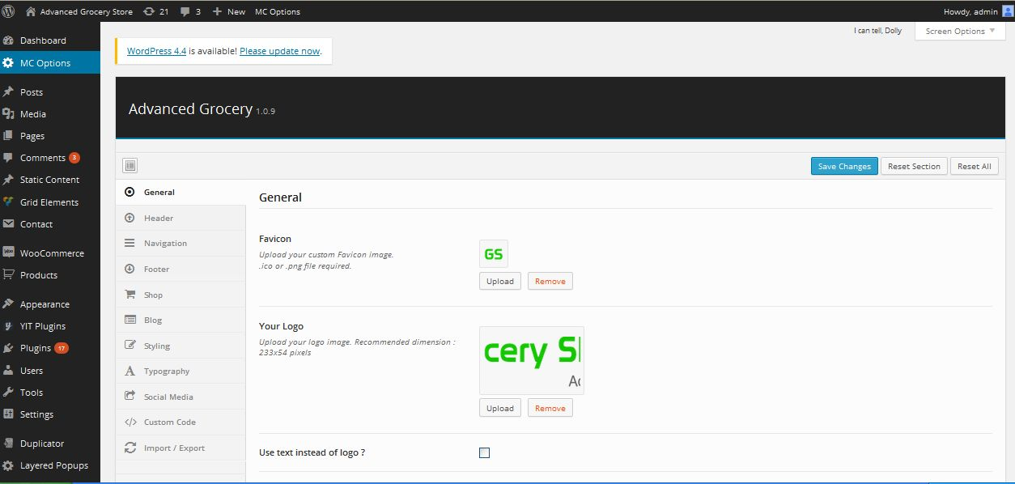

**Description:**

Admin can manage settings of logo and favicon

**Header**

**Activity:**

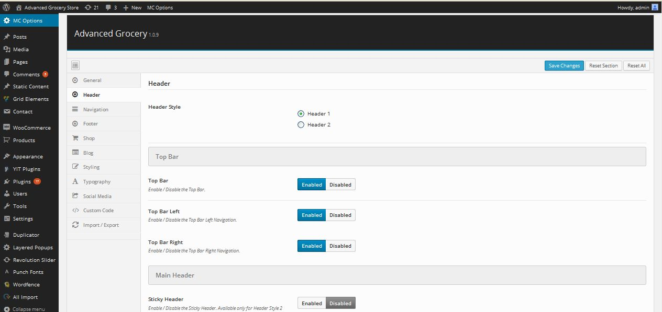

**Description:**

Admin manage setting of header

**Navigation**

**Activity:**

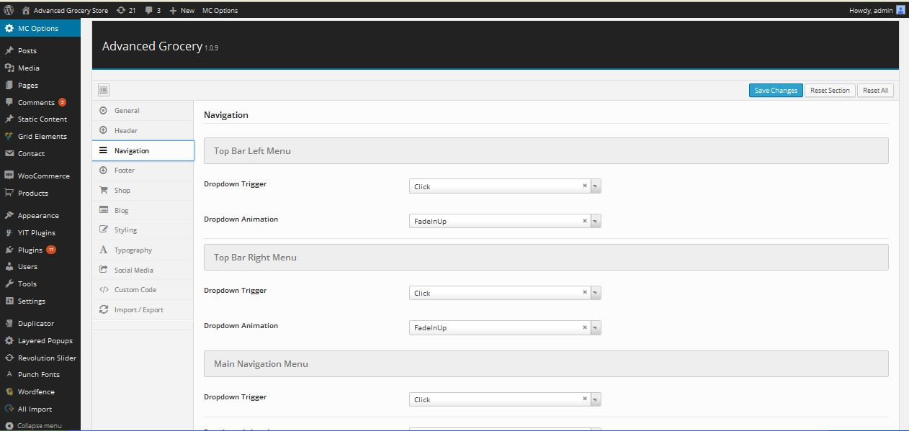

**Description:**

Admin manage settings menu navigation

**Footer**

**Activity:**

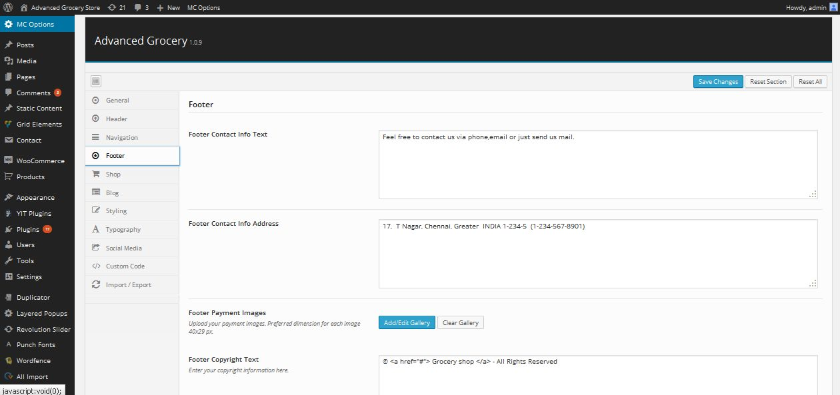

**Description:**

Admin manage settings of footer

**Shop**

**Activity:**

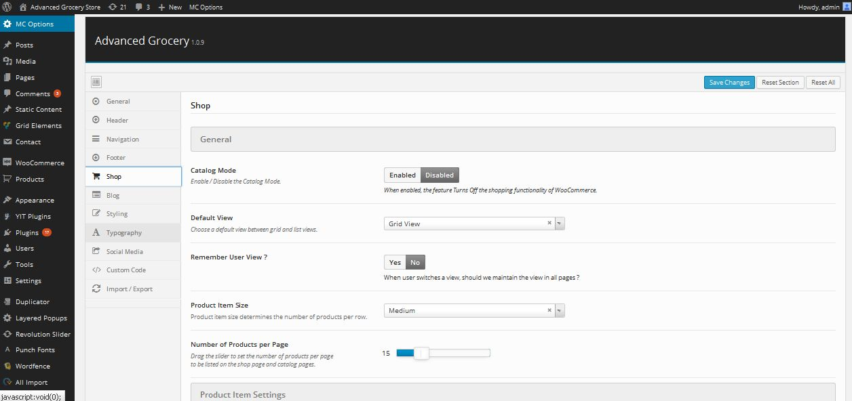

**Description:**

Admin manage settings of shop

**Blog**

**Activity:**

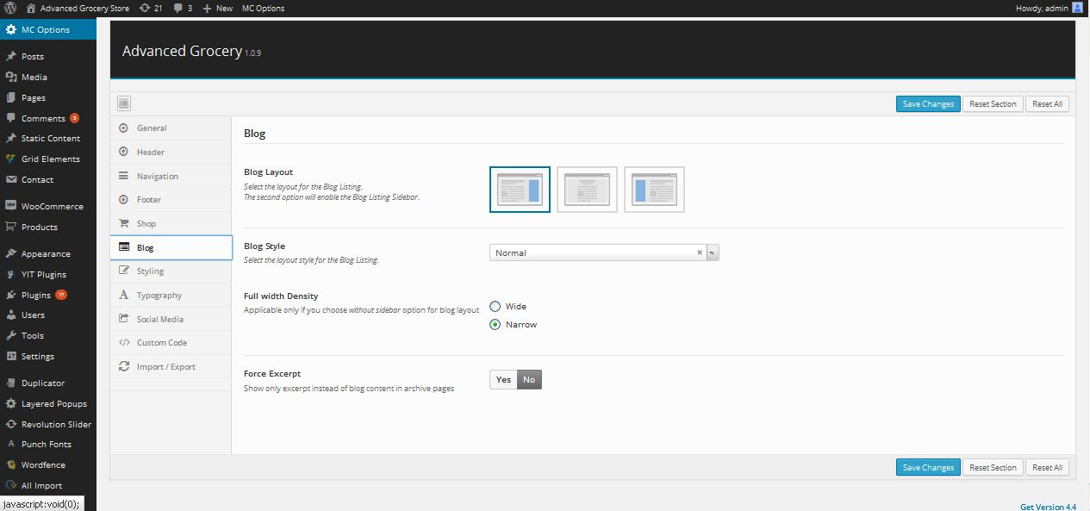

**Description:**

Admin manage settings of blog layout

**Styling**

**Activity:**

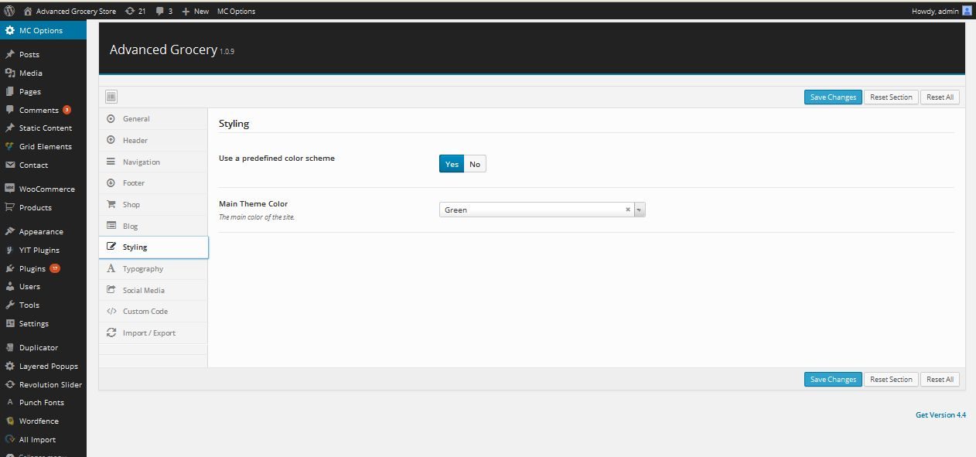

**Description:**

Admin manage color settings of site

**Typography**

**Activity:**

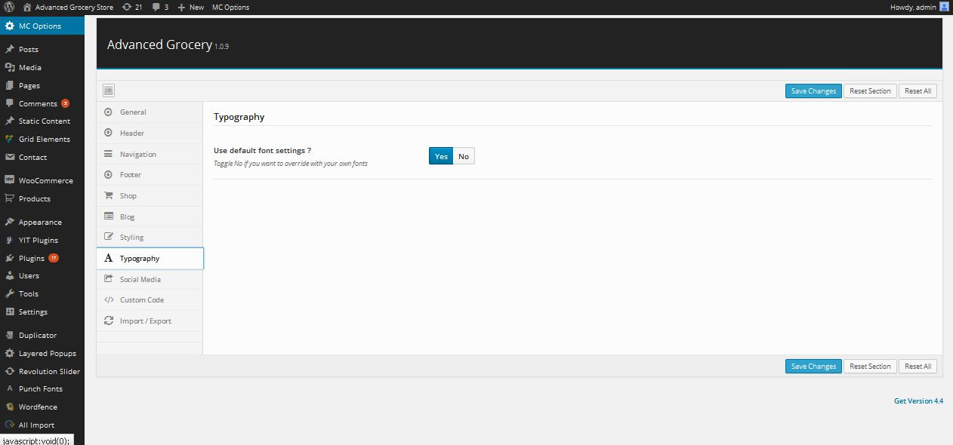

**Description:**

Admin can enable or disable the typography

**Social media**

**Activity:**

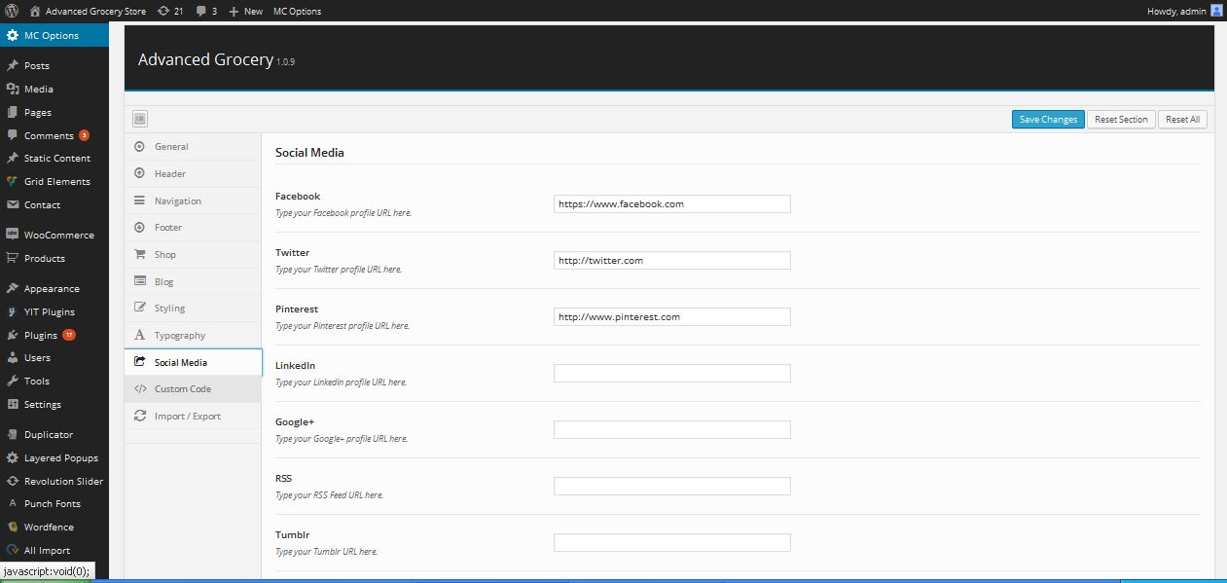

**Description:**

Admin manage links of social connection

**Custom code**

**Activity:**

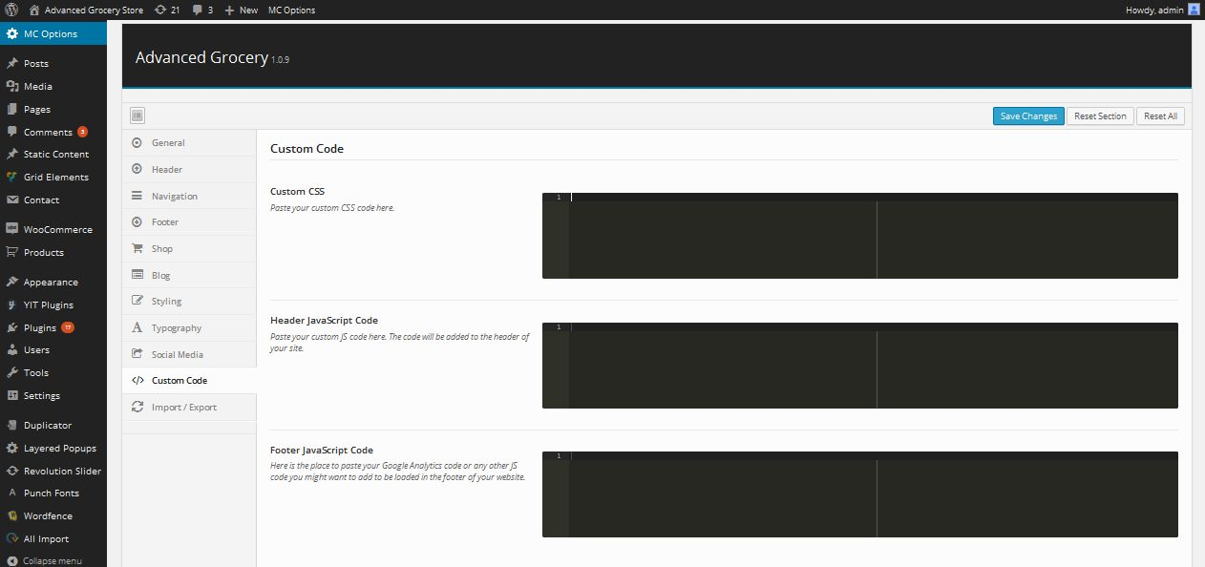

**Description:**

Admin can edit the script using CSS

**Import/Export**

**Activity:**

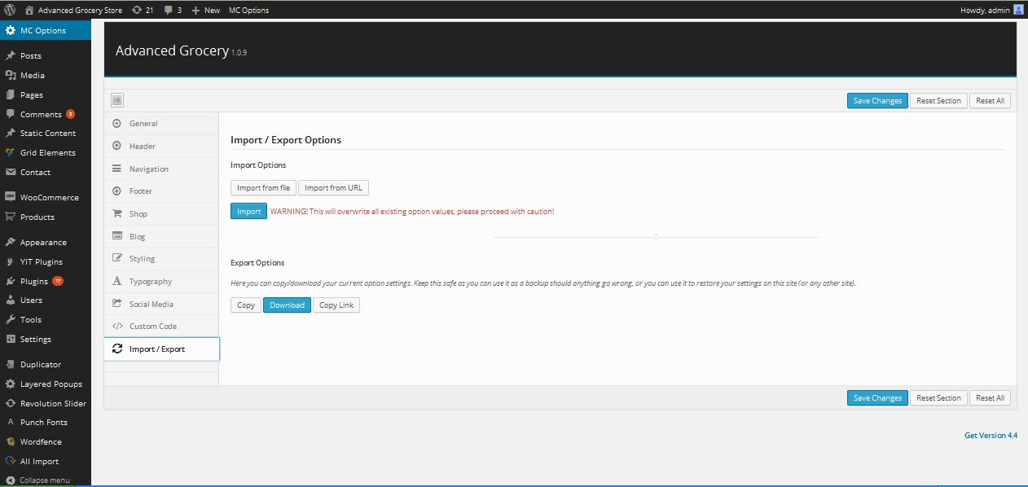

**Description:**

Admin can import and export site using these links

**Post**

**View post**

**Activity:**

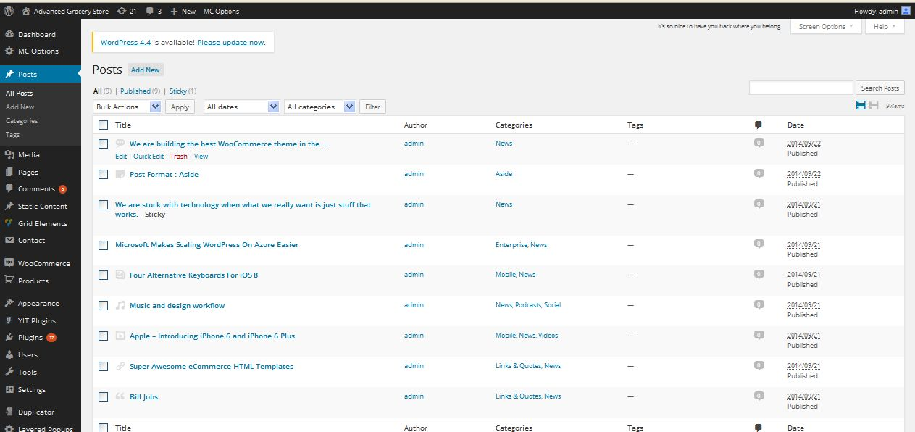

**Description:**

Admin can view all active and inactive post

**Add post**

**Activity:**

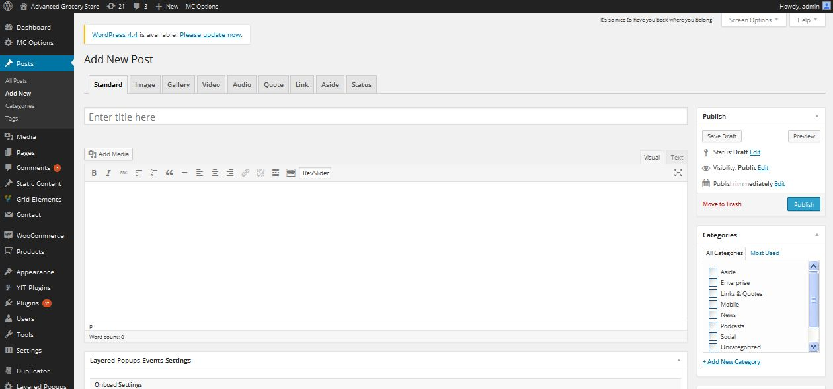

**Description:**

Admin can add new post

**Post category**

**Activity:**

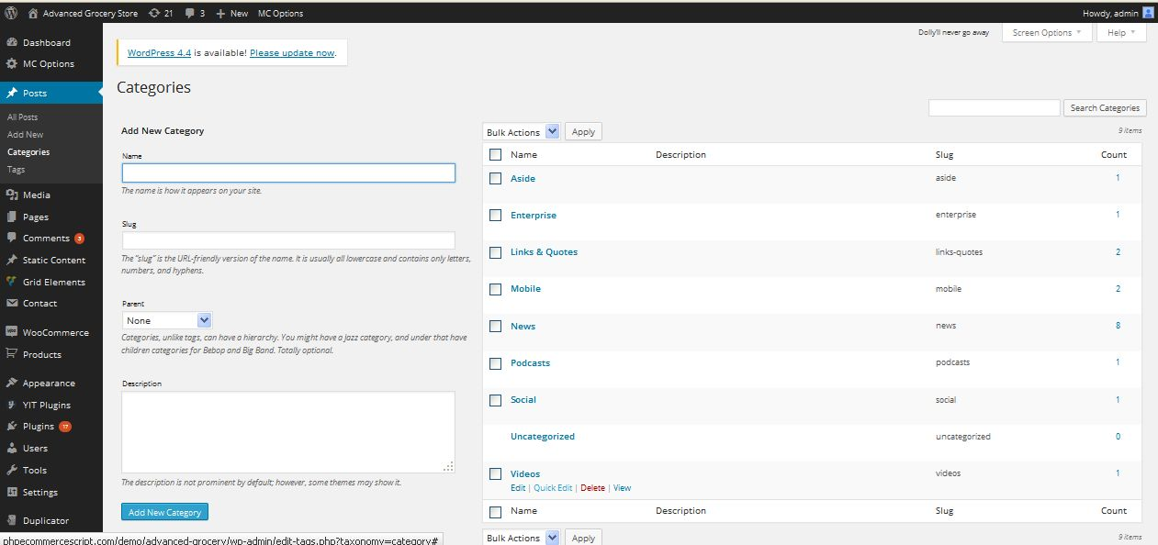

**Description:**

Admin can add and manage post category

**Post tag**

**Activity:**

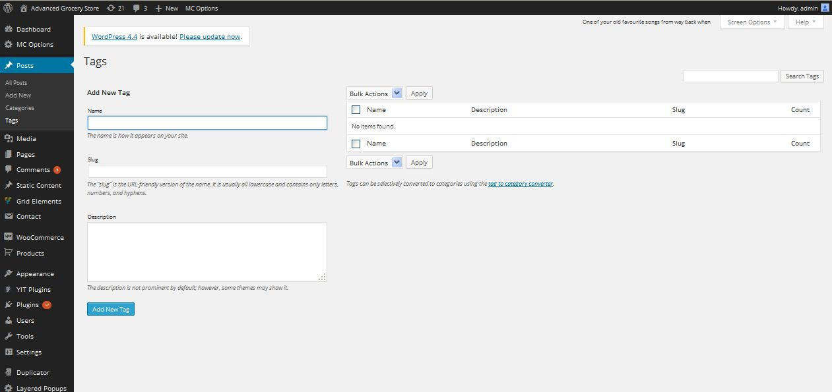

**Description:**

Admin can add and manage post tag

**Media**

**Library**

**Activity:**

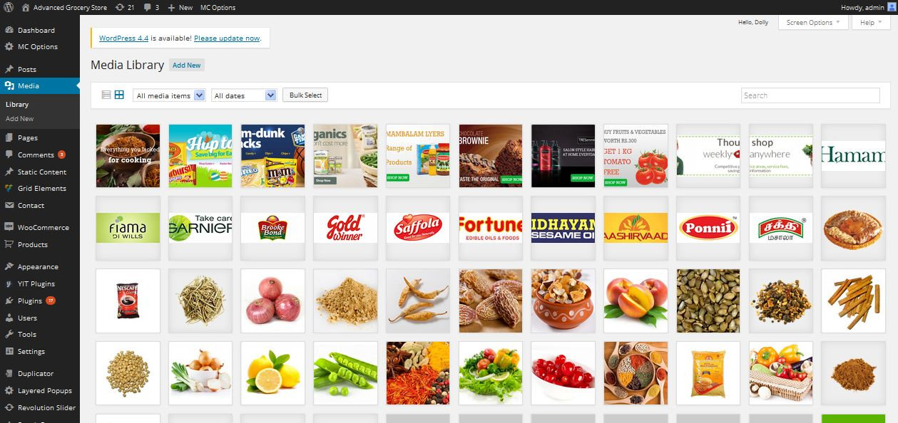

**Description:**

Admin can view all media related with site

**Upload media**

**Activity:**

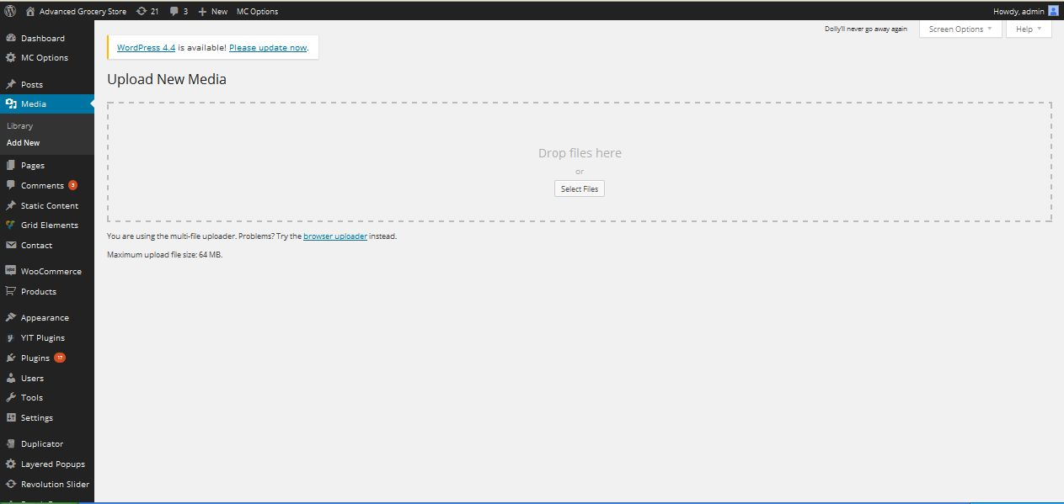

**Description:**

Admin can upload media to the site

**Page**

**View page**

**Activity:**

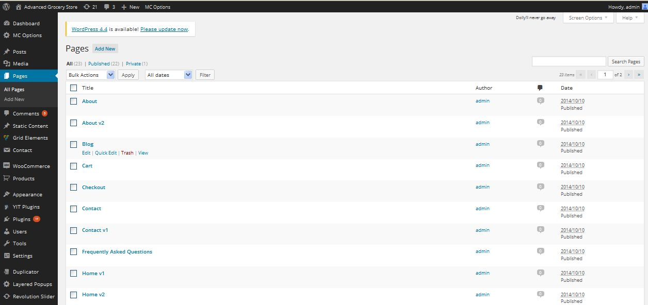

**Description:**

Admin can view all pages of the site

**Add page**

**Activity:**

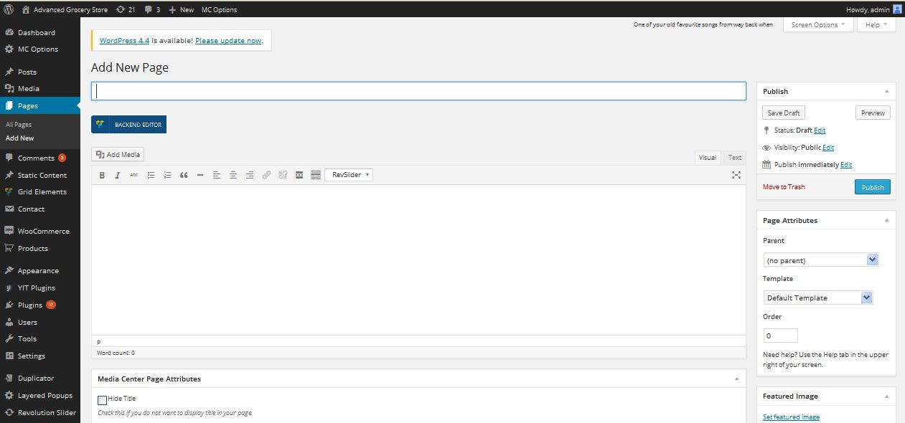

**Description:**

Admin can add new page

**Comment**

**Activity:**

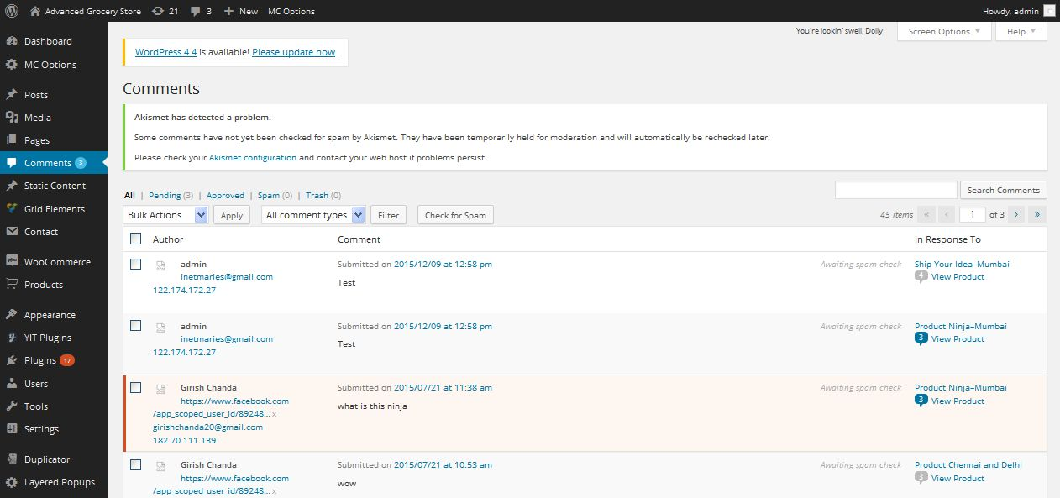

**Description:**

Admin manage all comments related with site

**Static content block**

**View static content block**

**Activity:**

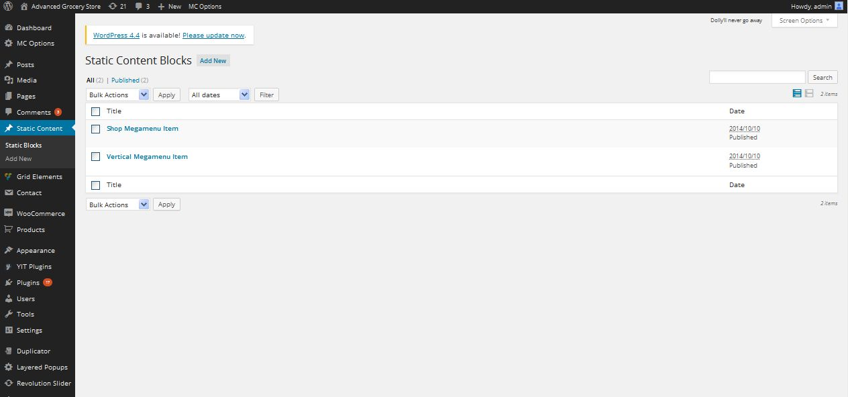

**Description:**

Admin can view all static content block

**Add static content**

**Activity:**

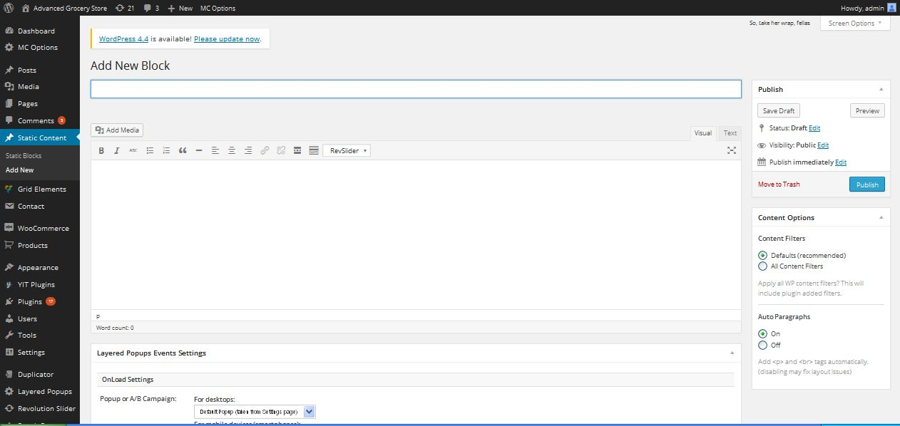

**Description:**

Admin can add new static content block

**Contact form**

**View contact form**

**Activity:**

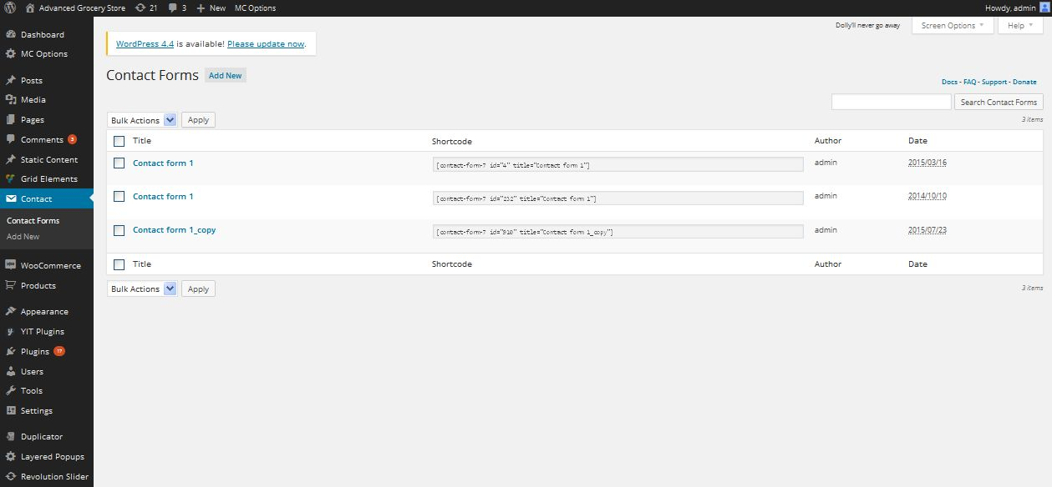

**Description:**

Admin can view contact form details

**Add contact form**

**Activity:**

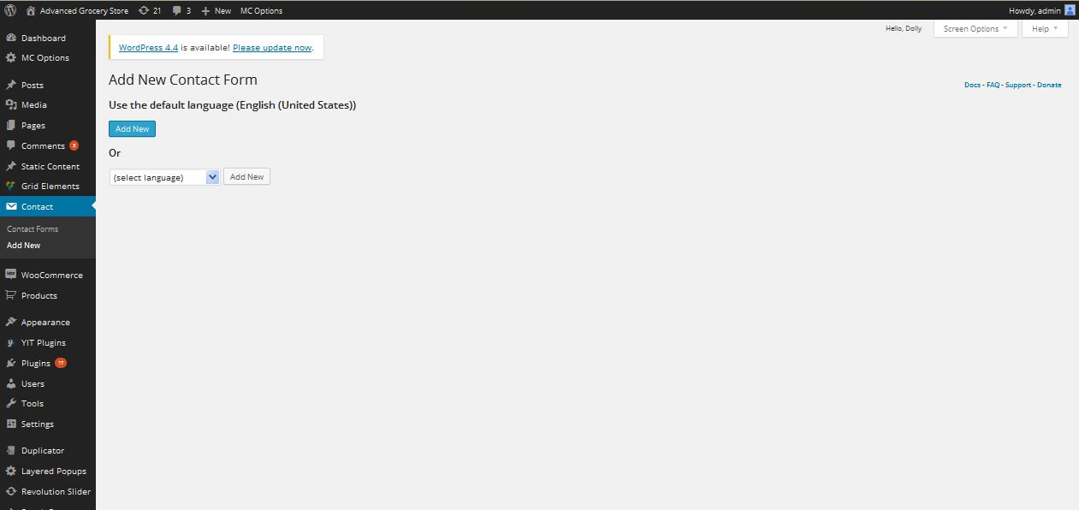

**Description:**

Admin can add new contact form

**Woo-Commerce**

**Orders**

**Activity:**

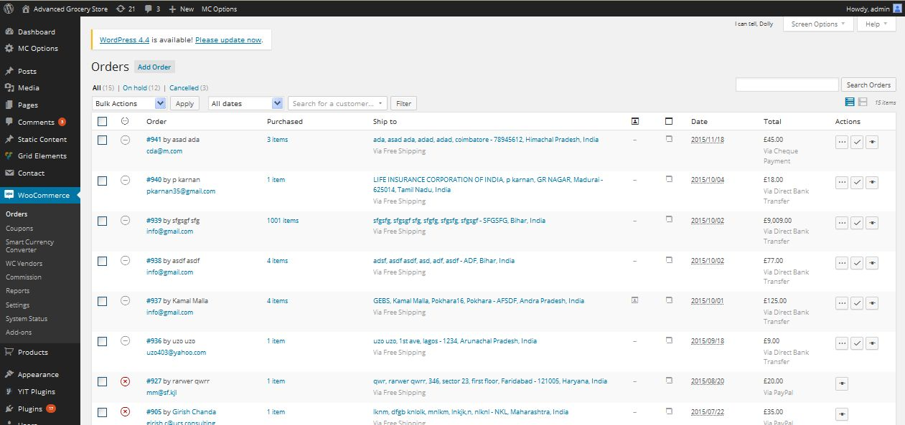

**Description:**

Admin can view all orders of the products

**Coupon**

**View coupon**

**Activity:**

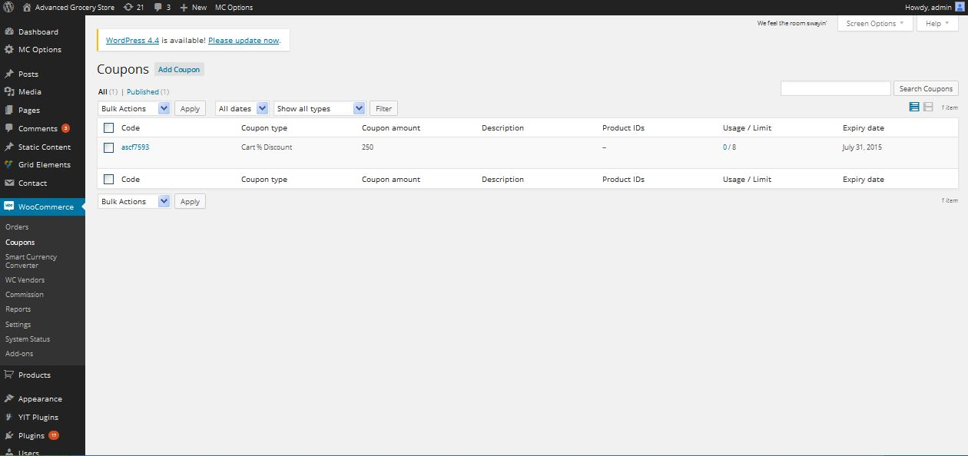

**Description:**

Admin can view active and inactive all coupon details

**Add coupon**

**Activity:**

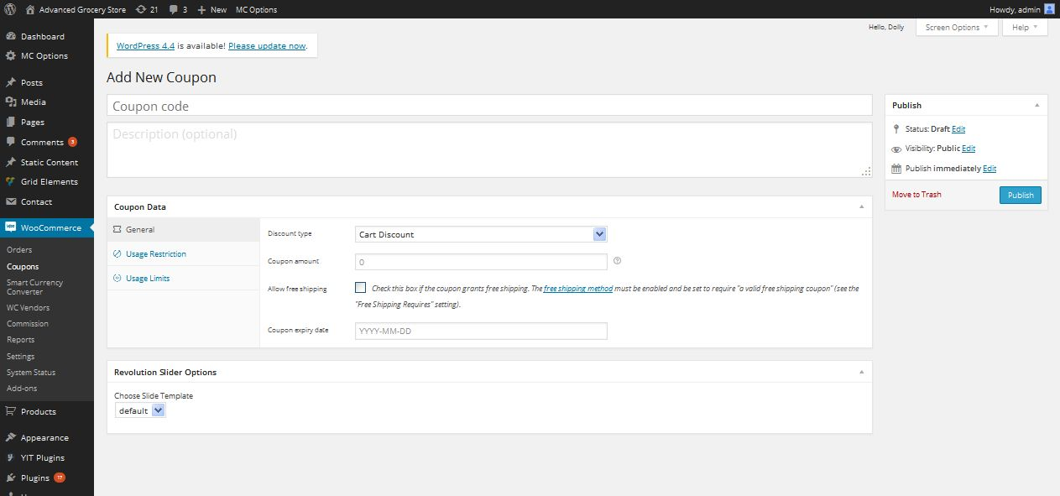

**Description:**

Admin can add new coupon with details

**Smart currency converter**

**Activity:**

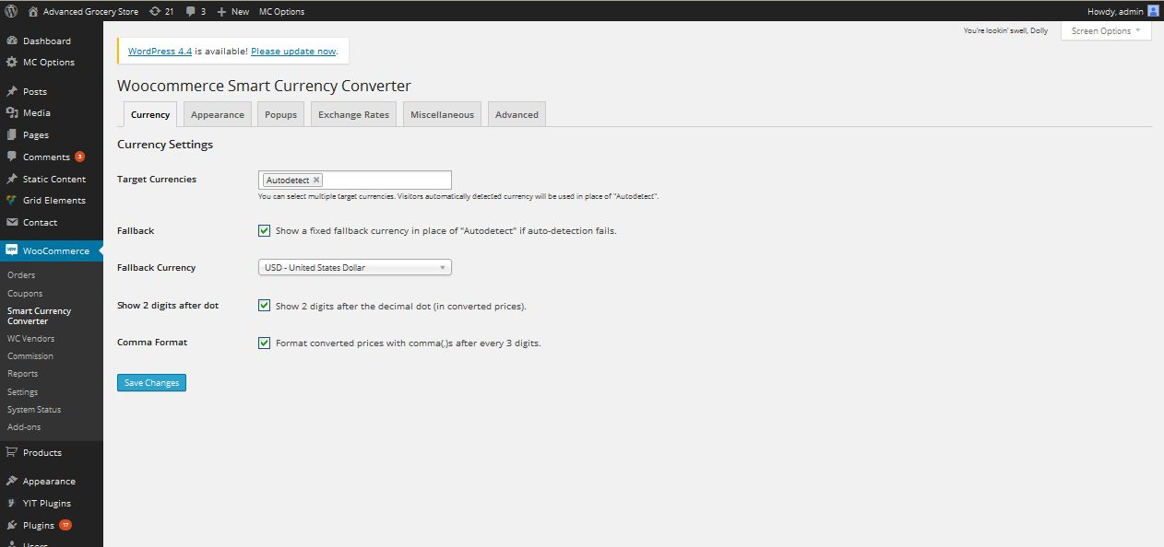

**Description:**

Admin can manage currency value and appearance settings

**Wc-Vendor**

**Activity:**

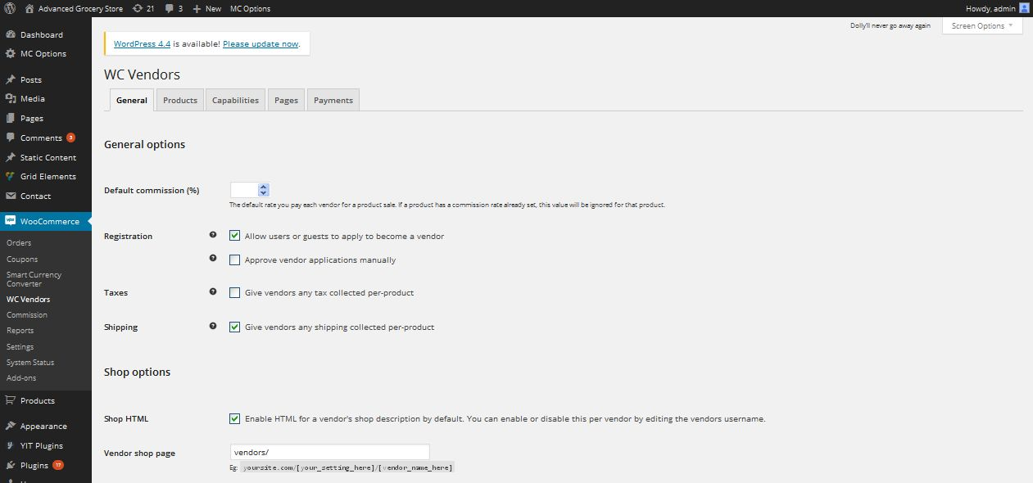

**Description:**

Admin can manage permission settings for vendors

**Commission**

**Activity:**

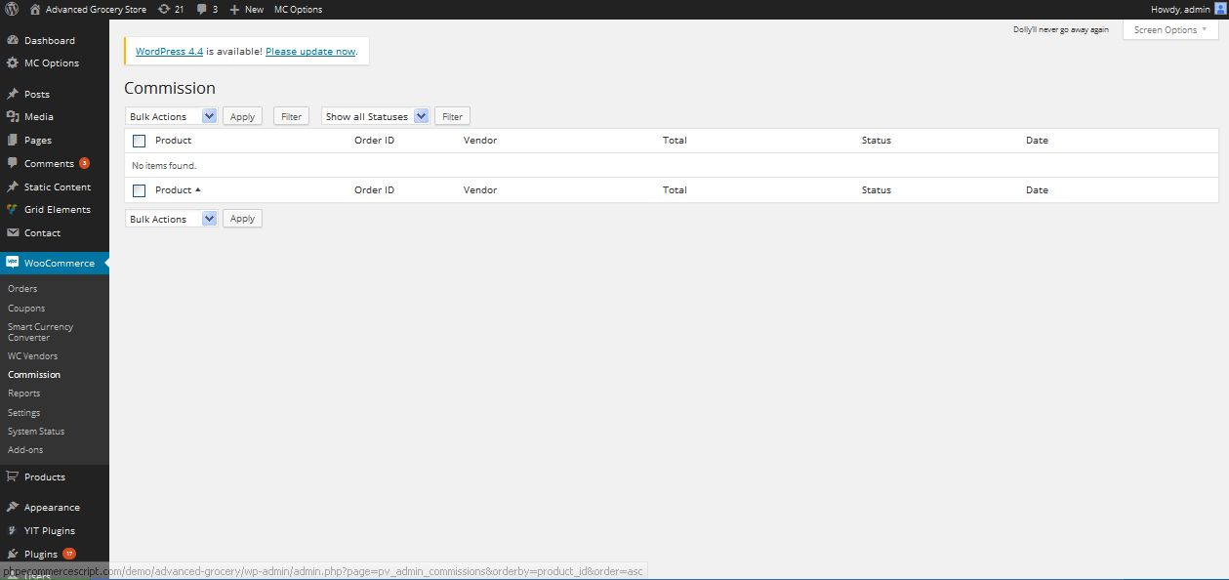

**Description:**

Admin can manage commisson details

**Reports**

**Activity:**

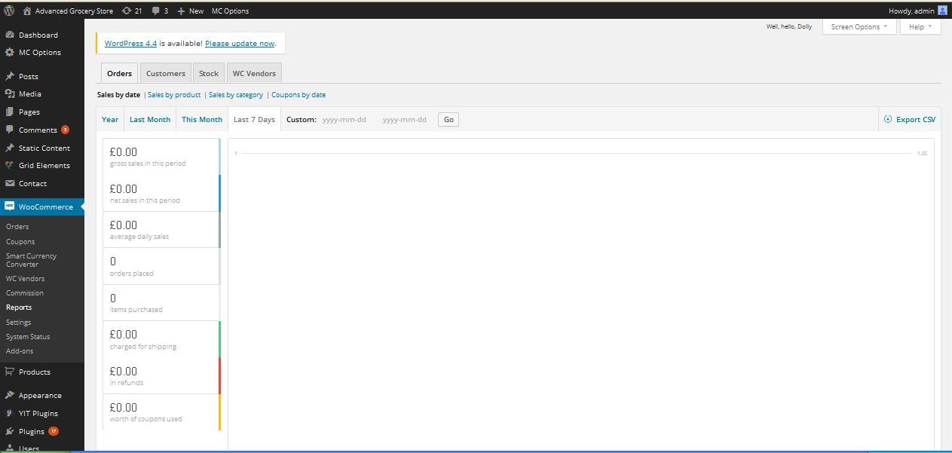

**Description:**

Admin can take report of orders, customers, stock and vendors details in CSV file

**Settings**

**Activity:**

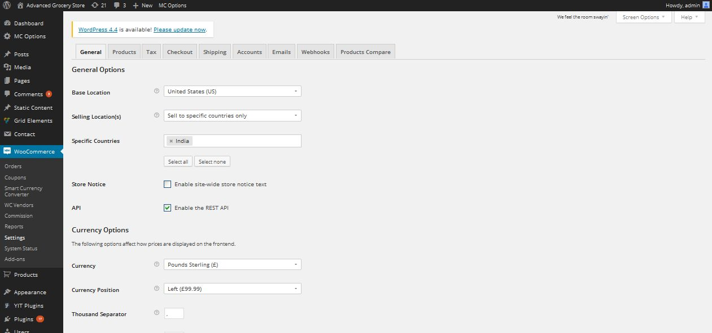

**Description:**

Admin manage basic seetings of woo-commerce

**System status**

**Activity:**

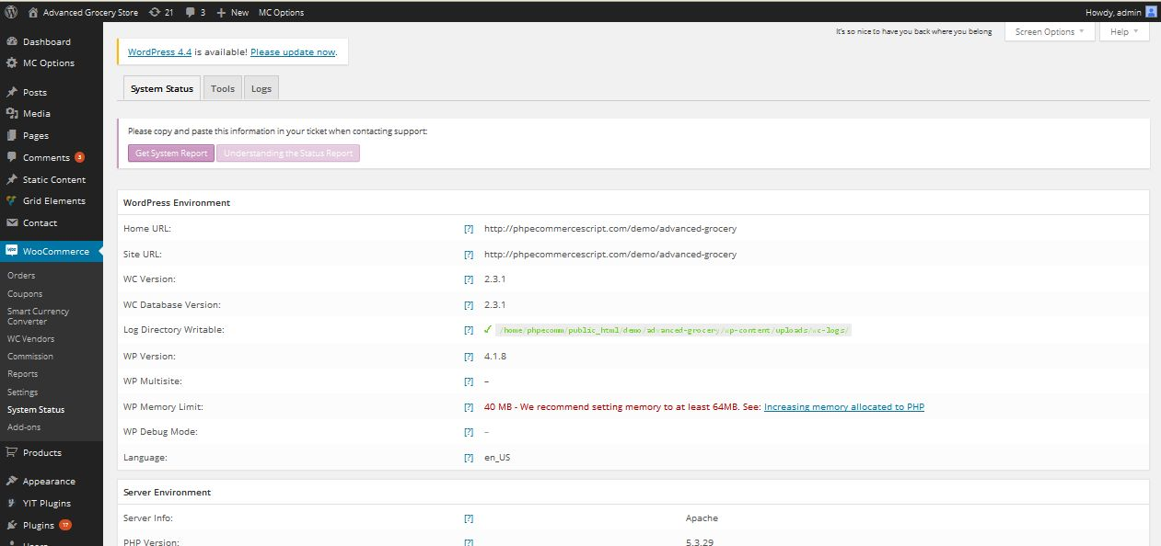

**Description:**

Admin can view their system staus

**Products**

**View product**

**Activity:**

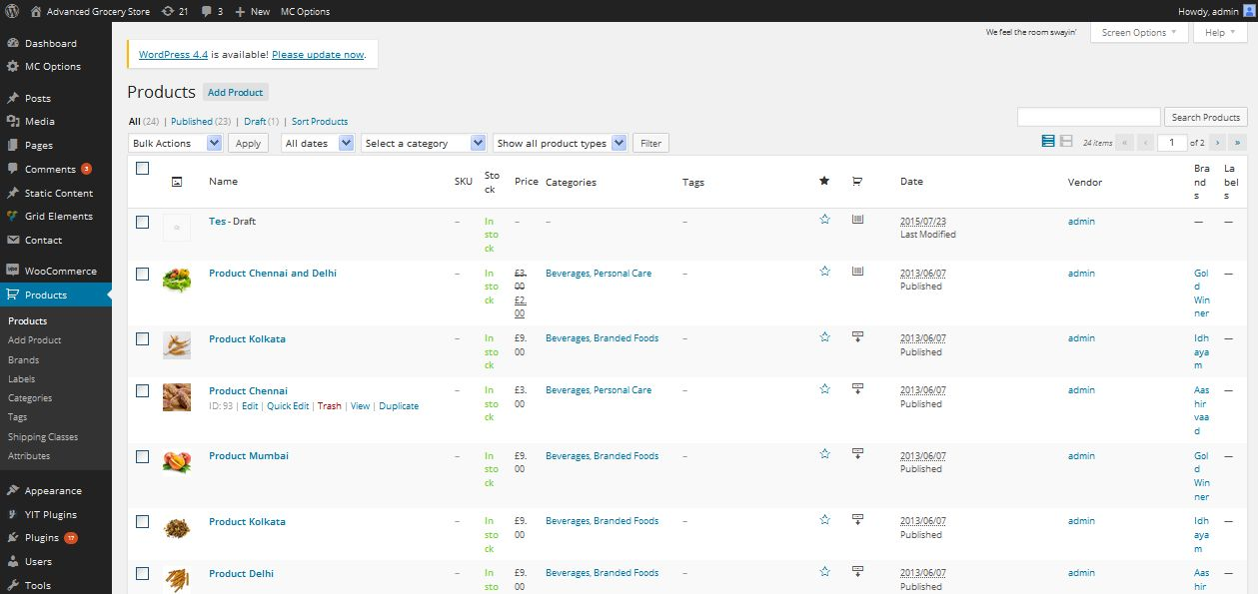

**Description:**

Admin can view their site products with details

**Add product**

**Activity:**

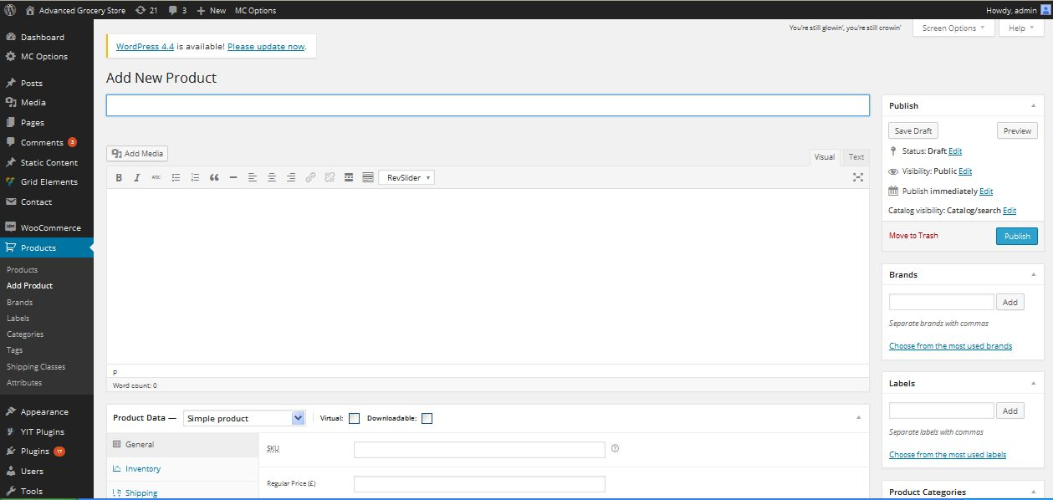

**Description:**

Admin can add new product with details

**Product brand**

**Activity:**

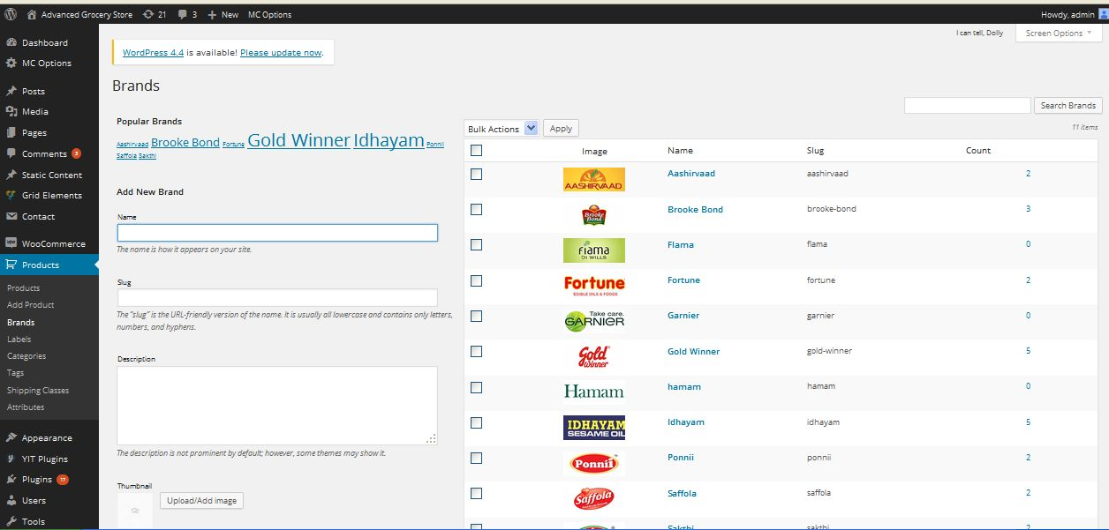

**Description:**

Admin can add and manage product brand

**Label**

**Activity:**

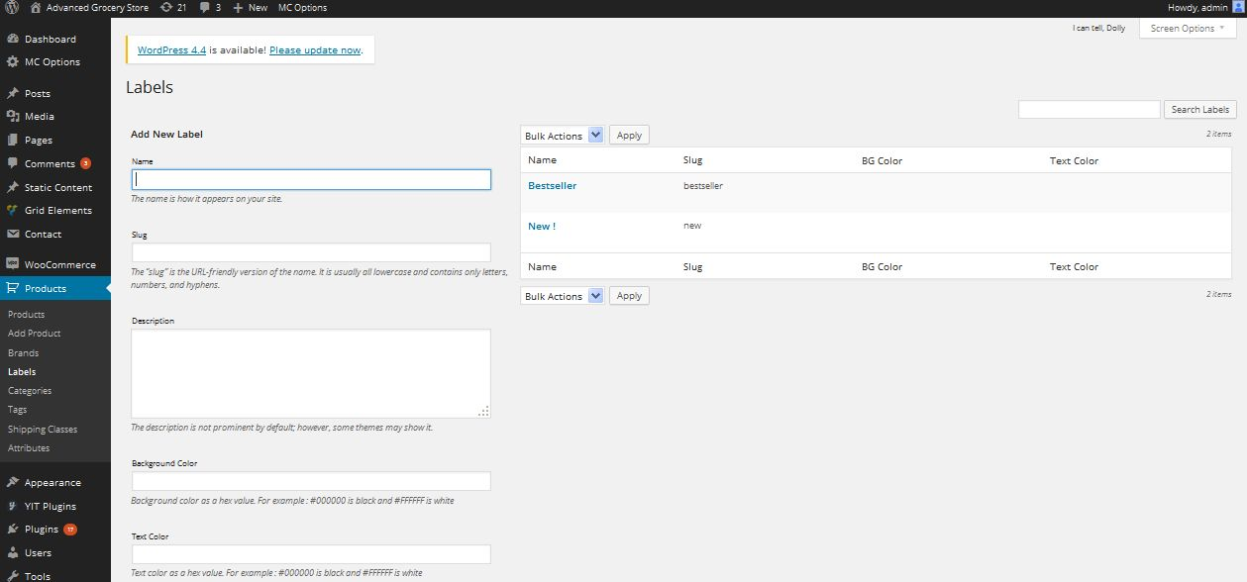

**Description:**

Admin can add and manage product label

**Product category**

**Activity:**

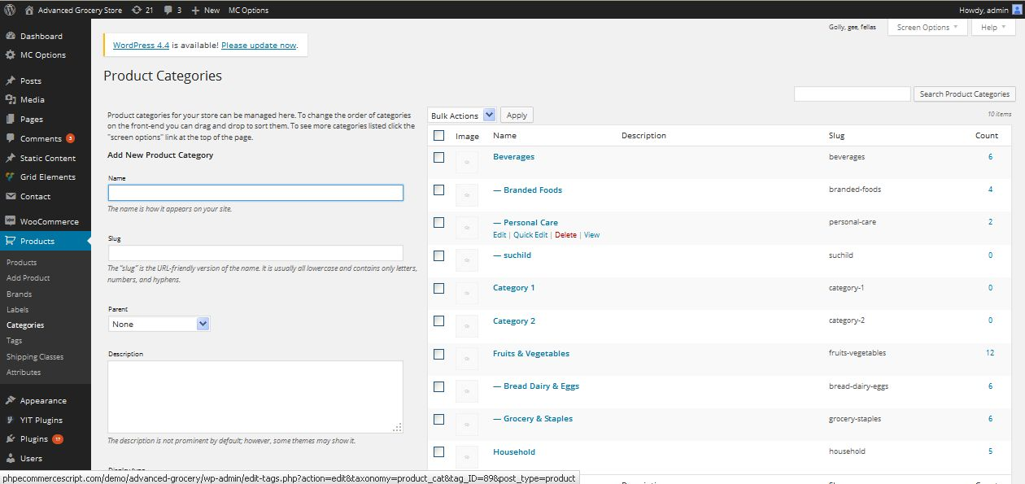

**Description:**

Admin can add and manage product category

**Product tag**

**Activity:**

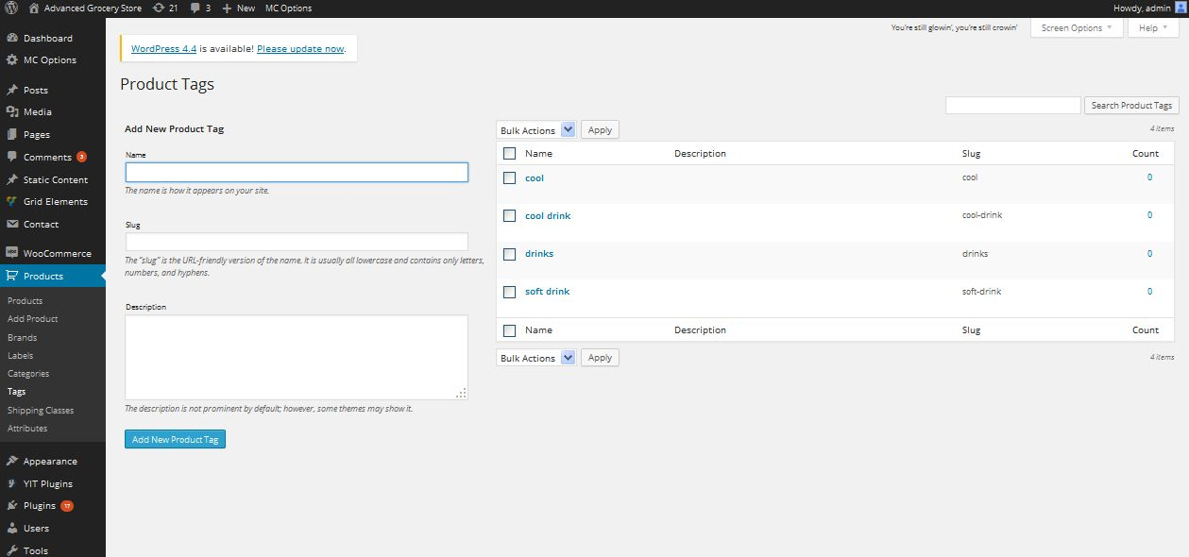

**Description:**

Admin can add and manage product tag

**Shipping class**

**Activity:**

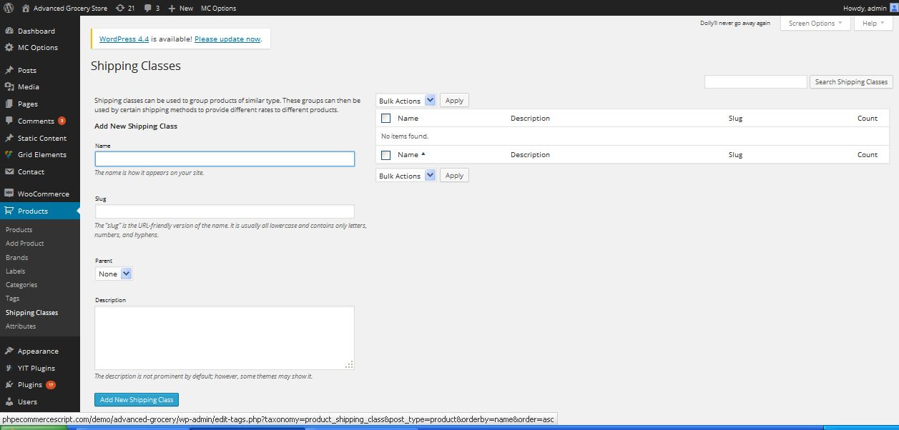

**Description:**

Admin can add and manage shipping class

**Attribute**

**Activity:**

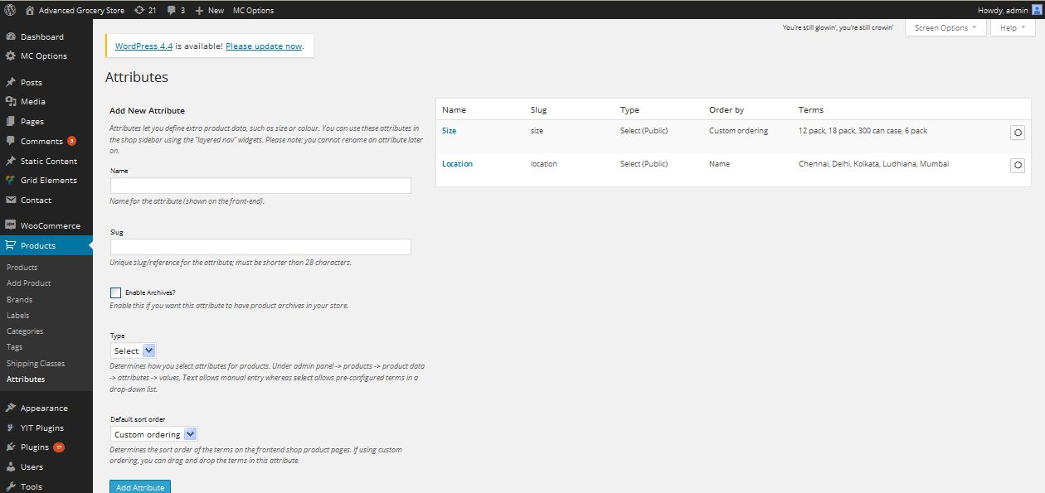

**Description:**

Admin can add and manage attribute about the product

**Appearance**

**Theme**

**Activity:**

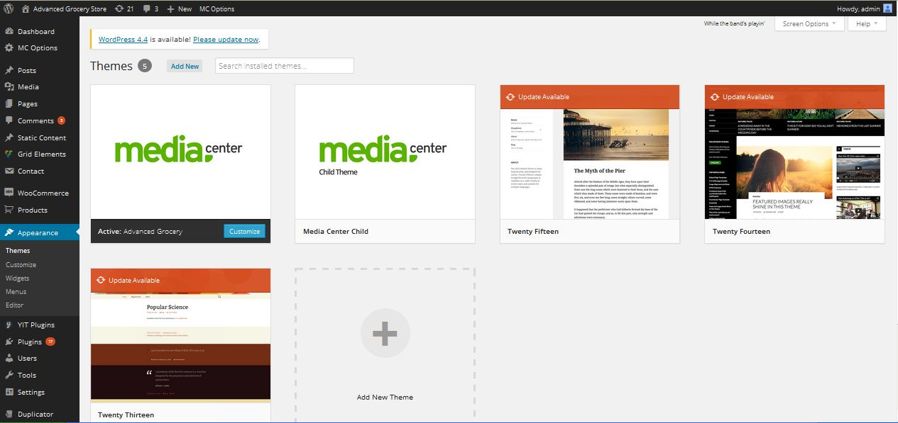

**Description:**

Admin can updat etheir theme

**Customization**

**Site title and tagline**

**Activity:**

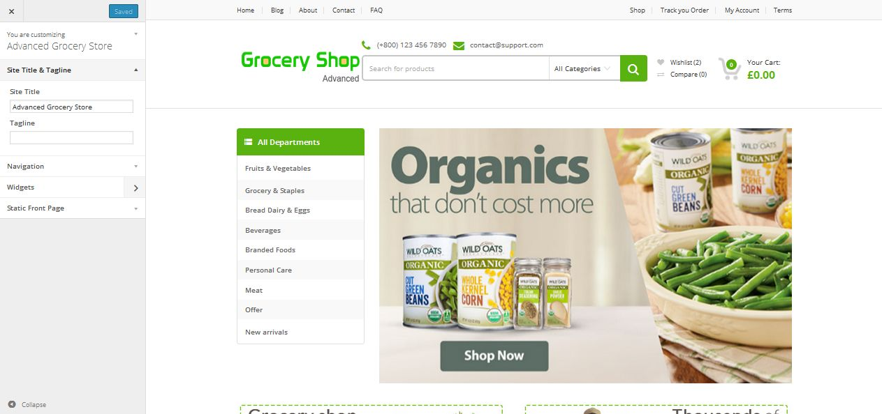

**Description:**

Admin can manage content of site title and tagline

**Navigation**

**Activity:**

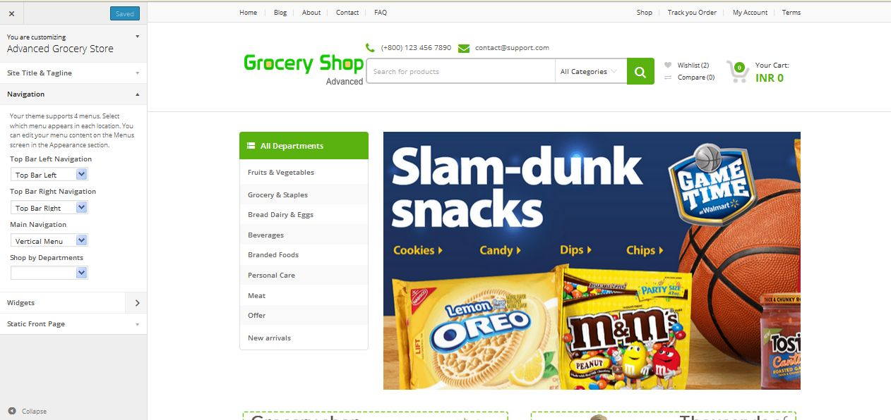

**Description:**

Admin manage menu navigation settings

**Widgets**

**Footer widgets**

**Activity:**

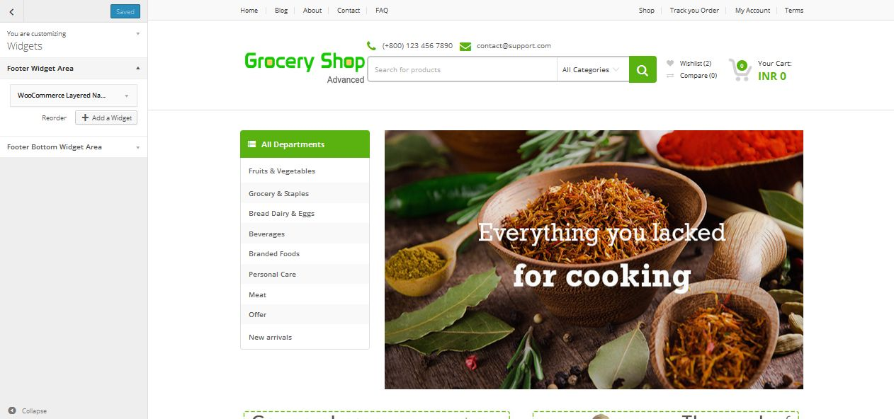

**Description:**

Admin manage footer widgets content

**Bottom widget**

**Activity:**

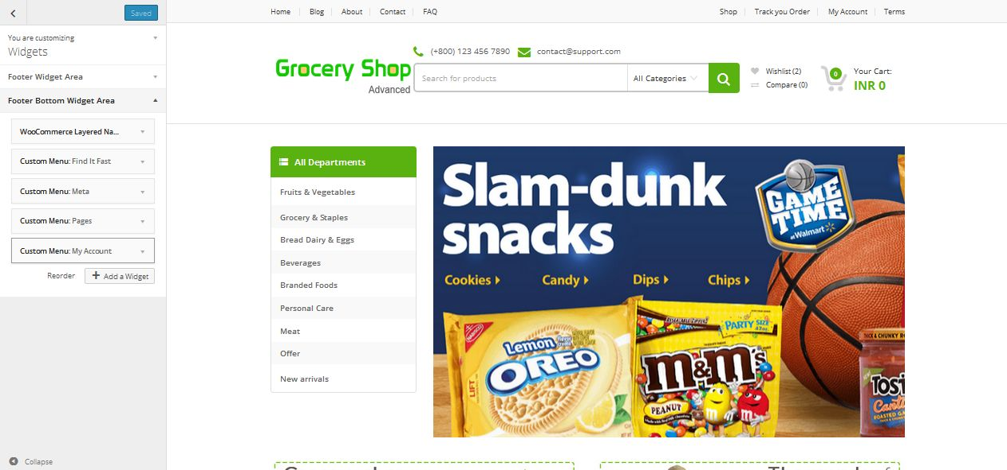

**Description:**

Admin manage bottom widget content

**Static front page**

**Activity:**

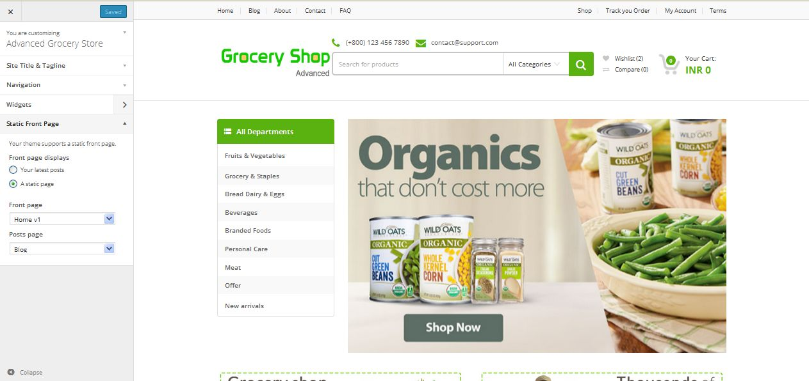

**Description:**

Admin manage settings of static front page

**Widget**

**Activity:**

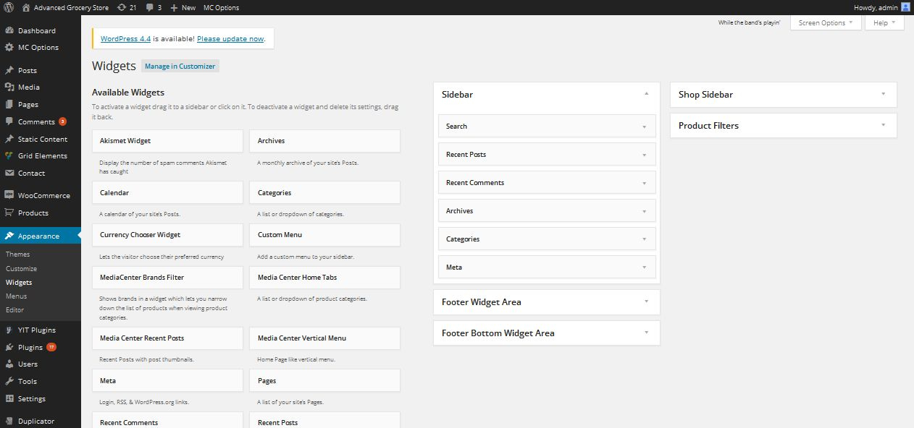

**Description:**

Admin manage settings of widget

**Menu**

**Activity:**

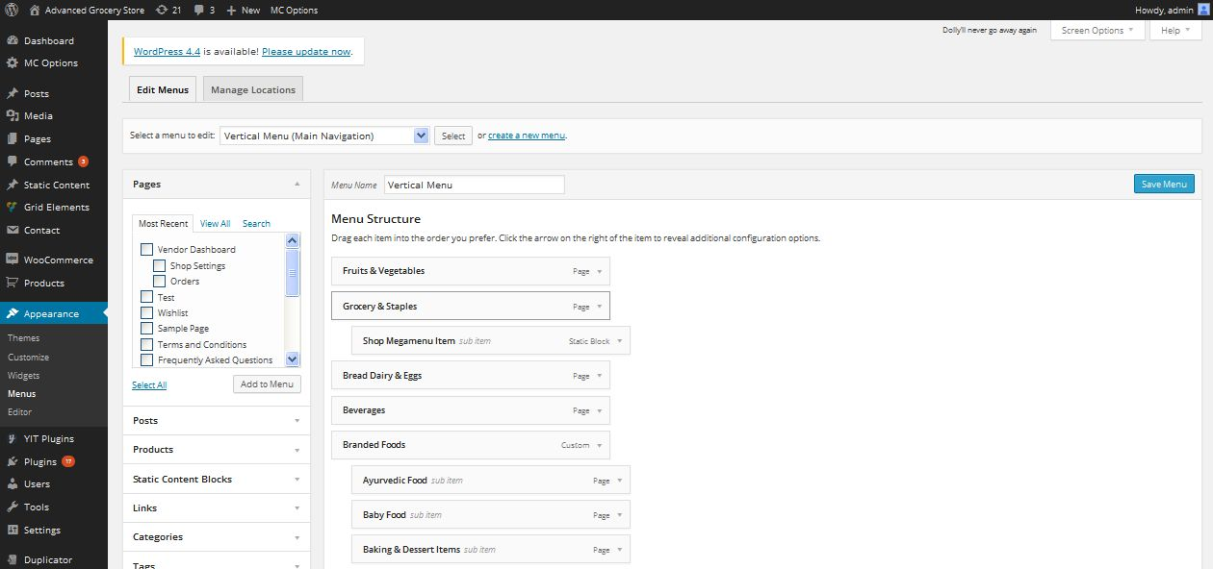

**Description:**

Admin manage settings of menu

**Menu location**

**Activity:**

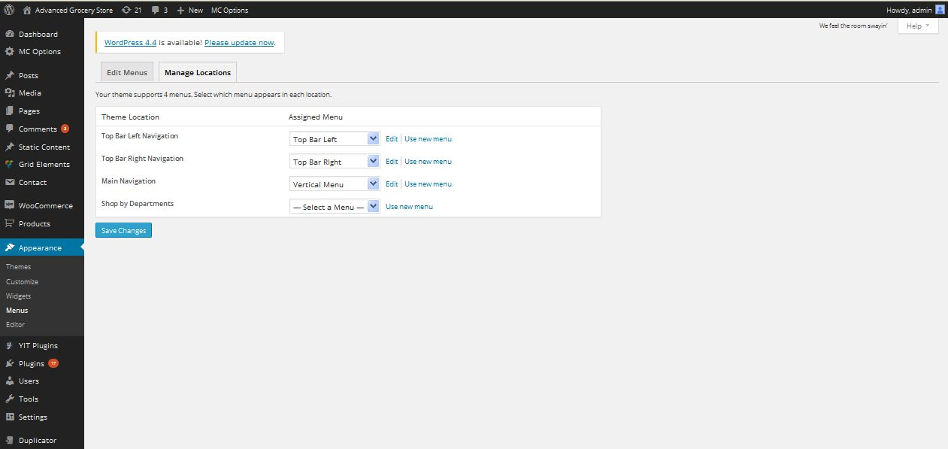

**Description:**

Admin can manage menu location

**Editor**

**Activity:**

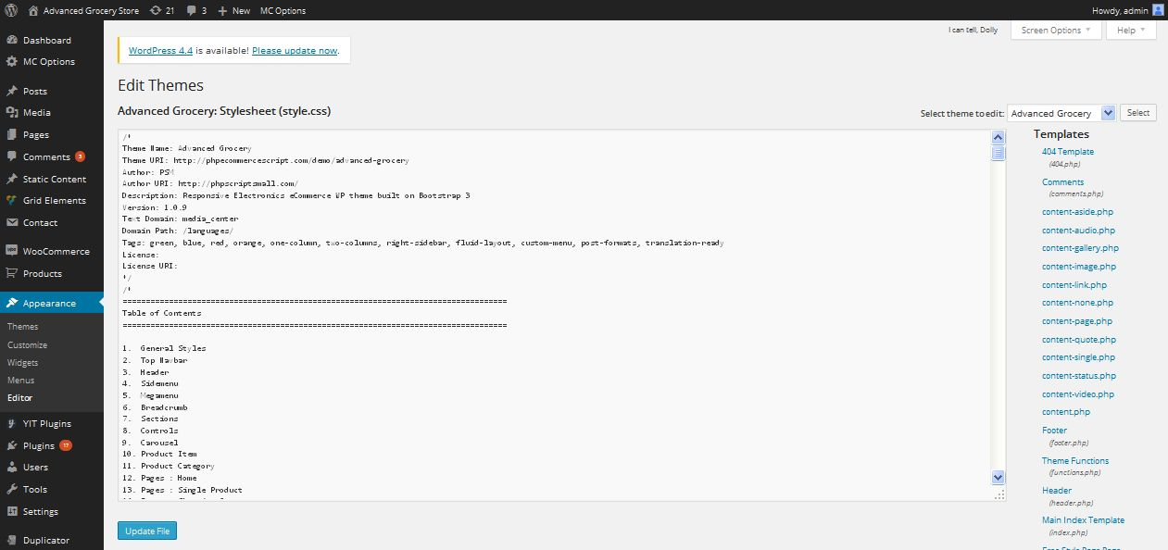

**Description:**

Admin can edit script using CSS

**User**

**View users**

**Activity:**

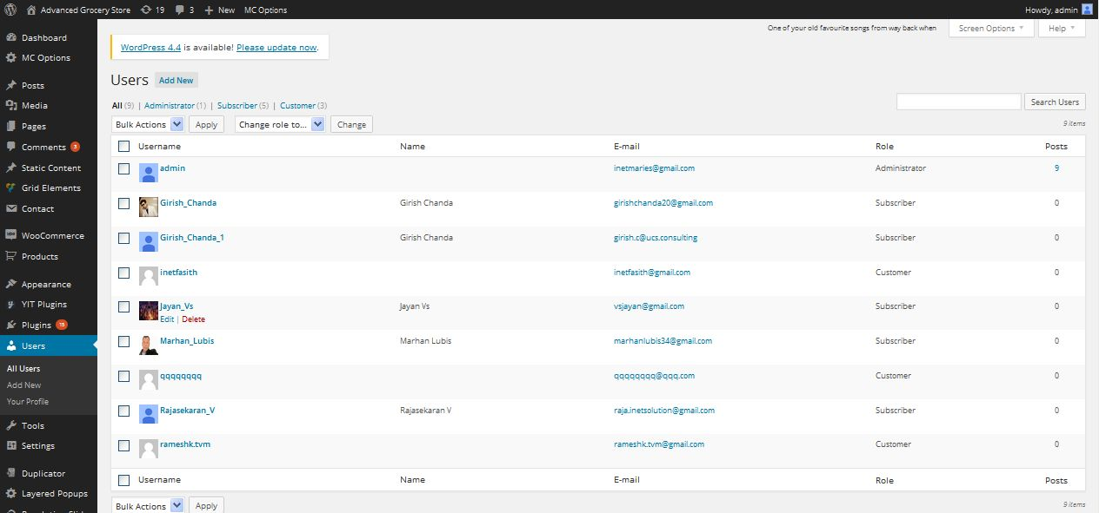

**Description:**

Admin can veiw all users of the site

**Add user**

**Activity:**

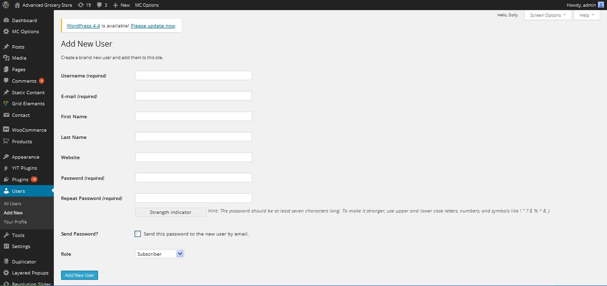

**Description:**

Admin can add new user

**Profile view**

**Activity:**

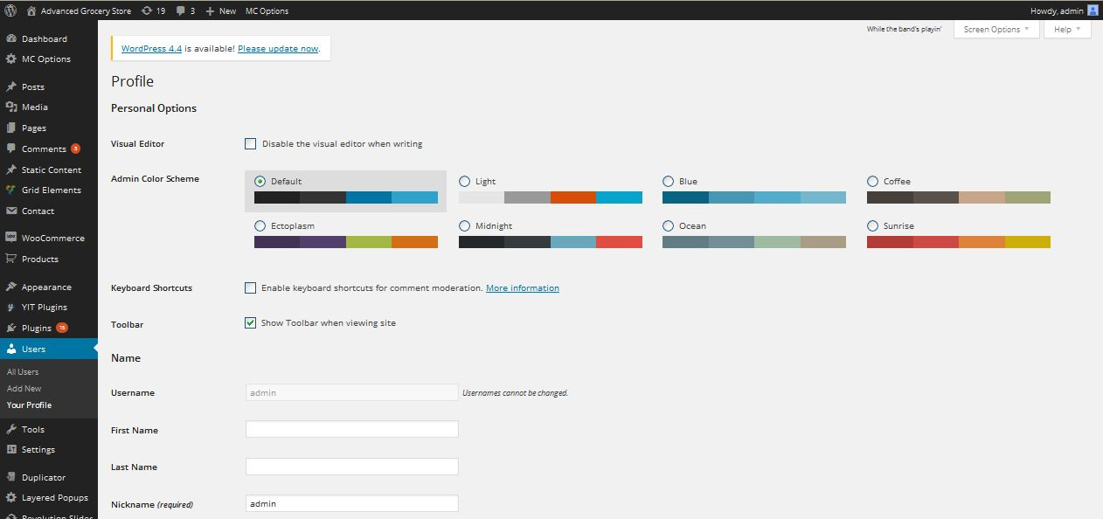

**Description:**

Admin can view their profile details

**Tools**

**Available tools**

**Activity:**

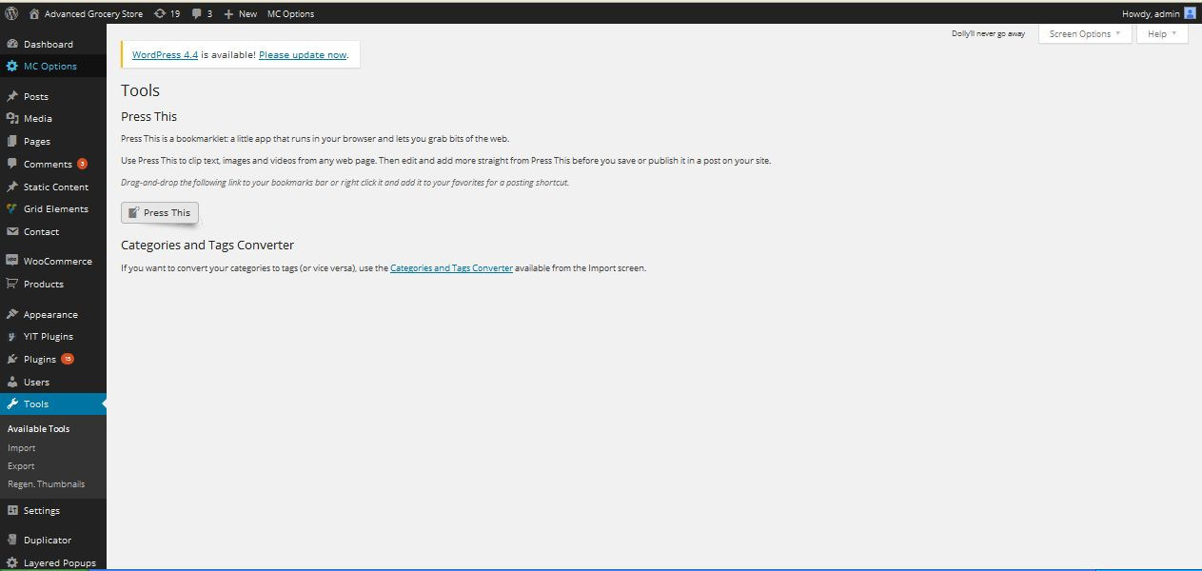

**Description:**

Admin can avaialabl etools in the site

**Import**

**Activity:**

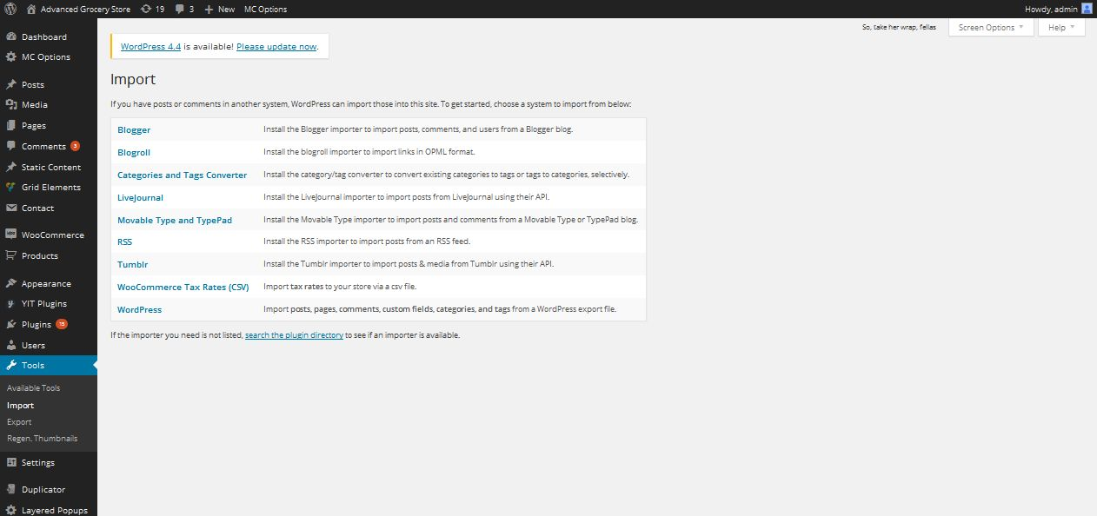

**Description:**

Admin can manage settings of import tools

**Export**

**Activity:**

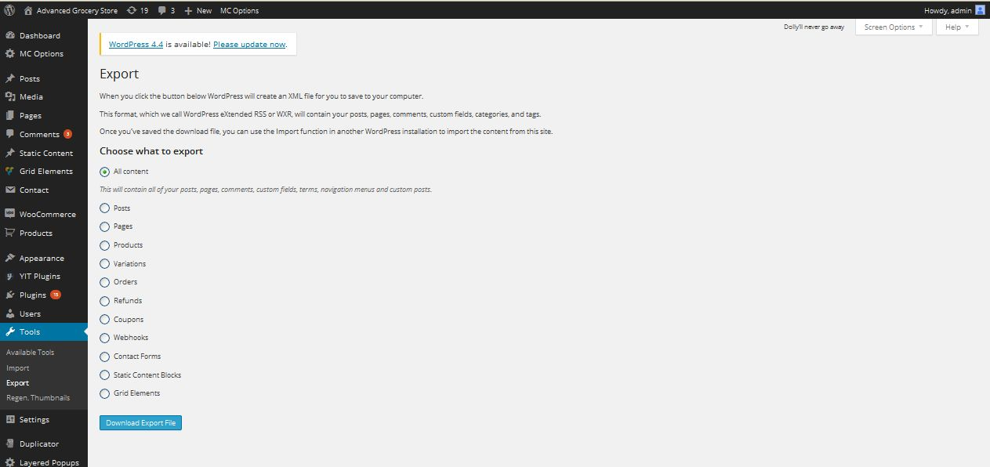

**Description:**

Admin can export site details using these link

**Re-generate thumbnails**

**Activity:**

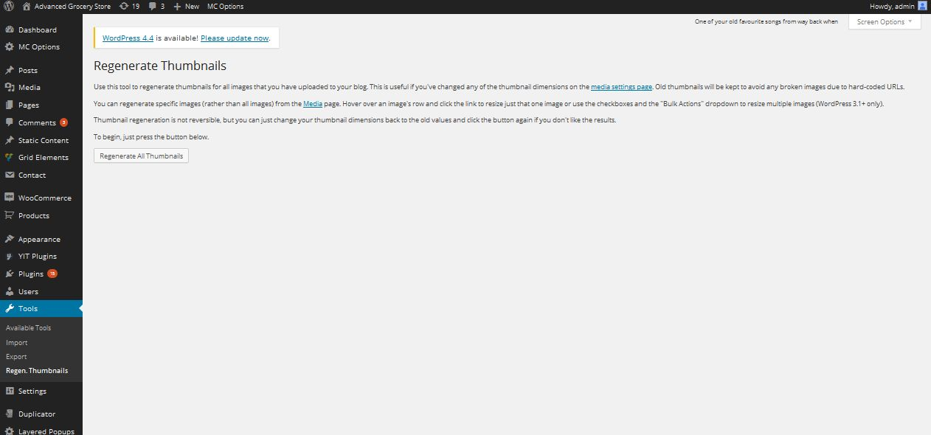

**Description:**

Admin can re-generate product image using this tool

**Settings**

**General settings**

**Activity:**

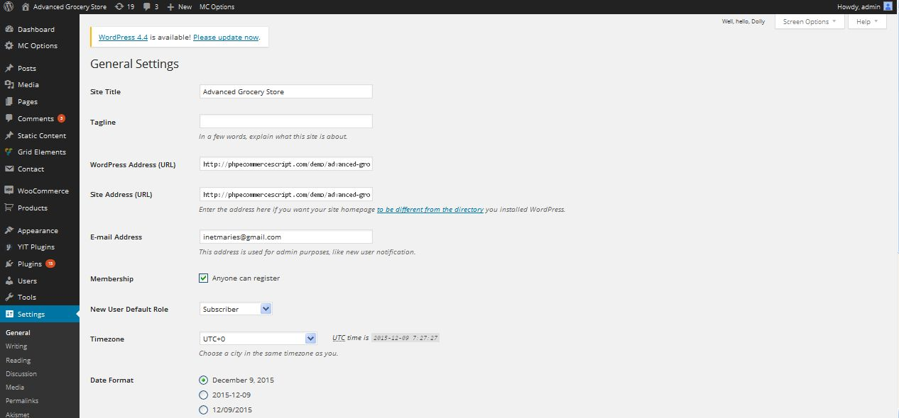

**Description:**

Admin can manage general settings of the site

**Writing**

**Activity:**

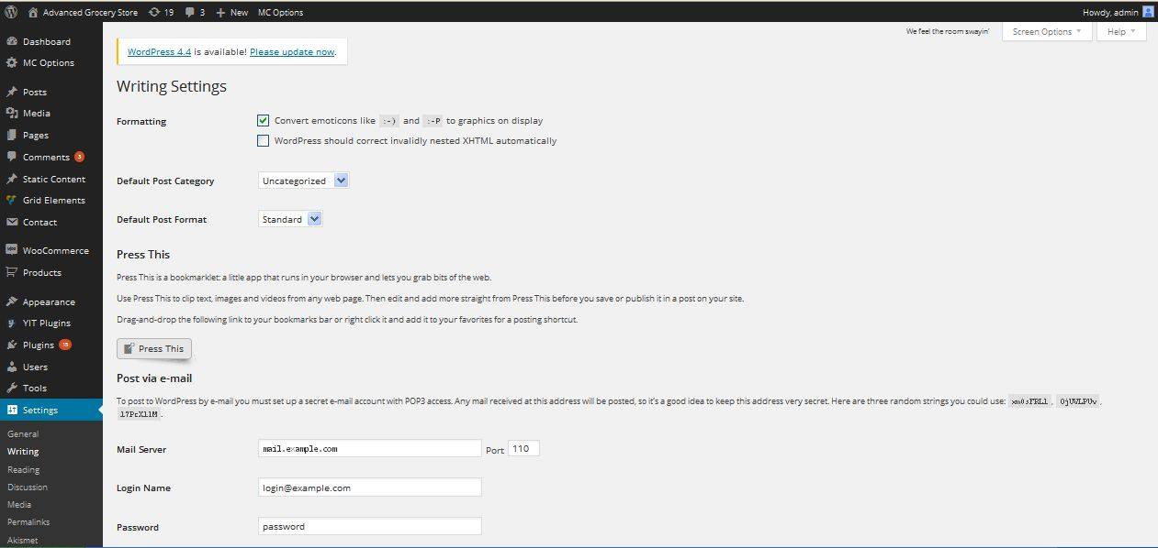

**Description:**

Admin can manage settings of writing

**Reading**

**Activity:**

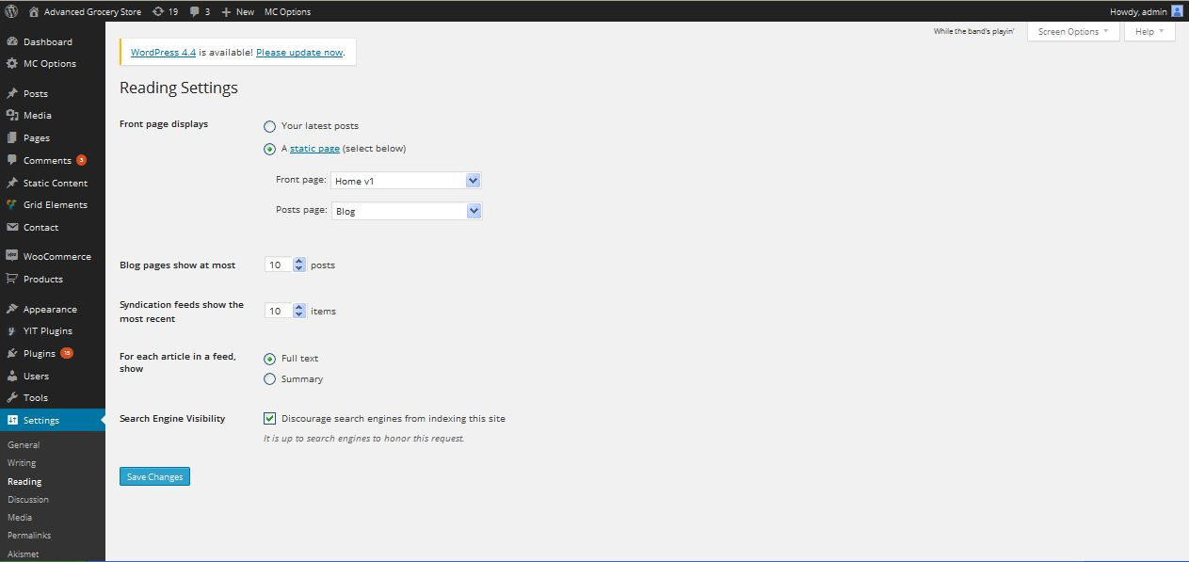

**Description:**

Admin can manage settings of reading

**Discussion**

**Activity:**

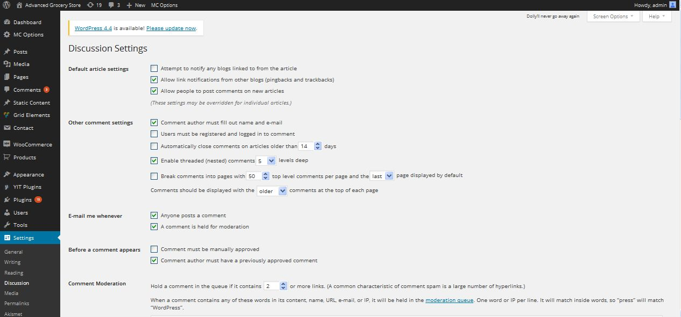

**Description:**

Admin can manage settings of discussion

**Media**

**Activity:**

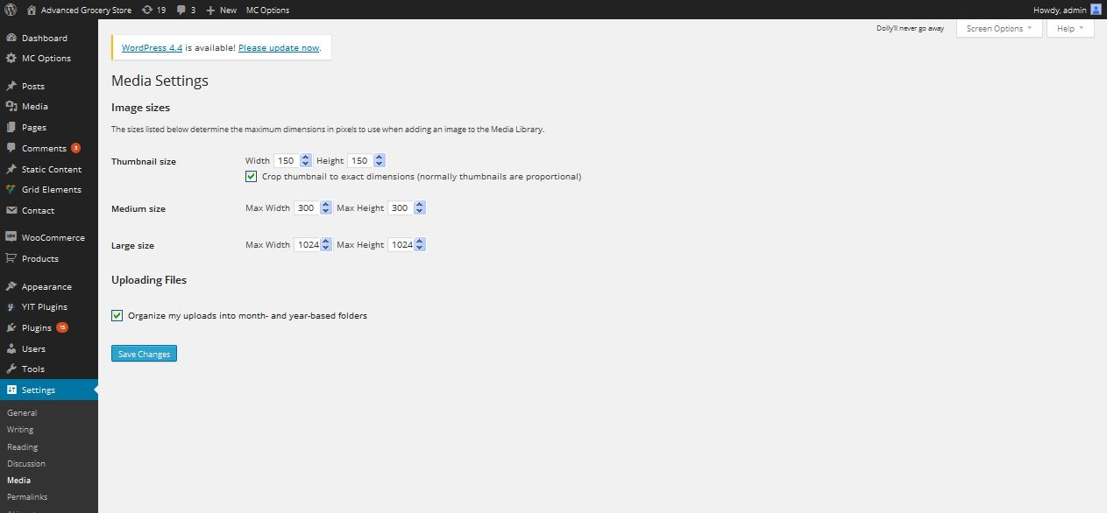

**Description:**

Admin can settings of media

**Permalink**

**Activity:**

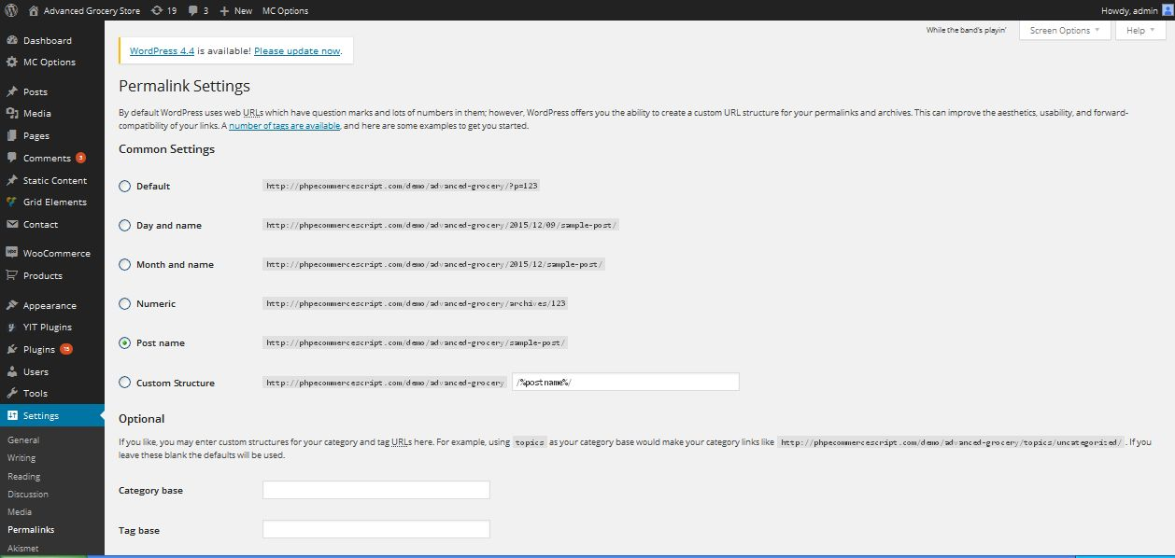

**Description:**

Admin manage settings of permalink

**Popup plugin**

**Activity:**

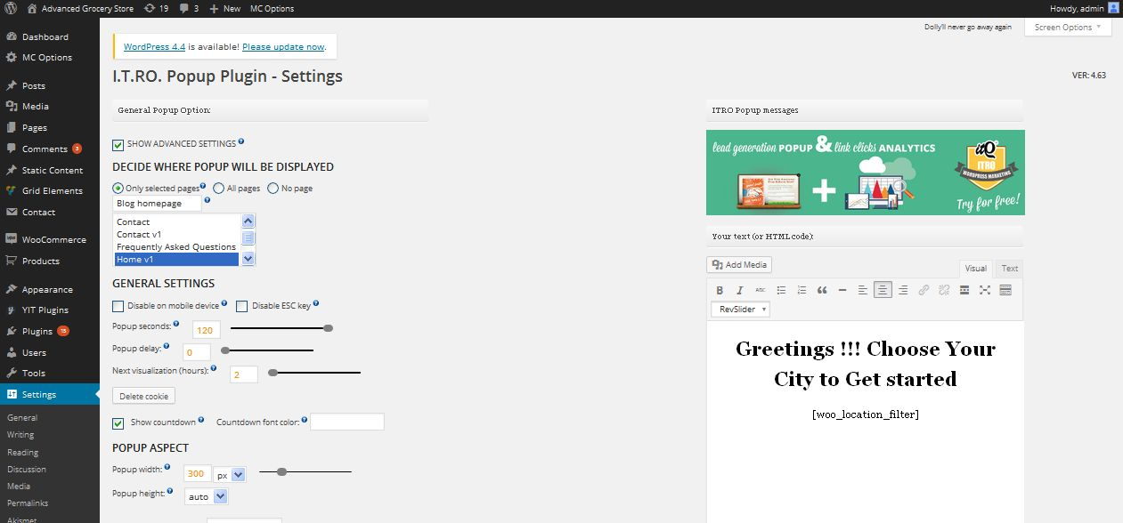

**Description:**

Admin manage settings of popup plugins

**Updraft backup/restore**

**Activity:**

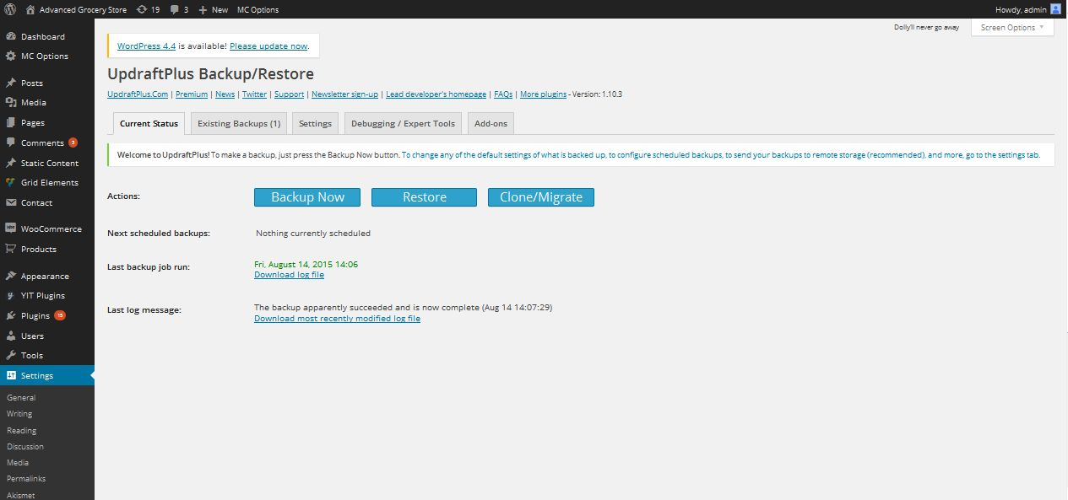

**Description:**

Admin manage settings of backup and restore f the site

**Social login settings**

**Activity:**

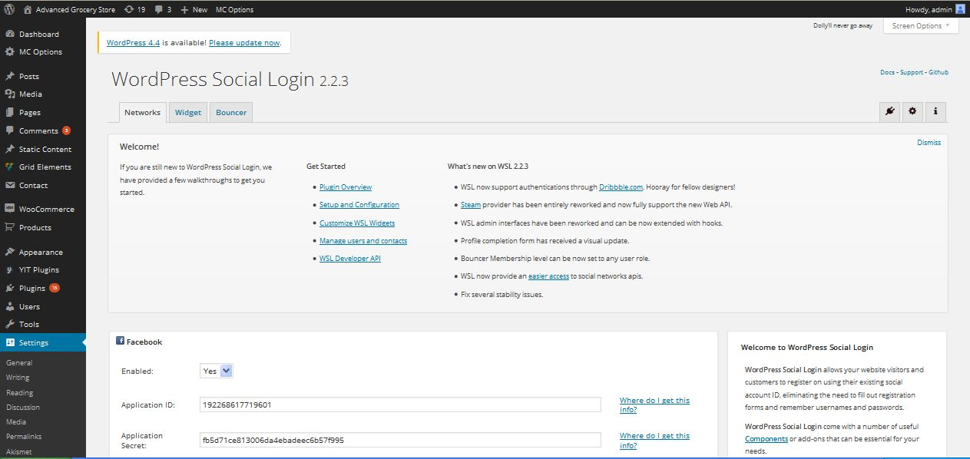

**Description:**

Admin manage social login settings

**Visual composer settings**

**Activity:**

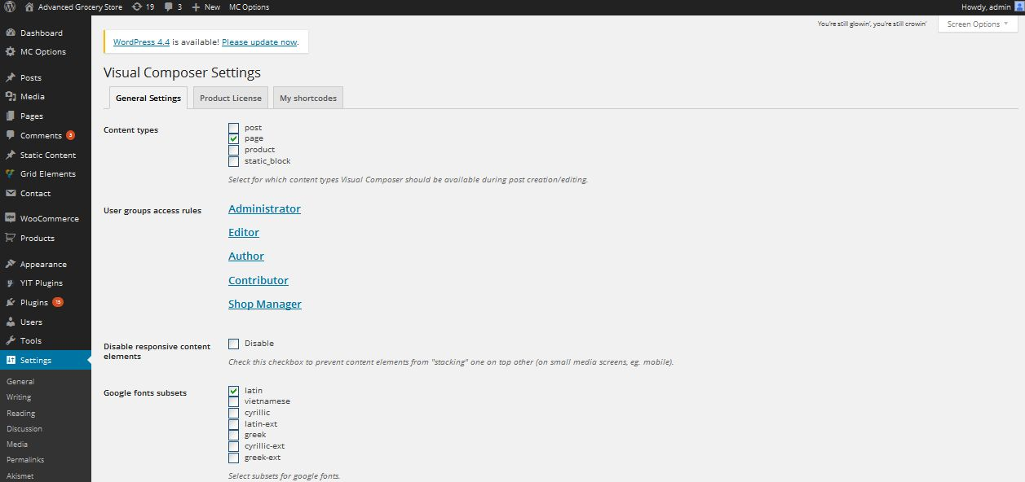

**Description:**

Admin manage settings of visual composer

**Akismet**

**Activity:**

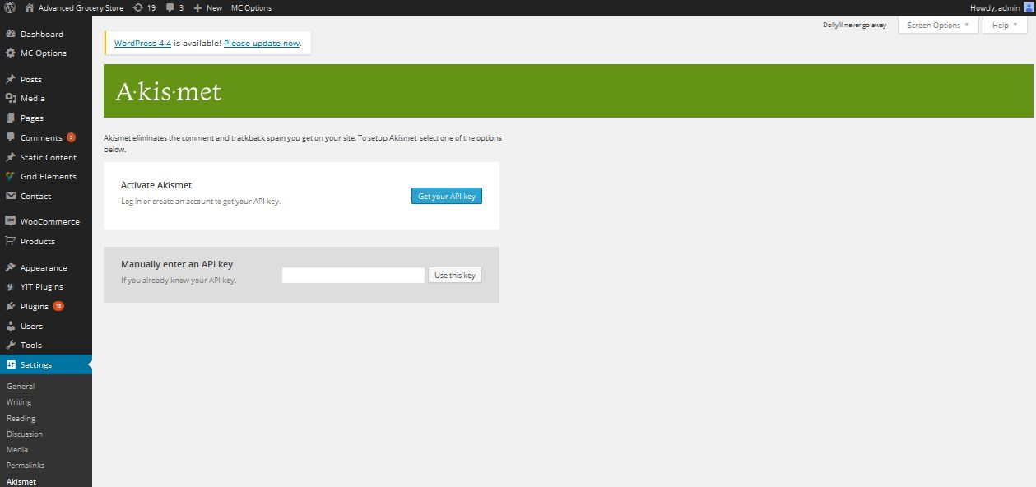

**Description:**

Admin manage spam mails

**Layered popup**

**View popup details**

**Activity:**

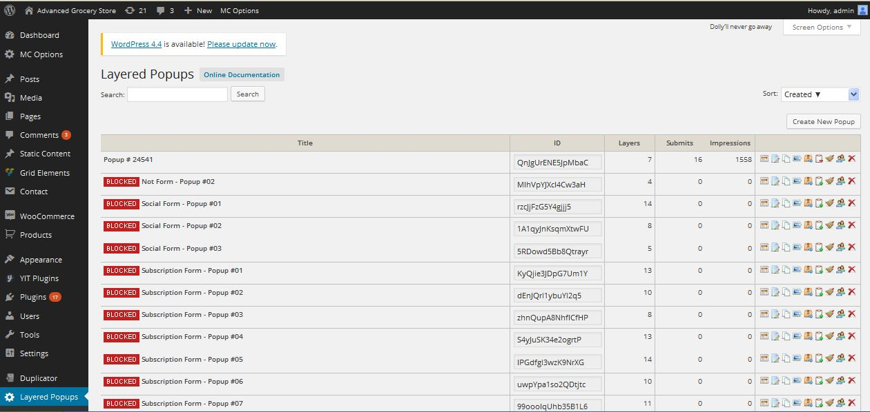

**Description:**

Admin can view popup status

**Create popup**

**Activity:**

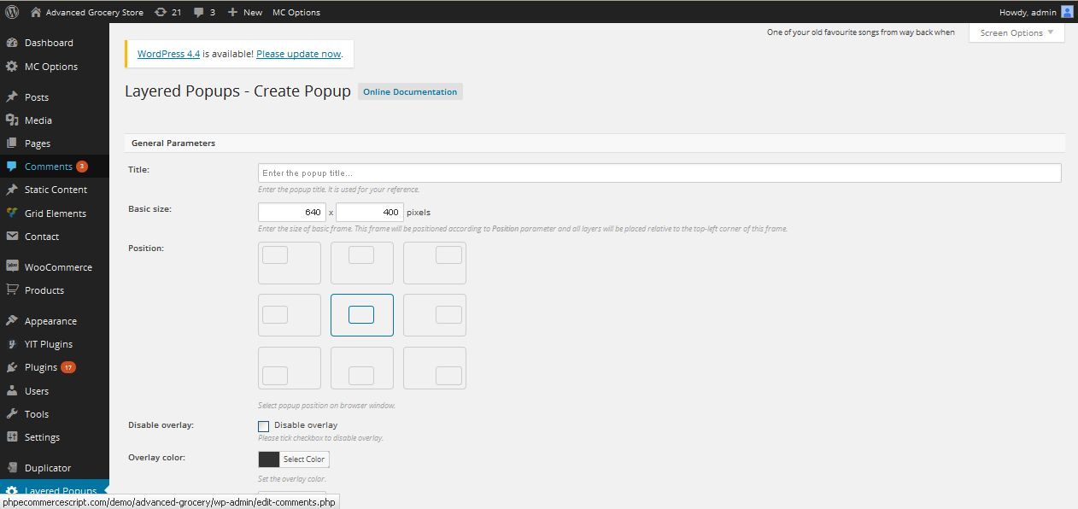

**Description:**

Admin can create new popup with details

**Security plugin**

**Wordfence scan**

**Activity:**

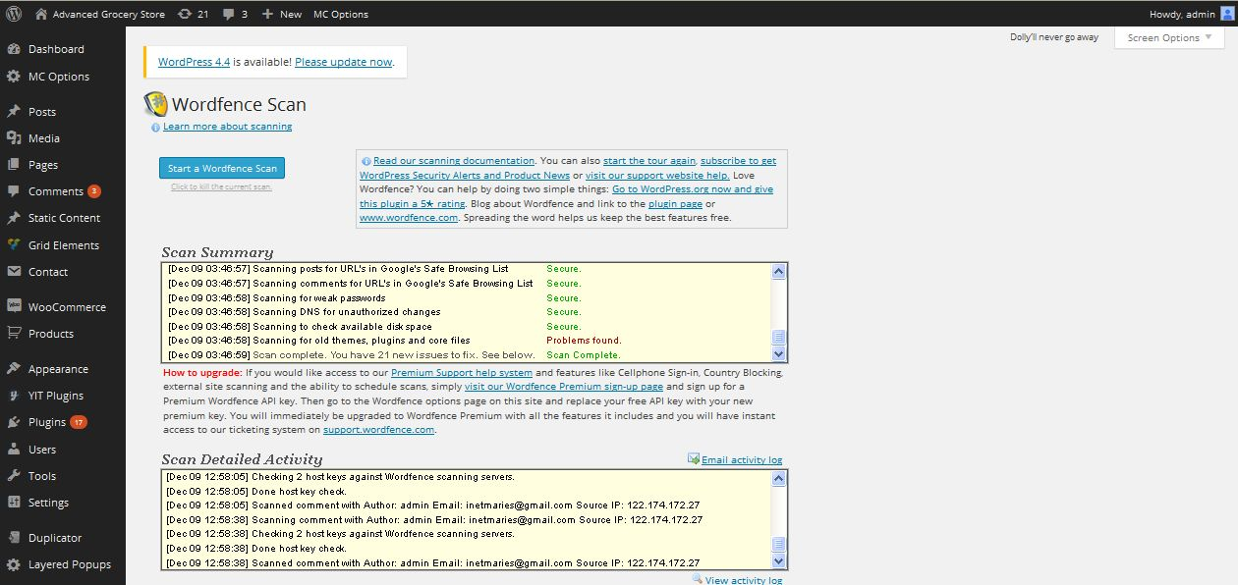

**Description:**

Admin can view their security status

**Block IP**

**Activity:**

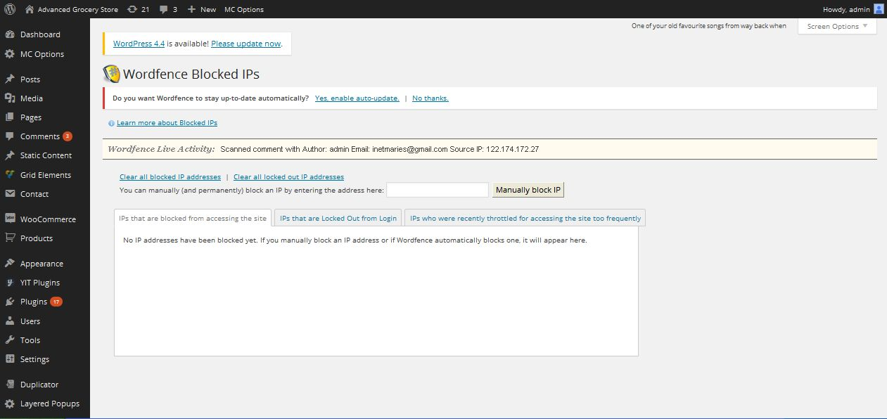

**Description:**

Admin can block IP address to access

**Password audit**

**Activity:**

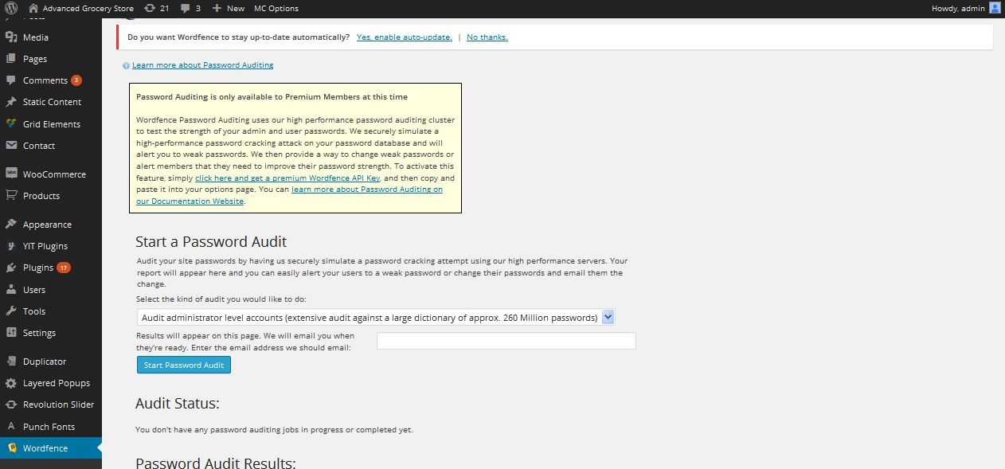

**Description:**

Admin can manage password audit

**SEO plugin**

**SEO**

**Activity:**

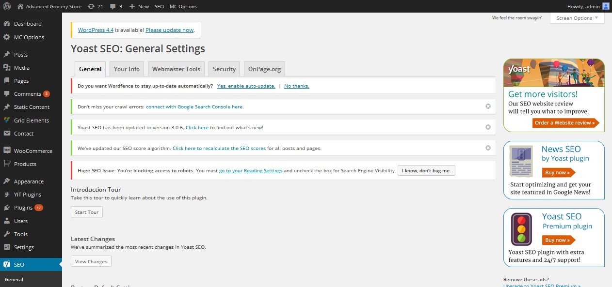

**Description:**

Admin can view SEO status

**Your info**

**Activity:**

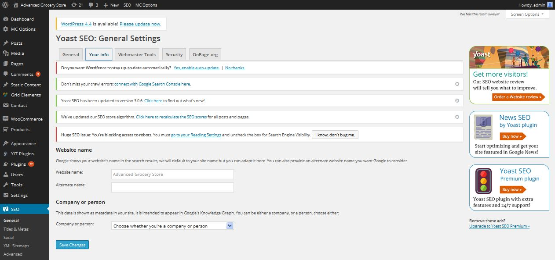

**Description:**

Admin can manage site name in Google

**Security**

**Activity:**

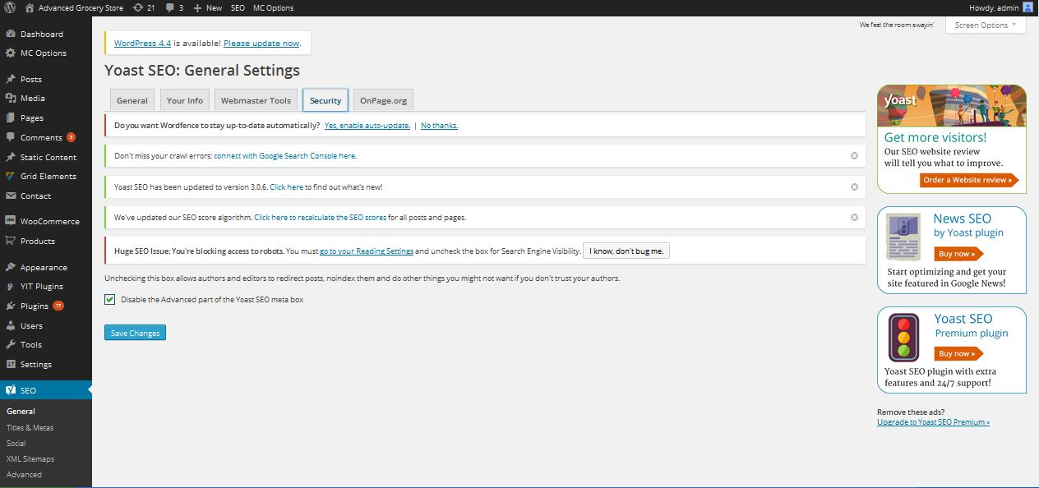

**Description:**

Admin can manage SEO security settings