GIFT SHOP
Theme option
Site setting:
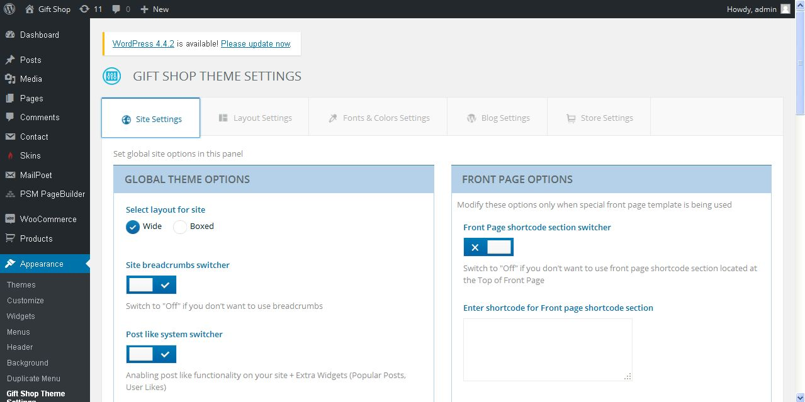
Description:
Admin can manage layout of the site, header & footer options and logo settings

Layout settings:
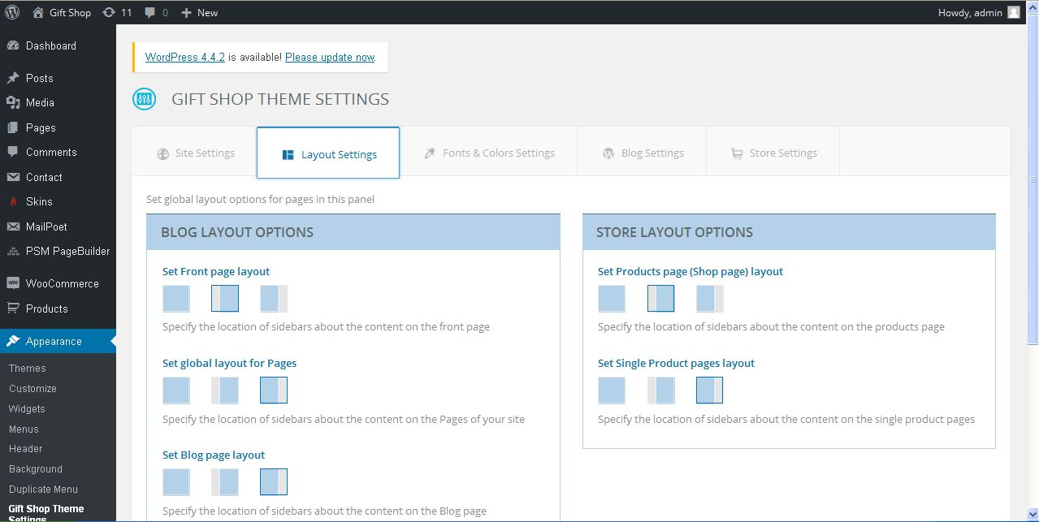
Description:
Admin can manage settings of layout style of store and blog

Fonts & colors settings:
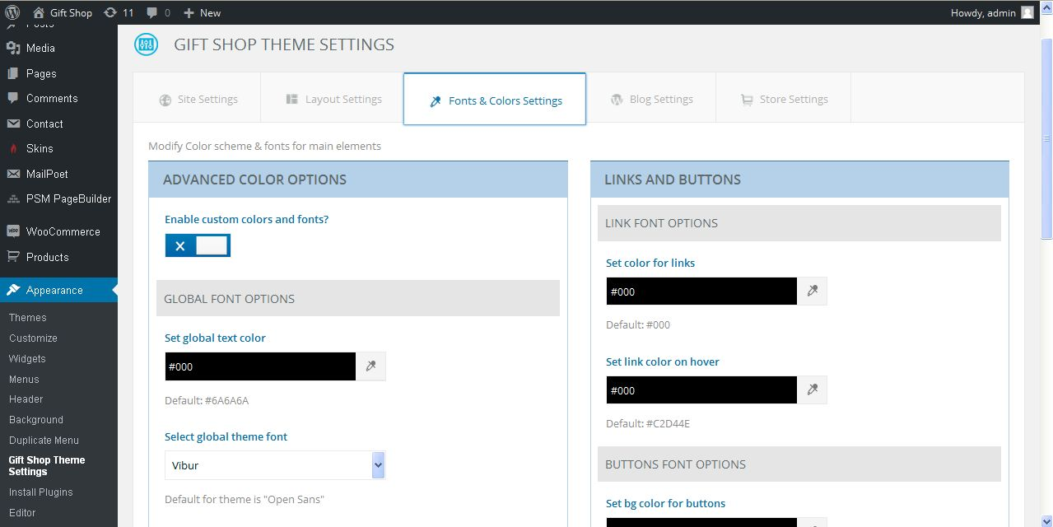
Description:
Admin can manage fonts and color settings

Blog settings:
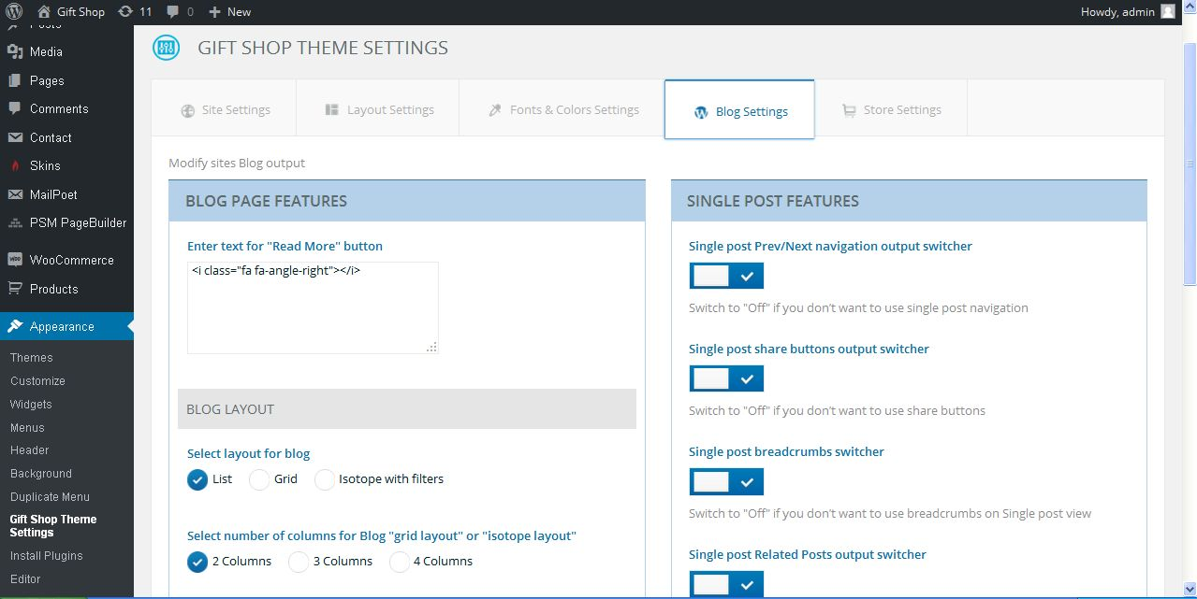
Description:
Admin can manage blog layout, gallery options and post features settings

Store settings:
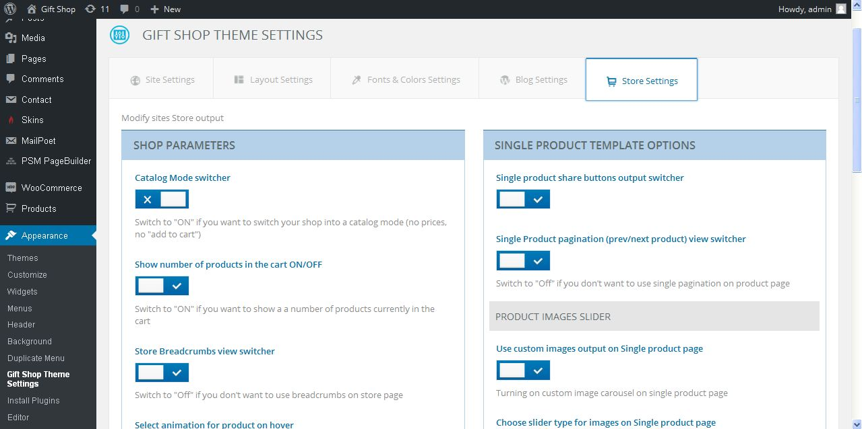
Description:
Admin can manage shop product template, image slider, product template and shop parameter settings

Skins settings:
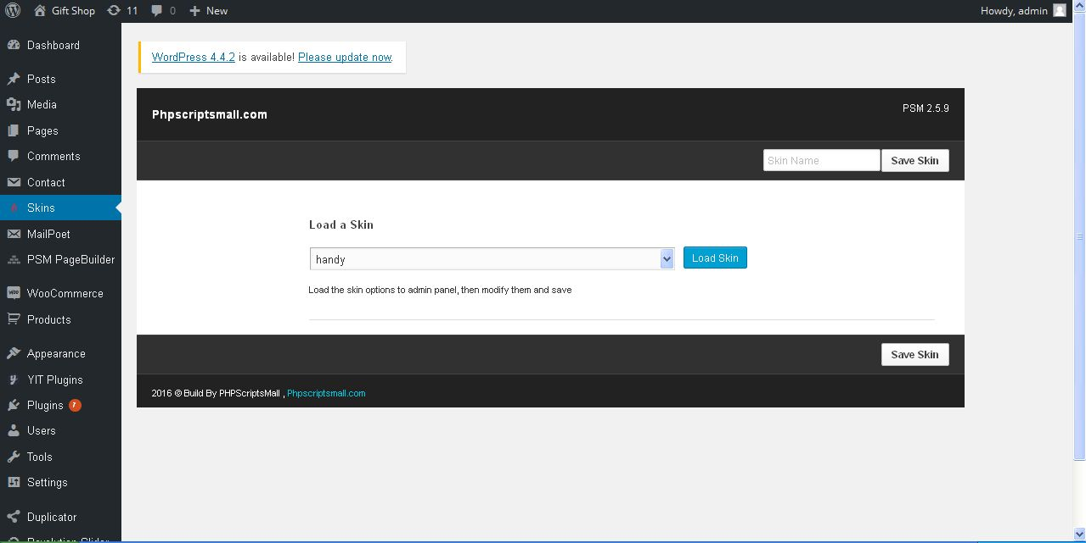
Description:
Admin can change their theme skin using these functionality

Edit theme:
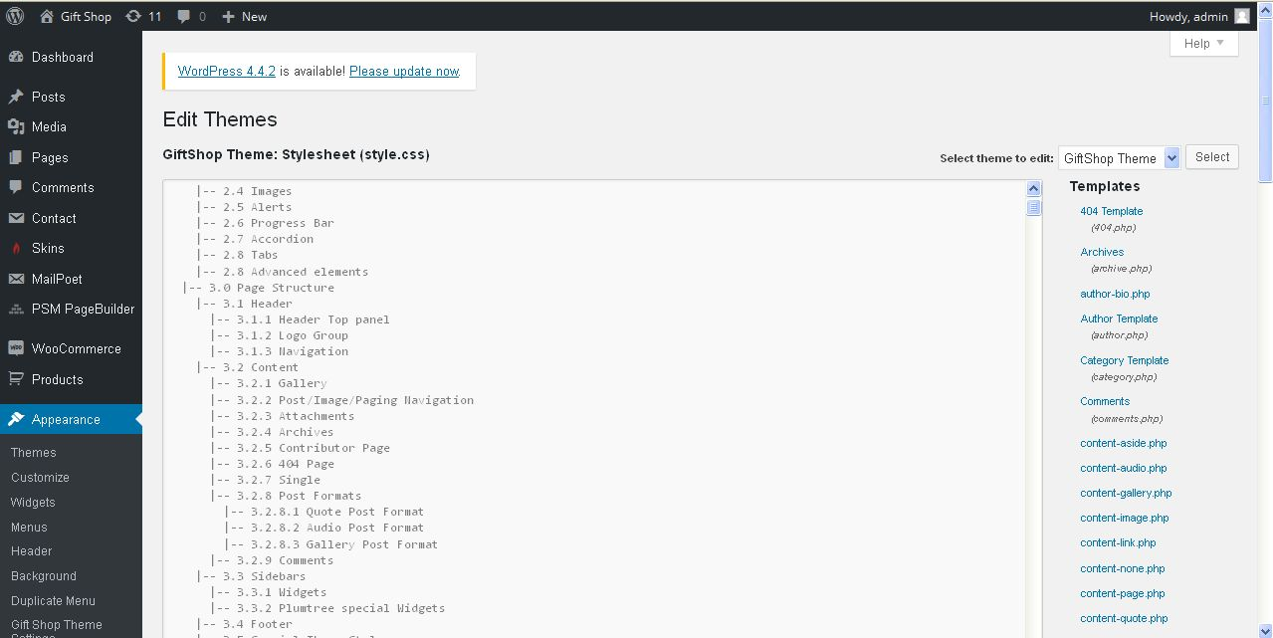
Description:
Admin can add new CSS query using edit theme

Product
Product:
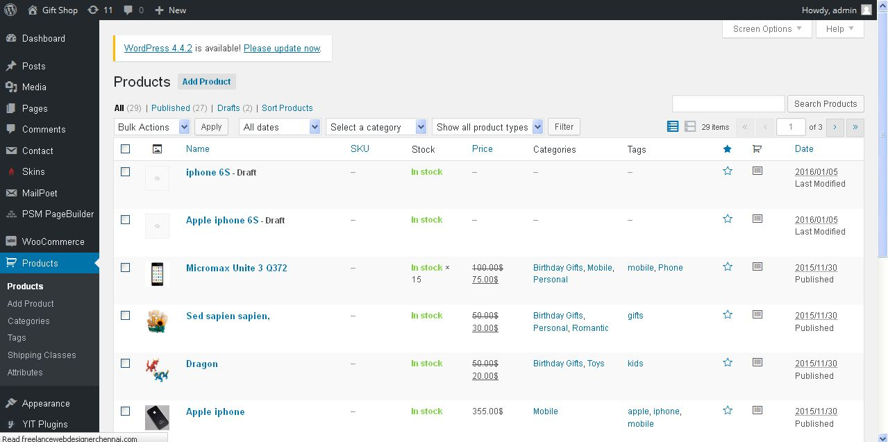
Description:
Admin can view and manage site products also having search option

Add product:
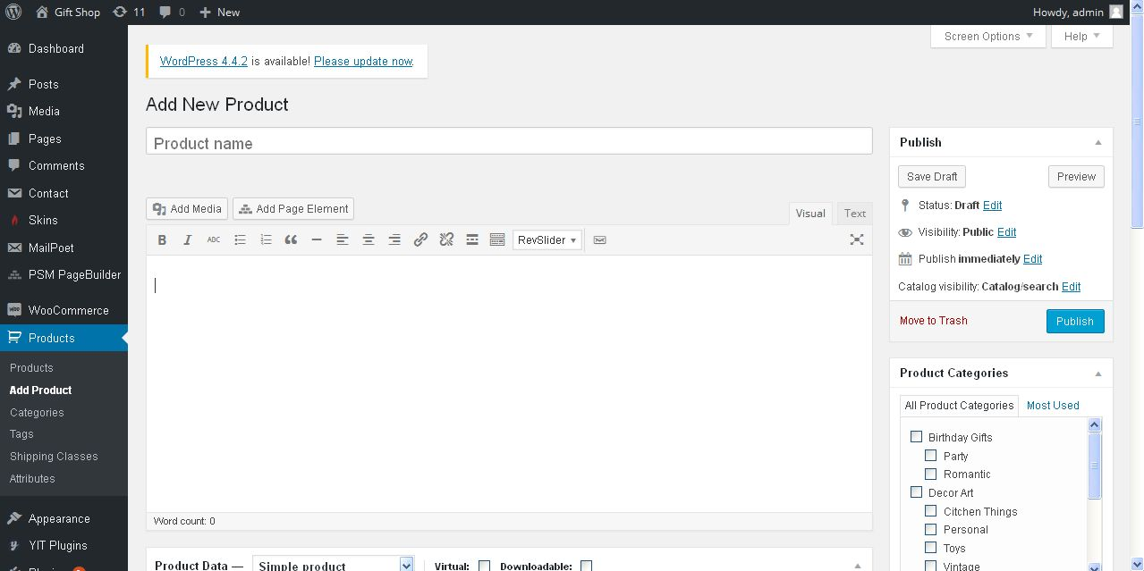
Description:
Admin can add new product with detailed

Product category:
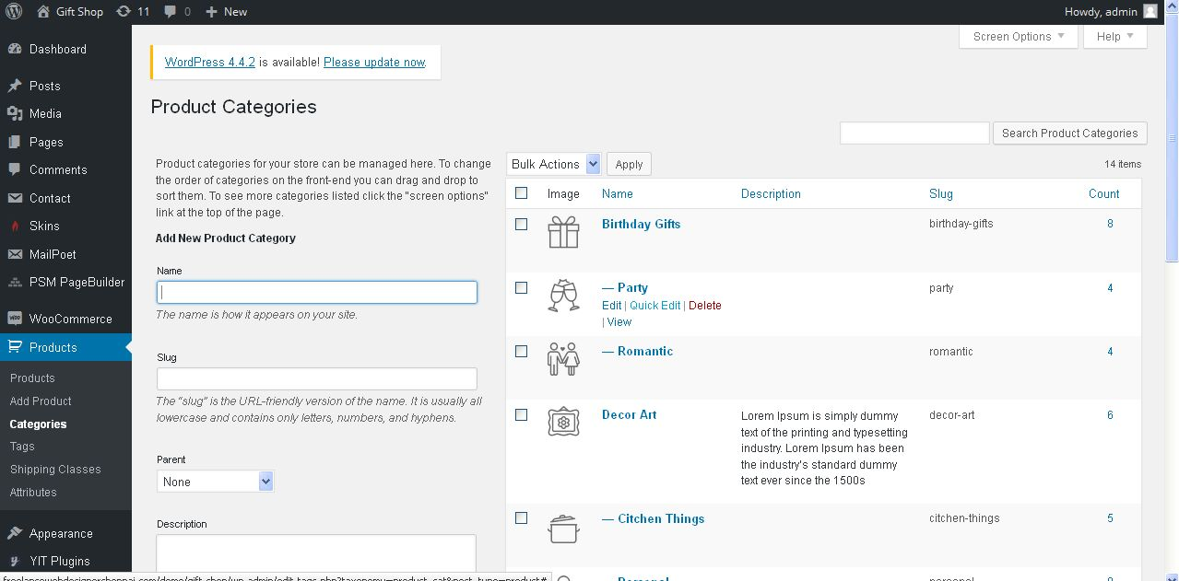
Description:
Admin can add and manage product category

Product tag:
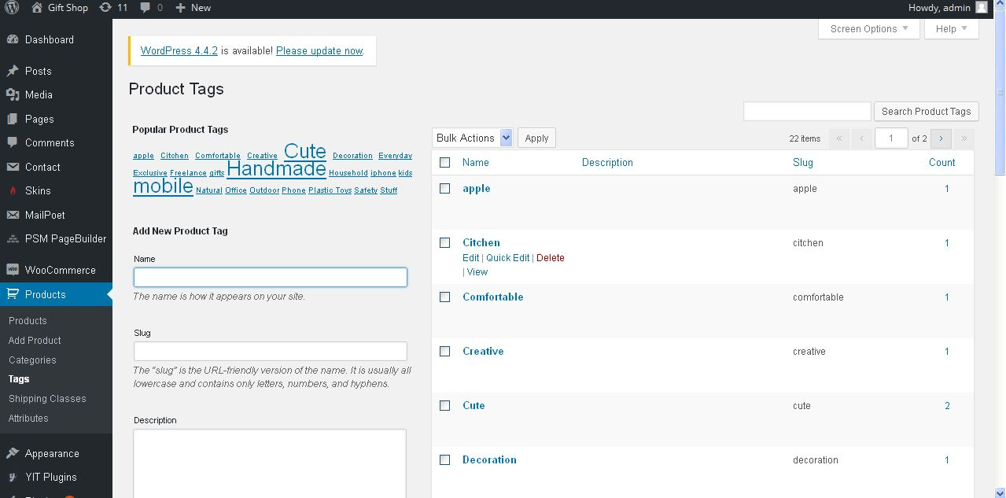
Description:
Admin can add and manage product tag

Woo-commerce
Order:
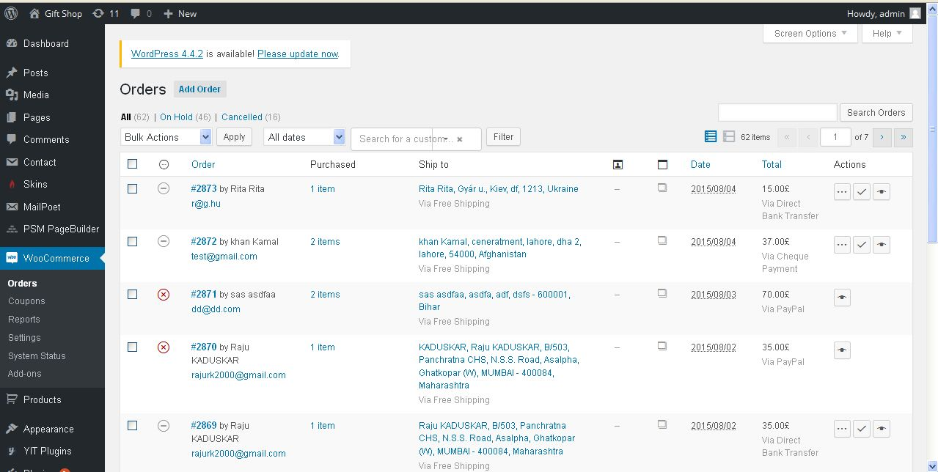
Description:
Admin can view their user order details also search user orders

Coupon:
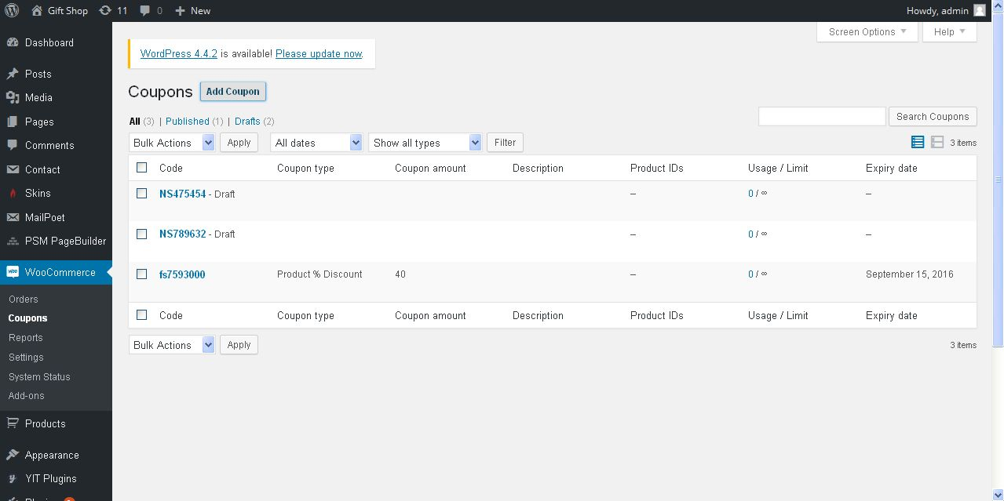
Description:
Admin can view available coupon details

Add coupon:
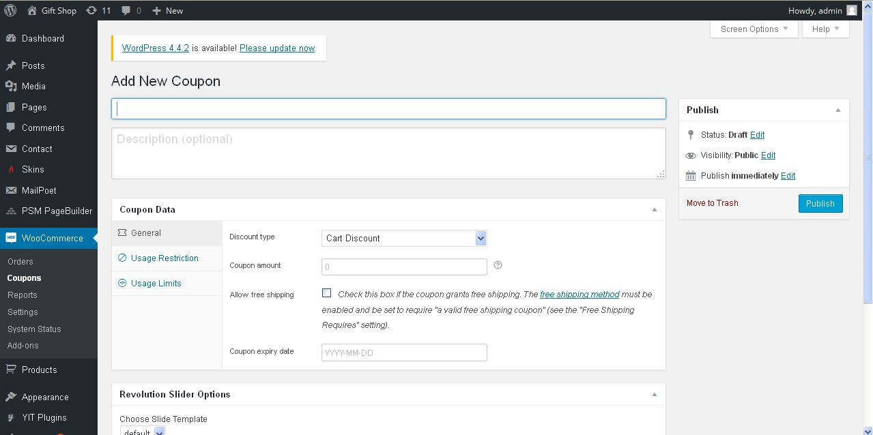
Description:
Admin can add new coupon with detailed

Report:
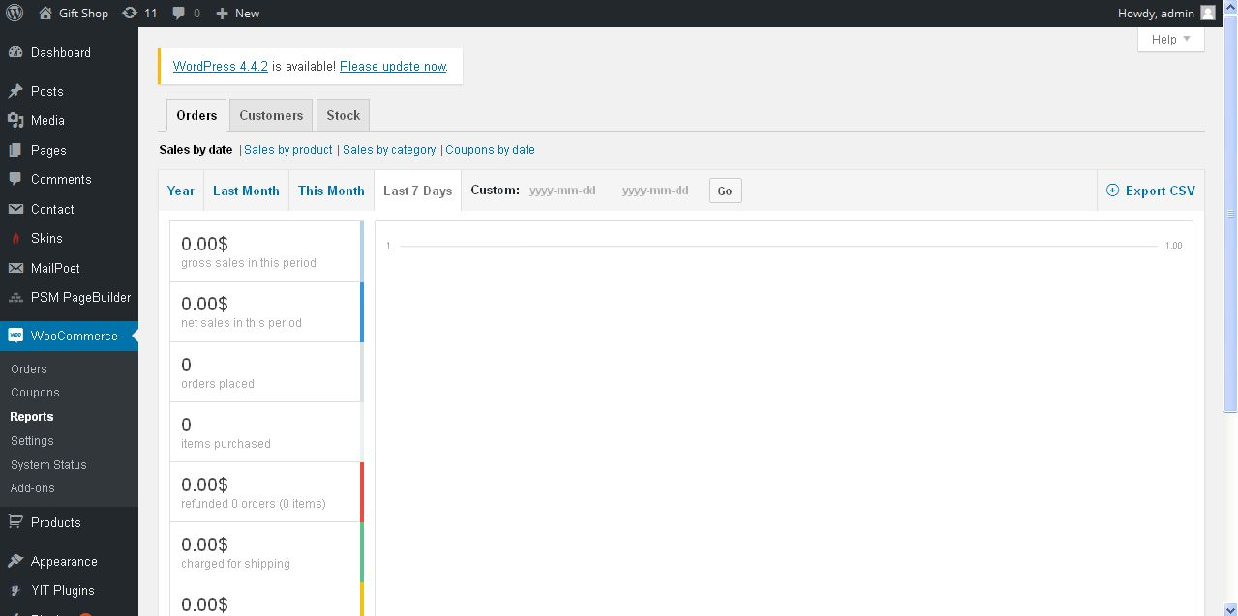
Description:
Admin can take report of user order, customer details and stock detail in CSV format

Settings:
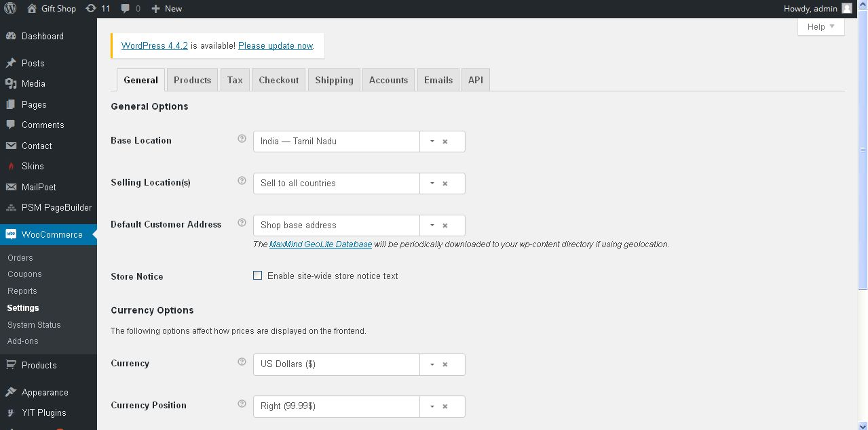
Description:
Admin can manage woo commerce settings following checkout and tax and related settings

System status:
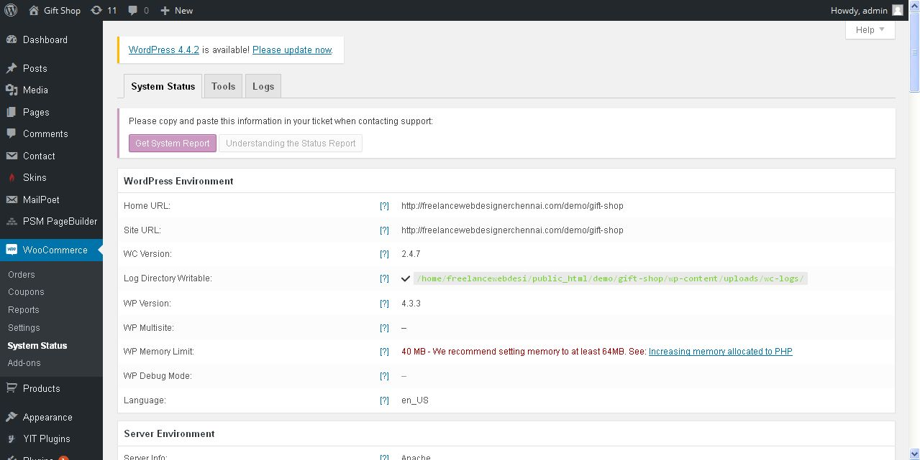
Description:
Admin can view woo-commerce status with detail

Add-ons:
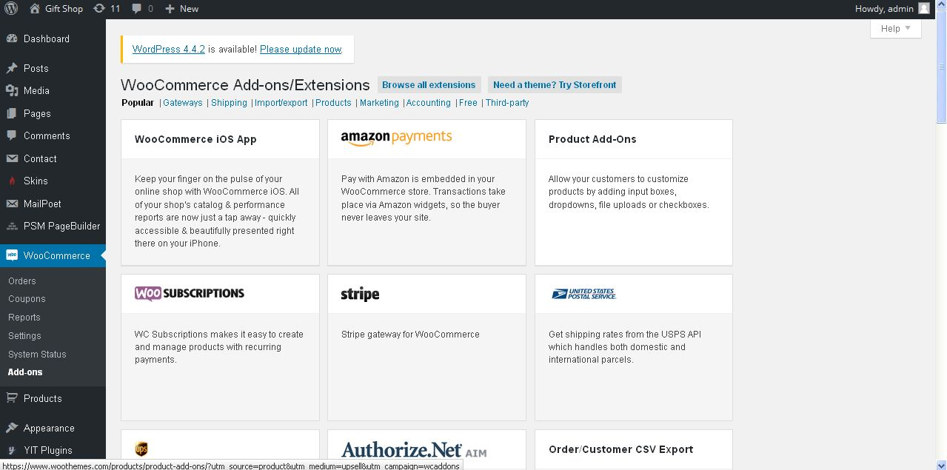
Description:
Admin can view add on details

Appearance
Theme:
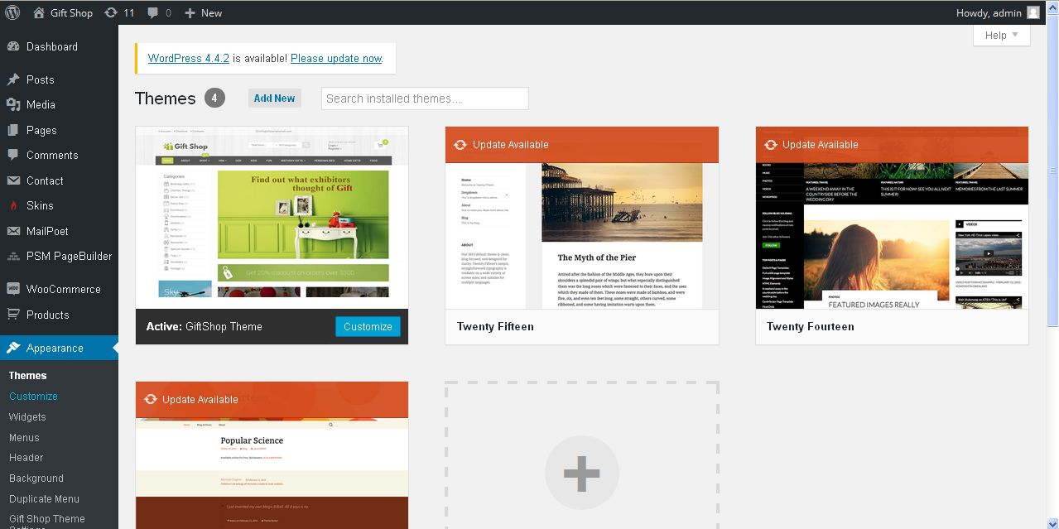
Description:
Admin can view available theme and can change their theme style

Customization:
Description:
Admin can view appearance available customization options

Site identity:
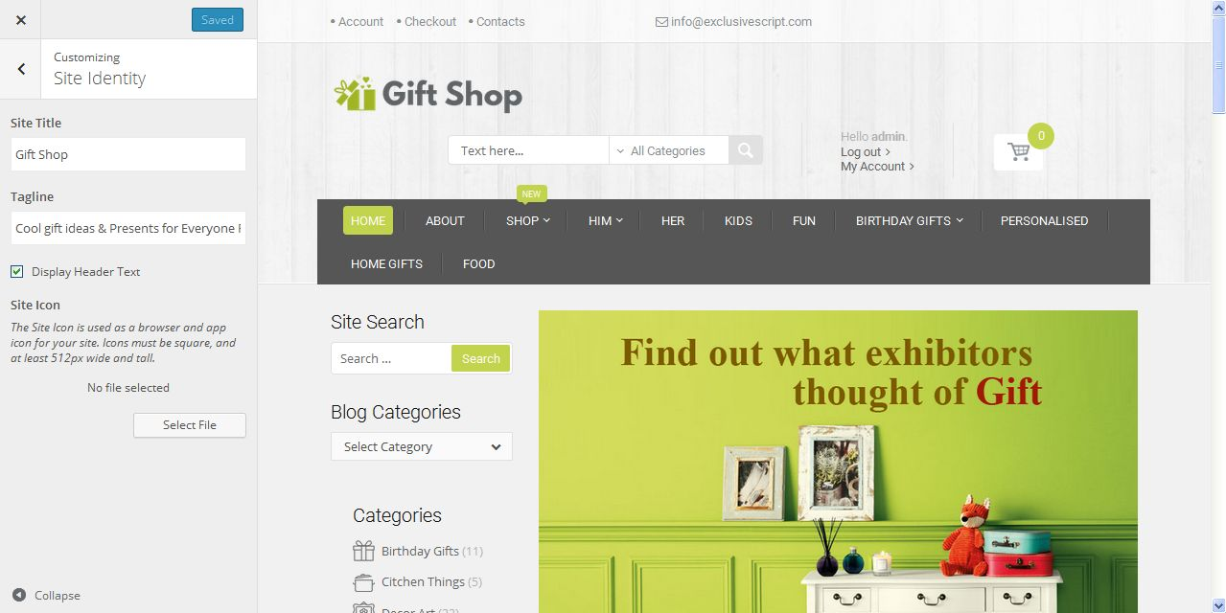
Description:
Admin can manage site title and tag line

Color:
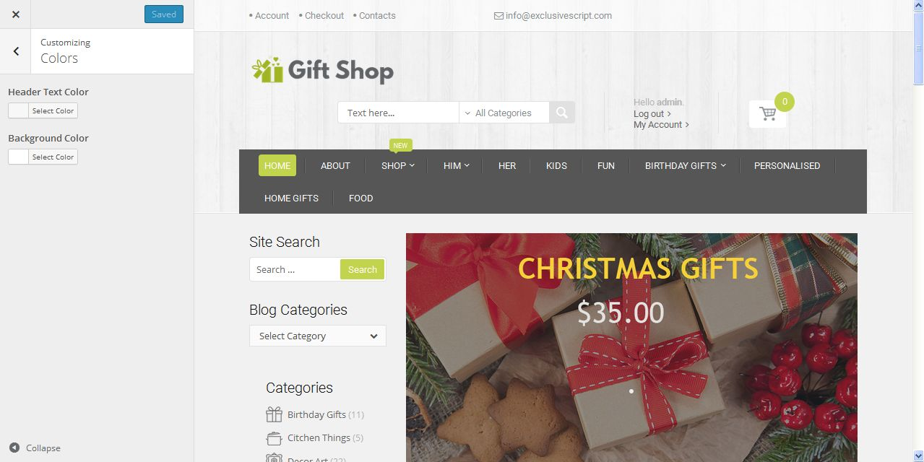
Description:
Admin can manage site color
Header image:
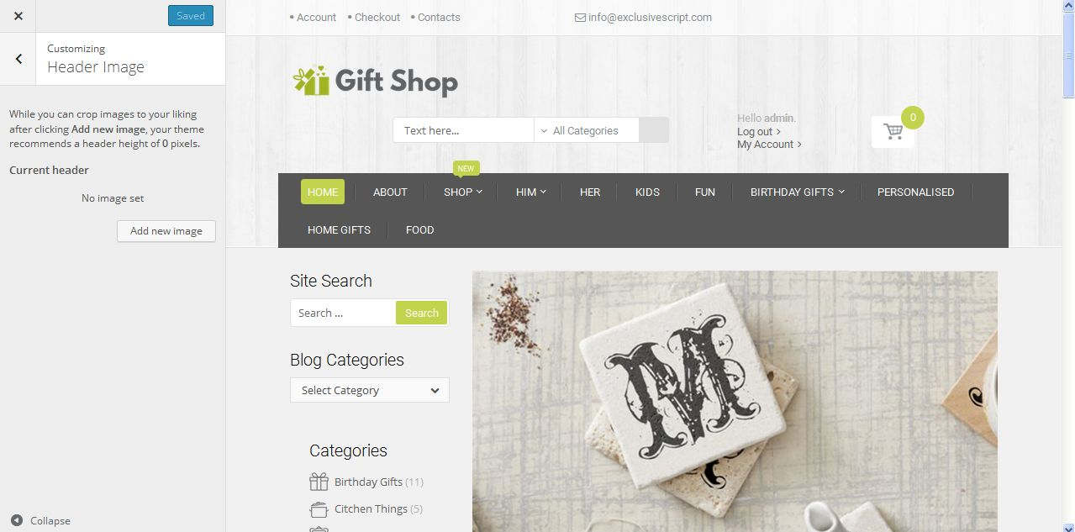
Description:
Admin can add and manage header image

Background image:
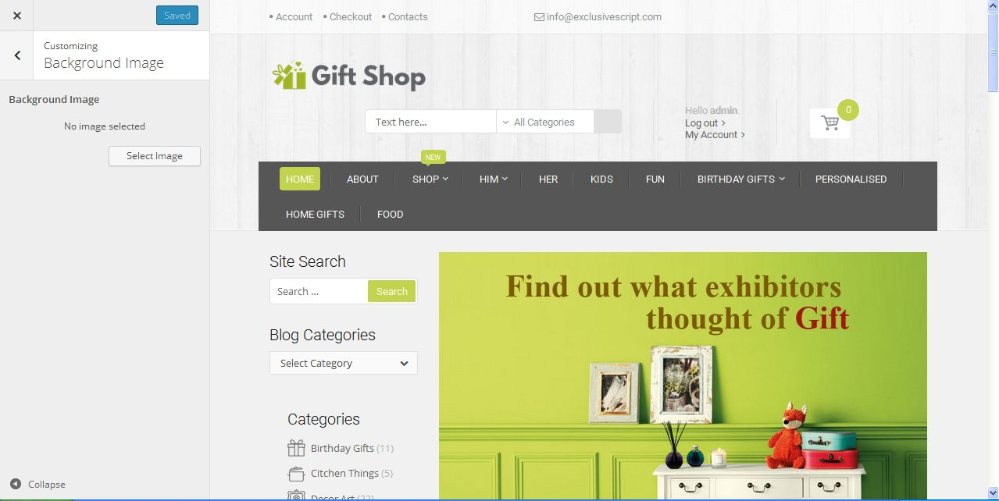
Description:
Admin can add and manage background image

Widget:
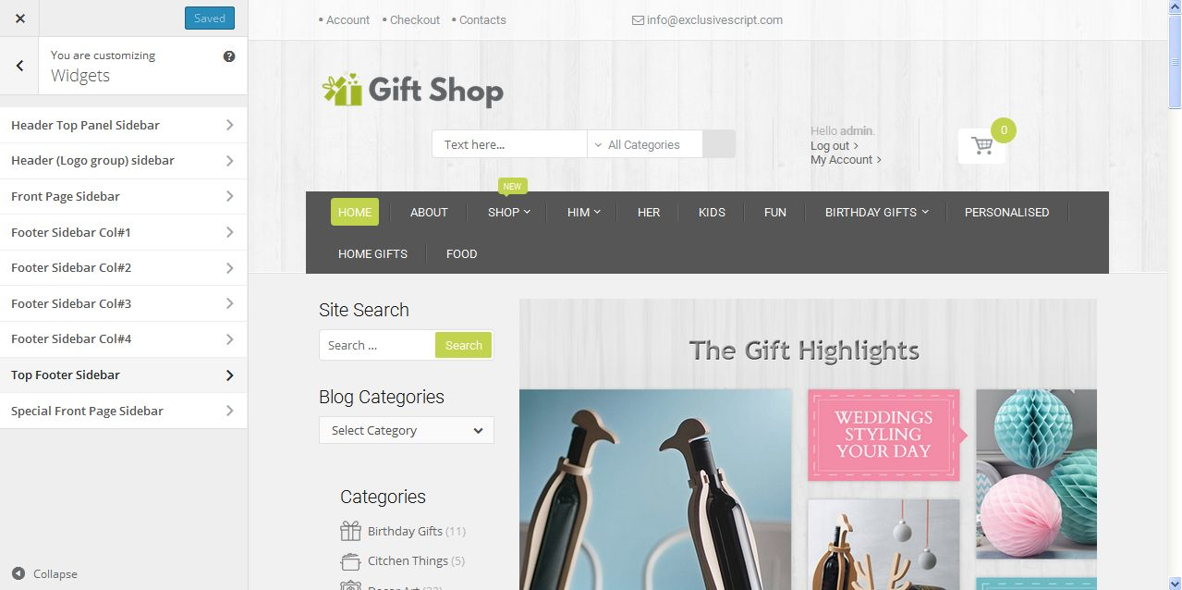
Description:
Admin can manage widget setting where they used

Static front page:
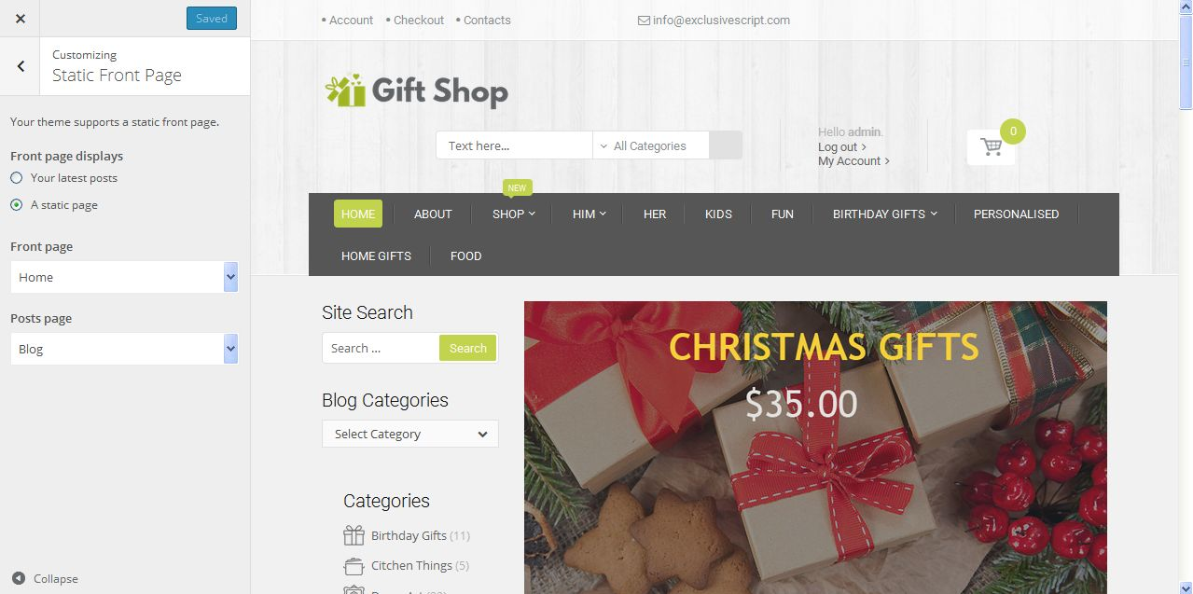
Description:
Admin can manage static page front page menu and post page menu settings

Widget:
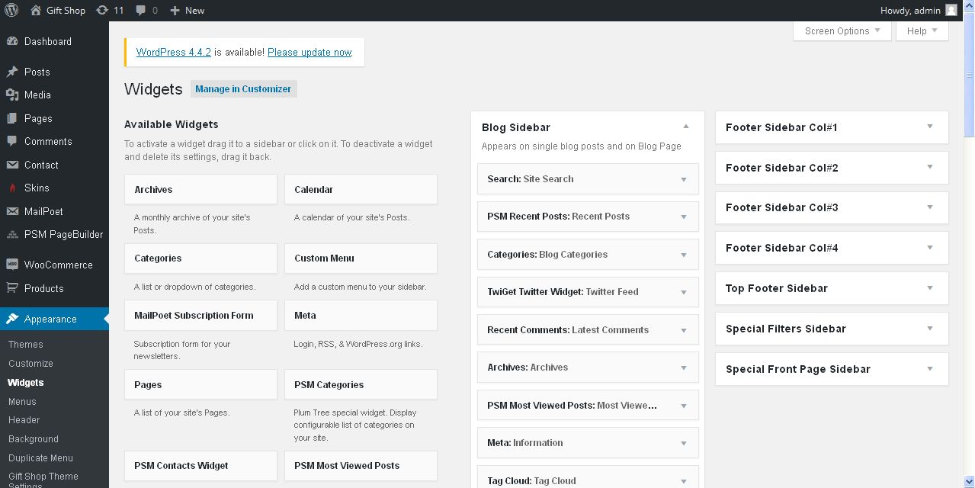
Description:
Admin can manage widget settings

Menu:
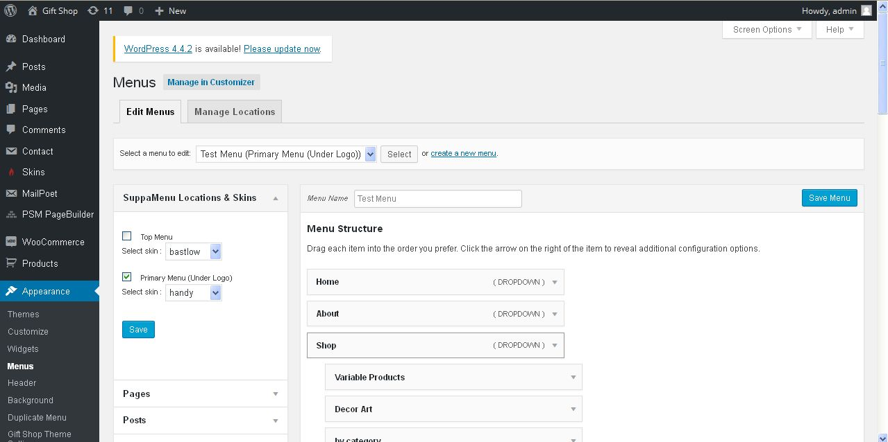
Description:
Admin can manage menu appearance settings

Duplicate menu:
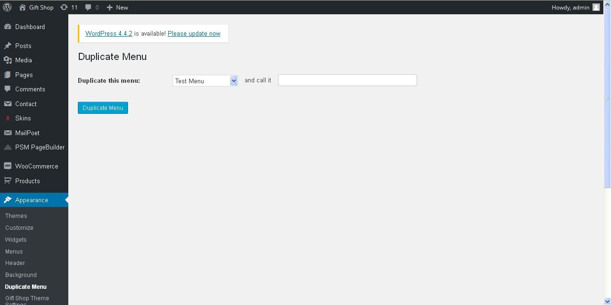
Description:
Admin can add new menu

Blog
Post:
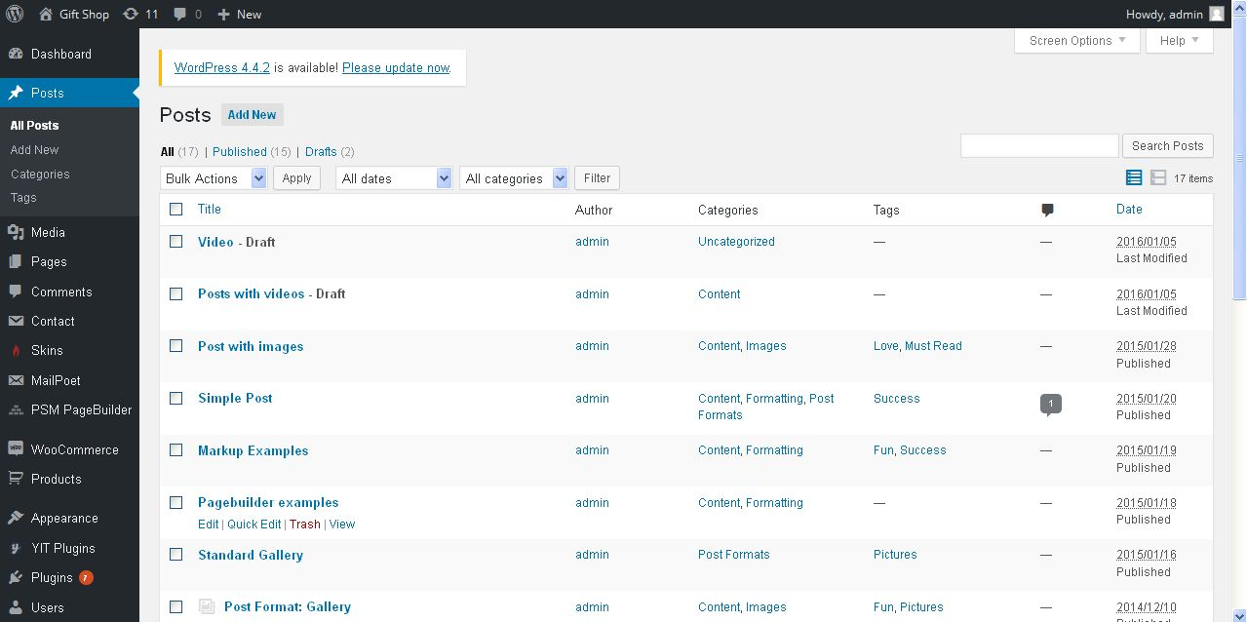
Description:
Admin can manage available blog

Add blog:
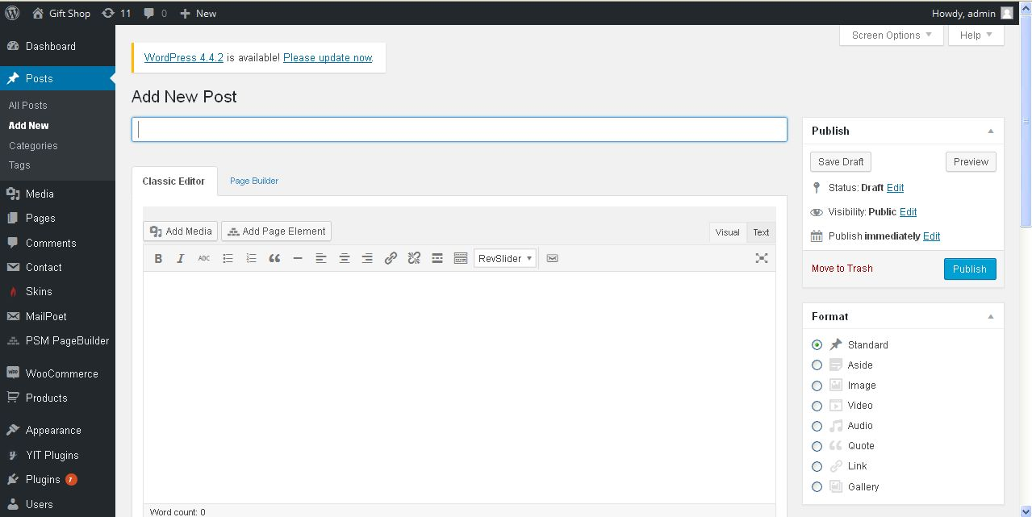
Description:
Admin can add new blog

Blog category:
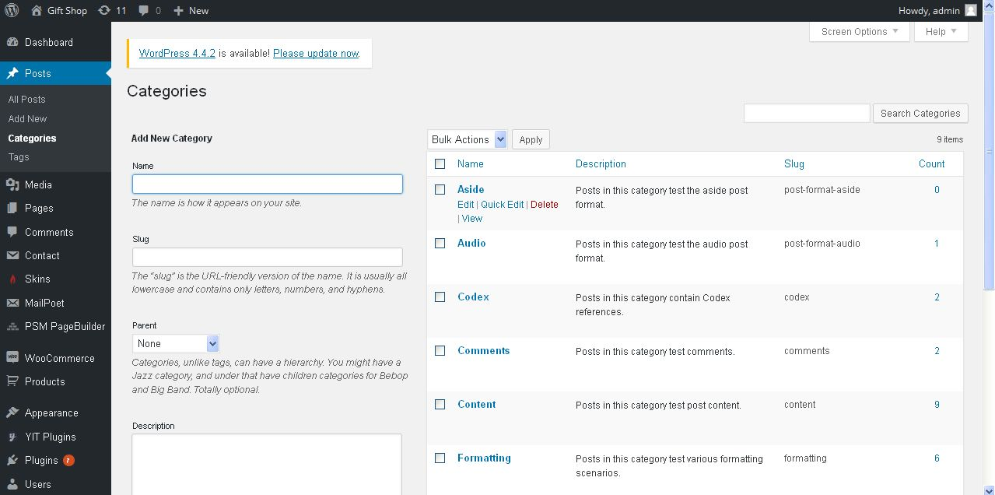
Description:
Admin can add and manage new category for blog

Blog tag:
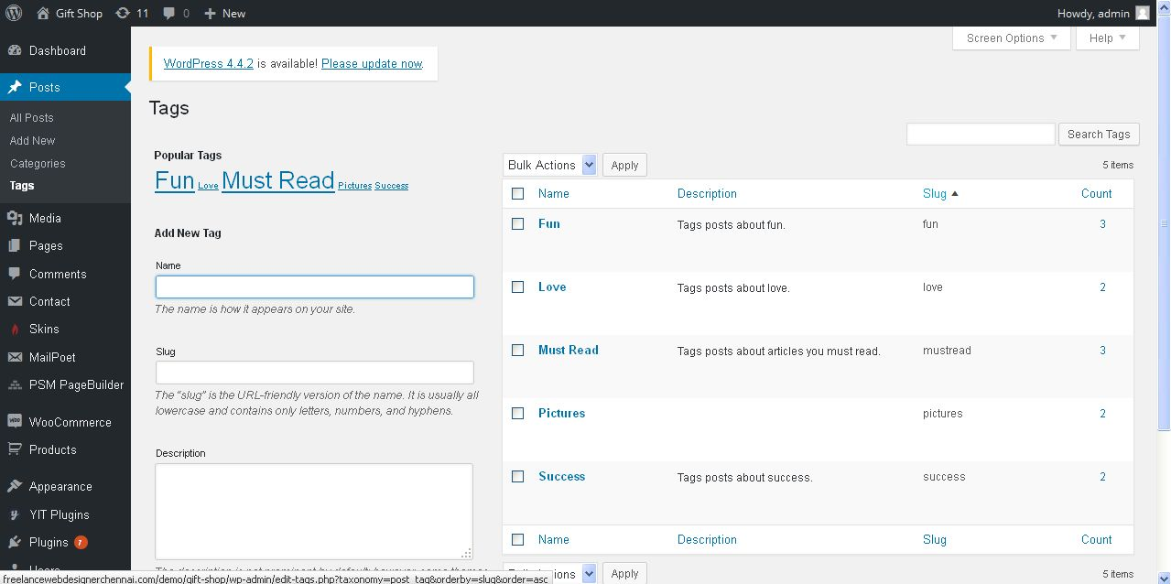
Description:
Admin can add and manage blog tag

Media
Library:
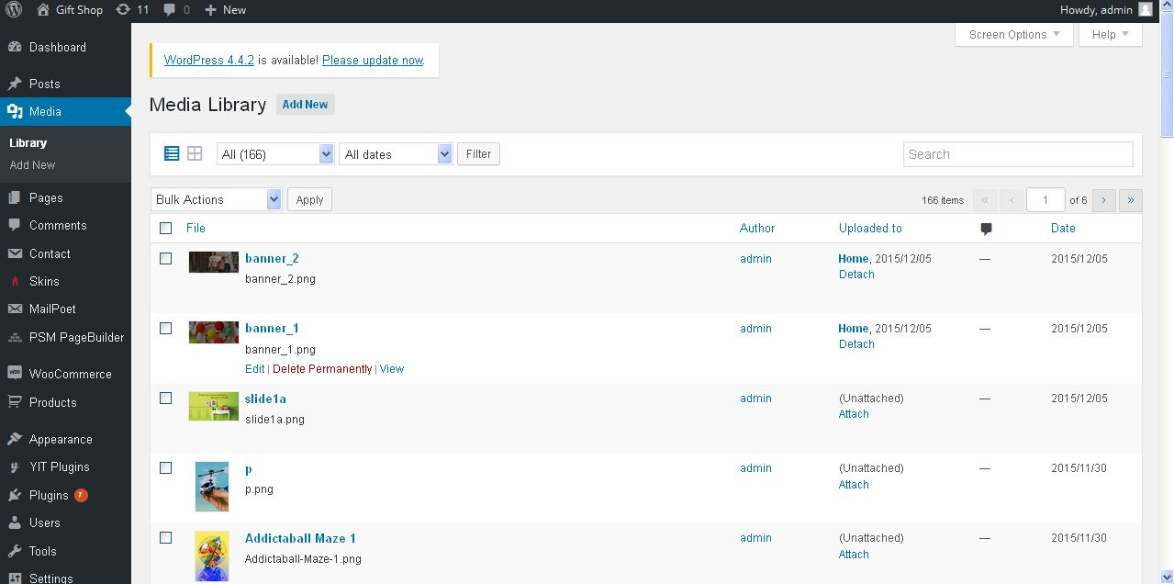
Description:
Admin can view all media of site

Add media:
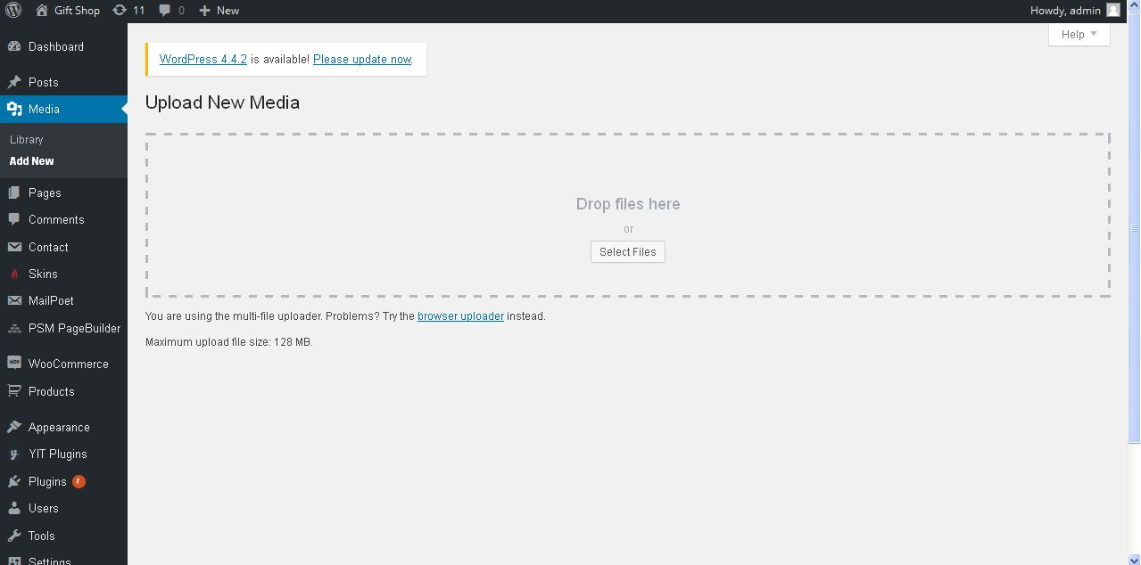
Description:
Admin can add new media through this function

Page
Page:
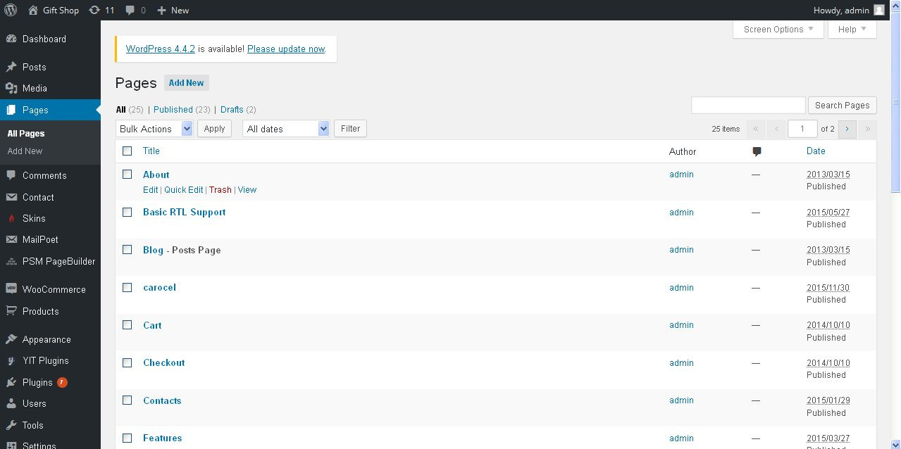
Description:
Admin can manage available pages

Add page:
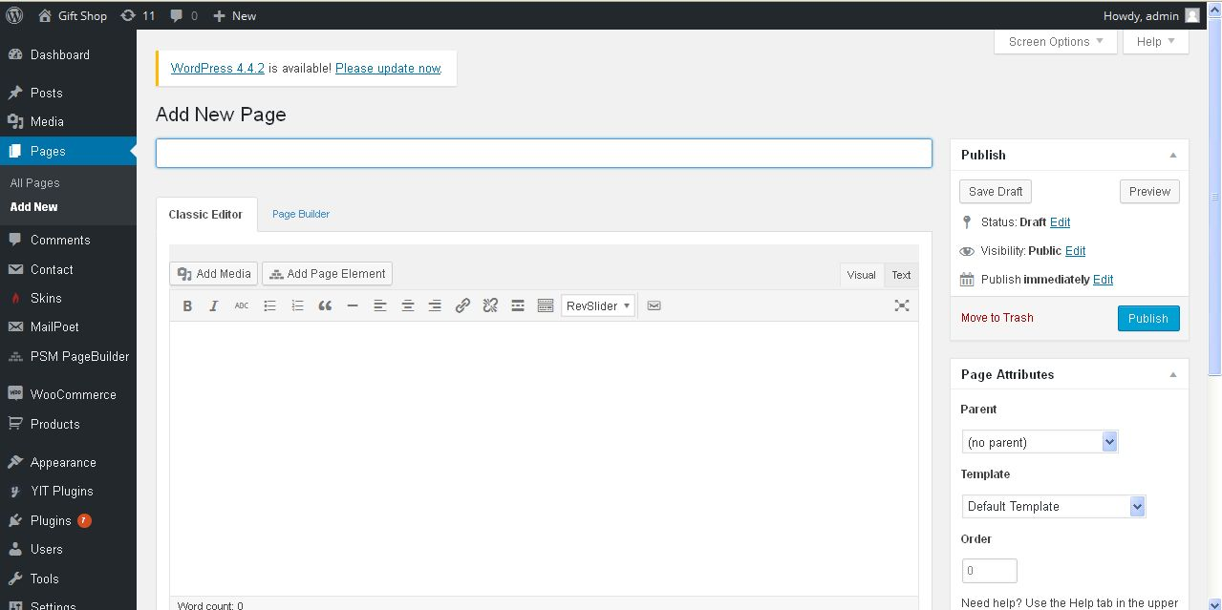
Description:
Admin can add new page with detail

Comment:
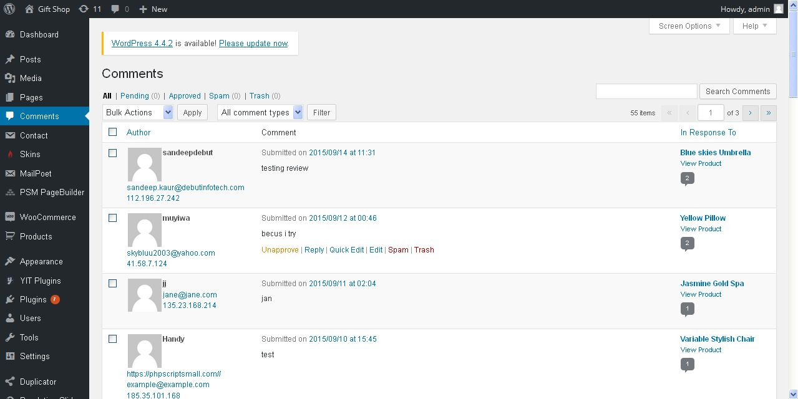
Description:
Admin can manage product comments

Contact form
Contact form:
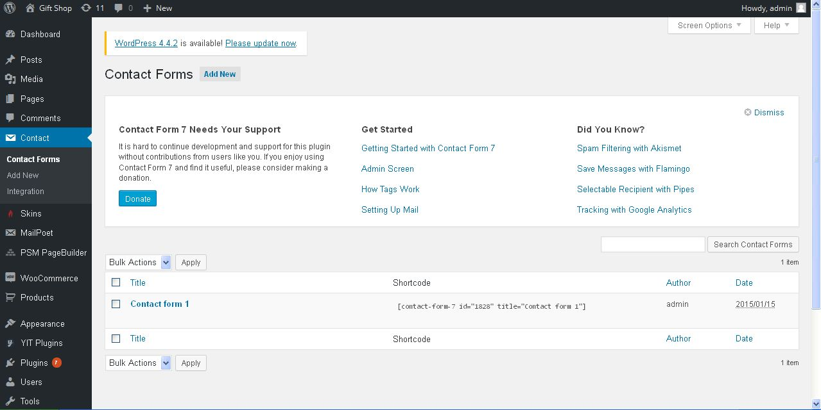
Description:
Admin can view available contact form details

Add contact form:
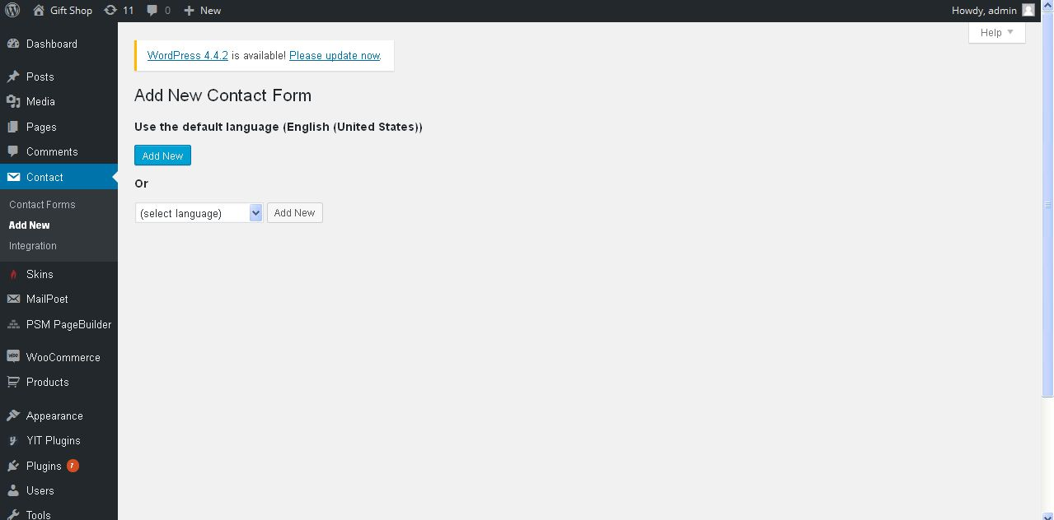
Description:
Admin can add new contact form

Newsletter
Newsletter:
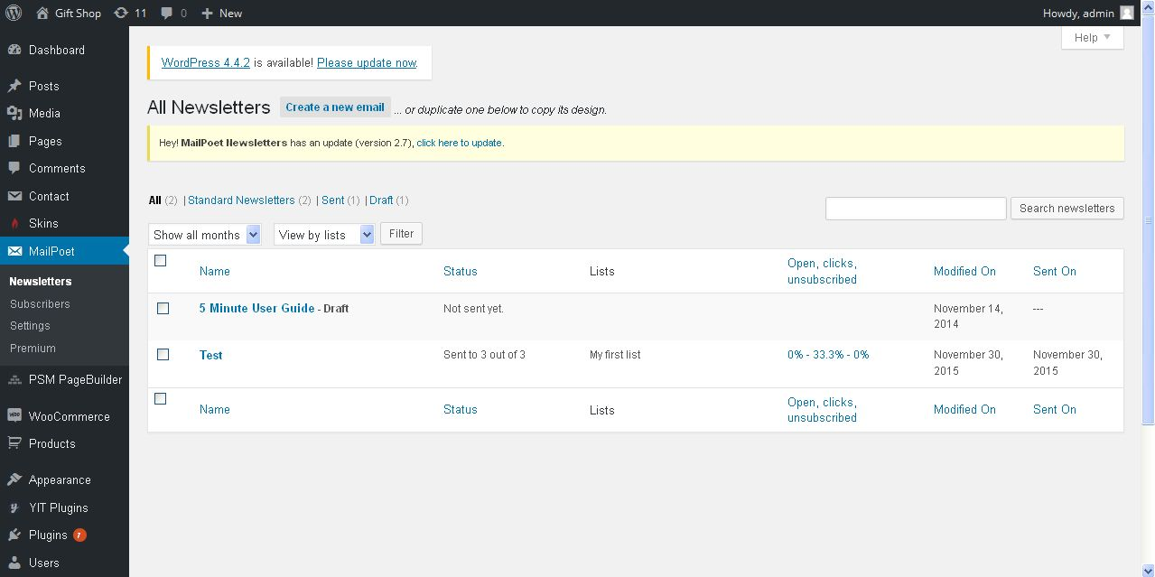
Description:
Admin can view sent history of newsletters

Subscribers:
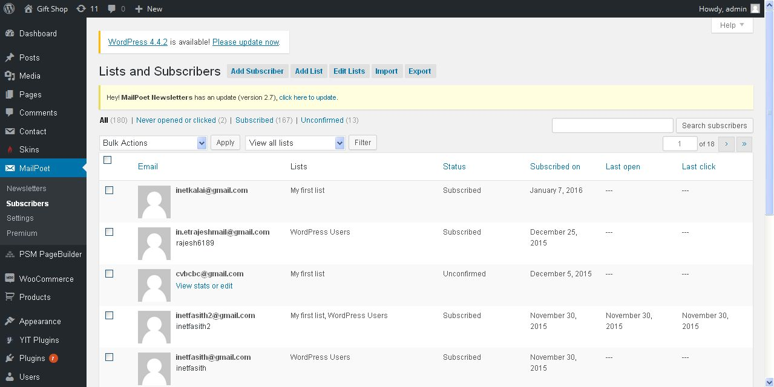
Description:
Admin can view subscribers list also admin can subscribers

Settings:
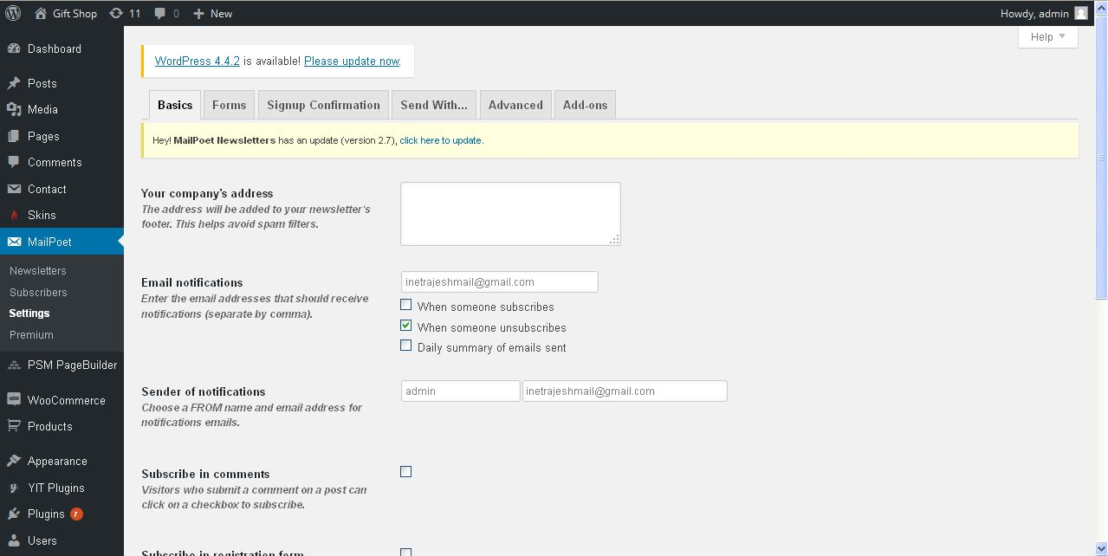
Description:
Admin can manage settings of newsletter

PSM page builder:
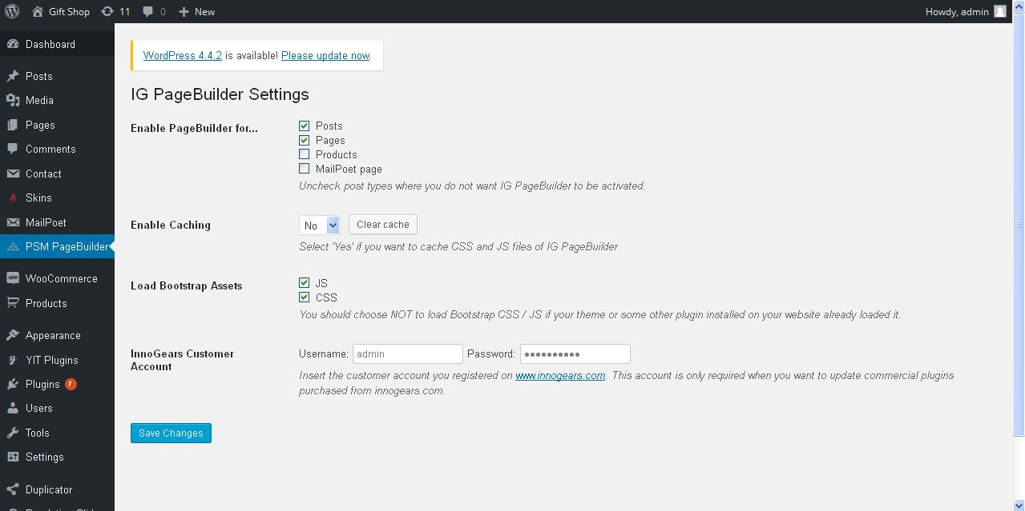
Description:
Admin can manage settings of page builder

Plugins:
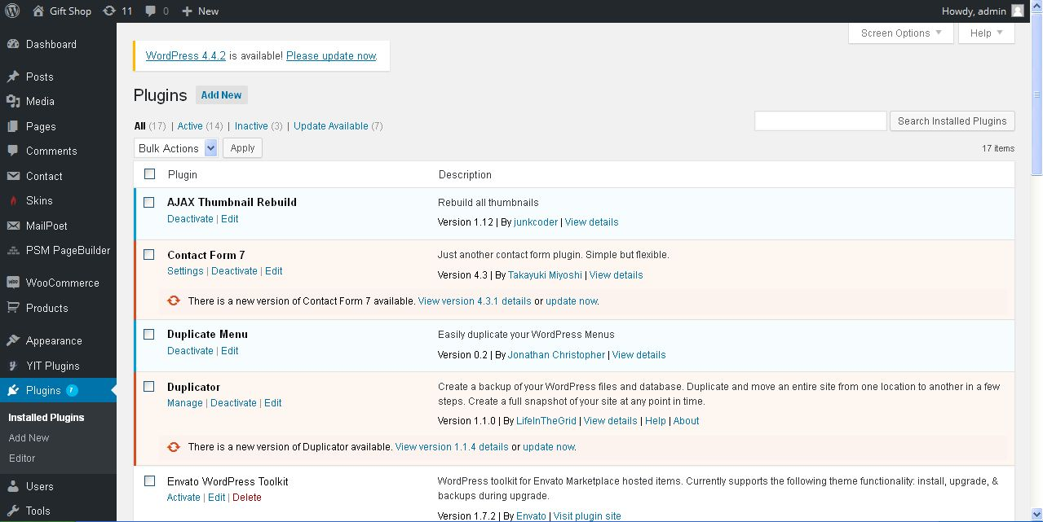
Description:
Admin can view installed plugins

User
Users:
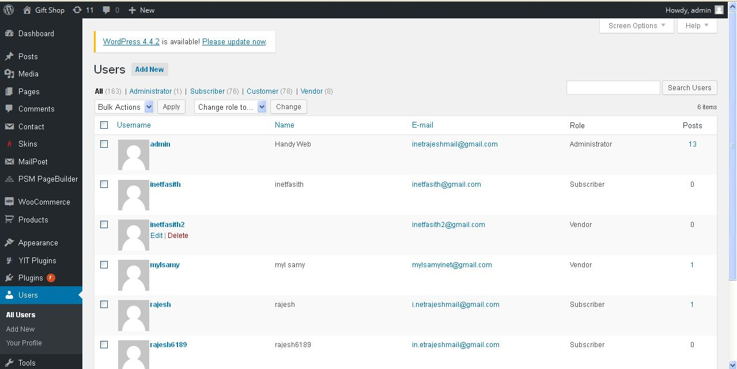
Description:
Admin can view user details

Add user:
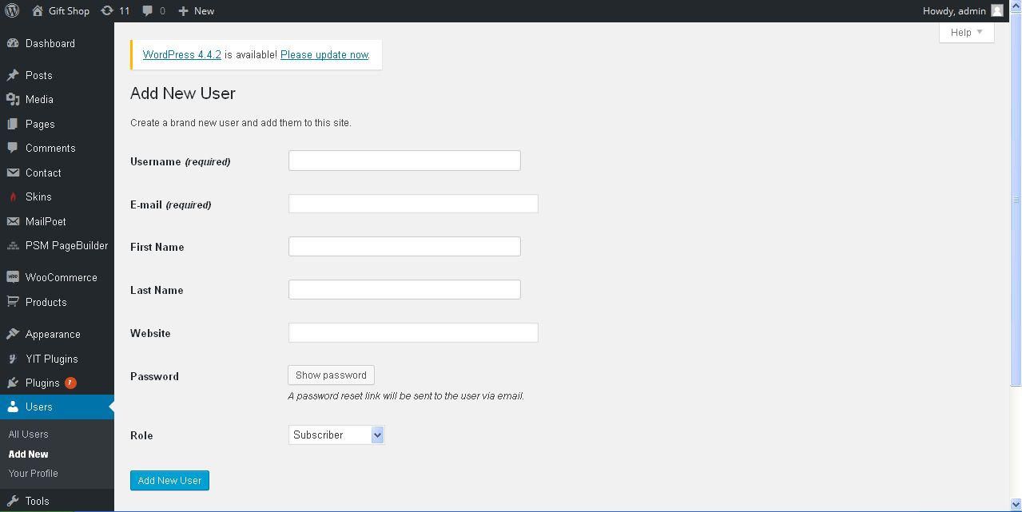
Description:
Admin can add new user with details

Profile:
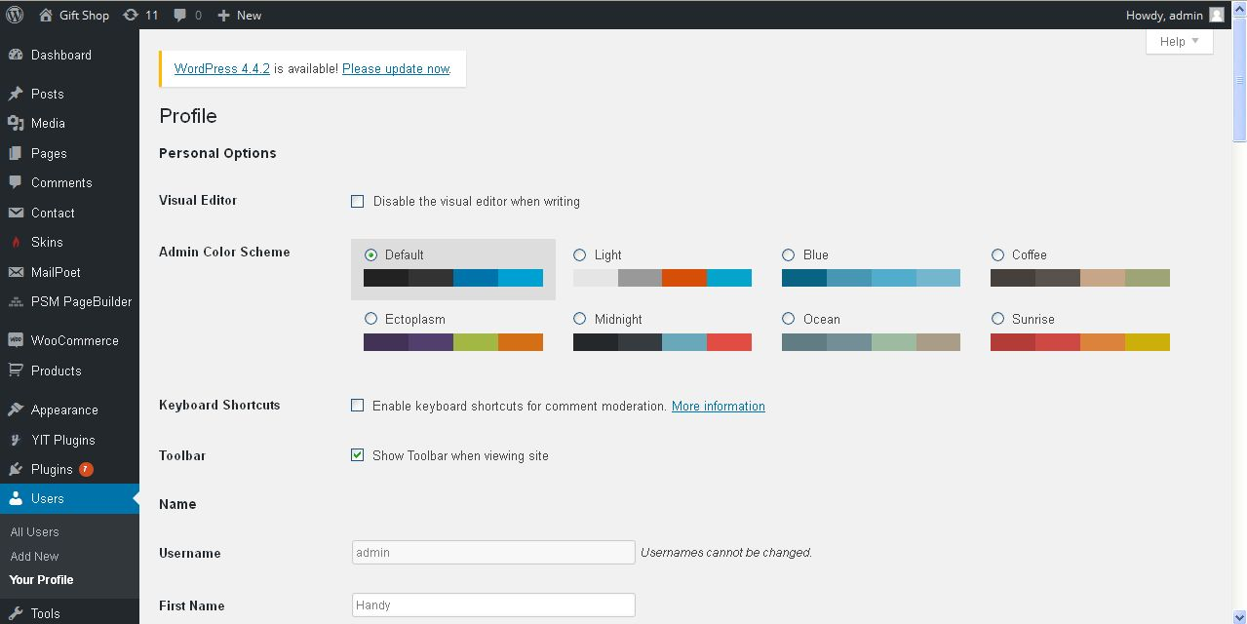
Description:
Admin can view their profile details

Tool
Import:
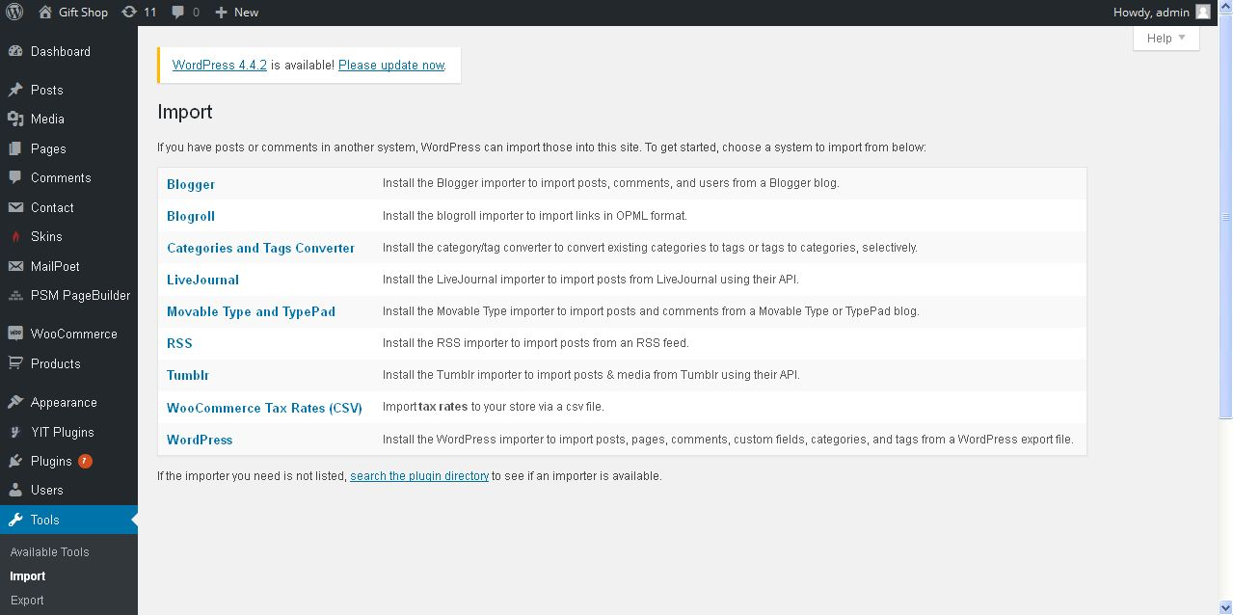
Description:
Admin can import their post

Export:
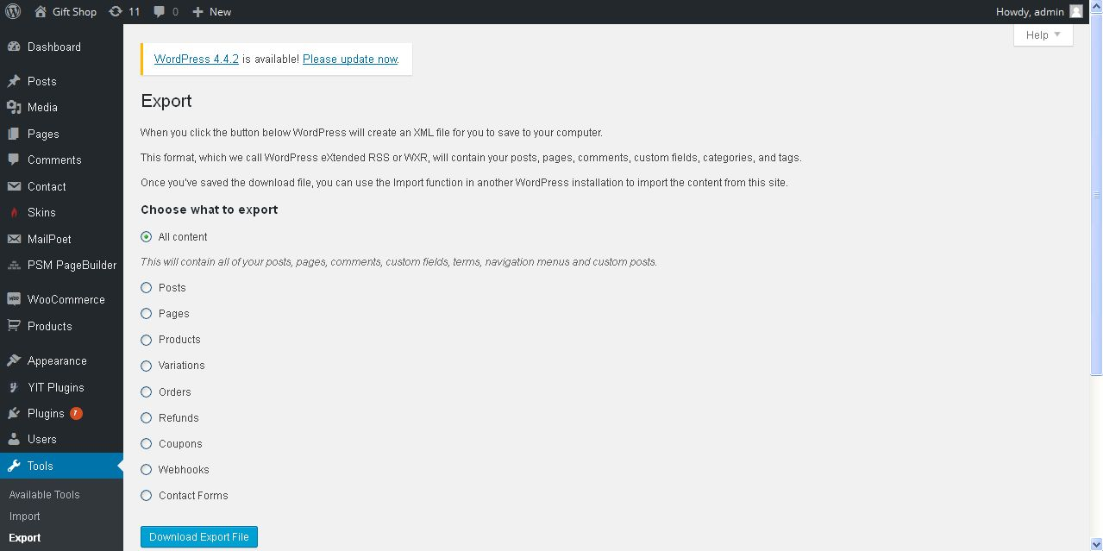
Description:
Admin can export post details with chosen functionality

Widget import & export:
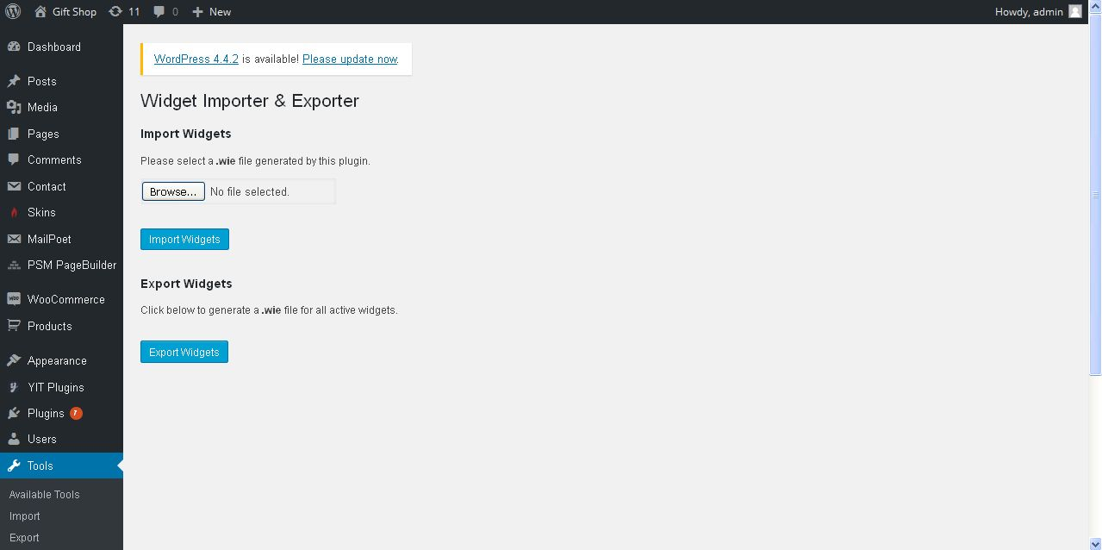
Description:
Admin can import and export widgets

Rebuild thumbnails:
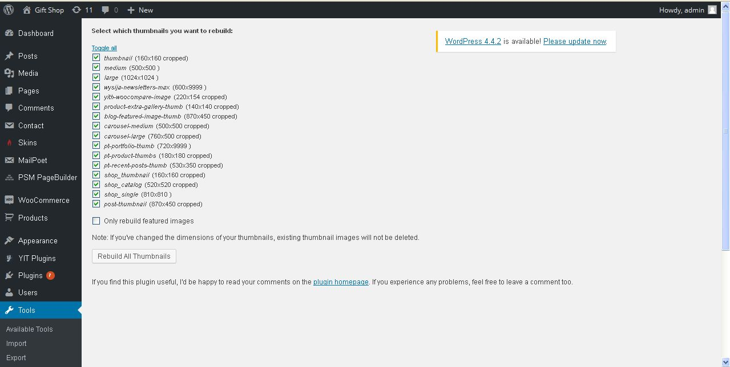
Description:
Admin can rebuild thumbnails for all products

Search & replace:
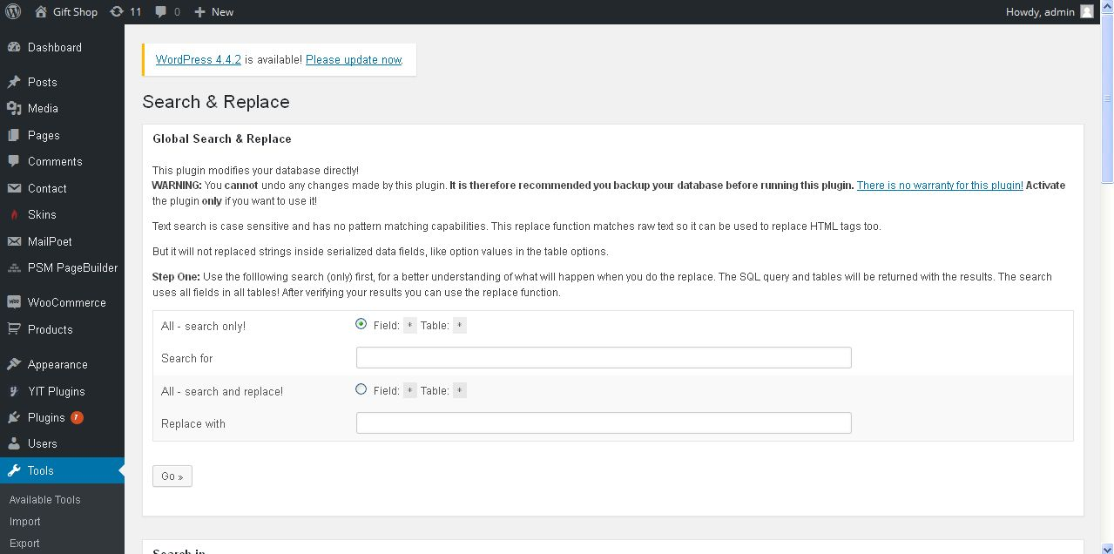
Description:
Admin can search and replace files from the database

Settings
General settings:
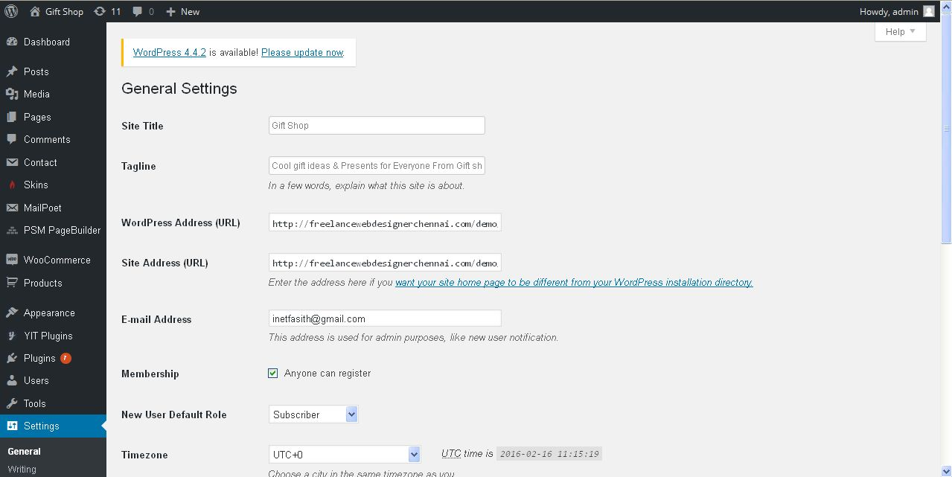
Description:
Admin manage general settings of the website

Writing settings:
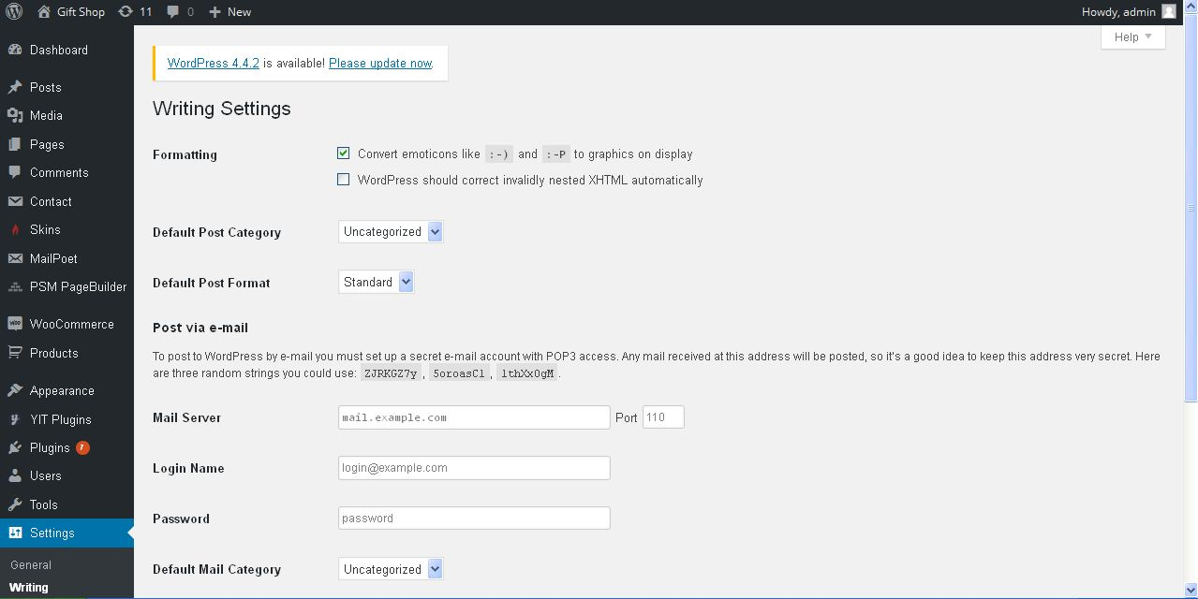
Description:

Reading settings:
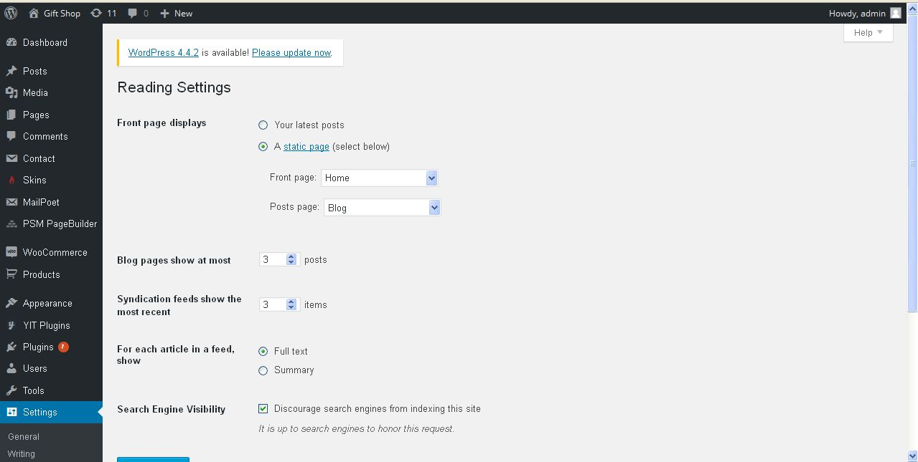
Description:
Admin manage settings of reading

Discussion settings:
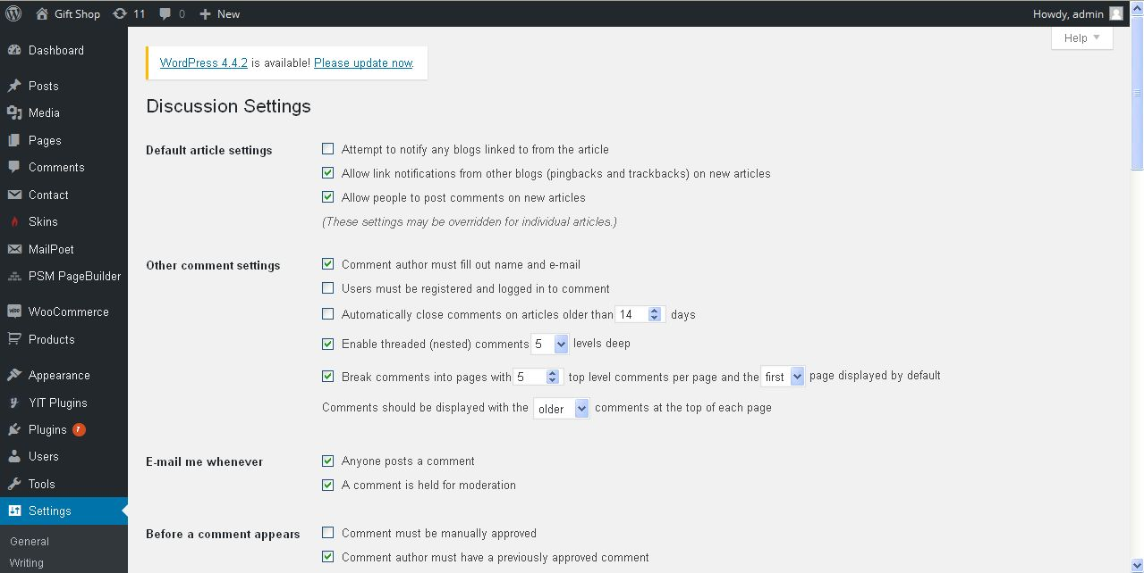
Description:
Admin manage settings of discussion

Media settings:
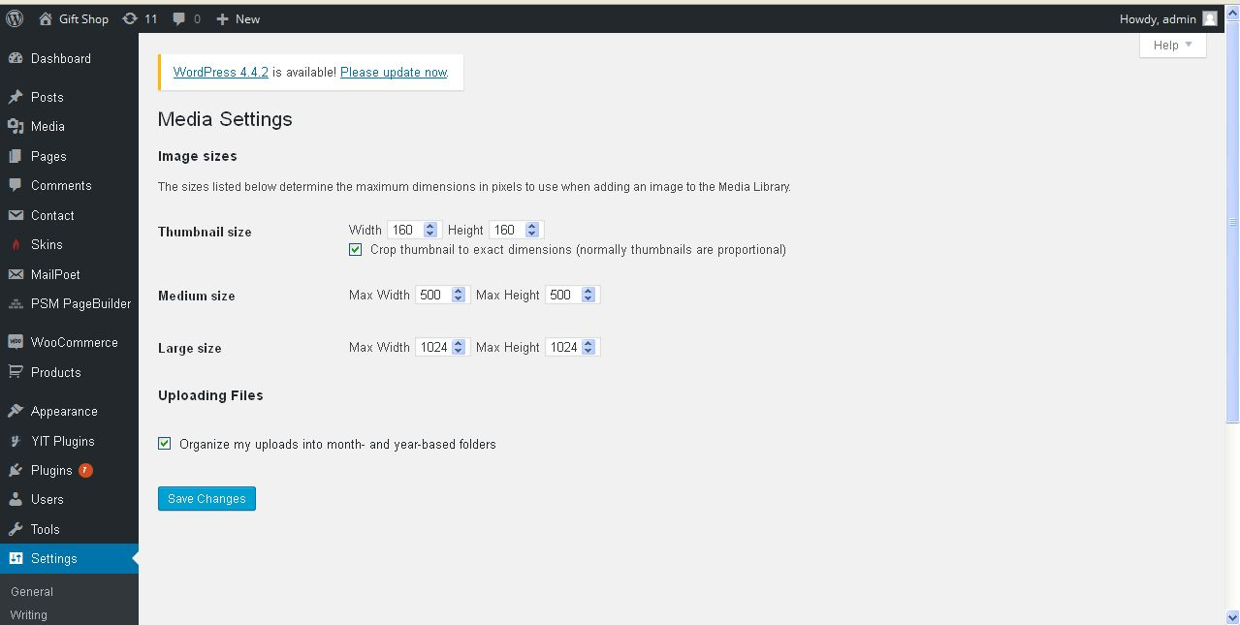
Description:
Admin manage settings of media

Permalink settings:
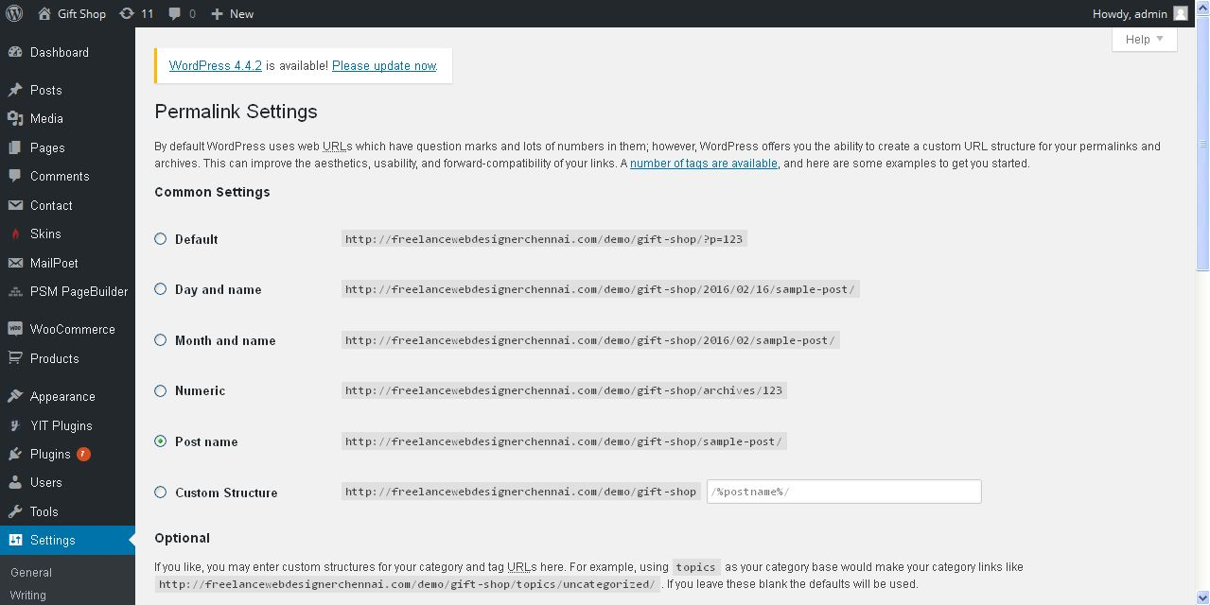
Description:
Admin manage settings permalink

Twitter settings:
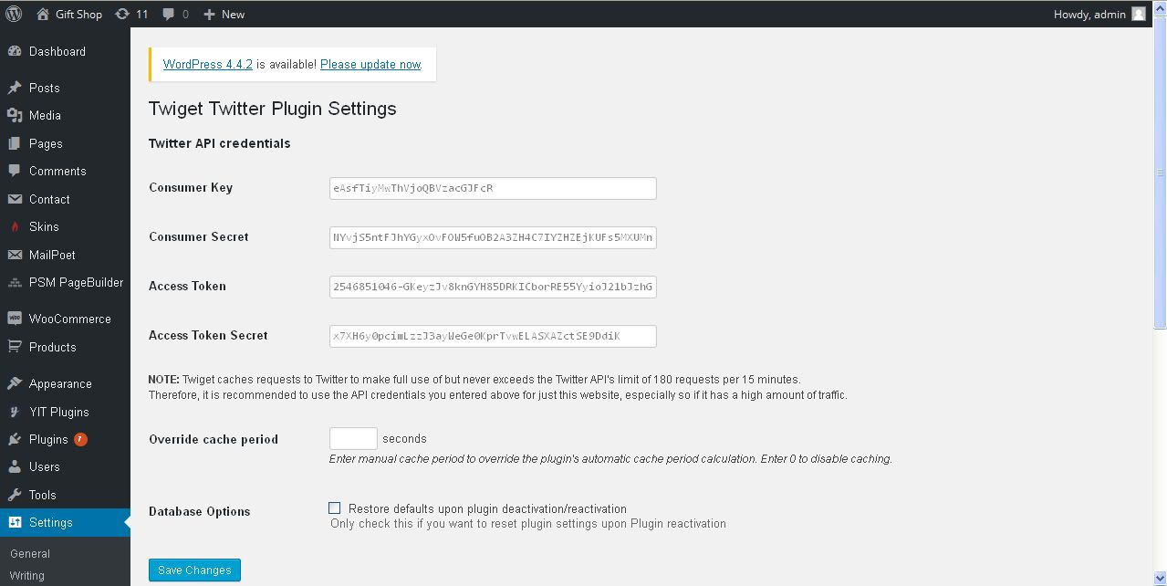
Description:
Admin manage their twitter API account settings

