**FOUR IN ONE REAL ESTATE**

**Properties**

**View property**

**Activity:**

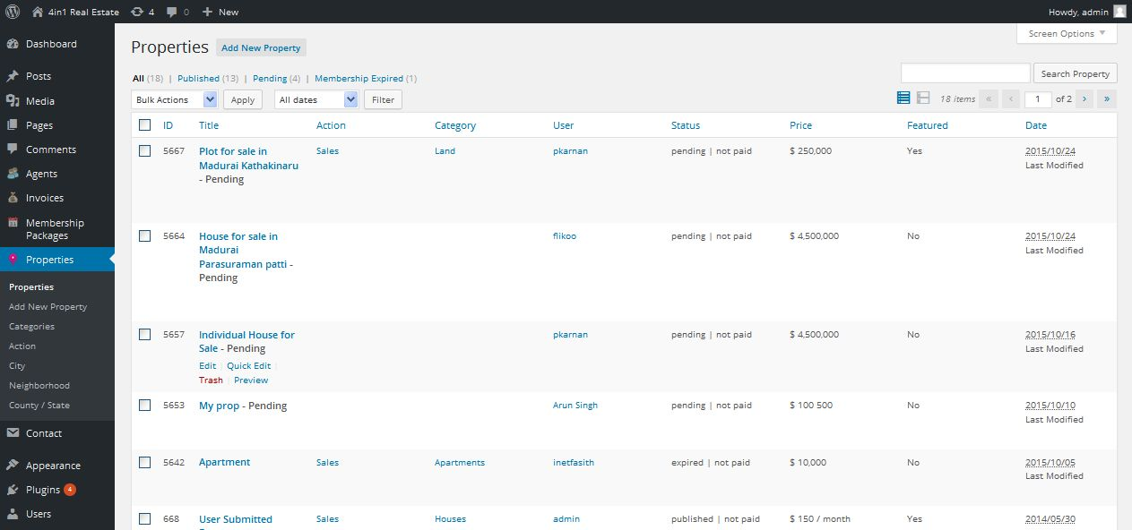

**Description:**

Admin can view all approved and pending property and their status

**Add property**

**Activity:**

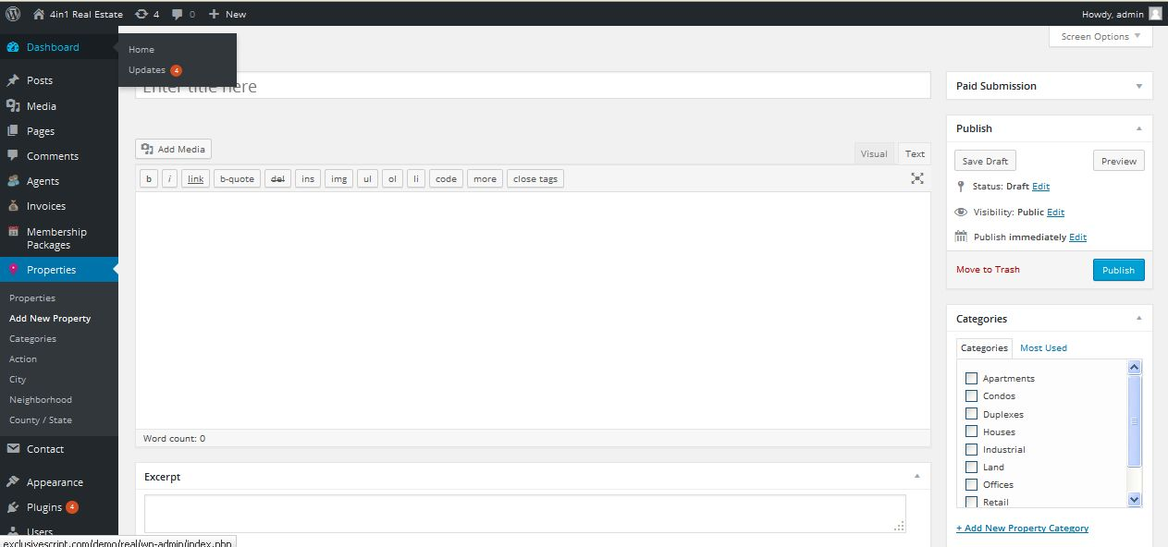

**Description:**

Admin can add new property with property details

**Property category**

**Activity:**

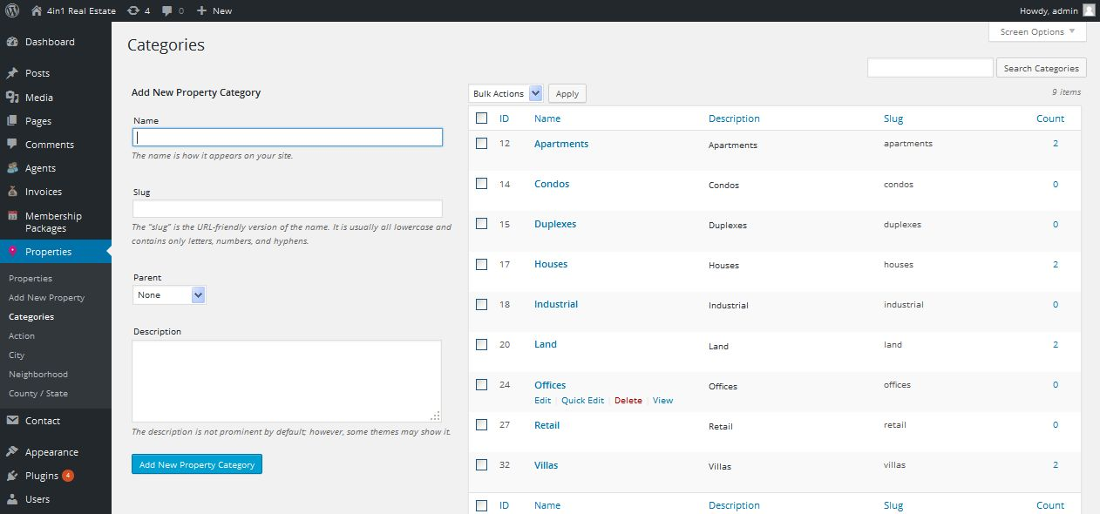

**Description:**

Admin can manage property category

**Property actions**

**Activity:**

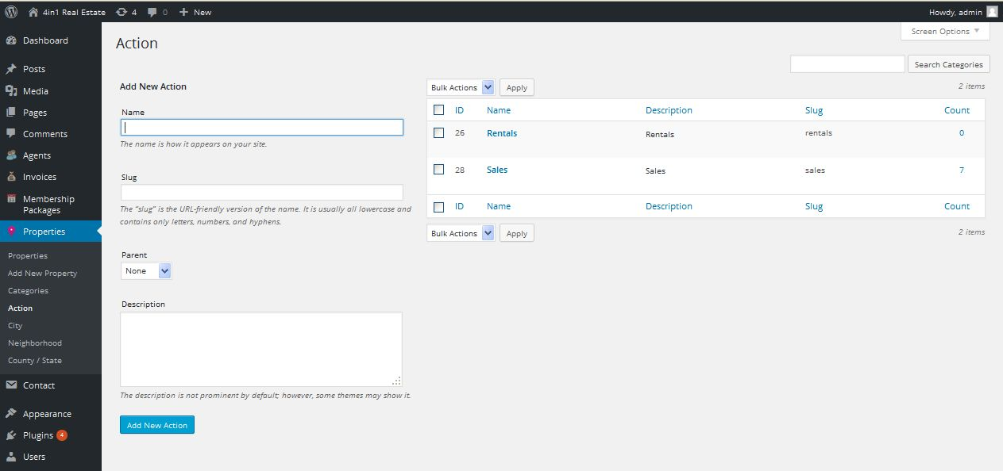

**Description:**

Admin can add and manage property actions like rent, sale and etc

**Property city**

**Activity:**

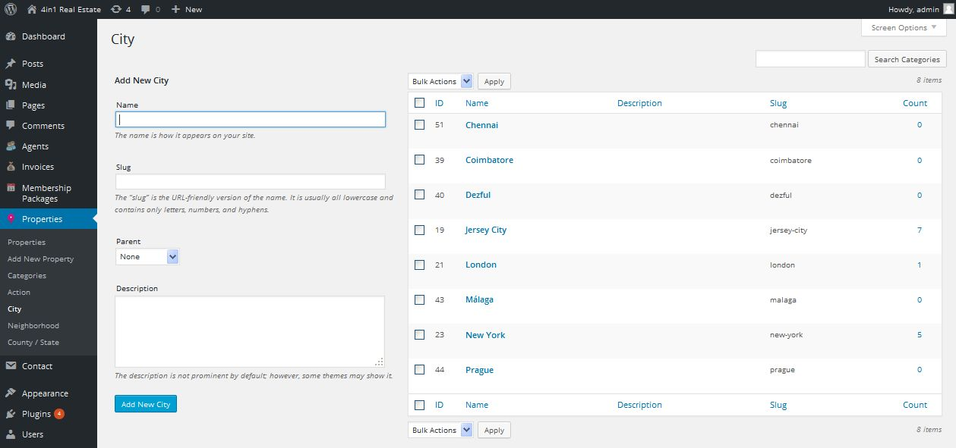

**Description:**

Admin can add and manage property available city

**Property neighborhood**

**Activity:**

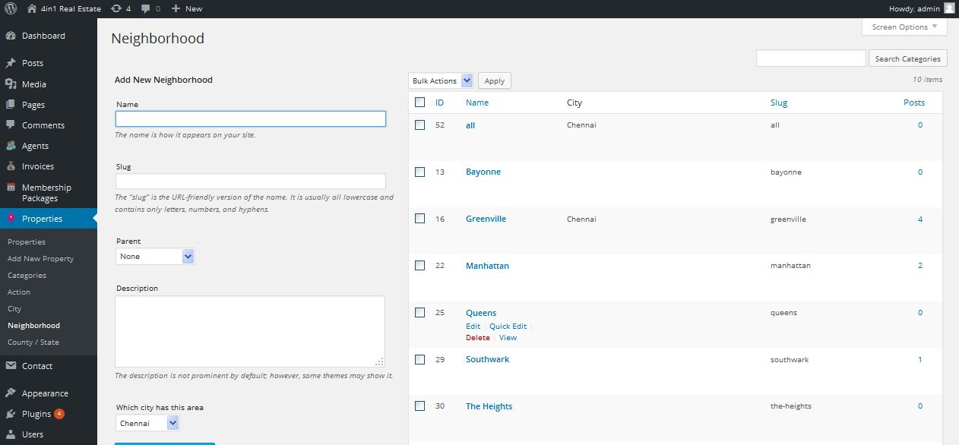

**Description:**

Admin can add and manage property neighborhood

**Property country**

**Activity:**

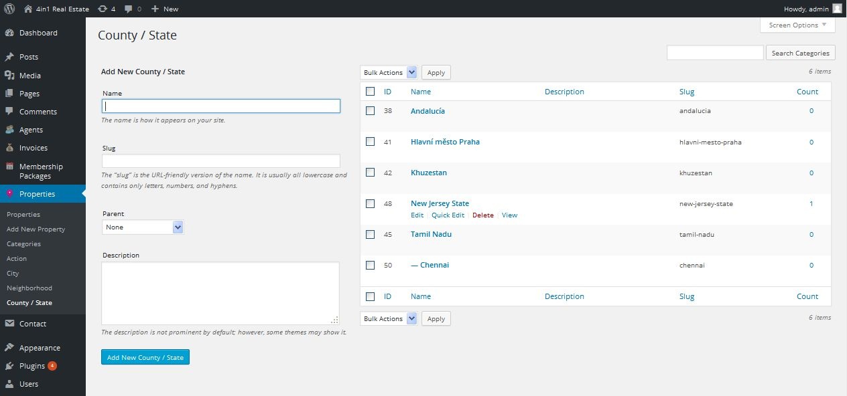

**Description:**

Admin can add and manage property available country

**Agents**

**View agents**

**Activity:**

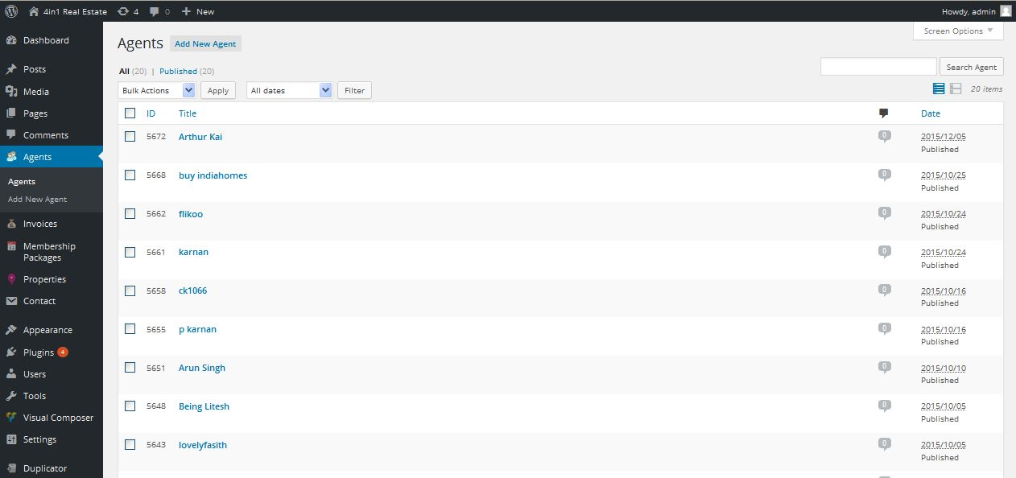

**Description:**

Admin can view active and inactive agents details

**Add agent**

**Activity:**

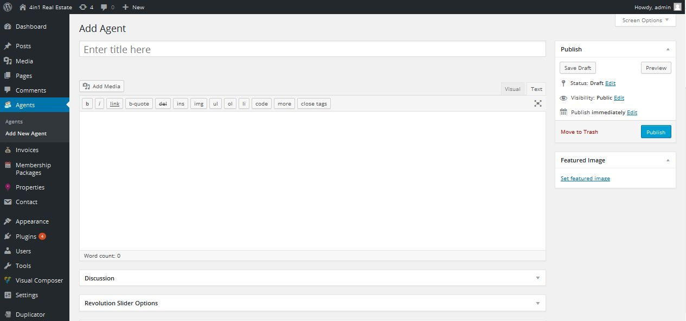

**Description:**

Admin can add new agent with details

**Membership plan**

**View membership plan**

**Activity:**

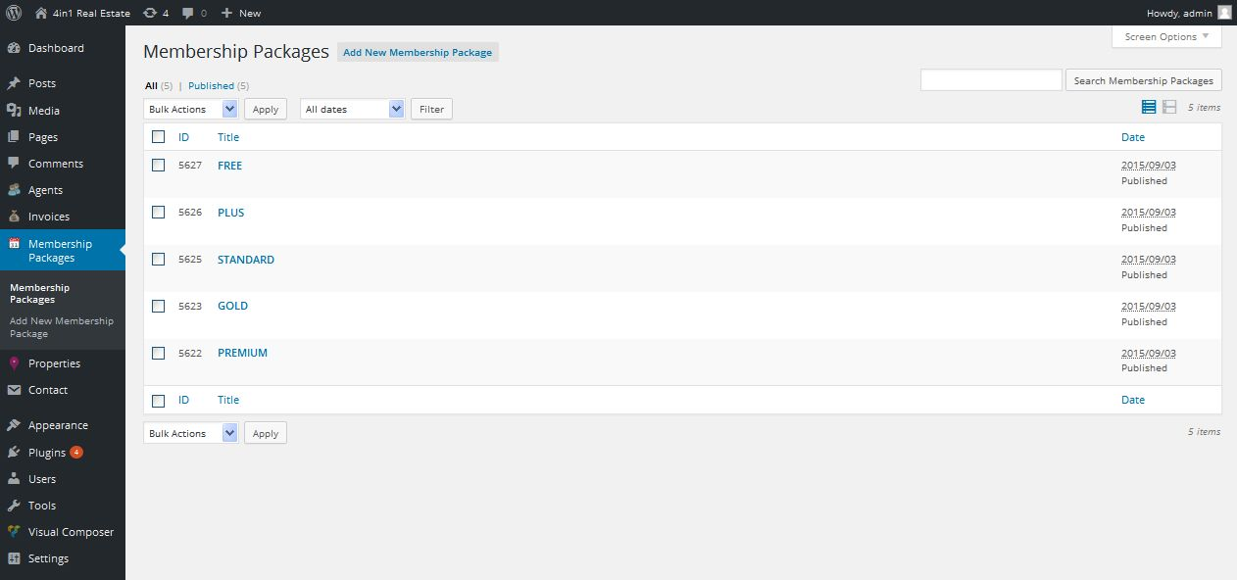

**Description:**

Admin can view current active and inactive membership plans

**Add new membership plan**

**Activity:**

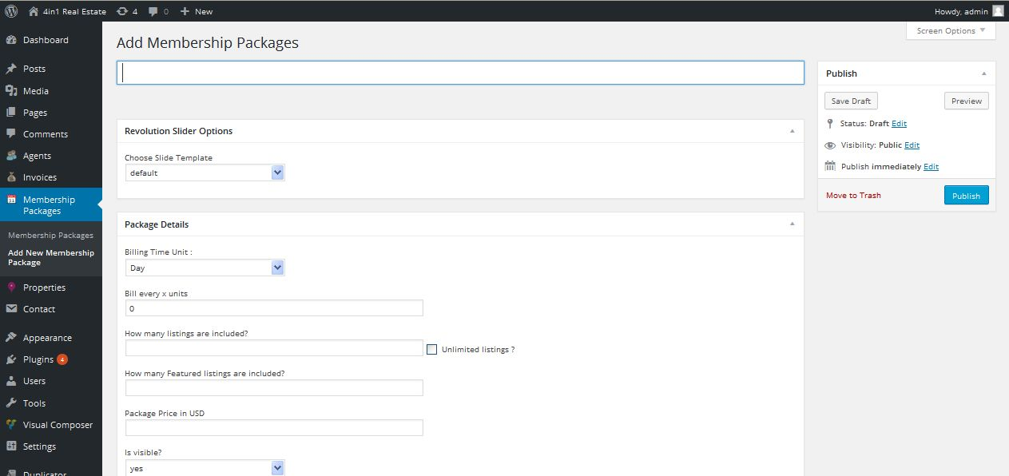

**Description:**

Admin can add new membership plan with details

**Appearance-Real estate option**

**General settings**

**Activity:**

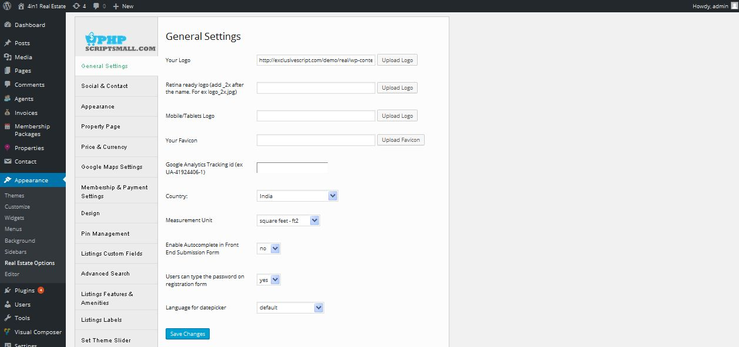

**Description:**

Admin manage general settings of logo and favicon settings

**Social and contact**

**Activity:**

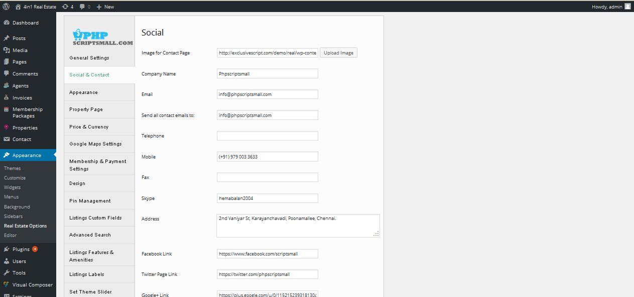

**Description:**

Admin mange links of their social connections and social login settings

**Appearance**

**Activity:**

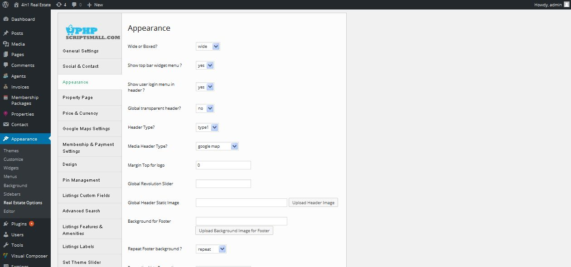

**Description:**

Admin manage settings of site appearance like font and footer and blog background

**Property page**

**Activity:**

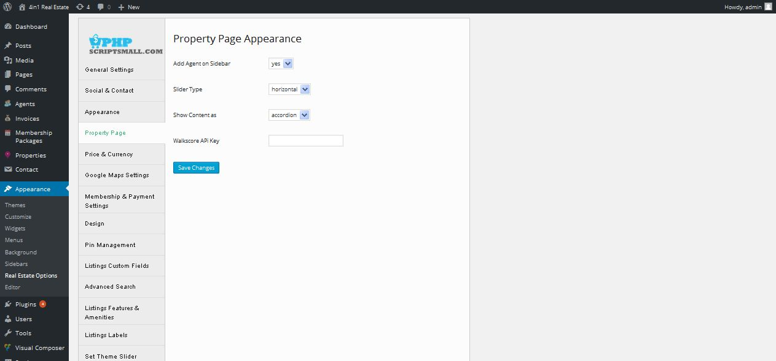

**Description:**

Admin manage settings of property appearance

**Price & Currency**

**Activity:**

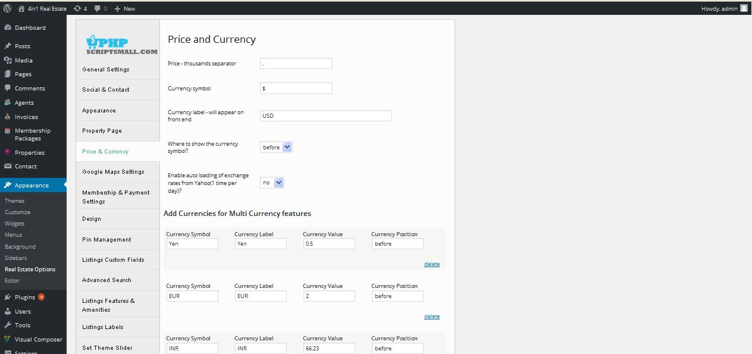

**Description:**

Admin manage settings of price and currency

**Google map**

**Activity:**

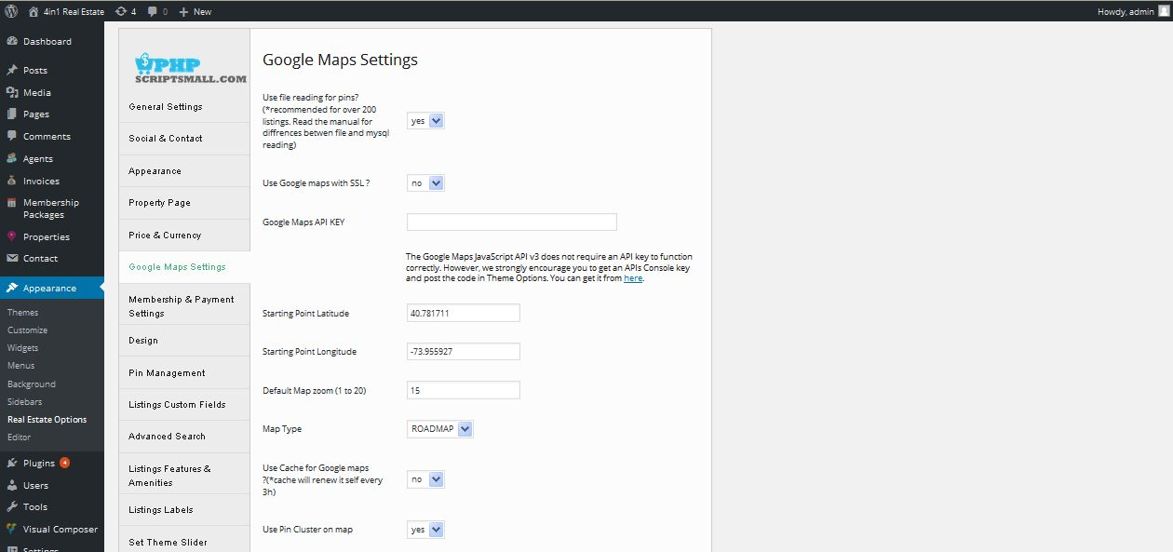

**Description:**

Admin manage Google map settings

**Membership & payment settings**

**Activity:**

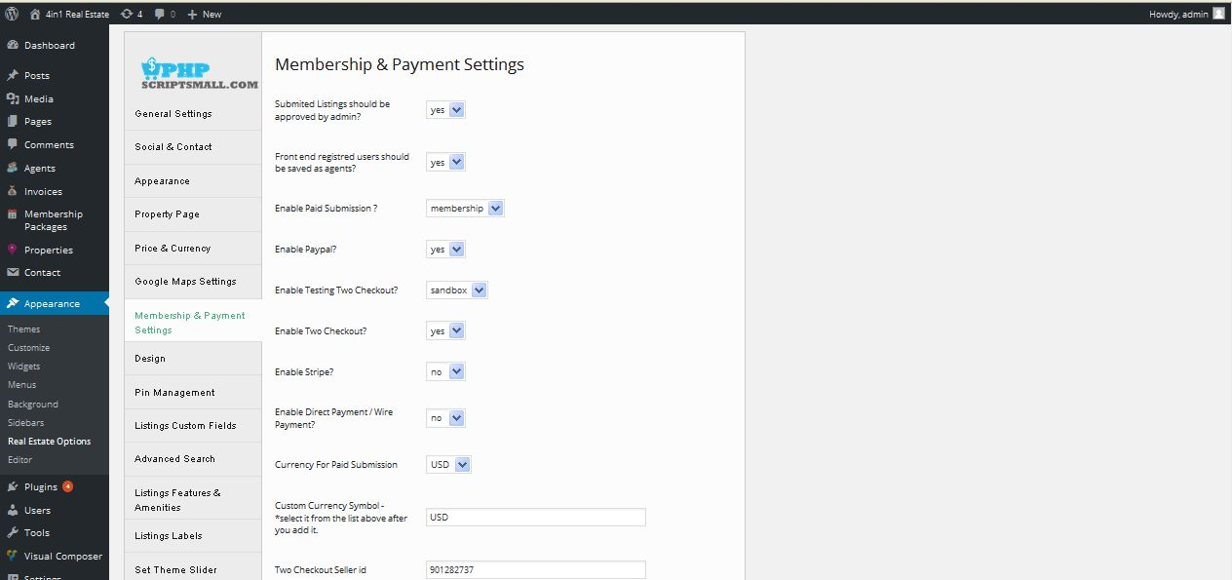

**Description:**

Admin manage settings of PayPal and allow membership signup option settings

**Design**

**Activity:**

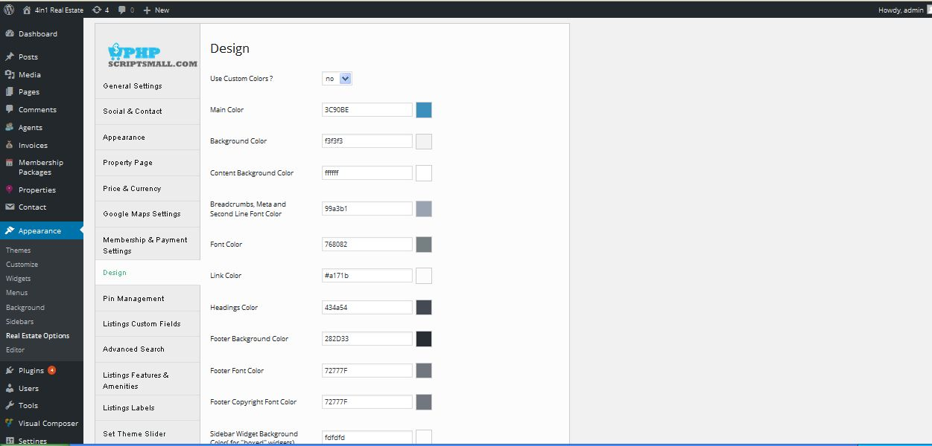

**Description:**

Admin manage site all pages color settings

**Pin management**

**Activity:**

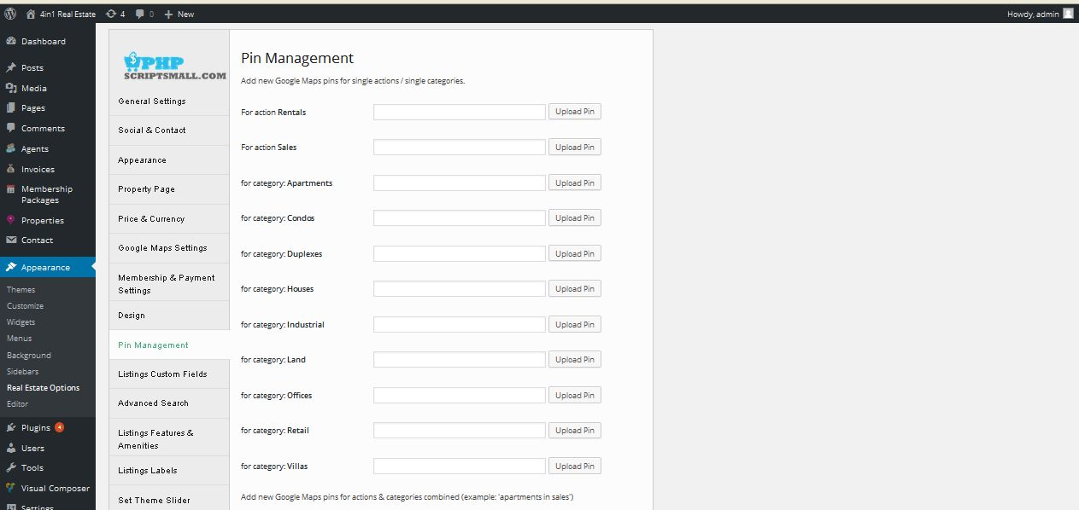

**Description:**

Admin can add pin for all the activity to activate and inactivate

**Custom fields**

**Activity:**

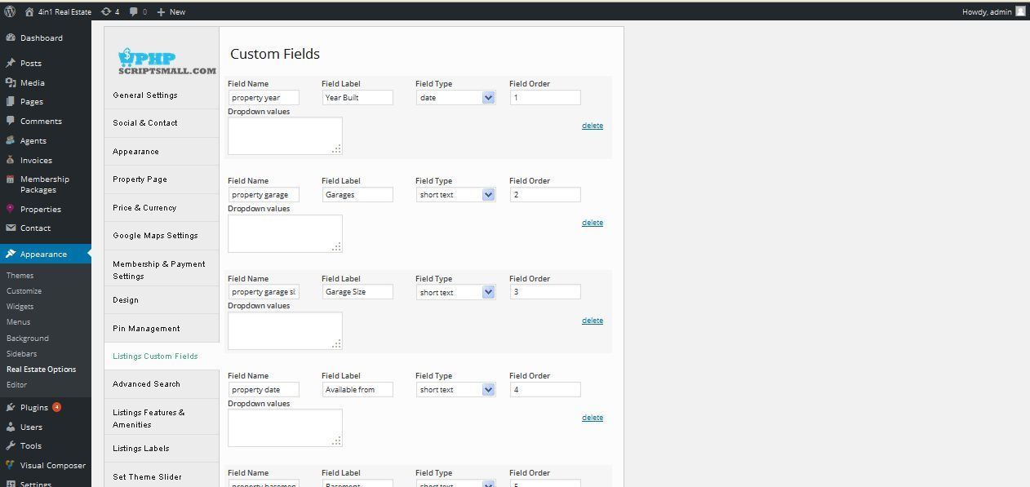

**Description:**

Admin manage settings custom fields

**Advance search**

**Activity:**

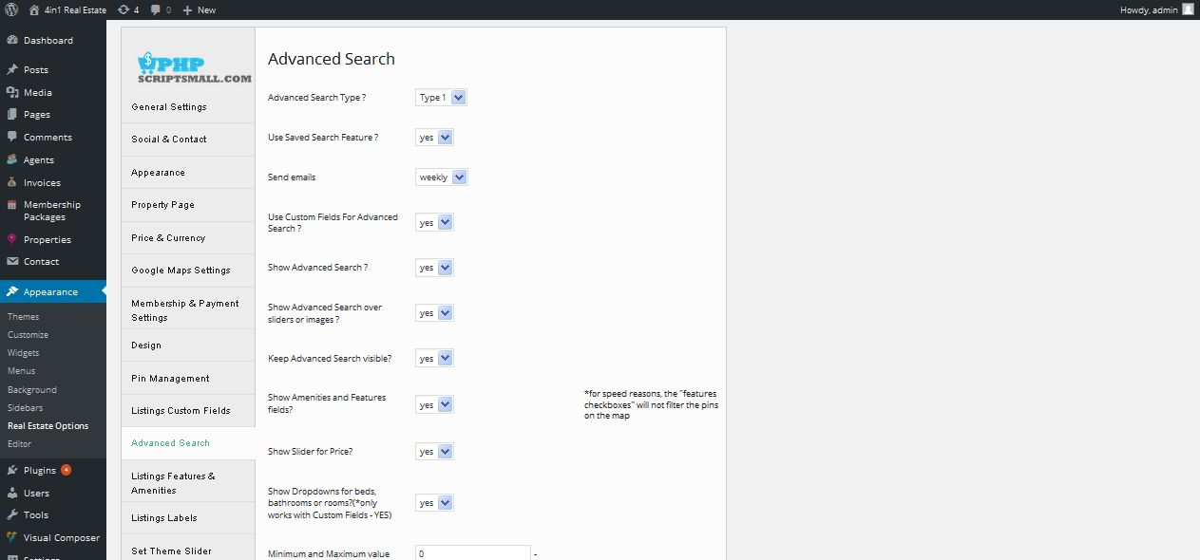

**Description:**

Admin manage settings search result and search custom fields of search

**Listing features and amentias**

**Activity:**

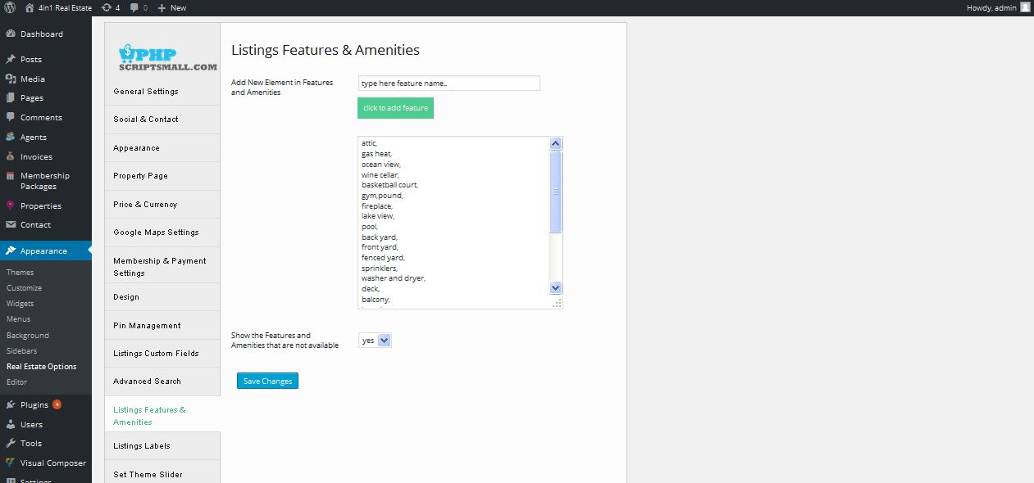

**Description:**

Admin can add and manage features

**Listing label**

**Activity:**

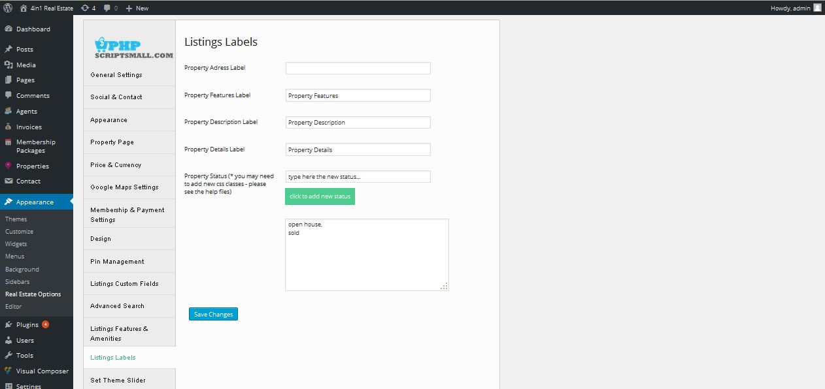

**Description:**

Admin manage settings property listing label

**Theme slider**

**Activity:**

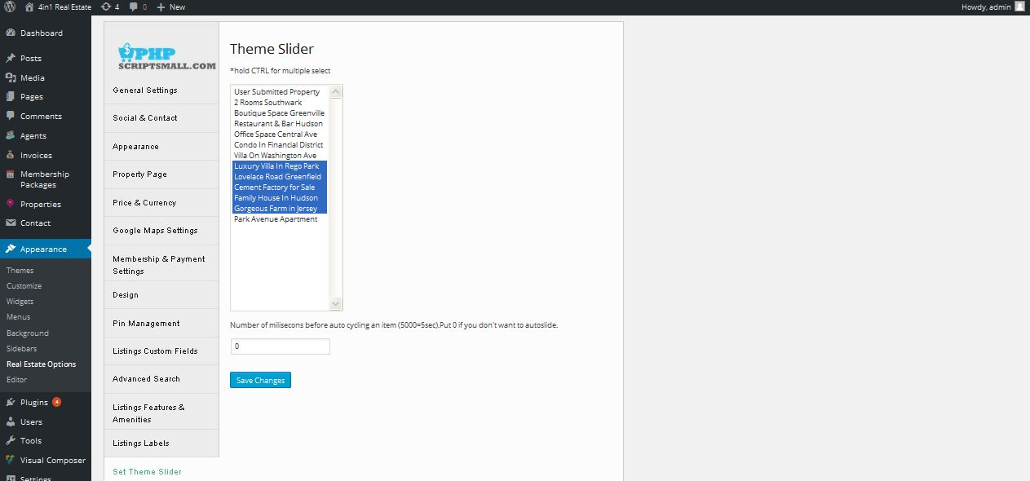

**Description:**

Admin manage theme slider settings

**Generate pin**

**Activity:**

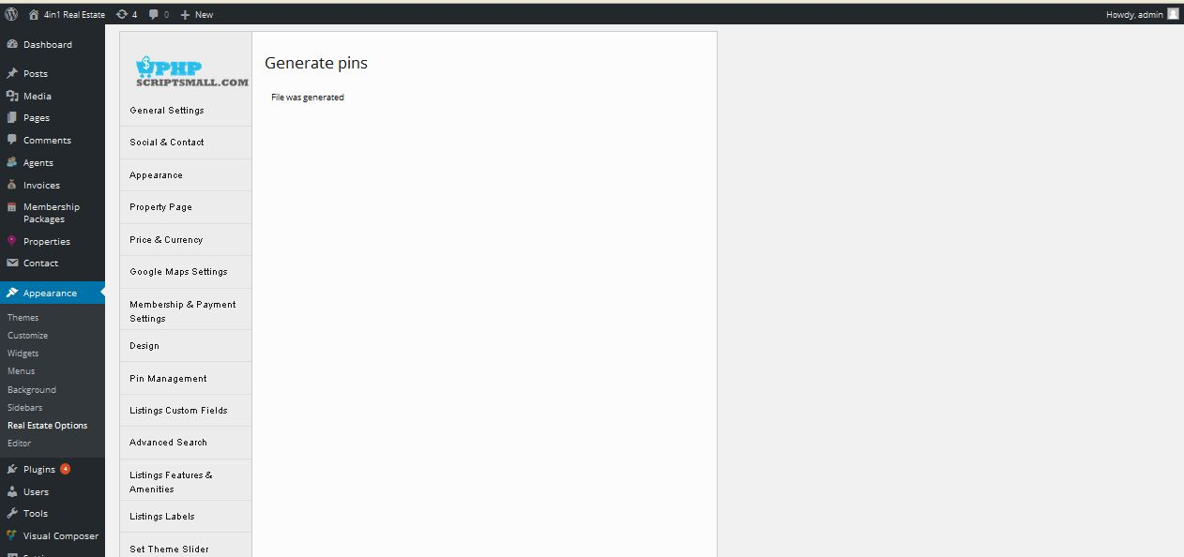

**Description:**

Admin generate pin using these links

**Email management**

**Activity:**

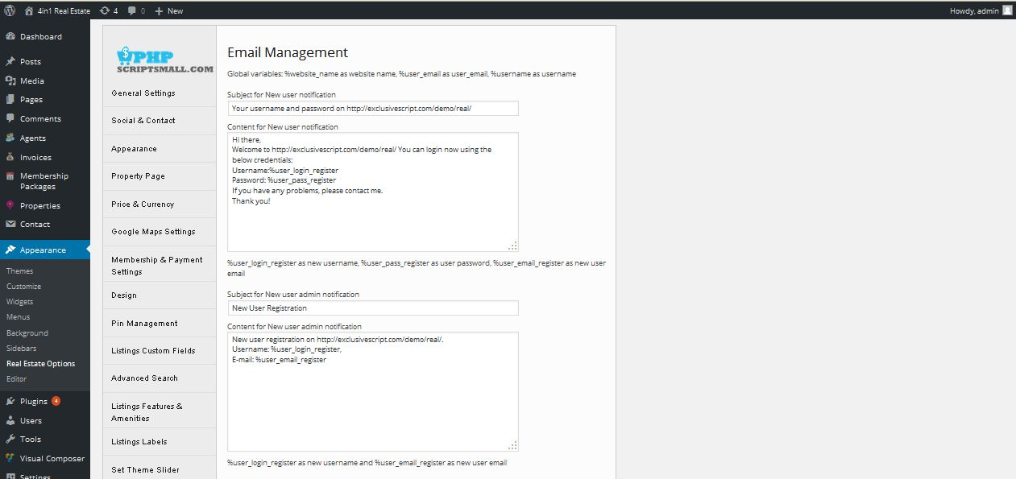

**Description:**

Admin manage email content and subject all send mail send through admin

**Editor**

**Activity:**

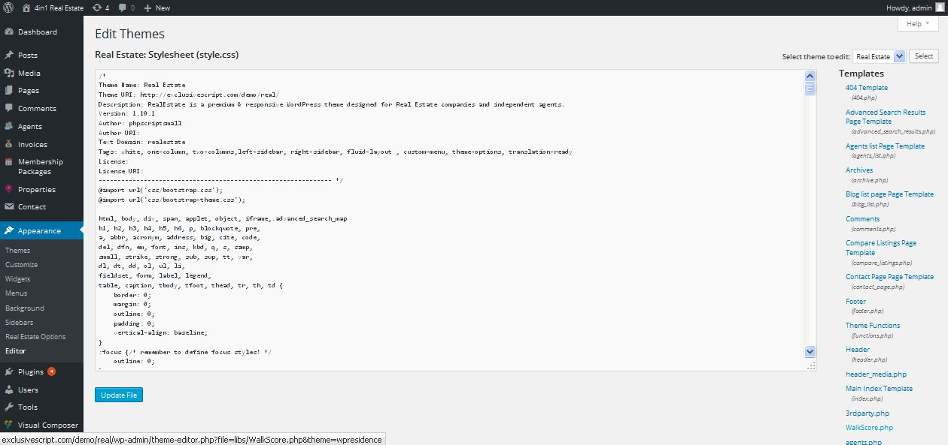

**Description:**

Admin can edit script using CSS

**Appearance**

**Themes**

**Activity:**

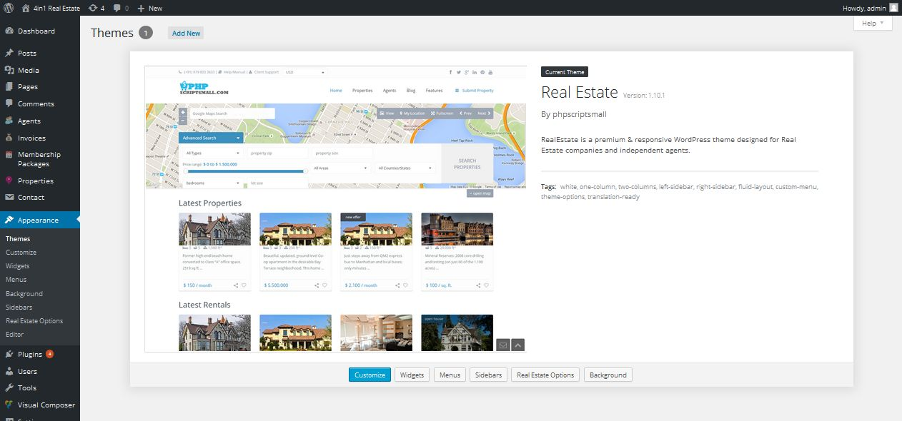

**Description:**

Admin can update their theme

**Customize**

**Site title & tagline**

**Activity:**

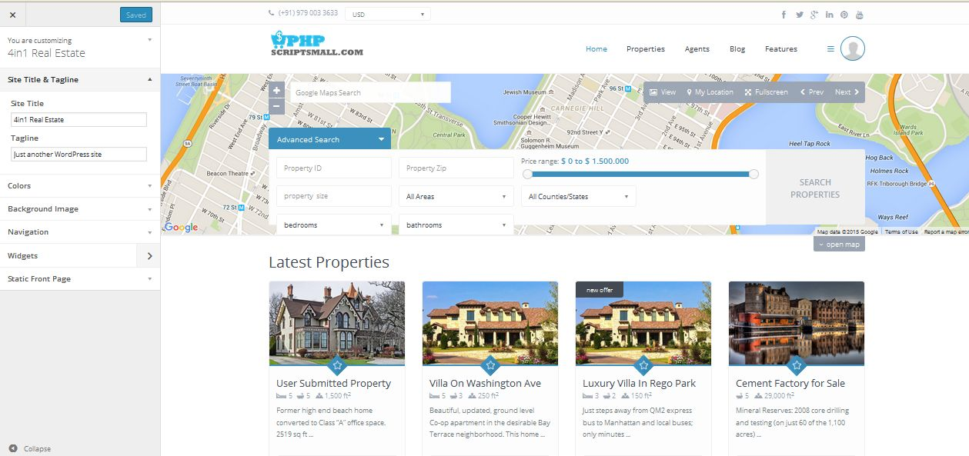

**Description:**

Admin can update their site title and tagline content

**Colors**

**Activity:**

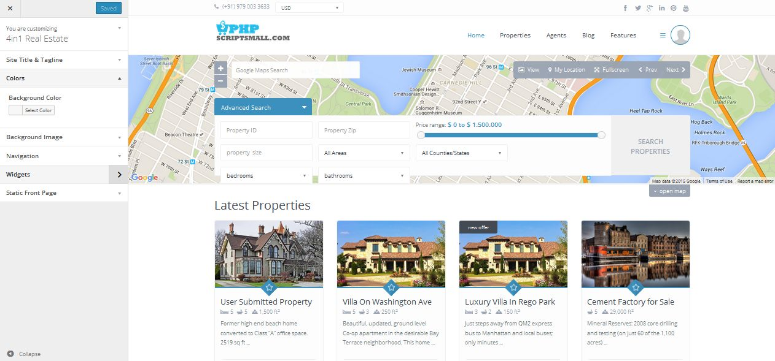

**Description:**

Admin mange site color settings

**Background image**

**Activity:**

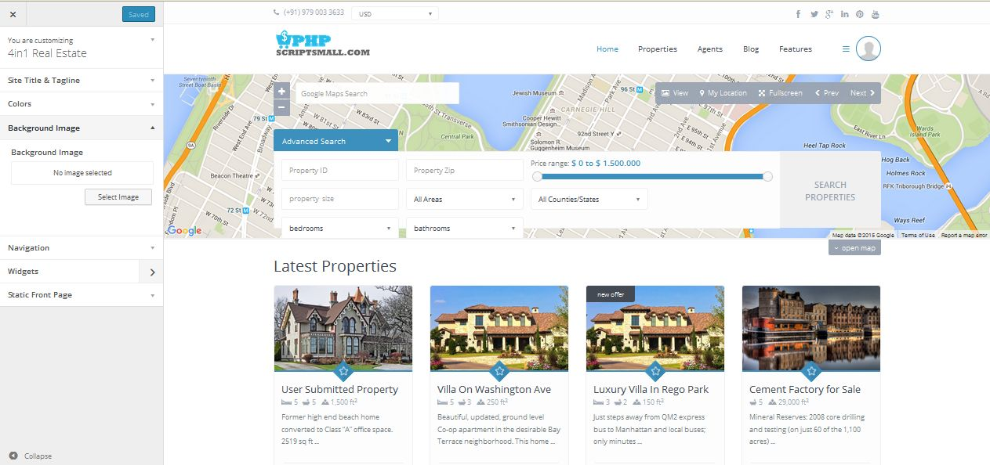

**Description:**

Admin can update their background image

**Navigation**

**Activity:**

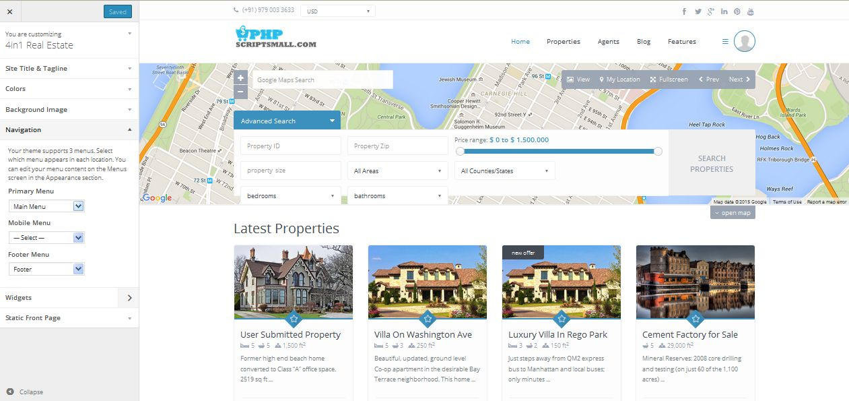

**Description:**

Admin manage settings of menu navigation

**Widgets**

**Footer widgets**

**Activity:**

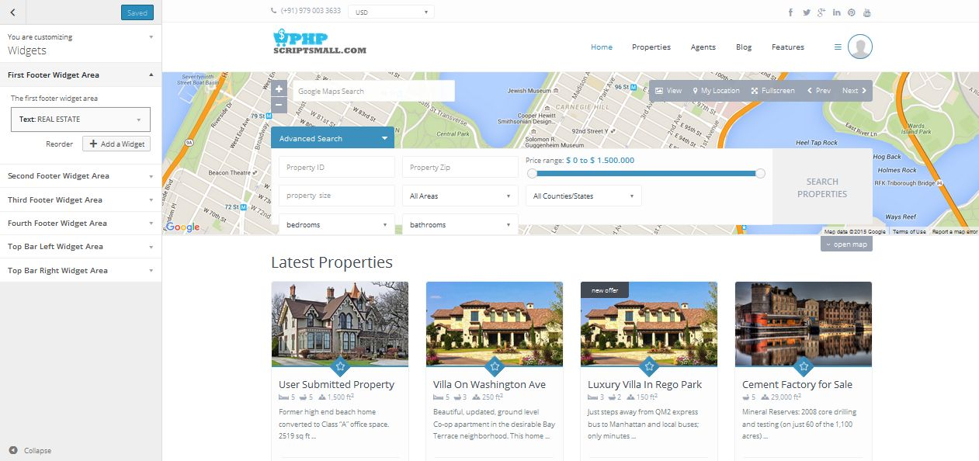

**Description:**

Admin manage footer content of first to four widget contents

**Top bar left widget**

**Activity:**

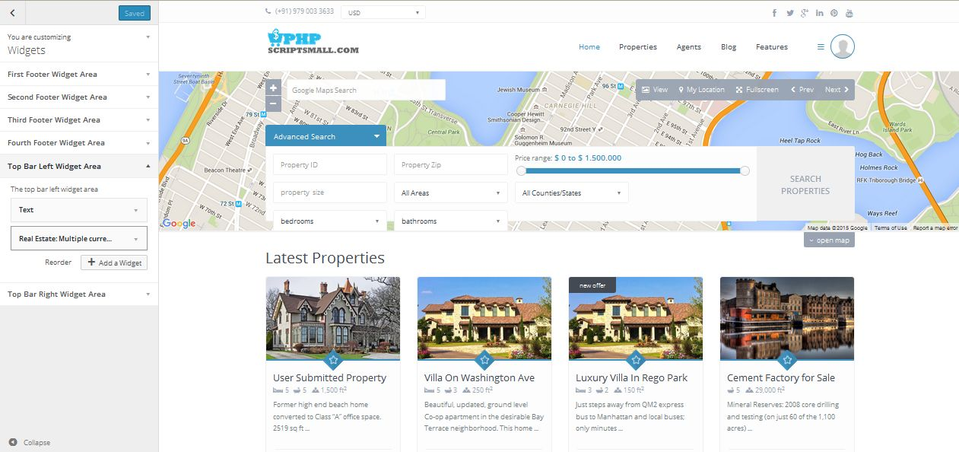

**Description:**

Admin manage content of top bar left widget content

**Top bar right widget**

**Activity:**

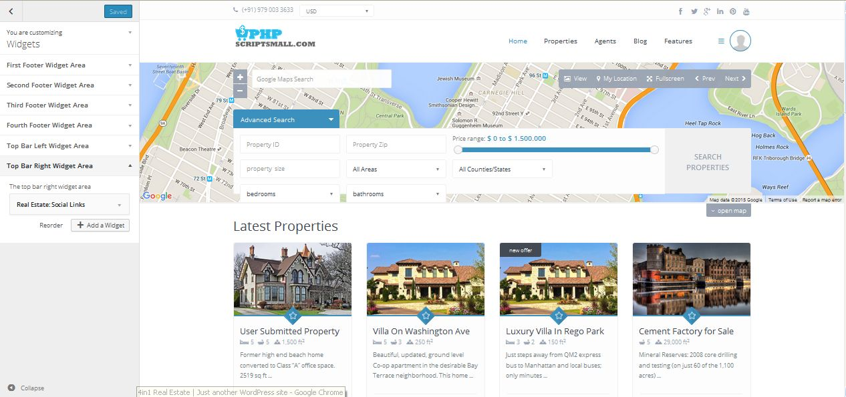

**Description:**

Admin manage content of top bar right widget

**Static front image**

**Activity:**

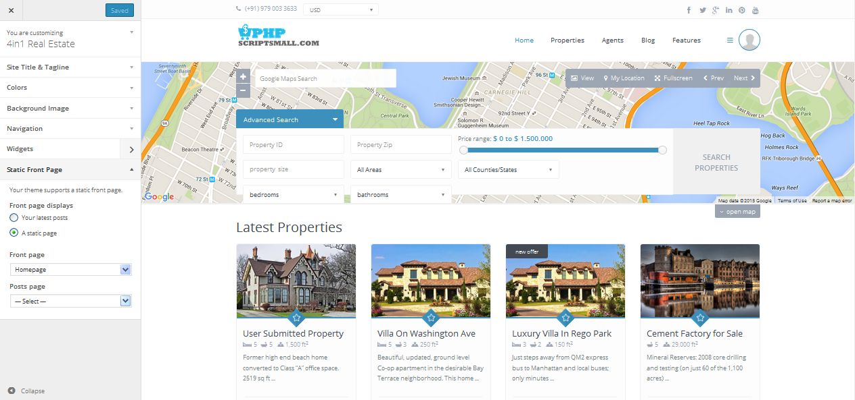

**Description:**

Admin manage static image settings

**Widgets**

**Activity:**

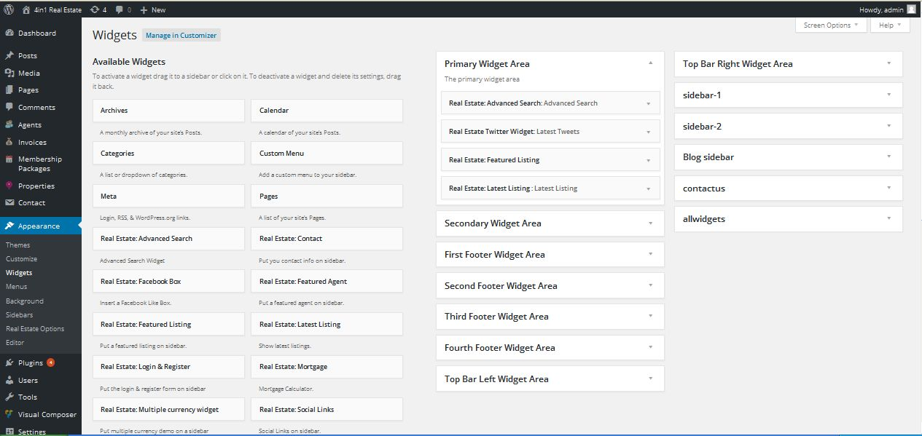

**Description:**

Admin manage widgets settings

**Menu**

**Activity:**

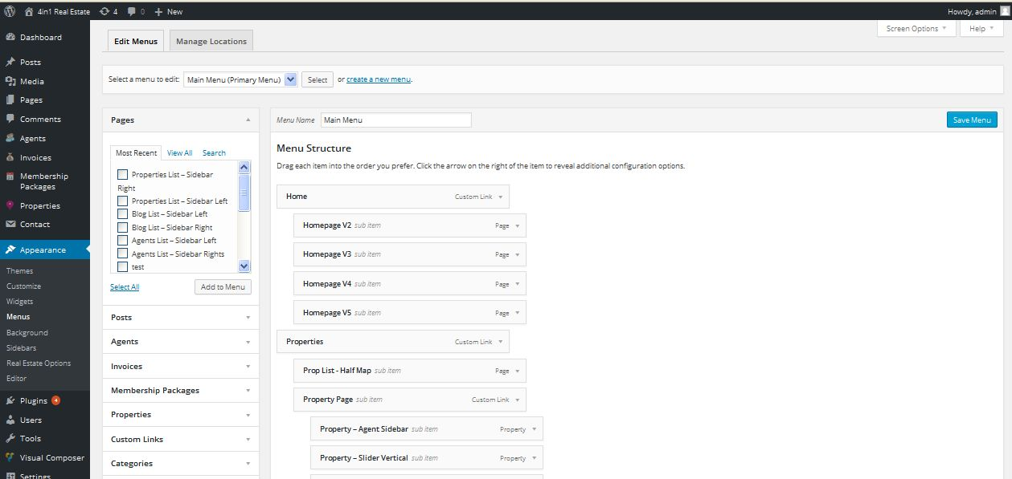

**Description:**

Admin manage settings of menu

**Menu location**

**Activity:**

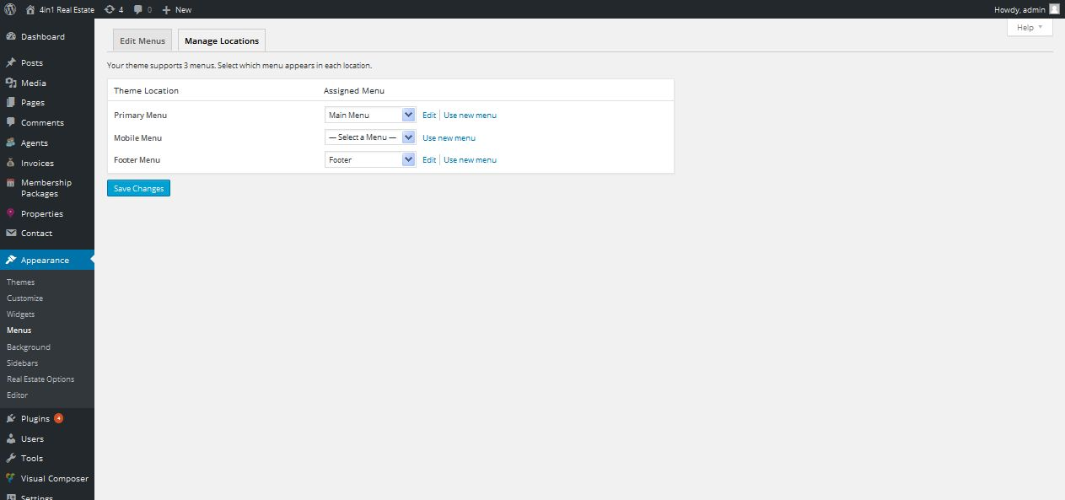

**Description:**

Admin manage settings of menu location settings

**Background**

**Activity:**

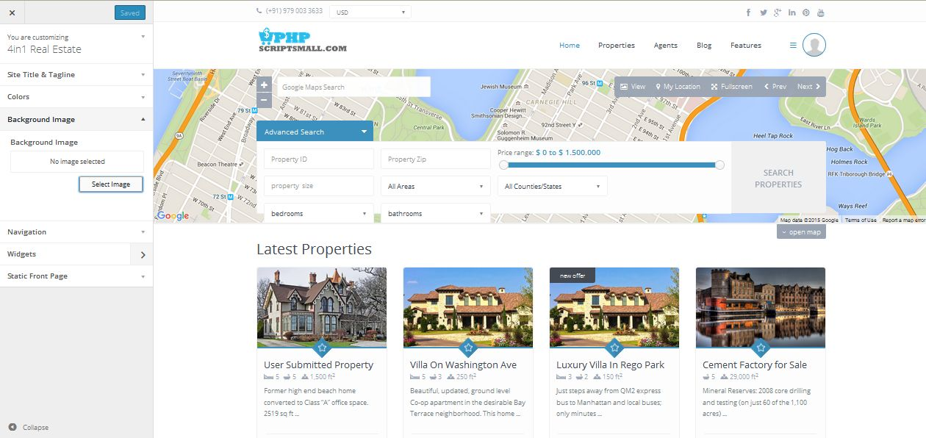

**Description:**

Admin manage settings of background image

**Sidebar**

**Activity:**

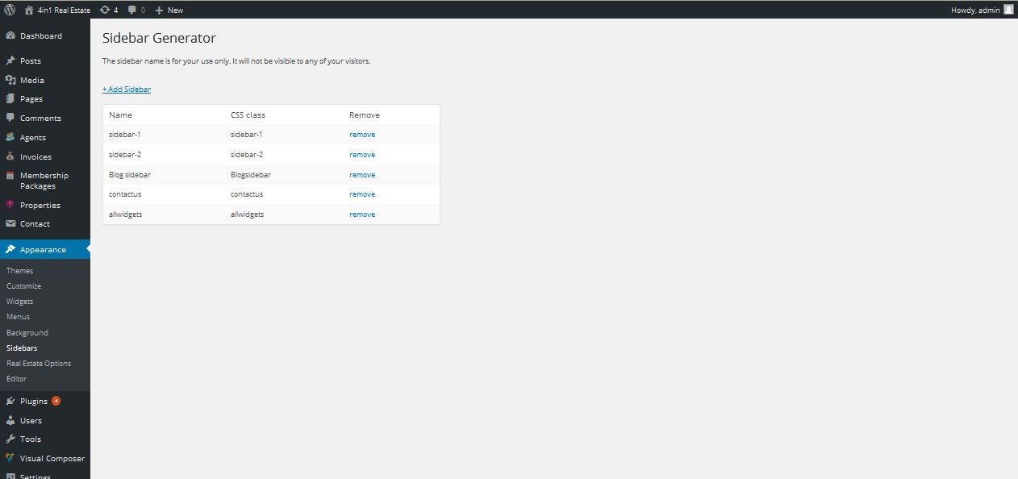

**Description:**

Admin manage settings of sidebar generation

**Post**

**View post**

**Activity:**

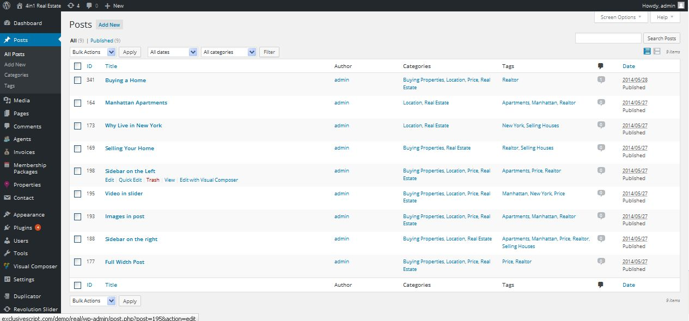

**Description:**

Admin can manage all posted post

**Add post**

**Activity:**

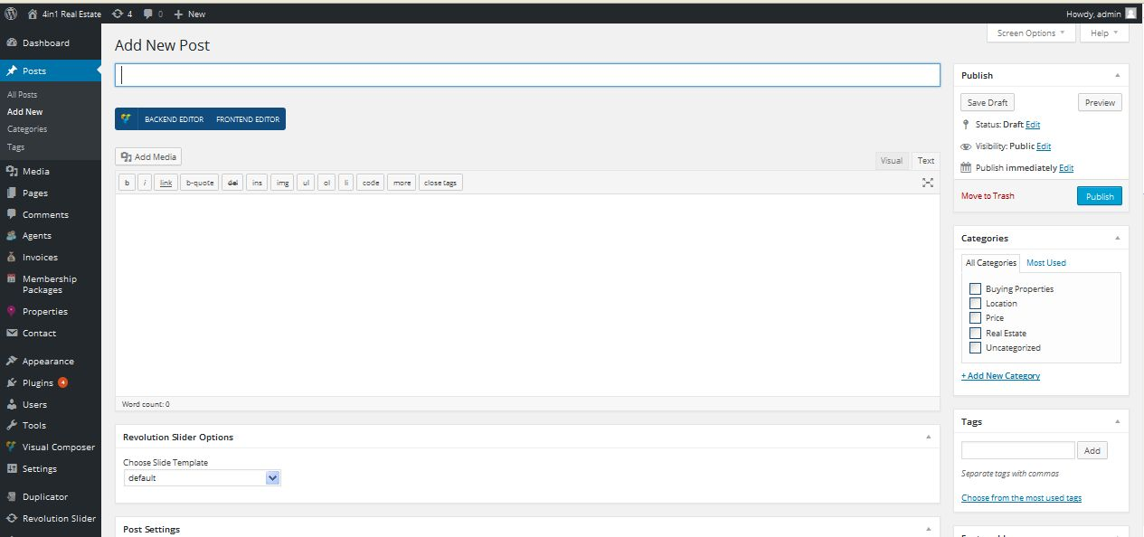

**Description:**

Admin can add new post

**Post category**

**Activity:**

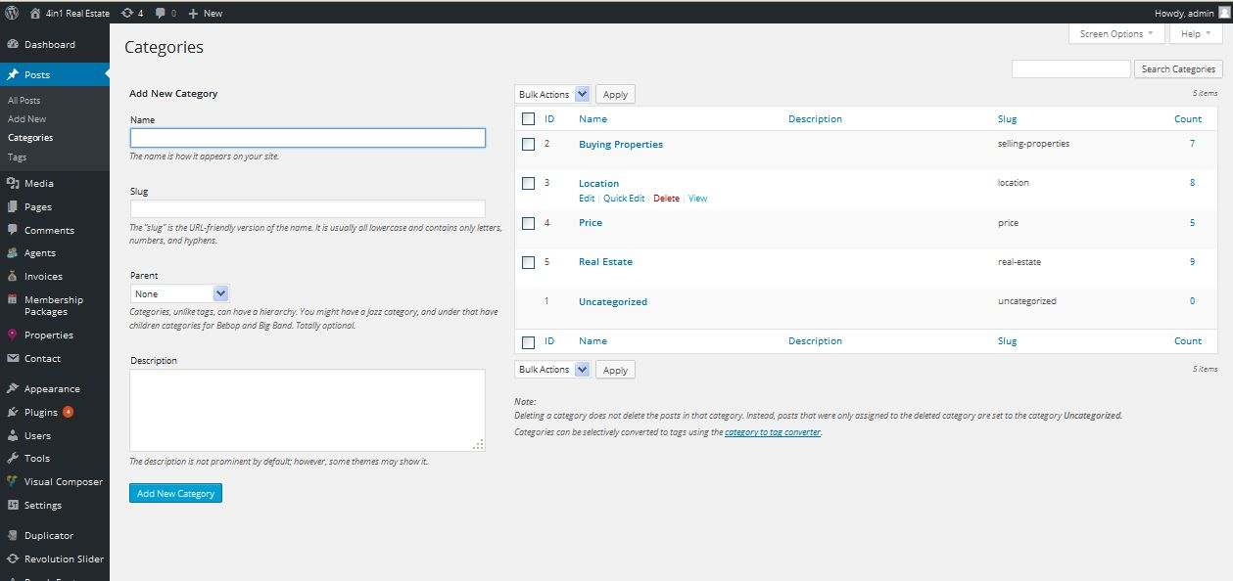

**Description:**

Admin can add and manage post category

**Post tag**

**Activity:**

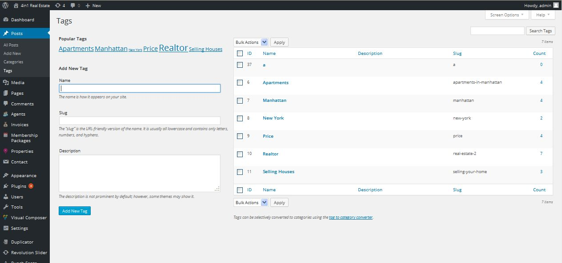

**Description:**

Admin can add and manage post tag

**Media**

**Library**

**Activity:**

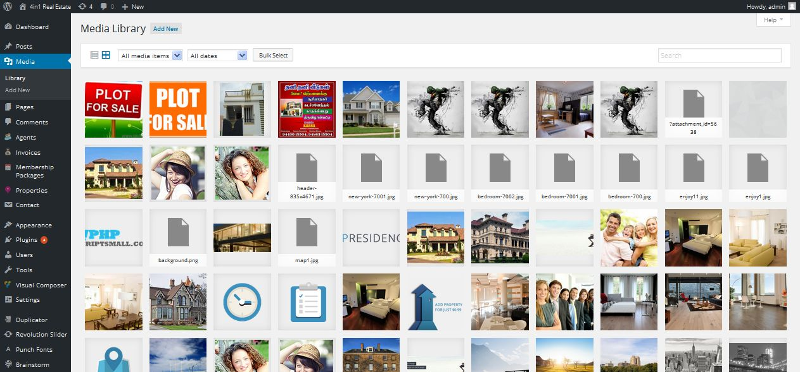

**Description:**

Admin can view all media related with site

**Upload media**

**Activity:**

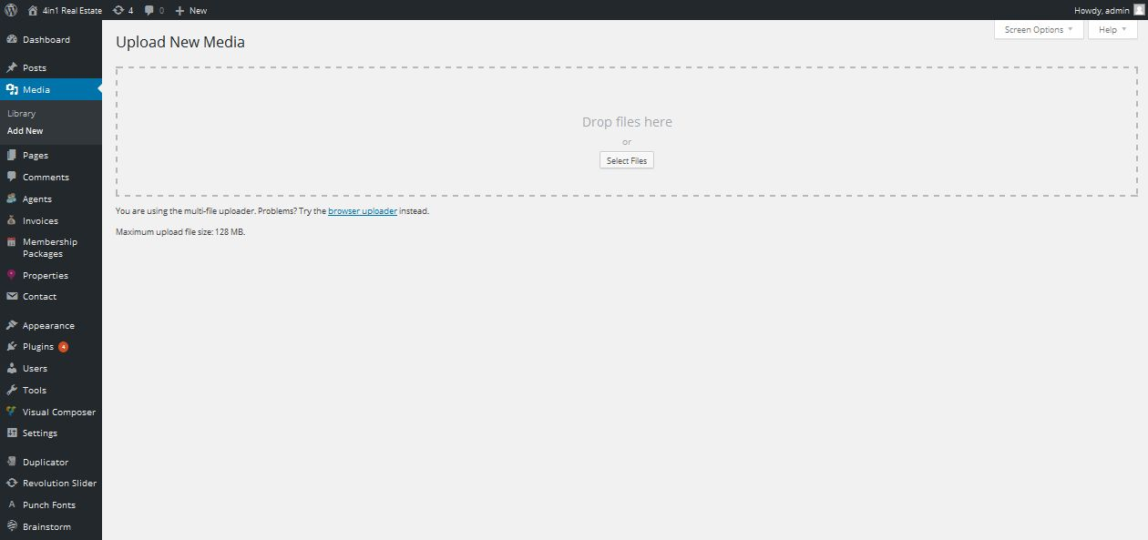

**Description:**

Admin can add new media

**Page**

**View pages**

**Activity:**

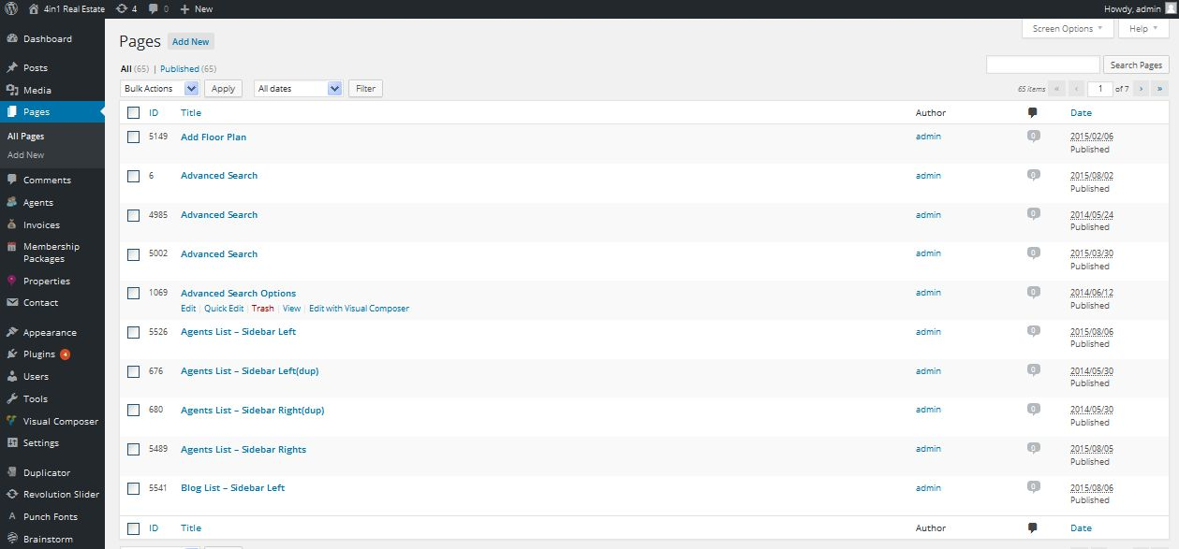

**Description:**

Admin can view all active and inactive pages

**Add page**

**Activity:**

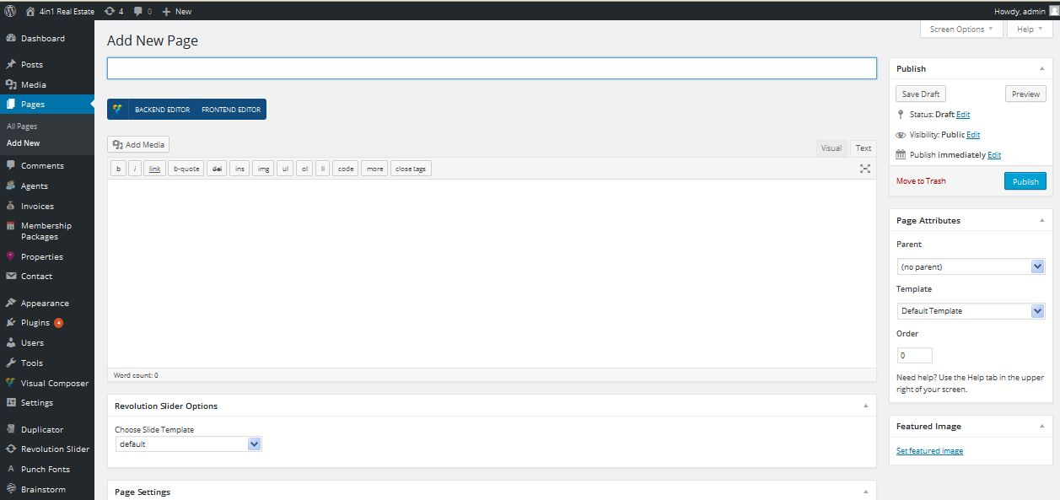

**Description:**

Admin can add new page

**Comments**

**Activity:**

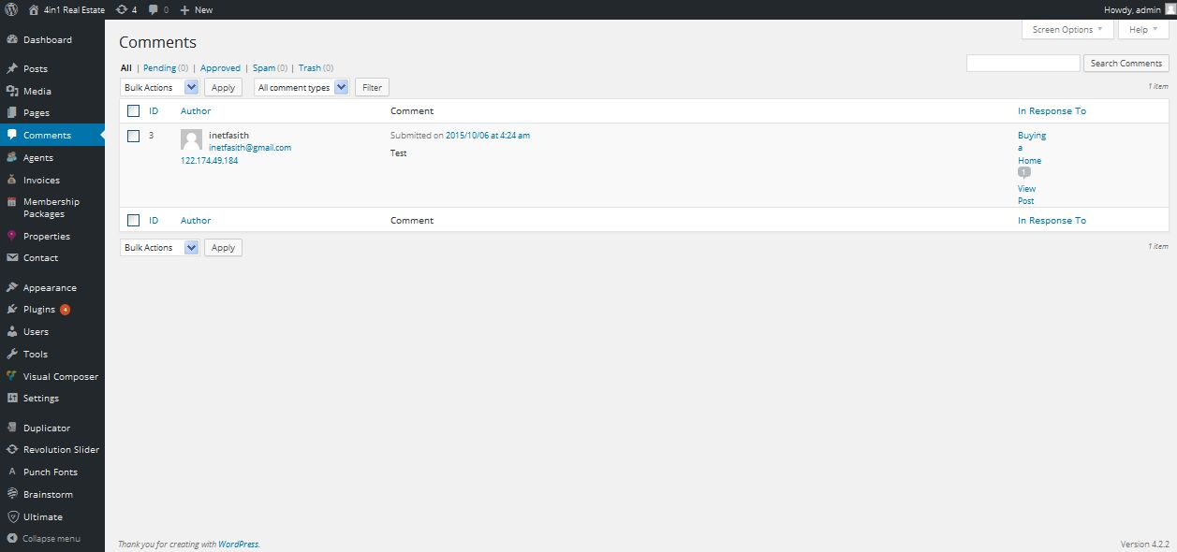

**Description:**

Admin can manage comments related with site

**Contact form**

**View contact form**

**Activity:**

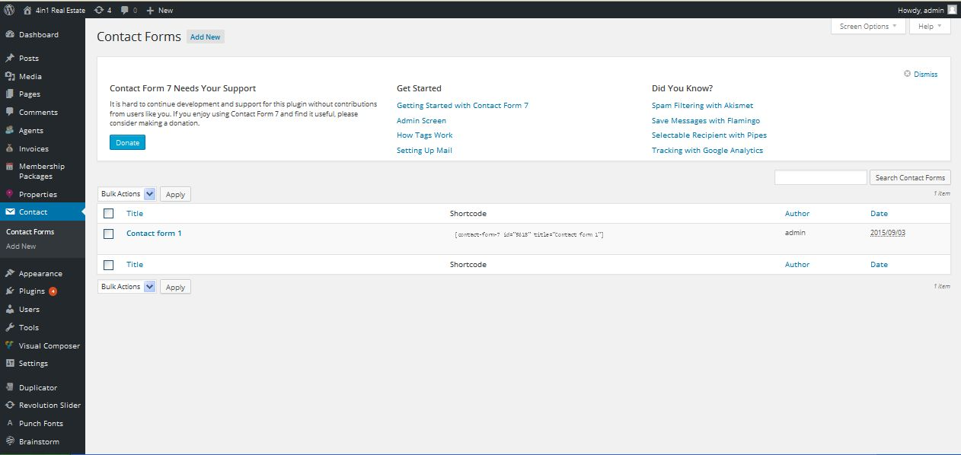

**Description:**

Admin can view current contact form details

**Add contact form**

**Activity:**

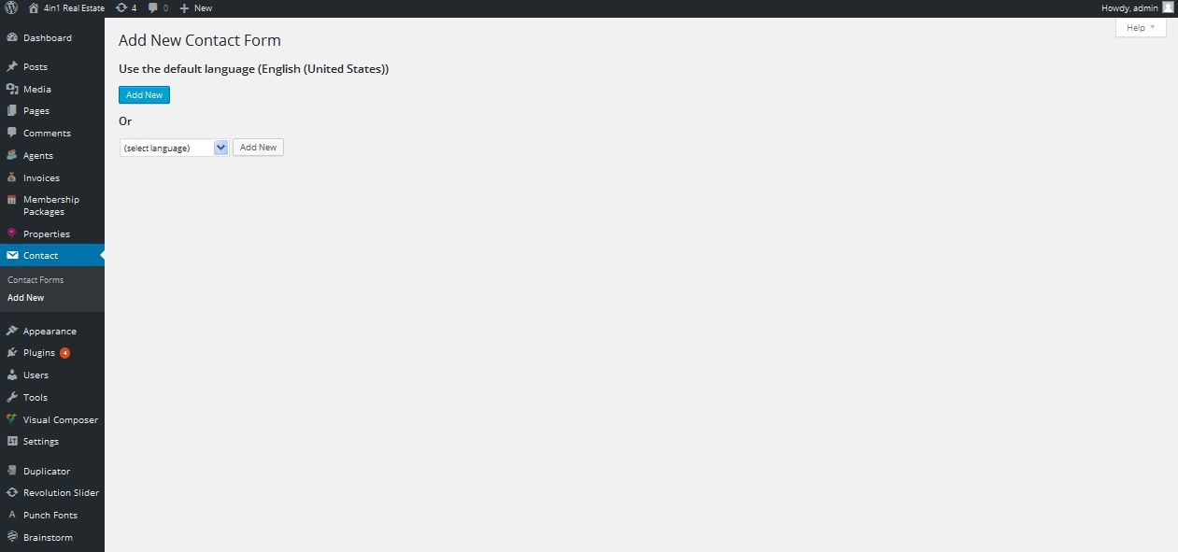

**Description:**

Admin can add new contact form

**Users**

**Activity:**

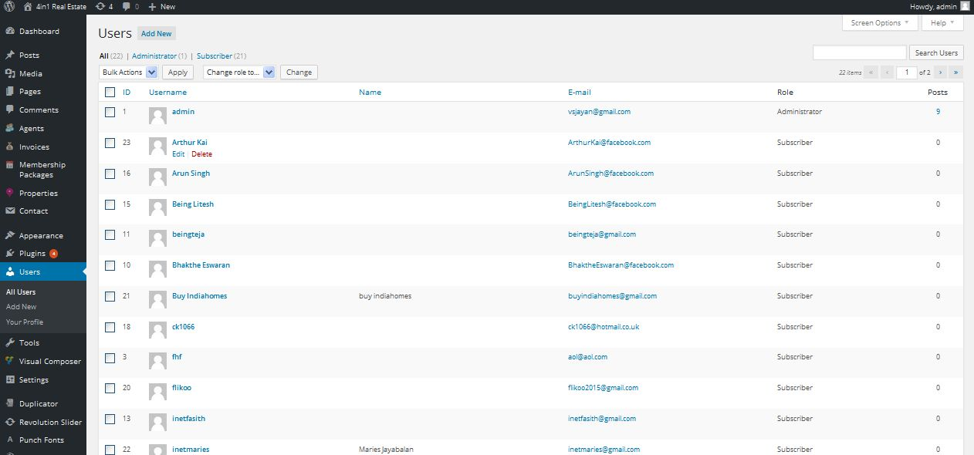**Description:**

Admin can view all the users of the site

**Add user**

**Activity:**

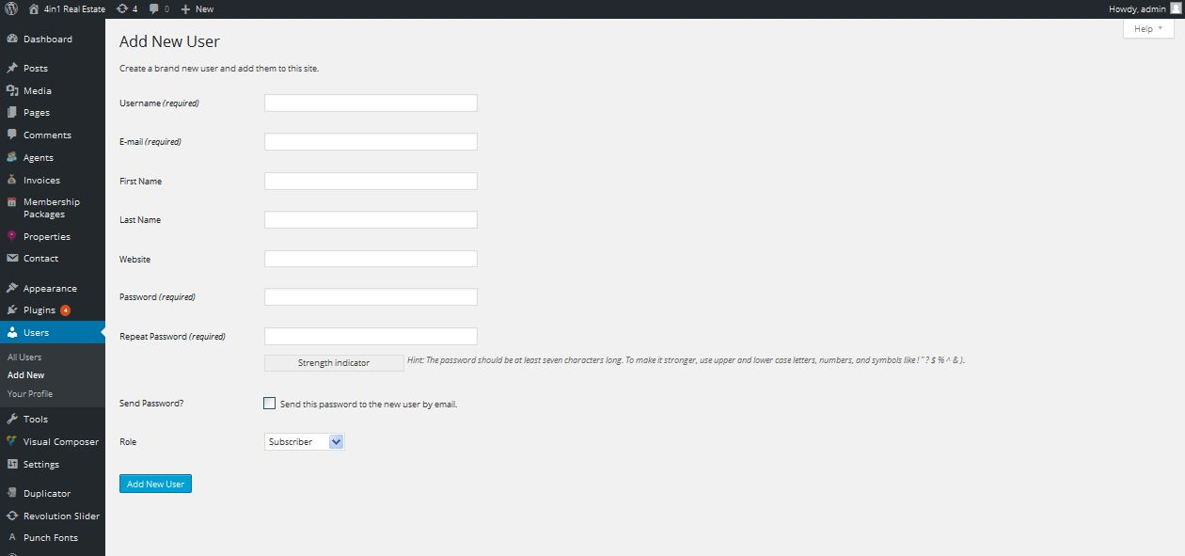

**Description:**

Admin can add new user

**View profile**

**Activity:**

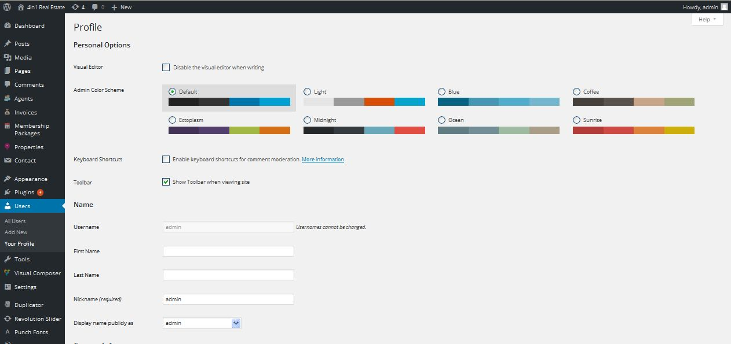

**Description:**

Admin can view their profile details

**Tools**

**Available tools**

**Activity:**

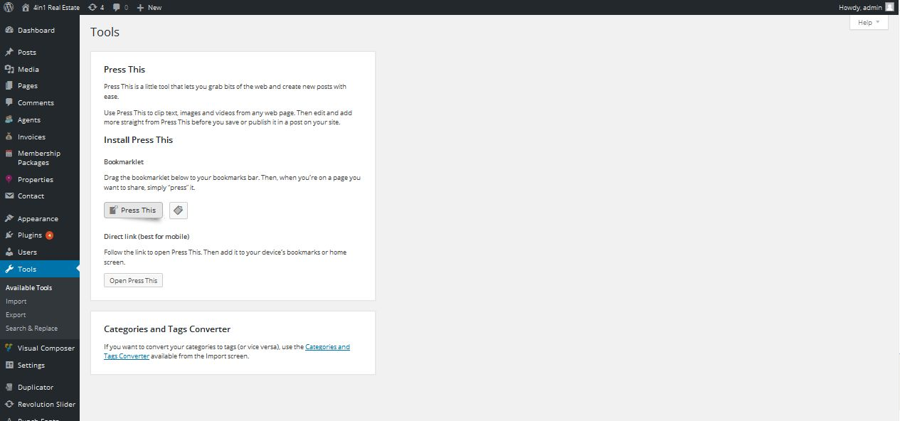

**Description:**

Admin can view available tools details

**Import**

**Activity:**

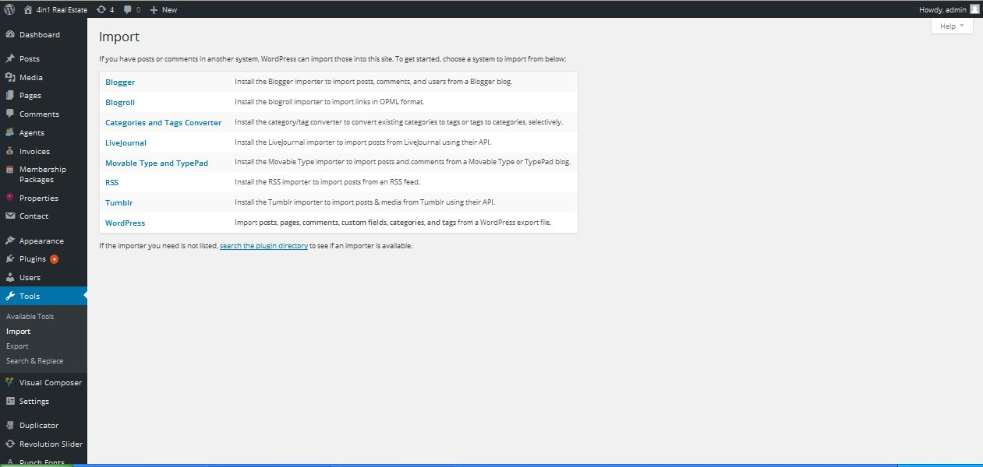

**Description:**

Admin can import tools

**Export**

**Activity:**

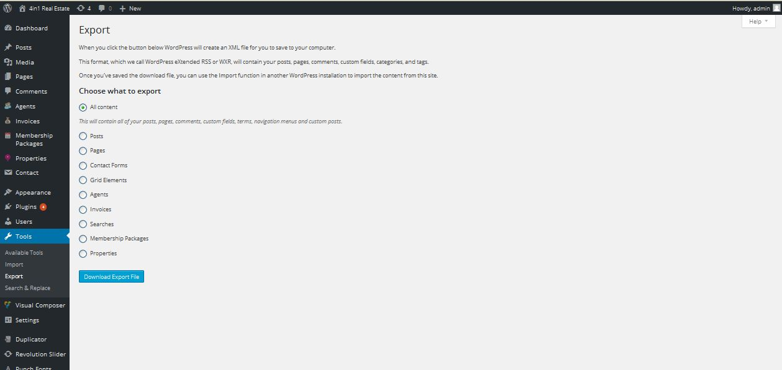

**Description:**

Admin can export site details

**Search & Replace**

**Activity:**

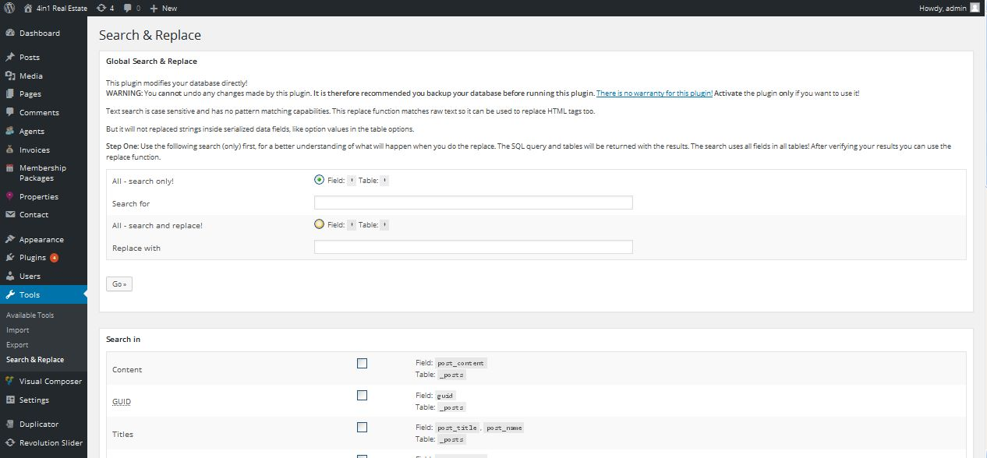

**Description:**

Admin can manage settings of search and replace tools

**Settings**

**General settings**

**Activity:**

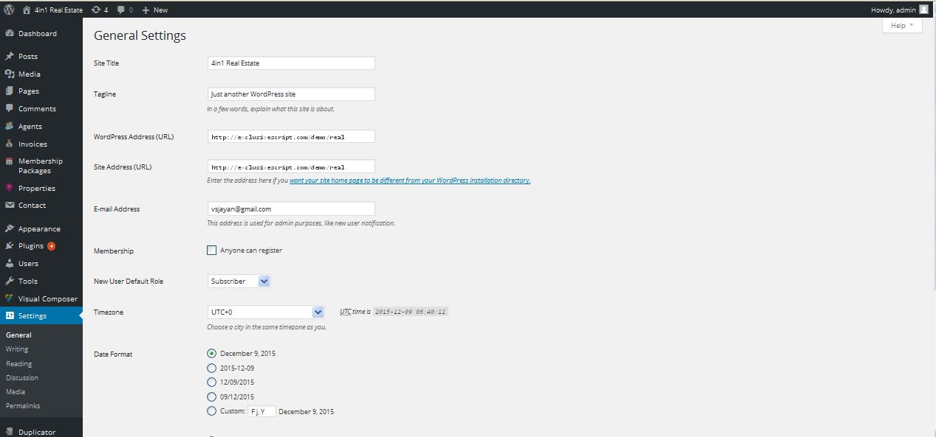

**Description:**

Admin manage site general setting site admin email and etc

**Writing settings**

**Activity:**

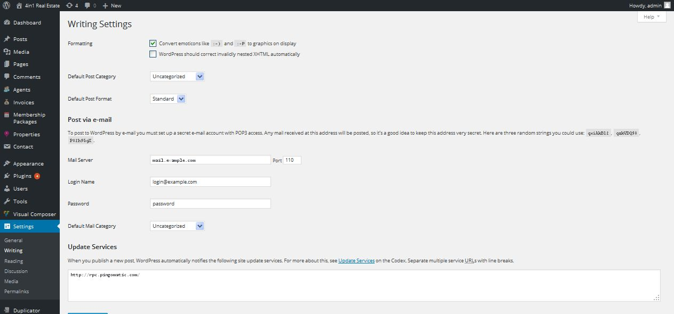

**Description:**

Admin manage settings of writing

**Reading**

**Activity:**

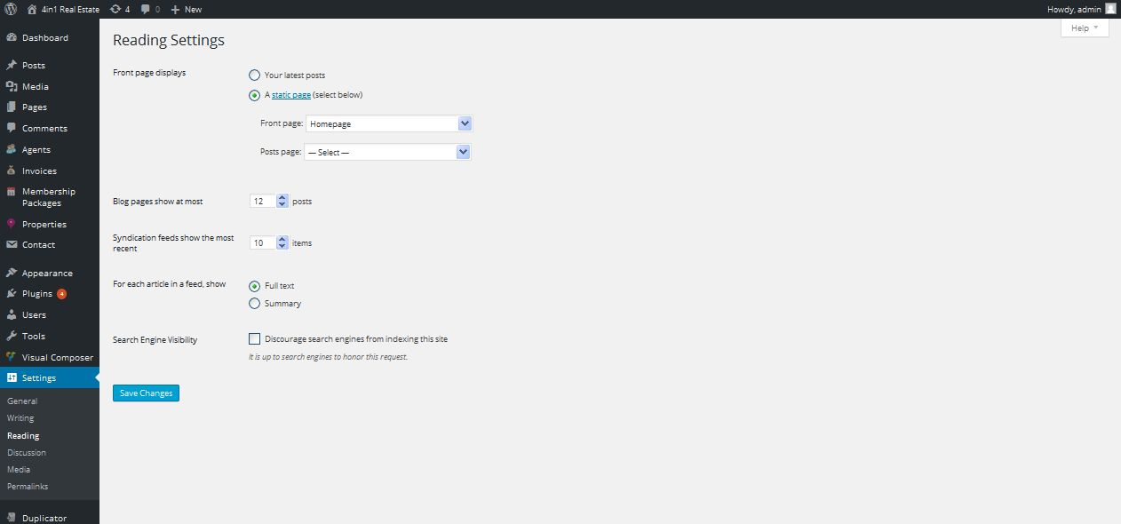

**Description:**

Admin can manage reading settings

**Discussion**

**Activity:**

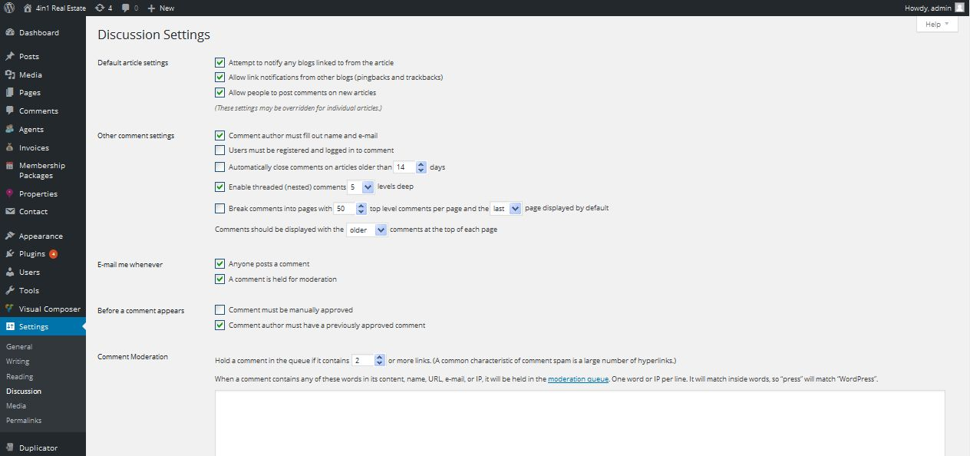

**Description:**

Admin manage settings of discussion

**Media**

**Activity:**

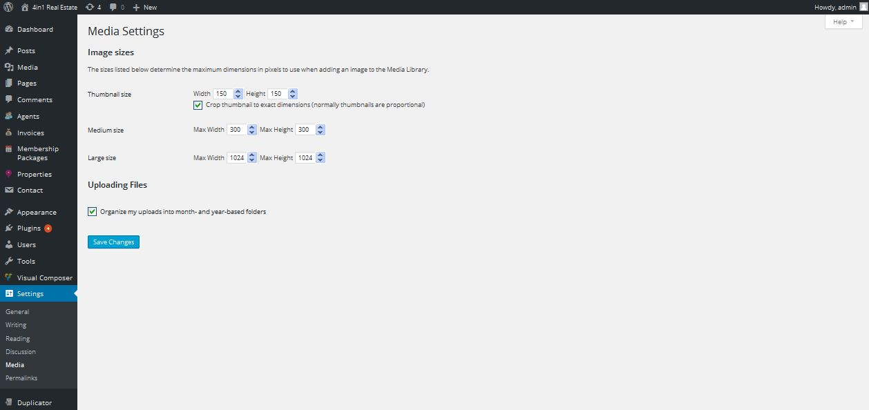

**Description:**

Admin manage settings of media

**Permalink**

**Activity:**

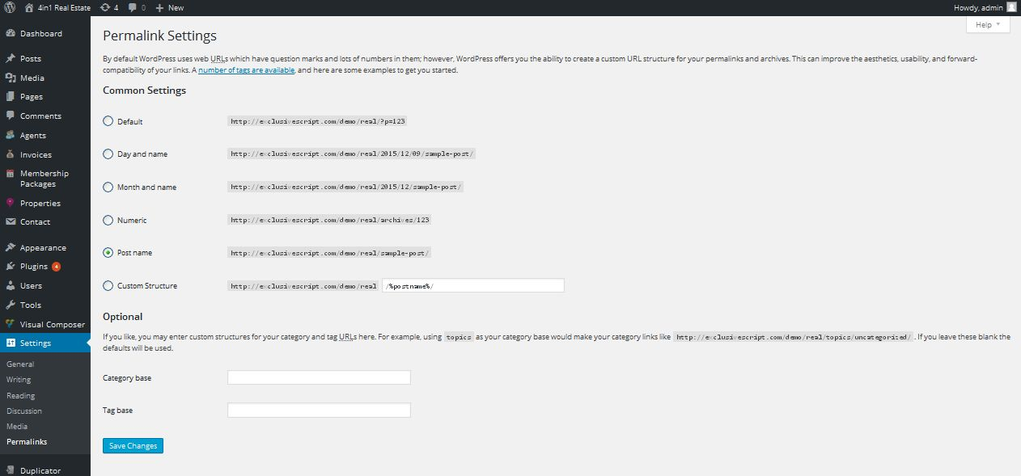

**Description:**

Admin manage settings of permalink