**FACEBOOK LIKE JQUERY INSTALLTION GUIDE**

**Add files to page**

**Activity:**

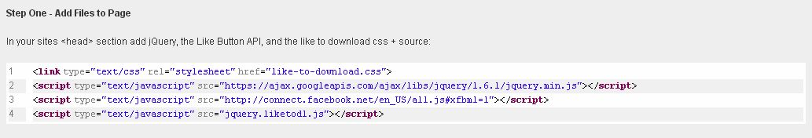

**Description:**

Admin enters code in header to add files

**Activity:**

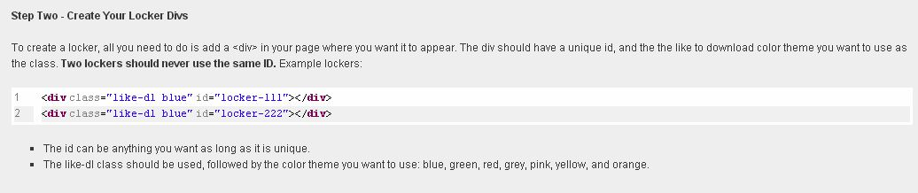

**Description:**

Admin need to create locker adding div file and enter the following comment

**Activity:**

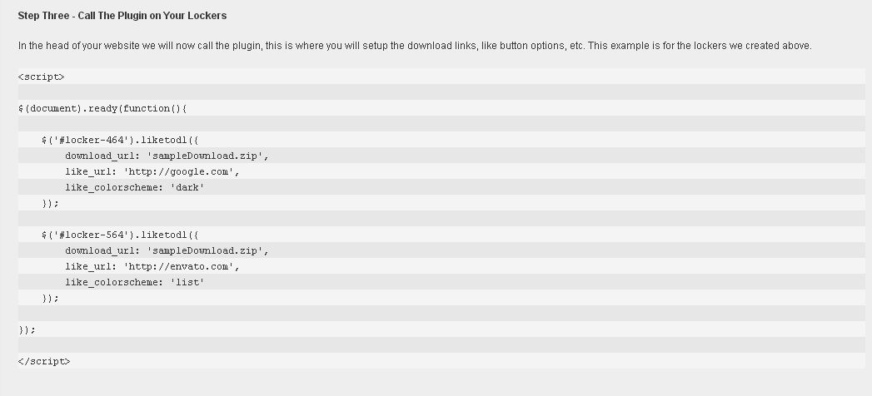

**Description:**

Admin edit comment to add function into locker using these coding